YEAR 4: JANUARY — Coordinator Notes

January can sometimes seem anti-climactic after the hustle and bustle of the Christmas season. The dreary cold can often sap us of our warm Christmas cheer. The Bible study Gold, Frankincense and Me! may be just the thing to warm your Mailbox Members again as it reminds them of the many gifts the Christmas season brought that have nothing to do with festive paper and bows.

Mailbox Members may work through the study alone, but it’s sometimes more enjoyable to share a discussion with someone else. Perhaps you and other members of your local group could offer to work through the study together with the Mailbox Members, either in person, over the telephone, or through a Facebook group.

Access the Bible study Gold, Frankincense and Me!

For Paper Copies:
- Download and print this month’s resource (in bold above) to share with each Mailbox Member.
- Remember to sign the message with your contact information!

For Electronic Communication:
- Send a new email and type “LWML Mailbox Member Greeting” in the subject line.
- Copy and paste the Mailbox Member message on the next page into your email.
- Attach the resource(s) for the month.

Distribute the resource to your Mailbox Members with the note found below.

-----------------------------------------------------------------------------------------------------------------------------------
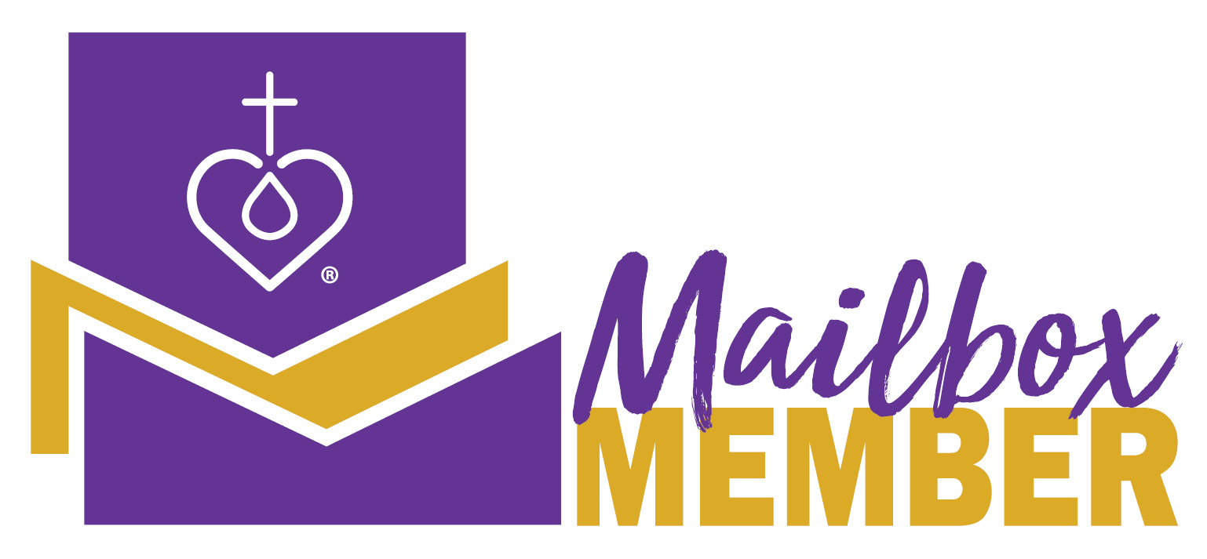
Hello from LWML!

January can sometimes seem anti-climactic after the hustle and bustle of the Christmas season. The dreary cold can often sap us of our warm Christmas cheer. The Bible study Gold, Frankincense and Me! may be just the thing to warm you again as it reminds you of the many gifts the Christmas season brought that have nothing to do with festive paper and bows.

As always, contact me with any questions. You are in my prayers!

Your Sister in Christ,

______________________________________

-----------------------------------------------------------------------------------------------------------------------------------

LWML Group and Leader Development Committee
Copyright © 2022 Lutheran Women’s Missionary League. All rights reserved.
lwml.org

