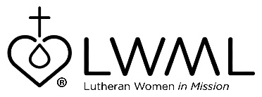
LWML Mission Grant #8
Bulletin Bytes

Light of Christ in Eastern Europe
Mission Central — $56,000

Missionaries in the Czech Republic lead an English Talk Group as part of their ministry in Eastern Europe. This group meets to practice English and to hear the Gospel. Open to any high school student, God continues to send new members to hear the Good News of Jesus Christ. Check out this mission grant at:
lwml.org/2021-2023-mission-grant-8.

Through your mite offerings, missionaries are able to use social media platforms to effectively reach out to untold thousands of people, not only in Eastern Europe, but worldwide. For information on the Light of Christ in Eastern Europe ministry, go to: lwml.org/2021-2023-mission-grant-8.

Gary Thies of Mission Central shares, “Over five million Muslims now live in Germany. The challenge is very great but, there is hope. In Berlin a German Lutheran Pastor has a congregation of more than a thousand former Muslims, and is reaching out to these people who do not know Jesus as their Savior. Check out this mission grant at: lwml.org/2021-2023-mission-grant-8.

