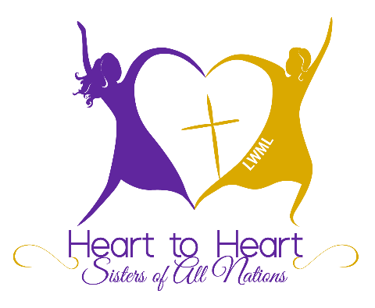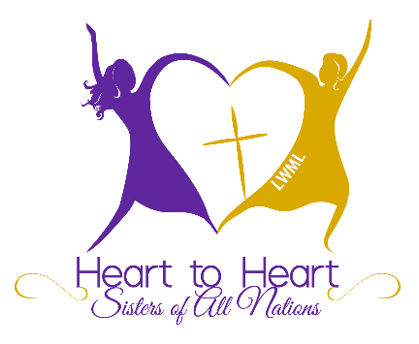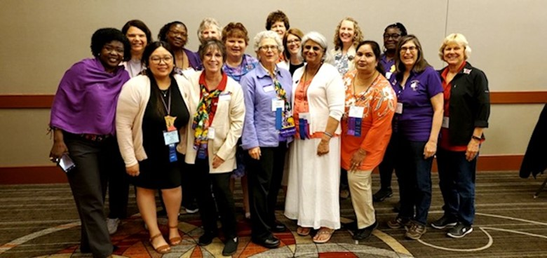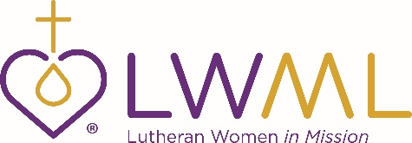

*Through the Heart to Heart — Sisters of All Nations program, we recognize that the body of Christ grows and is strengthened when all women are welcomed, mentored, and encouraged to be active partners in the shared mission of the LWML.*

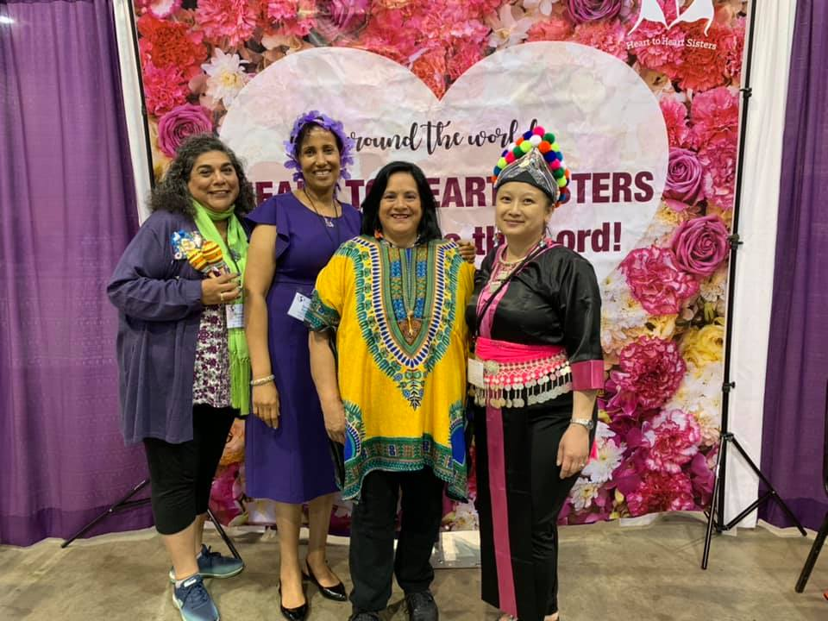

*The Heart to Heart — Sisters of All Nations program is an intentional effort to ensure that multicultural women participate in a life of service as Lutheran Women in Mission (LWML).*

**2021 Heart to Heart — Sisters of All Nations Class**

Thank you for your service in the LWML. You can encourage multicultural women in this district on two levels:

**Individuals** — All women in our churches can be wonderful additions to the LWML as sisters in Christ serving the Lord with gladness. Make an intentional effort to seek out, meet, and invite women of all cultures to join in telling others about Jesus through words and actions.

**Zones** — After scheduling events or meetings, reach out to churches in your zone that do not have LWML groups and encourage all women to participate.

To find out more, go to

***www.lwml.org/heart-to-heart***

or contact your Heart to Heart — Sisters of All Nations District Leader.

**Heart to Heart —Sisters of All Nations**