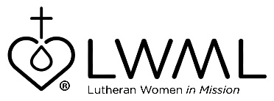
LWML Mission Grant #5
Bulletin Bytes

Helping Hands for Lutheran Deaf Outreach
Lutheran Deaf Outreach — $50,000

Lutheran Deaf Outreach has a passion for teaching others to share Jesus with deaf people. Over 98 percent of deaf and hard-of-hearing individuals do not know Jesus or attend a Christian church. Lutheran Deaf Outreach is equipping both deaf and hearing people with Gospel materials so the saving message of Jesus can be shared with the deaf community. For information and how to help, go to: lwml.org/2021-2023-mission-grant-5.

LWML Mission Grant #5 for the 2021–2023 biennium, Helping Hands for Lutheran Deaf Outreach, has one primary goal: to help deaf people develop a saving relationship with Jesus Christ. They provide resources and training specifically designed for deaf people to learn about the love of Jesus and to share it with others. Check out lwml.org/2021-2023-mission-grant-5.

