YEAR 1: SEPTEMBER — Coordinator Notes

School is in full swing all around the country. Kids are excited about their classes. Parents welcome the return to a routine. But some kids are still hungry. Their only “real” meals are the ones served to them during school hours.

Encourage your Mailbox Members — and your local group members as well — to collect food supplies that can be distributed through local food programs or food banks. As you distribute this information to your Mailbox Member, pray for this Lutheran Woman in Mission!

Access the food collection ideas and determine what works best for your local group.
Optional resource: “Fill a Backpack Full of Nutritious Food for ‘Feeding America’”.

For Paper Copies:
- Download and print this month’s resource (in bold above) to share with each Mailbox Member.
- Remember to sign the message with your contact information!
For Electronic Communication:
- Send a new email, and type LWML Mailbox Member Greetings in the subject line.
- Copy and paste the Mailbox Member message on the next page into your email.
- Attach the resource(s) for the month.

Distribute the resource to your Mailbox Member participants with the note found on the next page:

(NOTE: If “Feeding America” is not the program used in your area, personalize this note with the accurate information specific to your setting. Edit the note on the following page to reflect the food collection idea(s) that you will be using.)

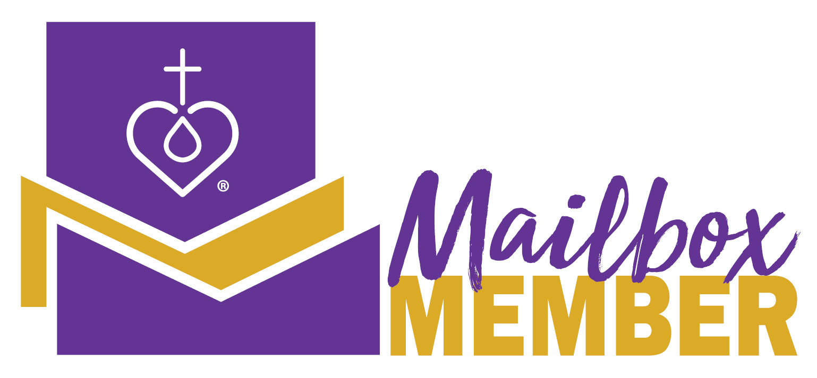
Hello from LWML!

It is September and schoolchildren around the country have returned to their classrooms, ready and excited to learn new subjects and experience new challenges. But many of those children come from families that are food insecure, meaning they lack consistent access to enough food for an active, healthy life.

This month our local group and Mailbox Members will help provide food for these kids. The food items we gather this month will be distributed in our local schools or food banks so children will not go hungry when they are away from their regular school-provided meals.

You can be involved in this collection by providing nutritious, kid-friendly foods, supporting the collection with a monetary donation, and/or praying for the children who will be receiving this food.

Your prayers for the children’s health, well-being, and safety are important. We know our loving heavenly Father encourages us to pray without ceasing (1 Thessalonians 5:7). Join us in praying for this outreach into our community this month.

As always, contact me with any questions. Together we will lift up the children of our church and community in prayer.

Your Sister in Christ,

_______________________________

----------------------------------------------------------------------------------------------------

Revised by the LWML Growth and Development Committee 2021
Published by Lutheran Women’s Missionary League
www.lwml.org

