YEAR 1: JUNE — Coordinator Notes

June is a traditional month for weddings, but we, in LWML, tend to associate this month with conventions! One of the joys of being an LWML participant is reading and understanding the LWML Pledge. The words in the pledge bring to mind the real purpose, emotion, and reason why so many women are committed to serving together in the LWML.

Access the LWML Pledge.
Optional devotion: LWML Pledge: Responsive Reading, available in regular or large print
Optional LWML song: Praise, Love, Serve, available in regular or large print

For Paper Copies:
- Download and print this month’s resource (in bold above) to share with each Mailbox Member.
- Remember to sign the message with your contact information!
For Electronic Communication:
- Send a new email, and type LWML Mailbox Member Greetings in the subject line.
- Copy and paste the Mailbox Member message below into your email.
- Attach the resource(s) for the month.

Distribute the resource to your Mailbox Member participants with the note found below.

----------------------------------------------------------------------------------------------------
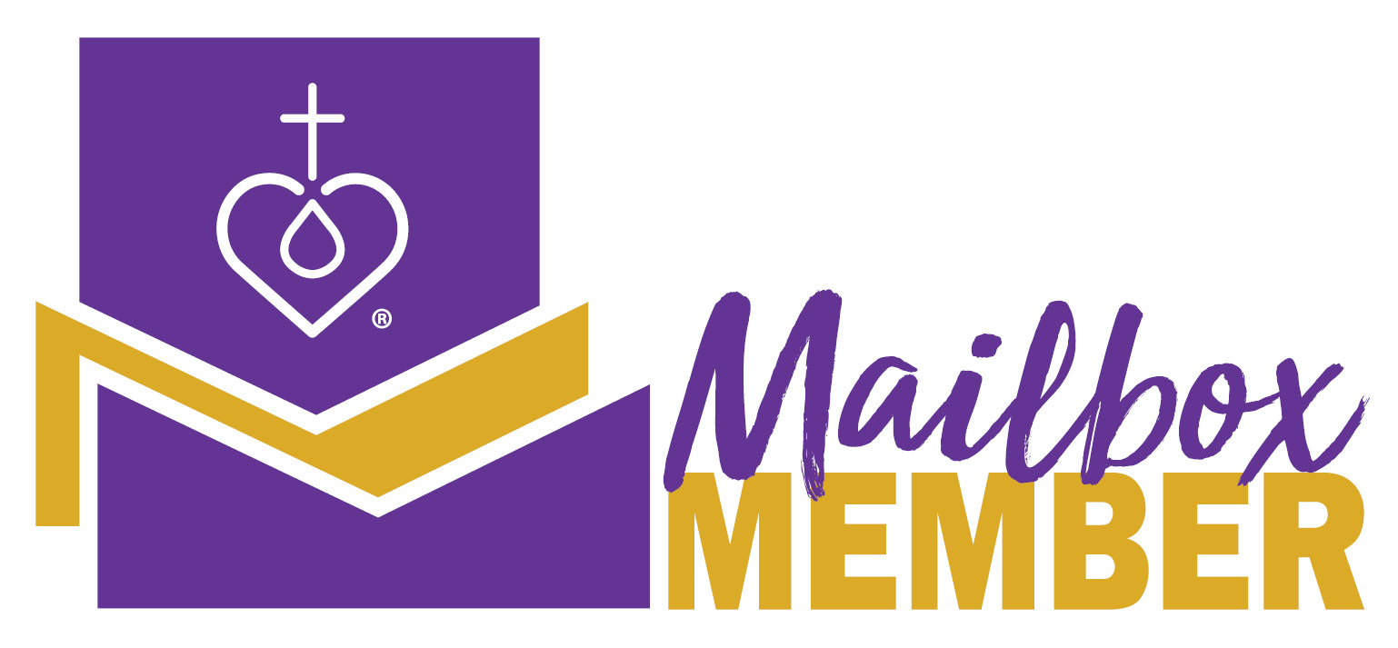
Hello from LWML!

The Lutheran Women’s Missionary League has a 75+ year history, and part of that history is the LWML Pledge which reminds us of our reasons for being in mission and our pledge of commitment to our Lord. A song, based on the LWML Pledge, was published in 2013.

Use the LWML Pledge or song in your devotion time, either by yourself or with others, to reaffirm your personal commitment to share the Gospel message.

As always, contact me with any questions. You are in my daily prayers.

Your Sister in Christ,

_______________________________

----------------------------------------------------------------------------------------------------

Revised by the LWML Growth and Development Committee 2021
Published by Lutheran Women’s Missionary League
www.lwml.org

