YEAR 2: DECEMBER — Coordinator Notes

It is December and once again we have the pleasure of gathering to pray, praising our Infant King. This month, you will be giving two items to your Mailbox Members:

Access the Mustard Seed Devotion It’s a New Day and the LWML Christmas Bookmark.

For Paper Copies:
- Download and print this month’s resource (in bold above) to share with each Mailbox Member.
- Remember to sign the message with your contact information!
For Electronic Communication:
- Send a new email, and type “LWML Mailbox Member Greeting” in the subject line.
- Copy and paste the Mailbox Member message below into your email.
- Attach the resource(s) for the month.
Optional:
- Consider including a box of colored pencils to decorate and embellish the bookmarks as the Mailbox Members prepare to share them with others.

Distribute the resource to your Mailbox Member participants with the note found below.

----------------------------------------------------------------------------------------------------

Christmas Blessings!

Christmas is just around the corner. You may have all your preparations completed or maybe you are still working on them. Either way, take a break during this busy month and enjoy the Mustard Seed Devotion, It’s a New Day.

The “LWML Christmas Bookmarks” are yours to color and enjoy or share. You can enclose them with Christmas cards or give them to guests as they arrive at your home. Use them as a way to remind yourself and others that our Savior Jesus is born!
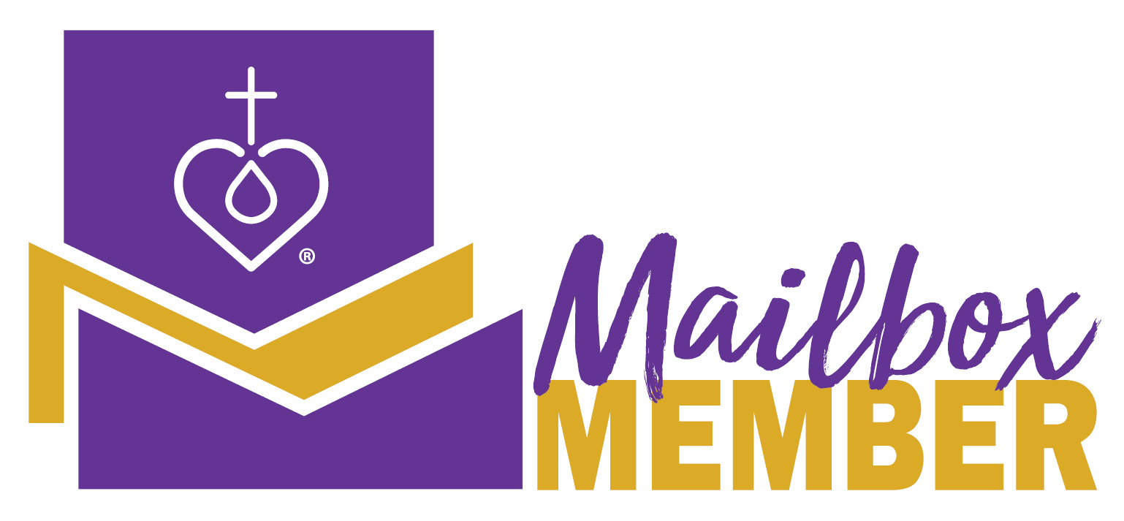
As always, contact me with any questions. This month, I pray that you find joy in the journey as you celebrate Jesus’ birthday!

Your Sister in Christ, _______________________________

----------------------------------------------------------------------------------------------------

Revised by the LWML Growth and Development Committee 2021
Published by Lutheran Women’s Missionary League
www.lwml.org

