YEAR 2: AUGUST — Coordinator Notes

August is traditionally a month for vacations. Families pack up and head off to a national park or visit a museum in a nearby city. While we are traveling, we may find ourselves in a place where we have the opportunity to share God's love with someone. This month’s devotion tells the story of one simple encounter that God used to bring about change and healing for a woman in need.

Access the devotion Witness Opportunities

For Paper Copies:
- Download and print this month’s resource (in bold above) to share with each Mailbox Member.
- Remember to sign the message with your contact information!
For Electronic Communication:
- Send a new email, and type “LWML Mailbox Member Greeting” in the subject line.
- Copy and paste the Mailbox Member message below into your email.
- Attach the resource(s) for the month.

Distribute the resource to your Mailbox Member participants with the note found below.

----------------------------------------------------------------------------------------------------

Happy Travels!

Warm summer days are upon us. Many people are taking a break and going on vacation. Families pack up and head off to a national park or visit a museum in a nearby city. While we are traveling, we may find ourselves in a place where we have the opportunity to share God's love with someone.

In this month’s devotional thought, Witness Opportunities, an LWML member tells the story of one simple encounter that God used to bring about change and healing for a woman in need.

As you read through the devotion this month, reflect on a time when you have shared God’s love with someone. Take a moment to pray for that person and give thanks to God for allowing you the opportunity of witnessing to that person so that they might hear of God’s love for them.
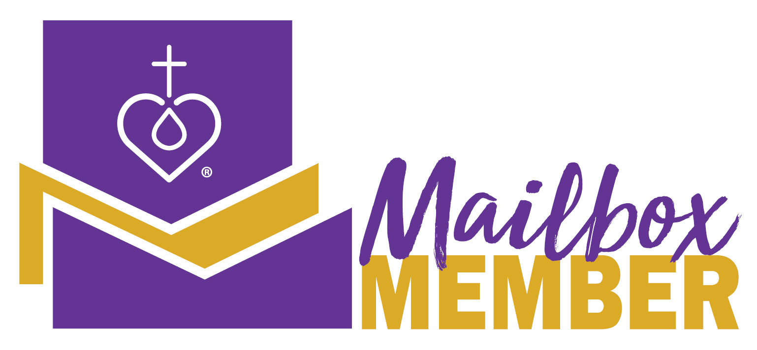
This month, I pray that you seek or take advantage of opportunities to share your faith.

As always, contact me with any questions.

Your Sister in Christ, _______________________________

----------------------------------------------------------------------------------------------------

Revised by the LWML Growth and Development Committee 2021
Published by Lutheran Women’s Missionary League
www.lwml.org

