January 2020
Mission Grant
Bulletin Bytes
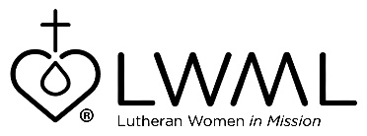

Lutheran Women’s Missionary League Grant #18 —
Sri Lanka Multipurpose Building Construction
Office of International Mission — $50,000

Lutheran Women’s Missionary League (LWML) Grant #18 for the 2019-2021 biennium is “Sri Lanka Multipurpose Building Construction.” This building project will house a new sanctuary, a central office for the Ceylon Evangelical Lutheran Church (CELC), seminary classrooms, dormitory space, and a preschool. For more information, go to www.lwml.org/2019-2021-mission-grant-18.

Once the Sri Lanka multipurpose building is completed with the assistance from LWML mission grant #18, the LCMS and the CELC will be able to move forward in training local pastors, offering a welcoming worship area, and giving the congregation a chance to reestablish their preschool program. For more information, go to www.lwml.org/2019-2021-mission-grant-18.

