November 2020
Mission Grant
Bulletin Bytes
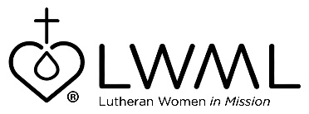

Lutheran Women’s Missionary League Grant #16 — Preparing Leaders for Tomorrow
LCMS School Ministry — $80,000

A large number of Lutheran school administrators are projected to retire from service in the next few years, causing a tremendous void in critical leadership. The LCMS School Leadership Development (SLED) Program has been initiated to help resolve this situation. Its purpose includes identification and recruitment of leadership participants who serve in Lutheran schools and train them through events conducted by LCMS School Ministry. For more information on this mission grant, go to www.lwml.org/2019-2021-mission-grant-16.

LWML Mission Grant #16 for the 2019-2021 biennium is “Preparing Leaders for Tomorrow.” This project seeks to strengthen and revitalize Lutheran schools by training school leaders to serve as vital and effective administrators. It is our prayer that through this mission grant God’s children will be well served so His kingdom can expand. For more information, go to www.lwml.org/2019-2021-mission-grant-16.

