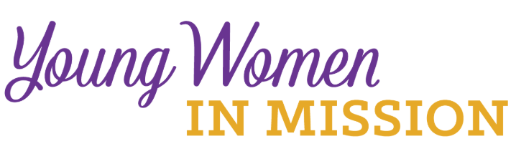
Young Woman Representative Application
Convention (circle one): National District Date: ____________

Convention Location: ___________________________________________
Name_____________________________________ Age ______________
Address _____________________________________________________
City _____________________________ State _________ Zip ___________
Occupation ____________________________________________________
Home Congregation ______________________________________________
Phone _______________________ Email _________________________
Please answer the following questions. Use a separate sheet of paper if needed. Return the completed form to your district president.
1) The LWML motto is “Serve the Lord with Gladness” (Psalm 100:2). How do you do this in your life?
2) What groups and activities are you involved in or have you been involved in at your church?
3) What do you know about the LWML? Have you been involved at any level?

4) Why do you desire to be a Young Woman Representative for the district?
5) What do you feel your special interests, talents, and gifts are?
6) Will you commit to serve in some capacity in your district after the convention?

7) Your district is making a financial commitment to send you to the LWML convention. It will be an exciting and spiritually inspiring event with very little free time. You are expected to participate in the full scope of the convention. Are you able to do so?

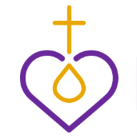
Please ask someone who knows you well, perhaps the person who encouraged you to apply, to answer the following question, “Why do you feel this woman would make a good LWML Young Woman Representative?”

Ask this person to answer on a separate sheet of paper and include their name and relationship to you. Attach their sheet to your application form.

