October 2020
Mission Grant
Bulletin Bytes
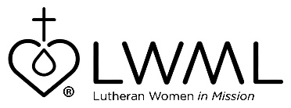

Lutheran Women’s Missionary League Grant #15 —
Pre- and Post-Seminary Training for Local Church Workers
Mission Training Center, Africa — $62,650

In villages across Ghana, Kenya, Malawi, Rwanda, Tanzania, Uganda, and Zambia, most local congregations are led by helpers and evangelists. Others are led by seminary-trained and ordained pastors. Both groups are eager for opportunities to study enabling them to better serve the congregations God has entrusted to their care. The Pre- and Post-Seminary Training for Local Church Workers mission grant will provide funds to help cover the cost of lodging, food, and transportation as they travel to and from their classes. For more information, go to www.lwml.org/2019-2021-mission-grant-15.

LWML Grant #15 for the 2019-2021 biennium is Pre- and Post-Seminary Training for Local Church Workers. The Lutheran church continues to grow in Ghana, Kenya, Malawi, Rwanda, Tanzania, Uganda, and Zambia. The churches are led by lay leaders and ordained pastors desiring more training. There are approximately 250 people taking part in various areas of study through LCMS Continuing Education courses. The grant will help to provide funds to cover transportation, lodging, and food costs. For more information, go to www.lwml.org/2019-2021-mission-grant-15.

