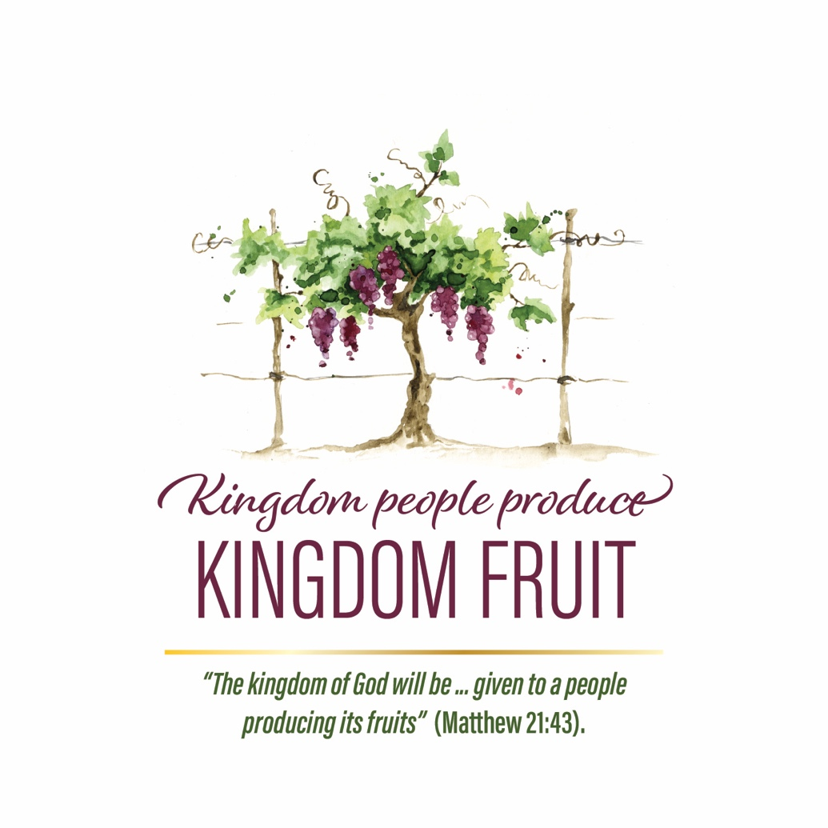

2020 LWML SUNDAY
Worship Service

The Lutheran Women’s Missionary League (LWML) is an official auxiliary of The Lutheran Church—Missouri Synod. Since 1942, the LWML has affirmed each woman’s identity as a child of God and her relationship with Jesus Christ. Lutheran Women in Mission are women of faith, empowered for active service in Jesus’ name and bold support of missions through Mite Box offerings. As Christians, we have been given the kingdom of God to bear its fruit.

Kingdom People Produce
Kingdom Fruit

GATHERING

OPENING HYMN “Open Now Thy Gates of Beauty” LSB 901
Open now thy gates of beauty; Zion, let me enter there,
Where my soul in joyful duty Waits for Him to answer prayer.
Oh, how blessed is this place, Filled with solace, light, and grace!

Gracious God, I come before Thee; Come Thou also unto me.
Where we find Thee and adore Thee, There a heav’n on earth must be.
To my heart, O enter Thou; Let it be Thy temple now!

Here Thy praise is gladly chanted; Here Thy seed is duly sown.
Let my soul, where it is planted, Bring forth precious sheaves alone,
So that all I hear may be Fruitful unto life in me.

CONFESSION AND FORGIVENESS
(adapted from LSB, Divine Service, Setting Two)
P: In the name of the Father and of the † Son and of the
Holy Spirit.
C: Amen.
P: If we say we have no sin, we deceive ourselves and the truth is not in us.
C: But if we confess our sins, God, who is faithful and just, will forgive our sins and cleanse us from all unrighteousness.
P: Let us then confess our sins to God our Father.
C: Most merciful God, we confess that we are by nature sinful and unclean. We have sinned against You in thought, word, and deed, by what we have done and by what we have left undone. We have not fully lived as Your kingdom people. We have not brought forth the fruits of righteousness as we ought. We justly deserve Your present and eternal punishment. For the sake of Your Son, Jesus Christ, have mercy on us. Forgive us, renew us, and lead us, so that we may delight in Your will, walk in Your ways, and bear kingdom fruit to the glory of Your holy name. Amen.
P: Almighty God in His mercy has given His only Son to die for you and for His sake forgives you all of your sins. As a called and ordained servant of Christ, and by His authority, I therefore forgive you all your sins in the name of the Father and of the † Son and of the Holy Spirit.
C: Amen.

SERVICE OF THE WORD

INTROIT
L: Oh, give thanks to the Lord, for He is good; for steadfast love endures forever!
L: The stone that the builders rejected has become the cornerstone.
C: This is the LORD's doing; it is marvelous in our eyes.
L: This is the day that the LORD has made;
C: Let us rejoice and be glad in it.
ALL: Glory be to the Father and to Son and to the Holy Spirit; as it was in the beginning, is now, and will be forever. Amen.
L: Oh give thanks to the LORD, for he is good; for his steadfast love endures forever!

HYMN OF PRAISE “Glory Be to God the Father” LSB 506
Glory be to God the Father, Glory be to God the Son,
Glory be to God the Spirit; Great Jehovah, Three in One!
Glory, glory, While eternal ages run.

Glory be to Him who loved us, Washed us from each spot and stain;
Glory be to Him who bought us, Made us kings with Him to reign!
Glory, glory, To the Lamb that once was slain!

Glory, blessing, praise eternal! Thus the choir of angels sings;
Honor, riches, pow’r, dominion! Thus its praise creation brings.
Glory, glory, Glory to the King of kings!

SALUTATION AND COLLECT OF THE DAY
P: The Lord be with you.
C: And also with you.
P: Let us pray.
Gracious God, You gave Your Son into the hands of sinful men who killed Him. Forgive us when we reject Your unfailing love and grant us the fullness of Your salvation; through Jesus Christ, Your Son, our Lord, who lives and reigns with You and the Holy Spirit, one God, now and forever.
C: Amen.

FIRST READING Isaiah 5:1–7
¹Let me sing for my beloved my love song concerning his vineyard:
My beloved had a vineyard on a very fertile hill.
²He dug it and cleared it of stones, and planted it with choice vines; he built a watchtower in the midst of it, and hewed out a wine vat in it; and he looked for it to yield grapes, but it yielded wild grapes.
³And now, O inhabitants of Jerusalem and men of Judah, judge between me and my vineyard.
⁴What more was there to do for my vineyard, that I have not done in it? When I looked for it to yield grapes, why did it yield wild grapes?
⁵And now I will tell you what I will do to my vineyard. I will remove its hedge, and it shall be devoured; I will break down its wall, and it shall be trampled down.
⁶I will make it a waste; it shall not be pruned or hoed, and briers and thorns shall grow up; I will also command the clouds that they rain no rain upon it.
⁷For the vineyard of the Lord of hosts is the house of Israel, and the men of Judah are his pleasant planting; and he looked for justice, but behold, bloodshed; for righteousness, but behold, an outcry!

L: This is the Word of the Lord.
C: Thanks be to God.

PSALM Psalm 80:7–19
L: ⁷Restore us, O God of hosts; let your face shine, that we may be saved!
C: ⁸You brought a vine out of Egypt; you drove out the nations and planted it.
L: ⁹You cleared the ground for it; it took deep root and filled the land.
C: ¹⁰The mountains were covered with its shade, the mighty cedars with its branches.
L: ¹¹It sent out its branches to the sea and its shoots to the River.
C: ¹²Why then have you broken down its walls, so that all who pass along the way pluck its fruit?
L: ¹³The boar from the forest ravages it, and all that move in the field feed on it.
C: ¹⁴Turn again, O God of hosts! Look down from heaven, and see; have regard for this vine,
L: ¹⁵the stock that your right hand planted, and for the son whom you made strong for yourself.
C: ¹⁶They have burned it with fire; they have cut it down; may they perish at the rebuke of your face!
L: ¹⁷But let your hand be on the man of your right hand, the son of man whom you have made strong for yourself!
C: ¹⁸Then we shall not turn back from you; give us life, and we will call upon your name!
L: ¹⁹Restore us, O Lord God of hosts! Let your face shine, that we may be saved!
ALL: Glory be to the Father and to Son
and to the Holy Spirit;
as it was in the beginning,
is now, and will be forever. Amen.

SECOND READING Philippians 3:4b–14
⁴If anyone else thinks he has reason for confidence in the flesh, I have more: ⁵circumcised on the eighth day, of the people of Israel, of the tribe of Benjamin, a Hebrew of Hebrews; as to the law, a Pharisee; ⁶as to zeal, a persecutor of the church; as to righteousness under the law, blameless. ⁷But whatever gain I had, I counted as loss for the sake of Christ. ⁸Indeed, I count everything as loss because of the surpassing worth of knowing Christ Jesus my Lord. For his sake I have suffered the loss of all things and count them as rubbish, in order that I may gain Christ ⁹and be found in him, not having a righteousness of my own that comes from the law, but that which comes through faith in Christ, the righteousness from God that depends on faith — ¹⁰that I may know him and the power of his resurrection, and may share his sufferings, becoming like him in his death, ¹¹that by any means possible I may attain the resurrection from the dead.
¹²Not that I have already obtained this or am already perfect, but I press on to make it my own, because Christ Jesus has made me his own. ¹³Brothers, I do not consider that I have made it my own. But one thing I do: forgetting what lies behind and straining forward to what lies ahead, ¹⁴I press on toward the goal for the prize of the upward call of God in Christ Jesus.

L: This is the Word of the Lord.
C: Thanks be to God.

ALLELUIA VERSE
P: Alleluia! The stone that the builders rejected has become the cornerstone.
C: This was the Lord’s doing, and it is marvelous in our eyes. Alleluia.

HOLY GOSPEL Matthew 21:33–46
P: The Holy Gospel according to St. Matthew, the twenty-first chapter.
C: Glory to You, O Lord.

[Jesus said,] ³³“Hear another parable. There was a master of a house who planted a vineyard and put a fence around it and dug a winepress in it and built a tower and leased it to tenants, and went into another country. ³⁴When the season for fruit drew near, he sent his servants to the tenants to get his fruit. ³⁵And the tenants took his servants and beat one, killed another, and stoned another. ³⁶Again he sent other servants, more than the first. And they did the same to them. ³⁷Finally he sent his son to them, saying, ‘They will respect my son.’ ³⁸But when the tenants saw the son, they said to themselves, ‘This is the heir. Come, let us kill him and have his inheritance.’ ³⁹And they took him and threw him out of the vineyard and killed him. ⁴⁰When therefore the owner of the vineyard comes, what will he do to those tenants?” ⁴¹They said to him, “He will put those wretches to a miserable death and let out the vineyard to other tenants who will give him the fruits in their seasons.”
⁴²Jesus said to them, “Have you never read in the Scriptures:
“‘The stone that the builders rejected has become the cornerstone; this was the Lord's doing, and it is marvelous in our eyes’?
⁴³Therefore I tell you, the kingdom of God will be taken away from you and given to a people producing its fruits. ⁴⁶And the one who falls on this stone will be broken to pieces; and when it falls on anyone, it will crush him.”
⁴⁵When the chief priests and the Pharisees heard his parables, they perceived that he was speaking about them. ⁴⁶And although they were seeking to arrest him, they feared the crowds, because they held him to be a prophet.

P: This is the Gospel of the Lord.
C: Praise to You, O Christ!

NICENE CREED

HYMN OF THE DAY "Praise, Love, Serve"
(Based on LWML Pledge, Text: Jean Hansen Kammerer, Tune: LSB 361)
Our God and Father, made the earth, And when we went astray,
Our God, the Son, descended here To take our sins away.
With His own blood He bought us. He broke the bonds of sin.
Then God the Spirit came into Our hearts to dwell within.

In gratitude we pledge ourselves, To Him with all we have.
Our hands will work; our voices sing; Our lips proclaim His love.
His errands we’ll do gladly; His Gospel we’ll defend;
Our silver and our gold we’ll use — His Kingdom to extend.

Wherever He has need of us, We will His call obey.
Whenever He calls out to us, We’ll answer right away.
His will is ours that lost souls Will turn away from sin
And come to have eternal life Through fellowship with Him.
SERMON “Kingdom People Produce Kingdom Fruit”
“The kingdom of God will be … given to a people producing its fruits” (Matthew 21:43).

LWML PLEDGE (© 1955 LWML authored by Rev. Harry Fricke)
In fervent gratitude for the Savior's dying love and His blood-bought gift of redemption we dedicate ourselves to Him with all that we are and have; and in obedience to His call for workers in the harvest fields, we pledge Him our willing service wherever and whenever He has need of us. We consecrate to our Savior our hands to work for Him, our feet to go on His errands, our voice to sing His praises, our lips to proclaim His redeeming love, our silver and our gold to extend His Kingdom, our will to do His will, and every power of our life to the great task of bringing the lost and the erring into eternal fellowship with Him. Amen.

PRAYER OF THE CHURCH
(Adapted from Evening Prayer, LSB)
P: For the peace from above and for our salvation, let us pray to the Lord:
C: Lord, have mercy.
P: For the peace of the whole world, for the well-being of the Church of God, and for the unity of all, let us pray to the Lord:
C: Lord, have mercy.
P: For this holy house and for all who offer here their worship and praise, let us pray to the Lord:
C: Lord, have mercy.
P: For the mission of the Lutheran Women’s Missionary League to assist each woman of The Lutheran Church—Missouri Synod in affirming her relationship with the Triune God so that she is enabled to use her gifts in ministry to the people of the world, and to support global missions through the gathering of mites and providing of mission grants, let us pray to the Lord:
C: Lord, have mercy.
P: For all Your kingdom people that they may produce kingdom fruit to Your glory and for the expansion of Your kingdom on earth, let us pray to the Lord:
C: Lord, have mercy.
P: For those who work to bring peace, justice, health, and protection in this and every place, let us pray to the Lord:
C: Lord, have mercy.
P: For favorable weather, for an abundance of the fruits of the earth, and for peaceful times, let us pray to the Lord:
C: Lord, have mercy.
P: For our deliverance from all affliction, wrath, danger, and need, let us pray to the Lord:
C: Lord, have mercy.
P: For…(additional bids for prayer may be added here)…let us pray to the Lord:
C: Lord, have mercy.
P: Into Your hands, O Lord, we commend all for whom we pray, trusting in Your goodness and remembering with thankfulness Your mercies, which are new every morning; through Jesus Christ, our Lord.
C: Amen.

OFFERING

OFFERTORY HYMN “Let the Vineyards Be Fruitful” LSB 955

SERVICE OF THE SACRAMENT

PREFACE
P: The Lord be with you.
C: And also with you.
P: Lift up your hearts.
C: We lift them to the Lord.
P: Let us give thanks to the Lord our God.
C: It is right to give Him thanks and praise.
P: It is truly good, right, and salutary that we should at all times and in all places give thanks to You, holy Lord, almighty Father, everlasting God, through Jesus Christ, our Lord, who, out of love for His fallen creation, humbled Himself by taking the form of a servant, becoming obedient unto death, even death upon a cross. Risen from the dead, He has made us the people of His kingdom, freeing us from eternal death, and giving us everlasting life.
Therefore, with angels and archangels and the whole company of heaven, we laud and magnify Your glorious name, evermore praising You and singing:

SANCTUS Tune: LSB 798
(Verse reprinted from “The God of Abraham Praise,” Public Domain)
The God who reigns on high The great archangels sing,
And “Holy, holy, holy!” cry, “Almighty King!
Who was and is the same. And evermore shall be:
Jehovah, Father, Great I AM! We worship Thee!”

LORD’S PRAYER
C: Our Father, who art in heaven,
hallowed be Thy name,
Thy kingdom come,
Thy will be done on earth as it is in heaven;
give us this day our daily bread;
and forgive us our trespasses as we forgive those who trespass against us; and lead us not into temptation,
but deliver us from evil,
For Thine is the kingdom and the power and the glory
forever and ever.
Amen.

THE WORDS OF OUR LORD
P: Our Lord Jesus Christ, on the night He was betrayed, took bread, and when He had given thanks, He broke it and gave it to the disciples and said, “Take, eat; this is My † body, which is given for you. This do in remembrance of Me.”
In the same way also He took the cup after supper, and when He had given thanks, He gave it to them, saying, “Drink of it, all of you; this cup is the new testament in My † blood, which is shed for you for the forgiveness of sins. This do, as often as you drink it, in remembrance of Me.”

THE PROCLAMATION OF CHRIST AND THE PEACE
P: As often as we eat this bread and drink this cup, we proclaim the Lord’s death until He comes.
C: Amen. Come, Lord Jesus.
P: The peace of the Lord be with you always.
C: Amen.

BEHOLD THE LAMB OF GOD Tune: LSB 346
(The first verse is Verse 3 from “When All the World was Cursed,” LSB 346; the second verse is original by Rev. Larry Krueger)
Behold the Lamb of God That bears the world’s transgression,
Whose sacrifice removes The devil’s dread oppression.
Behold the Lamb of God, Who takes away our sin,
Who for our peace and joy [Did] full atonement win.
O Holy Lamb of God, have mercy now upon us.
Under the bread and wine, Your body now is given us,
Your blood poured out for all, We now in faith receive.
Grant us Your peace, O Lord, That we in You may live.

DISTRIBUTION HYMNS
“Jesus Christ, Our Blessed Savior” LSB 627
“Oh, for a Thousand Tongues to Sing” LSB 528
“Spread the Reign of God the Lord” LSB 830

DISMISSAL
P: The body and blood of our Lord Jesus Christ strengthen and preserve us in body and soul to life everlasting. Depart † in peace.
C: Amen.

THANKSGIVING “O Jesus, Blessed Lord, to Thee” LSB 632

POST-COMMUNION PRAYER
P: Let us pray.
Gracious God, our heavenly Father, You have given us a foretaste of the kingdom feast to come in the Holy Supper of Your Son’s body and blood. Keep us as Your kingdom people throughout our days that we may bear fruit in keeping with repentance till that day when we celebrate the feast of the Lamb in His kingdom which has no end; through Jesus Christ, Your Son, our Lord, who lives and reigns with You and the Holy Spirit, one God, now and forever.
C: Amen.

BLESSING
P: Let us bless the Lord.
C: Thanks be to God.
P: The Lord bless you and keep you. The Lord make His face shine on you and be gracious to you. The Lord look upon you with favor and † give you peace.
C: Amen.

CLOSING HYMN “Serve the Lord with Gladness”
Text: Prof. Ernest Lewerenz, Tune: LSB 662
“Serve the Lord with gladness!”  It is He alone  Who redeemed us sinners,  Guides us as His own  To enjoy the blessings  Of His love and grace,  Will at last in glory  Meet us face to face.  Onward, then, for Jesus!  Let this be our aim:  “Serve the Lord with gladness!”  Glorify His name.  “Serve the Lord with gladness!”  He gave us command  To proclaim His Gospel  Now in every land  So that fellow sinners  May, like us, be blest.  Leading them to Jesus,  We can serve Him best.  Onward, then, for Jesus!  Let this be our aim:  “Serve the Lord with gladness!”  Glorify His name! | “Serve the Lord with gladness!”  There’s no greater joy  Than to serve the Master,  Work in His employ.  As we build His kingdom  Angels, too, rejoice  Over every sinner  Brought to hear His voice.  Onward, then, for Jesus!  Let this be our aim:  “Serve the Lord with gladness!”  Glorify His name!

Acknowledgments
Portions from Lutheran Service Book.
Unless otherwise indicated, all scripture quotations are from The Holy Bible, English Standard Version, copyright © 2001 by Crossway Bibles, a division of Good News Publishers. Used by permission. All rights reserved.
2020 LWML Sunday Worship Service authored by Rev. Larry Krueger.
The author grants permission for use in local worship settings.

