May 2020
Mission Grant
Bulletin Bytes
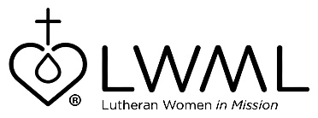

Lutheran Women’s Missionary League Grant #10 — Ministry in Motion
Trinity Lutheran Church in Mobile, Alabama — $58,000

Lutheran Women’s Missionary League (LWML) Grant #10 for the 2019-2021 biennium is Ministry in Motion Trinity Lutheran Church, Mobile, Alabama. This grant will provide transportation to and from church in a bus that provides easier and safer access for all ages with lower steps and handrails, a wider door, and wider rows and aisles. For more information, go to www.lwml.org/2019-2021-mission-grant-10.

Trinity Lutheran Church serves an impoverished neighborhood in Mobile, Alabama. Through this grant, Trinity will be able to expand its outreach to those in need by making vital transportation available to children, youth, parents, and seniors. For more information, go to www.lwml.org/2019-2021-mission-grant-10.

