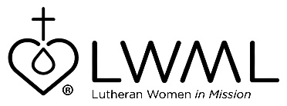
December 2019
Mission Grant
Bulletin Bytes

Lutheran Women’s Missionary League Grant #5 — God’s Word Changes Everything — Lutheran Bible Translators — $95,000

Lutheran Women’s Missionary League Mission Grant #5 — Lutheran Bible Translators — God’s Word Changes Everything for $95,000, will provide funds for one year of training as part of a four-year seminary training track. It will equip pastors and church leaders in Tanzania, Ethiopia, and elsewhere to be involved in translating God’s Word for their people. In praise to the Lord, you can be engaged in this vital ministry where over 170 million people who speak more than 1,500 languages can read the Gospel in their native language. They will know that God hears the prayers of all His people in all languages, not just English. Through your prayers and mite donations, you can be a part of sharing Jesus with the world. For more information, go to http://www.lwml.org/2019-2021-mission-grant-5.

Your mites can support LWML Mission Grant #5 — Lutheran Bible Translators — God’s Word Changes Everything. There are over 170 million people who speak more than 1,500 languages who have never read the Bible in their native dialect. Bible translation is absolutely foundational to the mission of the church. This grant will pay for one year of a four-year training program for pastors and church leaders in Tanzania, Ethiopia and elsewhere to be directly involved in translating God’s Word for their people. With your prayers and mite donations, this vital ministry will share the Gospel of Jesus Christ in the language of the people. For more information, please go to http://www.lwml.org/2019-2021-mission-grant-5.

