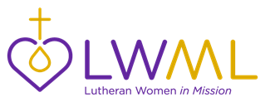
LWML Toolkits

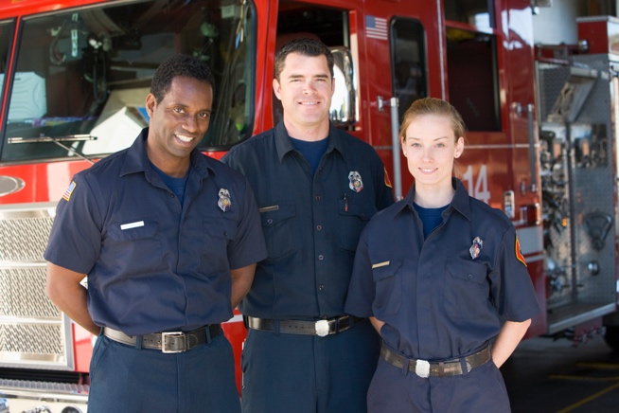 | LWML Toolkits are kit suggestions that you may use for Gifts from the Heart collections in your district, zone, and local groups. Be sure everyone knows where your kits will be donated before you start collecting items. It is suggested that agencies be contacted to make sure they are able to take the kits, if there are items they are not allowed to include, and how many kits they may currently need. Different agencies may also request certain items to better serve their clients. This First Responder Kit list is simply a “jumping off” point to use as you share God’s love and serve the Lord with Gladness.

First Responder Kit

- Drawstring bag to contain items
- Hand sanitizer
- Pocket tissues
- Band-Aids
- Beef jerky / Slim Jims
- Energy bars / granola bars
- Trail mix packets
- Powdered electrolyte replacement drink mix
- Chewing gum / hard candy / mints
- Cough drops
- A gift card to a local coffee shop
- Lip balm
- Bottled water
- Small spiral memo pad and pen
- Sporting event tickets donated by a local major or minor league sports team
- Mustard Seeds Simple Trust or Living in Faith from Concordia Publishing House
- Note of thanks with indication that you are praying for them

Specific to situations when children are involved:
- A small stuffed animal
- A small blanket
- Coloring book and crayons

