October 2019
Mission Grant
Bulletin Bytes
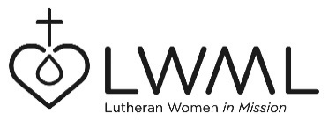

#3 – At-Risk Young Women in Africa
Lutheran Hour Ministries – $100,000

At-Risk young women and their children in Kenya and Cameroon suffer from poverty and hunger. Many end up in a life of prostitution or are imprisoned. Lutheran Hour Ministries has programs in place to help change this desperate situation. For information and how to help go to lwml.org, click on Mission Grants, then on Mission Grants Resources: www.lwml.org/2019-2021-mission-grant-3.

LWML Mission Grant #3 for the 2019-2021 Biennium, Mission Outreach to At-Risk Young Women in Africa, will enable Lutheran Hour Ministries to continue ongoing programs to help young women and their children who are forced into unhealthy life styles learn of Jesus and turn their lives around. Go to lwml.org, click on Mission Grants, then on Mission Grants Resources: www.lwml.org/2019-2021-mission-grant-3.

