August 2019
Mission Grant
Bulletin Bytes
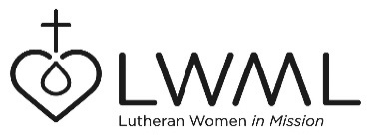

#1 – Water and the Word for Rural Schools in Kenya
Evangelical Lutheran Church in Kenya (ELCK) schools and orphanages – $80,000

The children in Kenya struggle to have water in their schools and often walk miles each day to gather water. The water they gather is not necessarily clean water. Very often, the children must leave school and walk to the local water source. Mission Grant, Water and the Word for Rural Schools in Kenya, will provide clean water and the Living Word by expanding the clean water project to the Evangelical Lutheran Church in Kenya (ELCK) schools and orphanages. For more information, go to www.lwml.org/2019-2021-mission-grant-1.

LWML Grant #1 for the 2019-2021 biennium is Water and the Word for Rural Schools in Kenya. This grant will provide funds for the installation of water harvesting equipment (rain gutters and tanks), filters, hand wash stations and clean water storage in Kenya Lutheran schools and orphanages. For more information, go to www.lwml.org/2019-2021-mission-grant-1.

