LWML Sunday 2019

Author bio
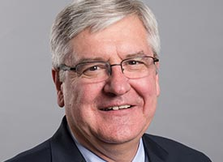
Rev. Dr. Dean Nadasdy has served as a parish pastor, seminary professor, vice president of the LCMS (2004-2010), and Minnesota South District President (2012-2018). For several years he edited the topics/Bible studies for the LWML Lutheran Woman’s Quarterly. He has been the proclaimer at two international LWML conventions. He has designed worship for several national youth gatherings and has contributed to Creative Worship for the Lutheran Parish, Concordia Pulpit Resources, and Creative Communications. He enjoys writing drama, poetry, and choral lyrics and is a frequent presenter in homiletics at pastoral conferences.

