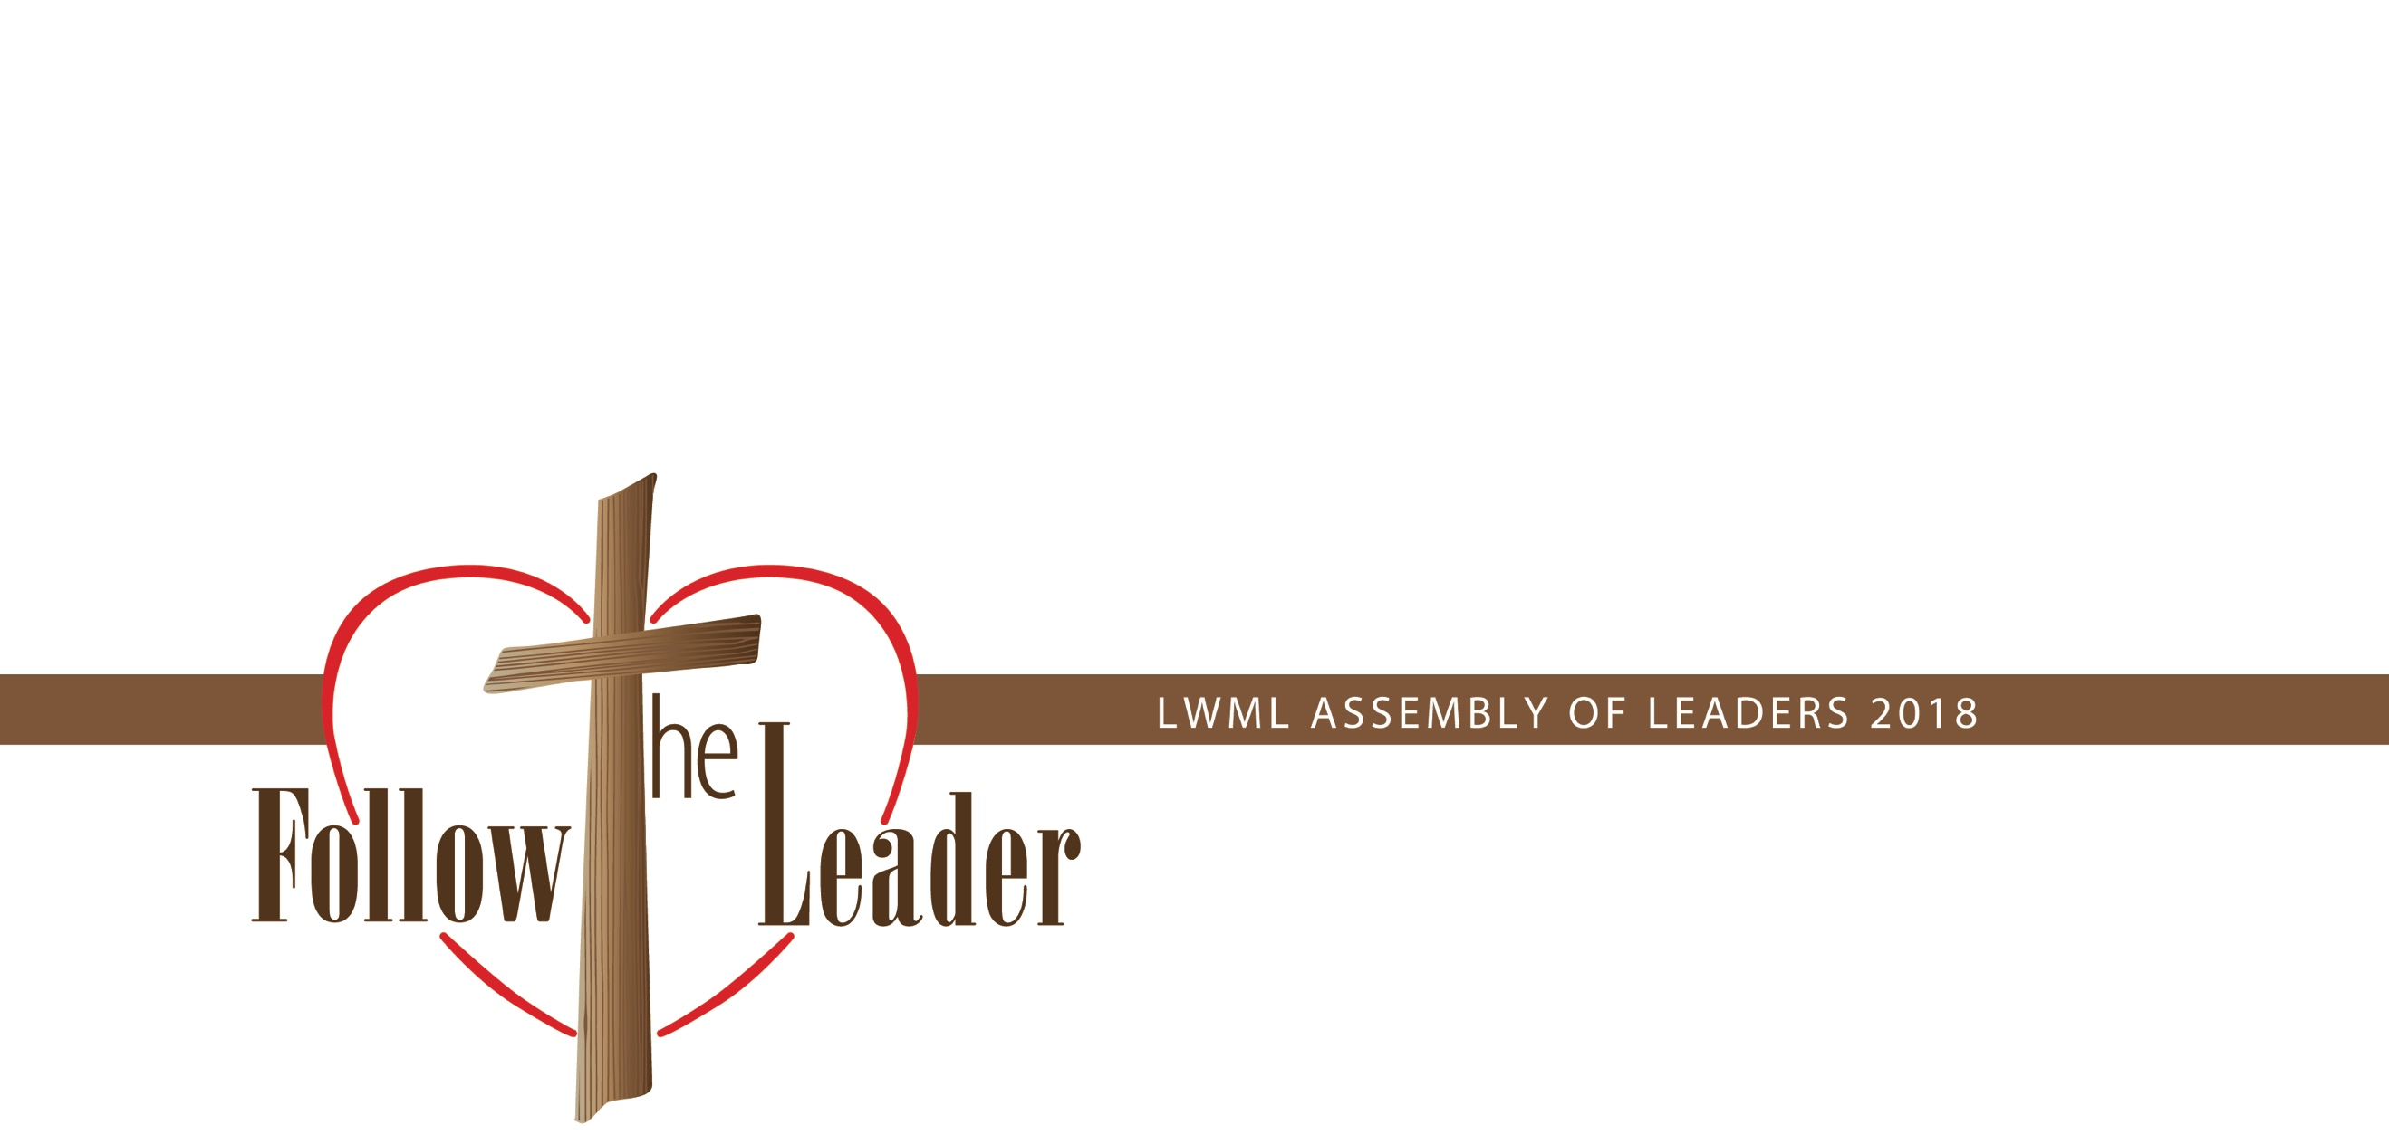
Lutheran Women in Mission’s
Assembly of Leaders Training
Based on Philippians 4:9
November 7–10, 2018
Hilton St. Louis Airport, St. Louis, Missouri

Initial Plan of Action for Zone and Group Events
Bring this document to the AOL Closing Worship Service Saturday, November 10, 2018 and submit an electronic version by email to Strategic Plan Facilitator by Tuesday, November 13, 2018. (Your email version may be a duplicate or may include more detailed action steps if desired.)

District: ______________________________________________________

Target Audience: _______________________________________________

Goal: (What do you want to accomplish?)

Objectives: (How are you going to accomplish your goal? Get specific.)

Initial Plan of Action: (Include: steps for sharing the information, name leaders/trainers and expected participants, timeline/schedule; cost, etc.)

(Signed) ______________________________________________________
District President

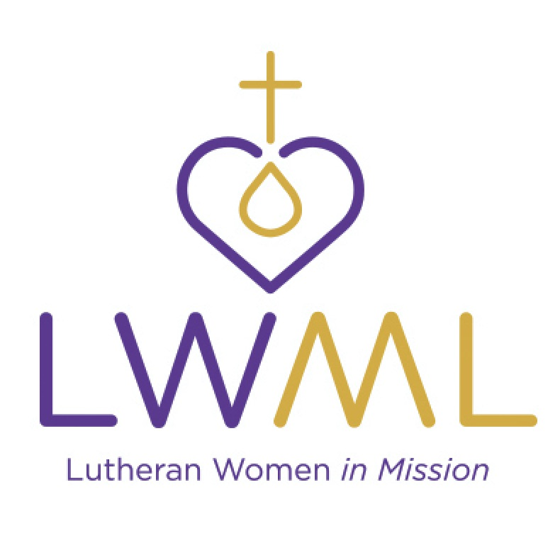
(Signed) ______________________________________________________
District Participant

(Signed) ______________________________________________________
District Participant

(Signed) ______________________________________________________
District Participant

