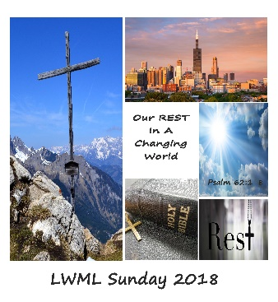
Bulletin Bytes—LWML Sunday 2018
Use the following short articles to promote LWML Sunday 2018 in your bulletins and newsletters. The LWML Sunday 2018 logo, biographical information, and a photo of Reverend Ken Hennings may be downloaded. Share the exciting mission of the LWML with your congregation.

Any time before your church’s LWML Sunday celebration:
Celebrate LWML Sunday with us on (month, date)
The first Sunday in October is traditionally set aside for the observation of LWML Sunday, but it may be celebrated at any time. Come celebrate here at (Name of church) on Sunday, (month, date). Based upon Psalm 62:1–8, the theme chosen for LWML Sunday 2018 is “Our Rest in a Changing World.” As God’s children, we rest in the assurance that He loves us and sent His Son to redeem us. God is our rock and salvation. That firm foundation enables us to reach out into a changing world in need of the Gospel. Since 1942, the LWML has affirmed each woman’s identity as a child of God and her relationship with Jesus Christ, encouraging and equipping Christian women to live out their lives in active mission ministries, and to support missions around the world through their sacrificial gifts of mites, tithes, offerings, and tireless service.

LWML Celebration on Sunday (month, date)
Based upon Psalm 62:1–8, the theme chosen for LWML Sunday 2018 is “Our Rest in a Changing World.” LWML Sunday is celebrated annually in The Lutheran Church—Missouri Synod (LCMS) churches. Come celebrate LWML Sunday on (month, date) 2018. Watch for more information about the LWML and becoming involved in reaching others with the love of our Lord, Jesus Christ.

LWML Sunday — Celebrate Lutheran Women in Mission
A special worship service is planned for Sunday (month, date) 2018, to celebrate all that God has done through the LWML. The author of this service, Reverend Ken Hennings selected the theme, “Our Rest in a Changing World,” based upon Psalm 62:1–8. Since 1942, the LWML has affirmed each woman’s identity as a child of God and her relationship with Jesus Christ, encouraging and equipping Christian women to live out their lives in active mission ministries, and to support missions around the world through their sacrificial gifts of mites, tithes, offerings, and tireless service. (If your LWML group is planning additional activities, include them here.)

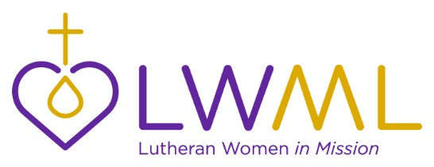

The Lutheran Women’s Missionary League (LWML)
is the official women’s auxiliary of
The Lutheran Church—Missouri Synod.

