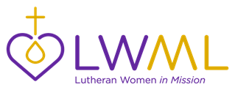
LWML Toolkit Kits

LWML Toolkit Kits are kit suggestions that you can use for Gifts from the Heart in your district, zone, and local groups. Be sure to know where your kits will be given before you start collecting. It is suggested that agencies be contacted to be sure they can take the kits and in what quantity. Different agencies may also request certain items to better serve their clients. These kit lists are simply a “jumping off” point to use as you share God’s love and serve the Lord with Gladness.

Kit for Sick Children

- Bubbles
- Story books about Jesus such as Arch Books from Concordia Publishing House
- The Story of Jesus Coloring and Activity Book from Concordia Publishing House
- CDs
- Stress ball
- View Master or other small toy
- Popsicles or freeze pops
- Visit from child’s friends

Children’s Hospital Kit

- Create a card
- Memory labels and put in Children’s Bible
- Fleece tied blankets
- Sleepers and bibs
- Coloring book and crayons
- Balloons
- Sew or donate Teddy Bears

