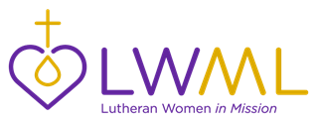
LWML Toolkit Kits

LWML Toolkit Kits are kit suggestions that you can use for Gifts from the Heart in your district, zone, and local groups. Be sure to know where your kits will be given before you start collecting. It is suggested that agencies be contacted to be sure they can take the kits and in what quantity. Different agencies may also request certain items to better serve their clients. This kit list is simply a “jumping off” point to use as you share God’s love and serve the Lord with Gladness.

Shut-In and Nursing Home Visit Kit

- Large print address book filled with family, friends, etc.
- Large print calendar with family birthdays (etc.) entered
- Stationery/notecards with stamps and return address labels
- Playing cards
- Large print crossword/Sudoku puzzle books
- Light-up magnifier or page magnifier
- Hymns of Faith CD from Concordia Publishing House or CD of local church service
- Large-print Mustard Seed devotions
- Living as a Woman in Mission Mustard Seeds
- Homemade heating pads (made with rice)
- Personal hygiene items (shampoos, lotions, lip balms)
- Bible-themed bookmark/tract.
- Picture books for Memory Care Unit
- Walker tote and/or pouch
- Create cards
- Homemade flowers
- Send flowers with inspirational card

