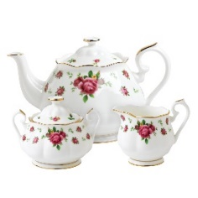
Friendship Tea
~ May 11th from 12-2 pm. ~
Invite your spouse, mother, sister, sister-in-law, friends, and neighbors.
The more the merrier!

*There will be a Youth Fashion Show
*You may bring your favorite tea cup and share your story
*Please bring a canned good for the Community Food Bank
*Fellowship, laughs and good times.

RSVP by May 4

