Living Faith Messenger

Summer Edition 2021

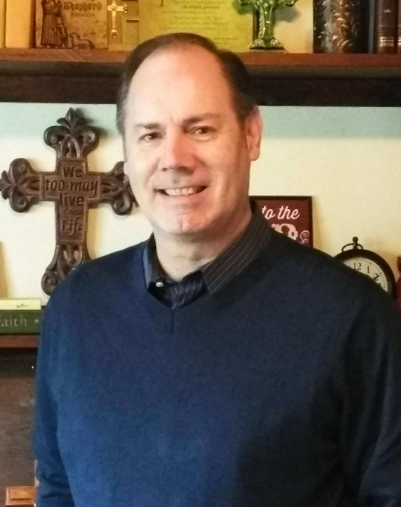
From the
Pastor’s
Desk

By Pastor
Troy Billow

“The Kingdom is Here”

“Heavenly Father, Your kingdom come, and Your will be done, on earth as it is in heaven.” ~ Prayer of Jesus - Mat. 6

I’ve noticed something very powerful and very inspirational this past year here at our church as we have gone through this unprecedented time of a global pandemic, along with our own nation’s civil unrest, growing violence, political polarization, food and home insecurity, and the year-long shutdown of businesses, schools, and society – I’ve noticed that God the Father is still building His kingdom and carrying out His will in our world, and yes, even here in our own town-and-country church of Romeoville – pretty amazing if you ask me.
God is still answering this prayer of his Son two thousand years later in a world and nation that is rapidly changing and falling apart as we approach the end of time. We can see His kingdom still being built here at LFCC - as we have seen in this past year God answers prayer in amazing ways, we have seen new people come through our doors finding a church home, we have seen

the youth group grow along with children trusting in Jesus for the first time, we have
seen children and adults requesting to be baptized, we have seen people and leaders grow and mature in their faith, and we have seen new ministries develop and make an eternal impact. We have seen Jesus’ prayer being answered here in our very midst. We have seen His kingdom come and it is here! Praise God!
Jesus had prayed this prayer long ago in front of his disciples to remind them of His will in uncertain and difficult days. As we see the answer to this prayer with our own eyes here at LFCC, we should be inspired and greatly encouraged as we sojourn forward through these changing times. As in the days of God’s Son and now in our own time, when things in our society are spiritually dark - this is a great time for the light of the Good News that brings hope and eternal life to others to shine brightly. Let’s continue to let the love and truth of God shine through us as He continues to build His kingdom here.

====///====

Living Faith Youth Group
June 2021
By: Megan Bustamante

The youth ministries here at Living Faith Community Church have some very exciting things happening right now. It has been amazing to see how God is working through youth group and Sunday school to transform the lives of students and leaders. My prayer is that this pattern continues and we start to see God’s transformation in families and our community as well.

On Thursdays we have seen a jump in the number of students attending and this led us to undergo a “youth group reset” as we called it. This reset included bringing in more adult leaders and helpers, working as a group to form community standards that are respectful of ourselves, others and God and to re-structure our space to best meet the needs of our larger group. I have already seen some very fruitful outcomes from the reset. We have been able to spend more time playing games and building community along with being able to really focus on our lessons and learning what it means to follow Jesus.

During youth group we have been studying the life of Jesus. We have entered into the final week of his life and I am eager to see how God works as we study these events. We recently had a student give his life to Jesus! And that in and of itself is enough reason to celebrate but I am praying for even more! When this student shared his news with the group, many students started asking some deep and thoughtful questions. I could see the wheels spinning and their curiosity was peaked. This led to a few individual conversations with some as a few specific students are really seeking out what Jesus really means. Please pray with me that as we study the death and resurrection of Jesus, that the Holy Spirit will be at work and that students will come to know Him as their Lord and Savior.

I am so thankful for all that God has been teaching me, for the leaders he has brought alongside me to help, for the growth of students in numbers and even more importantly for the growth I get to witness in their understanding and faith. As always please continue to pray for myself, the leaders and the youth. The power of prayer is strong and I am always thankful to know there are people faithfully praying and supporting this ministry.

====///====

Elsie’s Pantry
God continues pouring out His gracious blessings on the pantry.
- We are getting an industrial freezer FREE from the Greater Chicago Food Depository.
- A generous donor gave money to the Greater Chicago Food Depository intended to be given to five volunteers from each pantry and soup kitchen in the form of a $50 gift card from Uber Eats. The donor was impressed that through the pandemic most pantries stayed open and wanted to give a small token of appreciation. We chose those who aren’t in management: Chuck Anderson, Matt Birk, Scott Gehle, Jane Martin and Erin McAvoy. They should be receiving their gift card this month.
- The City of Hickory Hills and Jewel Osco had a food drive May 1st and gave us 4 pallets full of food.
- We asked for a 10% reduction in USDA commodities, so instead of 6,000 pounds of food we will receive roughly 5,400 pounds. We will still receive grocery and meat from Food Rescue and distribute 10,000 pounds a month.
- The Greater Chicago Food Depository is giving us a grant for the technology expense we incurred for a new Client intake system. It will practically replace what we had to spend. They will also pay $160 of the $190 Food Handlers Safety Class our volunteer Karen Walsh had to take this year.
- We still have two Missionaries from Utah helping us and praying with us at the beginning of the pantry distribution.
A special thanks to all who serve, every week and sometimes more than twice a week! Pastor Troy Billow, Pastor Marty Pauschke, Beth, Bob, Carmen, Chuck, Dan, David, Donna, Gloria, Herb, Jackie, Jane, Joann, Joyce, Juanita, Karen, Linda, Matt, Naomi, Scott, Tony, Tom W. and Tommy ~ Elsie’s Pantry Staff

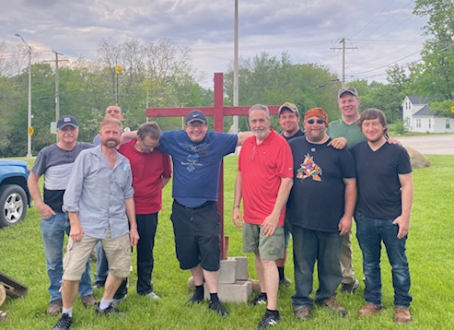

God’s Warriors: Awakened in Christ

This year for Gods Warriors has been a challenging year. Our leadership of Tom and Katy Heinrich and Allyce and John Beechy tried to hold the ropes of Gods Warriors Ministry up from falling through these difficult uncertain times. The Lord redirected our ministry early this year from specifically trying to minister to the Young Adults to a Ministry for the whole church at Living Faith. We have been led by the Holy spirit and the wisdom of Pastor Troy to strengthen the fellowship through Church activities and events. From movie nights, game nights, bon fires to many other future church events. Our goal is to bring the church and those outside the church together through these activities to build rich relationships that will build the body of Christ and bring salvation to the lost. The Church is God’s number one entity on planet earth. We must be strong for the time we live in to be effective. Along with the other ministries of the church we can make our Church strong in the Lord and stand firm in these dark times. Lastly, I want to encourage you with the testimony of the first time we got together this year in February for movie night where we watched War Room (a movie on the power of prayer).. The weeks prior to the event we tried mightily hard to outreach for the movie night and our efforts didn’t seem to draw much interest at first. We were at point of no return for God’s Warriors if this didn’t turn out well. We got to a point where we just had nothing else we could do and had to leave it at God’s throne to do something if He desired. Wow, as soon as we did that we began to see God move. The interest for the movie night increased tenfold, it was completely amazing. Then the movie night came and we had 14 people turn out. The movie “War Room” challenged us so much to seek the Lord in prayer and let Him fight our battles, that after the movie was over everyone was so moved that we prayed for almost an hour as a group. We are living in times where God’s people must seek Him in prayer and be totally dependent on Him. In our flesh, we can’t. In our own Christian lives or in the Churches lives succeed and overcome, but in Christ we can do all things in His power. That is the hope of God’s Warriors: To be a light in these dark times and be a small part of helping the Church shine bright in the darkness.

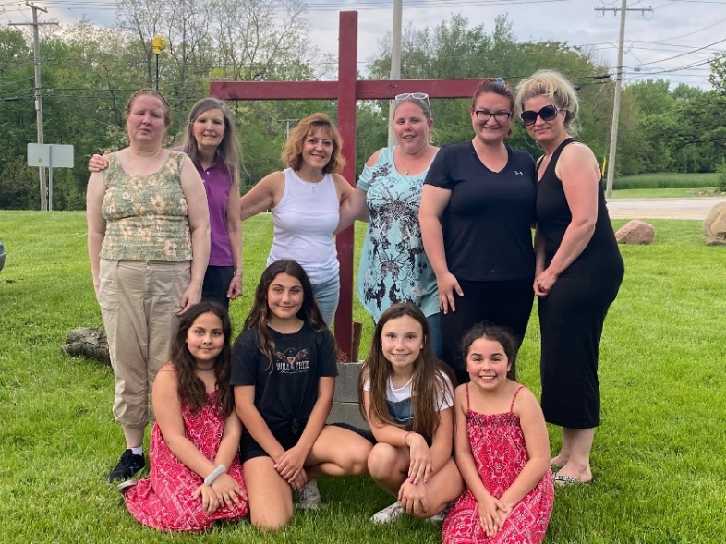

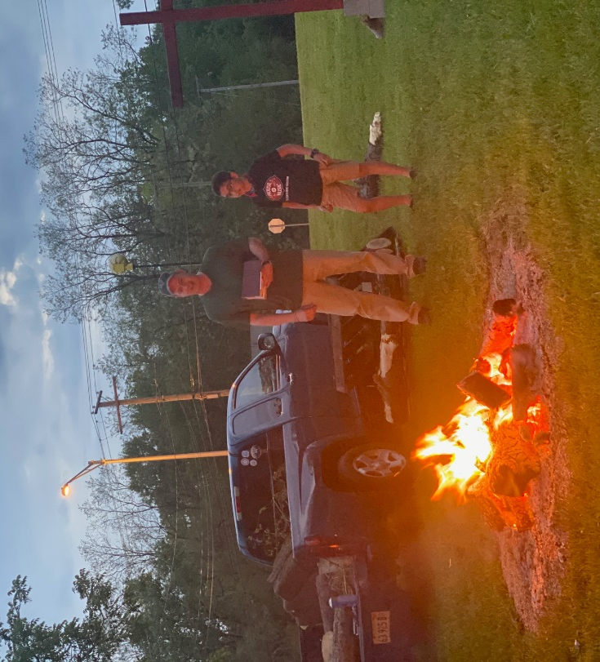

====///====

Birthdays

July
Troy Billow July 2
Scott Carevic July 3
Helene White July 5
Larry Sandy July 7
Donna Healy July 11
Noah Juarez July 15
Aimee’ Heinrich July 17
Elizabeth Healy July 18
Kathy Delgado July 21
Kevin Healy July 29

August
Emma Healy Aug. 12
Darrell Blasier Aug. 15
Ronnie Robison Aug. 16
Tony Juarez Aug. 28

September
Dennis Pepe Sept. 5
Marion Hays Sept. 10
Rene’ Blasier Sept. 20
Megan Bustamante Sept. 19
Lincoln Callahan Sept. 22
Roy Beehn Sept. 26
Chucho Bustamante Sept. 27
Edith Thompson Sept. 28
*Dorothy Martin Sept. 30
* Out of town
====///====
Upcoming Events
7/10 – LILAC Ministry “The Book of John” Tony Evans, 10:30 am

7/16 - Waffles and the Word Men’s Group, 8-10 am

7/22 - LFCC Prayer Circle with Pastor Troy, Thursdays at 6 pm in his office followed by Market Place Outreach (select dates to be announced as needed)

====///====
Mission Highlight

Every newsletter will highlight one Mission ministry Living Faith Community Church supports.

Guam
Ron and Rhonda Haynes became full-time ministry leaders in 2008 when they formed Lovely Feet Ministries (LFM) and left for La Paz, Bolivia where they first encountered ministry leaders of Cup of Cold Water.
Prior to becoming ministry leaders, Ron was an attorney fighting for equal justice for the poor, while Rhonda worked as an information analyst. LFM started with a love for the people of Bolivia, and over the years, that love has extended to Peru, Brazil, Mexico, Honduras, Uganda, South Korea, and now Guam and Micronesia.
Though the geography may change, the mission of LFM has always been the same, to make disciples who make disciples. Now in Guam, Rhonda and Ron have been called to be a part of educating the next generation of Christian leaders at Pacific Islands University (PIU) where Rhonda serves as Academic Vice President. PIU is a small liberal arts university that targets the marginalized and underserved of Micronesia through Christian education.
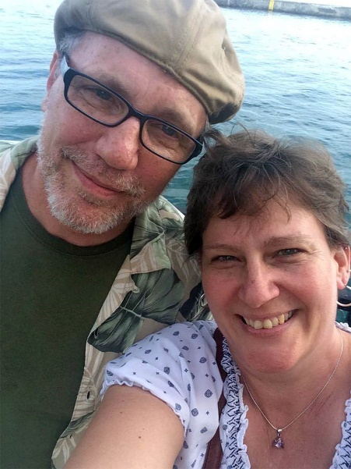
====///====

More from God’s Warriors Bonfire

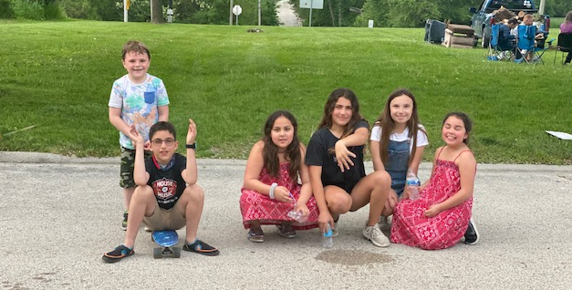

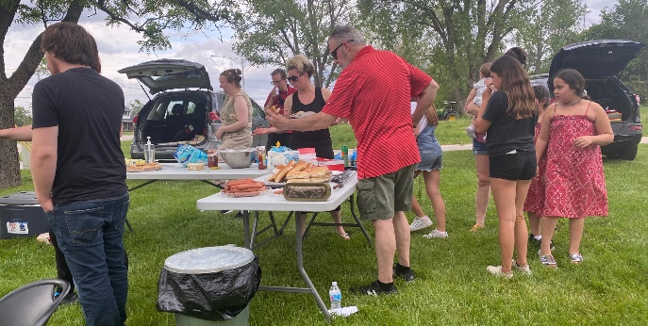

====///====

In Loving Memory Of

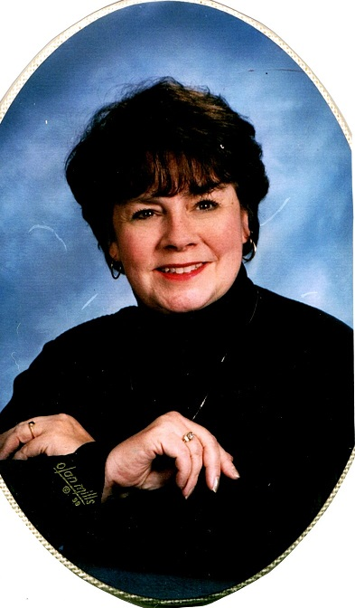

Carol June Billow
1941 – 2020

“Your life was a blessing, your memory a treasure;
You’re loved beyond words & missed beyond measure.”

Living Faith Messenger
The Monthly Newsletter Of
Living Faith Community Church
380 High Road, Lockport, IL 60441 815-838-6018

Living Faith Community Church
380 High Road Lockport, IL 60441

Dated Material
Address Change Requested

Stamp

