Servant Event

at KURE BEACH

2
0
2
1
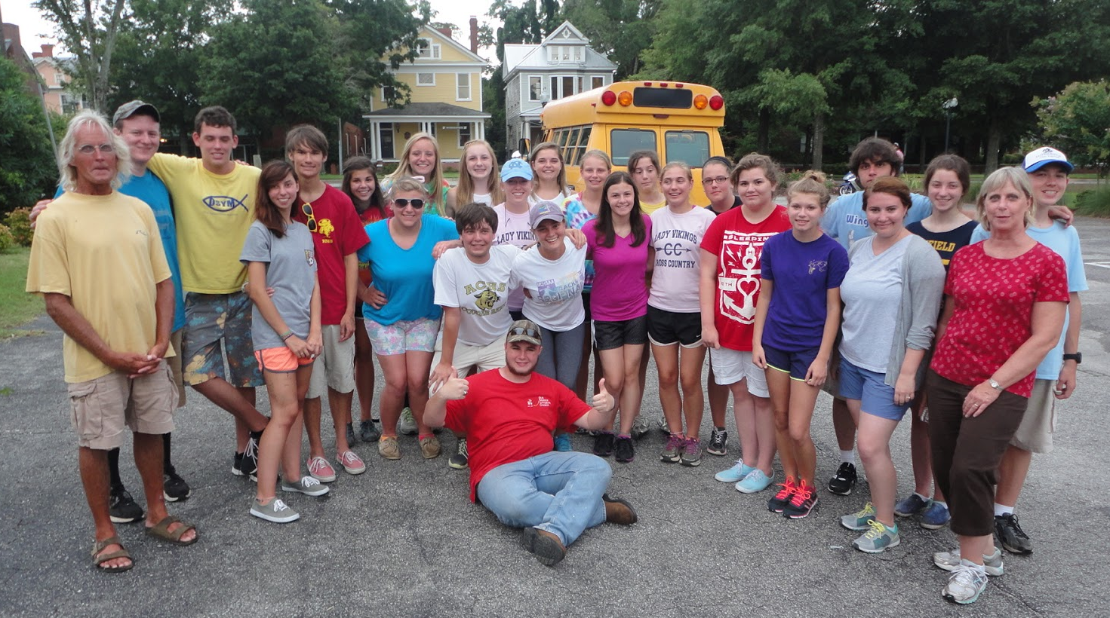

Bring your high-school youth group to hit the beach and explore deeper what it means to be a servant. Spend time working at different service agencies in the Wilmington area and see the face of Christ in the faces of your neighbors.

To learn more about Servant Events offered by
Agapé Kure Beach Ministries continue reading this packet.
If you have questions, please call Christa at (919) 552-9421.

AGAPÉ SERVANT EVENT INFORMATION PACKET

WELCOME to the exciting world of Servant Events. Agapé Kure Beach Ministries strives to provide the best quality experience around in order to see the faces of Christ in those around you. We hope you are as excited as we are about the dynamic ministry of Agapé Kure Beach Ministries Servant Event.

In this packet I will find the answers to:

What is Servant Event and what are the goals of the program?

Who plans and works the program?

What does the schedule look like?

What will we do?

How do we get around the area?

Where do we stay and what will we eat?

How do I sign up?

Tell me more about Camp Agapé!
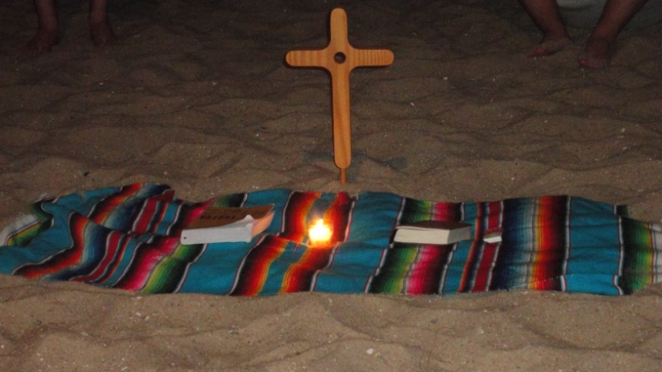

Agape Kure Beach Ministries
1369 Tyler Dewar Lane
Fuquay-Varina NC 27526
www.agapekurebeach.org
Christa Hassler
Program Director
program@agapekurebeach.org
919.552.9421

WHO IS AGAPÉ KURE BEACH MINISTRIES?

WHAT IS THIS MINISTRY ALL ABOUT?

Agapé † Kure Beach Ministries calls and gathers all people to experience the Spirit through encounters with Christ, in Creation and Community.

GOALS OF AGAPÉ CAMP PROGRAMS

- Build self-value and identity as a child of God.

- Provide quality Christian role models in our staff who can live out their faith in all aspects of their lives.

- Provide a safe environment for campers to grow emotionally, spiritually, mentally, and physically.

- Teach creation stewardship through environmental education experiences and by example.

- Develop and nurture leaders for the church and the world by focusing on camper’s call, gifts, and faith in vocation.

- Use music in a positive way to share our faith.

- Have FUN!

WHAT DOES CAMP DO?

- It builds your groups into a community. (It takes 16 hours of contiguous time to begin to build a true community)

- It builds a communal foundation for stronger youth ministry in your parish.

- It provides an opportunity for youth of similar interests to be together in developing and strengthening Christian values.

- It encourages individuals to explore decision-making and problem-solving skills.

- It provides opportunities for individuals to grow in faith, experience new challenges, develop personal gifts and have fun.

- It improves the climate for learning within your group.

- It builds trusting relationships for the tough times back home.

- IT CHANGES LIVES!!!

WHAT IS SERVANT EVENT?

Servant Event is a fun, exciting, and meaningful week for senior high youth. Pastors/Youth Leaders will have time to work side-by-side with their high school youth group at direct-service agencies in the Wilmington area. The week also has time for group building, surfing, exploring Wilmington, and hanging out on the beach! Each event is somewhat different depending upon our ability to match services with the needs of the people with whom we are working.

WHAT ARE THE GOALS OF SERVENT EVENT?

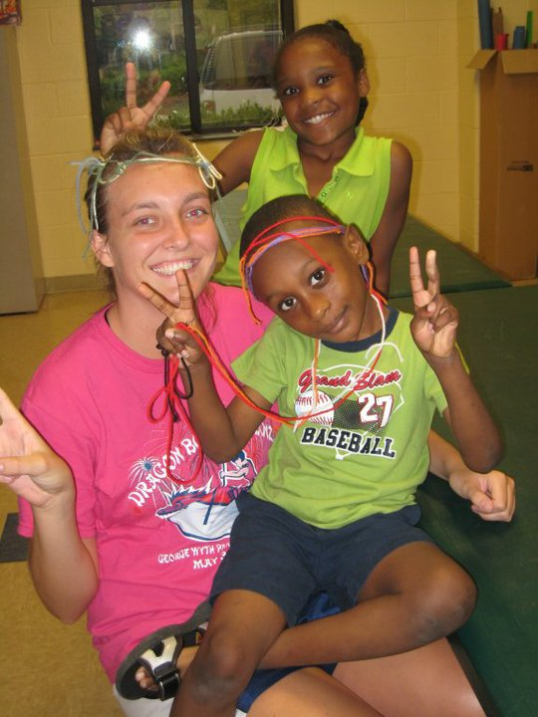
- AWARENESS - of who our neighbors are, not just the ones with whom we typically associate with; of the needs that surrounds us; of the gifts we each possess as children of God to meet the needs of those we encounter.

- VISION - of the Biblical understanding of serving; of how the world can be when we serve those in need.

- APPRECIATION - for the services and organizations that are in place in our communities; for the people sharing their gifts with those in need.

- EMPOWERMENT - of participants leaving the Servant Event, not paralyzed into inaction by the overwhelming problems in the world, but assured that each one of us can and does make a difference.

- LIFESTYLE CHANGE - of all Servant Event participants - that they consider what this week means for the rest of their lives. Service does not end when our time together at the beach ends, but it becomes a way of life as we share our experiences with friends, family, church members, and neighbors and strive to live out our gifts and serve wherever we are!

WHO IS THE LEADERSHIP FOR SERVANT EVENT?

Christa Hassler, Program Director, and Pastor Dan Keck, Ministry Partner, will set up and plan your program. Pastor Dan will contact and set service locations and will orient groups each day to the nature of their service. Christa will work with you to make sure you have everything you need before you head to Kure Beach and will orient staff. Two A+KB summer staff members will be your leaders, guiding you through the week.
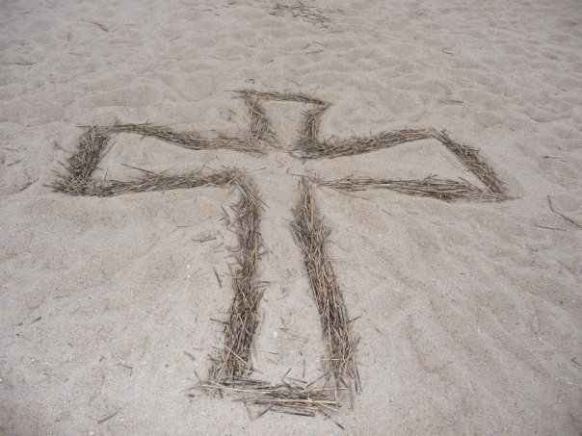
Your adult chaperones will oversee supervision of your group at all times, and may be called upon to share in some small-group leadership (all small-group materials will be ready to pick up and lead with little or no preparation).

HOW DOES THE SCHEDULE WORK FOR SERVANT EVENT?

Typically, the beginning of each day will be devoted to the service-learning projects. The afternoon will focus more on understanding and appreciating the unique aspects of living and playing on the beach. Throughout the week we will have time dedicated to devotions, Bible Study and Worship. On our last night of camp together, we like to close with a service of affirmation, where participants will be called upon to affirm each other.
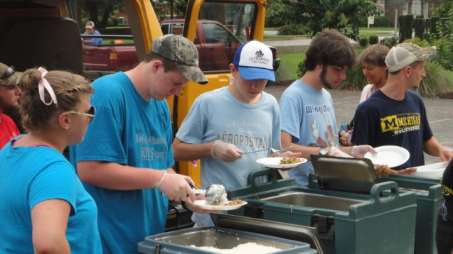
WHAT PROJECTS WILL WE DO?

Elements of the week could include working with:

- A shelter for those experiencing homelessness, helping them with projects around the facility

- The local state park, serving the environment through beach clean-up and trail maintenance

- A retirement community, walking with seniors, visiting with them (unlikely in 2021, maybe window visits)

- A Boys and Girls Club, playing and bonding with local community youth

- A food pantry, distributing food.

WHAT OTHER ACTIVITIES COULD WE DO?

These activities could include:

- Sun bathing and wave crashing on the beach (the beach directly in front of our facility has a lifeguard station occupied by Kure Beach lifeguards)

- A Surfing program through Surf Camp (this activity is scheduled for each program week at a specific time and the cost is included in the camper program fees. If your chaperones would like to participate, then it will be an additional $75 per adult). Scheduling based on company availability.

- Visiting the Kure Beach pier

- Fort Fisher Historical Site, with remnants of the American Civil War fort and small
museum focusing on the pivotal battles for control of the port of Wilmington,

HOW DOES TRANSPORTATION WORK?

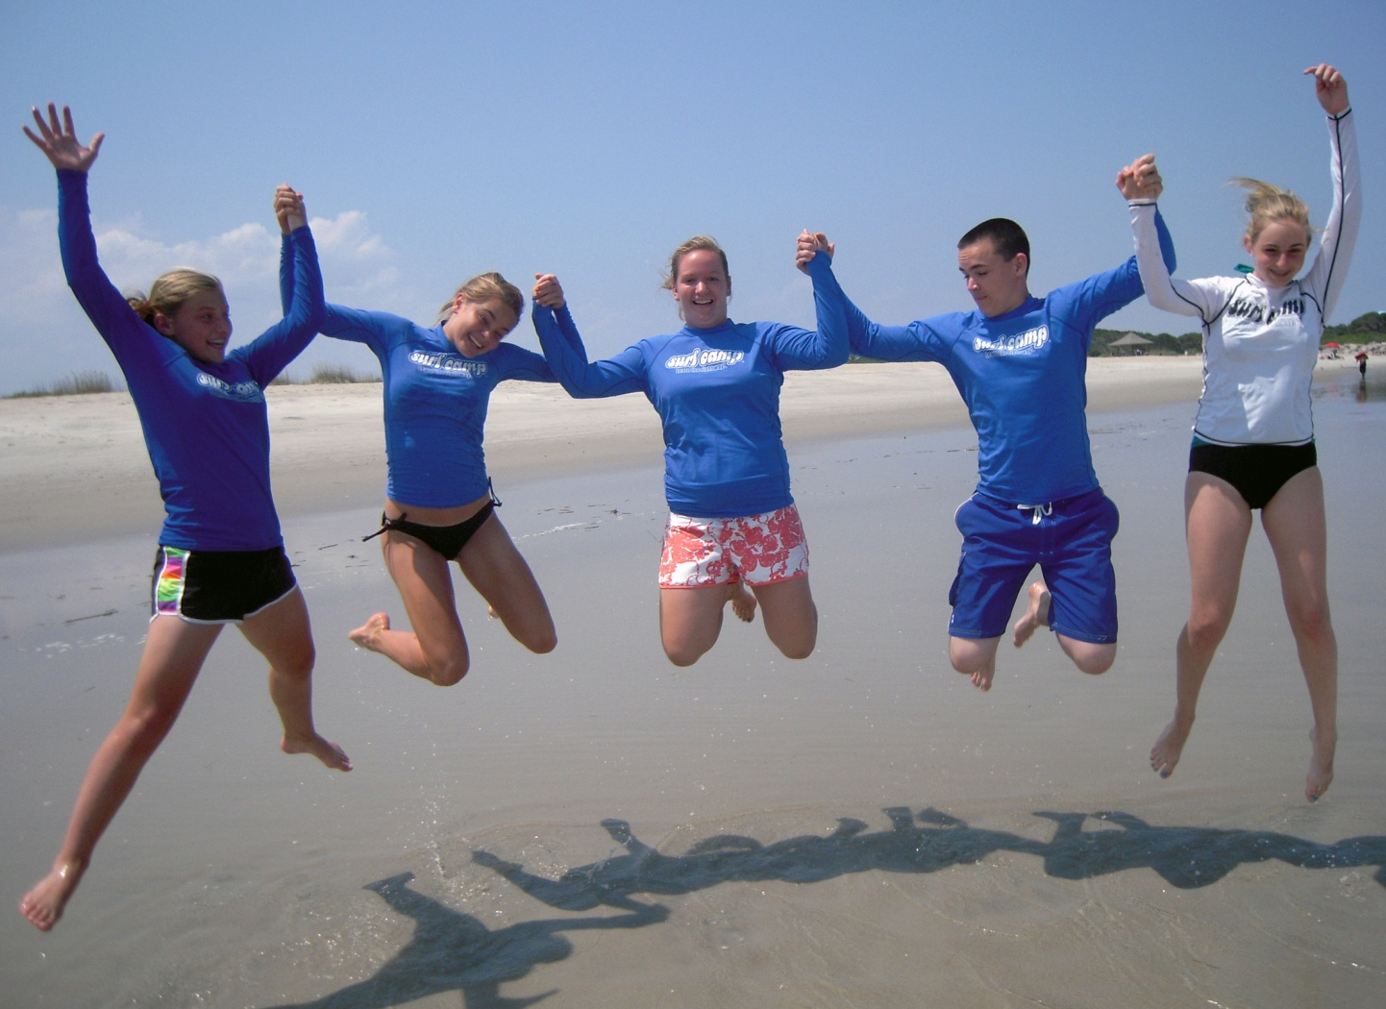
Congregations will need to use their vehicles to travel to and from different service sites. Groups need to plan for trips from Kure Beach to Wilmington almost daily, which can add about 100 miles per vehicle to your total trip. We will split your group up for service projects because most non-profits are not equipped to take large groups at their site. We ask that congregations take this into consideration when planning their mode of transportation (i.e. minivans are ideal, while large church or charter buses are not).

WHERE DO WE STAY?

Depending on which week, you could either be housed at our Kure Beach Faith Center or a beach house (similar facilities), just down the road from the Center. Our minimum group size is 12 campers (not including chaperones). If your group has fewer than 14 campers, we reserve the right to recruit other participants. For the Kure Beach Faith Center, our maximum currently is about 30 (staff, adult leaders and youth).

WHAT DO WE EAT?

At Kure Beach, we do not have our own food service program operating on a regular basis. Most breakfasts (bagels, cereal, toast, juice, etc.) will be prepared by the servant group members in the kitchens of our lodging facilities. Lunches are typically packed sandwiches, chips, fruit, dessert, and other options to give us the maximum time for service and beach programming. Dinners will be a combination of meals prepared for us by our Kure Beach staff, caterer, and community members. All meal costs are covered in your registration.

I AM SOLD! HOW DO I SIGN UP FOR SERVANT EVENT?

Cost (may change)
Participants: $440.00
(Everything included)

Adults: $260.00 per adult
+ $75.00 per adult who would like to surf
(must be at least 21 years old)

Summer 2021

July 18-22

Contact for other 2021 availability!

*Cost includes 4 nights lodging,12 meals, program and services of Agapé Kure Beach Ministries staff, and some specific program options through local businesses. All other expenses are the responsibility of your group members.

Timeline to Plan Servant Event

- Sign and return the copy of your contract with a $100 deposit as soon as possible.
- Send $100.00 per camper deposit by April 1st, 2021 (no adult deposit needed). Mark this deposit on the back of your contract copy for your records to aid you in final balance calculation.
- Send another $100.00 per camper deposit by May 30th, 2021 (no adult deposit needed). Mark this deposit on the back of your contract copy for your records to aid you in final balance calculation.
- Distribute letters and forms to participants (please use white paper for health forms).
- Send a check for the balance due by July 1, 2021, which can be figured using the tool on the back of your contract and will be invoiced to you.
- Collect forms and mail a copy (on white paper) of health and profile forms to Camp Agapé on or before July 1st, 2021. Make a copy of health forms for each of your vehicles.
- Check with parents for any dietary needs and phone in or email to Christa at Camp Agapé at least two weeks (preferably a month) in advance of your trip
- Meet with your group to form a group covenant and cover pre-event questions.
- Re-read all materials about a week or two before the event to make sure nothing has been missed.
- Double check what-to-bring and what-not-to-bring lists with each participant upon departure.
- Adhere to all COVID-19 protocols and support Agapé staff in monitoring/enforcing as needed.

Contact Christa for information or to schedule our Servant Events for 2021 at
program@agapekurebeach.org or call (919) 552-9421

Loving God and sharing that life-giving love with campers, while having fun, is our ultimate goal.

