PLEASE NOTE THE FOLLOWING: COVID numbers are expected to fluctuate over the next few months. To keep our worshipping community safe, if on any Saturday Radford City numbers per https://www.vdh.virginia.gov/coronavirus/coronavirus/covid-19-in-virginia-locality/
exceed 40 cases per 100,000 people, we will NOT have indoor worship. We will contact everyone who has pre-registered for the service and send email correspondence to the church email list.

Grove United Methodist Church

1020 Tyler Avenue, Radford, Virginia 24141
(540) 639-2807 radfordgroveumc@gmail.com
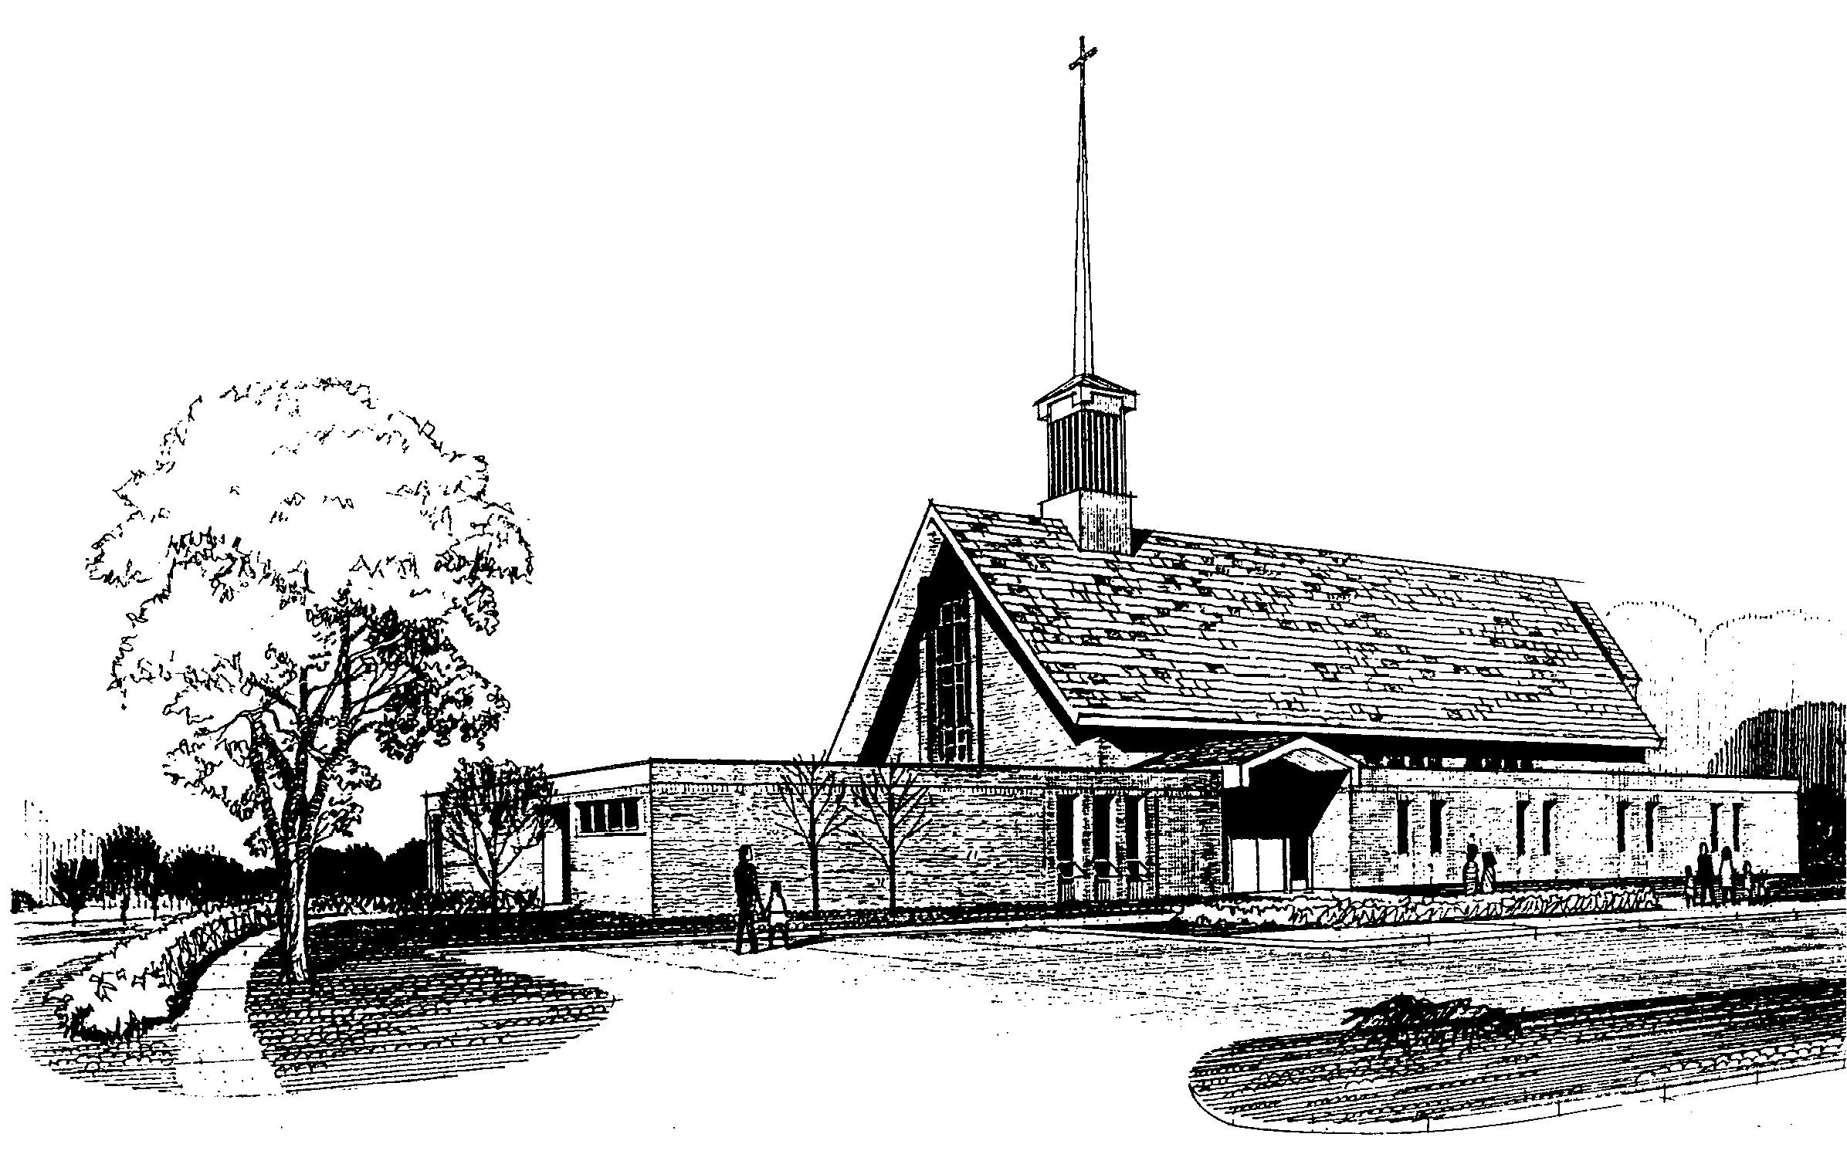

Pat Brown  Organist | Adam McAllister  Choir Director | Libby Watts  Handbell Choir Director
Jim Harrison  Pianist | Ila Schepisi  Deacon in Residence | Dana E. Watson  Administrative Assistant
Lynn Wright  Custodian |  | Joanna Corvin  Finance
Rev. Dr. Jan Nicholson Angle
Minister

February 7, 2021
The Order of Worship
Fifth Sunday After the Epiphany

Please follow the directions of
your ushers and worship leaders.
Due to COVID-19, congregants are invited to welcome one another with handwaves and other non-verbal signs of celebration and worship.
------------------------------------
Thank you for remaining in your seat,
always wearing your mask,
and listening to instead of singing the hymns.

GATHERING AND ANNOUNCEMENTS

PRELUDE AND TIME OF SILENT PREPARATION
CALL TO WORSHIP (based on Psalm 147)
Praise the Lord!
The Lord rebuilds Jerusalem,
gathering up Israel’s exiles.
God heals the brokenhearted
and bandages their wounds.
God counts the stars by number,
giving each one a name.
Our Lord is great and strong!
God’s knowledge can’t be grasped!
God covers the skies with clouds;
God makes rain for the earth;
God makes the mountains sprout green grass.
God gives food to the animals –
even to the baby ravens when they cry out.
The Lord treasures the people who honor him,
the people who wait for his faithful love.
Praise the Lord!

HYMN 698 God of the Ages (stanzas 1 and 2)

PRAYERS OF THE PEOPLE

SCRIPTURE READING Isaiah 40:21-31
CHILDREN’S MESSAGE

SERMON That’s Life! Rev Dr. Jan Nicholson Angle

COMMUNION

HYMN 470 My God, I Love Thee (stanzas 1, 4, and 5)

BENEDICTION

OFFERING AND POSTLUDE
Ash Wednesday Virtual Service
February 17th
(Grove UMC YouTube; or click the link on our website at groveumcradford.com)
Lent is a time of repentance, fasting, and preparation for Easter. Ash Wednesday marks the beginning of Lent. Ashes and earth are often symbolically used during the Ash Wednesday worship service to help us focus on our human sinfulness and mortality and our need for repentance and God’s grace in Jesus Christ. This year, due to COVID, we will be giving each Ash Wednesday participant a small packet of ashes from Grove UMC’s grounds, 2019 palms and soil. Participants may carry these packets with you during Lent. Packets will be made available at the Feb 14th service and by calling the church office.

The Congregation is to remain seated
and wait for ushers to dismiss by rows.
An offering may be made at the exit
in the touch-free dropbox.

SOUND SYSTEM
Tommy Fisher Susan Lesko
USHERS
Bob Boggess Frank Herzog
Adam McAllister Wayne Pridgen

COUNTERS
Bob Boggess Barry Anderson
Memorial and Honorary Gifts
by Drew Dehart in honor of
Clay & Jean Carson.

by Chester & Amy Black in honor of
Wayne & Nancy Pridgen.

by Tom Shufflebarger in memory
of Emmett & Barbara Shufflebarger.

Susan Boggess

PRAYERS
Jinnie Pennington Lockridge, Amy Black, Janice Herzog, Keegan, Brent Lesko, Patty McAllister, Junior Surver, Mike Porter, Mildred Wall, Graham Wickline, those who are homebound and those in assisted living.
ANNOUNCEMENTS

ASH WEDNESDAY SERVICE: February 17th, virtual on Grove’s YouTube channel. The week prior, we will hand out packets of ashes mixed with soil from Grove UMC, which you may keep as a reminder of our mortality and connection to Christ's Church.

COMMITMENT SUNDAY: Today, we are invited to prayerfully make an outward commitment of our prayers, presence, gifts, and service to Grove UMC for 2021 by filling out a Commitment Card and placing it in this week’s offering. You may also mail your cards to Grove UMC 1020 Tyler Ave Radford VA 24141 or email to groveumcfinance@gmail.com. If you did not receive or have misplaced your card, please contact the church office at 540-639-2807. May God bless your support of Christ’s Church through Grove UMC.

USE YOUR FREE AMPLIFY ACCOUNT: Amplify Media is a streaming service that is FREE to all Grove members. You have unlimited video access to discover diverse resources that encourage deeper discipleship and equip churches to pursue their mission with greater impact. See the Grove Greeter newsletter or call the church office for more information.

UPPER ROOMS: You may pick up your January/February Upper Rooms in the narthex.
BIBLE STUDY: “A Disciple’s Path” by James A. Harnish and Justin LaRosa. A hybrid (in-person and Zoom) six-week study that focuses on stewardship and spiritual gifts. Facilitated by Rev. Dr. Jan Nicholson Angle. Begins Wed. February 17th at 6 pm. Call the church to register.
FREE WEBINAR SERIES: Holston Conference presents "Conversations on Race – TN Valley Sessions" every Tuesday in February from 7 pm to 8:30 pm via Zoom. All are welcome. To access, please register at Conversations on Race - Tennessee Valley Sessions (brtapp.com)
BOOK CLUB: “America’s Original Sin” by Jim Wallis meets Monday nights at 6:30 pm via Zoom. Facilitated by Adam McAllister. Let us know you are joining by emailing Adam at groveumchoir@gmail.com.

VIRTUAL LAY SERVANT TRAINING:
Holston Conference's Lay Servant Training will be offered online through Zoom meetings in 2021. See the Grove Greeter newsletter or call the church office for more information.
GROVE WEBSITE: Please check our website at groveumcradford.com for information and updates on what is happening in the Grove!

God of the Ages
Hymn 698 (Stanzas 1 and 2)
Words: Daniel C. Roberts, 1876
Music: George W. Warren, 1894

God of the ages,
whose almighty hand
leads forth in beauty
all the starry band
of shining worlds
in splendor through the skies,
our grateful songs
before thy throne arise.

Thy love divine
hath led us in the past.
In this free land
with thee our lot is cast.
be thou our ruler,
guardian, guide, and stay,
Thy Word our law,
thy paths our chosen way.

My God, I Love Thee
Hymn 470 (Stanzas 1, 4, and 5)
Words: Latin, 17th century,
translated by Edward Caswall, 1849
Music: Est’s The Whole Booke of Psalmes, 1592
Harmony from Hymns Ancient and Modern,1861

My God, I love thee,
not because I
hope for heaven thereby,
nor yet because,
if I love not,
I must forever die.

Not with the hope
of gaining aught,
Not seeking a reward
but as thyself
hast loved me,
O everlasting Lord.

So would I love thee,
dearest Lord,
and in thy praise will sing;
because thou art
my loving God
and my eternal King.

