January 22nd, 2017
9:00 am

THIRD SUNDAY
AFTER
THE EPIPHANY

Grace Lutheran Church
2713 Flagler Ave.
Key West, FL 33040
305-296-5161
GraceLutheranKW@att.net
gracelutherankw.360unite
Pastor Faith
(504) 858-8872
garyfaith@aol.com

THIRD SUNDAY AFTER THE EPIPHANY
JANUARY 22ND, 2017 9:00 a.m.
In the Name of Jesus!
Our Mission Statement: Anchored in Christ, each person a missionary.

PRELUDE

ANNOUNCEMENTS:
We welcome you. We are glad you are here to share with us the joy and peace we have in Jesus Christ. It doesn’t matter whether this is your first time in this church or if you are a lifelong member, you are welcome. We come together today in order to celebrate the gift God has given us-His own Son, Jesus, Our Savior.

PREPARATION
(Please Stand…)
HYMN: “The People That in Darkness Sat” LSB 412
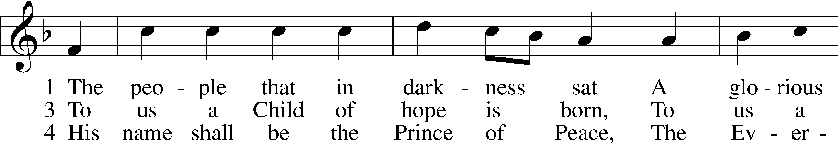
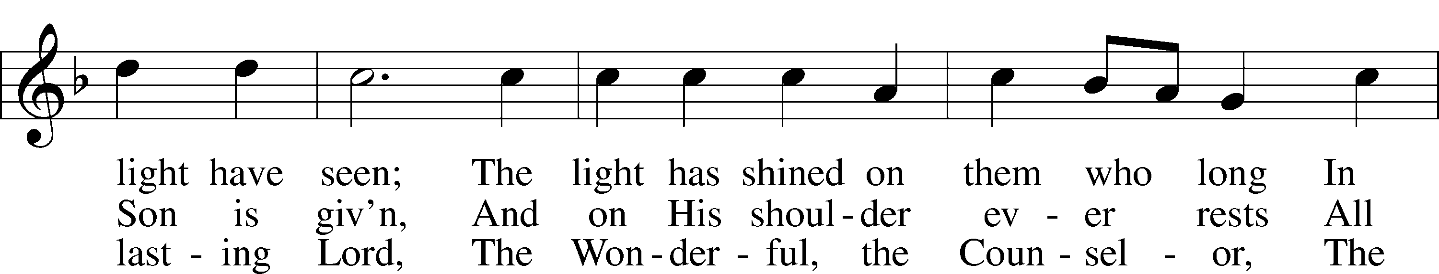
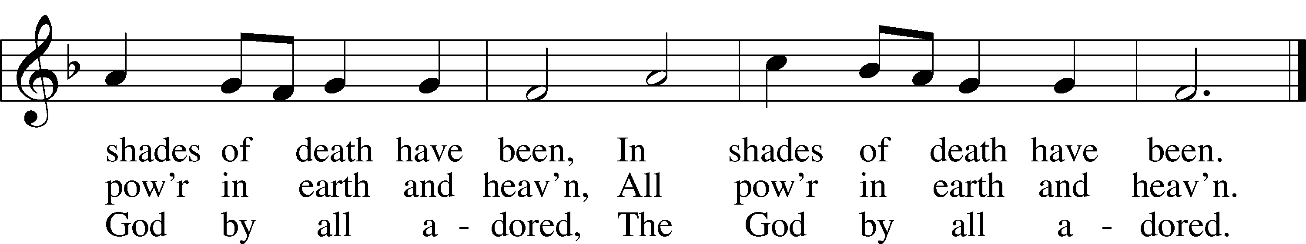

5 His righteous government and pow’r
Shall over all extend;
On judgment and on justice based,
His reign shall have no end,
His reign shall have no end.
Public domain

Pastor: In the Name of the Father and of the Son and Holy Spirit.
Congregation: Amen.

(Please Remain Standing Or You May Kneel…)
GOD’S PEOPLE CONFESS THEIR SINS:
Pastor: By grace you have been saved, through faith-and this is not from yourselves, it is the gift of God-not of works, so that no man can boast, for we are God’s workmanship, created in Christ Jesus.
Congregation: I know that nothing good lives in me, that is, in my sinful nature, for I have the desire to do what is good, but I cannot carry it out.
Pastor: What I do is not the good I want to do; no, the evil I do not want to do-this I keep doing.
Congregation: In my heart I delight in God’s law, the law that points out what a wretched person I am! Who will rescue me from this body of death?
Pastor: Thanks be to God through Jesus Christ our Lord! Only He can achieve the perfection we fail to achieve. By the forgiveness He purchased on the cross, our forgiveness is complete!

SERVICE OF THE WORD

You may be seated…
THE FIRST READING: Isaiah 9:1-4
Lector: This is the Word of the Lord.
People: Thanks be to God.

THE EPISTLE LESSON: 1 Corinthians 1:10-18 Lector: This is the Word of the Lord.
People: Thanks be to God.

Please stand…
THE HOLY GOSPEL: Matthew 4:12-25
Pastor: The Holy Gospel according to St. Matthew the 4th Chapter
People: Glory to You, O Lord.
Pastor: This is the Gospel of the Lord.
People: Praise to You, O Christ!

SPECIAL MUSIC: “Rise and Shine” Children’s Vocal Choir

Please be seated…
CHILDREN’S MESSAGE

NOISE OFERING

THE SERMON HYMN: “My Faith Looks Up to Thee” LSB 702
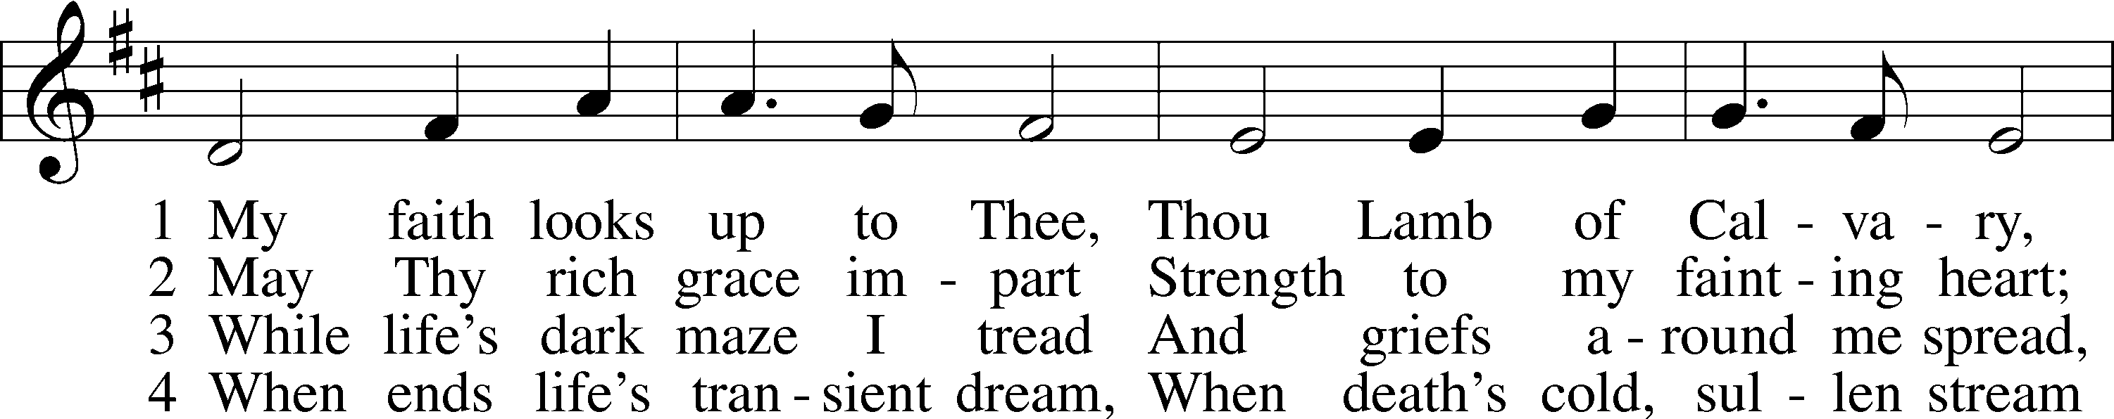
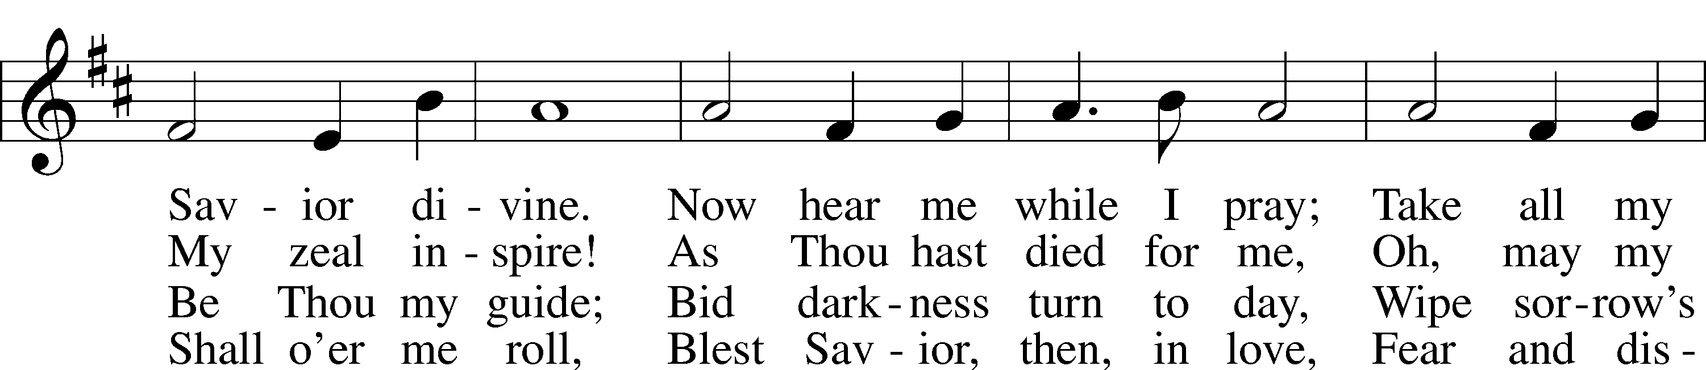
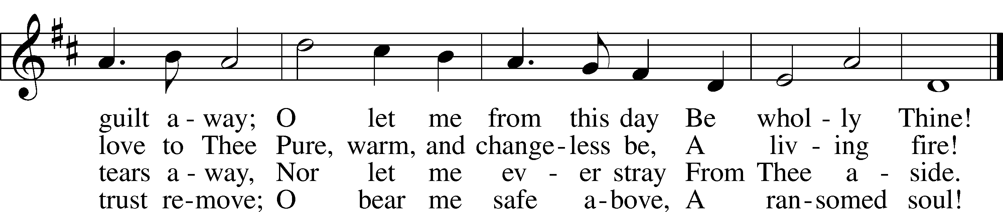
Public domain

THE SERMON: “Living on the Edge” Isaiah 9:1-4

(Please stand…)
THE PROFESSION OF FAITH:
Pastor: God has given us a great message to take to His world. Let us remind ourselves and one another of what that message is:
Pastor: I believe in God the Father, Almighty
Congregation: Maker of heaven and earth
Pastor: And in His Son, Jesus Christ our Lord,
Congregation: Who was conceived by the Holy Spirit
Pastor: Born of the Virgin Mary
Congregation: Suffered under Pontius Pilate
Pastor: Was crucified, died and was buried
Congregation: He descended into hell.
Pastor: On the third day He rose again from the dead,
Congregation: And ascended into heaven
Pastor: And sits on the right hand of God, the Father almighty
Congregation: From there He will come to judge the living and the dead
Pastor: I believe in the Holy Spirit,
Congregation: The Holy Christian Church as
All: the communion of saints; the forgiveness of sins, the resurrection of the body, and the life everlasting. Amen.

(You may be seated…)
OFFERING RECEIVED: “Come, O Thou Traveler Unknown” Bell Choir
Originally published under the title "Wrestling Jacob", "Come, O Thou Traveler Unknown" is a poem and hymn on the nature of God. The hymn is generally considered to be Charles Wesley's greatest work. It focuses on the change that can occur in one's own heart and is based on Genesis 32:24-32, which is the story of Jacob wrestling with an angel sent by God at Peniel.

(Please stand…)
“Praise God, from Whom All Blessings Flow” LSB 805
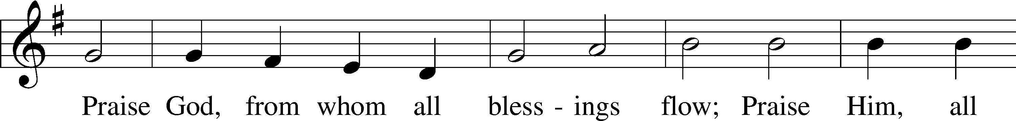
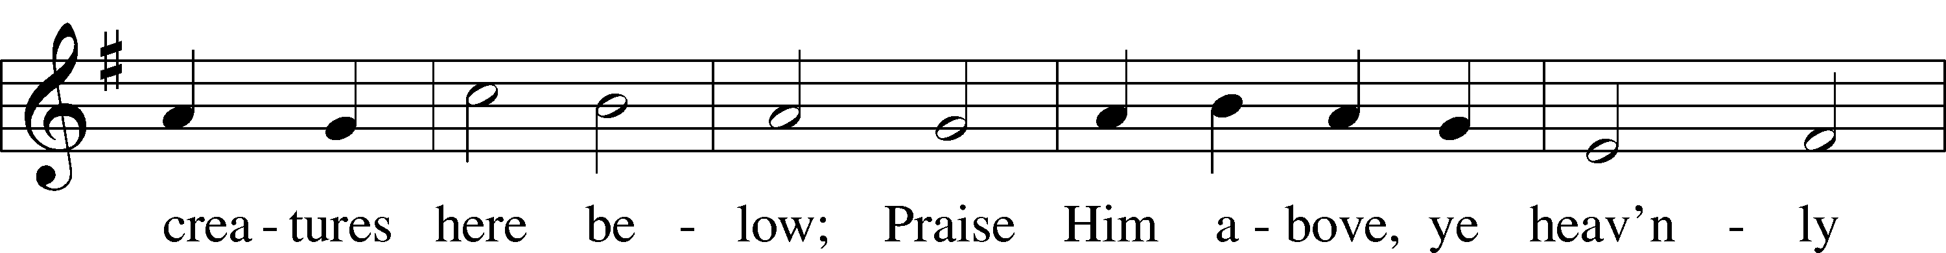
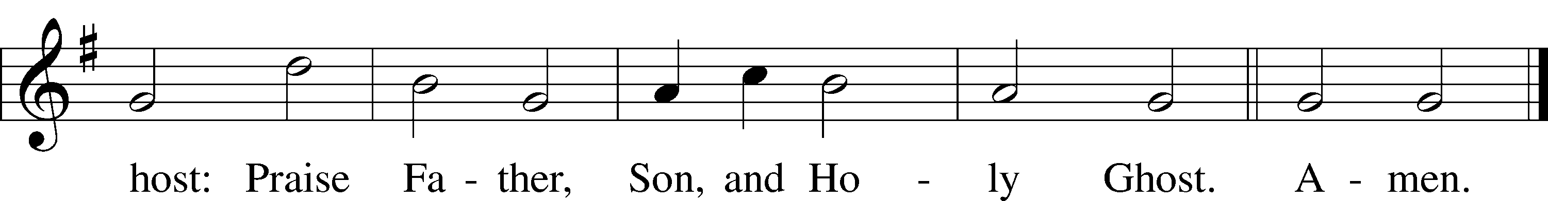
Public domain
THE PRAYERS OF THE CHURCH: based on Psalm 98
Pastor: Dear Lord, we thank You for everything You’ve done for us, and most of all for Your own Son, Jesus, our Savior. We will never stop praising You for this wonderful gift.
Congregation: Sing to the Lord a new song, for He has done marvelous things; His right hand and His holy arm have worked salvation for Him.
Pastor: We thank You for those missionaries long ago who brought the Good News to our people. When we were in darkness, You sent men and women to bring us the light. Thank you, Lord.
Congregation: The Lord has made His salvation known and revealed His Righteousness to the nation.
Pastor: O Lord, You are our Savior, we trust in You for all our needs, give healing to the sick, courage to those who are afraid, and peace to those we name in our hearts either silently or out loud. (a moment of silence) We praise You, gracious Lord, for all Your benefits to us. You give us home, friends and family, food, shelter, rest and everything we need. You give us sight and hearing and touch and taste and provide for all of our needs.
Congregation: Shout for joy to the Lord, praise His Name Amen.

SERVICE OF THE SACRAMENT

(Please be seated…)
THE WORDS OF INSTITUTION

DISTRIBUTION HYMNS: “Jesus Loves Me” LSB 588
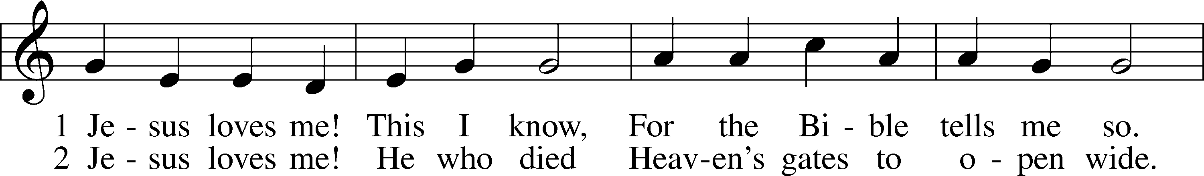
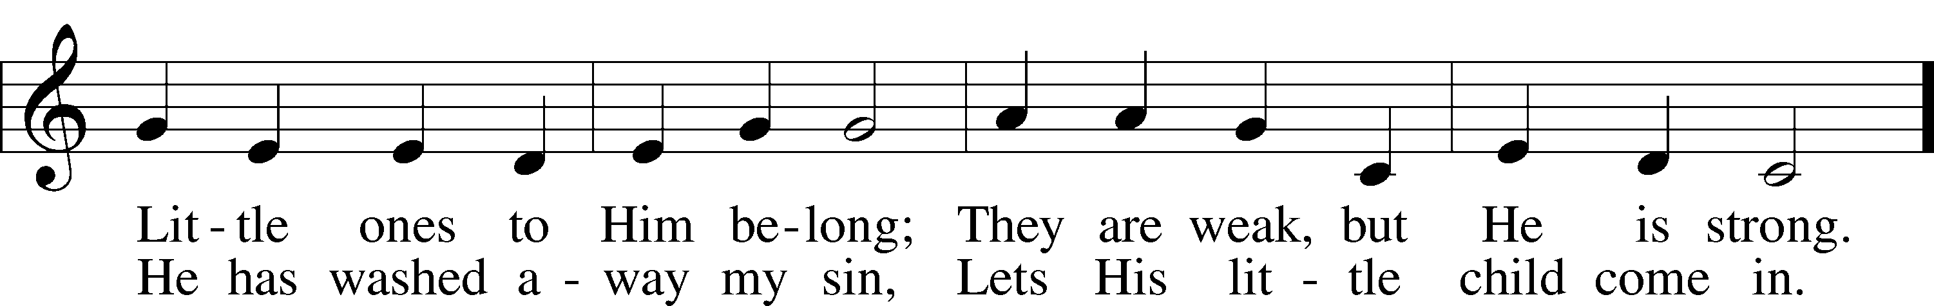
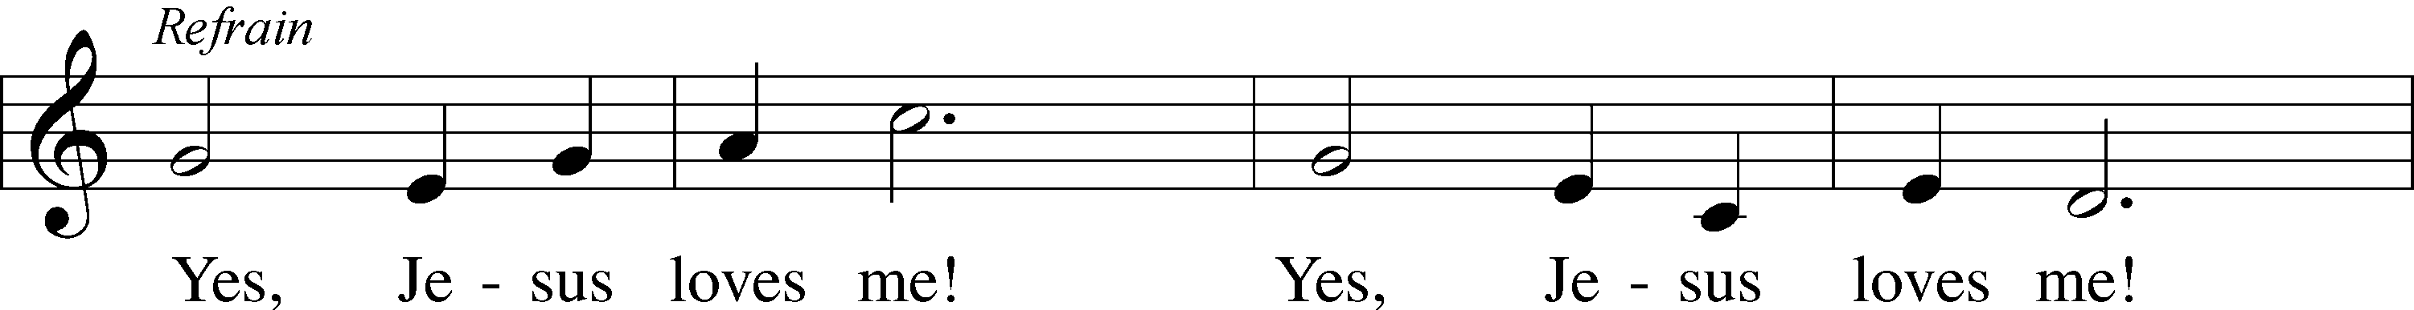
Public domain

Jesus let the things that break
your heart also break our hearts.
Amen

“Praise the One Who Breaks the Darkness” LSB 849
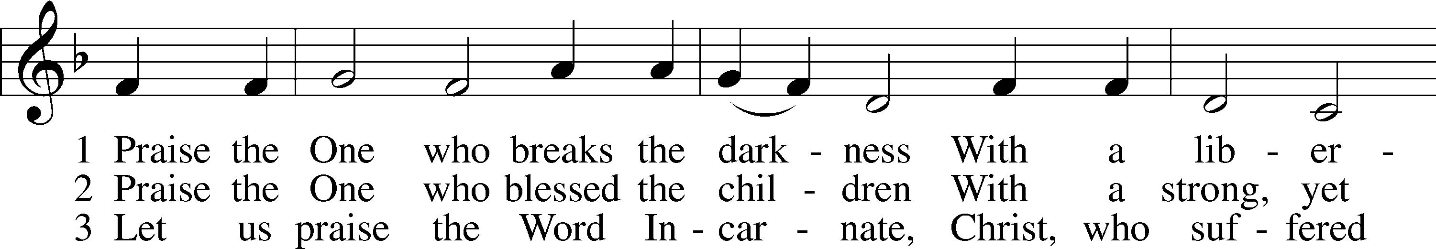
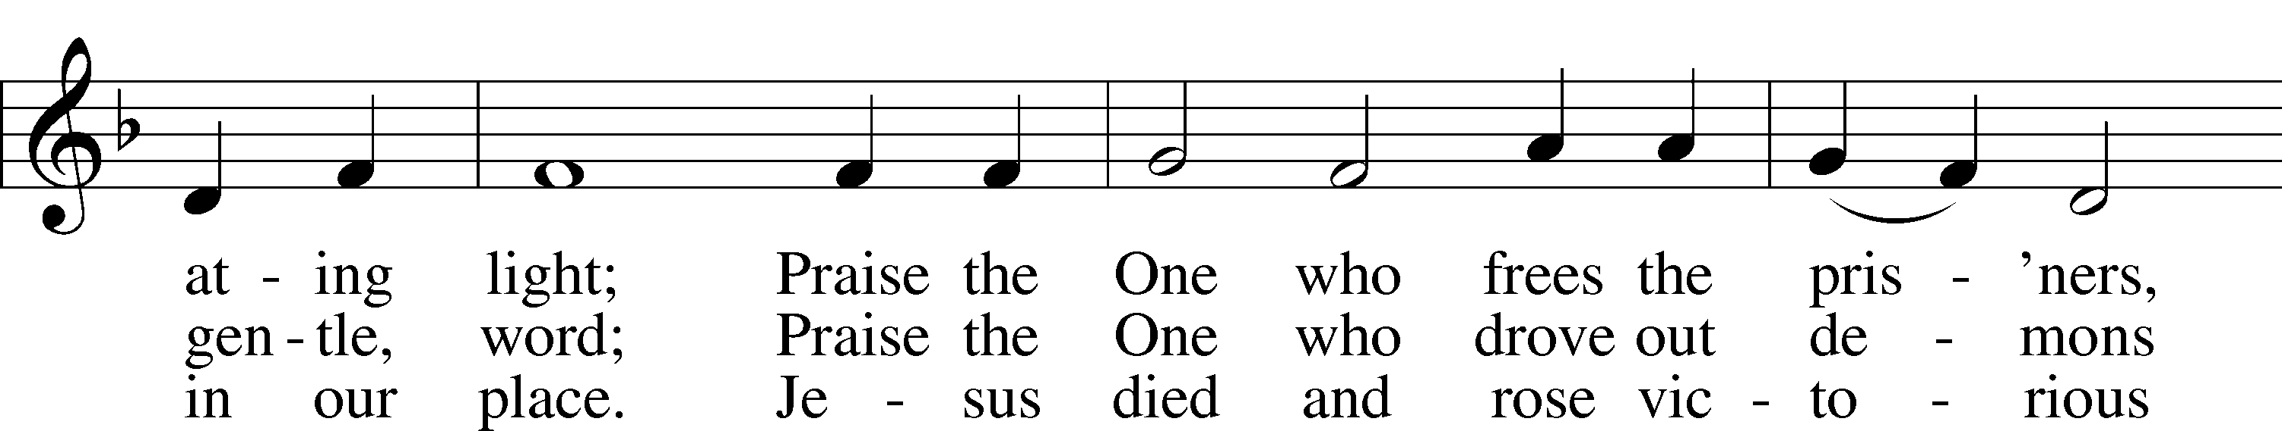
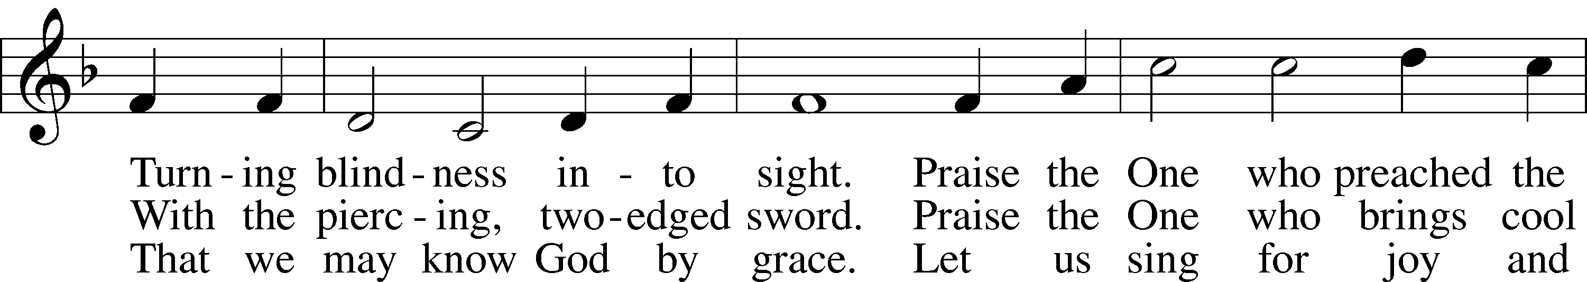
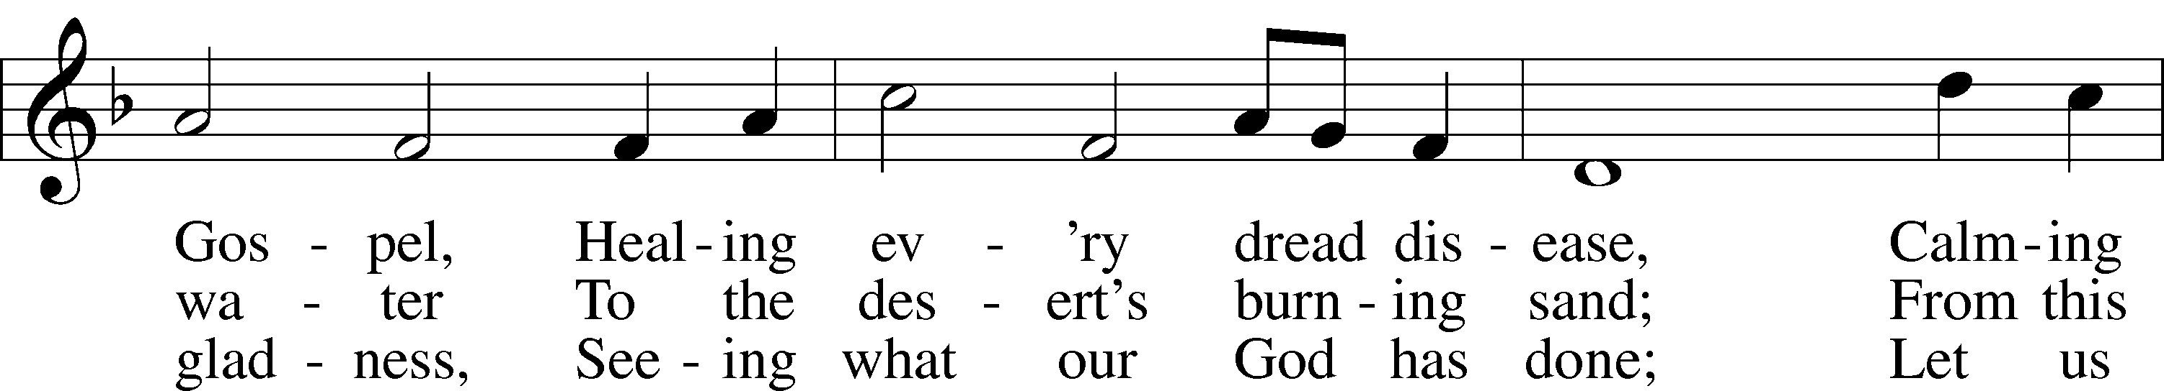
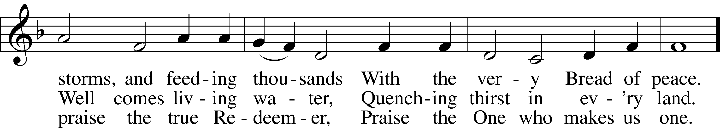
© 1987 Hope Publishing Co. Used by permission: LSB Hymn License .NET, no. 100011641.

“On Eagles' Wings” LSB 727
*Vocal Choir will sing the verses and the congregation will sing the Refrain.
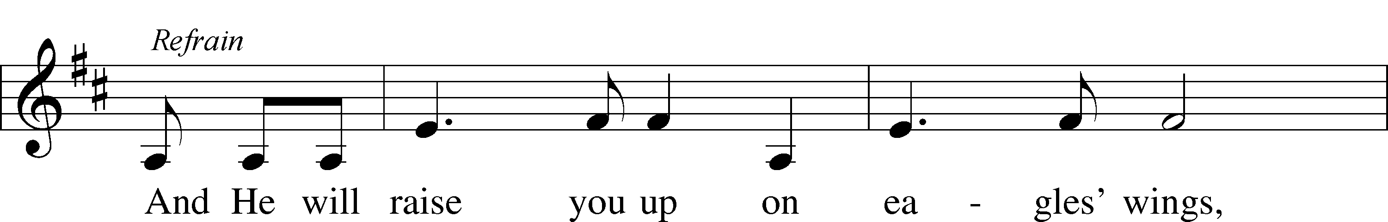
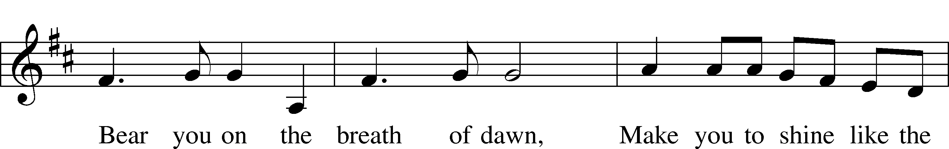
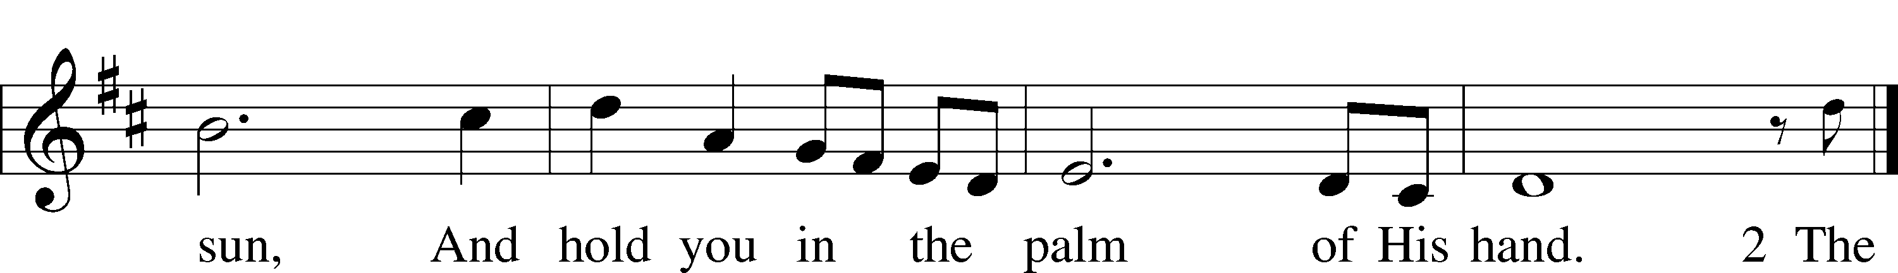
© OCP Publications. Used by permission: LSB Hymn License .NET, no. 100011641.
“O Christ, Who Called the Twelve” LSB 856
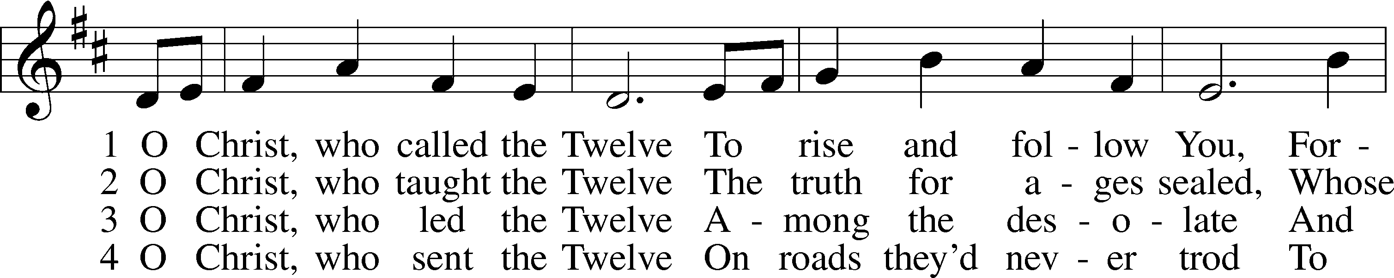
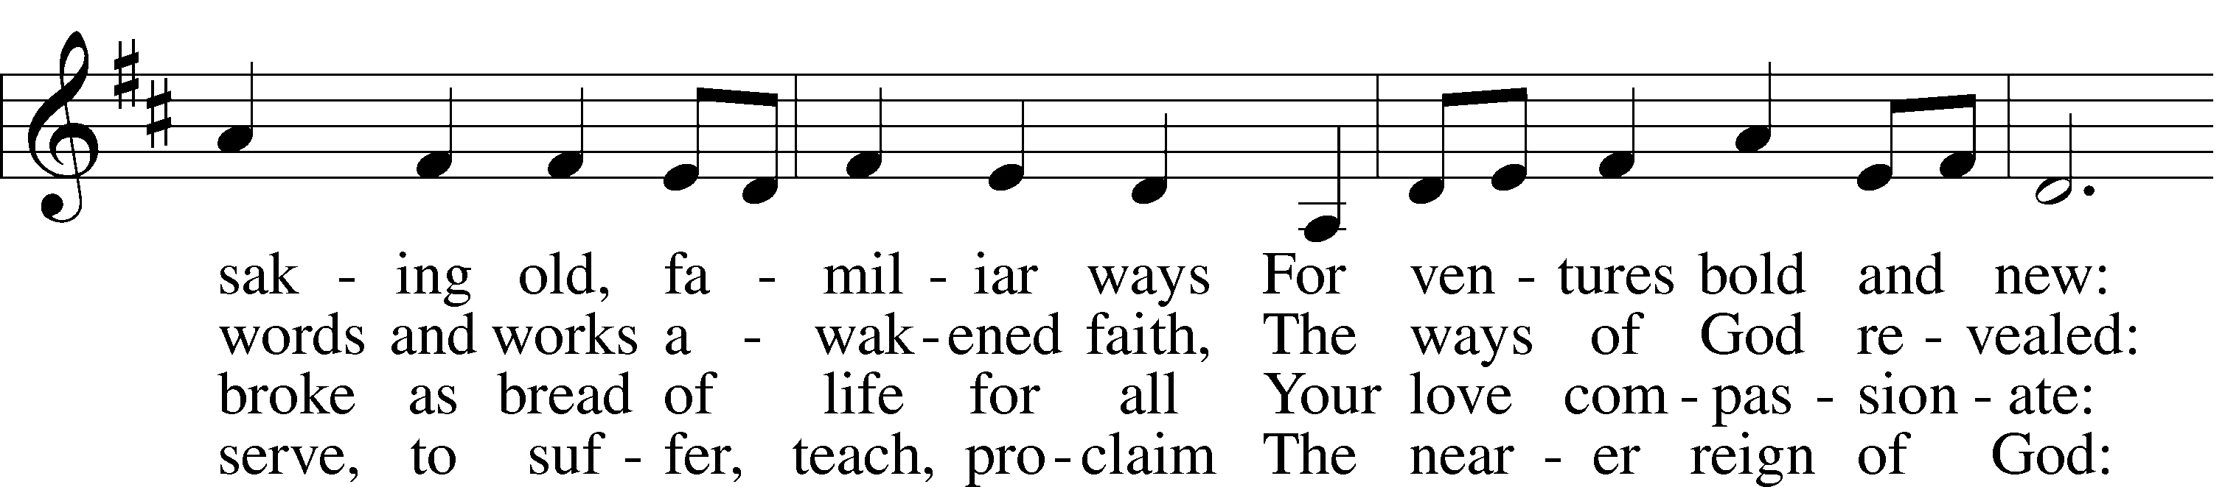
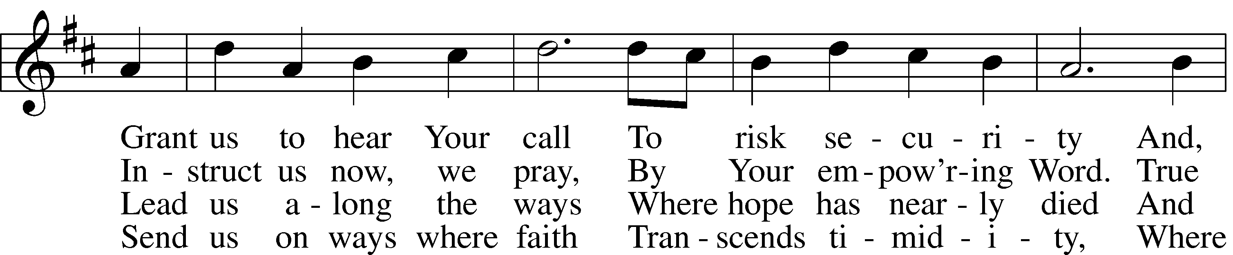
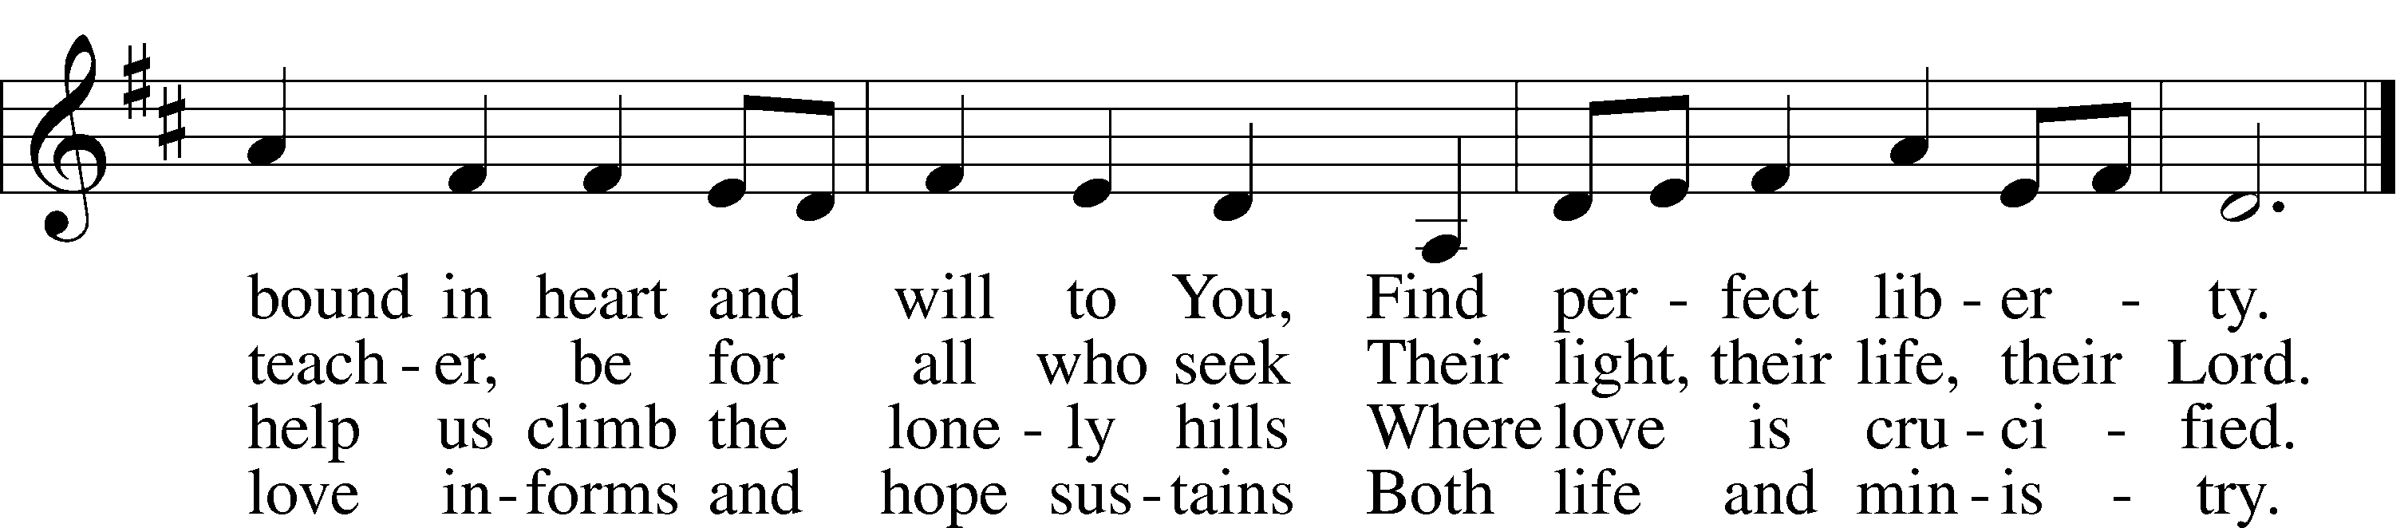
5 O Christ, the_apostles’ Lord,
The martyrs’ strength and song,
The crucified and risen King
To whom the saints belong:
Though generations pass,
Our tribute still we bring,
Our hymns a sacrifice of praise,
Our lives an offering.
© 1993 GIA Publications, Inc. Used by permission: LSB Hymn License .NET, no. 100011641.
Public domain

(Please stand…)
THE LORD’S PRAYER:
All: Our Father, who art in heaven, hallowed be thy name, thy kingdom come, thy will be done, on earth as it is in heaven. Give us this day our daily bread; and forgive us our trespasses as we forgive those who trespass against us; and lead us not into temptation, but deliver us from evil. For thine is the kingdom, and the power, and the glory, forever and ever. Amen.

THE BENEDICTION

THE CLOSING HYMN: “Sent Forth by God's Blessing” LSB 643
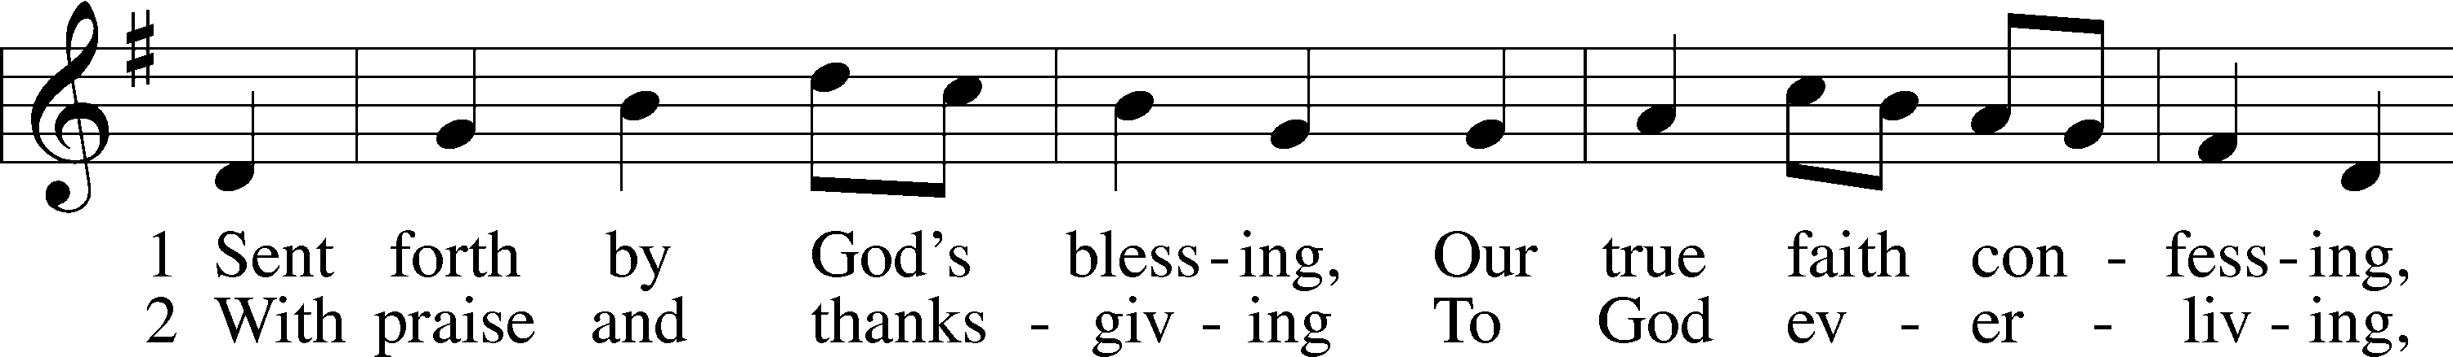
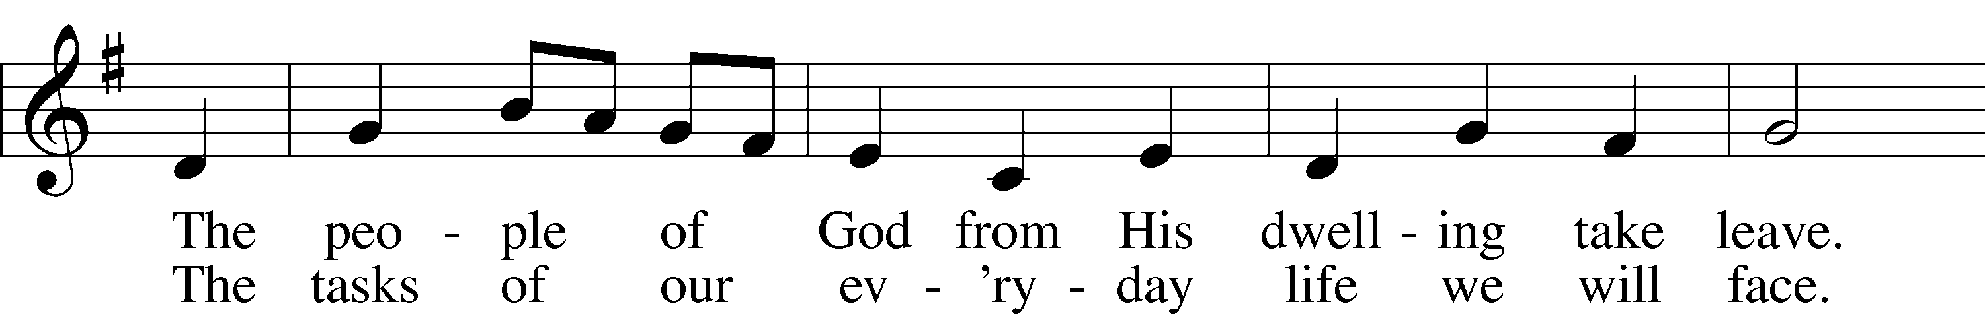
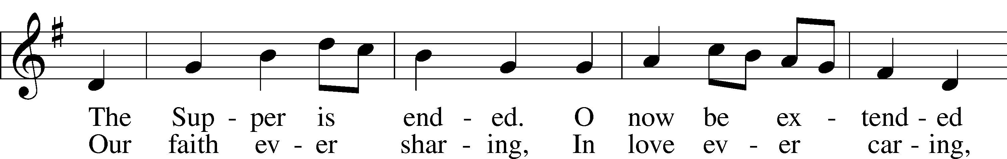
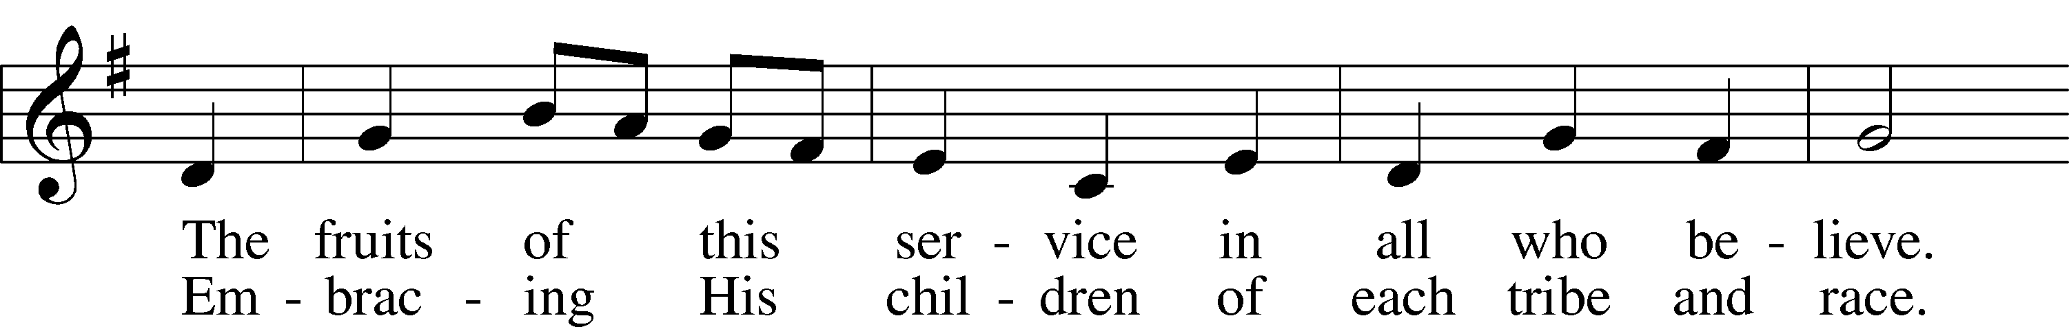
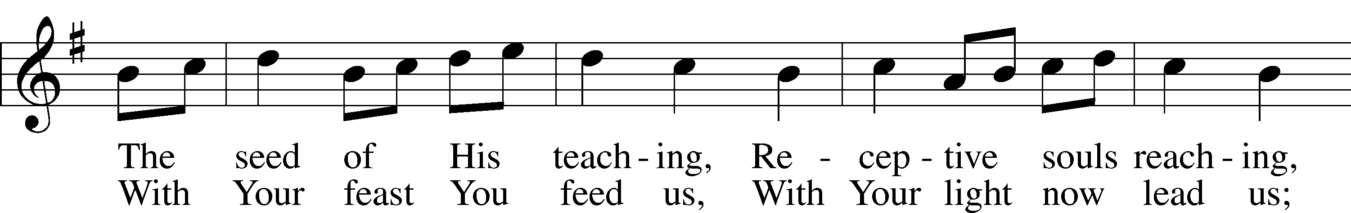
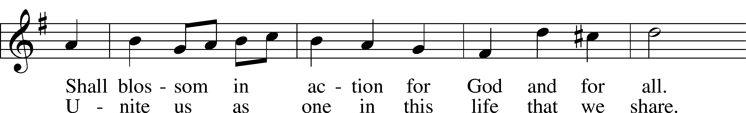
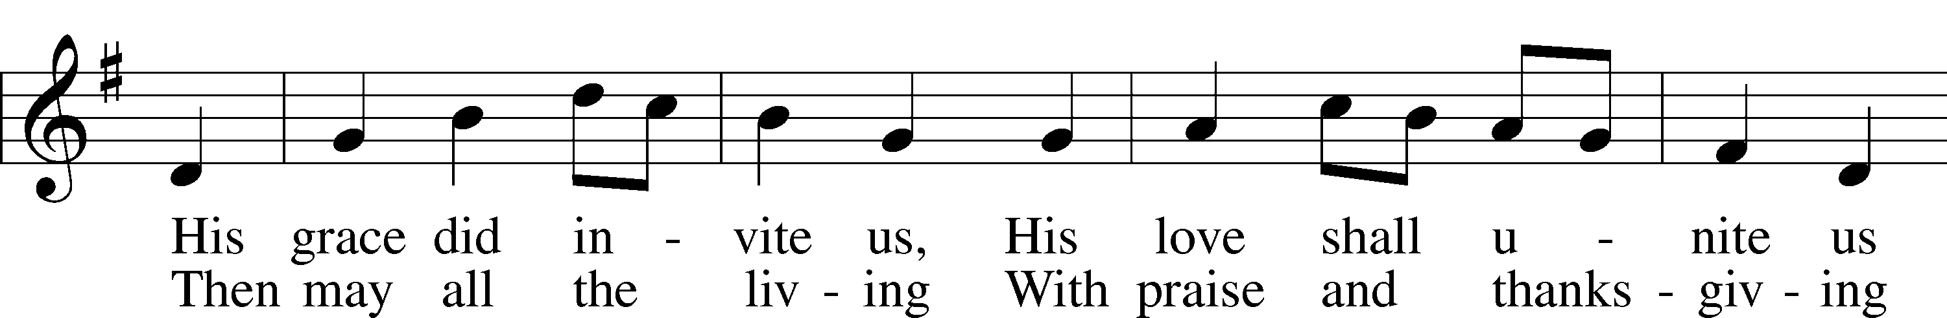
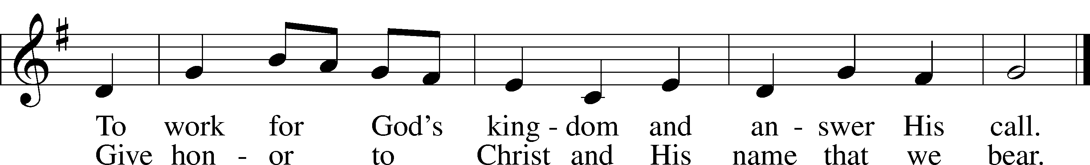
© 1964 World Library Publications. Used by permission: LSB Hymn License .NET, no. 100011641. Public domain

ANNOUNCEMENTS

WELCOME TO GRACE LUTHERAN CHURCH: We are glad that you are here to worship God with us today! We pray that you will enjoy the wonderful fellowship as friends in Christ as God gathers us around His means of grace, the Word and Sacraments, to bless us with His treasured gifts of forgiveness, faith, abundant life and eternal salvation. If you are a guest, please also sign our Guest Book. Please talk to Pastor if you would like to learn more about becoming a member of Grace. Also, please join us for refreshments and fellowship after the Service. We invite you to come and worship with us often as God gathers us in His Grace.

WELCOME TO THE LORD’S TABLE: We invite and encourage all present who are baptized and faithful Christians, and who confess the Father, Son, and Holy Spirit to be the only true God and who believe that Jesus Christ died for the sins of the World and is our only hope and salvation…to join us in receiving the very and true body and blood of Christ in this Sacrament. The clear liquid cups in the center of the tray are non-alcoholic wine.

Children not yet confirmed in the faith are always welcome to join their parents at the Lord’s Table, but should keep their hands folded in front of them. The Pastor will give them a blessing.

SERVING TODAY: Acolyte: Elizabeth Reynolds; Lector: David Walker; Communion Assistant: Vince Winters and Max Broadbent; Usher: Ed Morris; Altar Care: _________; Refreshments: The Oster Family.

SERVING NEXT SUNDAY: Acolyte: James Reynolds; Lector: Jessy Archer; Communion Assistants: Vince Winters and Max Broadbent; Usher: Ed Morris; Altar Care: __________; Refreshments: _______________.

FLOWERS: were placed on the alter to the glory of God for His many blessings.

“What are we doing that nobody else is doing to reach people that nobody else is reaching?”

THIS WEEK AT A GLANCE:
Today: January 22nd
9:00 am Worship Service with Communion
10:10 am Children’s Vocal and Chime Choir Rehearsal
10:15 am Fellowship/Refreshments
10:30 am Adult Bible Class/Children’s Sunday School

Monday: January 23rd
Pastor’s Day Off
5:30 pm Zumba

Tuesday: January 24th
3:00 pm Jan’s Mobile Gym
6:00 pm Weight Watcher’s (Parish Hall)

Wednesday: January 25th
4:15 pm Jr. Confirmation Class
5:45 pm Hand Bell Choir Rehearsal
6:30 pm Vocal Choir Rehearsal

Thursday: January 26th
7:00 pm Missional Communities (Room 3)

Next Sunday: January 29th
9:00 am Worship Service with Communion
10:10 am Children’s Vocal and Chime Choir Rehearsal
10:15 am Fellowship/Refreshments
10:30 am Adult Bible Class/Children’s Sunday School

IN YOUR PRAYERS THIS WEEK: Ted Baird, Walt Lepperd, Family and friends of Will Plagens, Kay Sattelmeier, Megan Schoepf, family of Rev. Alfred Schubert II, Dennis Julson, Vernon Julson, Olga Odland, Jean Grafsgaard, Jenie Howard, Jenny Dean, Katie Higgs Wyrwicki, George Licis, Kathy Wickers and family, Charles, Braydon, Champ, Amy, Elsie Hamilton, Nancy Amling, Sharon Jardas, Mary Ellen Jessel, Marcos Diaz, Kaci Doran, Auwina Weed, Sandy Harris, and those you are praying for at home. If anyone has a special prayer request please submit it in writing in the collection plate; or you may call Pastor Gary Faith at (504-858-8872), or Kris Howard at (305-296-5161).
GIFTS, TITHES, & ATTENDANCE LAST SUNDAY for January 15th were $3012.00 with an attendance of 74 and the noise offering received was $56.16.

TO HELP US GROW… The Bible readings for next Sunday’s service readings are Micah 6:1-8, 1 Corinthians 1:18-31, and Matthew 5:1-12.

THANK YOU TO ALL my brothers and sisters in Christ for all your prayers and support to my husband and me during a very needed time. He went to his heavenly home with our Lord in heaven rejoicing. Thank you Pastor for being there, Noelle Plagens

WE HAVE SET THE SCHEDULES for ushers, acolytes, lectors, and communion assistants for the 1st three months. If you would like to serve in any of these positions, please let Pastor or Kris know.

STEWARDSHIP LISTS: On the bulletin board by the front door of the church you will find the Altar Care, Refreshments, and Flower sign-up sheets for 2017. If you are able to help out with any of these please place your name in the spot on the date requested.

IF ANYONE IS INTERESTED IN TAKING THE ADULT INFORMATION CLASS because they want to know more about what we teach/believe and/or might be interested in membership please let pastor or Kris know.

SOME DATES TO MARK ON YOUR CALENDAR

THE GRACIOUS LADIES OF GRACE: The Gracious Ladies of Grace dined Italian style at Roostica's pizzeria on Tuesday. Entrees included deep dish Sicilian pizza, meat balls and polenta, sausage and peppers, calzone, and beet salad. All very good and beautifully prepared. We will be gathering again on January 31st at Spencer's at the Reach Resort at 11:30. This is the best ocean front table on the island so don't miss it ladies.

STAINED GLASS WINDOWS: We only have 9 clear glass impact windows in the bathrooms and front entry, and the two side entry doors that need to be replaced. When those are completed, the entire church will be protected with hurricane proof, impact windows. The cost of the windows is roughly $2000.00 each depending on size. Thank you, donors of the stained-glass windows and to all those who have contributed to the building fund for this project. Your generous giving is much appreciated

THE GRACE LUTHERAN CHURCH WEB PAGE AND FACE BOOK PAGE now contains a vocal recording of last week’s sermon. So, if you are not able to attend church on Sunday please go to our website where you will find a copy of the bulletin and a recording of Pastor Faith’s sermon. https://gracelutherankw.360unite.com/home.

A NUMBER OF CAPITAL IMPROVEMENTS are needed to keep our facilities in good health for the future. Roof repairs are needed on school buildings and the parsonage. If you can help it would be much appreciated! A big thanks to all who
have contributed to these repairs.

SUNDAY SCHOOL: Sunday school for all ages will follow refreshments from 10:30 until 11:30 in the following rooms.

High school with Pastor Dart is in room number 1 (just past the adult Bible study room on the right)

Middle school, 6th 7th and 8th grades, in room number 3 with Mike Sattelmeier and Jim Schuetzler. (Turn left down the school hallway to the first room).

3rd, 4th and 5th grades in room 5 with Don and Kris Bly. (third room left down the school hallway).

Preschool through second grade with JoAnn Broadbent in room 7. (Last room on the left down the school hallway)

Hope to see everyone there! Any questions? Ask Kris Bly, Sunday School director, 305-509-1447 or Kris Howard, church Secretary.

IF YOU ARE INSTRUMENTALLY INCLINED and would like to share your talents with an instrument during our services or accompany our organist and/or choir, please speak to our organist Debbie Schuetzler.

MUSIC MINISTRY: "Make a joyful noise to the Lord, all the earth!" Psalm 100:1. Whether you are here year-round or only part-time, we invite you to participate in our music ministry. Please speak with Beverly Walker or contact her with any questions at beverlywalker@gmail.com .

Children's Choir - Rehearsal today from 10:10 - 10:25 am.

Bell Choir: Rehearsal on Wednesday from 5:45 - 6:30 pm.

Vocal Choir: Rehearsal on Wednesday 6:30 - 7:30 pm.

MEN’S BIBLE FELLOWSHIP: They meet the first and third Wednesday’s of each month at 12:30pm. Their next meeting will be February 1st located at Chico’s on Stock Island. All guys are welcome.

MISSIONAL COMMUNITES will meet this Thursday at 7pm in Classroom 3.

WOMEN’S BIBLE STUDY: The Ladies Bible Study will begin again on February 8th at 4:30pm in classroom 3. We will enjoying the a book by Tish Harrison Warren titled Liturgy of the Ordinary. She states that "God is near in overlooked moments and routines, we can become aware of God's presence in surprising ways. How do we embrace the sacred in the ordinary and the ordinary in the sacred? Come discover the holiness of your every day." If there questions please contact Monica Bacle 305 923-0856
BBQ with Pastor Tilahun Mendendo

