January 15th, 2017
9:00 am

SECOND SUNDAY AFTER
THE EPIPHANY

Grace Lutheran Church
2713 Flagler Ave.
Key West, FL 33040
305-296-5161
GraceLutheranKW@att.net
Pastor Faith
(504) 858-8872
garyfaith@aol.com

SECOND SUNDAY AFTER THE EPIPHANY
JANUARY 15TH, 2017 9:00 a.m.
WORSHIP SERVICE
In the Name of Jesus!
Our Mission Statement: Anchored in Christ, each person a missionary.

GUEST PASTOR: Pastor Tilahun Mendedo

PRELUDE

ANNOUNCEMENTS:
We welcome you. We are glad you are here to share with us the joy and peace we have in Jesus Christ. It doesn’t matter whether this is your first time in this church or if you are a lifelong member, you are welcome. We come together today in order to celebrate the gift God has given us-His own Son, Jesus, Our Savior.

PREPARATION

(Please Stand…)
HYMN: “When I Behold Jesus Christ” LSB 542
This hymn was written by a 16 year old girl, Almaz Belhu, from Ethiopia, and was submitted to a hymn competition where it won first prize. Almaz was writing during a time in the Ethiopian evangelical revival when it was difficult to be a believer. Almaz wrote the tune also, traditionally sung without accompaniment and transcribed from a tape recording. The hymn was translated into English by several professors at the Mekane Yesus Seminary in Addis Ababa, sometime during the late 1970s or early 80s. It has also been translated into Hindi.
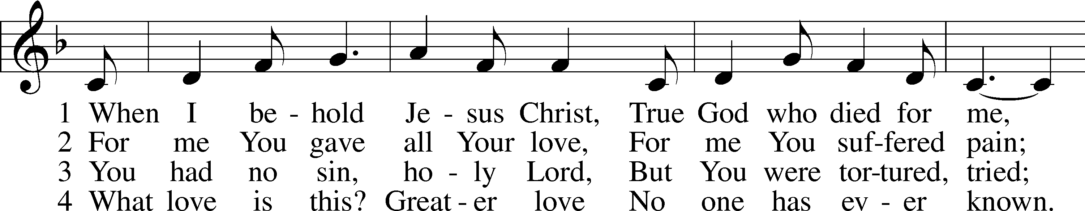
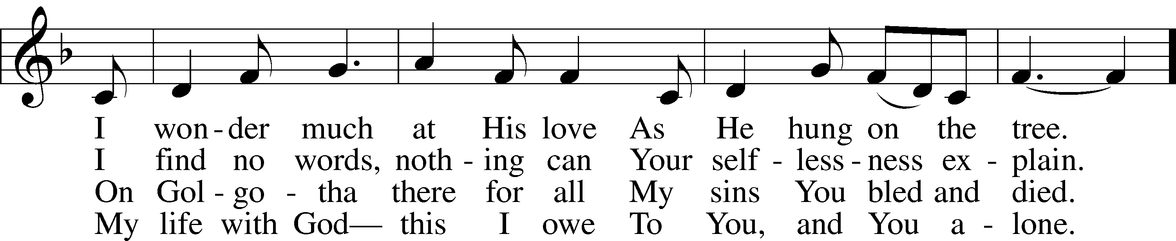
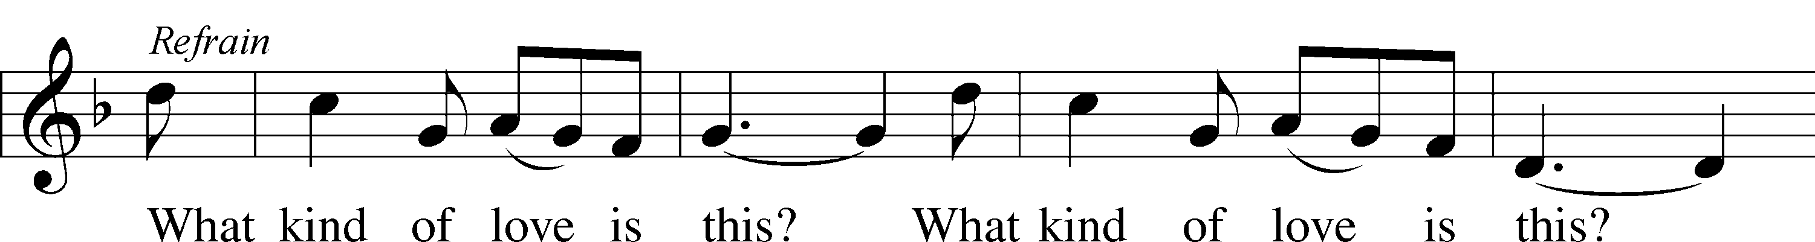
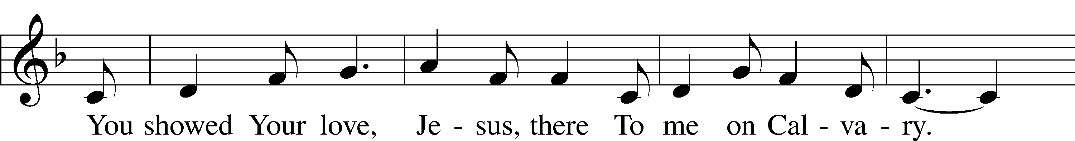
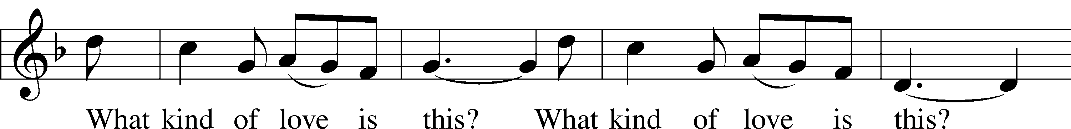
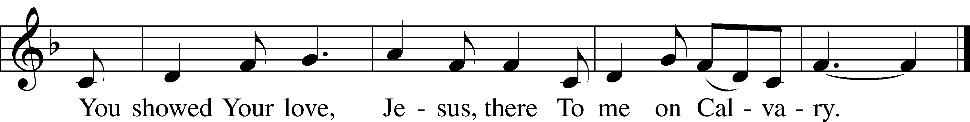
© 1998 Concordia Publishing House. Used by permission: LSB Hymn License .NET, no. 100011641.
© 1970 Ethiopian Evangelical Church Mekane Yesus. Used by permission: LSB Hymn License .NET, no. 100011641.

Pastor: In the Name of the Father and of the Son and Holy Spirit.
Congregation: Amen.

(Please Remain Standing Or You May Kneel…)
GOD’S PEOPLE CONFESS THEIR SINS:
Pastor: By grace you have been saved, through faith-and this is not from yourselves, it is the gift of God-not of works, so that no man can boast, for we are God’s workmanship, created in Christ Jesus.
Congregation: I know that nothing good lives in me, that is, in my sinful nature, for I have the desire to do what is good, but I cannot carry it out.
Pastor: What I do is not the good I want to do; no, the evil I do not want to do-this I keep doing.
Congregation: In my heart I delight in God’s law, the law that points out what a wretched person I am! Who will rescue me from this body of death?
Pastor: Thanks be to God through Jesus Christ our Lord! Only He can achieve the perfection we fail to achieve. By the forgiveness He purchased on the cross, our forgiveness is complete!

SERVICE OF THE WORD

You may be seated…
THE OLD TESTAMENT READING: Isaiah 49:1-7
Lector: This is the Word of the Lord.
People: Thanks be to God.

THE EPISTLE LESSON: 1 Corinthians 1:1-9
Lector: This is the Word of the Lord.
People: Thanks be to God.
Please stand…
THE HOLY GOSPEL: John 1:29-42a
Pastor: The Holy Gospel according to St. John the 1st Chapter
People: Glory to You, O Lord.
Pastor: This is the Gospel of the Lord.
People: Praise to You, O Christ!

Please be seated…
CHILDREN’S MESSAGE

NOISE OFERING

THE SERMON HYMN: “The Lamb” LSB 547
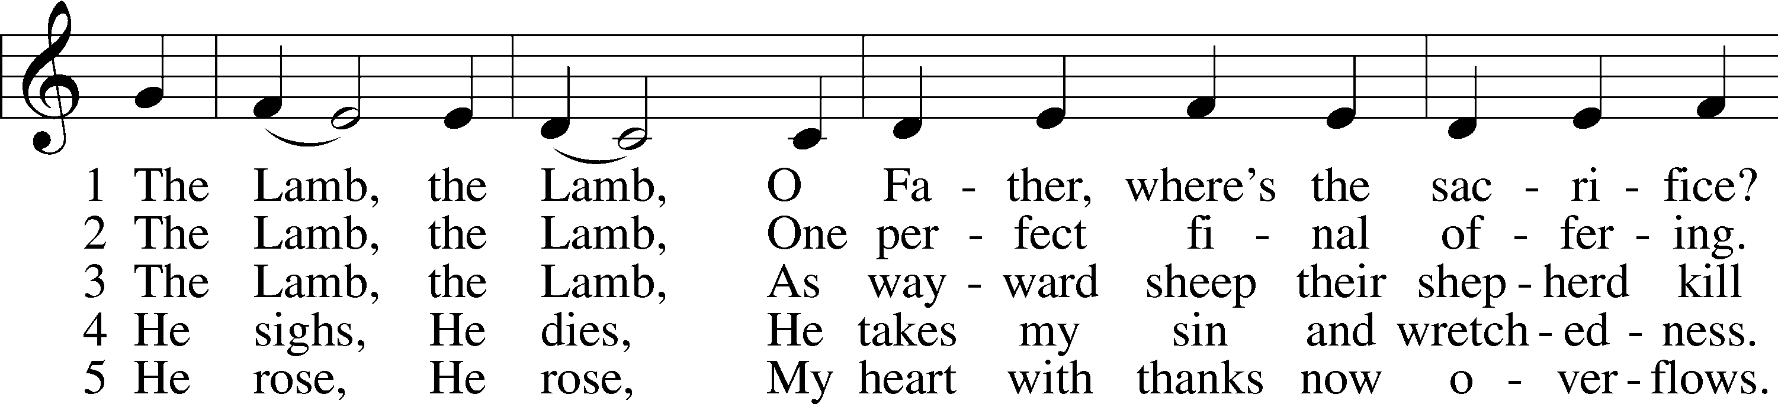
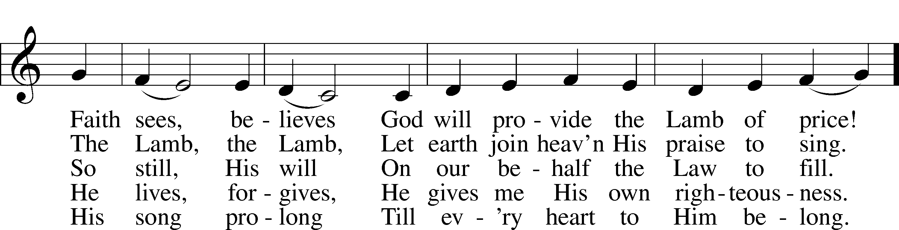
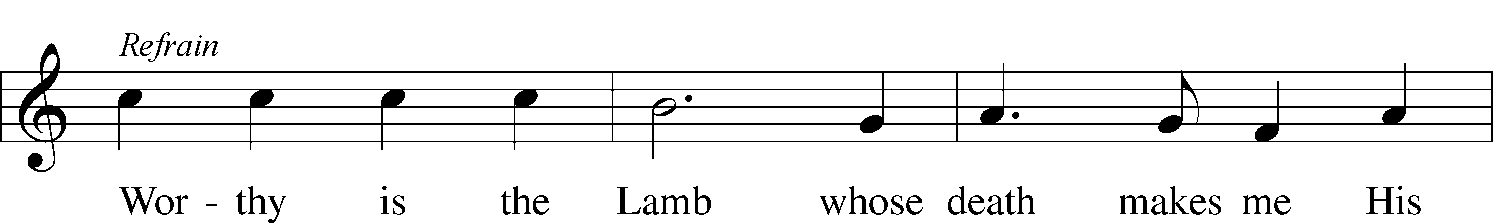
© 1987 and 1997 MorningStar Music Publishers. Used by permission: LSB Hymn License .NET, no. 100011641.

SERMON: “Behold the Lamb of God” Pastor Tilahun Mendedo

THE PROFESSION OF FAITH:
Pastor: God has given us a great message to take to His world. Let us remind ourselves and one another of what that message is:
Pastor: I believe in God the Father, Almighty
Congregation: Maker of heaven and earth
Pastor: And in His Son, Jesus Christ our Lord,
Congregation: Who was conceived by the Holy Spirit
Pastor: Born of the Virgin Mary
Congregation: Suffered under Pontius Pilate
Pastor: Was crucified, died and was buried
Congregation: He descended into hell.
Pastor: On the third day He rose again from the dead,
Congregation: And ascended into heaven
Pastor: And sits on the right hand of God, the Father almighty
Congregation: From there He will come to judge the living and the dead
Pastor: I believe in the Holy Spirit,
Congregation: The Holy Christian Church as
All: the communion of saints; the forgiveness of sins, the resurrection of the body, and the life everlasting. Amen.

(You may be seated…)
OFFERING RECEIVED: “There is a Redeemer” Vocal Choir

“Praise God, from Whom All Blessings Flow” LSB 805
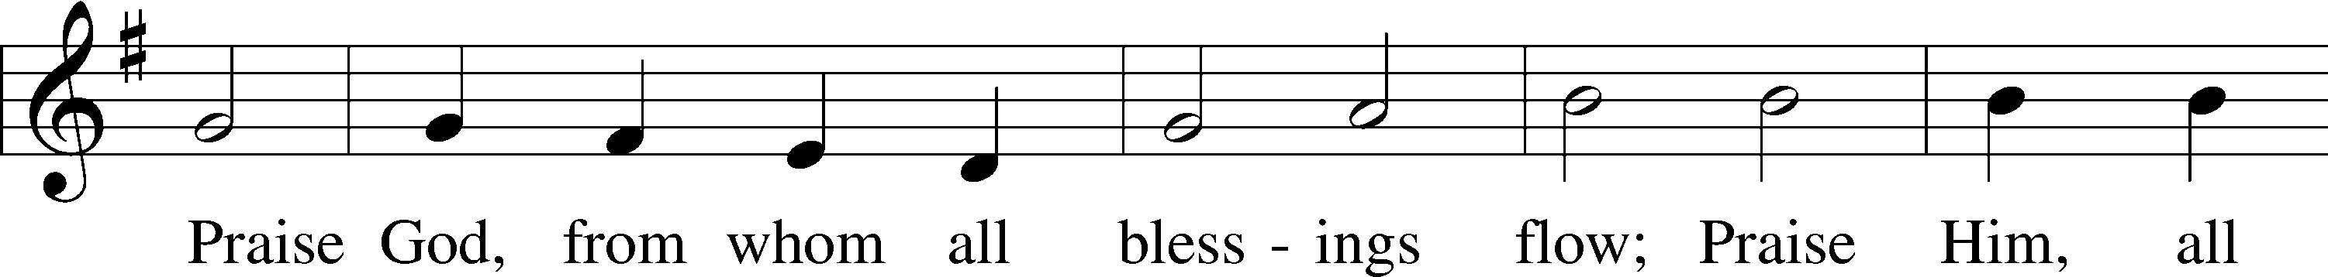
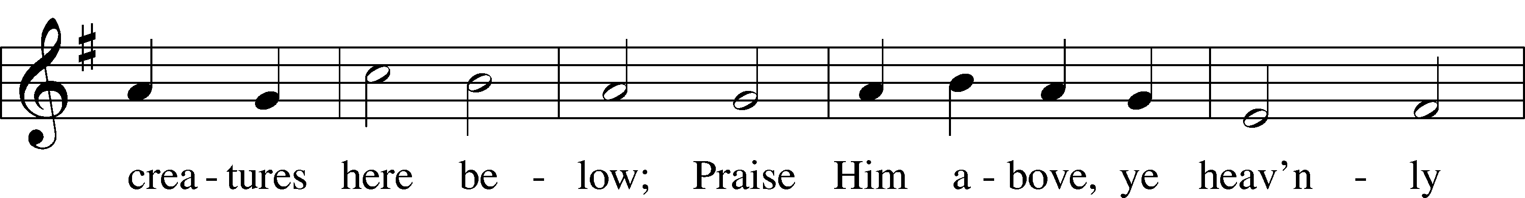
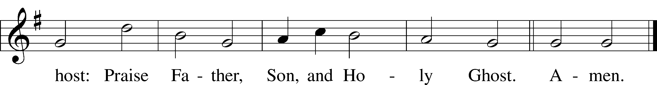
Public domain

(Please stand…)
THE PRAYERS OF THE CHURCH: based on Psalm 98
Pastor: Dear Lord, we thank You for everything You’ve done for us, and most of all for Your own Son, Jesus, our Savior. We will never stop praising You for this wonderful gift.
Congregation: Sing to the Lord a new song, for He has done marvelous things; His right hand and His holy arm have worked salvation for Him.
Pastor: We thank You for those missionaries long ago who brought the Good News to our people. When we were in darkness, You sent men and women to bring us the light. Thank you, Lord.
Congregation: The Lord has made His salvation known and revealed His Righteousness to the nation.
Pastor: O Lord, You are our Savior, we trust in You for all our needs, give healing to the sick, courage to those who are afraid, and peace to those we name in our hearts either silently or out loud. (a moment of silence) We praise You, gracious Lord, for all Your benefits to us. You give us home, friends and family, food, shelter, rest and everything we need. You give us sight and hearing and touch and taste and provide for all of our needs.
Congregation: Shout for joy to the Lord, praise His Name Amen.

SERVICE OF THE SACRAMENT

(Please be seated…)
THE WORDS OF INSTITUTION

DISTRIBUTION HYMNS: “Lord Be Glorified”
Words and Music by Bob Kilpatrick

“Lamb of God” LSB 550
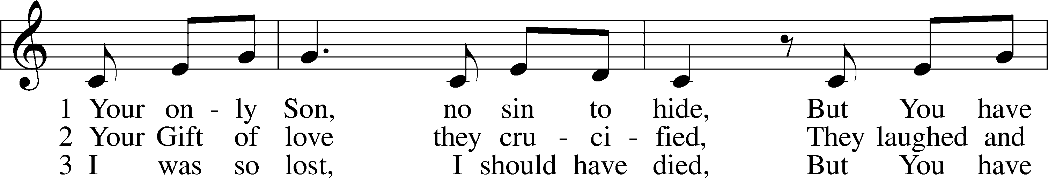
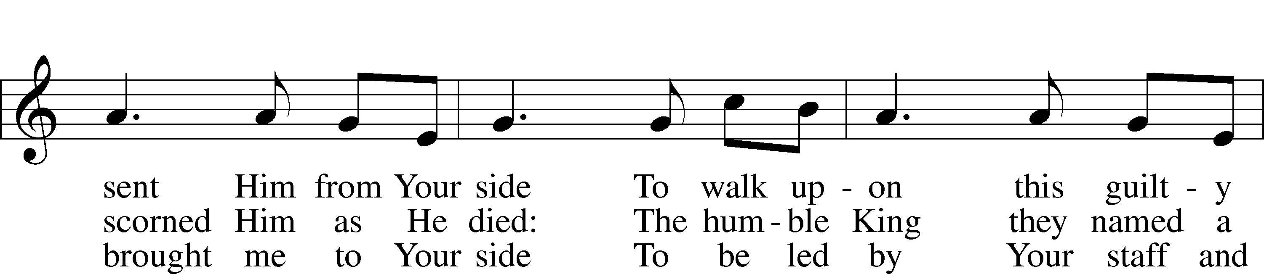
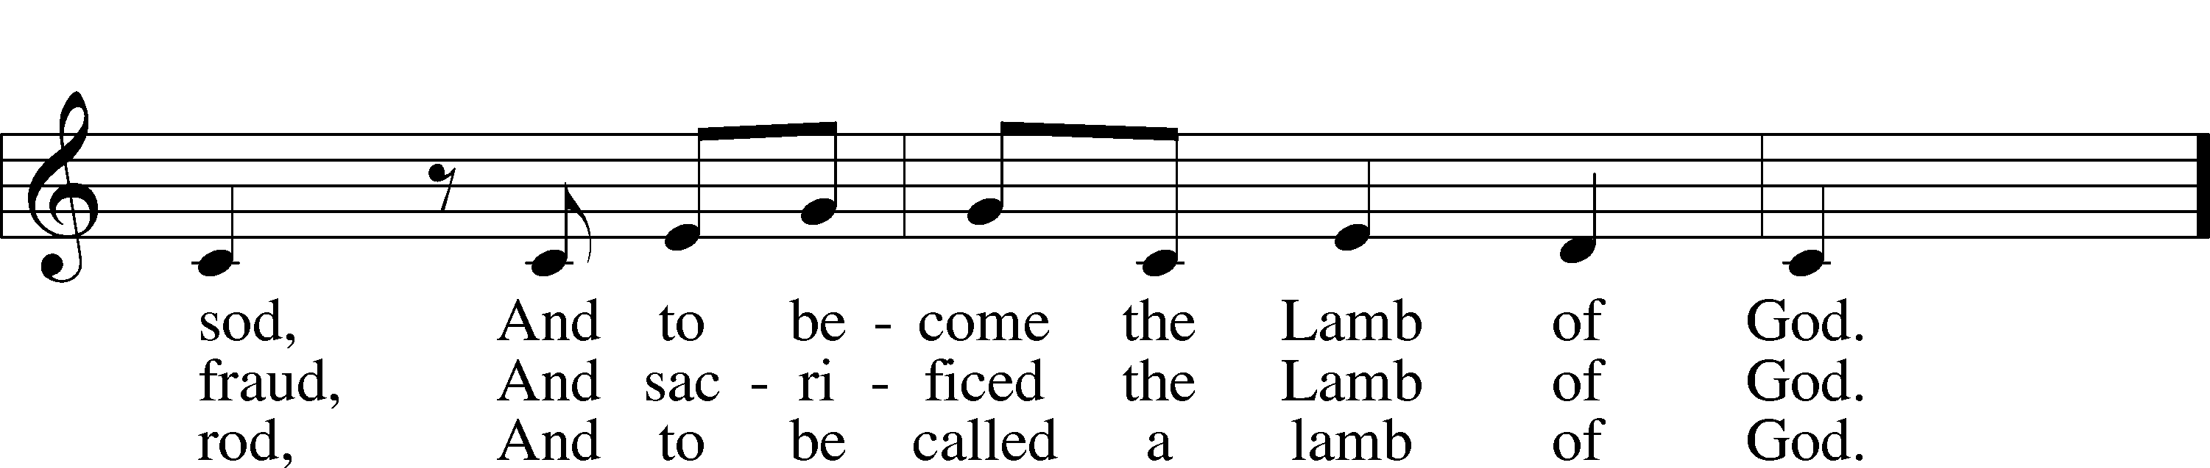
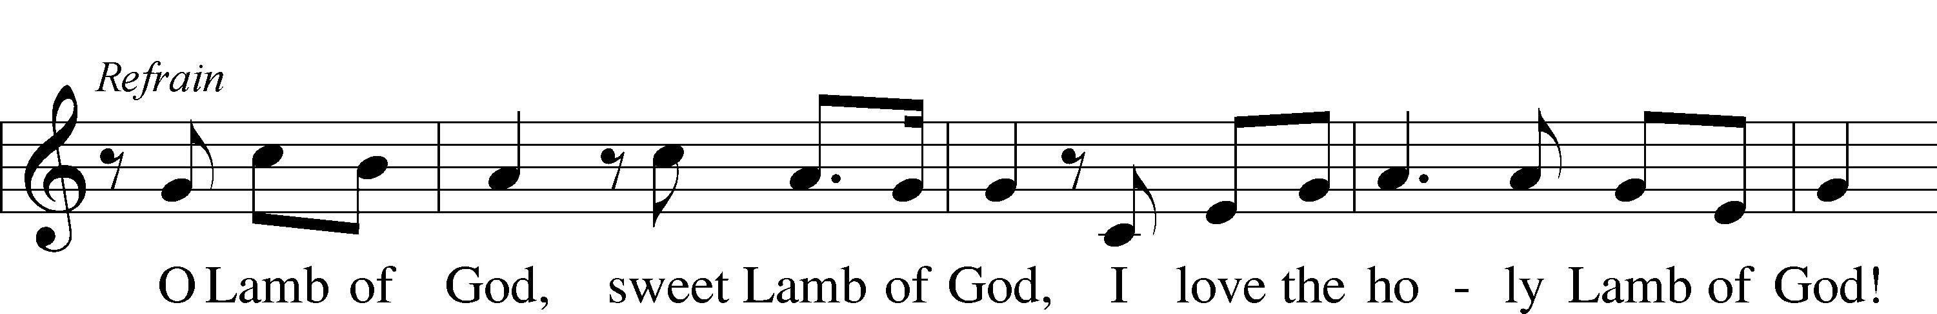
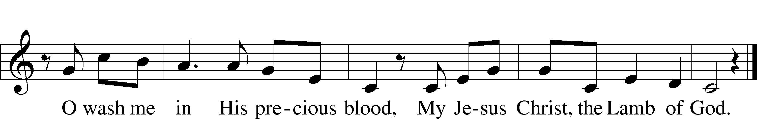
© 1985 Straightway Music; admin. EMI . Used by permission: LSB Hymn License .NET, no. 100011641.

“Hark, the Voice of Jesus Calling” LSB 827
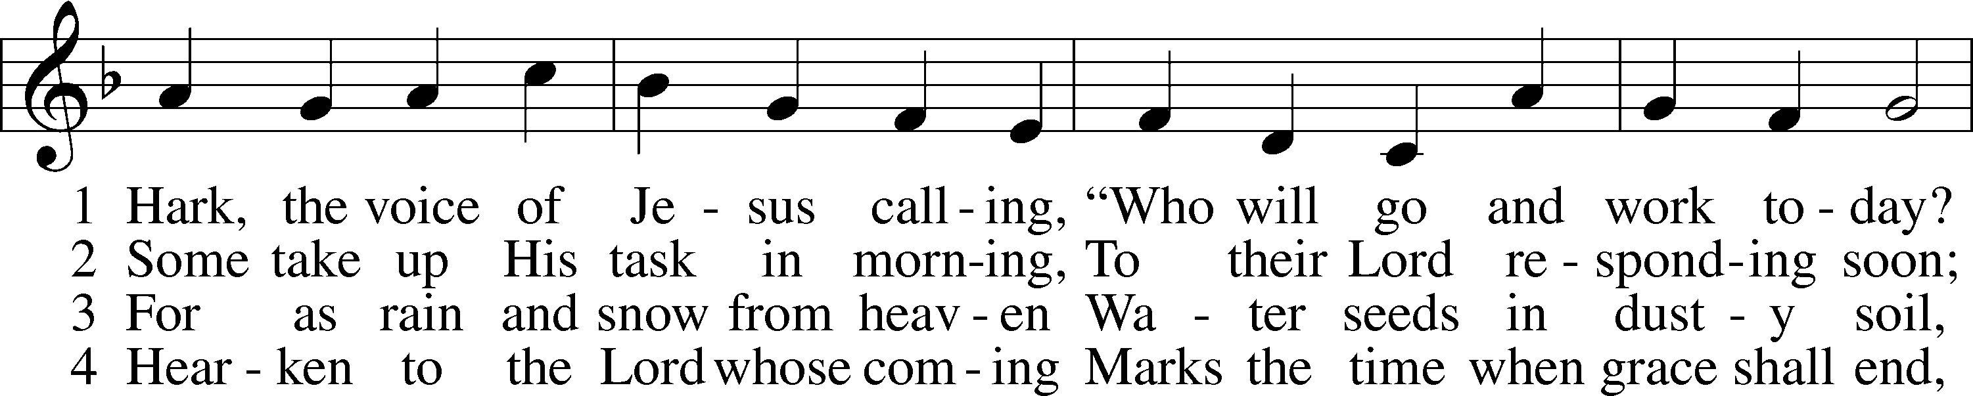
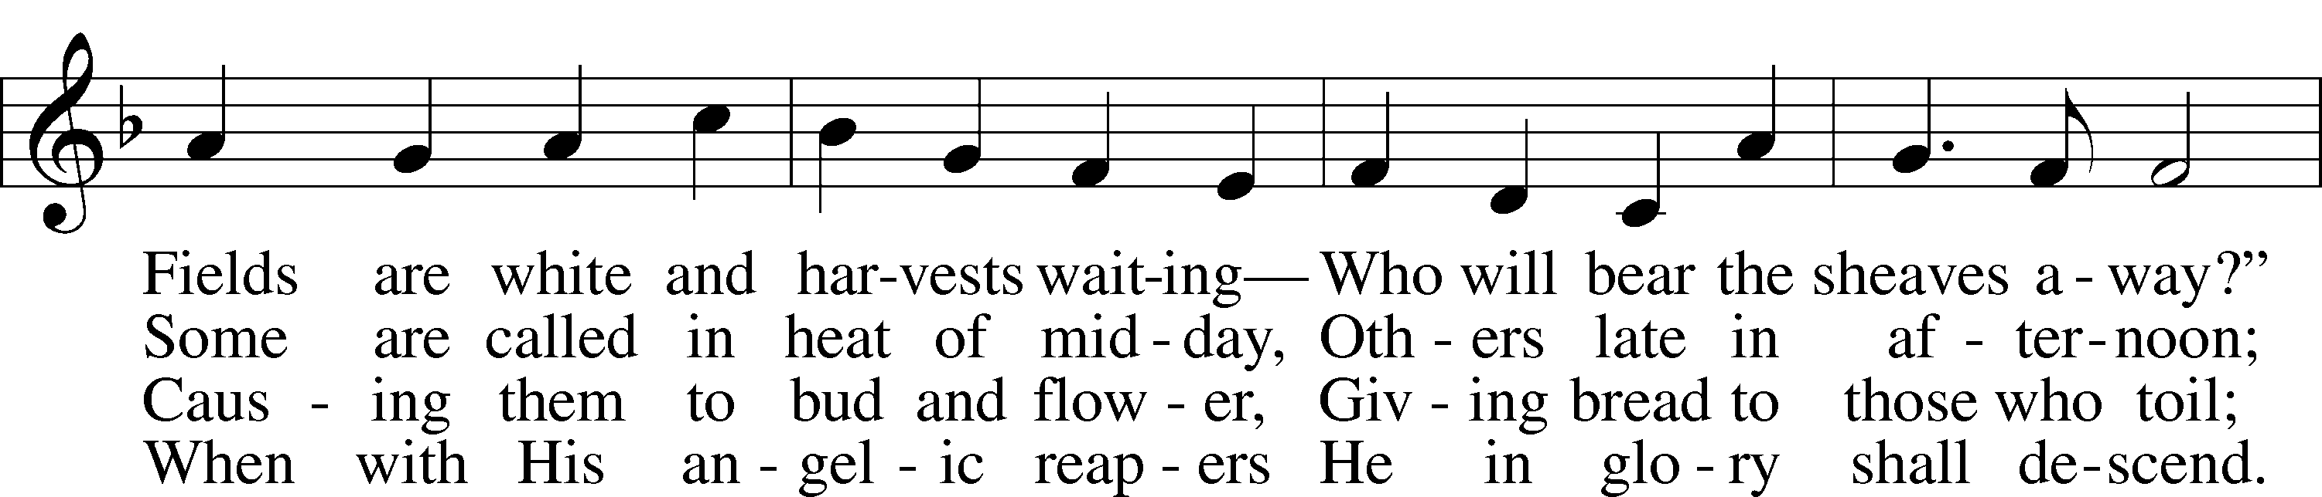
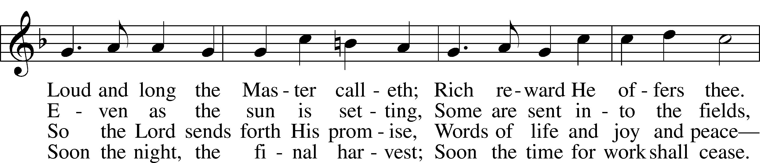
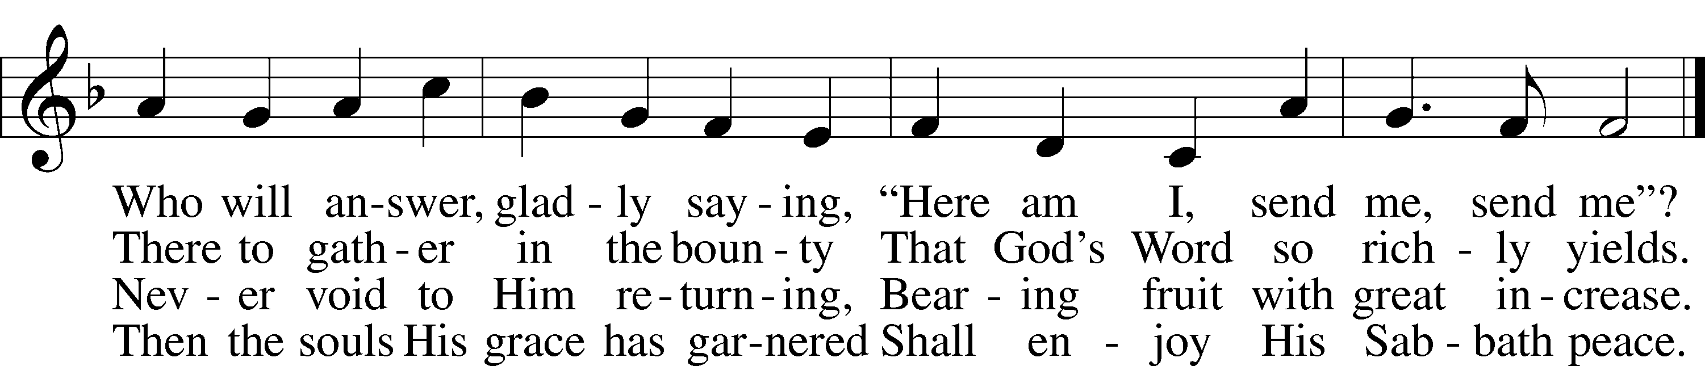
© 2001 Stephen P. Starke. Used by permission: LSB Hymn License .NET, no. 100011641.
Public domain

“Christ, the Word of God Incarnate” LSB 540
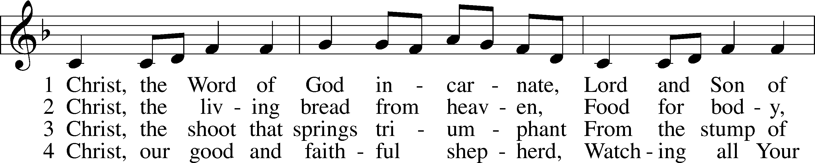
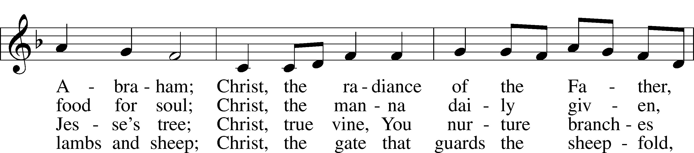
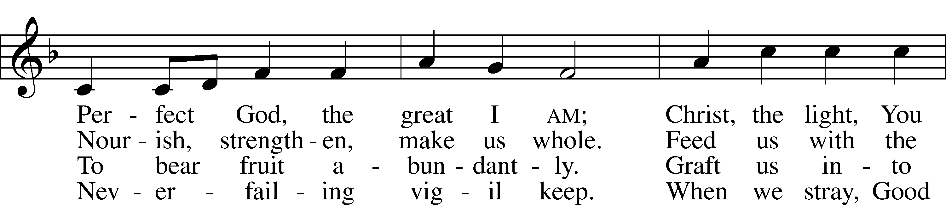
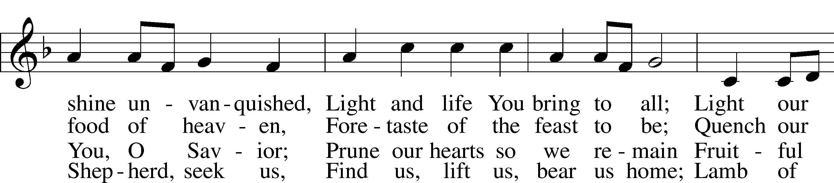
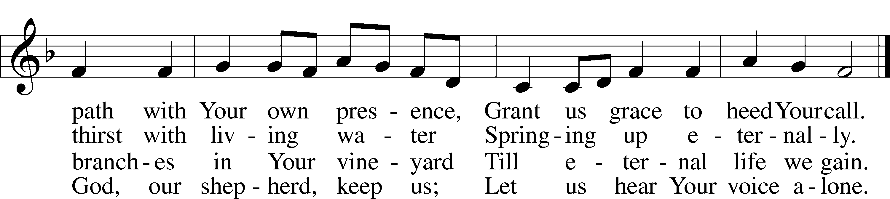

5 Christ, the way that leads unfailing
To the Father’s home on high,
Christ, the truth that frees the captive,
Christ, the life that cannot die.
Mediator to the Father,
Sacrifice and great High Priest:
Lead us to Your heav’nly mansions,
There to share Your wedding feast.

6 Christ, the Alpha and Omega,
Christ, the firstborn from the dead,
Christ, the life and resurrection,
Christ, the Church’s glorious head:
Praise and thanks and adoration
And unending worship be
To the Father and the Spirit
And to You eternally.
© 2001 Steven P. Mueller. Used by permission: LSB Hymn License .NET, no. 100011641.
Public domain

Jesus let the things that break your heart
also break our hearts.
Amen

(Please stand…)
THE LORD’S PRAYER:
All: Our Father, who art in heaven, hallowed be thy name, thy kingdom come, thy will be done, on earth as it is in heaven. Give us this day our daily bread; and forgive us our trespasses as we forgive those who trespass against us; and lead us not into temptation, but deliver us from evil. For thine is the kingdom, and the power, and the glory, forever and ever. Amen

THE BENEDICTION

THE CLOSING HYMN: “Lift High the Cross” LSB 837
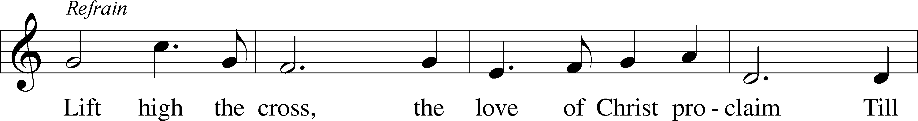
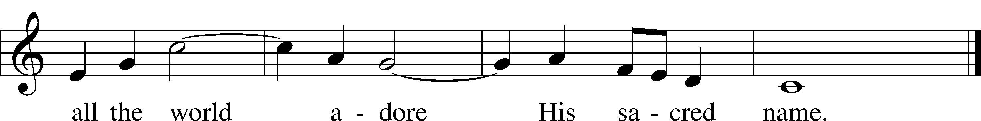
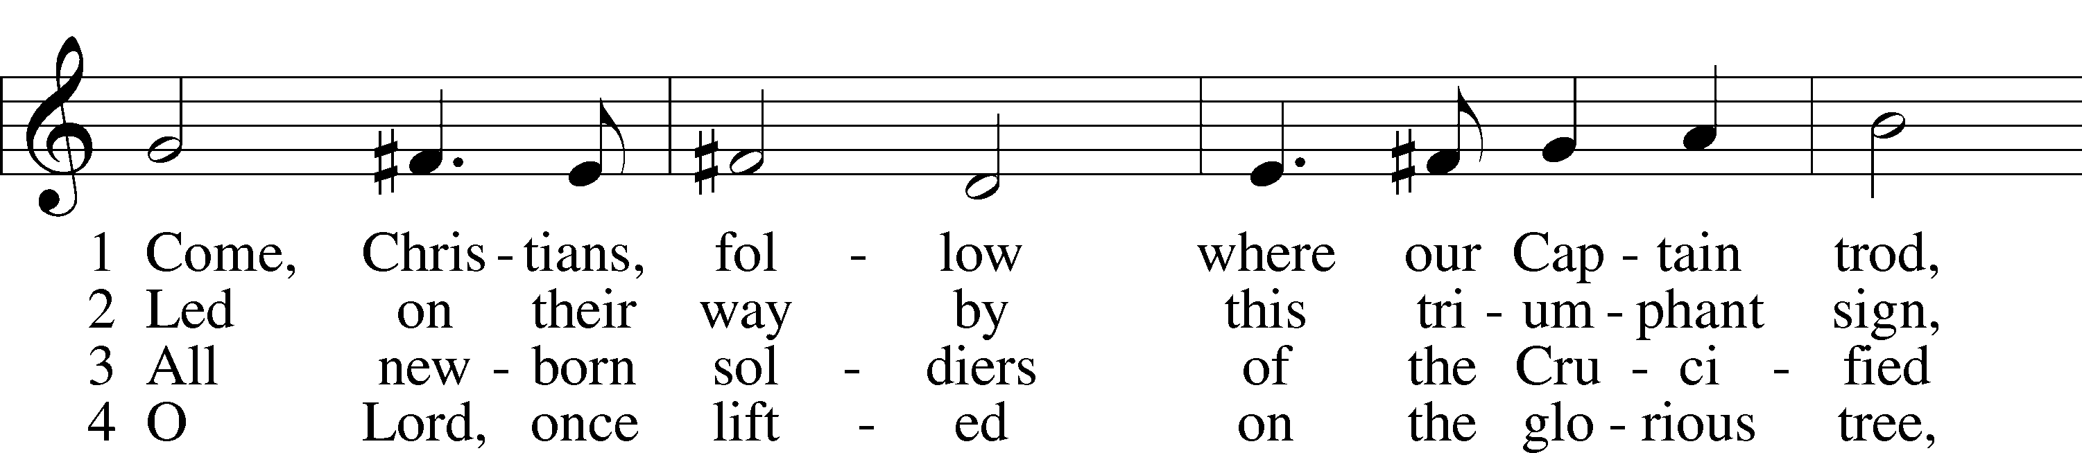
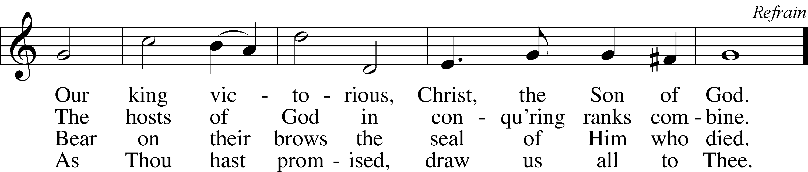
© 1997 Hope Publishing Co. Used by permission: LSB Hymn License .NET, no. 100011641.
© 1974 Hope Publishing Co. Used by permission: LSB Hymn License .NET, no. 100011641.
ANNOUNCEMENTS

WELCOME TO GRACE LUTHERAN CHURCH: We are glad that you are here to worship God with us today! We pray that you will enjoy the wonderful fellowship as friends in Christ as God gathers us around His means of grace, the Word and Sacraments, to bless us with His treasured gifts of forgiveness, faith, abundant life and eternal salvation. If you are a guest, please also sign our Guest Book. Please talk to Pastor if you would like to learn more about becoming a member of Grace. Also, please join us for refreshments and fellowship after the Service. We invite you to come and worship with us often as God gathers us in His Grace.

WELCOME TO THE LORD’S TABLE: We invite and encourage all present who are baptized and faithful Christians, and who confess the Father, Son, and Holy Spirit to be the only true God and who believe that Jesus Christ died for the sins of the World and is our only hope and salvation…to join us in receiving the very and true body and blood of Christ in this Sacrament. The clear liquid cups in the center of the tray are non-alcoholic wine.

Children not yet confirmed in the faith are always welcome to join their parents at the Lord’s Table, but should keep their hands folded in front of them. The Pastor will give them a blessing.

SERVING TODAY: Acolyte: Lillian Howard; Lector: Mike Sattelmeier; Communion Assistant: Vince Winters and Max Broadbent; Usher: Ed Morris; Altar Care: _________; Refreshments: ______________

SERVING NEXT SUNDAY: Acolyte: Elizabeth Reynolds; Lector: David Walker; Communion Assistants: Vince Winters and Max Broadbent; Usher: Ed Morris; Altar Care: __________; Refreshments: _______________.

FLOWERS: were placed on the alter to the glory of God for His many blessings.

“What are we doing that nobody else is doing to reach people that nobody else is reaching?”

THIS WEEK AT A GLANCE:
Today: January 15th
9:00 am Worship Service with Communion
10:10 am Children’s Vocal and Chime Choir Rehearsal
10:15 am Fellowship/Refreshments
10:30 am Adult Bible Class/Children’s Sunday School

Monday: January 16th
Pastor’s Day Off
5:30 pm Zumba

Tuesday: January 17th
11:30 am Gracious Ladies of Grace Luncheon (Roostica)
3:00 pm Jan’s Mobile Gym
6:00 pm Weight Watcher’s (Parish Hall)

Wednesday: January 18th
12:30 pm Men’s Bible Fellowship (Chico’s)
5:45 pm Hand Bell Choir Rehearsal
6:30 pm Vocal Choir Rehearsal

Thursday: January 19th
7:00 pm Missional Communities (Room 3)

Next Sunday: January 22^{thnd}
9:00 am Worship Service with Communion (with Pastor Tilahun)
10:10 am Children’s Vocal and Chime Choir Rehearsal
10:15 am Fellowship/Refreshments
10:30 am Adult Bible Class/Children’s Sunday School

IN YOUR PRAYERS THIS WEEK: Walt Lepperd, Family and friends of Will Plagens, Kay Sattelmeier, Megan Schoepf, family of Rev. Alfred Schubert II, Dennis Julson, Vernon Julson, Olga Odland, Jean Grafsgaard, Jenie Howard, Jenny Dean, Katie Higgs Wyrwicki, George Licis, Kathy Wickers and family, Charles, Braydon, Champ, Amy, Elsie Hamilton, Nancy Amling, Sharon Jardas, Mary Ellen Jessel, Marcos Diaz, Kaci Doran, Auwina Weed, Sandy Harris, and those you are praying for at home. If anyone has a special prayer request please submit it in writing in the collection plate; or you may call Pastor Gary Faith at (504-858-8872), or Kris Howard at (305-296-5161).
GIFTS, TITHES, & ATTENDANCE LAST SUNDAY for Saturday December 31st $2758.00 with an attendance of 71, the building fund received $10.00, and the combined noise offering received will be listed in next weeks bulletin.

TO HELP US GROW… The Bible readings for next Sunday’s service readings are Isaiah 9:1-4, 1 Corinthians 1:10-18, and Matthew 4:12-25.

PASTOR TILAHUN WILL BE PREACHING at our worship service today and presenting on the Master Builder Center during our Bible class time – Pastor Tilahun has been serving as a missionary from Ethiopia to the USA for over 10 years. We thank God for his ministry among us and to our country.

THANK YOU TO ALL my brothers and sisters in Christ for all your prayers and support to my husband and me during a very needed time. He went to his heavenly home with our Lord in heaven rejoicing. Thank you Pastor for being there, Noelle Plagens

THANK YOU everyone that could help with the ungreening of our church. If you were not able to be there Jeanette Dart was able to take some photos and you can see them on our website.

PASTOR AND PATTIE WILL BE OUT OF TOWN Thursday through Sunday morning. The plan is to return in time for worship. If you have needs contact one of our elders.

THANKS TO ALL who joined us for the BBQ yesterday. We have some great cooks in the congregation. Desserts, salads, and other sides…top notch. We hope you enjoyed getting to better know your fellow missionary.a

WE HAVE SET THE SCHEDULES for ushers, acolytes, lectors, and communion assistants for the 1st three months. If you would like to serve in any of these positions, please let Pastor or Kris know.

STEWARDSHIP LISTS: On the bulletin board by the front door of the church you will find the Altar Care, Refreshments, and Flower sign-up sheets for 2017. If you are able to help out with any of these please place your name in the spot on the date requested.

IF ANYONE IS INTERESTED IN TAKING THE ADULT INFORMATION CLASS because they want to know more about what we teach/believe and/or might be interested in membership please let pastor or Kris know.

SOME DATES TO MARK ON YOUR CALENDAR

THE GRACIOUS LADIES OF GRACE: dined in a 4* restaurant at the Shor Restaurant at the Hyatt Resort on Tuesday. We had the whole dining room and wait person to ourselves. Everyone just loved it. The food was fab, and the atmosphere was one of ocean, blue skies, and I want to be on vacation in this tropical isle. Crab cakes, fish tacos, and black grouper sandwiches were the fare of the day. There wasn't one complaint to be heard. The only thing missing were the ladies who couldn't attend. The next great dining event will be on January 17th at 11:30 at Roostica in downtown Stock Island. Everyone is welcome.

STAINED GLASS WINDOWS: We only have 9 clear glass impact windows in the bathrooms and front entry, and the two side entry doors that need to be replaced. When those are completed, the entire church will be protected with hurricane proof, impact windows. The cost of the windows is roughly $2000.00 each depending on size. Thank you, donors of the stained-glass windows and to all those who have contributed to the building fund for this project. Your generous giving is much appreciated

THE GRACE LUTHERAN CHURCH WEB PAGE AND FACE BOOK PAGE now contains a vocal recording of last week’s sermon. So, if you are not able to attend church on Sunday please go to our website where you will find a copy of the bulletin and a recording of Pastor Faith’s sermon. https://gracelutherankw.360unite.com/home.

A NUMBER OF CAPITAL IMPROVEMENTS are needed to keep our facilities in good health for the future. Roof repairs are needed on school buildings and the parsonage. If you can help it would be much appreciated! A big thanks to all who
have contributed to these repairs.

SUNDAY SCHOOL: Sunday school for all ages will follow refreshments from 10:30 until 11:30 in the following rooms.

High school with Pastor Dart is in room number 1 (just past the adult Bible study room on the right)

Middle school, 6th 7th and 8th grades, in room number 3 with Mike Sattelmeier and Jim Schuetzler. (Turn left down the school hallway to the first room).

3rd, 4th and 5th grades in room 5 with Lynn Jones and Monica Bacle. (third room left down the school hallway).

Preschool through second grade with JoAnn Broadbent in room 7. (Last room on the left down the school hallway)

Hope to see everyone there! Any questions? Ask Kris Bly, Sunday School director, 305-509-1447 or Kris Howard, church Secretary.

IF YOU ARE INSTRUMENTALLY INCLINED and would like to share your talents with an instrument during our services or accompany our organist and/or choir, please speak to our organist Debbie Schuetzler.

MUSIC MINISTRY: "Make a joyful noise to the Lord, all the earth!" Psalm 100:1. Whether you are here year-round or only part-time, we invite you to participate in our music ministry. Please speak with Beverly Walker or contact her with any questions at beverlywalker@gmail.com .

Children's Choir - Rehearsal today from 10:10 - 10:25 am.

Bell Choir: Rehearsal on Wednesday from 5:45 - 6:30 pm.

Vocal Choir: Rehearsal on Wednesday 6:30 - 7:30 pm.

MEN’S BIBLE FELLOWSHIP: They meet the first and third Wednesday’s of each month at 12:30pm. Their next meeting will be January 18th located at Chico’s on Stock Island. All guys are welcome.

MISSIONAL COMMUNITES will meet this Thursday at 7pm in Classroom 3.

