**January 1st, 2016**

**9:00 am**

**CIRCUMCISION**

**AND NAME OF**

**JESUS**



**Grace Lutheran Church**

**2713 Flagler Ave.**

**Key West, FL 33040**

**305-296-5161**

[**GraceLutheranKW@att.net**](mailto:GraceLutheranKW@att.net)

gracelutherankw.360unite

**Pastor Faith**

**(504) 858-8872**

**garyfaith@aol.com**

**CIRCUMCISION AND NAME OF JESUS**

**JANUARY 1ST, 2016 9:00 a.m.**

**WORSHIP SERVICE**

***In the Name of Jesus!***

**Our Mission Statement: Anchored in Christ, each person a missionary.**

**PRELUDE**

**ANNOUNCEMENTS:**

**God is with us all during the week, wherever we are and in whatever we are doing. This week, let’s enjoy His presence.**

*(Please Stand…)*

**HYMN: *“Let Us All with Gladsome Voice”* LSB 390**

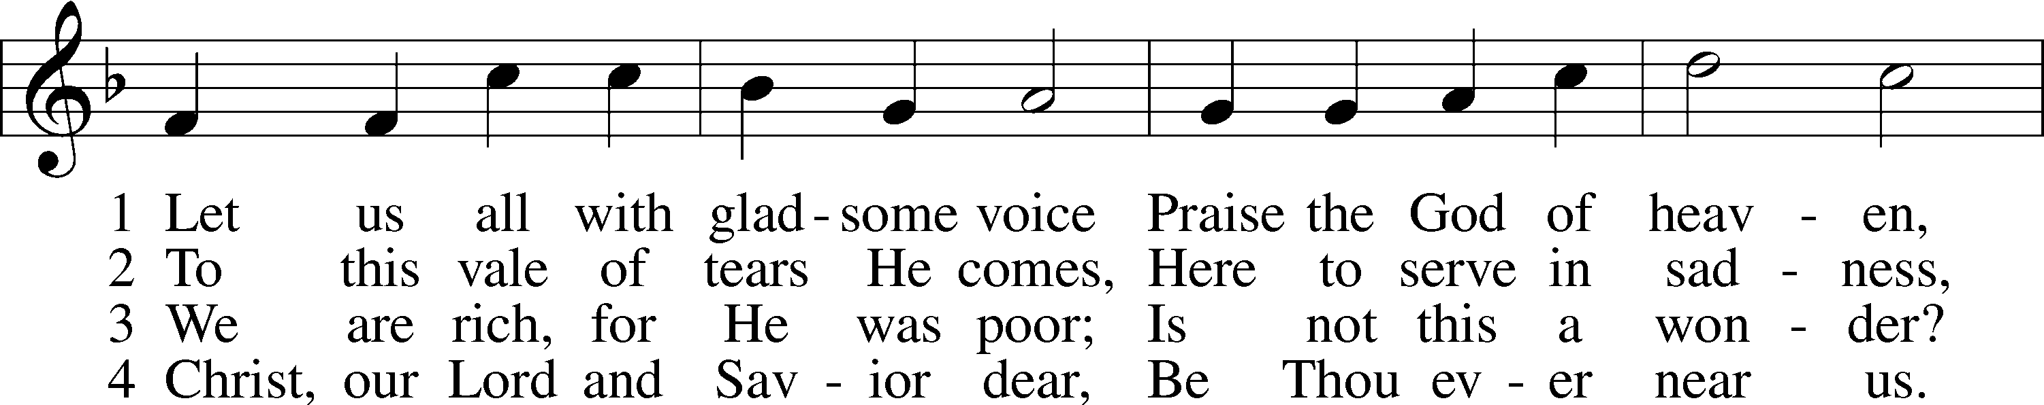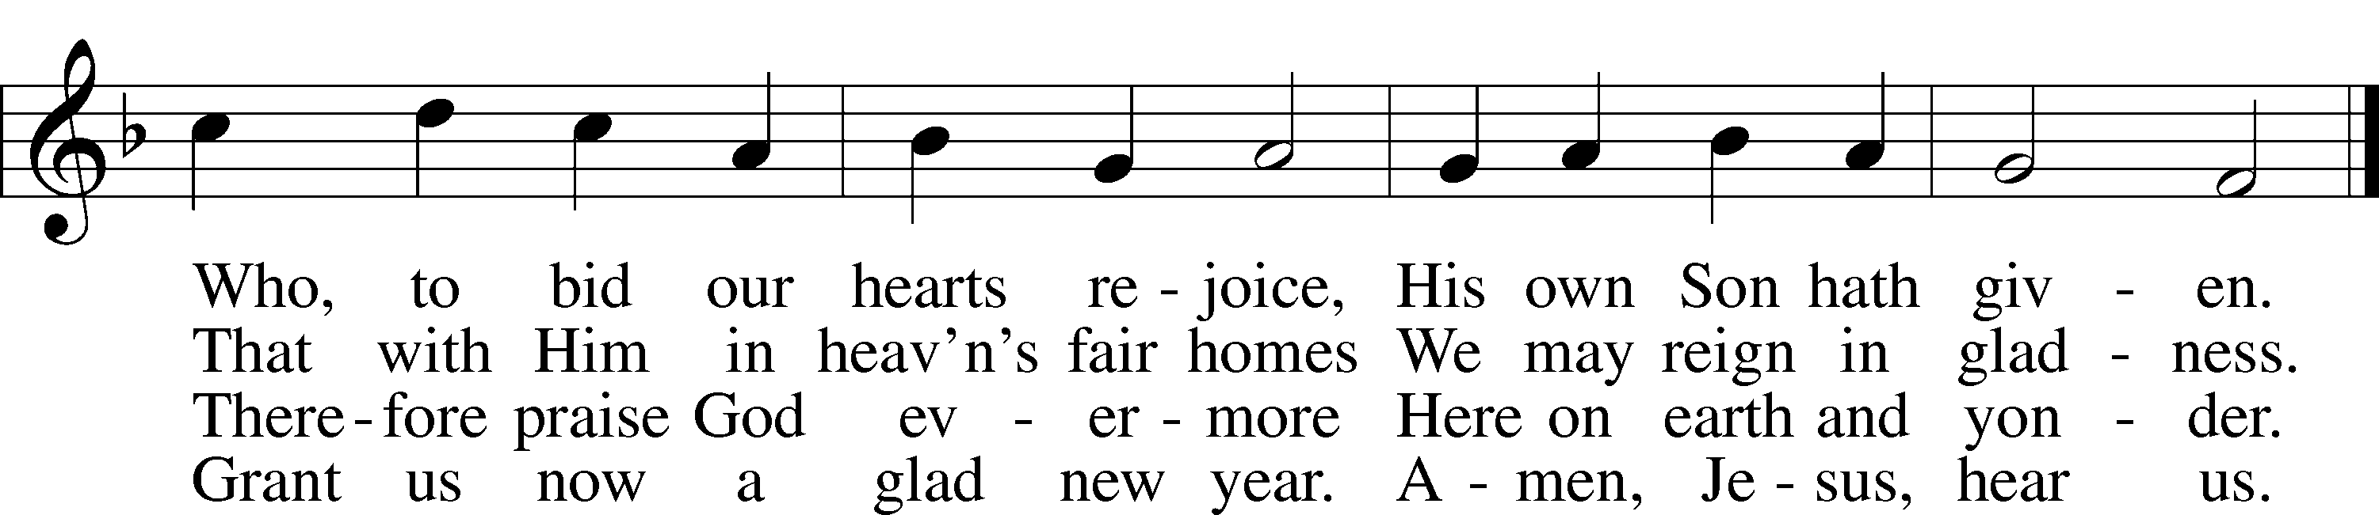

Public domain

Pastor: In the Name of the Father and of the Son and Holy Spirit.

**Congregation: Amen.**

**PREPARATION**

*(Please Remain Standing Or You May Kneel…)*

**CONFESSION OF SIN:**

**All: God, I admit I have broken all of your commandments; I am not holy or sinless even though I often pretend a righteousness I do not have. I offer excuses. I have broken relationships by what I have said, or done. I have not loved either You or my neighbor as I ought. (time for personal confession____)**

**YOU ARE FORGIVEN:**

Pastor: God is merciful and gracious; He has given His Son, Jesus Christ to die and rise again for us, the sinful ones that we might be forgiven and enjoy His Peace. This is also a reminder of God’s gifts and blessing that have become ours in Holy Baptism.

**Congregation: thank you God for Your blessing!**

Pastor: Yes, the Grace of our Lord Jesus Christ, and the Love of God, and the fellowship of His Holy Spirit is with you all.

**Congregation: And also with you.**

Pastor: In peace and as His forgiven people, we can pray to the Lord:

**Congregation: He is gracious to us and hears our prayers.**

Pastor: For the peace of the whole world and our involvement in Christ’s Mission in the world, we pray:

**Congregation: Keep us mindful of our purpose as Christians and our ability to share your blessings of peace and forgiveness with others.**

Pastor: We are the children of the Risen Christ. His victory is Our Victory!

**THE PRAYERS OF THE CHURCH:**

**All: O God, our Maker and Redeemer, You wonderfully created us and in the incarnation of Your Son yet more wondrously restored our human nature. Grant that we may ever be alive in Him who made Himself to be like us; through Jesus Christ, our Lord, who lives and reigns with You and the Holy Spirit, one God, now and forever. Amen.**

**SERVICE OF THE WORD**

**God speaks to us through his word, the Bible:**

*You may be seated…*

**THE OLD TESTAMENT LESSON: Numbers 6:22-27**

Lector: This is the Word of the Lord.

**People: Thanks be to God.**

**THE EPISTLE LESSON: Galatians 3:23-29**

Lector: This is the Word of the Lord.

**People: Thanks be to God.**

*Please stand…*

**THE HOLY GOSPEL: Luke 2:21**

Pastor: The Holy Gospel according to St. Luke the 2nd Chapter

**People: Glory to You, O Lord.**

Pastor: This is the Gospel of the Lord.

**People: Praise to You, O Christ!**

*Please be seated…*

**CHILDREN’S MESSAGE**

**NOISE OFERING**

**THE SERMON HYMN:  *“Come, Thou Fount of Every Blessing”*  LSB 686**

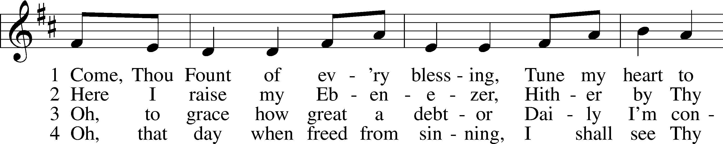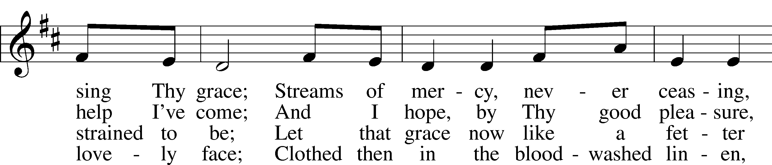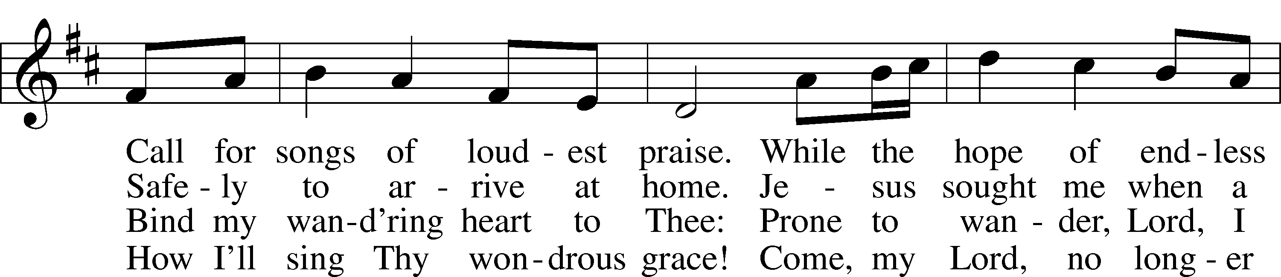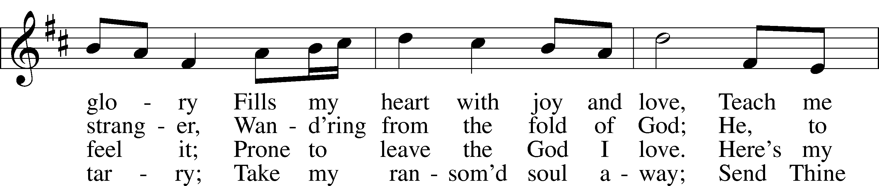

Public domain

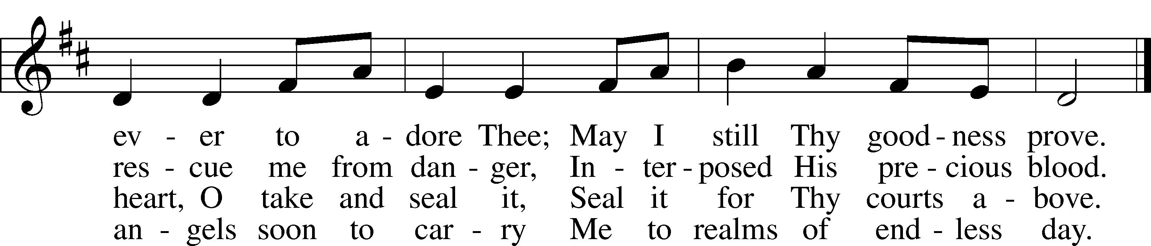

**THE SERMON:  *“The Lord Is Blessing You”* Numbers 6:22-27**

*(Please stand…)*

**THE PROFESSION OF FAITH:**

Pastor: God has given us a great message to take to His world. Let us remind ourselves and one another of what that message is:

Pastor: I believe in God the Father, Almighty

**Congregation: Maker of heaven and earth**

Pastor: And in His Son, Jesus Christ our Lord,

**Congregation: Who was conceived by the Holy Spirit**

Pastor: Born of the Virgin Mary

**Congregation: Suffered under Pontius Pilate**

Pastor: Was crucified, died and was buried

**Congregation: He descended into hell.**

Pastor: On the third day He rose again from the dead,

**Congregation: And ascended into heaven**

Pastor: And sits on the right hand of God, the Father almighty

**Congregation: From there He will come to judge the living and the dead**

Pastor: I believe in the Holy Spirit,

**Congregation: The Holy Christian Church as**

**All: the communion of saints; the forgiveness of sins, the resurrection of the body, and the life everlasting. Amen.**

*(You may be seated…)*

**OFFERING RECEIVED**

**(***Please stand…)*

***“Praise God, from Whom All Blessings Flow”* LSB 805**

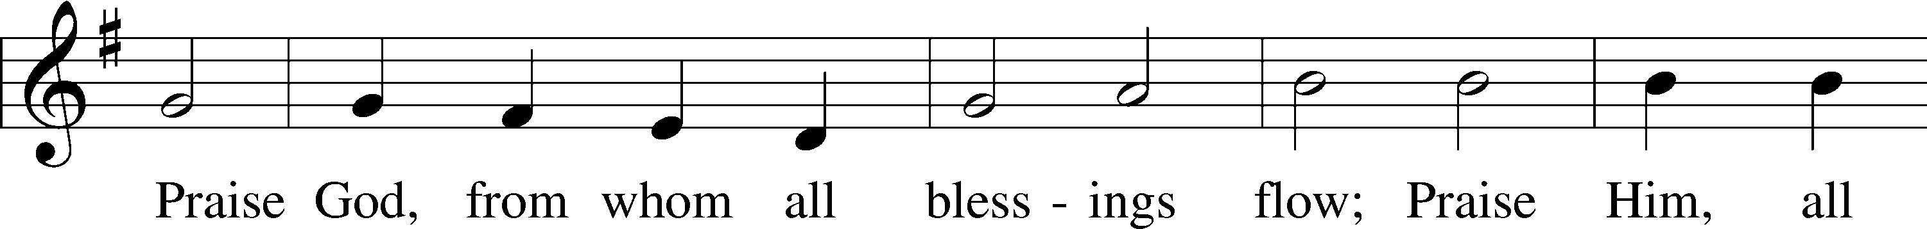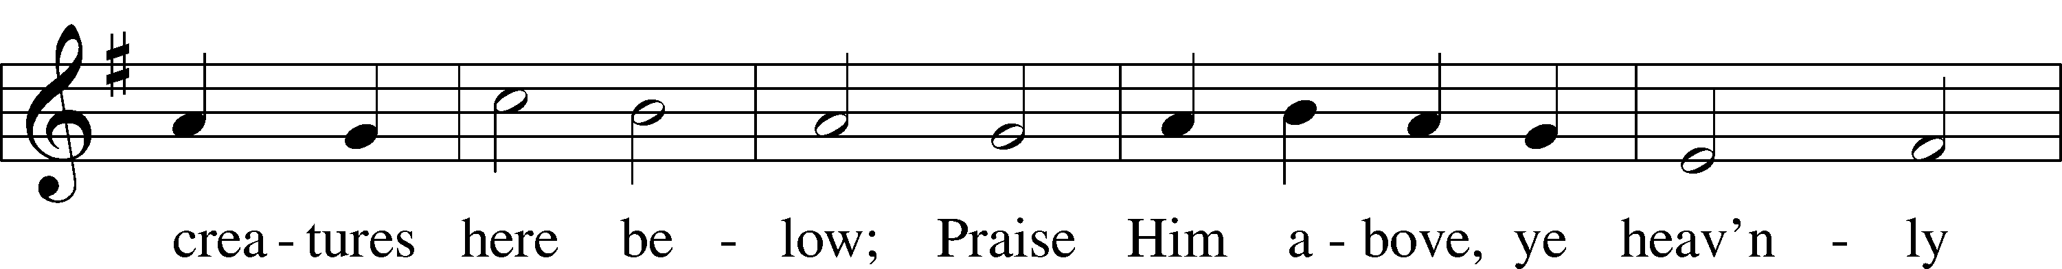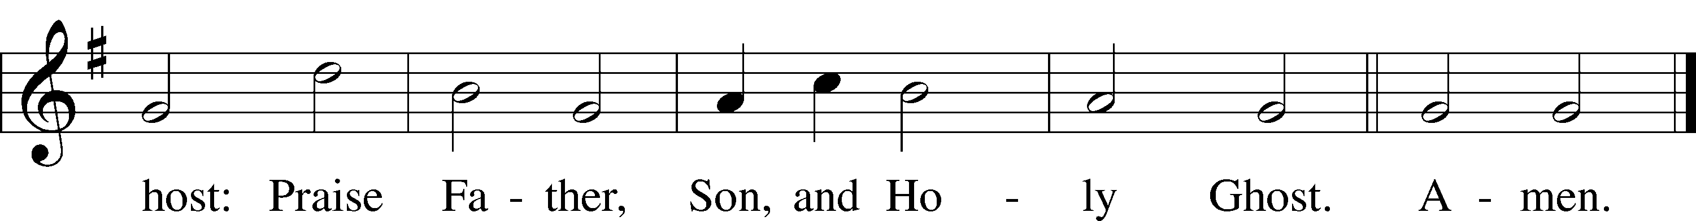

Public domain

**SERVICE OF THE SACRAMENT**

*(Please stand…)*

**PREPARE FOR THE LORD’S SUPPER:**

Pastor: We begin with the reminder: “The Lord is with you.”

**Congregation: We are mindful and thankful for His presence.**

Pastor: Let your life reflect the joy of your salvation.

**Congregation: We do give Him thanks and praise. We will share His blessing with others.**

Pastor: It is proper that we should at all times and in all places…(prayer)… we praise your name and join others in singing:

**All: (sing) “Holy, holy, holy Lord God of pow’r and might:**

**Heaven and earth are full of your glory.**

**Hosanna, Hosanna, Hosanna in the highest.**

**Blessed is he who comes in the name of the Lord.**

**Hosanna in the highest.”**

*(Please be seated…)*

**THE WORDS OF INSTITUTION**

**DISTRIBUTION HYMNS: *“Father, I Adore You”***

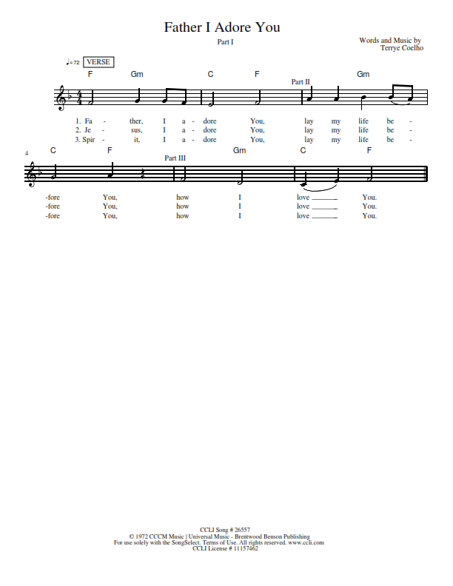

***“Children of the Heavenly Father”* LSB 725**

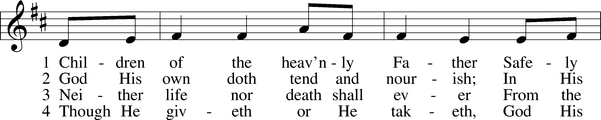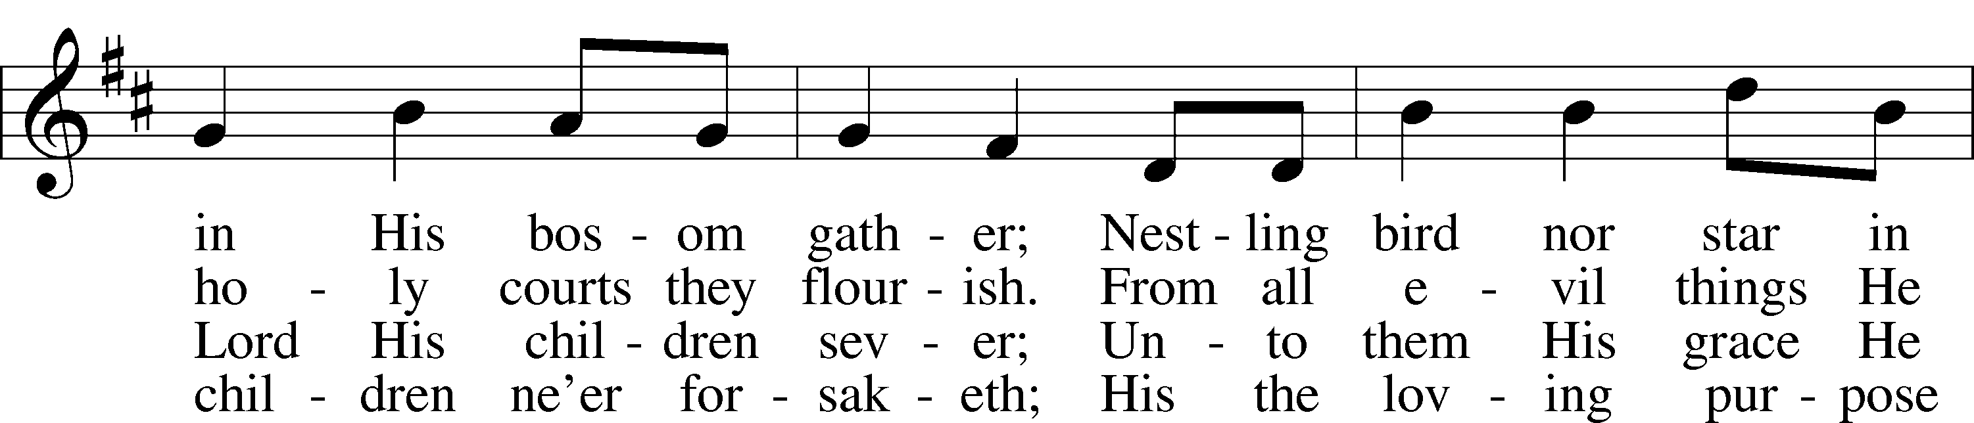

© Augsburg Publishing House. Used by permission: LSB Hymn License .NET, no. 100011641.Public domain

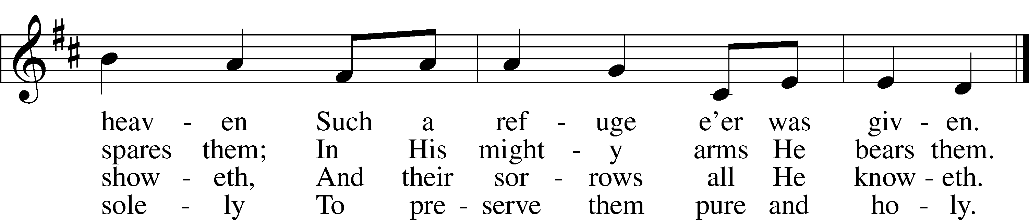

***“Jesus! Name of Wondrous Love”* LSB 900**

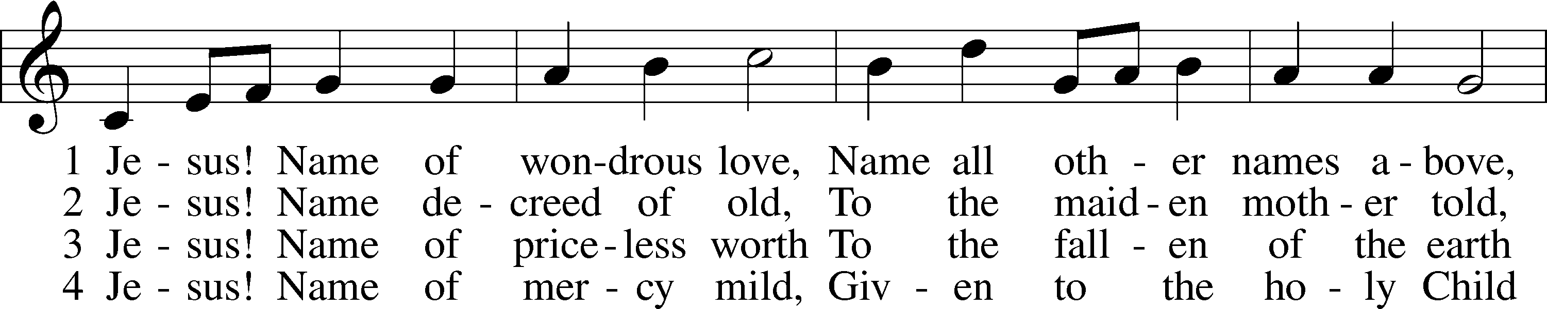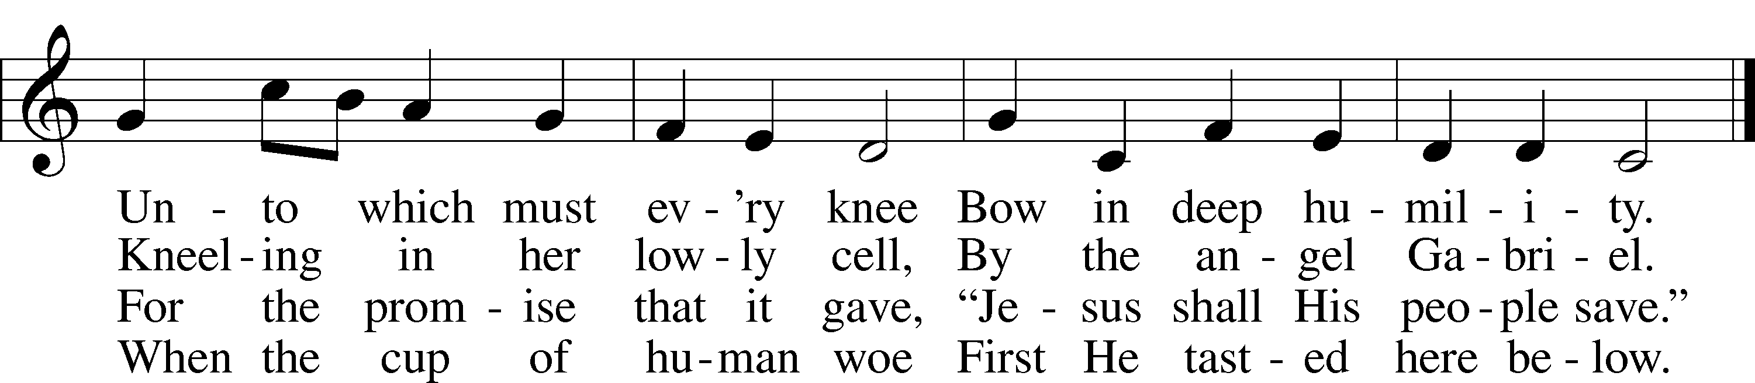

5 Jesus! Only name that’s giv’n  
Under all the mighty heav’n  
Whereby those to sin enslaved  
Burst their fetters and are saved.

6 Jesus! Name of wondrous love,  
Human name of God above;  
Pleading only this, we flee  
Helpless, O our God, to Thee.

Public domain



Jesus let the things that break

your heart also break our hearts.

Amen

***“The Ancient Law Departs”* LSB 898**

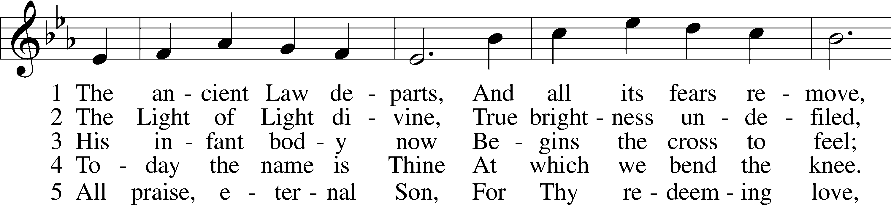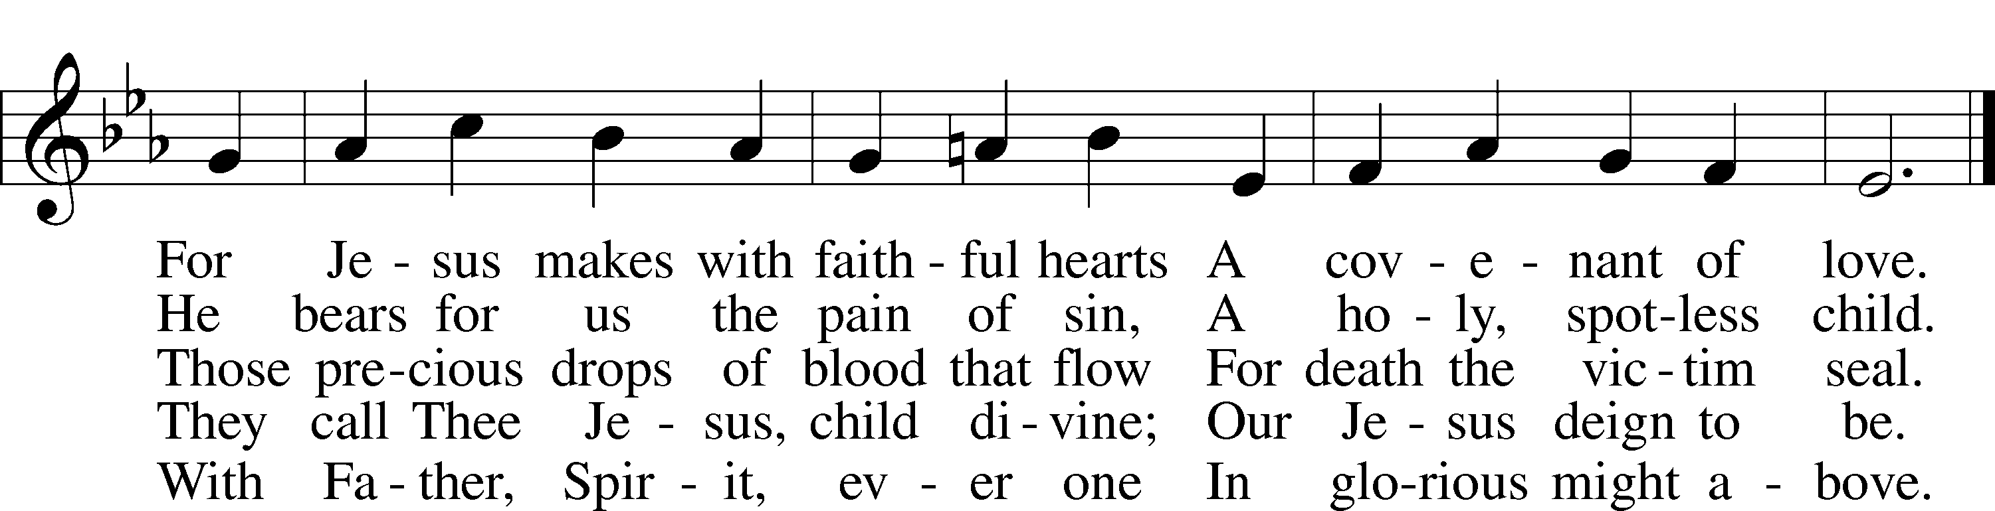

Public domain

*(Please stand…)*

**THE LORD’S PRAYER:**

**All: Our Father, who art in heaven, hallowed be thy name, thy kingdom come, thy will be done, on earth as it is in heaven. Give us this day our daily bread; and forgive us our trespasses as we forgive those who trespass against us; and lead us not into temptation, but deliver us from evil. For thine is the kingdom, and the power, and the glory, forever and ever. Amen**

**THE BLESSING AND BENEDICTION:**

Pastor: The Lord Blesses you and keeps you, the Lord makes His face to shine upon you and He is Gracious to you. The Lord looks upon you with His favor and gives you His peace.

**Congregation: God blesses us so that we can be a blessing to others.**

Pastor: Go in His peace and serve the Lord by serving others.

**Congregation: Amen**

**THE CLOSING HYMN: *“Go, My Children, with My Blessing”* LSB 922**

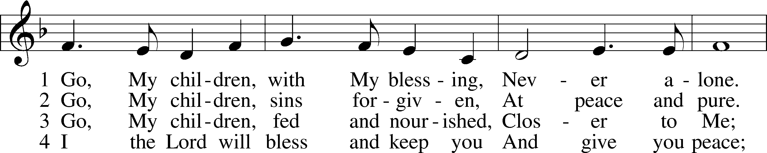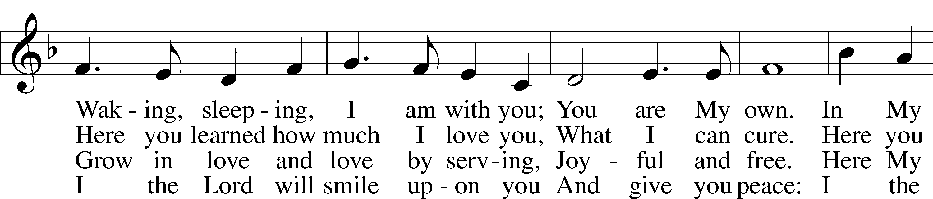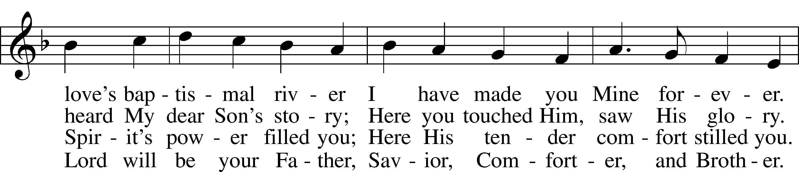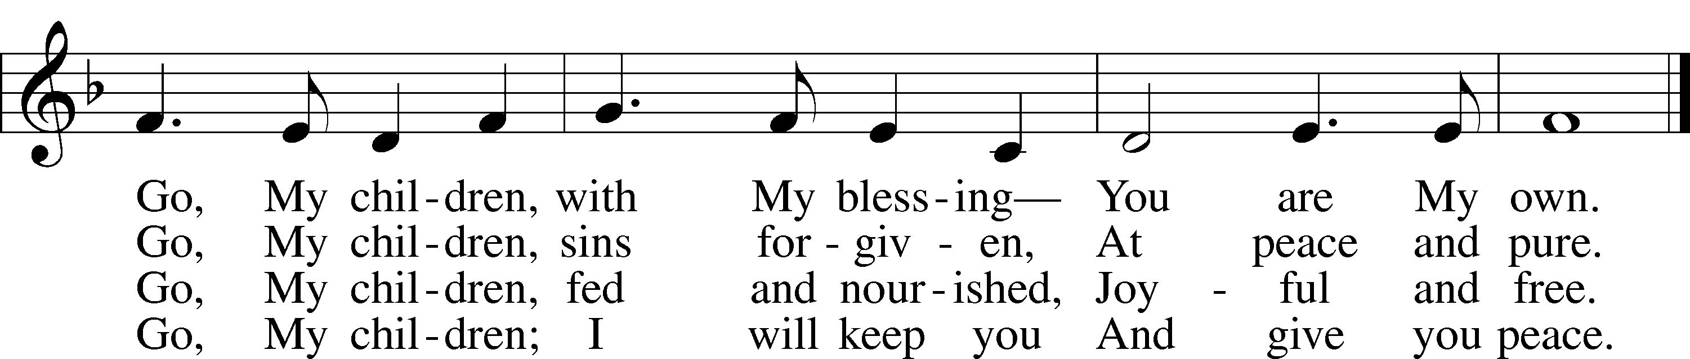

© 1983 Concordia Publishing House. Used by permission: LSB Hymn License .NET, no. 100011641.  
Public domain

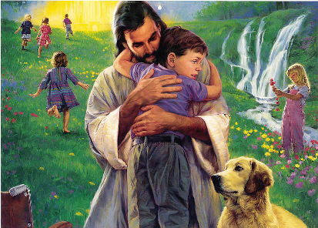

**ANNOUNCEMENTS**

**WELCOME TO GRACE LUTHERAN CHURCH:** We are glad that you are here to worship God with us today! We pray that you will enjoy the wonderful fellowship as friends in Christ as God gathers us around His means of grace, the Word and Sacraments, to bless us with His treasured gifts of forgiveness, faith, abundant life and eternal salvation. If you are a guest, please also sign our Guest Book. Please talk to Pastor if you would like **to learn more about becoming a member of Grace. Also, please join us for refreshments** and fellowship after the Service. We invite you to come and worship with us often as God gathers us in His Grace.

**WELCOME TO THE LORD’S TABLE:** We invite and encourage all present who are baptized and faithful Christians, and who confess the Father, Son, and Holy Spirit to be the only true God and who believe that Jesus Christ died for the sins of the World and is our only hope and salvation…to join us in receiving the very and true body and blood of Christ in this Sacrament. The clear liquid cups in the center of the tray are non-alcoholic wine.

Children not yet confirmed in the faith are always welcome to join their parents at the Lord’s Table, but should keep their hands folded in front of them. The Pastor will give them a blessing.

**SERVING TODAY:** Acolyte: Eli Morris; Lector: Garnet Picking; Communion Assistant: Vince Winters and Max Broadbent; Usher: Ed Morris; Altar Care: _______; Refreshments: _________.

**SERVING NEXT SUNDAY:** Acolyte: Emily Howard; Lector: Jim Picking; Communion Assistants: Vince Winters and Max Broadbent; Usher: Ed Morris; Altar Care: The Bly Family; Refreshments: Pastor Faith, Pattie, and friends.

**FLOWERS**: were placed on the alter to the glory of God for His many blessings.



THIS WEEK AT A GLANCE:

**Today: January 1st**

9:00 am Worship Service with Communion

10:15 am Fellowship/Refreshments

10:30 am Adult Bible Class/Children’s Sunday School

**Monday: January 2nd**

Pastor’s Day Off

5:30 pm Zumba

**Tuesday: January 3rd**

11:30 am Gracious Ladies of Grace Luncheon (Hyatt)

6:00 pm Weight Watcher’s (Parish Hall)

**Wednesday: January 4th**

12:30 pm Men’s Bible Fellowship (Chico’s)

**Thursday: January 5th**

7:00 pm Missional Communities (Room 3)

**Next Sunday: January 8th**

9:00 am Worship Service with Communion

10:10 am Children’s Vocal and Chime Choir Rehearsal

10:15 am Fellowship/Refreshments

10:30 am Adult Bible Class/Children’s Sunday School

**IN YOUR PRAYERS THIS WEEK:** Family and friends of Will Plagens, Five Walker, Kay Sattelmeier, Megan Schoepf, family of Rev. Alfred Schubert II, Dennis Julson, Vernon Julson, Olga Odland, Jean Grafsgaard, Jenie Howard, Jenny Dean, the family and friends of Yvonne and Vernon Julson, The family of Joseph Boylan, Katie Higgs Wyrwicki, The family of Joe Loftus, George Licis, Kathy Wickers and family, Charles, Braydon, Champ, Amy, Elsie Hamilton, Nancy Amling, Sharon Jardas, Mary Ellen Jessel, Marcos Diaz, Kaci Doran, Auwina Weed, Sandy Harris, and those you are praying for at home. If anyone has a special prayer request please submit it in writing in the collection plate; or you may call Pastor Gary Faith at (504-858-8872), or Kris Howard at (305-296-5161).

**GIFTS, TITHES, & ATTENDANCE LAST SUNDAY** for Saturday December 24th Christmas Eve 6pm service was $1971.00 with an attendance of 96, our 10pm service was $669.00 with an attendance of 72, and our December 25th Christmas Day service was $9906.00 with and attendance of 67, the combined noise offering received will be listed in next Sunday’s Bulletin.

**TO HELP US GROW…** The Bible readings for next Sunday’s service readings are Isaiah 60:1-6, Ephesians 3:1-12, and Matthew 2:1-12.

**THANKS TO ALL** for the cards, gifts, goodies, and kind words. Your generosity is appreciated. It’s a blessing to be a part of the Grace family. Pastor and Pattie

**OKTOBERFEST IN JANUARY**! Saturday January 14th is an opportunity to build relationships. Our snowbirds always miss the Oktoberfest so we are going to try and duplicate it and even surpass it. We are scheduled to be blessed with Pastor Tilahun Mendedo joining us at parsonage. Party will run from noon til 3ish. Meat, bake beans, and drinks will be provided. If you like to bring a side dish and lawn chair please feel free. There is a sign-up sheet in the Narthex so that Pastor knows how much food to buy. Please sign your names and the guestimated number of people who will be coming with you.

**STEWARDSHIP LISTS:** On the bulletin board by the front door of the church you will find the Altar Care, Refreshments, and Flower sign-up sheets for 2017. If you are able to help out with any of these please place your name in the spot on the date requested.

**MISSIONAL COMMUNITES AND TUESDAY’S BIBLE CLASS** will start back up on its normal schedule, meeting every Thursday at 7pm in Room 3. We hope to see you there.

**IF ANYONE IS INTERESTED IN TAKING THE ADULT INFORMATION CLASS** because they want to know more about what we teach/believe and/or might be interested in membership please let pastor or Kris know.

**SEARCHING FOR A ROOM FOR RENT**: Daria Skripko, (415)712-4718 is a hostess at Tavern and Town, she is from Belarus. I am here for self-study and I prepare my future course in the UK (a Christian course), saving money for that as in my home country I would spend years for that. I am looking for a rent, affordable one. I would be happy and I appreciate if someone finds it ok to rent a room for me till the end of April, 2017. The rent payment can be around $500, or negotiated. Thank you☺

**SOME DATES TO MARK ON YOUR CALENDAR**

**THE GRACIOUS LADIES OF GRACE**: The Gracious Ladies of Grace dined oceanside again on another beautiful breezy day in paradise at Salute! This restaurant is one of our favorites and never disappoints in anyway. Except....we must get a table on the other side of the restaurant next time because the garbage trucks pick up at noon on Tuesdays!  Most popular this time were the shrimp and grouper cakes and the shrimp salad. Then we passed around two slices of their best in Key West mile high meringue Keylime pie! We gave it all a five* and decided to meet on January 3 at the Hyatt. Merry Christmas and a Happy New Year to one and all 🎄

**PASTOR TILAHUN WILL BE PREACHING** at our worship service and presenting on the Master Builder Center during our Bible class time on Sunday January 15th – Pastor Tilahun has been serving as a missionary from Ethiopia to the USA for over 10 years.

**STAINED GLASS WINDOWS:** We only have 9 clear glass impact windows in the bathrooms and front entry, and the two side entry doors that need to be replaced.  When those are completed, the entire church will be protected with hurricane proof, impact windows. The cost of the windows is roughly $2000.00 each depending on size. Thank you, donors of the stained-glass windows and to all those who have contributed to the building fund for this project. Your generous giving is much appreciated

**THE GRACE LUTHERAN CHURCH WEB PAGE AND FACE BOOK PAGE** now contains a vocal recording of last week’s sermon. So, if you are not able to attend church on Sunday please go to our website where you will find a copy of the bulletin and a recording of Pastor Faith’s sermon. <https://gracelutherankw.360unite.com/home>.

**A NUMBER OF CAPITAL IMPROVEMENTS** are needed to keep our facilities in good health for the future. Roof repairs are needed on school buildings and the parsonage. If you can help it would be much appreciated! A big thanks to all who

have contributed to these repairs.



**SUNDAY SCHOOL:** Sunday school for all ages will follow refreshments from 10:30 until 11:30 in the following rooms.

High school with Pastor Dart is in room number 1 (just past the adult Bible study room on the right)

Middle school, 6th 7th and 8th grades, in room number 3 with Mike Sattelmeier and Jim Schuetzler. (Turn left down the school hallway to the first room).

3rd, 4th and 5th grades in room 5 with Lynn Jones and Monica Bacle. (third room left down the school hallway).

Preschool through second grade with JoAnn Broadbent in room 7. (Last room on the left down the school hallway)

Hope to see everyone there! Any questions? Ask Kris Bly, Sunday School director, 305-509-1447 or Kris Howard, church Secretary.



**IF YOU ARE INSTRUMENTALLY INCLINED** and would like to share your talents with an instrument during our services or accompany our organist and/or choir, please speak to our organist Debbie Schuetzler.

**MUSIC MINISTRY:** "Make a joyful noise to the Lord, all the earth!" Psalm 100:1. Whether you are here year-round or only part-time, we invite you to participate in our music ministry. Please speak with Beverly Walker or contact her at [beverlywalker@gmail.com](mailto:beverlywalker@gmail.com) if you have any questions.

Children's Choir for Kindergarten - 5th grade - No Rehearsal today. The next rehearsal will be Sunday, January 8 from 10:10 - 10:25. Please meet by the piano.

Bell Choir: The next rehearsal will be Wednesday, January 11 from 5:45 - 6:30 pm.

Vocal Choir: The next rehearsal will be Wednesday, January 11 from 6:30 - 7:30 pm.



**MEN’S BIBLE FELLOWSHIP**: They meet the first and third Wednesday’s of each month at 12:30pm. Their next meeting will be January 4thlocated at Chico’s on Stock Island. All guys are welcome.

**MISSIONAL COMMUNITES** will resume this Thursday at 7pm in Classroom 3.

