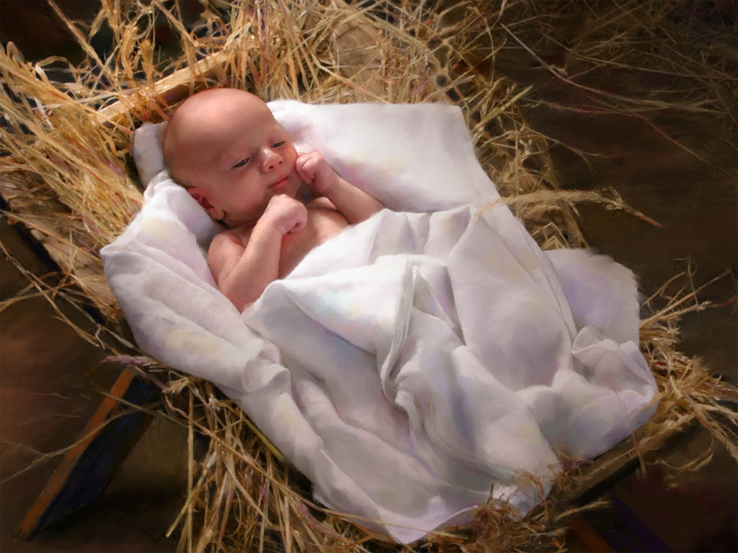

**CHRISTMAS DAY**

**December 18th, 2016 9:00 am**

**Grace Lutheran Church**

**2713 Flagler Ave.**

**Key West, FL 33040**

**305-296-5161**

[**GraceLutheranKW@att.net**](mailto:GraceLutheranKW@att.net)

**gracelutherankw.360unite**

**Pastor Faith (504) 858-8872 garyfaith@aol.com**

**CHRISTMAS DAY**

**DECEMBER 25TH, 2016 9:00 a.m.**

***In the Name of Jesus!***

**Our Mission Statement: Anchored in Christ, each person a missionary.**

**PRELUDE**

**THEME OF THE DAY:** Whoever takes the Son gets it all. That’s Joseph’s story, and ours as well. For when we take the Son-either for the first, fiftieth, or five-hundredth time we get it all-every last bit of God’s mercy, grace and love that come in the names **Jesus and Immanuel**.

Pastor:In the Name of the Father and of the Son and Holy Spirit.

**Congregation: Amen.**

**INVOCATION AND CALL TO WORSHIP:**

Pastor:In the beginning was the Word, and Word was with God, and the Word was God.

**Congregation: Through him all things were made.**

Pastor: In him was life,

**Congregation: And that life was the light of men.**

Pastor: The light shines in the darkness,

**Congregation: But the darkness has not overcome it.**

Pastor: The Word became flesh,

**Congregation: And made his dwelling among us.**

Pastor: To us a child is born.

**Congregation: To us a Son is given.**

Pastor: And the government will be on his shoulders.

**Congregation: And he will be called,**

Pastor: Wonderful Counselor, Mighty God, Everlasting Father, Prince of

Peace!

**All: Let us worship the newborn King!**

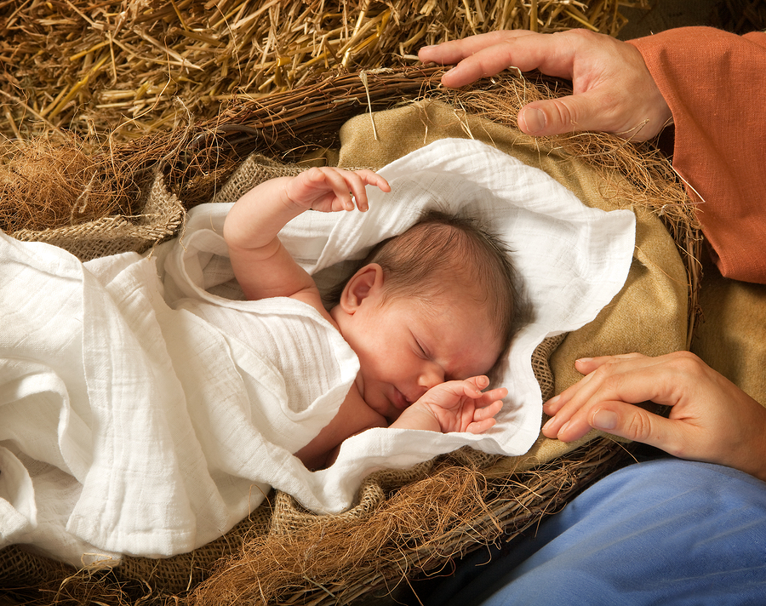

**PREPARATION**

*(Please Stand…)*

**HYMN: *“O Come, All Ye Faithful”* LSB 379**

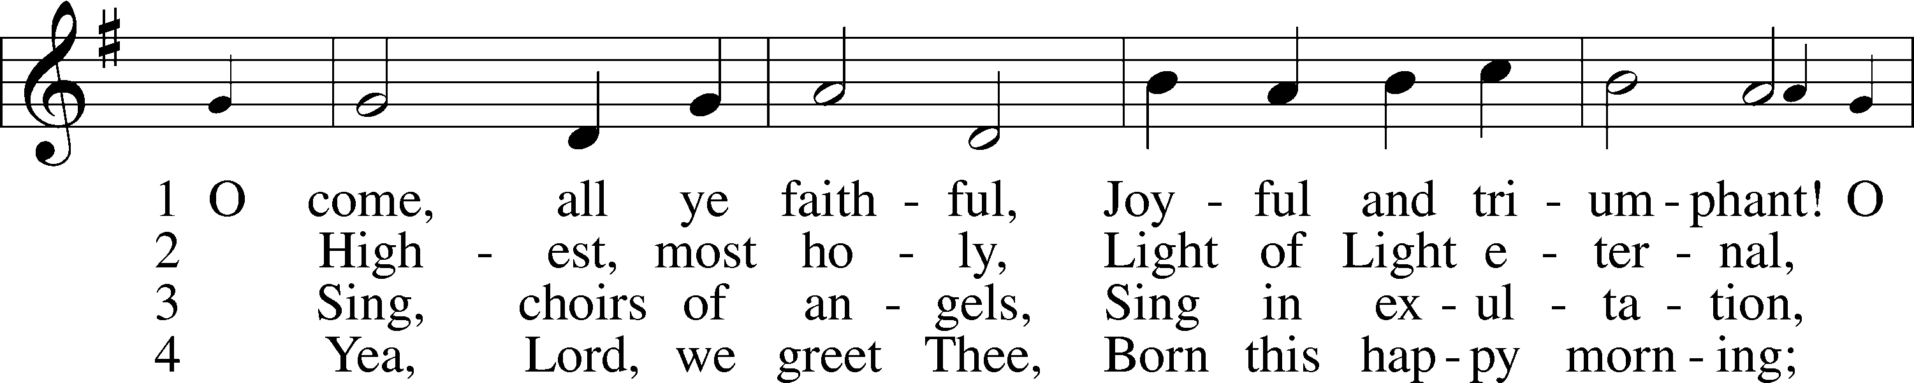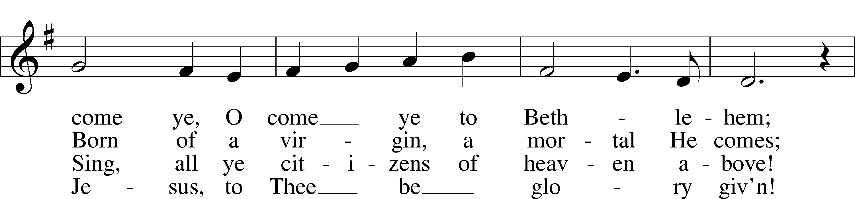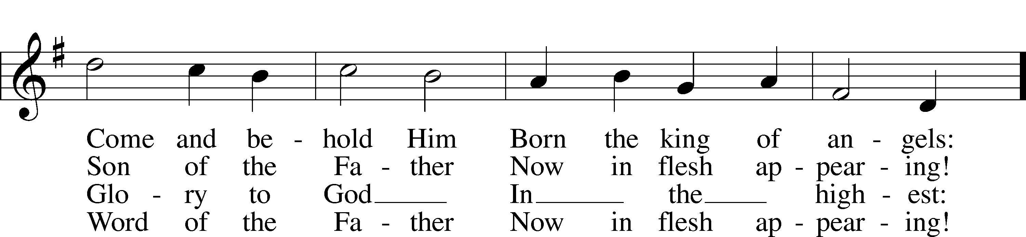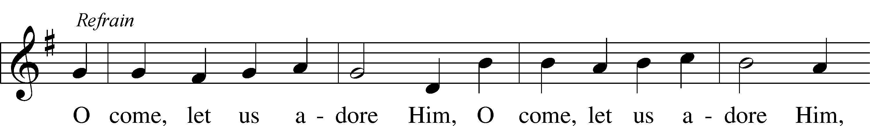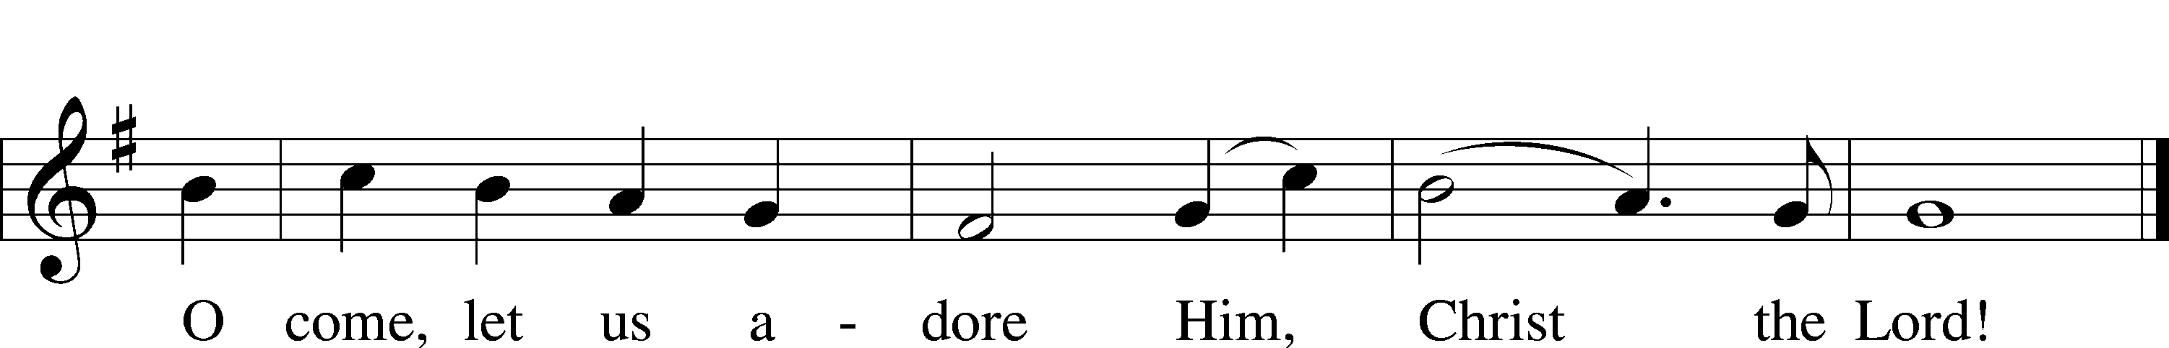

Public domain

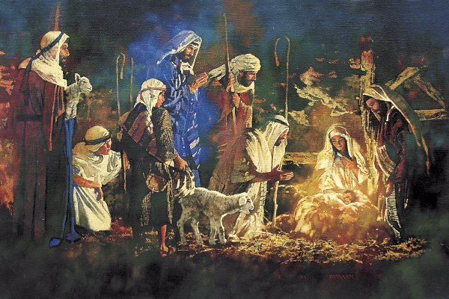

*(Please Remain Standing Or You May Kneel…)*

**CONFESSION AND ABSOLUTION:**

Pastor: On this holy morning, merciful Father, hear our confession that frequently we hesitate to take your Son..

**Congregation: Instead we take the forbidden fruit, hiding behind the bushes.**

Pastor: We take advantage of others, while mouthing pious words.

**Congregation: We take your blessings for granted, living with thankless**

**hearts.**

Pastor: We take vengeance upon those who hurt us, promising retaliation.

**Congregation: We take life into our own hands, ignoring your holy will.**

Pastor: We take refuge and satisfaction in sin, spurning your

commandments.

**Congregation: We take hold of our possessions, refusing to let them go.**

Pastor: We take part in sinful conversations, oblivious as to how they break your heart.

*+ Silence for a time of personal reflection +*

Pastor: Matthew writes in this morning’s Gospel lesson, “She will give birth to a Son, and you are to give Him the name Jesus, because He will save His people from their sins’ (At. 1:21). Jesus took our place in the manger and upon the cross. He took all of our sin, shame and brokenness as the Lamb of God who takes away the sin of the world. As a servant of Christ, I announce the complete and full pardon of all our sins, in the name of the Father, and of the Son, and of the Holy Spirit.

**Congregation: Amen.**

Pastor: Let us worship the newborn King!

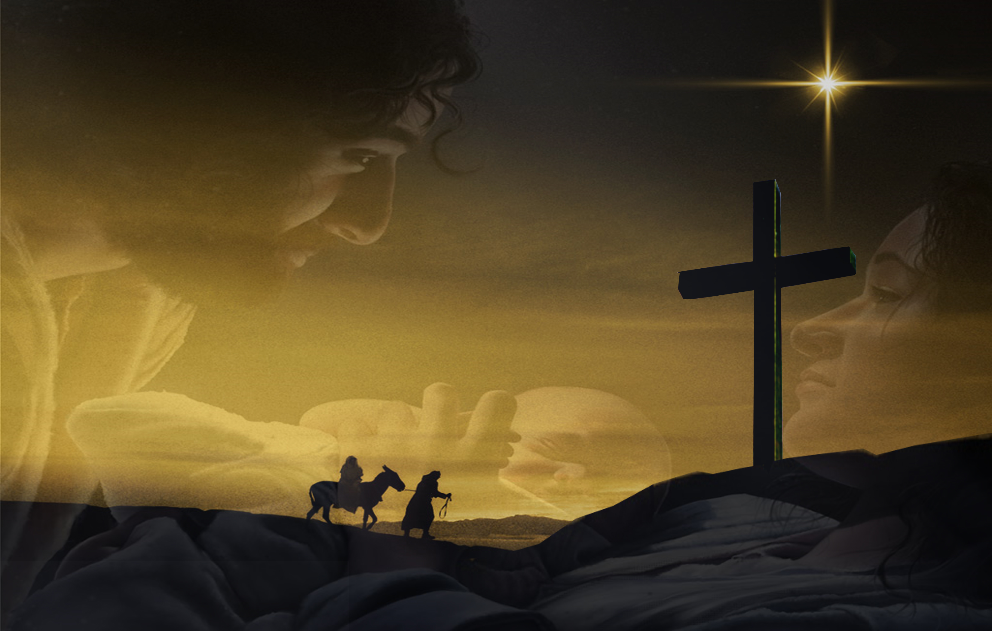

**SERVICE OF THE WORD**

*You may be seated…*

**THE OLD TESTAMENT READING: Isaiah 9:2-7**

Lector: This is the Word of the Lord.

**People: Thanks be to God.**

**THE EPISTLE LESSON: Galatians 4:4-7**

Lector: This is the Word of the Lord.

**People: Thanks be to God.**

*Please stand…*

**THE HOLY GOSPEL: Matthew 1:18-25**

Pastor: The Holy Gospel according to St. Matthew the 1st Chapter

**People: Glory to You, O Lord.**

Pastor: This is the Gospel of the Lord.

**People: Praise to You, O Christ!**

*Please be seated…*

**CHILDREN’S MESSAGE**

**NOISE OFERING**



**SERMON HYMN: *“Away in a Manger”* LSB 364**

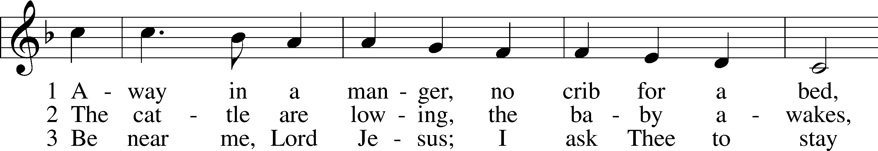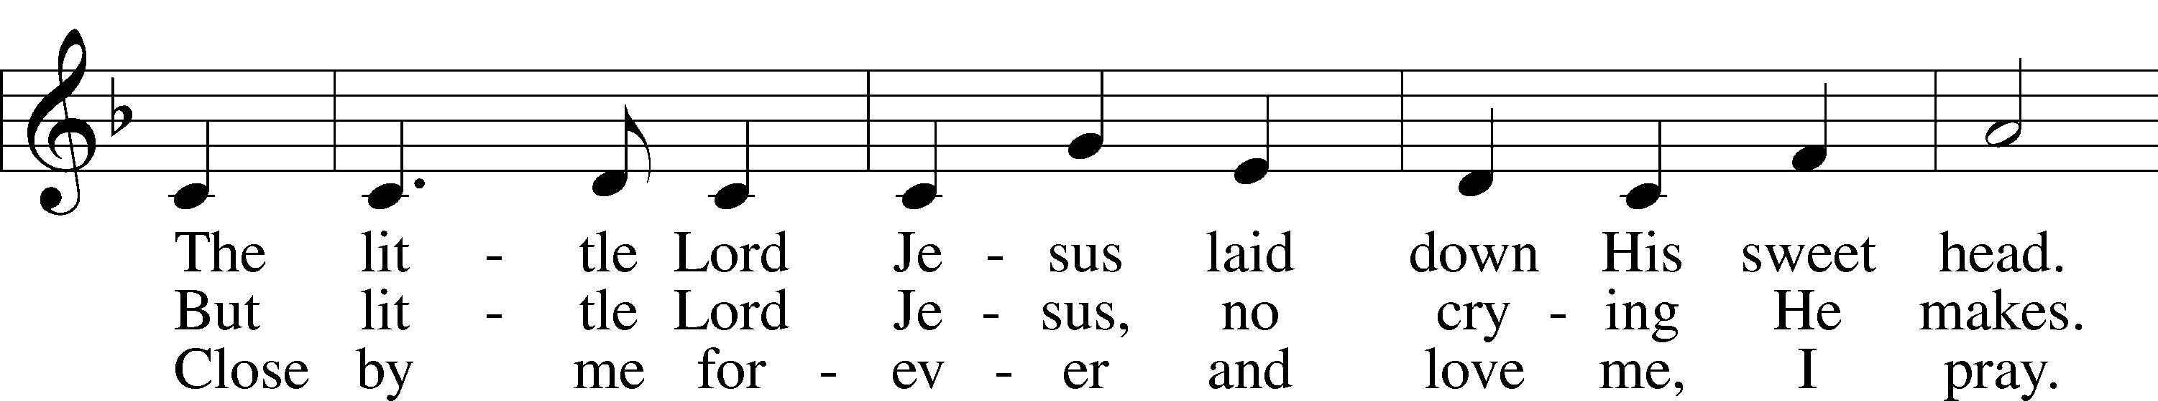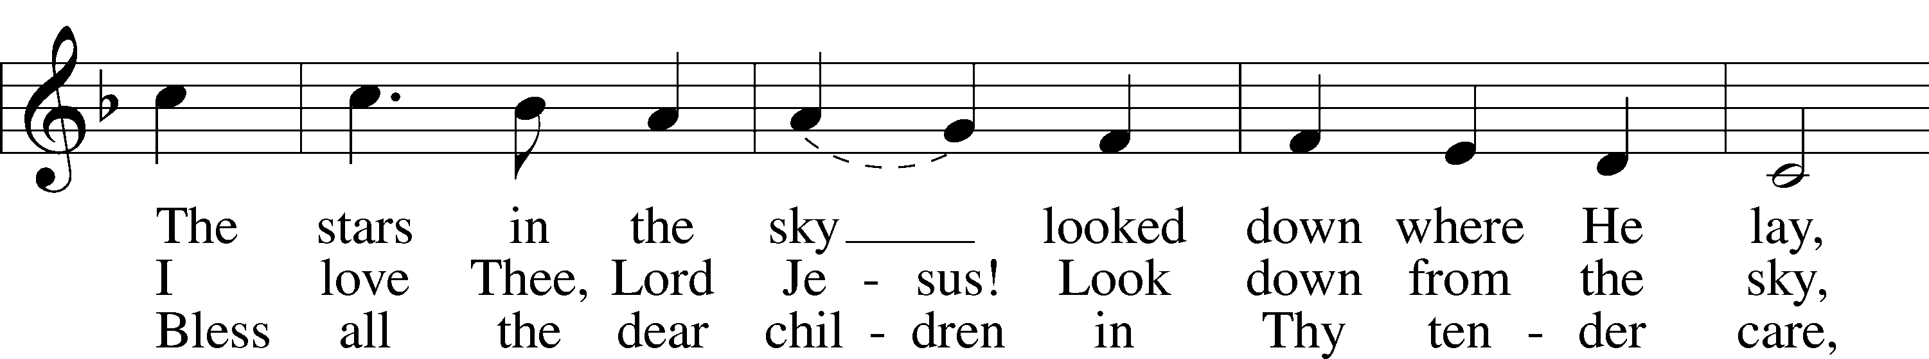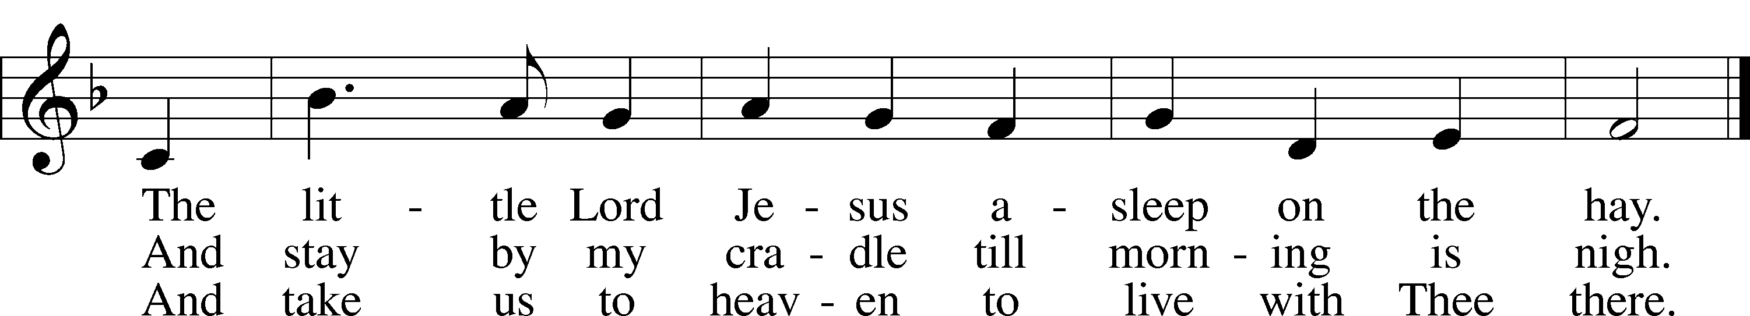

Public domain

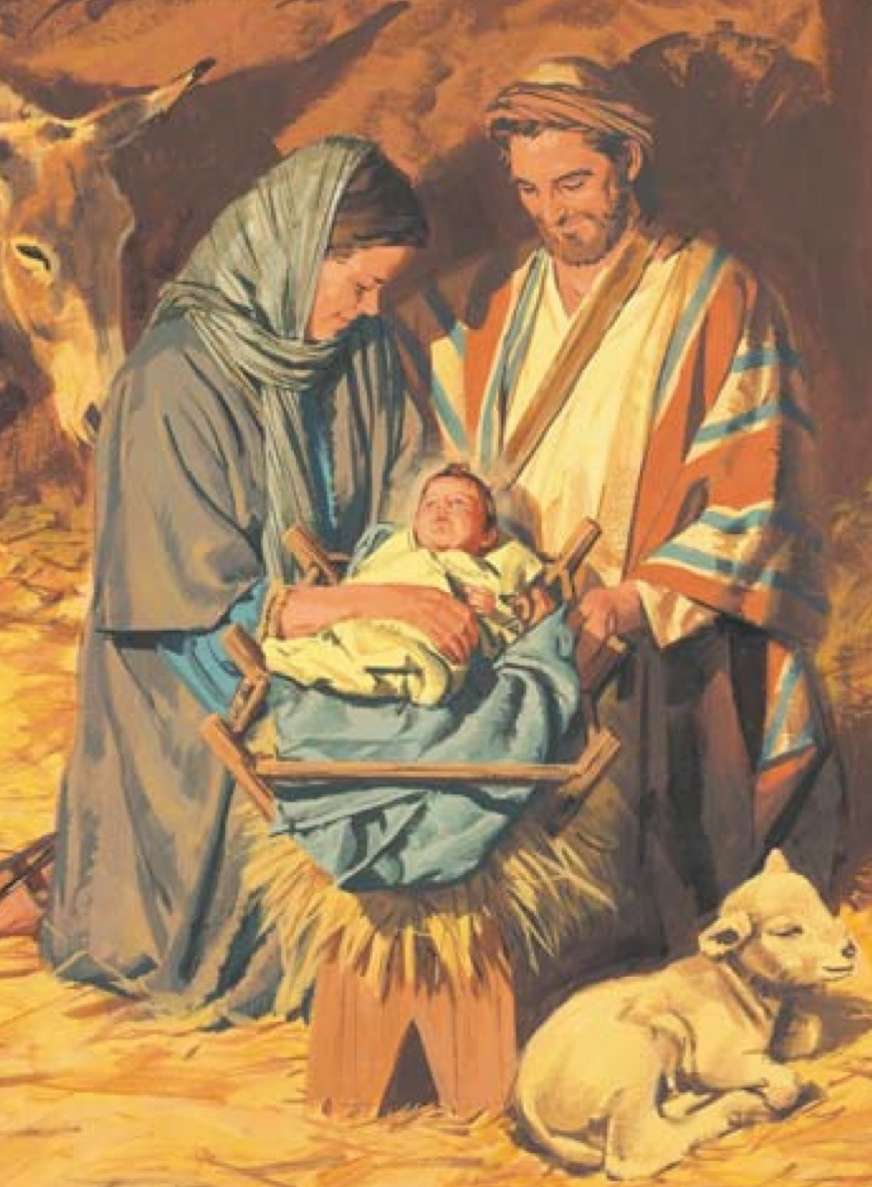

**THE SERMON: *Family Life “Whoever Takes the Son Gets It all”* Matthew 1:18-25**

*(Please stand…)*

**THE PROFESSION OF FAITH:**

Pastor: God has given us a great message to take to His world. Let us remind ourselves and one another of what that message is:

Pastor: I believe in God the Father, Almighty

**Congregation: Maker of heaven and earth**

Pastor: And in His Son, Jesus Christ our Lord,

**Congregation: Who was conceived by the Holy Spirit**

Pastor: Born of the Virgin Mary

**Congregation: Suffered under Pontius Pilate**

Pastor: Was crucified, died and was buried

**Congregation: He descended into hell.**

Pastor: On the third day He rose again from the dead,

**Congregation: And ascended into heaven**

Pastor: And sits on the right hand of God, the Father almighty

**Congregation: From there He will come to judge the living and the dead**

Pastor: I believe in the Holy Spirit,

**Congregation: The Holy Christian Church as**

**All: the communion of saints; the forgiveness of sins, the resurrection of the body, and the life everlasting. Amen.**

*(You may be seated…)*

**OFFERING RECEIVED: *"When in the Moon of Winteretime”* Bell Choir**

**(***Please stand…)*

***“Praise God, from Whom All Blessings Flow”* LSB 805**

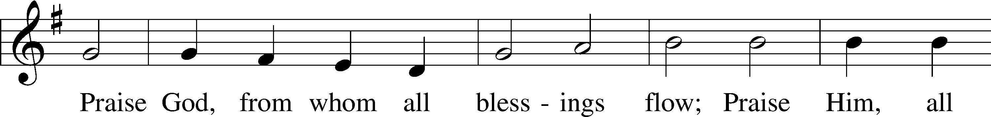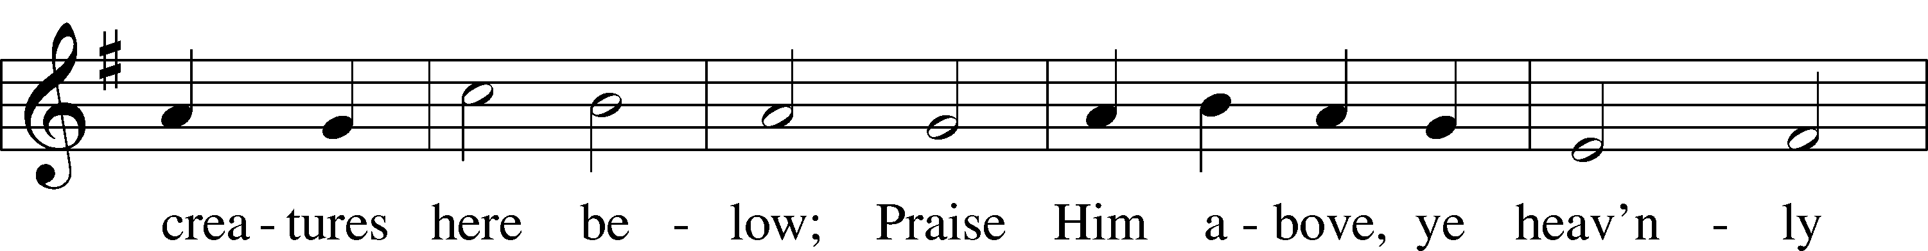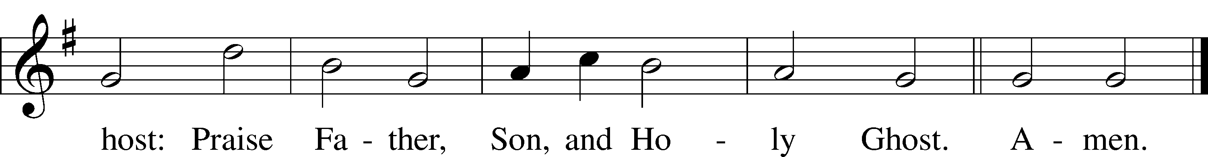

Public domain

**THE PRAYERS OF THE CHURCH:**

Pastor: Lord of Christmas, Lord of love; on this holy morning, we delight in confessing that-

**Congregation: Whoever takes the Son gets it all.**

Pastor: Stir our hearts and our homes to follow in the way of Joseph, who believed that-

**Congregation: Whoever takes the Son get all of your love.**

Pastor: For in the names of Jesus and Immanuel, you assure us that-

**Congregation: Whoever takes the Son gets all of your mercy.**

Pastor: Open our lips and our lives to share this message with the world, that-

**Congregation: Whoever takes the Son gets life.**

Pastor: Father, we bless and thank you that this life is forgiven and it is free and it is forever.

**Congregation: It is abundant and full and lasts forevermore.**

Pastor: Indeed, whoever takes the Son gets it all!

*+ Additional Prayers +*

Pastor: Lord of Christmas, Lord of love, we are overwhelmed with our gift of a Savior, for in him we get it all-every last bit of your mercy, grace and love that are packaged and delivered in two marvelous names-

**Congregation: Jesus and Immanuel.**

Pastor: Open our eyes to the opportunity to share your love with those that don’t yet know.

**Congregation: to share your love with those that don’t yet know.**

Pastor: Whoever take the Son gets it all

**Congregation: In the Christ child’s name**

Pastor: Amen



**SERVICE OF THE SACRAMENT**

*(Please be seated…)*

**THE WORDS OF INSTITUTION**

**DISTRIBUTION HYMNS: *“What Child Is This”* LSB 370**

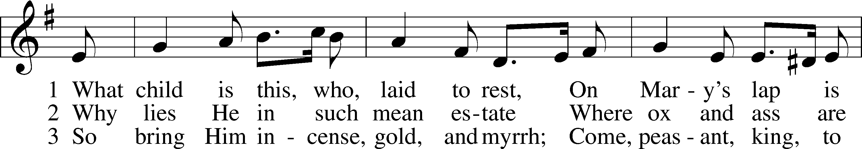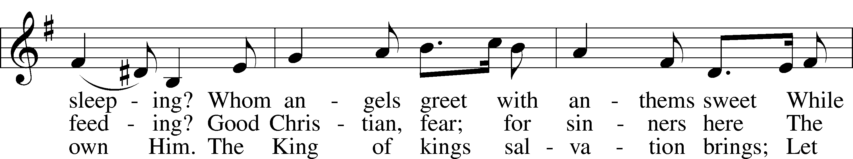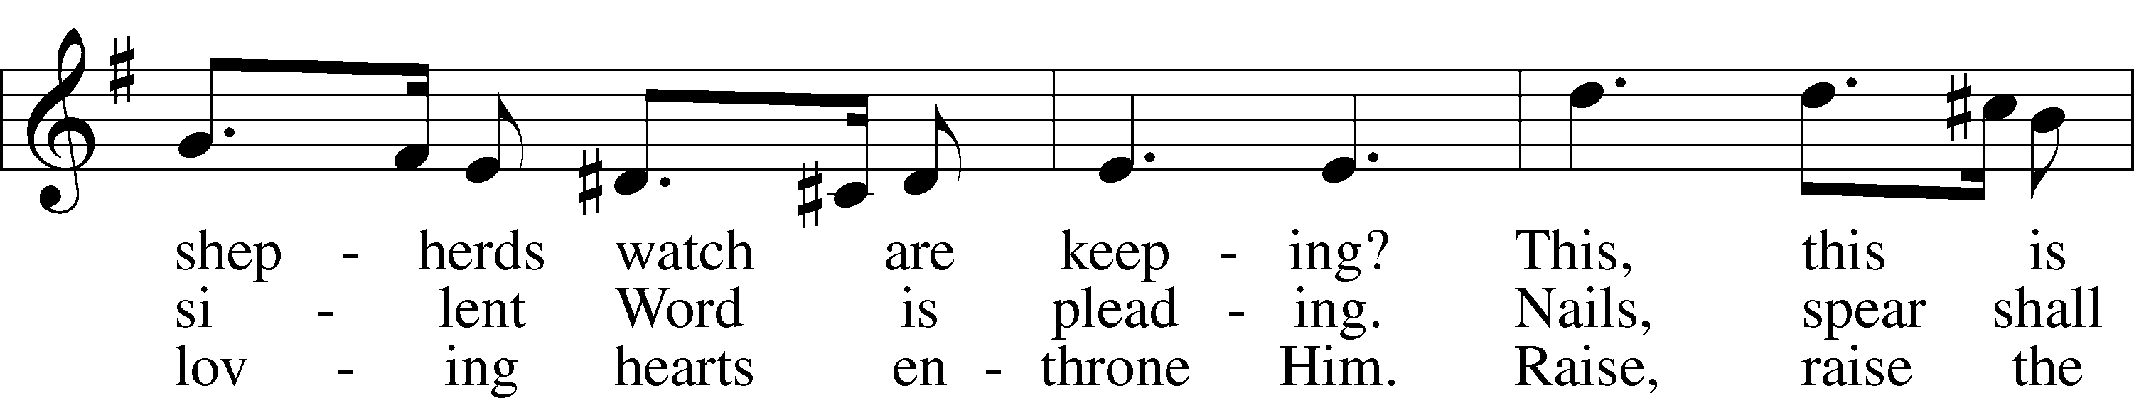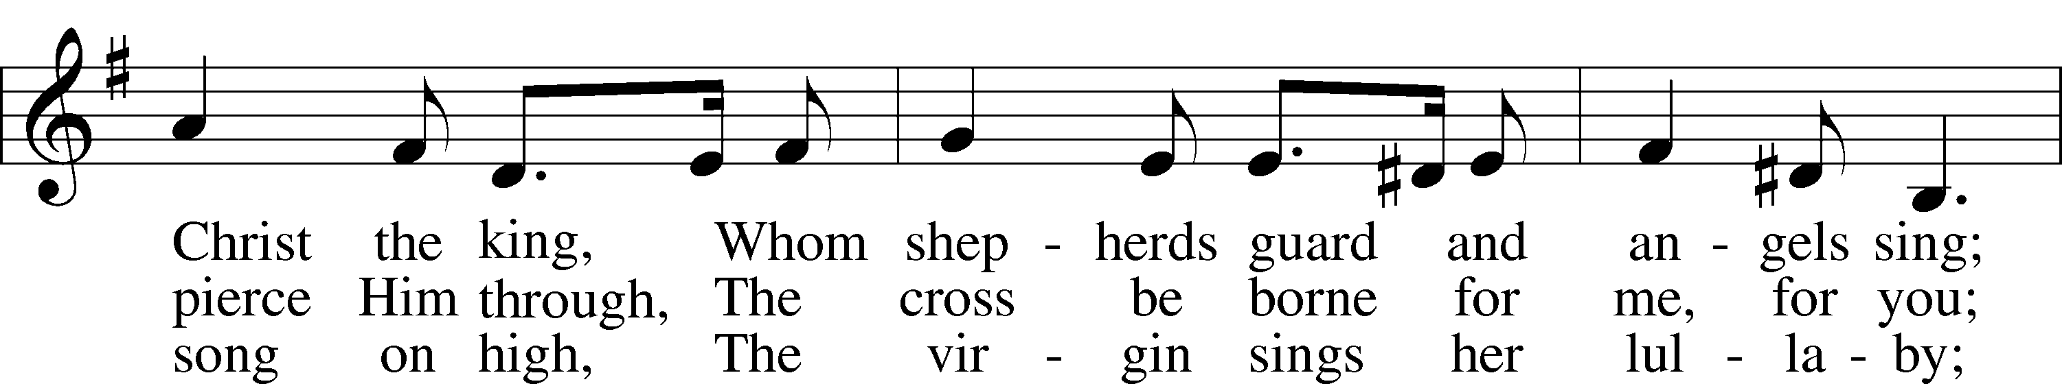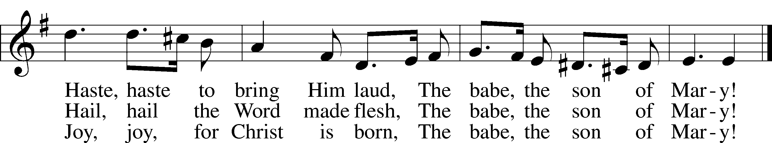

Public domain



Jesus let the things that break

your heart also break our hearts.

Amen

***“Hark! The Herald Angels Sing”* LSB 380**

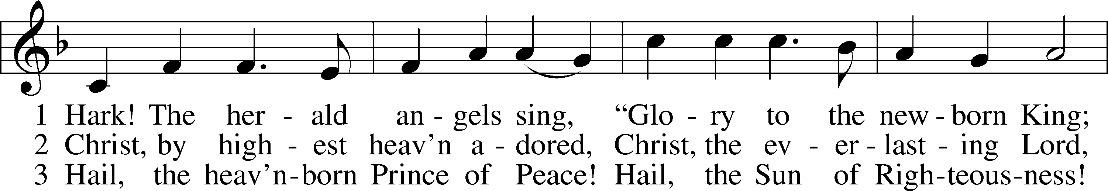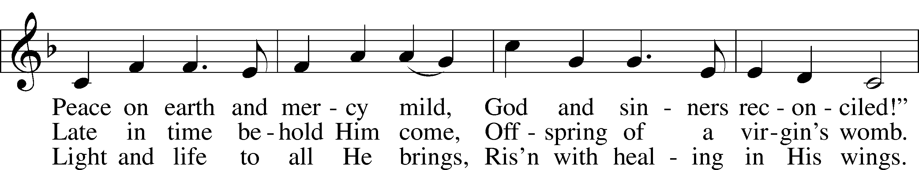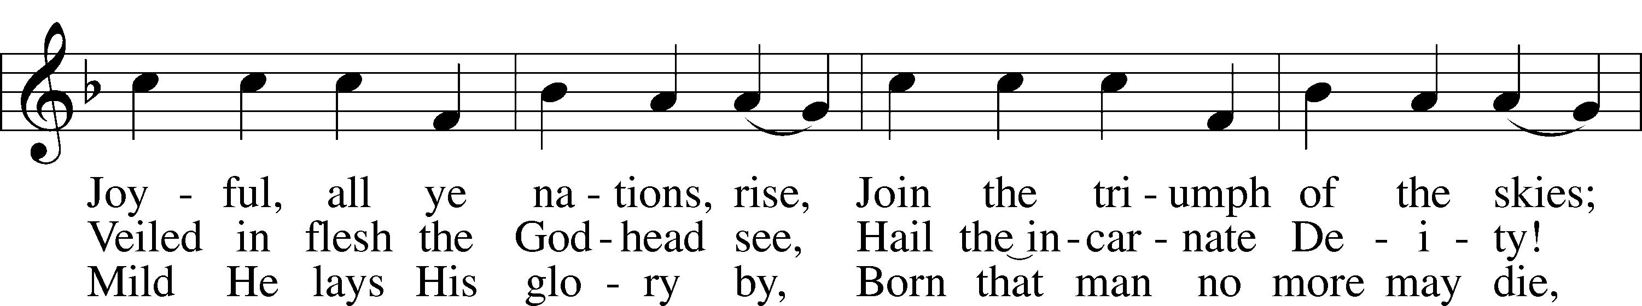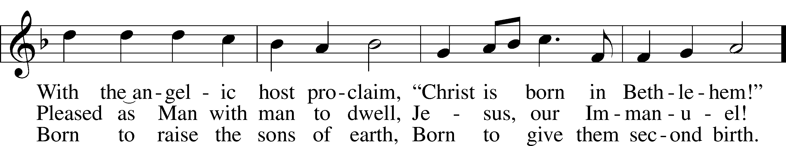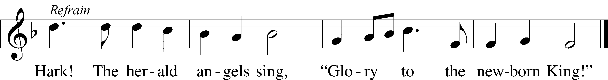

Public domain



***“Gentle Mary Laid Her Child”* LSB 374**

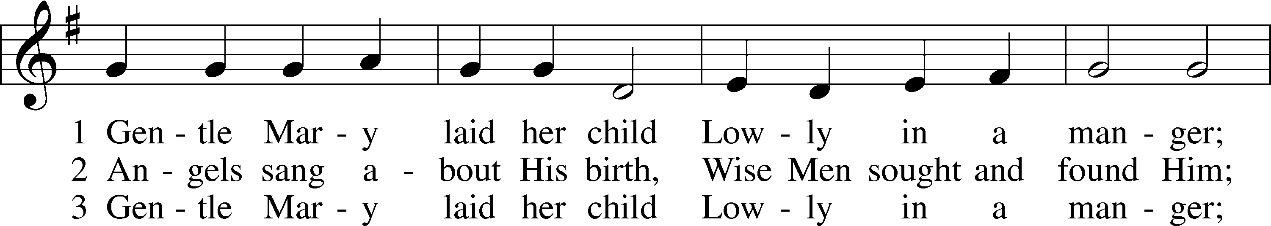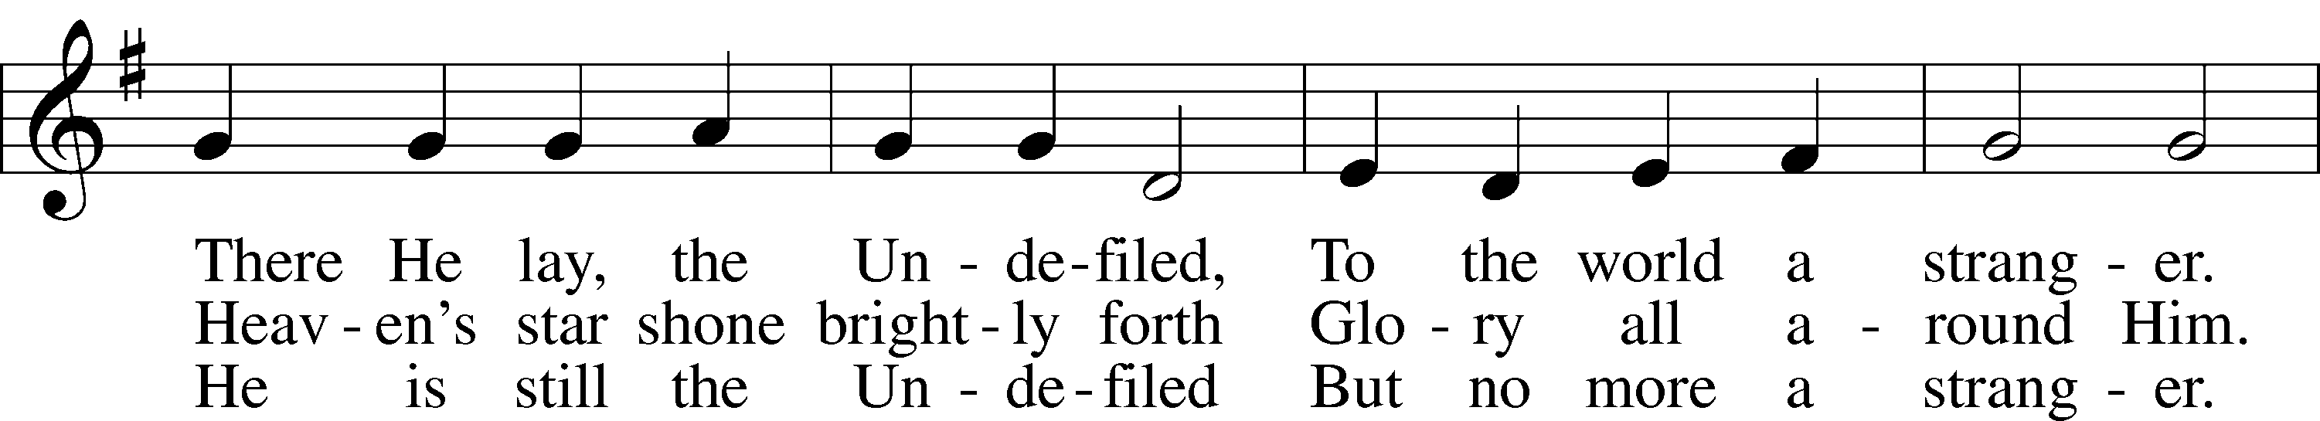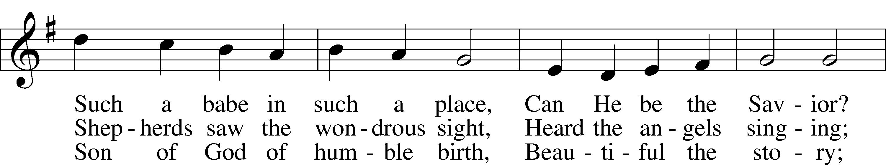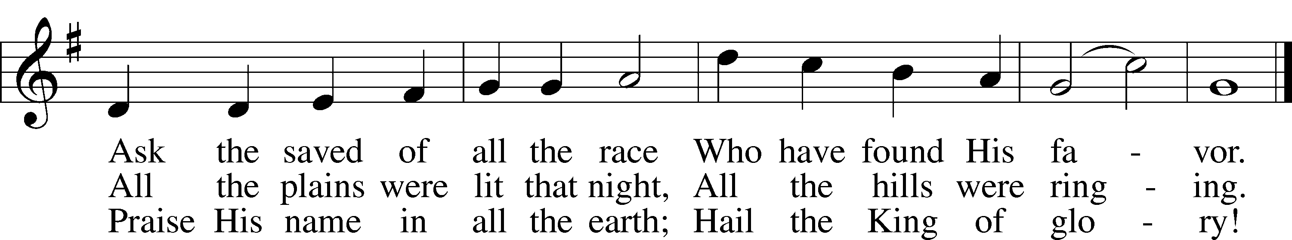

Public domain

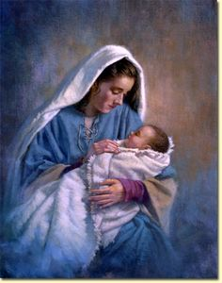

***“The First Noel” words & music Traditional English Carol***

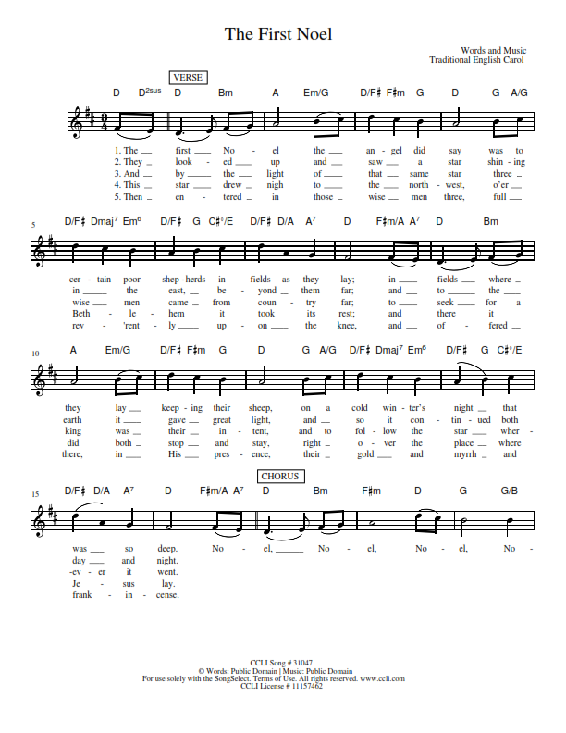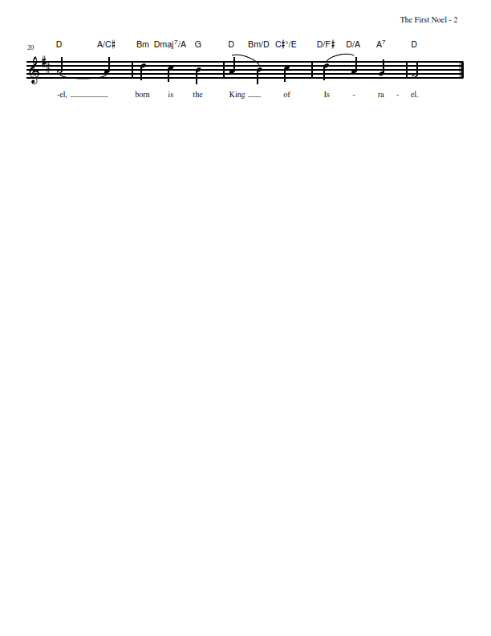

*(Please stand…)*

**THE LORD’S PRAYER:**

**All: Our Father, who art in heaven, hallowed be thy name, thy kingdom come, thy will be done, on earth as it is in heaven. Give us this day our daily bread; and forgive us our trespasses as we forgive those who trespass against us; and lead us not into temptation, but deliver us from evil. For thine is the kingdom, and the power, and the glory, forever and ever. Amen**

**THE BENEDICTION:**

Pastor: May our God-Father, Son, and Holy Spirit-pour out his grace upon

your family, giving you triumph over temptation, joy in your

journey and deliverance over every form of darkness.

**Congregation: Even so, come quickly, Lord Jesus. Amen!**

**THE CLOSING HYMN: *“Joy to the World”* LSB 387**

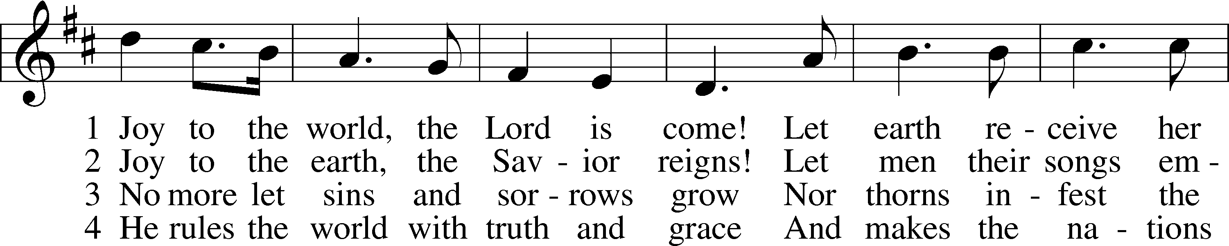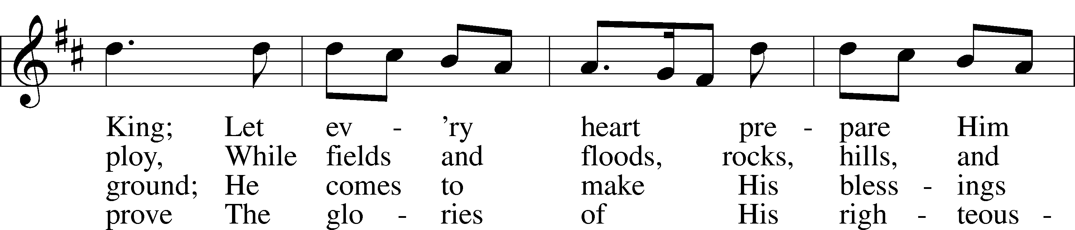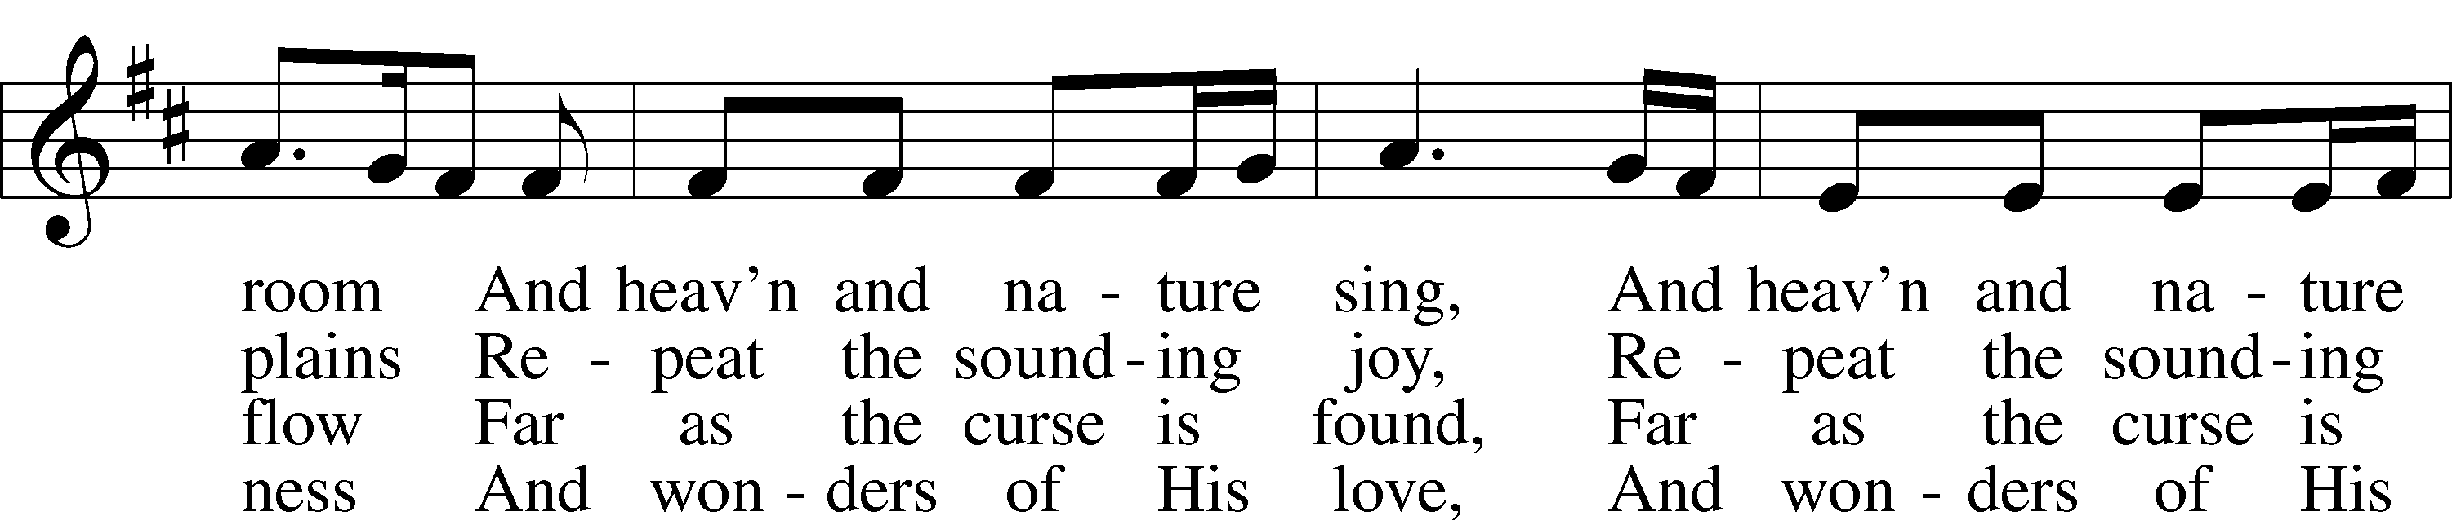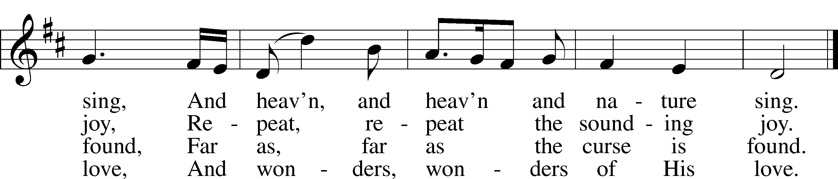

Public domain

**SILENT PRAYER: Father, by the power of your Holy Spirit, I take the Son, Jesus and Immanuel, into my heart and my home now and forevermore. In Christ’s name, I pray. Amen.**

**ANNOUNCEMENTS**

**WELCOME TO GRACE LUTHERAN CHURCH:** We are glad that you are here to worship God with us today! We pray that you will enjoy the wonderful fellowship as friends in Christ as God gathers us around His means of grace, the Word and Sacraments, to bless us with His treasured gifts of forgiveness, faith, abundant life and eternal salvation. If you are a guest, please also sign our Guest Book. Please talk to Pastor if you would like **to learn more about becoming a member of Grace. Also, please join us for refreshments** and fellowship after the Service. We invite you to come and worship with us often as God gathers us in His Grace.

**WELCOME TO THE LORD’S TABLE:** We invite and encourage all present who are baptized and faithful Christians, and who confess the Father, Son, and Holy Spirit to be the only true God and who believe that Jesus Christ died for the sins of the World and is our only hope and salvation…to join us in receiving the very and true body and blood of Christ in this Sacrament. The clear liquid cups in the center of the tray are non-alcoholic wine.

Children not yet confirmed in the faith are always welcome to join their parents at the Lord’s Table, but should keep their hands folded in front of them. The Pastor will give them a blessing.

**SERVING TODAY:** Acolyte: Amelia Bly; Lector: JoAnn Broadbent; Communion Assistant: Don Bly and Edward Morris; Usher: Terry Richardson; Altar Care: The Howard’s; Refreshments: The Howard’s.

**SERVING NEXT SUNDAY:** Acolyte: Eli Morris; Lector: Garnet Picking; Communion Assistants: Vince Winters and Max Broadbent; Usher: Ed Morris; Altar Care: ________; Refreshments: _________.

**FLOWERS**: were placed on the alter to the glory of God for His many blessings and to celebrate the birth of Jesus by the Howard Family.



THIS WEEK AT A GLANCE:

**Today: This Sunday**

9:00 am Worship Service with Communion

10:15 am Fellowship/Refreshments

**Monday: December 26th**

Pastor’s Day Off

5:30 pm Zumba

**Tuesday: December 27th**

3:00 pm Jan’s Mobile Gym (Parish Hall)

6:00 pm Weight Watcher’s (Parish Hall)

**Wednesday: December 28th**

9:00 am Confirmation

**Next Sunday: January 1st**

9:00 am Worship Service with Communion

10:15 am Fellowship/Refreshments

10:30 am Adult Bible Class/Children’s Sunday School

**IN YOUR PRAYERS THIS WEEK:** Family and friends of Will Plagens, Five Walker, Kay Sattelmeier, Megan Schoepf, family of Rev. Alfred Schubert II, Dennis Julson, Vernon Julson, Olga Odland, Jean Grafsgaard, Jenie Howard, Jenny Dean, the family and friends of Yvonne and Vernon Julson, The family of Joseph Boylan, Katie Higgs Wyrwicki, The family of Joe Loftus, George Licis, Kathy Wickers and family, Charles, Braydon, Champ, Amy, Elsie Hamilton, Nancy Amling, Sharon Jardas, Mary Ellen Jessel, Marcos Diaz, Kaci Doran, Auwina Weed, Sandy Harris, and those you are praying for at home. If anyone has a special prayer request please submit it in writing in the collection plate; or you may call Pastor Gary Faith at (504-858-8872), or Kris Howard at (305-296-5161).

**GIFTS, TITHES, & ATTENDANCE LAST SUNDAY** for Sunday December 18th was $3090 the noise offering received totaled $60.73. Our attendance was 104.

**TO HELP US GROW…** The Bible readings for next Sunday’s service readings are Numbers 6:22-27, Galatians 3:23-29, and Luke 2:21.

**STEWARDSHIP LISTS:** On the bulletin board by the front door of the church you will find the Altar Care, Refreshments, and Flower sign-up sheets for 2017. If you are able to help out with any of these please place your name in the spot on the date requested. I will also be putting together the acolyte, lector, communion assistant, and usher assignments this coming week. Please let me know if you would like to assist with any of these. If you need to change your availability to serve please let me know that also. You can either email or call the church office at [gracelutherankw@att.net](mailto:gracelutherankw@att.net) or 305-296-5161. Thank you all for all that you do.

**MISSIONAL COMMUNITES AND TUESDAY’S BIBLE CLASS** will not meet again until January.

**IF ANYONE IS INTERESTED IN TAKING THE ADULT INFORMATION CLASS** because they want to know more about what we teach/believe and/or might be interested in membership please let pastor or Kris know.

**SEARCHING FOR A ROOM FOR RENT**: Daria Skripko, (415)712-4718 is a hostess at Tavern and Town, she is from Belarus. I am here for self-study and I prepare my future course in the UK (a Christian course), saving money for that as in my home country I would spend years for that. I am looking for a rent, affordable one. I would be happy and I appreciate if someone finds it ok to rent a room for me till the end of April, 2017. The rent payment can be around $500, or negotiated. Thank you☺

**SOME DATES TO MARK ON YOUR CALENDAR**

**THE GRACIOUS LADIES OF GRACE**: The Gracious Ladies of Grace dined oceanside again on another beautiful breezy day in paradise at Salute! This restaurant is one of our favorites and never disappoints in anyway. Except....we must get a table on the other side of the restaurant next time because the garbage trucks pick up at noon on Tuesdays!  Most popular this time were the shrimp and grouper cakes and the shrimp salad. Then we passed around two slices of their best in Key West mile high meringue Keylime pie! We gave it all a five* and decided to meet on January 3 at the Hyatt. Merry Christmas and a Happy New Year to one and all 🎄

**A BBQ MEAL TO MEET** Pastor Tilahun Mendedo will be held on January 14th.

**PASTOR TILAHUN WILL BE PREACHING** at our worship service and presenting on the Master Builder Center during our Bible class time – Pastor Tilahun has been serving as a missionary from Ethiopia to the USA for over 10 years.

**STAINED GLASS WINDOWS:** We only have 9 clear glass impact windows in the bathrooms and front entry, and the two side entry doors that need to be replaced.  When those are completed, the entire church will be protected with hurricane proof, impact windows. The cost of the windows is roughly $2000.00 each depending on size. Thank you, donors of the stained-glass windows and to all those who have contributed to the building fund for this project. Your generous giving is much appreciated

**THE GRACE LUTHERAN CHURCH WEB PAGE AND FACE BOOK PAGE** now contains a vocal recording of last week’s sermon. So, if you are not able to attend church on Sunday please go to our website where you will find a copy of the bulletin and a recording of Pastor Faith’s sermon. <https://gracelutherankw.360unite.com/home>.

**A NUMBER OF CAPITAL IMPROVEMENTS** are needed to keep our facilities in good health for the future. Roof repairs are needed on school buildings and the parsonage. If you can help it would be much appreciated! A big thanks to all who

have contributed to these repairs.



**IF YOU ARE INSTRUMENTALLY INCLINED** and would like to share your talents with an instrument during our services or accompany our organist and/or choir, please speak to our organist Debbie Schuetzler.

**MUSIC MINISTRY:** "Make a joyful noise to the Lord, all the earth!" Psalm 100:1. Whether you are here year-round or only part-time, we invite you to participate in our music ministry. Please speak with Beverly Walker or contact her at [beverlywalker@gmail.com](mailto:beverlywalker@gmail.com) if you have any questions.

Children's Choir for Kindergarten - 5th grade - No Rehearsal today. The next rehearsal will be Sunday, January 8 from 10:10 - 10:25. Please meet by the piano.

Bell Choir: The next rehearsal will be Wednesday, January 11 from 5:45 - 6:30 pm.

Vocal Choir: The next rehearsal will be Wednesday, January 11 from 6:30 - 7:30 pm.



**MEN’S BIBLE FELLOWSHIP**: They meet the first and third Wednesday’s of each month at 12:30pm. Their next meeting will be December 21st located at Chico’s on Stock Island. All guys are welcome.

**MISSIONAL COMMUNITES** will not meet again until January.

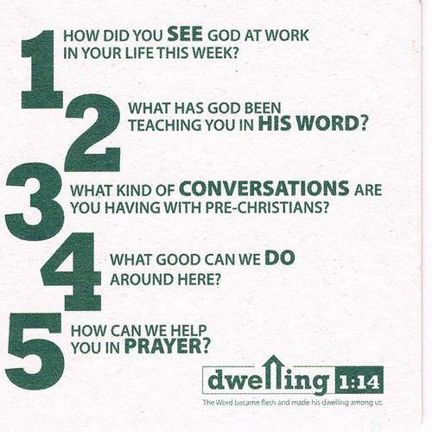

**CHRISTMAS DAY**

**Old Testament Reading:**

**Isaiah 9:2-7**

2The people walking in darkness  
    have seen a great light;  
on those living in the land of deep darkness  
    a light has dawned.  
3You have enlarged the nation  
    and increased their joy;  
they rejoice before you  
    as people rejoice at the harvest,  
as warriors rejoice  
    when dividing the plunder.  
4For as in the day of Midian’s defeat,  
    you have shattered  
the yoke that burdens them,  
    the bar across their shoulders,  
    the rod of their oppressor.  
5Every warrior’s boot used in battle  
    and every garment rolled in blood  
will be destined for burning,  
    will be fuel for the fire.  
6For to us a child is born,  
    to us a son is given,  
    and the government will be on his shoulders.  
And he will be called  
    Wonderful Counselor, Mighty God,  
    Everlasting Father, Prince of Peace.  
7Of the greatness of his government and peace  
    there will be no end.  
He will reign on David’s throne  
    and over his kingdom,  
establishing and upholding it  
    with justice and righteousness  
    from that time on and forever.  
The zeal of the Lord Almighty  
    will accomplish this.

**Epistle: Galatians 4:4-7**

4But when the set time had fully come, God sent his Son, born of a woman, born under the law, 5to redeem those under the law, that we might receive adoption to sonship. 6Because you are his sons, God sent the Spirit of his Son into our hearts, the Spirit who calls out, *“Abba*,Father.” 7So you are no longer a slave, but God’s child; and since you are his child, God has made you also an heir.

**Holy Gospel: Matthew 1:18-25**

18This is how the birth of Jesus the Messiah came about: His mother Mary was pledged to be married to Joseph, but before they came together, she was found to be pregnant through the Holy Spirit. 19Because Joseph her husband was faithful to the law, and yetdid not want to expose her to public disgrace, he had in mind to divorce her quietly.

20But after he had considered this, an angel of the Lord appeared to him in a dream and said, “Joseph son of David, do not be afraid to take Mary home as your wife, because what is conceived in her is from the Holy Spirit. 21She will give birth to a son, and you are to give him the name Jesus, because he will save his people from their sins.”

22All this took place to fulfill what the Lord had said through the prophet: 23“The virgin will conceive and give birth to a son, and they will call him Immanuel” (which means “God with us”).

24When Joseph woke up, he did what the angel of the Lord had commanded him and took Mary home as his wife. 25But he did not consummate their marriage until she gave birth to a son. And he gave him the name Jesus.