September 18th, 2016
9:00 am

EIGHTEENTH
SUNDAY
AFTER
PENTECOST

Grace Lutheran Church
2713 Flagler Ave.
Key West, FL 33040
305-296-5161
GraceLutheranKW@att.net
Pastor Faith
(504) 858-8872
garyfaith@aol.com

EIGHTEENTH SUNDAY AFTER PENTECOST
SEPTEMBER 18TH, 2016 9:00 a.m.
WORSHIP SERVICE
In the Name of Jesus!
Our Mission Statement: Anchored in Christ, each person a missionary.

PRELUDE

ANNOUNCEMENTS:
We welcome you. We are glad you are here to share with us the joy and peace we have in Jesus Christ. It doesn’t matter whether this is your first time in this church or if you are a lifelong member, you are welcome. We come together today in order to celebrate the gift God has given us-His own Son, Jesus, Our Savior.

PREPARATION

(Please Stand…)
HYMN: “All Hail the Power of Jesus' Name” LSB 549
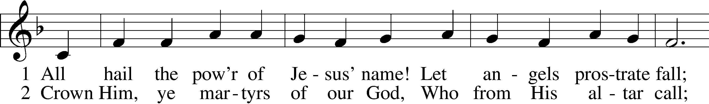
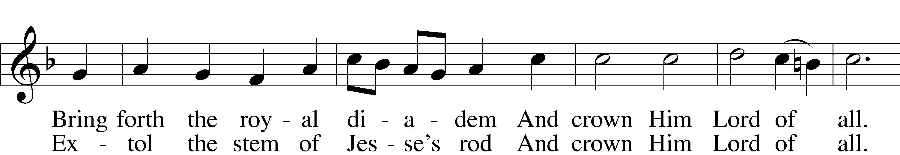
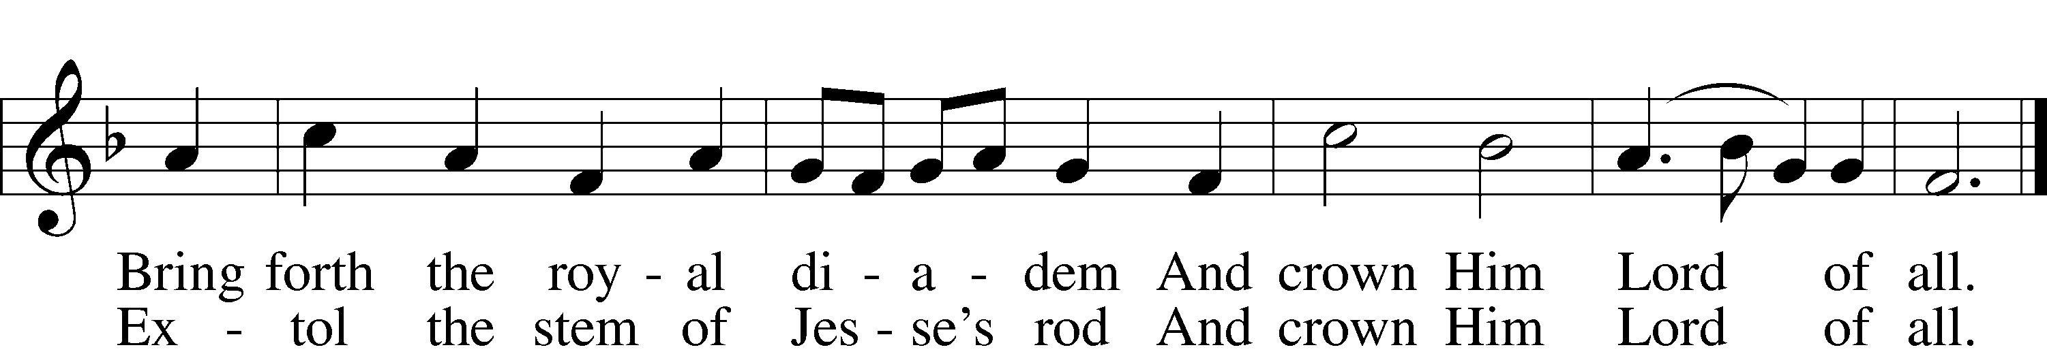

6 Let ev’ry kindred, ev’ry tribe,
On this terrestrial ball
To Him all majesty ascribe
And crown Him Lord of all.
[To Him all majesty ascribe
And crown Him Lord of all.]

7 Oh, that with yonder sacred throng
We at His feet may fall!
We’ll join the everlasting song
And crown Him Lord of all.
[We’ll join the everlasting song
And crown Him Lord of all.]
Public domain

Pastor: In the Name of the Father and of the Son and Holy Spirit.
Congregation: Amen.

(Please Remain Standing Or You May Kneel…)
GOD’S PEOPLE CONFESS THEIR SINS:
Pastor: By grace you have been saved, through faith-and this is not from yourselves, it is the gift of God-not of works, so that no man can boast, for we are God’s workmanship, created in Christ Jesus.
Congregation: I know that nothing good lives in me, that is, in my sinful nature, for I have the desire to do what is good, but I cannot carry it out.
Pastor: What I do is not the good I want to do; no, the evil I do not want to do-this I keep doing.
Congregation: In my heart I delight in God’s law, the law that points out what a wretched person I am! Who will rescue me from this body of death?
Pastor: Thanks be to God through Jesus Christ our Lord! Only He can achieve the perfection we fail to achieve. By the forgiveness He purchased on the cross, our forgiveness is complete!

SERVICE OF THE WORD

You may be seated…
THE FIRST READING: Amos 8:4-7
Lector: This is the Word of the Lord.
People: Thanks be to God.

THE EPISTLE LESSON: 1 Timothy 2:1-15
Lector: This is the Word of the Lord.
People: Thanks be to God.

Please stand…
THE HOLY GOSPEL: Luke 16:1-15
Pastor: The Holy Gospel according to St. Luke the 16th Chapter
People: Glory to You, O Lord.
Pastor: This is the Gospel of the Lord.
People: Praise to You, O Christ!

Please be seated…
CHILDREN’S MESSAGE

NOISE OFERING

THE SERMON HYMN: “I Surrender All” Words by Judson Van DeVenter
CCLI Song # 23189 Public Domain CCLI License # 11157462 All rights reserved. www.ccli.com Music by Winfield Scott Weeden
THE SERMON: “His Hearts Desire” 1 Timothy 2:15

(Please stand…)
THE PROFESSION OF FAITH:
Pastor: God has given us a great message to take to His world. Let us remind ourselves and one another of what that message is:
Pastor: I believe in God the Father, Almighty
Congregation: Maker of heaven and earth
Pastor: And in His Son, Jesus Christ our Lord,
Congregation: Who was conceived by the Holy Spirit
Pastor: Born of the Virgin Mary
Congregation: Suffered under Pontius Pilate
Pastor: Was crucified, died and was buried
Congregation: He descended into hell.
Pastor: On the third day He rose again from the dead,
Congregation: And ascended into heaven
Pastor: And sits on the right hand of God, the Father almighty
Congregation: From there He will come to judge the living and the dead
Pastor: I believe in the Holy Spirit,
Congregation: The Holy Christian Church as
All: the communion of saints; the forgiveness of sins, the resurrection of the body, and the life everlasting. Amen.
(You may be seated…)
OFFERING RECEIVED

(Please stand…)
THE PRAYERS OF THE CHURCH: based on Psalm 98
Pastor: Dear Lord, we thank You for everything You’ve done for us, and most of all for Your own Son, Jesus, our Savior. We will never stop praising You for this wonderful gift.
Congregation: Sing to the Lord a new song, for He has done marvelous things; His right hand and His holy arm have worked salvation for Him.
Pastor: We thank You for those missionaries long ago who brought the Good News to our people. When we were in darkness, You sent men and women to bring us the light. Thank you, Lord.
Congregation: The Lord has made His salvation known and revealed His Righteousness to the nation.
Pastor: O Lord, You are our Savior, we trust in You for all our needs, give healing to the sick, courage to those who are afraid, and peace to those we name in our hearts either silently or out loud. (a moment of silence) We praise You, gracious Lord, for all Your benefits to us. You give us home, friends and family, food, shelter, rest and everything we need. You give us sight and hearing and touch and taste and provide for all of our needs.
Congregation: Shout for joy to the Lord, praise His Name Amen.

SERVICE OF THE SACRAMENT

(Please be seated…)
THE WORDS OF INSTITUTION

DISTRIBUTION HYMNS: “Lord of All Hopefulness” LSB 738
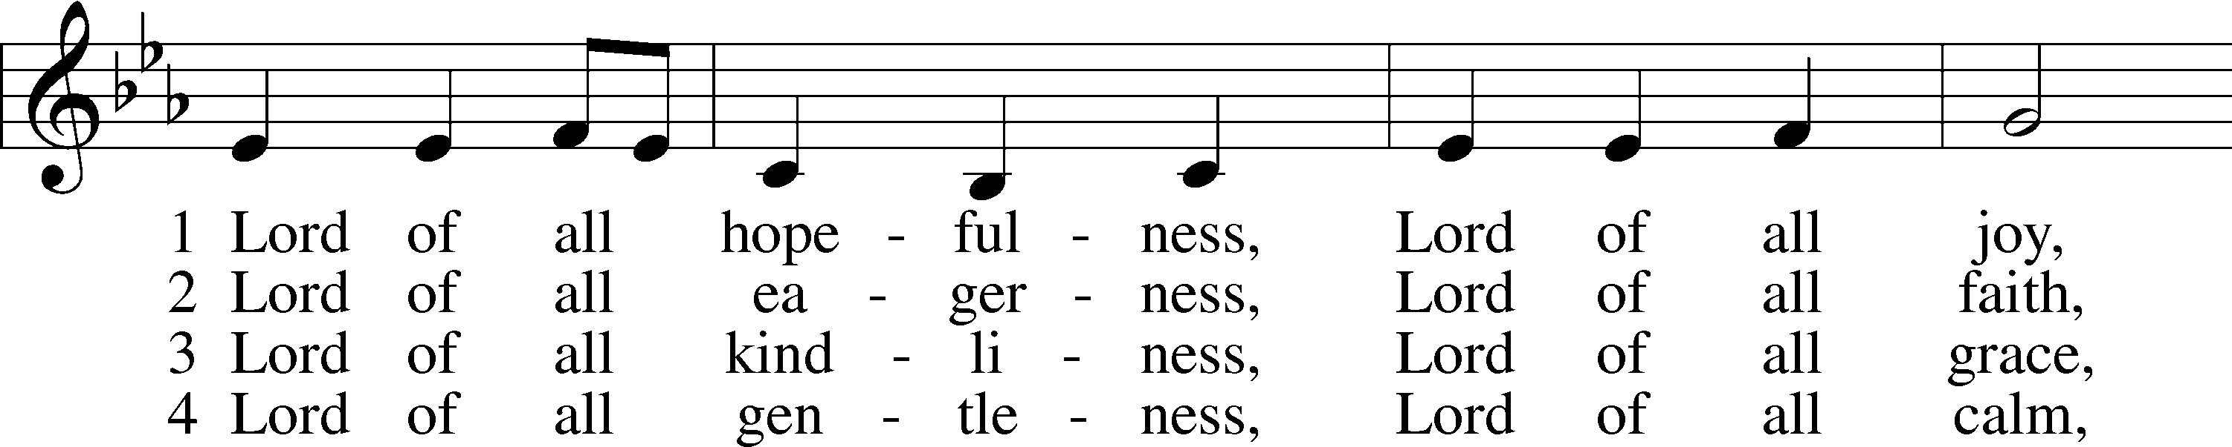
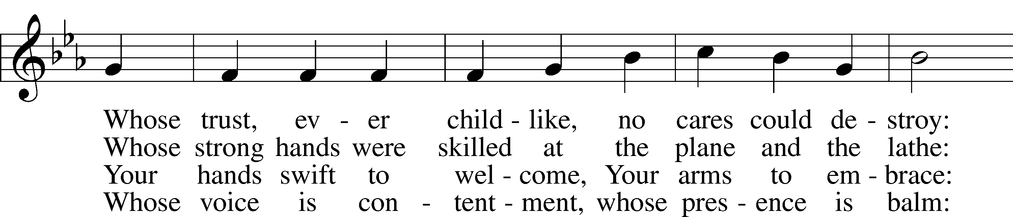
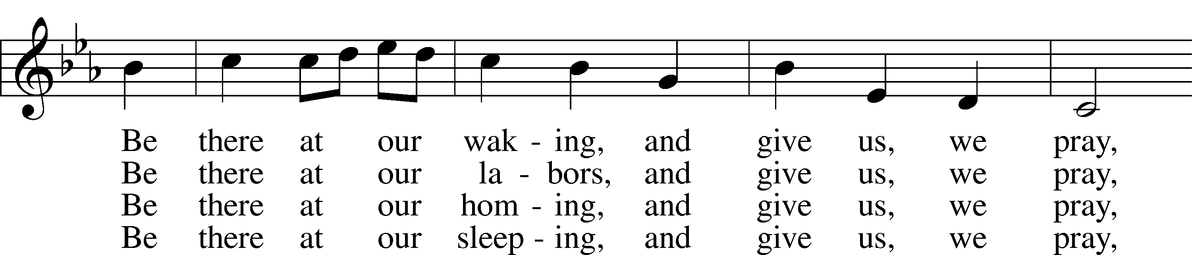
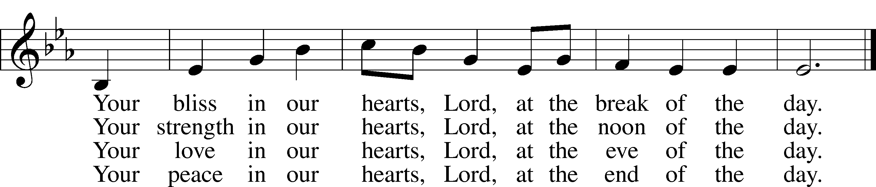
© Oxford University Press. Used by permission: LSB Hymn License .NET, no. 100011641.
Public domain

“Give Thanks with a Grateful Heart” LSB 806
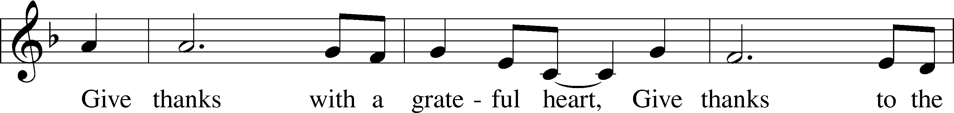
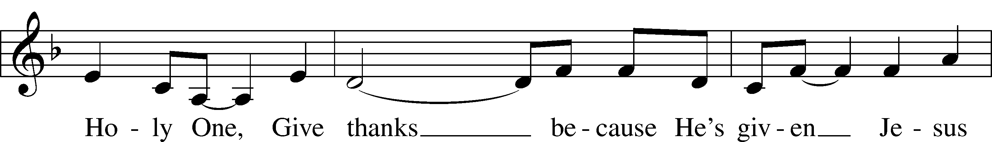
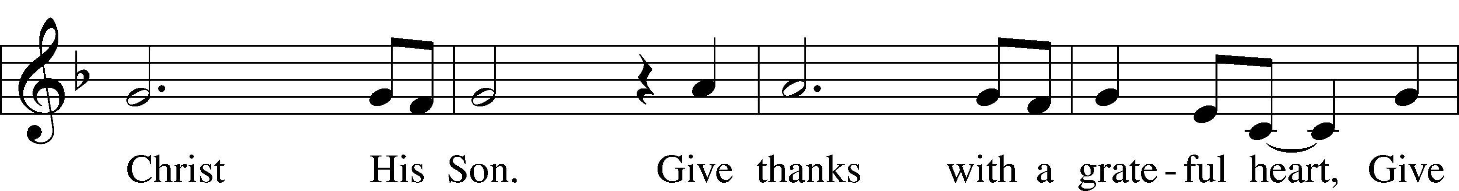
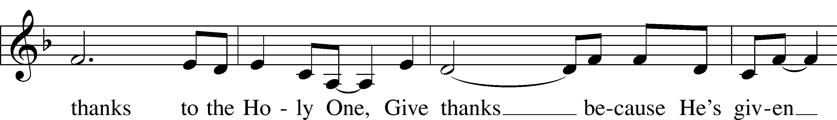
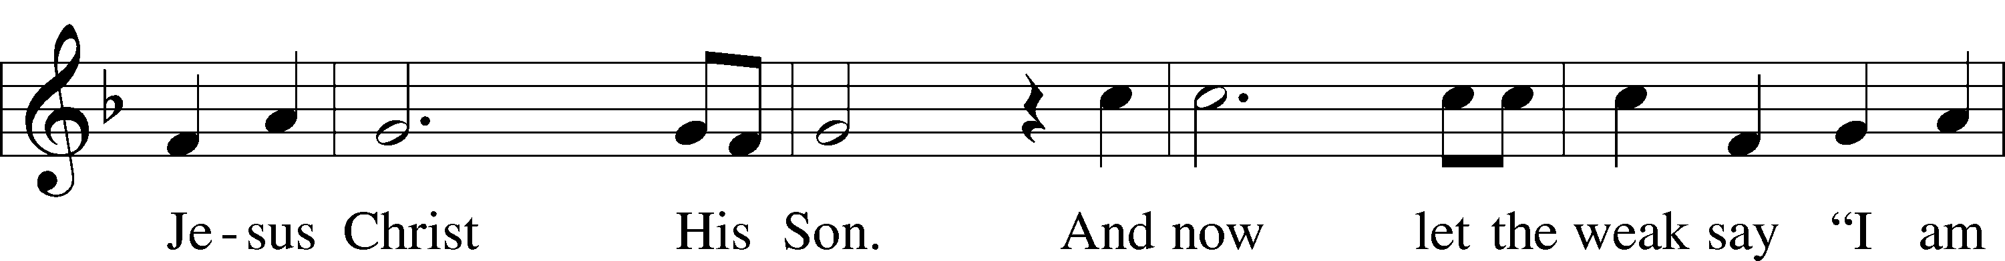
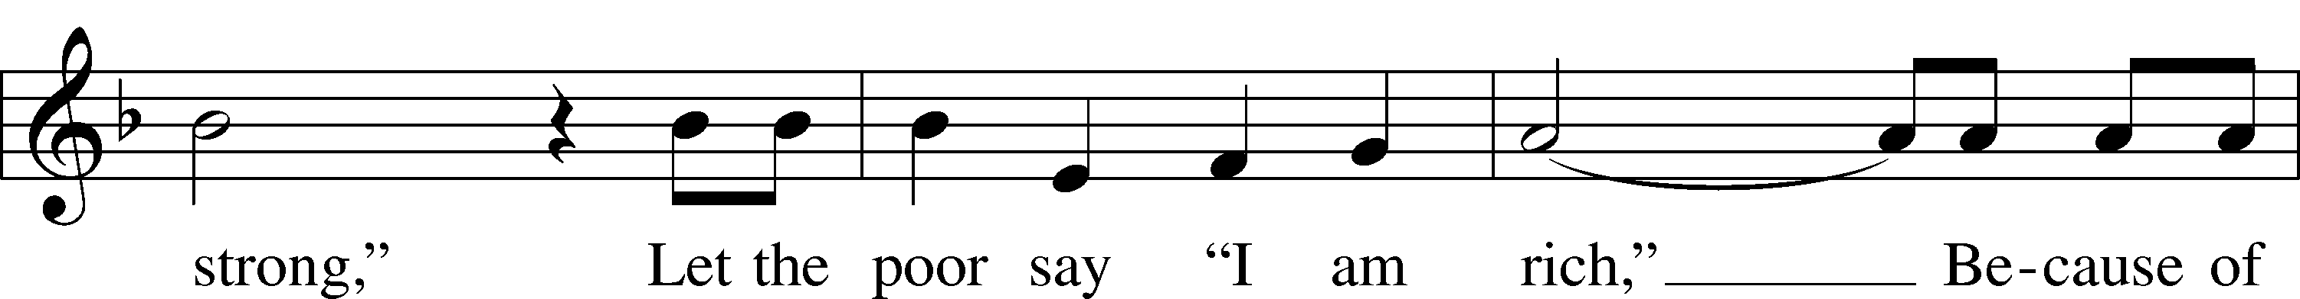
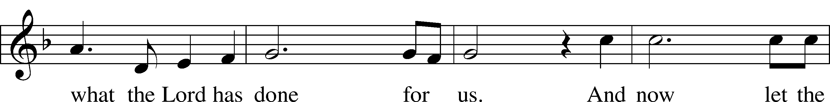
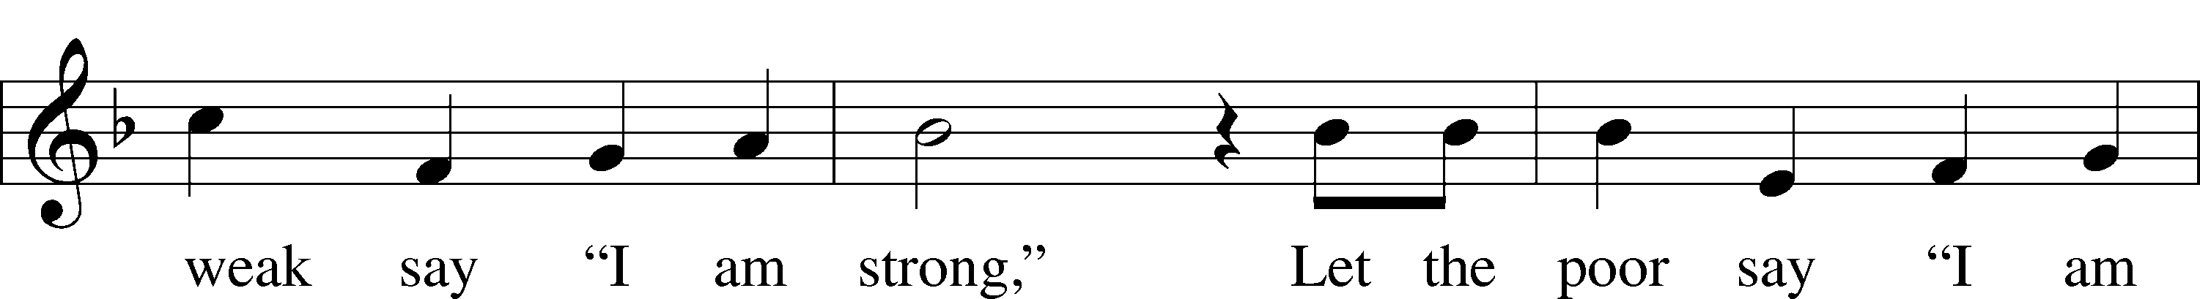
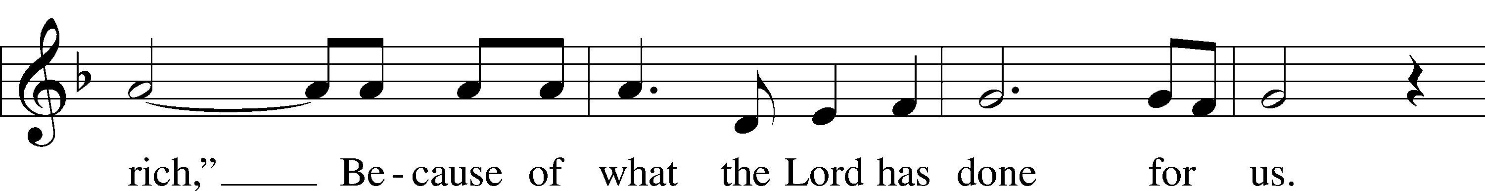
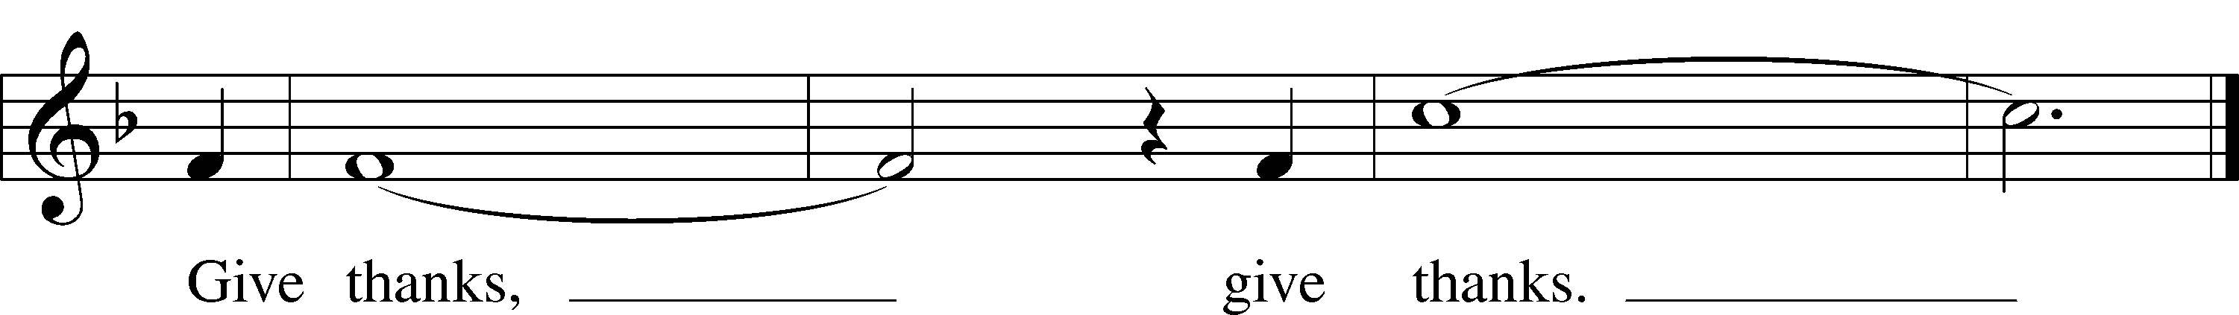
© 1978 Integrity’s Hosanna! Music. Used by permission: LSB Hymn License .NET, no. 100011641.

“Jesus Shall Reign” LSB 832
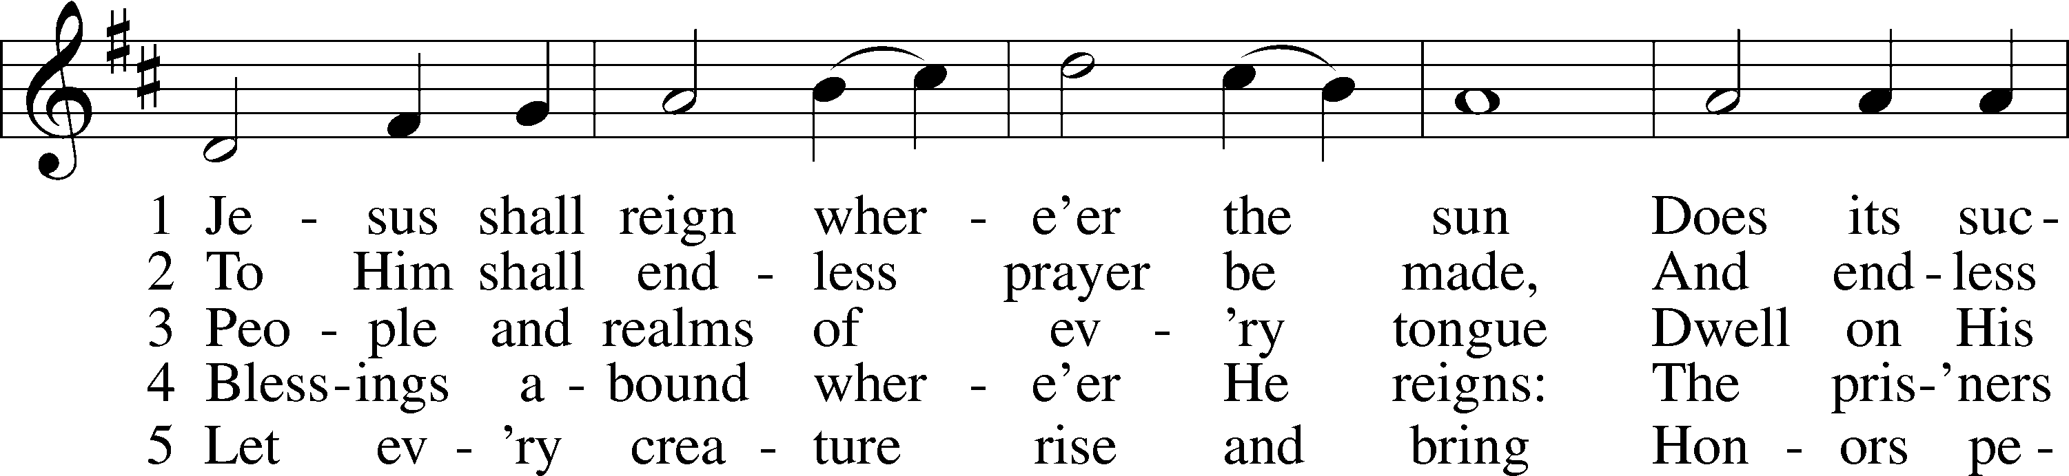
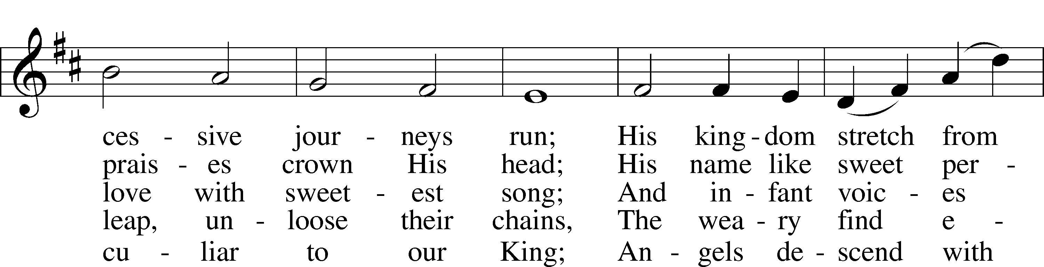
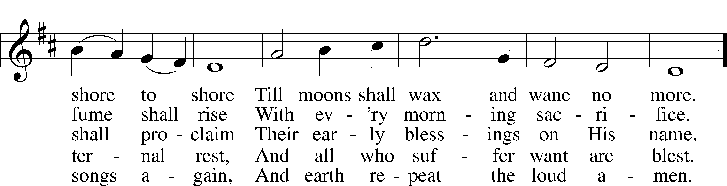
Public domain

Jesus let the things that break your heart
also break our hearts.

Amen

“God Loves Me Dearly” LSB 392
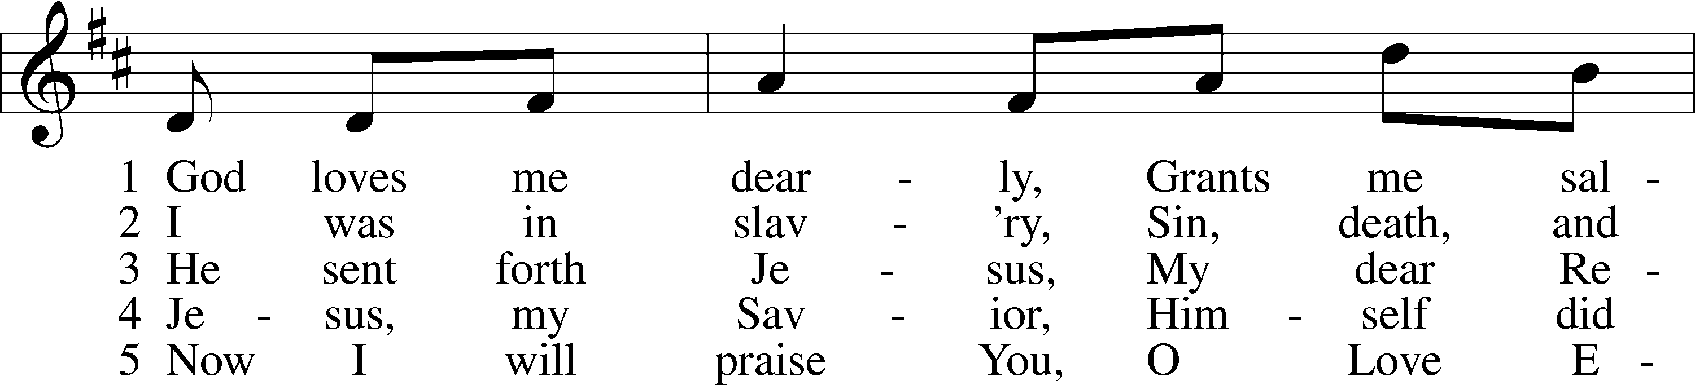
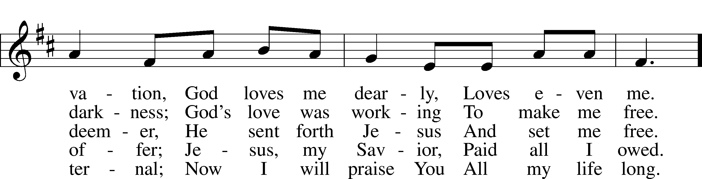
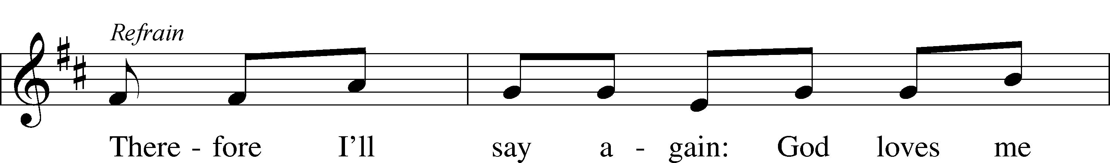
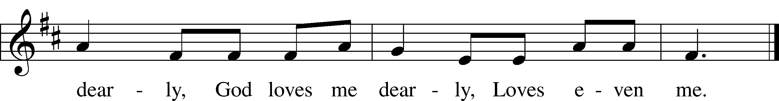
Public domain

(Please stand…)
THE LORD’S PRAYER:
All: Our Father, who art in heaven, hallowed be thy name, thy kingdom come, thy will be done, on earth as it is in heaven. Give us this day our daily bread; and forgive us our trespasses as we forgive those who trespass against us; and lead us not into temptation, but deliver us from evil. For thine is the kingdom, and the power, and the glory, forever and ever. Amen

THE BENEDICTION

THE CLOSING HYMN: “Great Is Thy Faithfulness” LSB 809
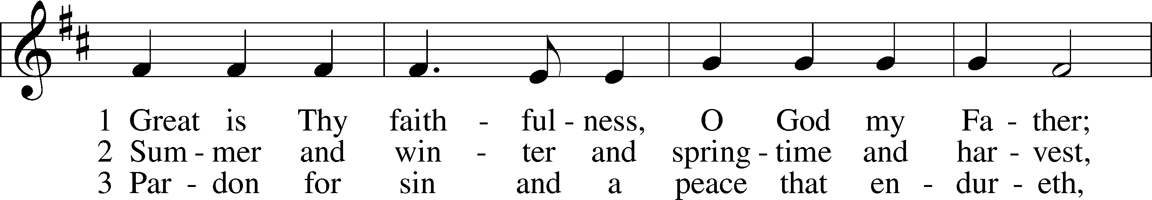
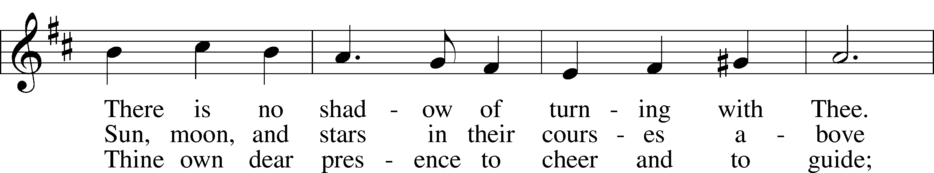
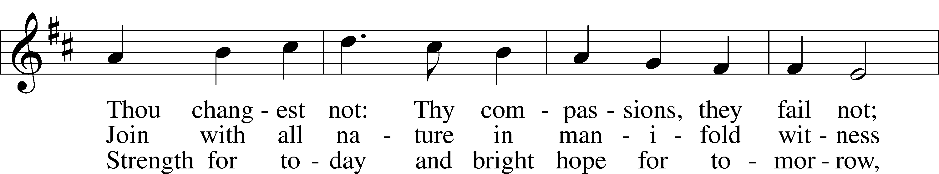
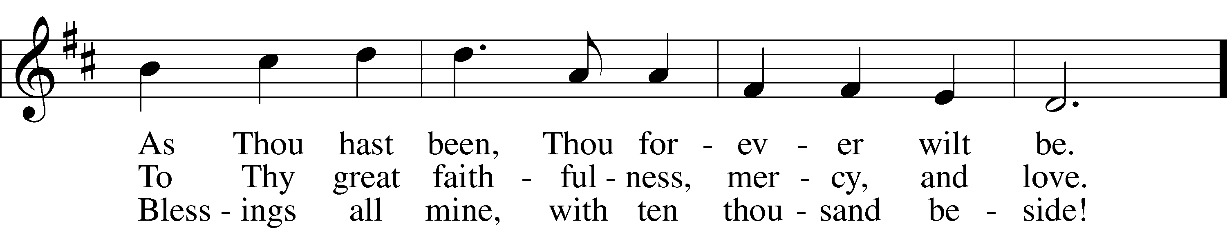
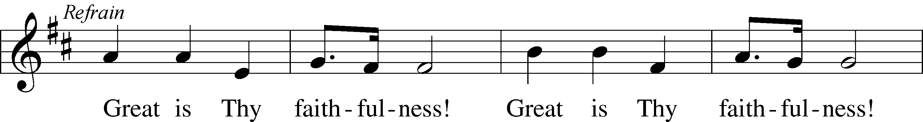
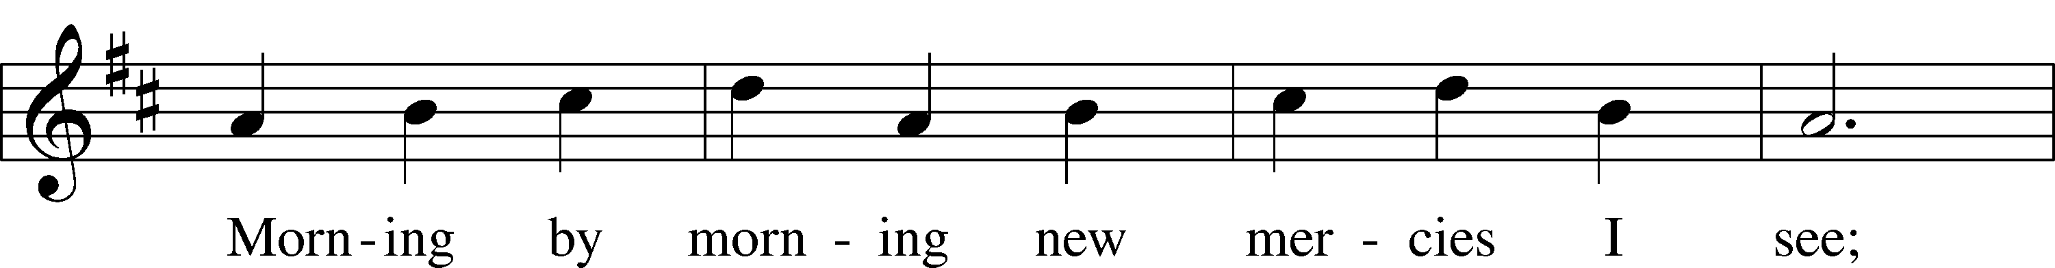
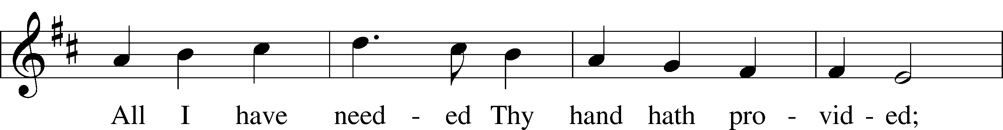
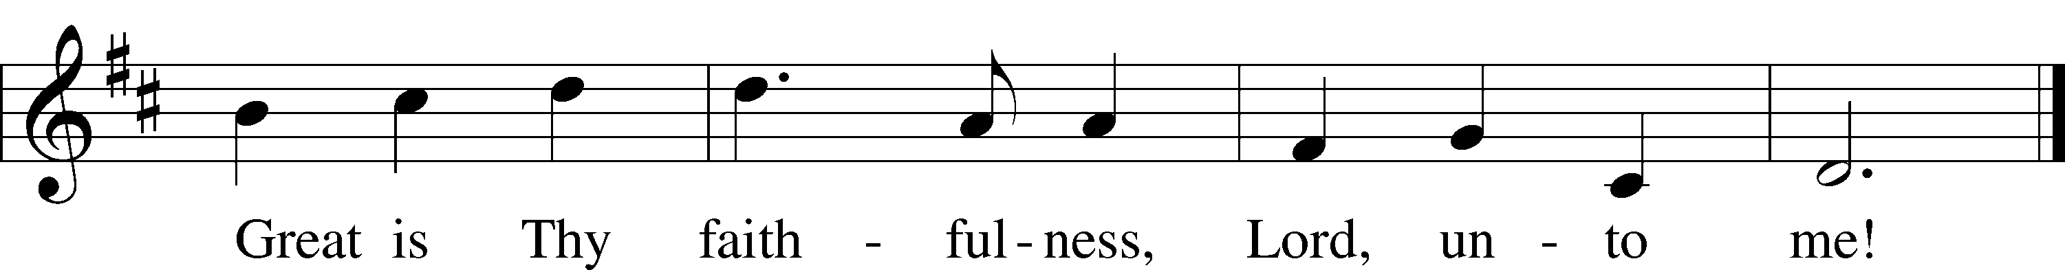
© 1923, renewed 1951 Hope Publishing Co. Used by permission: LSB Hymn License .NET, no. 100011641.

ANNOUNCEMENTS

WELCOME TO GRACE LUTHERAN CHURCH: We are glad that you are here to worship God with us today! We pray that you will enjoy the wonderful fellowship as friends in Christ as God gathers us around His means of grace, the Word and Sacraments, to bless us with His treasured gifts of forgiveness, faith, abundant life and eternal salvation. If you are a guest, please also sign our Guest Book. Please talk to Pastor if you would like to learn more about becoming a member of Grace. Also, please join us for refreshments and fellowship after the Service. We invite you to come and worship with us often as God gathers us in His Grace.

WELCOME TO THE LORD’S TABLE: We invite and encourage all present who are baptized and faithful Christians, and who confess the Father, Son, and Holy Spirit to be the only true God and who believe that Jesus Christ died for the sins of the World and is our only hope and salvation…to join us in receiving the very and true body and blood of Christ in this Sacrament. The clear liquid cups in the center of the tray are non-alcoholic wine.

Children not yet confirmed in the faith are always welcome to join their parents at the Lord’s Table, but should keep their hands folded in front of them. The Pastor will give them a blessing.

SERVING TODAY: Acolyte: Lillian Howard; Lector: Mary Chalmers; Communion Assistants: Don Bly and Deglys Chavarria; Usher: David Rose; Altar Care: ____________; Refreshments: __________.

SERVING NEXT SUNDAY: Acolyte: ___________; Lector: _________; Communion Assistants: Don Bly and Deglys Chavarria; Usher: David Rose; Altar Care: ____________; Refreshments: The Schuetzler Family.

FLOWERS: were placed on the altar today to the glory of God and to celebrate Auwina’s birthday.

THIS WEEK AT A GLANCE:

Today: This Sunday
9:00 am Worship Service with Communion
10:15 am Fellowship
10:30 am Adult / Children’s Bible Class
12:00 pm Adult Information Class

Monday: September 19th
Pastor’s Day Off
5:30 pm Zumba (Parish Hall)

Tuesday: September 20th
3:00 pm Jan’s Mobile Gym (Parish Hall)
6:00 pm Weight Watcher’s (Parish Hall)

Wednesday: September 21st
12:30 pm Men’s Bible Fellowship (Chico’s)

Thursday: September 22nd
5:30 pm Zumba (Parish Hall)
7:00 pm Missional Communities (Room #3)

Next Sunday: September 25th
9:00 am Worship Service with Communion
10:15 am Fellowship/Refreshments
10:30 am Adult / Children’s Bible Class

IN YOUR PRAYERS THIS WEEK: Joe and Sharon Jardas, Mary Ellen Jessel, Marcos Diaz, Kaci Doran, Michael Willard, Auwina Weed, Sandy Harris, and those you are praying for at home. If anyone has a special prayer request please submit it in writing in the collection plate; or you may call Pastor Gary Faith at (504-858-8872), or Kris Howard at (305-296-5161).

GIFTS, TITHES, & ATTENDANCE LAST SUNDAY for Sunday September 11th was $3581.00 and the noise offering was $62.95. Our attendance was 78.

TO HELP US GROW… The Bible readings for next Sunday’s service readings are Amos 6:1-7, 1 Timothy 3:1-13, and Luke 16:19-31.
PASTOR WILL BE ATTENDING the District Pastors Conference in Orland from Monday through Wednesday of this week. If you have needs, please call one of our elders.

THERE WILL BE NO JR CONFIRMATION this week (September 21st). We will resume on Wednesday September 28th.

SOME DATES TO MARK ON YOUR CALENDAR

GRACIOUS LADIES OF GRACE: will meet again on September 27th at Spencer’s which has a 25% discount for the month at 11:30. Fun, Fun, Fun. Please come and join in the wonderful fellowship while enjoying a fantastic meal.

SUNDAY SCHOOL: Sunday school for all ages will follow refreshments from 10:30 until 11:30 in the following rooms.

High school with Pastor Dart is in room number 1 (just past the adult Bible study room on the right)

Middle school, 6th 7th and 8th grades, in room number 3 with Mike Sattelmeier and Jim Schuetzler. (Turn left down the school hallway to the first room) Curriculum is 'Grapple' from Group: an interactive, lively discussion concerning pertinent issues facing middle school, Christian tweens.

3rd, 4th and 5th grades in room 5 with Lynn Jones and Monica Bacle. (third room left down the school hallway) Curriculum is Faithweavers Now: a fun hour of learning how to weave your faith into your daily life with Bible studies, songs, and crafts.

Preschool through second grade with Joanne Broadbent in room 7. (Last room on the left down the school hallway) Curriculum is also Faithweavers Now.

Our teachers are very excited about the classes this year. We are looking forward to a wonderful, fun filled, interactive year with the students! Please prayerfully consider sending your children to these well planned out classes to learn more about Jesus and the Bible and how to live as a Christian in this day and age. Hope to see everyone there! Any questions? Ask Kris Bly, Sunday School director, 305-509-1447 or Kris Howard, church Secretary.

WE HAVE SCHEDULED AN ADULT INFORMATION CLASS: Part 2 will be held today from noon until 2pm.

OKTOBERFEST an opportunity to build relationships. Mark your calendar for Saturday October 8th noon til 3pm. We will be celebrating our annual Oktoberfest at the parsonage. Meat, baked beans, and drinks will be provided. If you like, bring a side dish and lawn chair. There is a sign-up sheet in the Narthex so that Pastor knows how much food to buy. Please sign your name and the guestimated number of people who will be coming with you.

OCTOBER 31ST: Our church and school will be a blessing to the community as we pass out Halloween candy, hotdogs, and such in our back parking lot.

AT OUR MIDWEEK ADVENT GATHERING on December the 7th Ms. Lisa J. Smolowitz from Jews from Jesus will be giving a presentation on Hanukkah.

A BBQ MEAL TO MEET Pastor Tilahun Mendedo will be held on January 14th.

PASTOR TILAHUN WILL BE PREACHING at our worship service and presenting on the Master Builder Center during our Bible class time – Pastor Tilahun has been serving as a missionary from Ethiopia to the USA for over 10 years.

NEW LOCATION - MISSIONAL COMMUNITIE: Missional Communities continues again this Thursday. We have changed the location from the parsonage to classroom #3. We plan on meeting every Thursday to talk about how we see God at work and as time allows we will also prepare for Sunday worship by looking at the appointed scriptures for that Sunday. Everyone is welcome and encouraged to attend. We will start the 5 Questions at 7pm and end the session by 8pm. The room will be open at 6:30 for those who like to arrive early and chat.

STAINED GLASS WINDOWS: We only have 9 clear glass impact windows in the bathrooms and front entry, and the two side entry doors that need to be replaced. When those are completed, the entire church will be protected with hurricane proof, impact windows. The cost of the windows is roughly $2000.00 each depending on size. Thank you donors of the stained glass windows and to all those who have contributed to the building fund for this project. Your generous giving is much appreciated

THE GRACE LUTHERAN CHURCH WEB PAGE AND FACE BOOK PAGE now contains a vocal recording of last week’s sermon. So if you are not able to attend church on Sunday please go to our website where you will find a copy of the bulletin and a recording of Pastor Faith’s sermon.

A NUMBER OF CAPITAL IMPROVEMENTS are needed to keep our facilities in good health for the future. The narthex has been rebuilt. Roof repairs are needed on school buildings. If you can help it would be much appreciated! A big thanks to all who
have contributed to these repairs.

MUSIC MINISTRY: "Make a joyful noise to the Lord, all the earth!" Psalm 100:1. Whether you are here year-round or only part-time, we invite you to participate in our music ministry. Please speak with Beverly Walker or contact her at beverlywalker@gmail.com if you have any questions.

Children's Choir for Kindergarten - 5th Grade is today from 10:10 – 10:25. Please meet by the piano. We will be done in time for Sunday School.

Bell Choir begins on Wednesday, September 28 from 5:45 to 6:30 pm. Anyone in 5th grade - adult is welcome to join us.

Vocal Choir begins on Saturday, October 1 from 11:00 am - 12 noon.

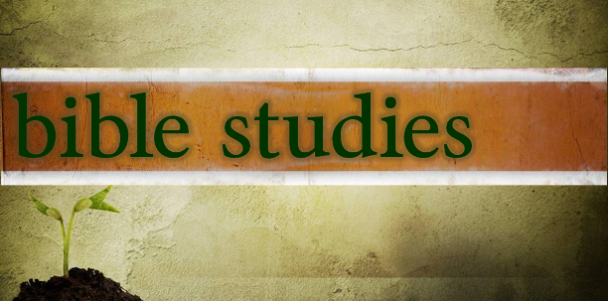

WOMEN’S BIBLE STUDY: The Ladies Bible Study finished their studies on “Stories of Deliverance from the Old Testament”, asking 7 questions that answered why it was told and what we are to take from it, mainly asking how does this story show how God loves me. We are looking forward to a new study in the fall please consider joining us for an hour of interesting insights and lively discussions.

MEN’S BIBLE FELLOWSHIP: They meet the first and third Wednesday’s of each month at 12:30pm. Their next meeting will be September 21st located at Chico’s on Stock Island. All guys are welcome.

