**September 11th, 2016**

**9:00 am**

**SEVENTEENTH**

**SUNDAY AFTER**

**PENTECOST**



**Grace Lutheran Church**

**2713 Flagler Ave.**

**Key West, FL 33040**

**305-296-5161**

**GraceLutheranKW@att.net**

**Pastor Faith**

**(504) 858-8872**

**garyfaith@aol.com**

**SEVENTEENTH SUNDAY AFTER PENTECOST**

**SEPTEMBER 11TH, 2016 9:00 a.m.**

**WORSHIP SERVICE**

***In the Name of Jesus!***

**Our Mission Statement: Anchored in Christ, each person a missionary.**

**PRELUDE**

**ANNOUNCEMENTS:**

**We welcome you. We are glad you are here to share with us the joy and peace we have in Jesus Christ. It doesn’t matter whether this is your first time in this church or if you are a lifelong member, you are welcome. We come together today in order to celebrate the gift God has given us-His own Son, Jesus, Our Savior.**

**PREPARATION**

*(Please Stand…)*

**HYMN:  *“Come, Thou Fount of Every Blessing”* LSB 686**

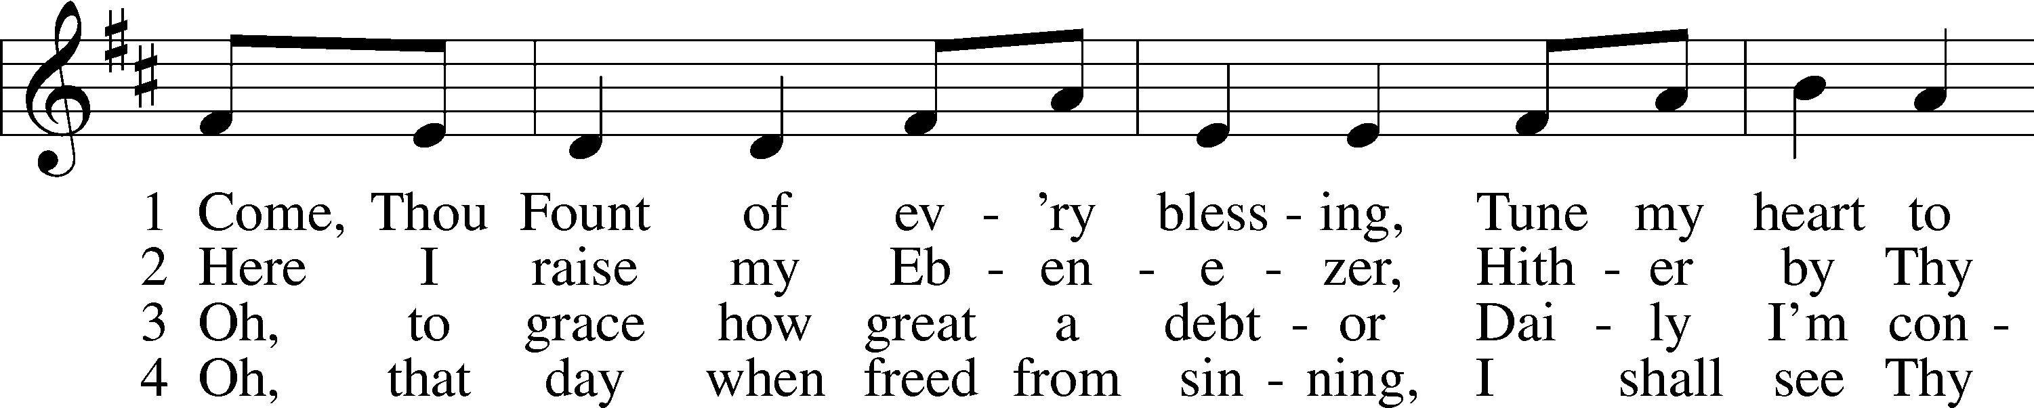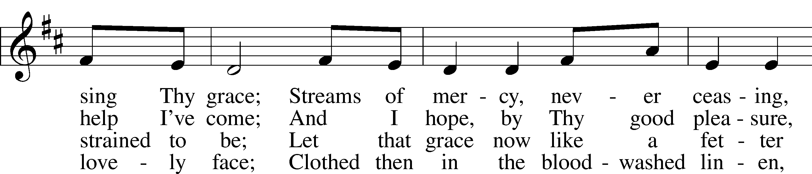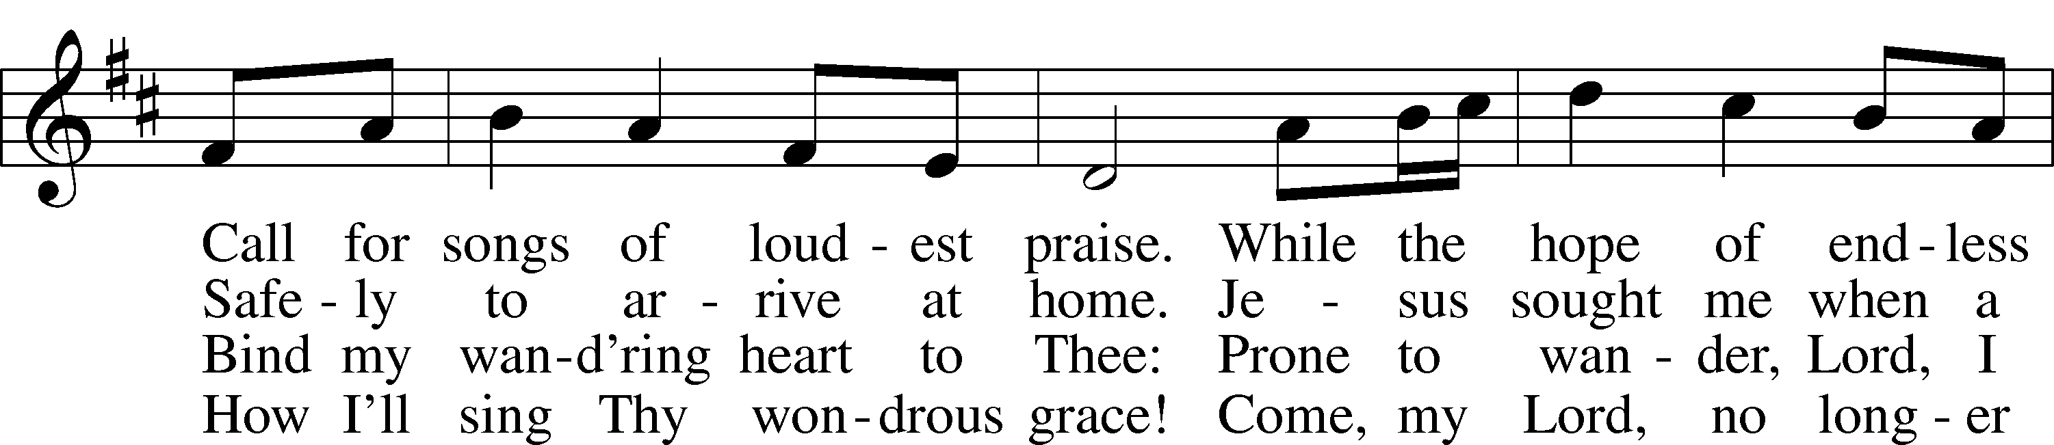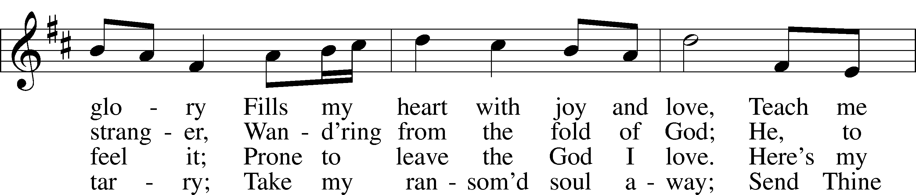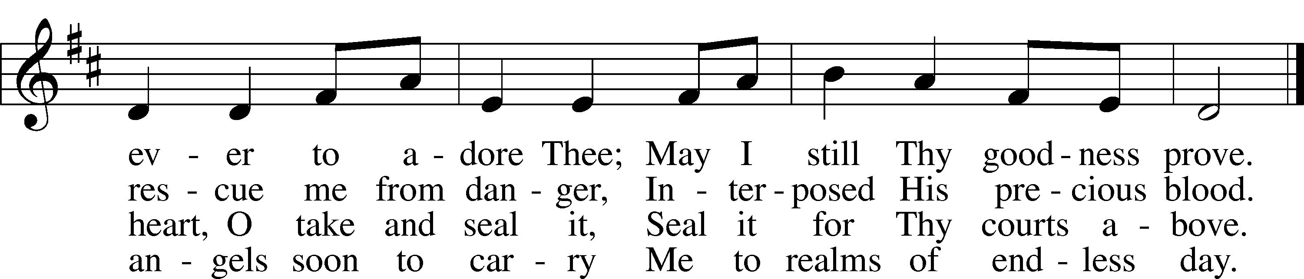

Public domain

Pastor: In the Name of the Father and of the Son and Holy Spirit.

**Congregation: Amen.**

*(Please Remain Standing Or You May Kneel…)*

**GOD’S PEOPLE CONFESS THEIR SINS:**

Pastor: By grace you have been saved, through faith-and this is not from yourselves, it is the gift of God-not of works, so that no man can boast, for we are God’s workmanship, created in Christ Jesus.

**Congregation: I know that nothing good lives in me, that is, in my sinful nature, for I have the desire to do what is good, but I cannot carry it out.**

Pastor: What I do is not the good I want to do; no, the evil I do not want to do-this I keep doing.

**Congregation: In my heart I delight in God’s law, the law that points out what a wretched person I am! Who will rescue me from this body of death?**

Pastor: Thanks be to God through Jesus Christ our Lord! Only He can achieve the perfection we fail to achieve. By the forgiveness He purchased on the cross, our forgiveness is complete!



**SERVICE OF THE WORD**

*You may be seated…*

**THE FIRST READING: Ezekiel 34:11-24**

Lector: This is the Word of the Lord.

**People: Thanks be to God.**

**THE EPISTLE LESSON: 1 Timothy 1:12-17**

Lector: This is the Word of the Lord.

**People: Thanks be to God.**

*Please stand…*

**THE HOLY GOSPEL: Luke 15:1-10**

Pastor: The Holy Gospel according to St. Luke the 15th Chapter

**People: Glory to You, O Lord.**

Pastor: This is the Gospel of the Lord.

**People: Praise to You, O Christ!**

*Please be seated…*

**CHILDREN’S MESSAGE**

**NOISE OFERING**

**THE SERMON HYMN: *“Standing on the Promises”* *Words & Music by Russell Kelso Carter***

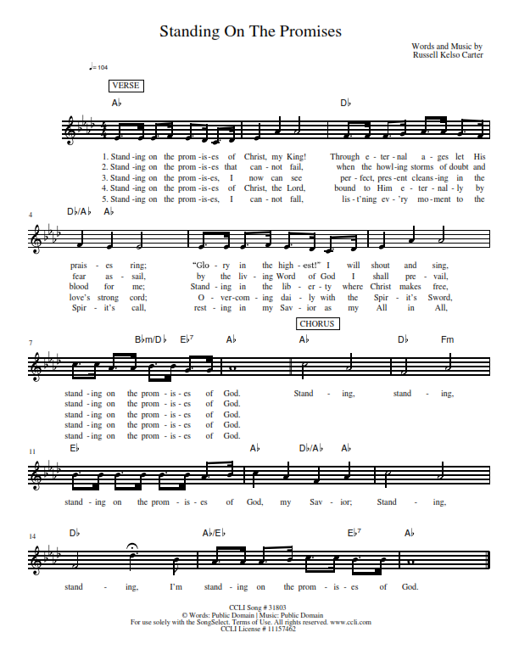

CCLI Song # 31803 ©Words: Public Domain │ Music: Public Domain For use soley with the SongSelect Terms of Use. All rights reserved. [www.ccli.com](http://www.ccli.com) CCLI License #11157462

**THE SERMON: *“Rejoice with Me”* Luke 15:1-10**



Jesus let the things that break

your heart also break our hearts.

Amen

*(Please stand…)*

**THE PROFESSION OF FAITH:**

Pastor: God has given us a great message to take to His world. Let us remind ourselves and one another of what that message is:

Pastor: I believe in God the Father, Almighty

**Congregation: Maker of heaven and earth**

Pastor: And in His Son, Jesus Christ our Lord,

**Congregation: Who was conceived by the Holy Spirit**

Pastor: Born of the Virgin Mary

**Congregation: Suffered under Pontius Pilate**

Pastor: Was crucified, died and was buried

**Congregation: He descended into hell.**

Pastor: On the third day He rose again from the dead,

**Congregation: And ascended into heaven**

Pastor: And sits on the right hand of God, the Father almighty

**Congregation: From there He will come to judge the living and the dead**

Pastor: I believe in the Holy Spirit,

**Congregation: The Holy Christian Church as**

**All: the communion of saints; the forgiveness of sins, the resurrection of the body, and the life everlasting. Amen.**

*(You may be seated…)*

**OFFERING RECEIVED**

**(***Please stand…)*

**THE PRAYERS OF THE CHURCH: based on Psalm 98**

Pastor: Dear Lord, we thank You for everything You’ve done for us, and most of all for Your own Son, Jesus, our Savior. We will never stop praising You for this wonderful gift.

**Congregation: Sing to the Lord a new song, for He has done marvelous things; His right hand and His holy arm have worked salvation for Him.**

Pastor: We thank You for those missionaries long ago who brought the Good News to our people. When we were in darkness, You sent men and women to bring us the light. Thank you, Lord.

**Congregation: The Lord has made His salvation known and revealed His Righteousness to the nation.**

Pastor: O Lord, You are our Savior, we trust in You for all our needs, give healing to the sick, courage to those who are afraid, and peace to those we name in our hearts either silently or out loud. **(a moment of silence)** We praise You, gracious Lord, for all Your benefits to us. You give us home, friends and family, food, shelter, rest and everything we need. You give us sight and hearing and touch and taste and provide for all of our needs.

**Congregation: Shout for joy to the Lord, praise His Name Amen.**

**SERVICE OF THE SACRAMENT**

*(Please be seated…)*

**THE WORDS OF INSTITUTION**

**DISTRIBUTION HYMNS: *“I Am Jesus' Little Lamb”* LSB 740**

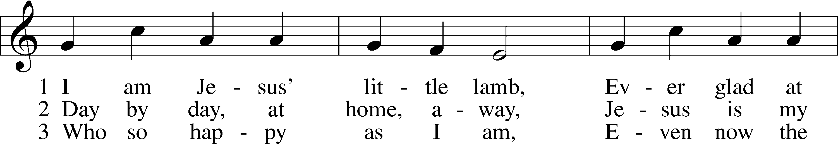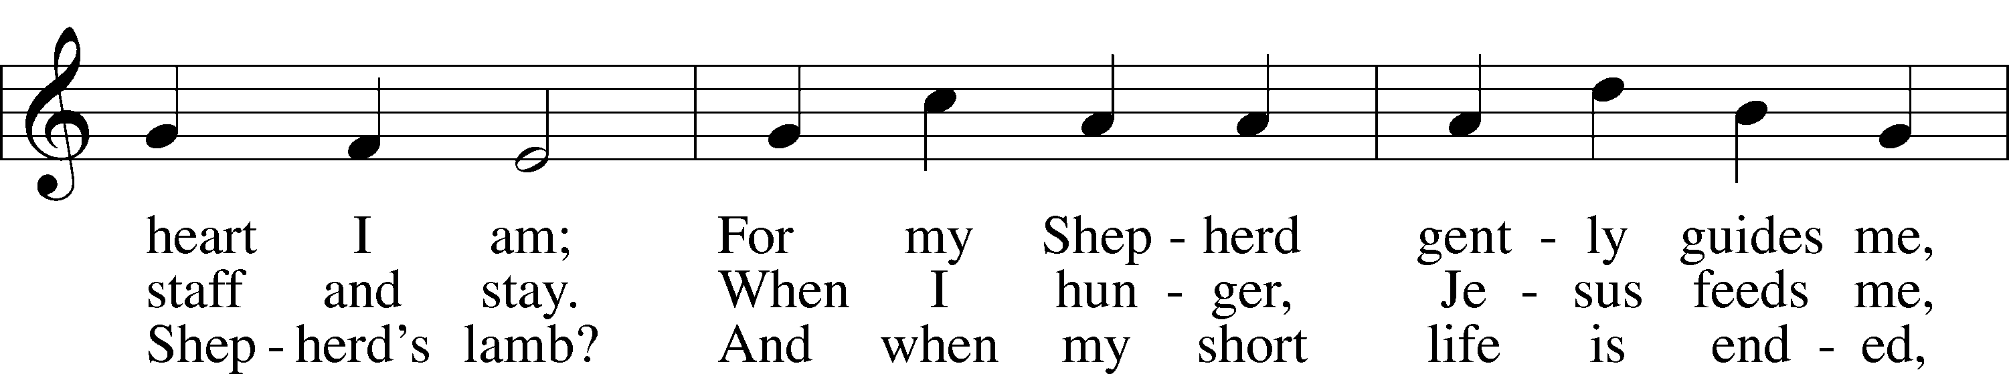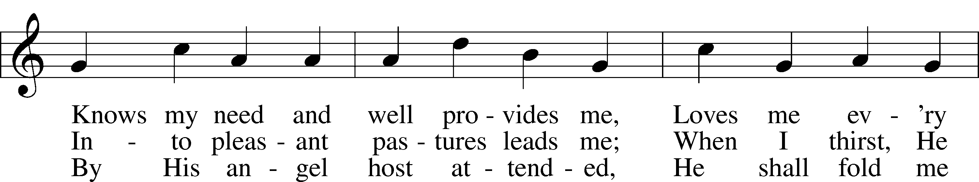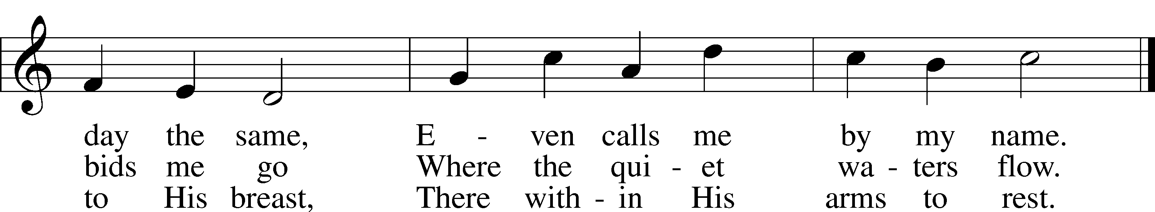

Public domain

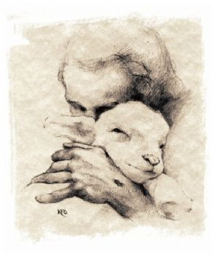

***“Lamb of God”* LSB 550**

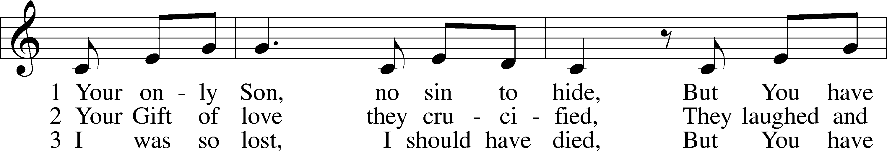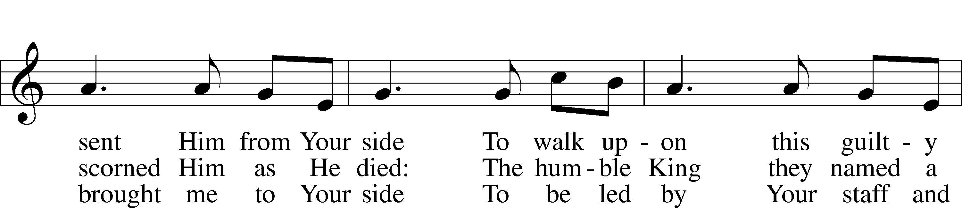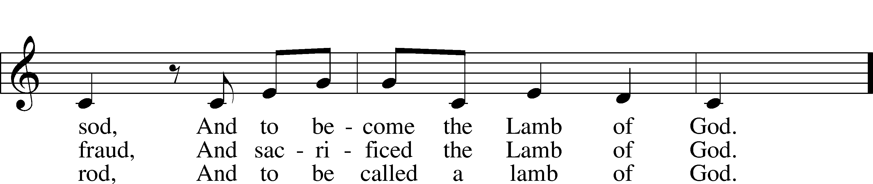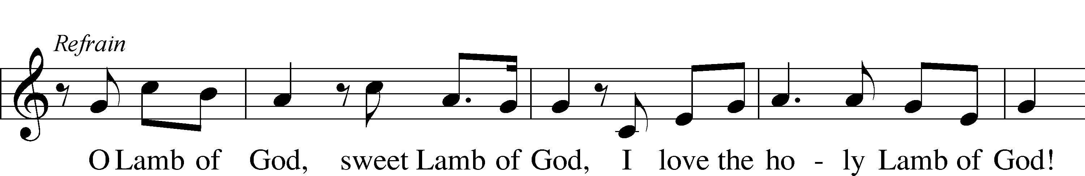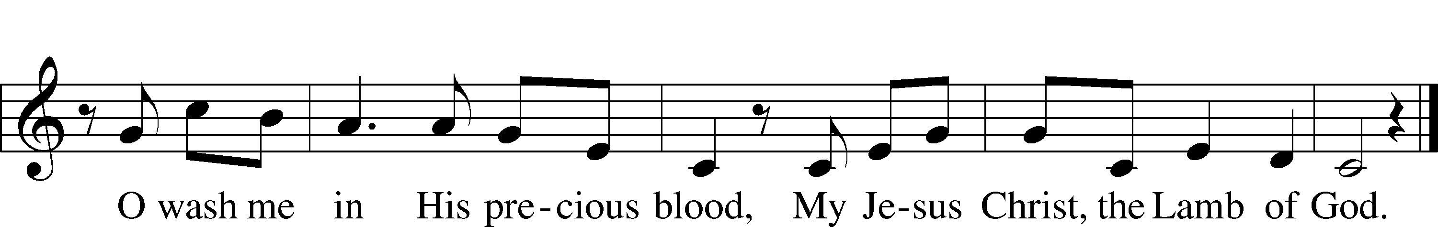

© 1985 Straightway Music; admin. EMI . Used by permission: LSB Hymn License .NET, no. 100011641.

***“Precious Lord, Take My Hand”* LSB 739**

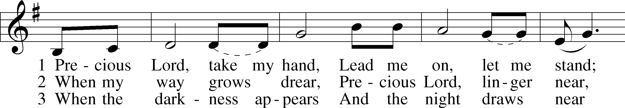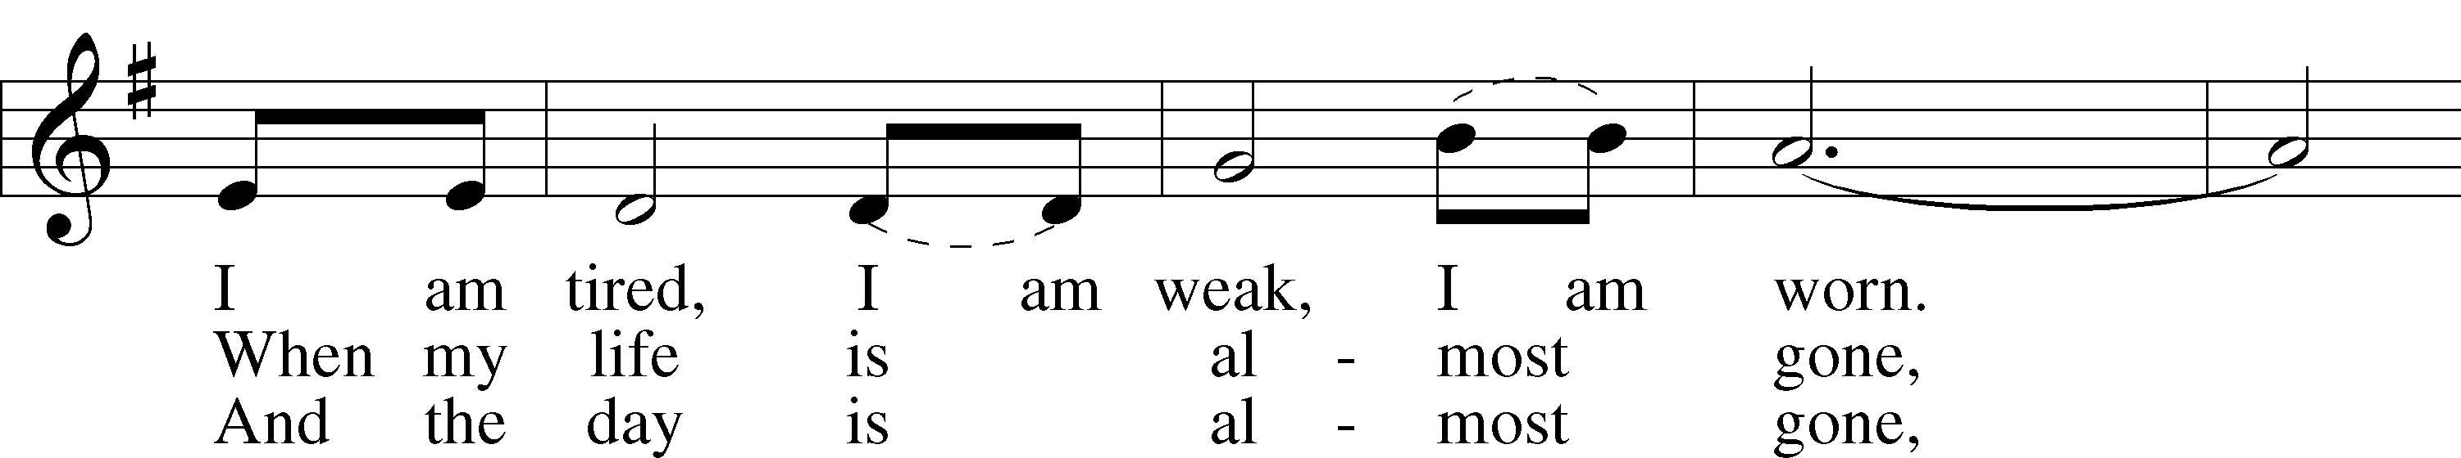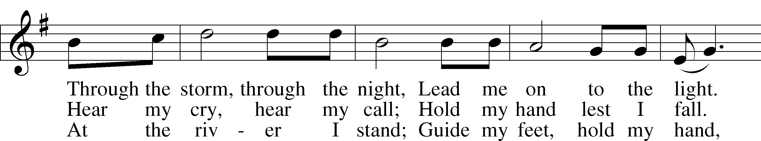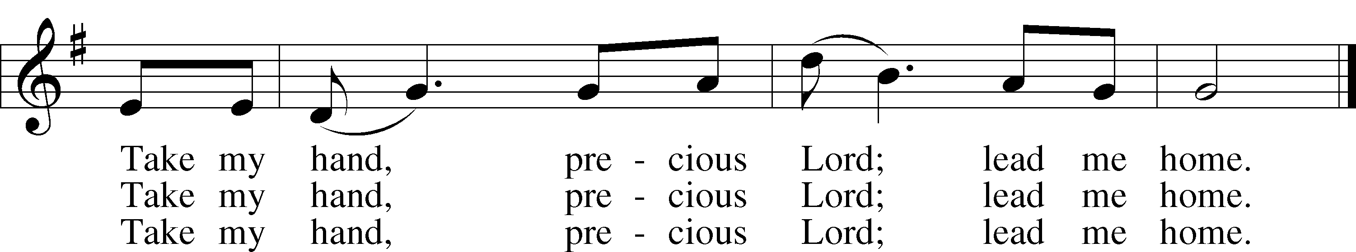

© 1938 Unichappell Music; admin. Alfred Publishing Co., Inc. Used by permission: LSB Hymn License .NET, no. 100011641.

***“The Lord's My Shepherd, I'll Not Want”* LSB 710**

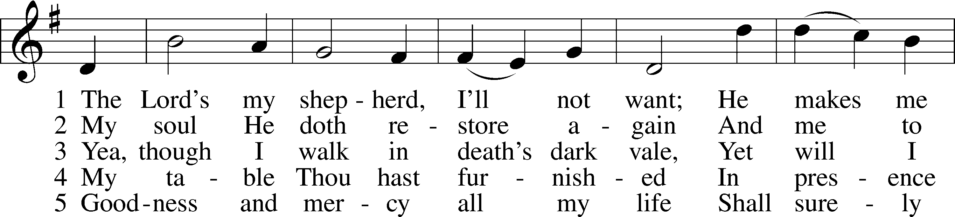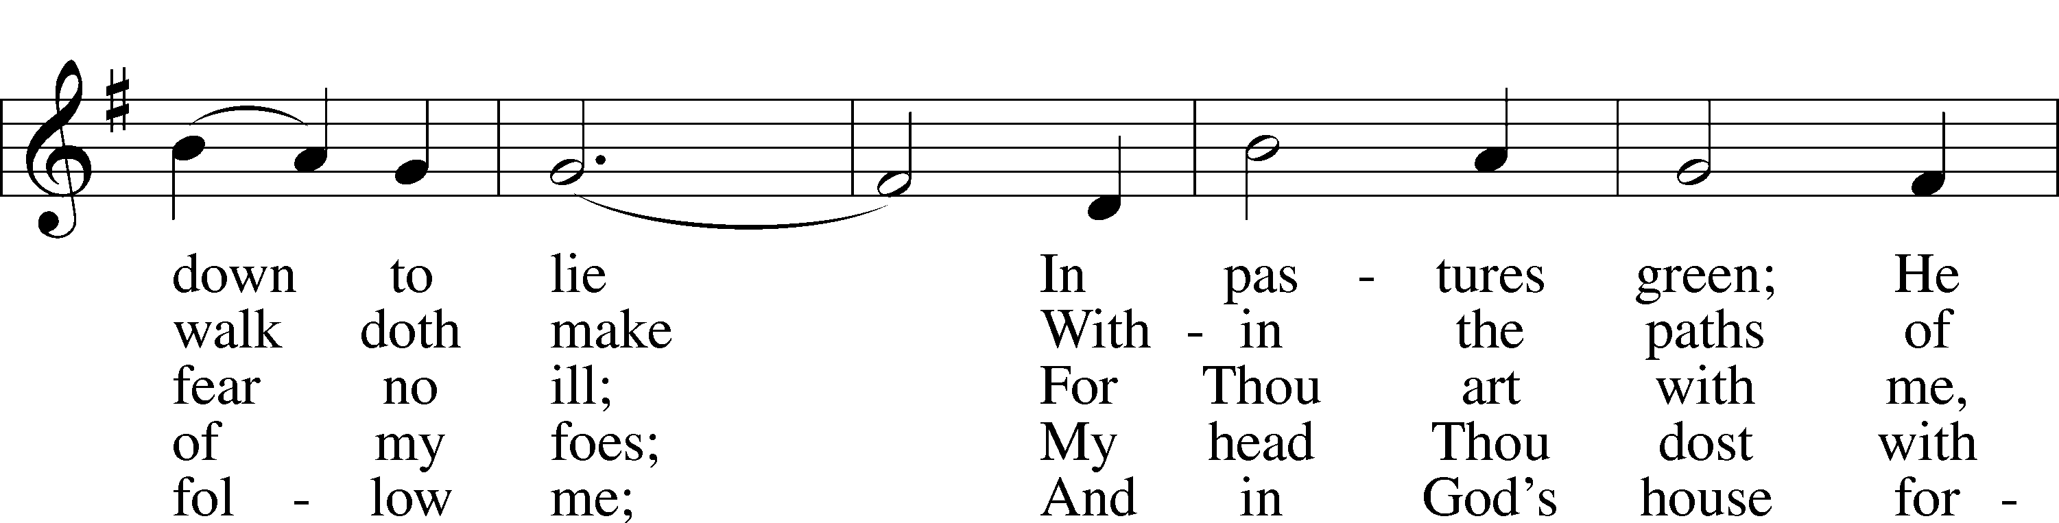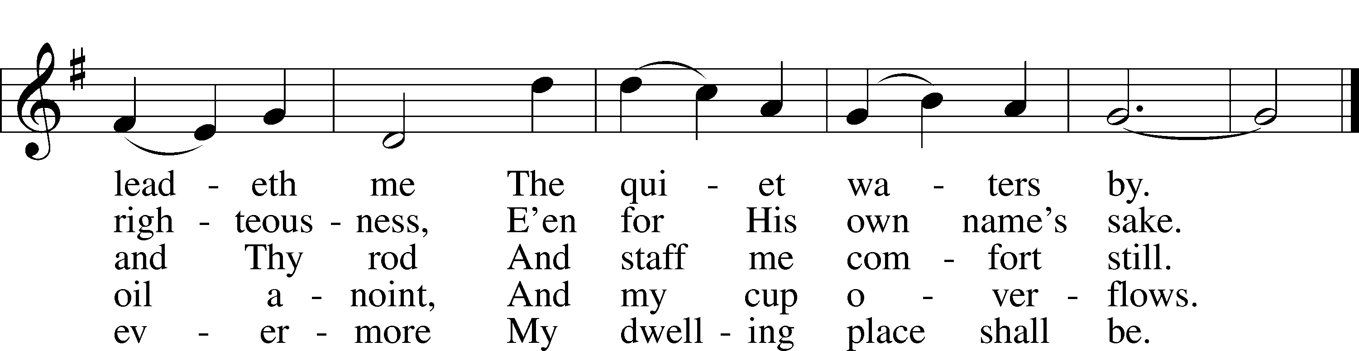

Public domain

*(Please stand…)*

**THE LORD’S PRAYER:**

**All: Our Father, who art in heaven, hallowed be thy name, thy kingdom come, thy will be done, on earth as it is in heaven. Give us this day our daily bread; and forgive us our trespasses as we forgive those who trespass against us; and lead us not into temptation, but deliver us from evil. For thine is the kingdom, and the power, and the glory, forever and ever. Amen**

**THE BENEDICTION**

**THE CLOSING HYMN: *“Joyful, Joyful We Adore Thee”* LSB 803**

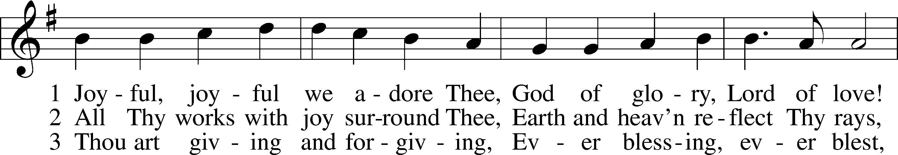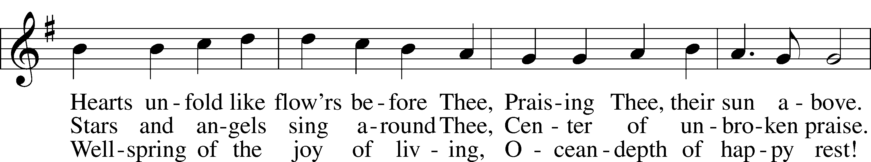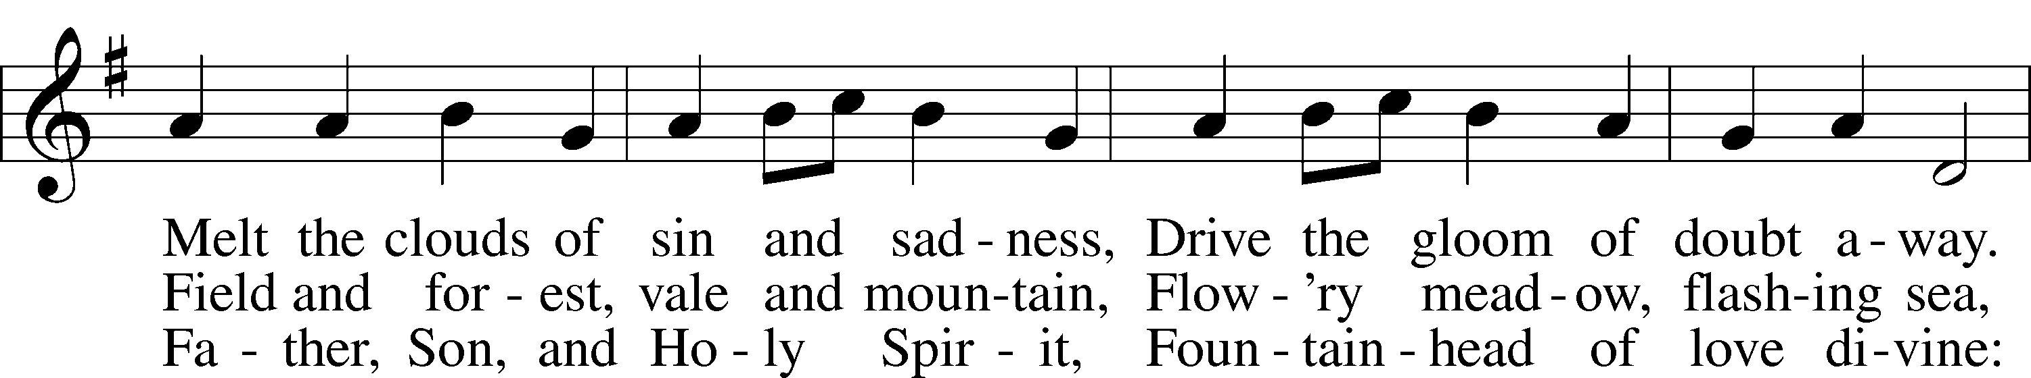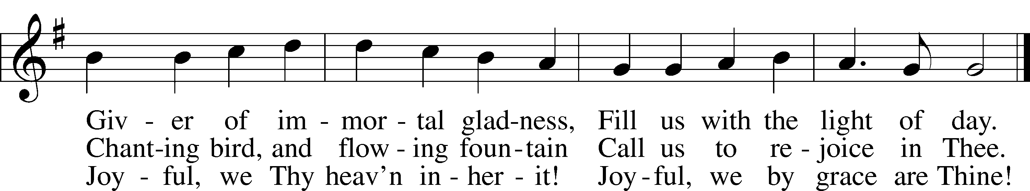

Public domain



**ANNOUNCEMENTS**

**WELCOME TO GRACE LUTHERAN CHURCH:** We are glad that you are here to worship God with us today! We pray that you will enjoy the wonderful fellowship as friends in Christ as God gathers us around His means of grace, the Word and Sacraments, to bless us with His treasured gifts of forgiveness, faith, abundant life and eternal salvation. If you are a guest, please also sign our Guest Book. Please talk to Pastor if you would like **to learn more about becoming a member of Grace. Also, please join us for refreshments** and fellowship after the Service. We invite you to come and worship with us often as God gathers us in His Grace.

**WELCOME TO THE LORD’S TABLE:** We invite and encourage all present who are baptized and faithful Christians, and who confess the Father, Son, and Holy Spirit to be the only true God and who believe that Jesus Christ died for the sins of the World and is our only hope and salvation…to join us in receiving the very and true body and blood of Christ in this Sacrament. The clear liquid cups in the center of the tray are non-alcoholic wine.

Children not yet confirmed in the faith are always welcome to join their parents at the Lord’s Table, but should keep their hands folded in front of them. The Pastor will give them a blessing.

**SERVING TODAY:** Acolyte: Elizabeth Reynolds; Lector: Jessy Archer; Communion Assistants: Don Bly and Deglys Chavarria; Usher: David Rose; Altar Care: ____________; Refreshments: Kim McGee.

**SERVING NEXT SUNDAY:** Acolyte: Lillian Howard; Lector: _________; Communion Assistants: Don Bly and Deglys Chavarria; Usher: David Rose; Altar Care: ____________; Refreshments: The Schuetzler Family.

**FLOWERS**: were placed on the altar today to the glory of God and to celebrate Dean Thompson and Peter Bacle’s birthdays.



**THIS WEEK AT A GLANCE:**

**Today: This Sunday**

9:00 am Worship Service with Communion

10:15 am Fellowship

10:30 am Adult / Children’s Bible Class

12:00 pm Adult Information Class

**Monday: September 12th**

Pastor’s Day Off

5:30 pm Zumba (Parish Hall)

**Tuesday: September 13th**

11:30 am Gracious Ladies of Grace Luncheon (Salute)

3:00 pm Jan’s Mobile Gym (Parish Hall)

6:00 pm Weight Watcher’s (Parish Hall)

**Wednesday: September 14th**

4:15 pm Jr. Confirmation (Room 5)

**Thursday: September 15th**

7:00 pm Missional Communities (Room #3)

**Next Sunday: September 18th**

9:00 am Worship Service with Communion

10:15 am Fellowship/Refreshments

10:30 am Adult / Children’s Bible Class

12:00 pm Adult Information Class

**IN YOUR PRAYERS THIS WEEK:** Mary Ellen Jessel, Marcos Diaz, Kaci Doran, Michael Willard, Auwina Weed, Sandy Harris, and those you are praying for at home. If anyone has a special prayer request please submit it in writing in the collection plate; or you may call Pastor Gary Faith at (504-858-8872), or Kris Howard at (305-296-5161).

**GIFTS, TITHES, & ATTENDANCE LAST SUNDAY** for Sunday September 4th was $4426.00, the building fund received $2220.00 and the noise offering was $62.95. Our attendance was 78.

**TO HELP US GROW…** The Bible readings for next Sunday’s service readings are Amos 8:4-7, 1 Timothy 2:1-15, and Luke 16:1-15.

**SOME DATES TO MARK ON YOUR CALENDAR**

**GRACIOUS LADIES OF GRACE:** Our lunch at Lynn Jones house was a hit with the Ladies and so were all the delicious salads that everyone brought to share.  The desserts were fab and over the top. Lynn must have been baking all night. Ooeey Gooey bars, Key Lime tarts, Autumn shortbread cookies, and Banana Cranberry muffins not to mention Kris Bly's Raspberry Cobbler with whip cream. She set a beautiful table and Elsie treated us with one of her beautiful floral creations. It was an occasion extraordinaire! Our next luncheons will be on Sept. 13 at Salute at 11:30 and Sept.27 at Spencer’s which has a 25% discount for the month at 11:30. Fun, Fun, Fun.

**SUNDAY SCHOOL:** Sunday school for all ages will start today after refreshments from 10:30 until 11:30 in the following rooms.

High school with Pastor Dart is in room number 1 (just past the adult Bible study room on the right)

Middle school, 6th 7th and 8th grades, in room number 3 with Mike Sattelmeier and Jim Schuetzler. (Turn left down the school hallway to the first room) Curriculum is 'Grapple' from Group: an interactive, lively discussion concerning pertinent issues facing middle school, Christian tweens.

3rd, 4th and 5th grades in room 5 with Lynn Jones and Monica Bacle. (third room left down the school hallway) Curriculum is Faithweavers Now: a fun hour of learning how to weave your faith into your daily life with Bible studies, songs, and crafts.

Preschool through second grade with Joanne Broadbent in room 7. (Last room on the left down the school hallway) Curriculum is also Faithweavers Now.

Our teachers are very excited about the classes this year. We are looking forward to a wonderful, fun filled, interactive year with the students! Please prayerfully consider sending your children to these well planned out classes to learn more about Jesus and the Bible and how to live as a Christian in this day and age. Hope to see everyone there! Any questions? Ask Kris Bly, Sunday School director, 305-509-1447 or Kris Howard, church Secretary.

**WE HAVE SCHEDULED AN ADULT INFORMATION CLASS:** Part 1 will be held today from noon until 2pm. Part 2 will be held on the following Sunday the 18th from noon until 2pm. This is for those who may be interested in joining and/or learning more about what we teach/believe. It is also a good review for our members.

**CRAFTING SATURDAYS ARE BACK**: Please join us to work on your crafts: Saturday September 17th from 10am – 2pm at Grace Lutheran in the Parish Hall.



**OKTOBERFEST** celebration will be held October the 8th at the parsonage.

**OCTOBER 31ST:** Our church and school will be a blessing to the community as we pass out Halloween candy, hotdogs, and such in our back parking lot.

**AT OUR MIDWEEK ADVENT GATHERING** on December the 7th Ms. Lisa J. Smolowitz from Jews from Jesus will be giving a presentation on Hanukkah.

**A BBQ MEAL TO MEET** Pastor Tilahun Mendedo will be held on January 14th.

**PASTOR TILAHUN WILL BE PREACHING** at our worship service and presenting on the Master Builder Center during our Bible class time – Pastor Tilahun has been serving as a missionary from Ethiopia to the USA for over 10 years.

**NEW LOCATION - MISSIONAL COMMUNITIE:** Missional Communities continues again this Thursday. We have changed the location from the parsonage to classroom #3. We plan on meeting every Thursday to talk about how we see God at work and as time allows we will also prepare for Sunday worship by looking at the appointed scriptures for that Sunday. Everyone is welcome and encouraged to attend. We will start the 5 Questions at 7pm and end the session by 8pm. The room will be open at 6:30 for those who like to arrive early and chat.

**STAINED GLASS WINDOWS:** We only have 9 clear glass impact windows in the bathrooms and front entry, and the two side entry doors that need to be replaced.  When those are completed, the entire church will be protected with hurricane proof, impact windows. The cost of the windows is roughly $2000.00 each depending on size. Thank you donors of the stained glass windows and to all those who have contributed to the building fund for this project. Your generous giving is much appreciated

**THE GRACE LUTHERAN CHURCH WEB PAGE AND FACE BOOK PAGE** now contains a vocal recording of last week’s sermon. So if you are not able to attend church on Sunday please go to our website where you will find a copy of the bulletin and a recording of Pastor Faith’s sermon.

**A NUMBER OF CAPITAL IMPROVEMENTS** are needed to keep our facilities in good health for the future. The narthex has been rebuilt. Roof repairs are needed on school buildings. If you can help it would be much appreciated! A big thanks to all who

have contributed to these repairs.

**MUSIC MINISTRY:** "Make a joyful noise to the Lord, all the earth!" Psalm 100:1. Whether you are here year-round or only part-time, we invite you to participate in our music ministry. Please speak with Beverly Walker or contact her at [beverlywalker@gmail.com](mailto:beverlywalker@gmail.com) if you have any questions.

**Children's Choir for Kindergarten - 5th Grade** begins today from 10:10 – 10:25. Please meet by the piano. We will be done in time for Sunday School.

**Bell Choir** begins on Wednesday, September 28 from 5:45 to 6:30 pm. Anyone in 5th grade - adult is welcome to join us.

**Vocal Choir** begins on Saturday, October 1 from 11:00 am - 12 noon.

**WOMEN’S BIBLE STUDY:** The Ladies Bible Study finished their studies on “Stories of Deliverance from the Old Testament”, asking 7 questions that answered why it was told and what we are to take from it, mainly asking how does this story show how God loves me. We are looking forward to a new study in the fall please consider joining us for an hour of interesting insights and lively discussions.

**MEN’S BIBLE FELLOWSHIP**: They meet the first and third Wednesday’s of each month at 12:30pm. Their next meeting will be September 21st located at Chico’s on Stock Island. All guys are welcome.