**September 4th, 2016**

**9:00 am**

**SIXTEENTH**

**SUNDAY AFTER PENTECOST**



**Grace Lutheran Church**

**2713 Flagler Ave.**

**Key West, FL 33040**

**305-296-5161**

[**GraceLutheranKW@att.net**](mailto:GraceLutheranKW@att.net)

gracelutherankw.360unite

**Pastor Faith**

**(504) 858-8872**

**garyfaith@aol.com**

**SIXTEENTH SUNDAY AFTER PENTECOST**

**SEPTEMBER 4TH, 2016 9:00 a.m.**

**WORSHIP SERVICE**

***In the Name of Jesus!***

**Our Mission Statement: Anchored in Christ, each person a missionary.**

**PRELUDE**

**ANNOUNCEMENTS:**

**God is with us all during the week, wherever we are and in whatever we are doing. This week, let’s enjoy His presence.**

*(Please Stand…)*

**HYMN:  *“All Our Work and All Our Being”***

***“A Hymn for Labor Day”***

***Threddingworth***

***Michael Morgan Thurlow Weed***

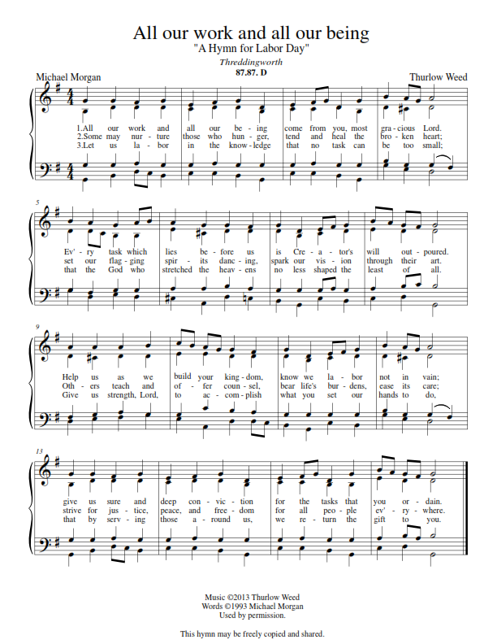

Pastor: In the Name of the Father and of the Son and Holy Spirit.

**Congregation: Amen.**

**PREPARATION**

*(Please Remain Standing Or You May Kneel…)*

**CONFESSION OF SIN:**

**All: God, I admit I have broken all of your commandments; I am not holy or sinless even though I often pretend a righteousness I do not have. I offer excuses. I have broken relationships by what I have said, or done. I have not loved either You or my neighbor as I ought. (time for personal confession____)**

**YOU ARE FORGIVEN:**

Pastor: God is merciful and gracious; He has given His Son, Jesus Christ to die and rise again for us, the sinful ones that we might be forgiven and enjoy His Peace. This is also a reminder of God’s gifts and blessing that have become ours in Holy Baptism.

**Congregation: thank you God for Your blessing!**

Pastor: Yes, the Grace of our Lord Jesus Christ, and the Love of God, and the fellowship of His Holy Spirit is with you all.

**Congregation: And also with you.**

Pastor: In peace and as His forgiven people, we can pray to the Lord:

**Congregation: He is gracious to us and hears our prayers.**

Pastor: For the peace of the whole world and our involvement in Christ’s Mission in the world, we pray:

**Congregation: Keep us mindful of our purpose as Christians and our ability to share your blessings of peace and forgiveness with others.**

Pastor: We are the children of the Risen Christ. His victory is Our Victory!

**THE PRAYERS OF THE CHURCH:**

**All: O merciful Lord, You did not spare Your only Son but delivered Him up for us all. Grant us courage and strength to take up the cross and follow Him, who lives and reigns with You and the Holy Spirit, one God, now and forever. Amen.**

**SERVICE OF THE WORD**

**God speaks to us through his word, the Bible:**

*You may be seated…*

**THE OLD TESTAMENT LESSON: Deuteronomy 30:15-20**

Lector: This is the Word of the Lord.

**People: Thanks be to God.**

**THE EPISTLE LESSON: Philemon 1-21**

Lector: This is the Word of the Lord.

**People: Thanks be to God.**

*Please stand…*

**THE HOLY GOSPEL: Luke 14:25-35**

Pastor: The Holy Gospel according to St. Luke the 14th Chapter

**People: Glory to You, O Lord.**

Pastor: This is the Gospel of the Lord.

**People: Praise to You, O Christ!**

*Please be seated…*

**CHILDREN’S MESSAGE**

**NOISE OFERING**

**THE SERMON HYMN:**

**THE SERMON:**

*(Please stand…)*

**THE PROFESSION OF FAITH:**

Pastor: God has given us a great message to take to His world. Let us remind ourselves and one another of what that message is:

Pastor: I believe in God the Father, Almighty

**Congregation: Maker of heaven and earth**

Pastor: And in His Son, Jesus Christ our Lord,

**Congregation: Who was conceived by the Holy Spirit**

Pastor: Born of the Virgin Mary

**Congregation: Suffered under Pontius Pilate**

Pastor: Was crucified, died and was buried

**Congregation: He descended into hell.**

Pastor: On the third day He rose again from the dead,

**Congregation: And ascended into heaven**

Pastor: And sits on the right hand of God, the Father almighty

**Congregation: From there He will come to judge the living and the dead**

Pastor: I believe in the Holy Spirit,

**Congregation: The Holy Christian Church as**

**All: the communion of saints; the forgiveness of sins, the resurrection of the body, and the life everlasting. Amen.**

*(You may be seated…)*

**OFFERING RECEIVED**

**SERVICE OF THE SACRAMENT**

*(Please stand…)*

**PREPARE FOR THE LORD’S SUPPER:**

Pastor: We begin with the reminder: “The Lord is with you.”

**Congregation: We are mindful and thankful for His presence.**

Pastor: Let your life reflect the joy of your salvation.

**Congregation: We do give Him thanks and praise. We will share His blessing with others.**

Pastor: It is proper that we should at all times and in all places…(prayer)… we praise your name and join others in singing:

**All: (sing) “Holy, holy, holy Lord God of pow’r and might:**

**Heaven and earth are full of your glory.**

**Hosanna, Hosanna, Hosanna in the highest.**

**Blessed is he who comes in the name of the Lord.**

**Hosanna in the highest.”**

*(Please be seated…)*

**THE WORDS OF INSTITUTION**

**DISTRIBUTION HYMNS: *“Just as I Am, without One Plea”* LSB 570**

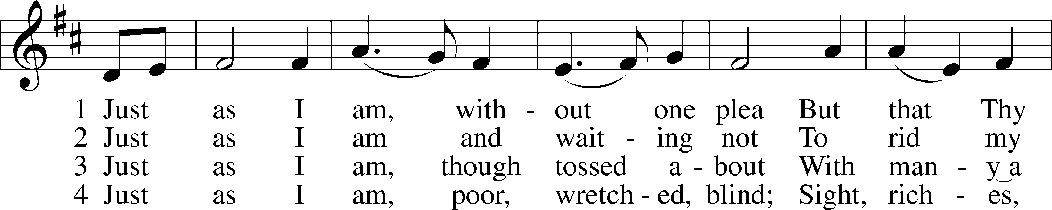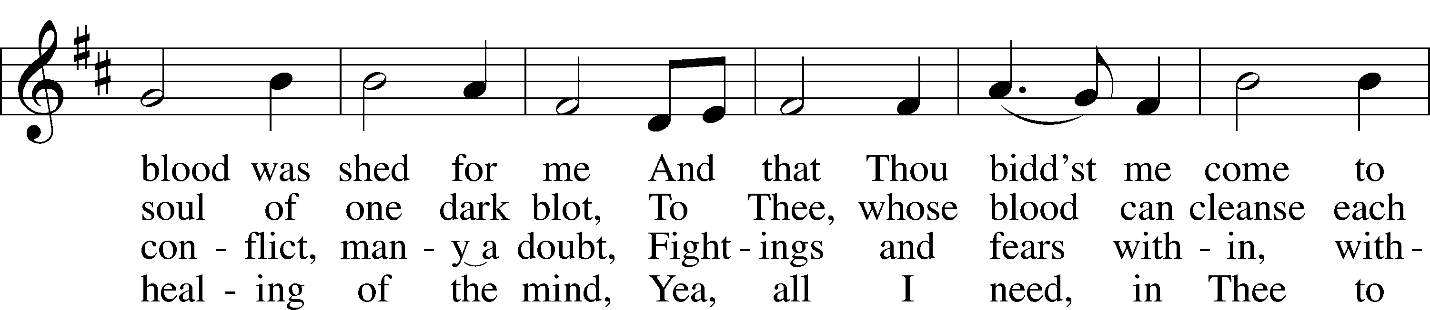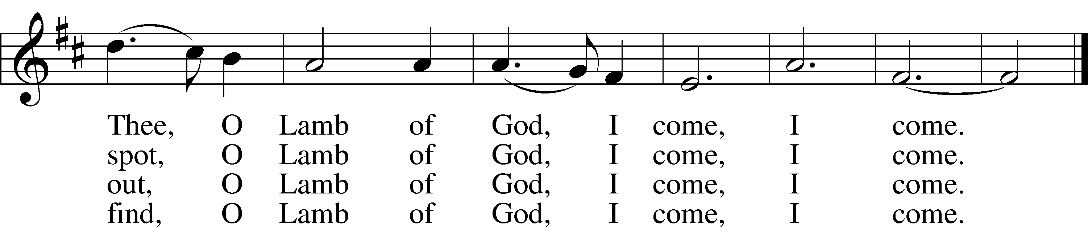

5 Just as I am, Thou wilt receive,  
Wilt welcome, pardon, cleanse, relieve;  
Because Thy promise I believe,  
 O Lamb of God, I come, I come.

6 Just as I am; Thy love unknown  
Has broken ev’ry barrier down;  
Now to be Thine, yea, Thine alone,  
 O Lamb of God, I come, I come.

Public domain

***“Lord, Help Us Walk Your Servant Way”* LSB 857**

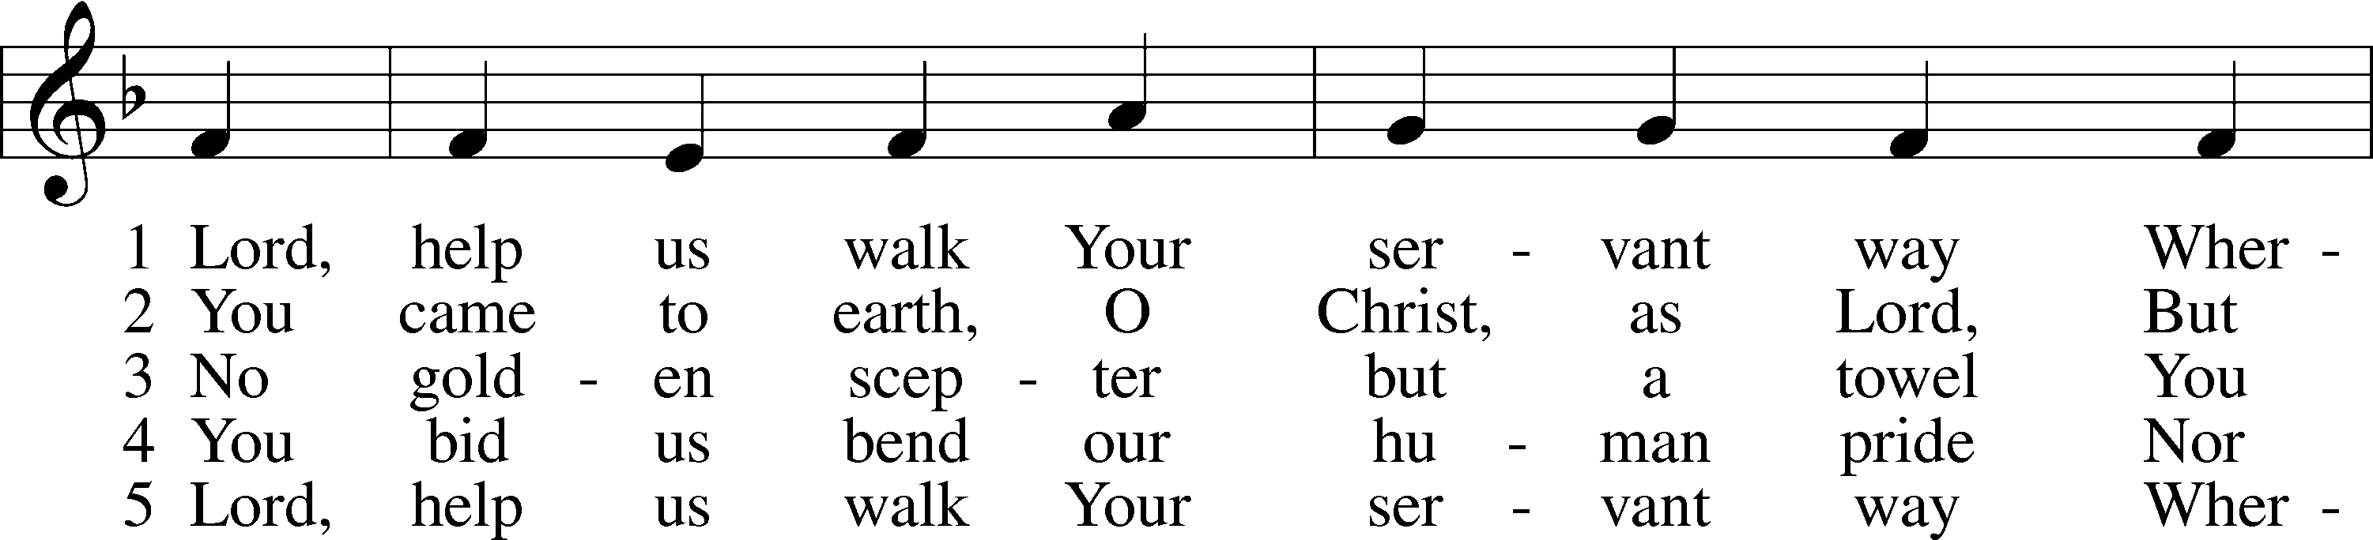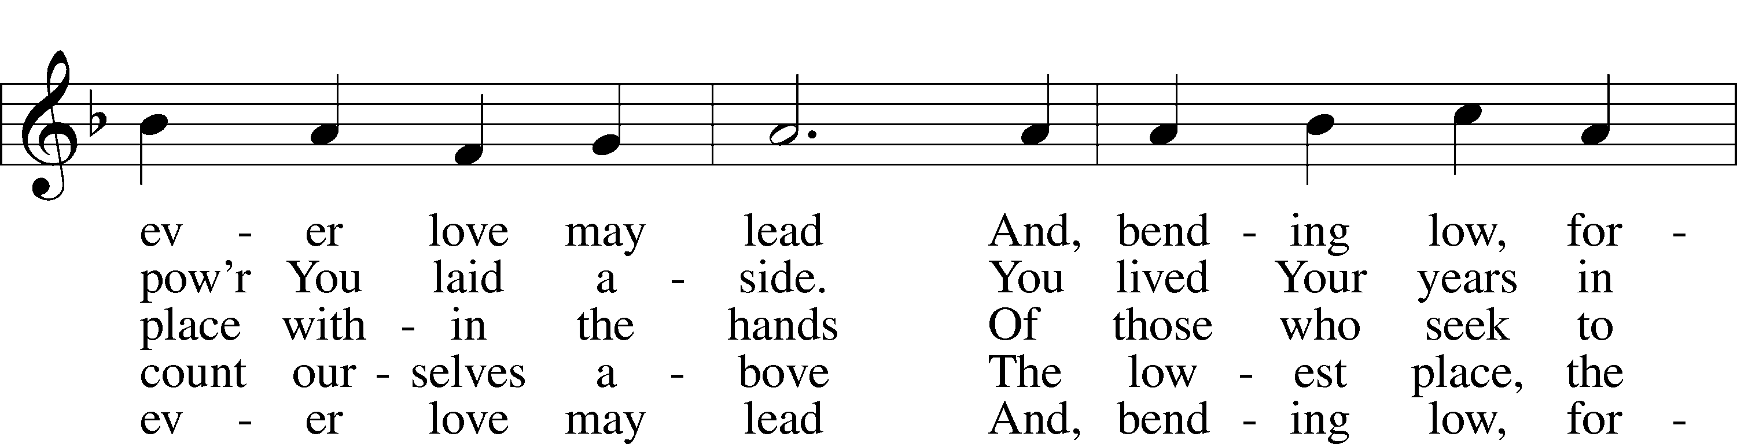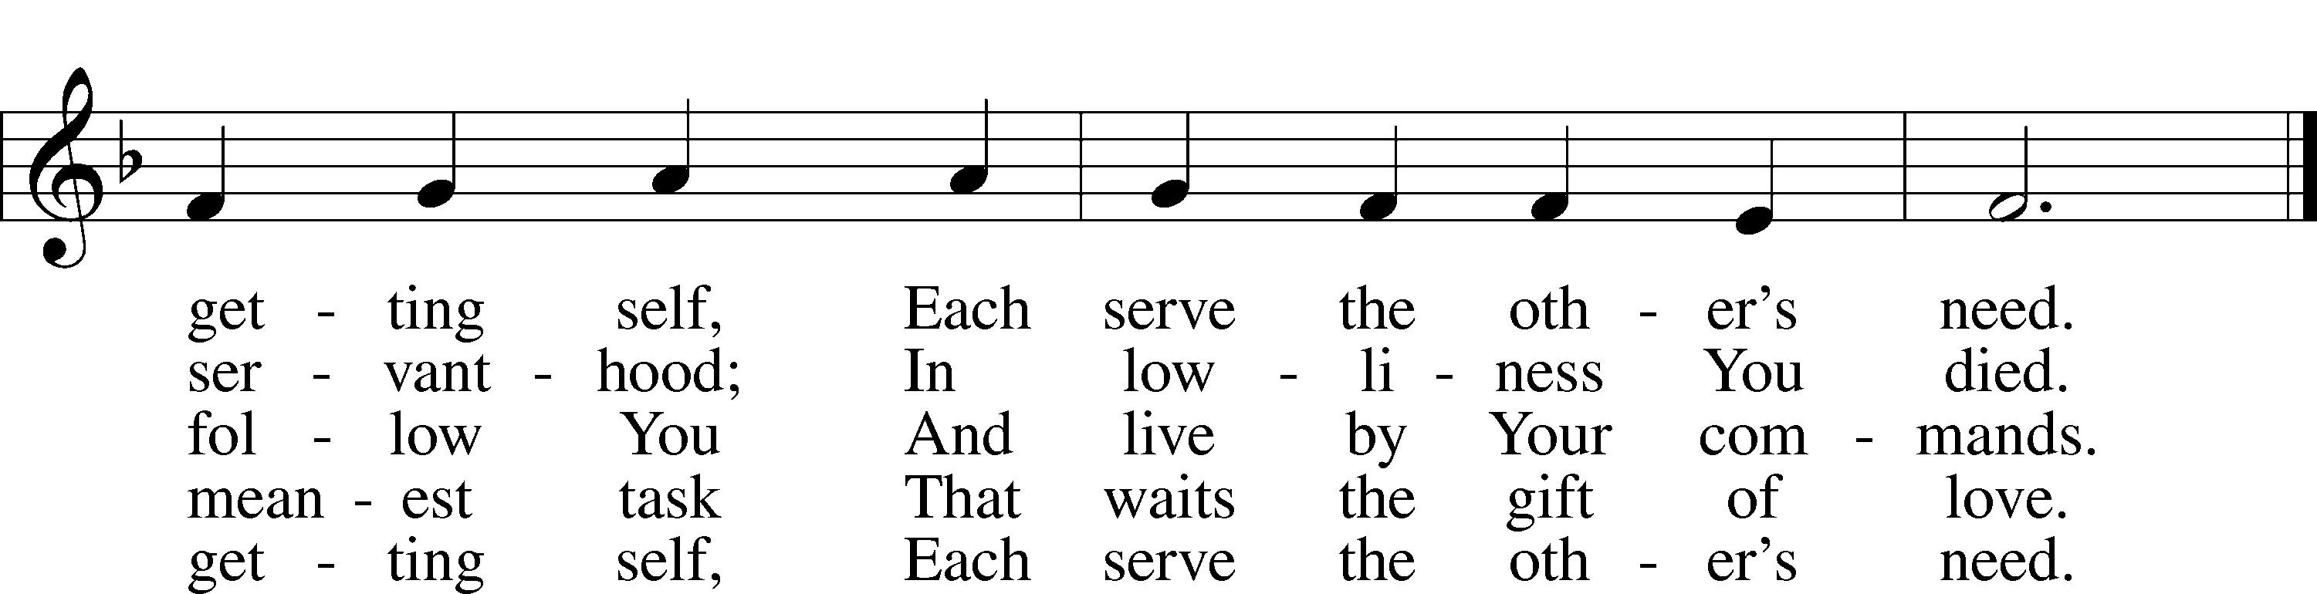

© 1997 GIA Publications, Inc. Used by permission: LSB Hymn License .NET, no. 100011641.  
Public domain



Jesus let the things that break

your heart also break our hearts.

Amen

***“In the Cross of Christ I Glory”* LSB 427**

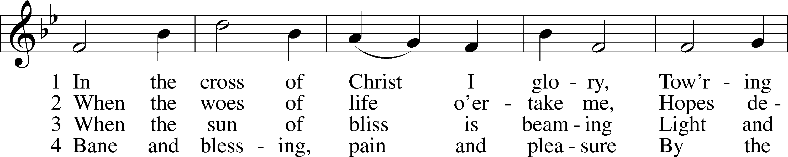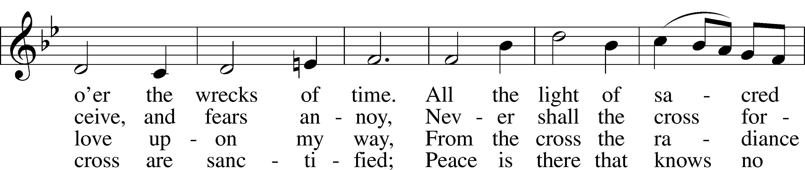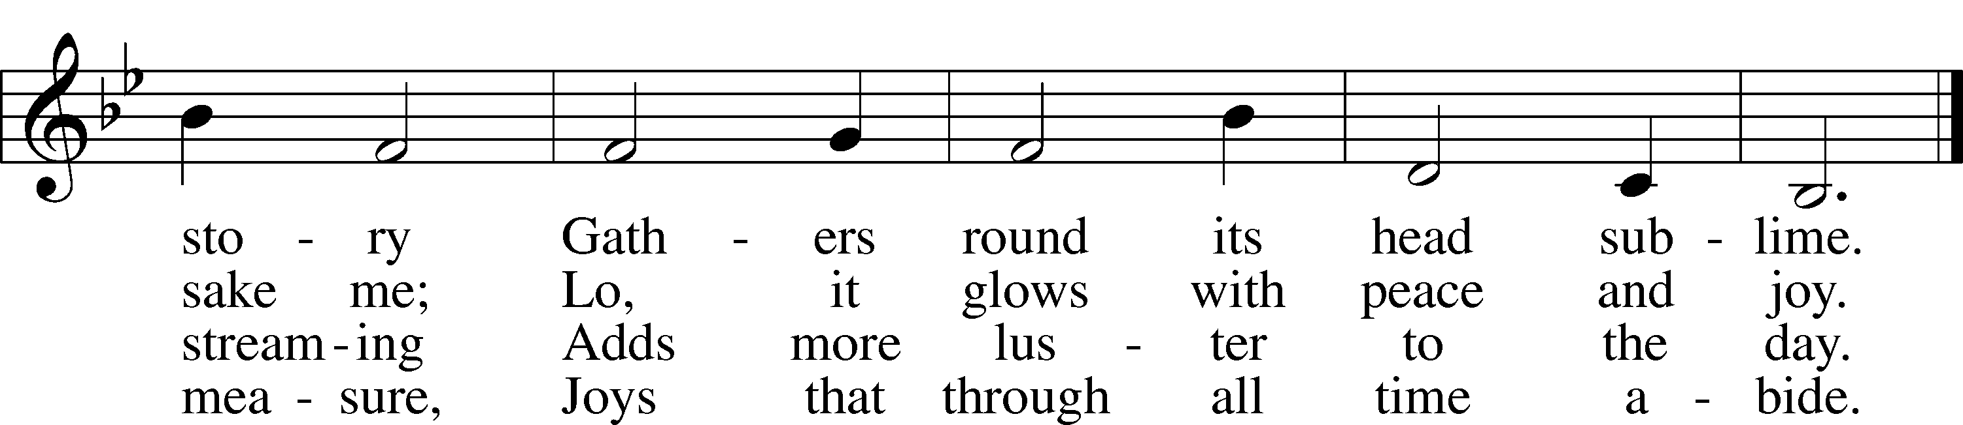

Public domain

*(Please stand…)*

**THE LORD’S PRAYER:**

**All: Our Father, who art in heaven, hallowed be thy name, thy kingdom come, thy will be done, on earth as it is in heaven. Give us this day our daily bread; and forgive us our trespasses as we forgive those who trespass against us; and lead us not into temptation, but deliver us from evil. For thine is the kingdom, and the power, and the glory, forever and ever. Amen**

**THE BLESSING AND BENEDICTION:**

Pastor: The Lord Blesses you and keeps you, the Lord makes His face to shine upon you and He is Gracious to you. The Lord looks upon you with His favor and gives you His peace.

**Congregation: God blesses us so that we can be a blessing to others.**

Pastor: Go in His peace and serve the Lord by serving others.

**Congregation: Amen**

**THE CLOSING HYMN: *“Before You, Lord, We Bow”* LSB 966**

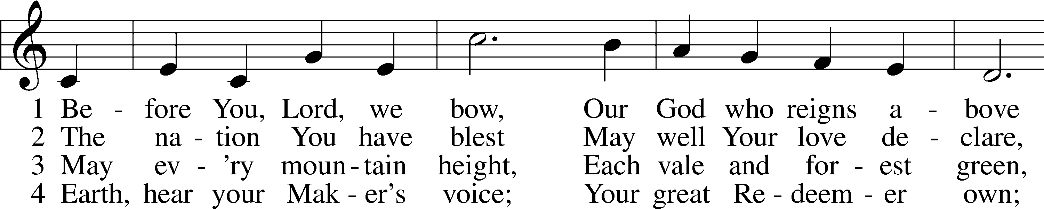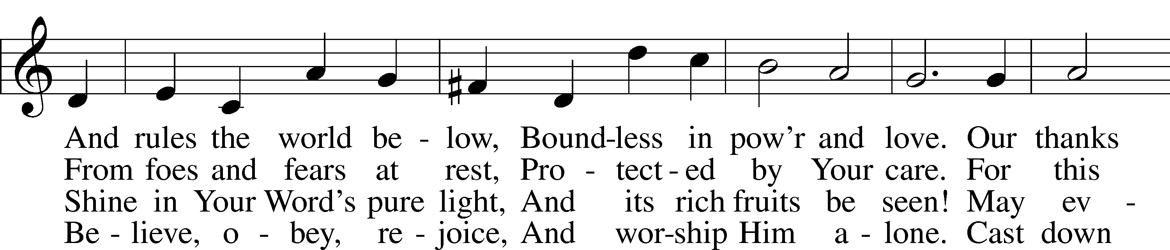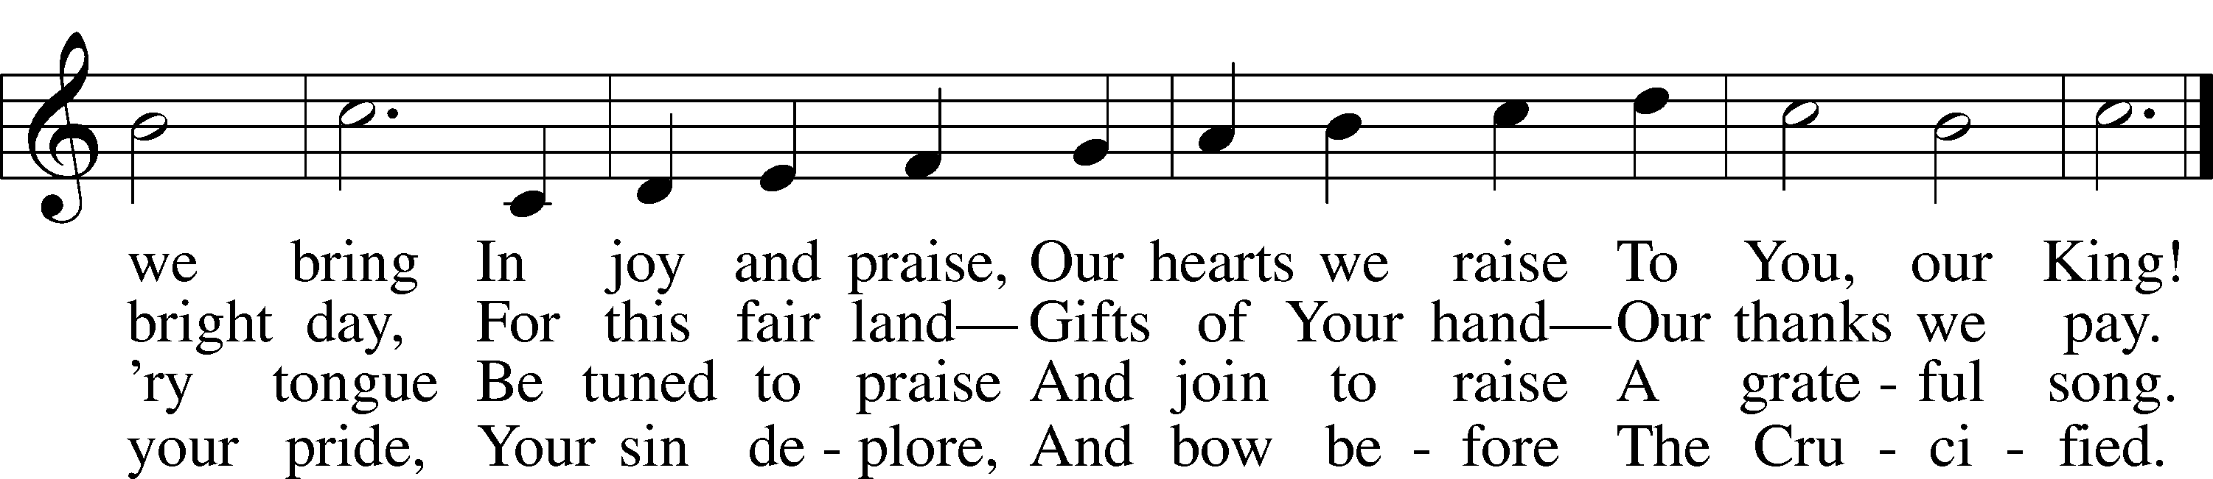

5 And when in pow’r He comes,  
 Oh, may our native land  
From all its rending tombs  
 Send forth a glorious band,  
A countless throng,  
 With joy to sing  
 To heav’n’s high King  
Salvation’s song!

Public domain



**ANNOUNCEMENTS**

**WELCOME TO GRACE LUTHERAN CHURCH:** We are glad that you are here to worship God with us today! We pray that you will enjoy the wonderful fellowship as friends in Christ as God gathers us around His means of grace, the Word and Sacraments, to bless us with His treasured gifts of forgiveness, faith, abundant life and eternal salvation. If you are a guest, please also sign our Guest Book. Please talk to Pastor if you would like **to learn more about becoming a member of Grace. Also, please join us for refreshments** and fellowship after the Service. We invite you to come and worship with us often as God gathers us in His Grace.

**WELCOME TO THE LORD’S TABLE:** We invite and encourage all present who are baptized and faithful Christians, and who confess the Father, Son, and Holy Spirit to be the only true God and who believe that Jesus Christ died for the sins of the World and is our only hope and salvation…to join us in receiving the very and true body and blood of Christ in this Sacrament. The clear liquid cups in the center of the tray are non-alcoholic wine.

Children not yet confirmed in the faith are always welcome to join their parents at the Lord’s Table, but should keep their hands folded in front of them. The Pastor will give them a blessing.

**SERVING TODAY:** Acolyte: Amelia Bly; Lector: Jessy Archer; Communion Assistants: Don Bly and Edward Morris; Usher: David Rose; Altar Care: ____________; Refreshments: ____________.

**SERVING NEXT SUNDAY:** Acolyte: ___________; Lector: Monica Bacle; Communion Assistants: Don Bly and Edward Morris; Usher: David Rose; Altar Care: ____________; Refreshments: _____________.

**FLOWERS**: were placed on the altar today to the glory of God and by the Morris family.



**THIS WEEK AT A GLANCE:**

**Today: This Sunday**

9:00 am Worship Service with Communion

10:15 am Fellowship

10:30 am Adult Bible Class

**Monday: September 5th**

Pastor’s Day Off

**Tuesday: September 6th**

3:00 pm Jan’s Mobile Gym (Parish Hall)

6:00 pm Weight Watcher’s (Parish Hall)

**Wednesday: September 7th**

12:30 pm Men’s Bible Fellowship (Hogfish on Stock Island)

**Thursday: September 8th**

7:00 pm Missional Communities (Room #3)

**Next Sunday: September 11th**

9:00 am Worship Service with Communion

10:15 am Fellowship/Refreshments

10:30 am Adult Bible Class

**IN YOUR PRAYERS THIS WEEK:** Mary Ellen Jessel, Marcos Diaz, Kaci Doran, Michael Willard, Auwina Weed, Sandy Harris, and those you are praying for at home. If anyone has a special prayer request please submit it in writing in the collection plate; or you may call Pastor Gary Faith at (504-858-8872), or Kris Howard at (305-296-5161).

**GIFTS, TITHES, & ATTENDANCE LAST SUNDAY** for Sunday August 28th was $4428.00.00 and the noise offering/door offering for the Louisiana flooding from Sunday August 21st and Sunday August 28th was $1071.36. Our attendance was 67.

**TO HELP US GROW…** The Bible readings for next Sunday’s service readings are Ezekiel 34:11-24, 1 Timothy 1:12-17, and Luke 15:1-10.

**SOME DATES TO MARK ON YOUR CALENDAR**

**GRACIOUS LADIES OF GRACE:** Our lunch at Lynn Jones house was a hit with the Ladies and so were all the delicious salads that everyone brought to share.  The desserts were fab and over the top. Lynn must have been baking all night. Ooeey Gooey bars, Key Lime tarts, Autumn shortbread cookies, and Banana Cranberry muffins not to mention Kris Bly's Raspberry Cobbler with whip cream. She set a beautiful table and Elsie treated us with one of her beautiful floral creations. It was an occasion extraordinaire! Our next luncheons will be on Sept. 13 at Salute at 11:30 and Sept.27 at Spencer’s which has a 25% discount for the month at 11:30. Fun, Fun, Fun.

**IT IS ALMOST TIME FOR CHILDREN/YOUTH SUNDAY SCHOOL** to start up again. We will provide classes for Kindergarten thru high school. Classes will start up September 11th and will be held at 10:30am each Sunday. If you have any questions about these wonderful classes, please contact Kris Bly (Sunday School Coordinator) at 305-509-1447. We hope to see your children/teens there.

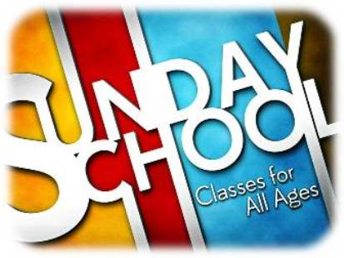

**WE HAVE SCHEDULED AN ADULT INFORMATION CLASS:** Part 1 will be held Sept 11th, noon until 2pm. Part 2 will be held on the following Sunday the 18th from noon until 2pm. This is for those who may be interested in joining and/or learning more about what we teach/believe. It is also a good review for our members.

**CRAFTING SATURDAYS ARE BACK**: Please join us to work on your crafts: Saturday September 17th from 10am – 2pm at Grace Lutheran in the Parish Hall.



**OKTOBERFEST** celebration will be held October the 8th at the parsonage.

**AT OUR MIDWEEK ADVENT GATHERING** on December the 7th Ms. Lisa J. Smolowitz from Jews from Jesus will be giving a presentation on Hanukkah.

**A BBQ MEAL TO MEET** Pastor Tilahun Mendedo will be held on January 14th.

**PASTOR TILAHUN WILL BE PREACHING** at our worship service and presenting on the Master Builder Center during our Bible class time – Pastor Tilahun has been serving as a missionary for Ethiopia to the USA for over 10 years.

**NEW LOCATION - MISSIONAL COMMUNITIE:** Missional Communities continues again this Thursday. We have changed the location from the parsonage to classroom #3. We plan on meeting every Thursday to talk about how we see God at work and as time allows we will also prepare for Sunday worship by looking at the appointed scriptures for that Sunday. Everyone is welcome and encouraged to attend. We will start the 5 Questions at 7pm and end the session by 8pm. The room will be open at 6:30 for those who like to arrive early and chat.

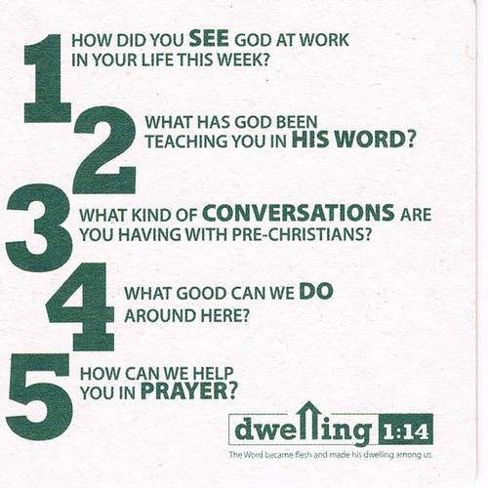

**JR. CONFIRMATION:** Calling all 5th graders and above who are interested in attending Confirmation Class this year. We will have our first meeting Wednesday August 31st at 4:30pm. Parents please plan on attending this first meeting with your child so that we can establish if this is a good day and time to meet and to give an overview of what is expected. Parents of 5th and 6th graders … if you prefer to wait until your child is in the 7th or 8th grade that is fine. We seem to be on a path that calls for having a class every other year. Questions, concerns give me a call/email.



**HELLO EVERYONE, I AM ON THE BOARD FOR KIDS COME FIRST** which is in the process of collecting items for needy children in our community that have no shoes or clothes for school. We have 400 homeless children right here in Monroe County and over 4,000 children on our free lunch program. I have set a goal to try and collect 400 pairs of sneakers in all sizes ranging from kindergarten to senior's in high school. If you feel you can help me in this goal please let me know and I can either pick up shoes or money to buy shoes. Thank you so much in advance.

Cheryl Cates Send checks to:

305-587-6726 Kids Come First

[CATESAUTO@aol.com](mailto:CATESAUTO@aol.com) 3405 Eagle Ave

Key West FL

**STAINED GLASS WINDOWS:** We only have 9 clear glass impact windows in the bathrooms and front entry, and the two side entry doors that need to be replaced.  When those are completed, the entire church will be protected with hurricane proof, impact windows. The cost of the windows is roughly $2000.00 each depending on size. Thank you donors of the stained glass windows and to all those who have contributed to the building fund for this project. Your generous giving is much appreciated

**THE GRACE LUTHERAN CHURCH WEB PAGE AND FACE BOOK PAGE** now contains a vocal recording of last week’s sermon. So if you are not able to attend church on Sunday please go to our website where you will find a copy of the bulletin and a recording of Pastor Faith’s sermon.

**A NUMBER OF CAPITAL IMPROVEMENTS** are needed to keep our facilities in good health for the future. The narthex has been rebuilt. Roof repairs are needed on school buildings. If you can help it would be much appreciated! A big thanks to all who

have contributed to these repairs.



**MUSIC MINISTRY:** "Make a joyful noise to the Lord, all the earth!" Psalm 100:1. Whether you are here year-round or only part-time, we invite you to participate in our music ministry. Please speak with Beverly Walker or contact her at [beverlywalker@gmail.com](mailto:beverlywalker@gmail.com) if you have any questions.

**Children's Choir for Kindergarten - 5th Grade** begins next Sunday, September 11 from 10:10 - 10:25. Please meet by the piano. We will be done in time for Sunday School.

**Bell Choir** begins on Wednesday, September 28 from 5:45 to 6:30 pm. Anyone in 5th grade - adult is welcome to join us.

**Vocal Choir** begins on Saturday, October 2 from 11:00 am - 12 noon.



**WOMEN’S BIBLE STUDY:** The Ladies Bible Study finished their studies on “Stories of Deliverance from the Old Testament”, asking 7 questions that answered why it was told and what we are to take from it, mainly asking how does this story show how God loves me. We are looking forward to a new study in the fall please consider joining us for an hour of interesting insights and lively discussions.

**MEN’S BIBLE FELLOWSHIP**: They meet the first and third Wednesday’s of each month at 12:30pm. Their next meeting will be September 7th located at Hogfish on Stock Island. All guys are welcome.