**August 28th, 2016**

**9:00 am**

**FIFTEENTH**

**SUNDAY AFTER**

**PENTECOST**



**Grace Lutheran Church**

**2713 Flagler Ave.**

**Key West, FL 33040**

**305-296-5161**

[**GraceLutheranKW@att.net**](mailto:GraceLutheranKW@att.net)

**gracelutherankw.360unite**

**Pastor Faith**

**(504) 858-8872**

**garyfaith@aol.com**

**FIFTEENTH SUNDAY AFTER PENTECOST**

**AUGUST 28TH, 2016 9:00 a.m.**

***In the Name of Jesus!***

**Our Mission Statement: Anchored in Christ, each person a missionary.**

**PRELUDE**

**ANNOUNCEMENTS:**

**We welcome you. We are glad you are here to share with us the joy and peace we have in Jesus Christ. It doesn’t matter whether this is your first time in this church or if you are a lifelong member, you are welcome. We come together today in order to celebrate the gift God has given us-His own Son, Jesus, Our Savior.**

**PREPARATION**

*(Please Stand…)*

**HYMN: *“Rejoice, O Pilgrim Throng”* LSB 813**

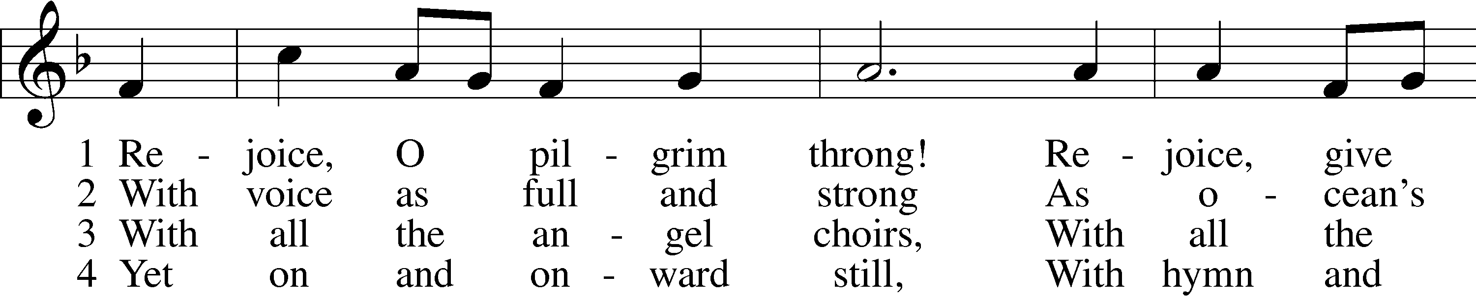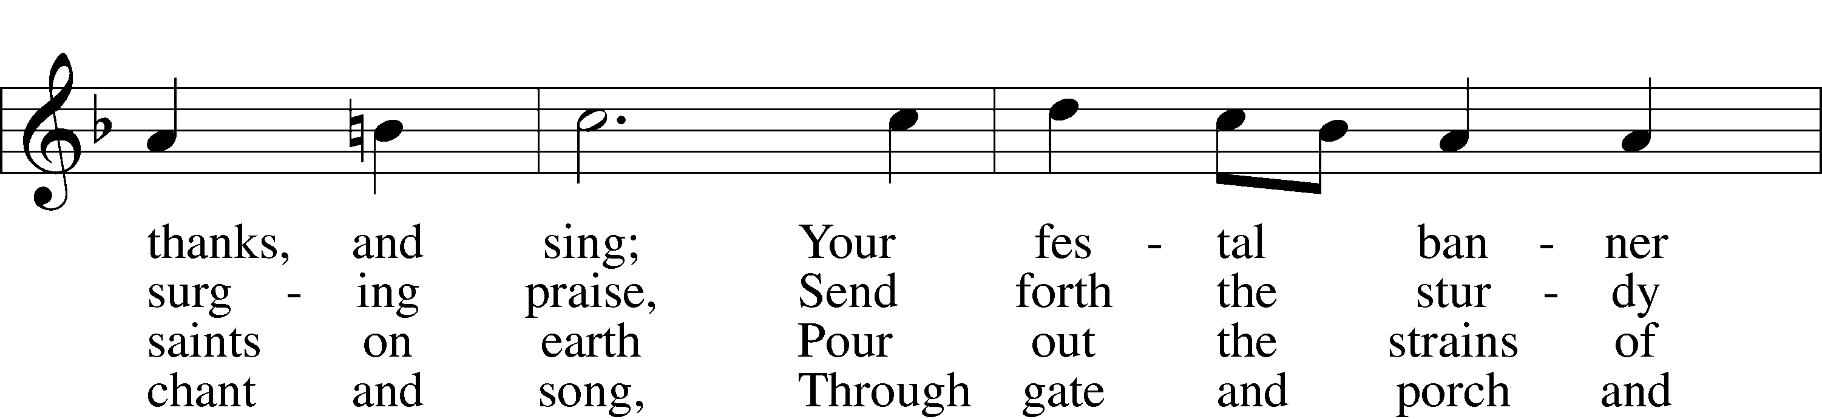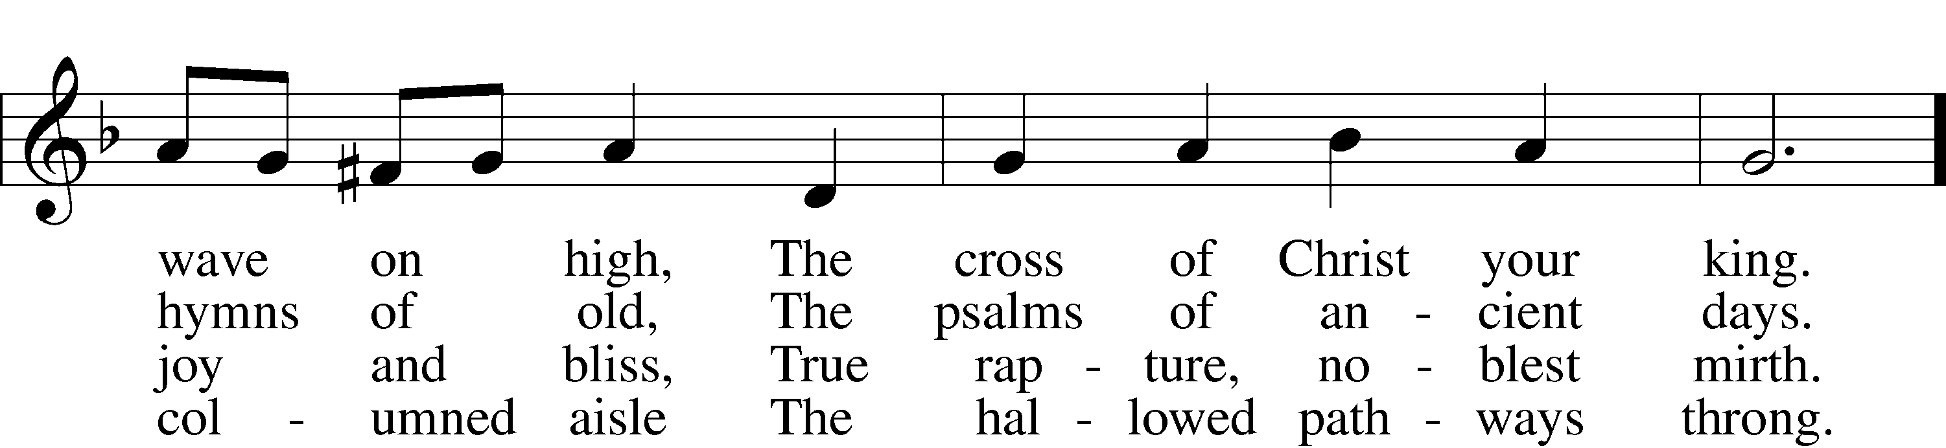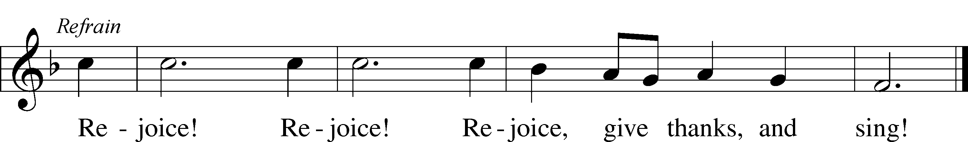

Public domain

**Pastor:** In the Name of the Father and of the Son and Holy Spirit.

**Congregation: Amen.**

*(Please Remain Standing Or You May Kneel…)*

**GOD’S PEOPLE CONFESS THEIR SINS:**

Pastor: By grace you have been saved, through faith-and this is not from yourselves, it is the gift of God-not of works, so that no man can boast, for we are God’s workmanship, created in Christ Jesus.

**Congregation: I know that nothing good lives in me, that is, in my sinful nature, for I have the desire to do what is good, but I cannot carry it out.**

Pastor: What I do is not the good I want to do; no, the evil I do not want to do-this I keep doing.

**Congregation: In my heart I delight in God’s law, the law that points out what a wretched person I am! Who will rescue me from this body of death?**

Pastor: Thanks be to God through Jesus Christ our Lord! Only He can achieve the perfection we fail to achieve. By the forgiveness He purchased on the cross, our forgiveness is complete!

**SERVICE OF THE WORD**

*You may be seated…*

**THE FIRST READING: Proverbs 25:2-10**

Lector: This is the Word of the Lord.

**People: Thanks be to God.**

**THE EPISTLE LESSON: Hebrews 13:1-17**

Lector: This is the Word of the Lord.

**People: Thanks be to God.**

*Please stand…*

**THE HOLY GOSPEL: Luke 14:1-14**

Pastor: The Holy Gospel according to St. Luke the 14th Chapter

**People: Glory to You, O Lord.**

Pastor: This is the Gospel of the Lord.

**People: Praise to You, O Christ!**

*Please be seated…*

**CHILDREN’S MESSAGE**

**NOISE OFERING**

**THE SERMON HYMN: *“Blessed Assurance”***

**Words by Fanny Jane Crosby, music by Phoebe Palmer Knapp**

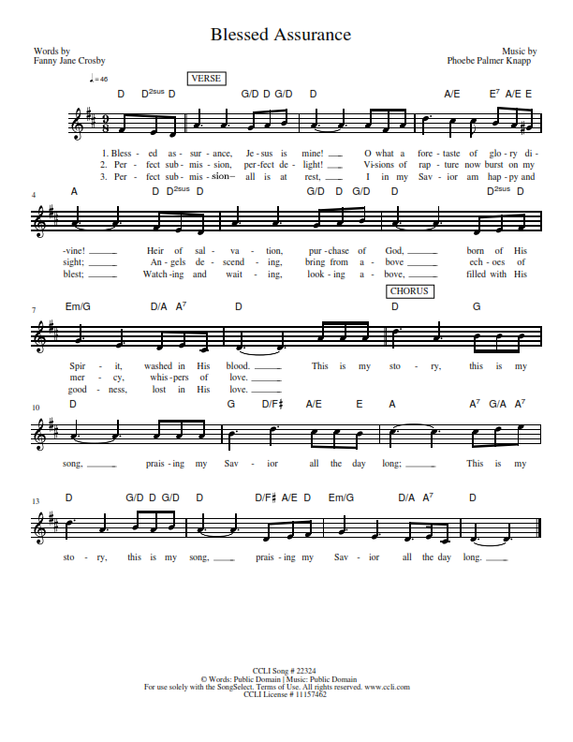

**CCLI Song # 22324 © words: Public Domain │ Music: Public Domain**

**For use solely with the SongSelect Terms of Use. All rights reserved.** [**www.ccli.com**](http://www.ccli.com) **CCLI License # 11157462**

**THE SERMON: *“Jesus is the Same”*  Hebrews 13:8**

*(Please stand…)*

**THE PROFESSION OF FAITH:**

Pastor: God has given us a great message to take to His world. Let us remind ourselves and one another of what that message is:

Pastor: I believe in God the Father, Almighty

**Congregation: Maker of heaven and earth**

Pastor: And in His Son, Jesus Christ our Lord,

**Congregation: Who was conceived by the Holy Spirit**

Pastor: Born of the Virgin Mary

**Congregation: Suffered under Pontius Pilate**

Pastor: Was crucified, died and was buried

**Congregation: He descended into hell.**

Pastor: On the third day He rose again from the dead,

**Congregation: And ascended into heaven**

Pastor: And sits on the right hand of God, the Father almighty

**Congregation: From there He will come to judge the living and the dead**

Pastor: I believe in the Holy Spirit,

**Congregation: The Holy Christian Church as**

**All: the communion of saints; the forgiveness of sins, the resurrection of the body, and the life everlasting. Amen.**

*(You may be seated…)*

**OFFERING RECEIVED**

**(***Please stand…)*

**THE PRAYERS OF THE CHURCH: based on Psalm 98**

Pastor: Dear Lord, we thank You for everything You’ve done for us, and most of all for Your own Son, Jesus, our Savior. We will never stop praising You for this wonderful gift.

**Congregation: Sing to the Lord a new song, for He has done marvelous things; His right hand and His holy arm have worked salvation for Him.**

Pastor: We thank You for those missionaries long ago who brought the Good News to our people. When we were in darkness, You sent men and women to bring us the light. Thank you, Lord.

**Congregation: The Lord has made His salvation known and revealed His Righteousness to the nation.**

Pastor: O Lord, You are our Savior, we trust in You for all our needs, give healing to the sick, courage to those who are afraid, and peace to those we name in our hearts either silently or out loud. **(a moment of silence)** We praise You, gracious Lord, for all Your benefits to us. You give us home, friends and family, food, shelter, rest and everything we need. You give us sight and hearing and touch and taste and provide for all of our needs.

**Congregation: Shout for joy to the Lord, praise His Name Amen.**

**SERVICE OF THE SACRAMENT**

*(Please be seated…)*

**THE WORDS OF INSTITUTION**

**DISTRIBUTION HYMNS: *“You Satisfy the Hungry Heart”*  LSB 641**

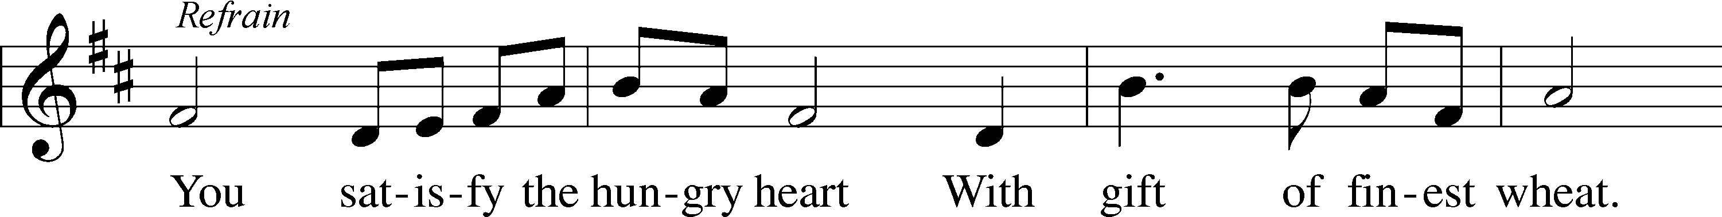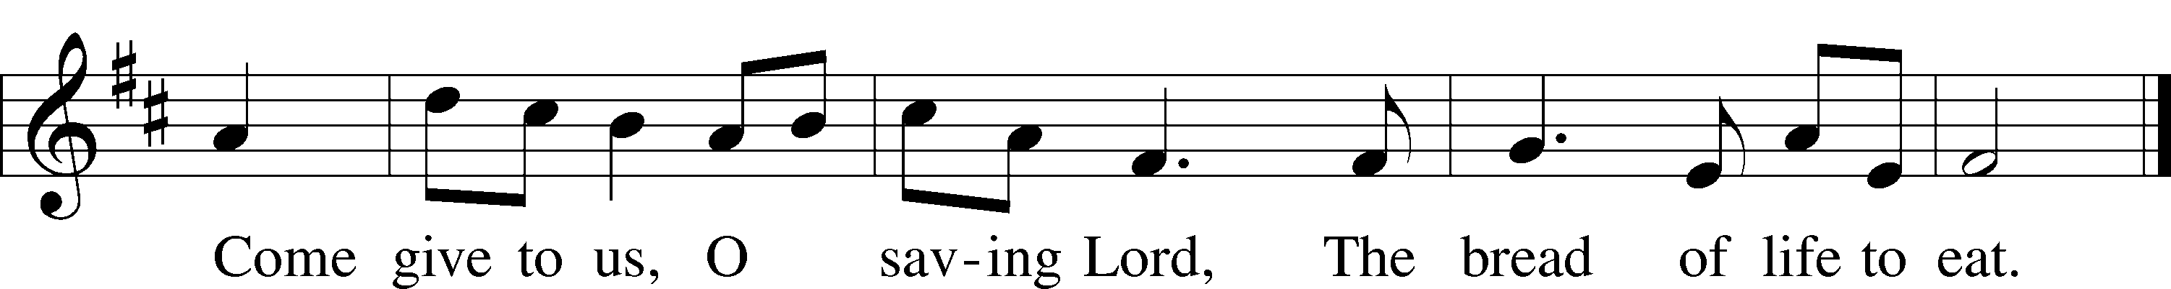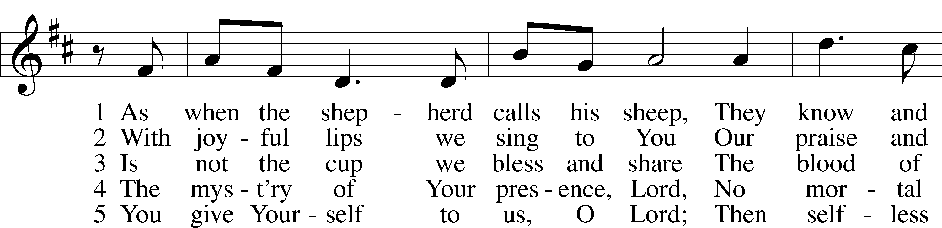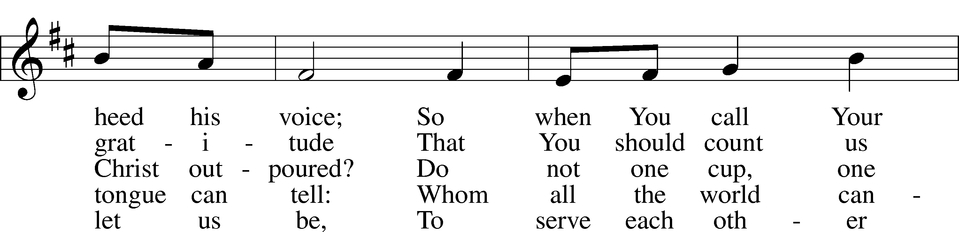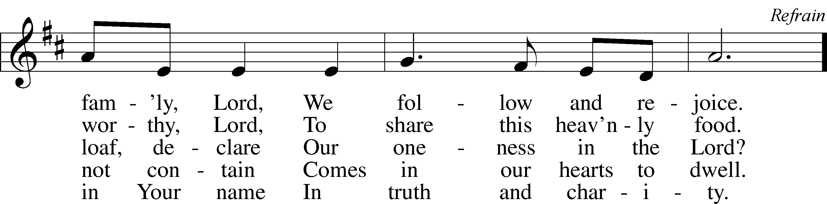

© 1977 Archdiocese of Philadelphia. Used by permission: LSB Hymn License .NET, no. 100011641.

***“Lord, Whose Love through Humble Service”* LSB 848**

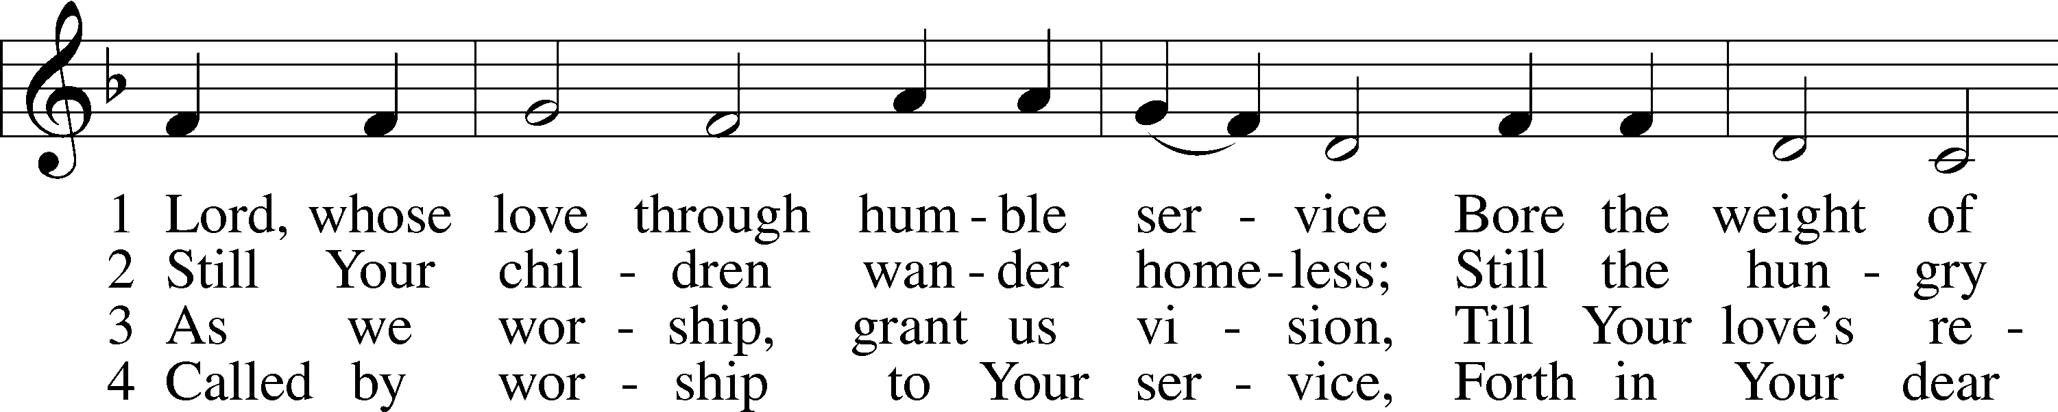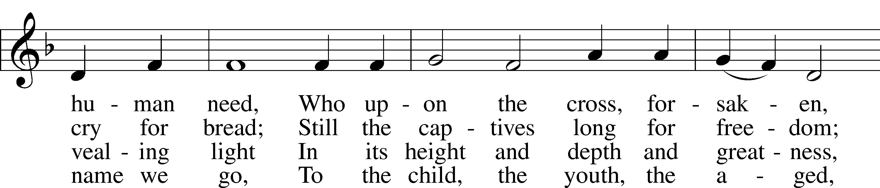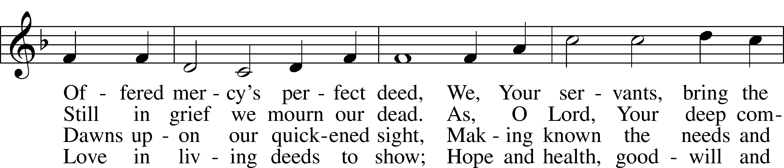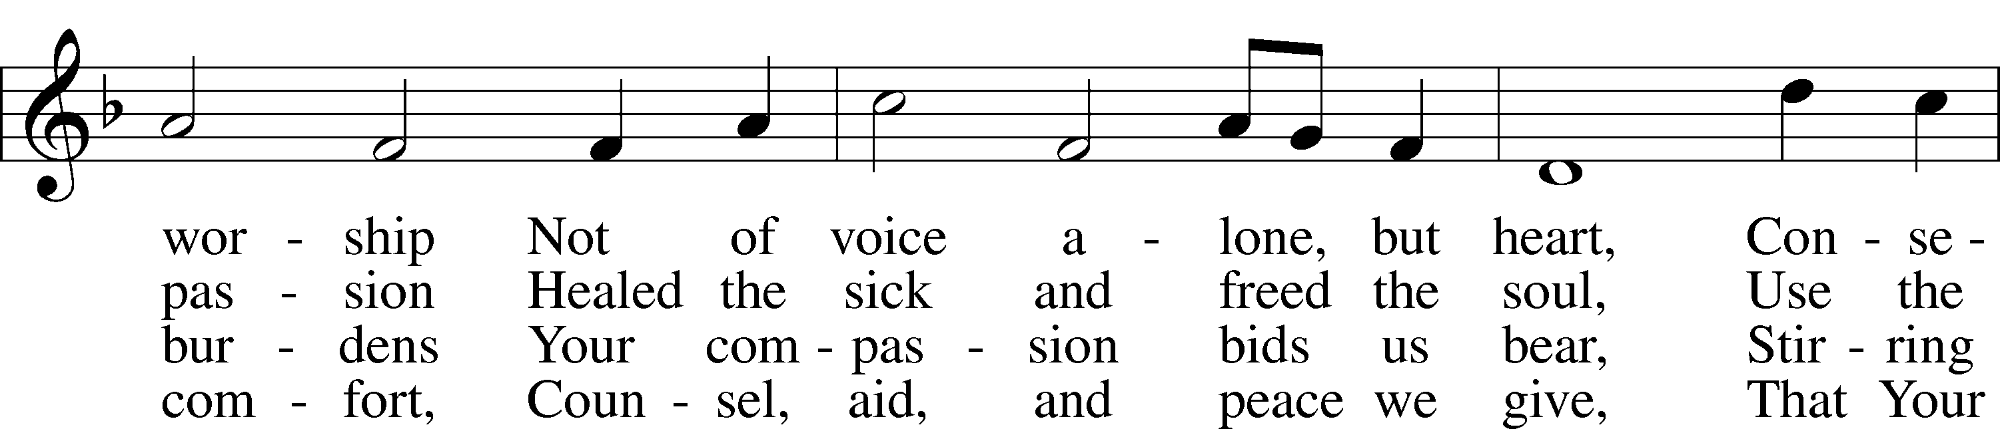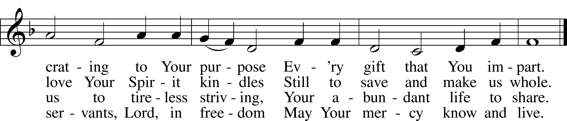

© Oxford University Press. Used by permission: LSB Hymn License .NET, no. 100011641.



Jesus let the things that break

your heart also break our hearts.

Amen

***“I Know That My Redeemer Lives”* LSB 461**

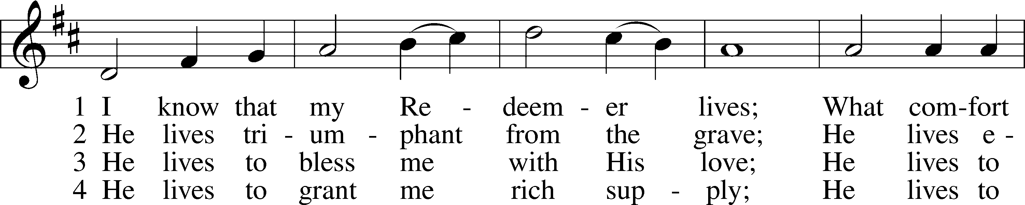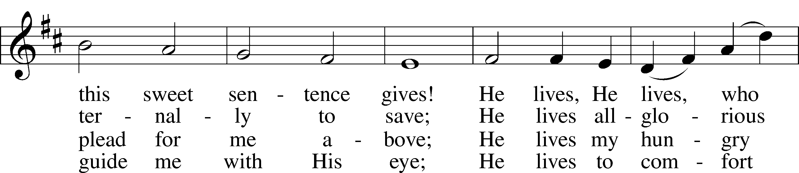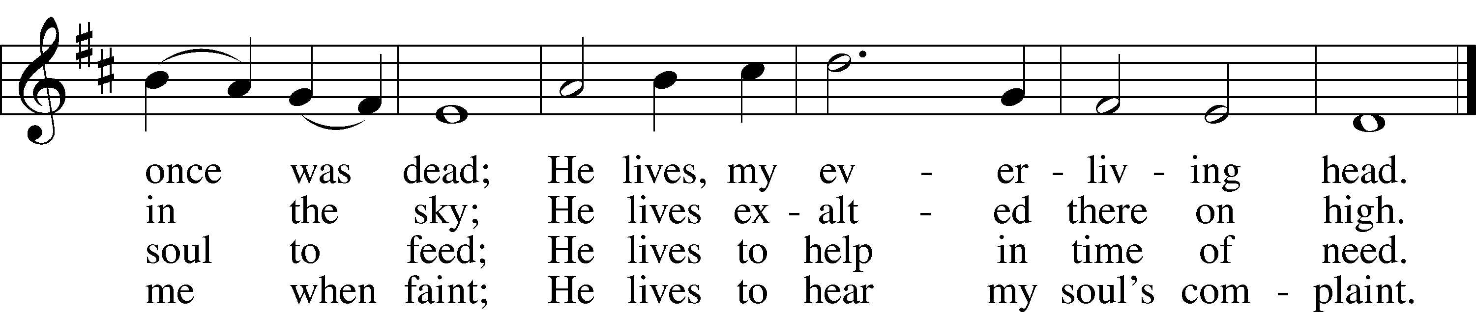

5 He lives to silence all my fears;  
He lives to wipe away my tears;  
He lives to calm my troubled heart;  
He lives all blessings to impart.

6 He lives, my kind, wise, heav’nly friend;  
He lives and loves me to the end;  
He lives, and while He lives, I’ll sing;  
He lives, my Prophet, Priest, and King.

7 He lives and grants me daily breath;  
He lives, and I shall conquer death;  
He lives my mansion to prepare;  
He lives to bring me safely there.

8 He lives, all glory to His name!  
He lives, my Jesus, still the same;  
Oh, the sweet joy this sentence gives:  
I know that my Redeemer lives!

Public domain

*(Please stand…)*

**THE LORD’S PRAYER:**

**All: Our Father, who art in heaven, hallowed be thy name, thy kingdom come, thy will be done, on earth as it is in heaven. Give us this day our daily bread; and forgive us our trespasses as we forgive those who trespass against us; and lead us not into temptation, but deliver us from evil. For thine is the kingdom, and the power, and the glory, forever and ever. Amen**

**THE BENEDICTION**

**THE CLOSING HYMN: *“Lift High the Cross”* LSB 837**

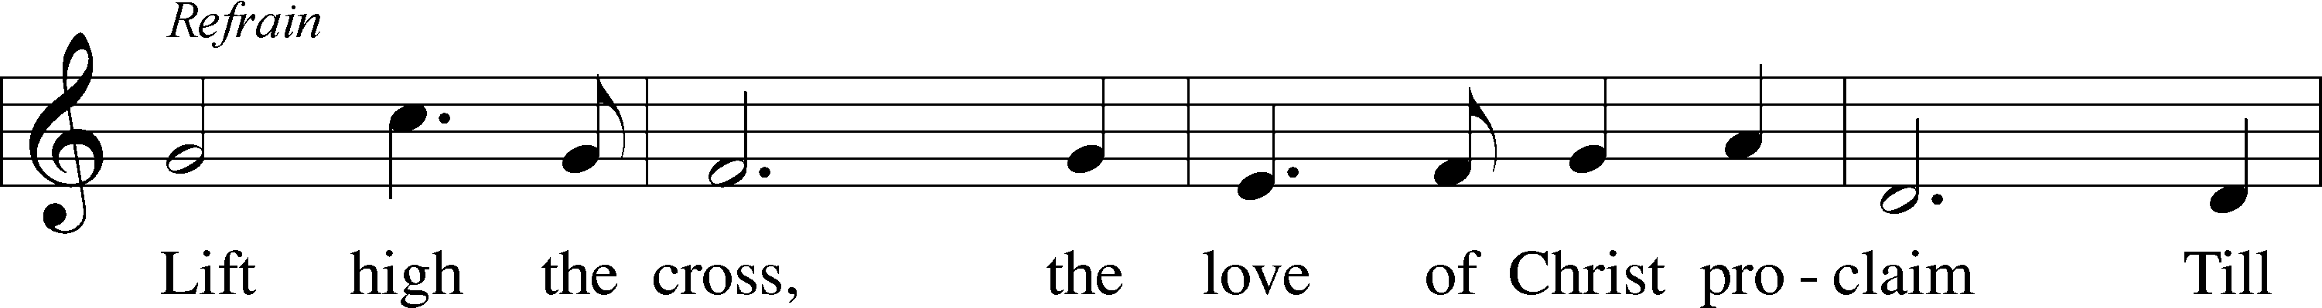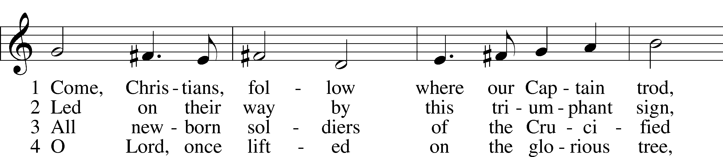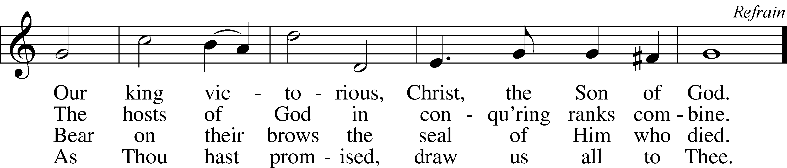

© 1997 Hope Publishing Co. Used by permission: LSB Hymn License .NET, no. 100011641.  
© 1974 Hope Publishing Co. Used by permission: LSB Hymn License .NET, no. 100011641.

**ANNOUNCEMENTS**

**WELCOME TO GRACE LUTHERAN CHURCH:** We are glad that you are here to worship God with us today! We pray that you will enjoy the wonderful fellowship as friends in Christ as God gathers us around His means of grace, the Word and Sacraments, to bless us with His treasured gifts of forgiveness, faith, abundant life and eternal salvation. If you are a guest, please also sign our Guest Book. Please talk to Pastor if you would like **to learn more about becoming a member of Grace. Also, please join us for refreshments** and fellowship after the Service. We invite you to come and worship with us often as God gathers us in His Grace.

**WELCOME TO THE LORD’S TABLE:** We invite and encourage all present who are baptized and faithful Christians, and who confess the Father, Son, and Holy Spirit to be the only true God and who believe that Jesus Christ died for the sins of the World and is our only hope and salvation…to join us in receiving the very and true body and blood of Christ in this Sacrament. The clear liquid cups in the center of the tray are non-alcoholic wine.

Children not yet confirmed in the faith are always welcome to join their parents at the Lord’s Table, but should keep their hands folded in front of them. The Pastor will give them a blessing.

**SERVING TODAY:** Acolyte: Elizabeth Reynolds; Lector: David Walker; Communion Assistants: David Rose and Steve Bringle; Usher: Terry Richardson; Altar Care: Kris Howard; Refreshments: The Morris Family.

**SERVING NEXT SUNDAY:** Acolyte: Amelia Bly; Lector: Jessy Archer; Communion Assistants: Don Bly and Edward Morris; Usher: David Rose; Altar Care: ____________; Refreshments: _____________.

**FLOWERS**: were placed on the altar today to the glory of God and by the Bly family to celebrate their 17th wedding anniversary.



**THIS WEEK AT A GLANCE:**

**Today: This Sunday**

9:00 am Worship Service with Communion

10:15 am Fellowship

10:30 am Adult Bible Class

12:00 pm Adult Information Class (Room #3)

**Monday: August 29th**

Pastor’s Day Off

5:30 pm Zumba

**Tuesday: August 30th**

11:30 pm Gracious Ladies of Grace Luncheon (Lynn Jones Home, 24 Bamboo Terrace)

3:00 pm Jan’s Mobile Gym (Parish Hall)

6:00 pm Weight Watcher’s (Parish Hall)

**Thursday: September 1st**

7:00 pm Missional Communities (Room #3)

**Next Sunday: September 4th**

9:00 am Worship Service with Communion

10:15 am Fellowship/Refreshments

10:30 am Adult Bible Class

**IN YOUR PRAYERS THIS WEEK:** Mary Ellen Jessel, Marcos Diaz, Kaci Doran, Michael Willard, Angela Kolhagen, Kristen Howell, Charlie Sutherland, Will Plagens, Rev. Alfred Schubert II, the family and friends of Harry Htut, Auwina Weed, Kit Billings, Bill Billings Jr., Laura MacQuarie, Gabriel Kirkland, family and friends of Bryan Kay, Kay Sattelmeier, Phil Zielinski, the family and friends of Mary Bacle, the victims of the Lahore Pakistan attack, Esther Faith, Jameson Parker, the family and friends of Hwana, Liz and Ryan Grady, Larry, Dan, Gabriel, Andrew, Julia Pateman, David Lopez, Annie Garner, Nancy Amling, Alicia Llama, Erich & Erika Hoffmann, Katharina Lutz, Robert and Regina Hoffmann, Walter Hulme, Carole Steinle, Joanne Cates, Jane Howard, Jean Grafsgaurd, Denis Julson, Mary Kay, Sandy Harris, and those you are praying for at home. If anyone has a special prayer request please submit it in writing in the collection plate; or you may call Pastor Gary Faith at (504-858-8872), or Kris Howard at (305-296-5161).

**\*The first Sunday of September we will have a new prayer list available. If you would like the name of a person that is on this current prayer list to remain in the bulletin, please let me know by Wednesday August 31st.**

**GIFTS, TITHES, & ATTENDANCE LAST SUNDAY** for Sunday August 21st was $3802.00, the building fund received $420.00 and the noise offering from Sunday August 14th was 31.39. Our attendance was 84.

**TO HELP US GROW…** The Bible readings for next Sunday’s service readings are Deuteronomy 30:15-20, Philemon 1-21, Luke 14:25-35.



**THIS SUNDAY** we will have a door offering to support the recovery work that the Lutheran Church is doing in Louisiana. If you are unable to attend next week and would like to donate either place your donation in the offering basket and label it Flood Recovery or drop your donation by the office.

Or you can mail your donation directly to: Southern District LCMS

100 Mission Dr.

Slidell, LA 70460

If you would like to volunteer travel to LA and help with the recovery see the Southern District Website: [www.southernlcms.org](http://www.southernlcms.org). Thank you for your prayers and support.

**THANKS TO ALL WHO HELPED** and contributed to last week’s teacher installation/pot luck. The teachers were appreciative of your efforts.

**SOME DATES TO MARK ON YOUR CALENDAR**

**JOIN SCOUTING NIGHT - MONDAY 8/29 @ 5:30 to 7 pm.** Cub Scout Pack 583 and Boy Scout Troop 578 will host "Join Scouting Night" on Monday 8/29 from 5:30 until 7 pm in the Scout Room on the second floor of St.Theresa's Hall.  All boys from 1st grade and up through 18 years of age are invited to attend.  Both units meet at St. Mary's on Monday evenings.  The Cub Scouts meet from 5:30 to 6:30 and the Boy Scouts meet from 6:30 to 8 pm.  For more information, call Mike Arnett at 808-230-6255.   

**GRACIOUS LADIES OF GRACE:** Well it was worth the journey heading up north to get a good meal and fellowship.  Our lunch at Square Grouper was 5* for cuisine, atmosphere, and service. There was a lot of ooing and ahhing and oh wow's. Ann and Martha finally showed up and joined us and it was like the good ole days.  We thought maybe they had found some other Grace Lutheran Church out in Arkansas that they liked better. No way!  We missed Patti, Deb, Garnet and Bev.  Not to mention Thelma and Louise oh I mean Faye and Yvonne. I think their off in their convertible looking for Robert Redford or some other famous handsome star and forgot about our luncheon date. We shared delicious desserts in honor of Angie's Birthday and remembered Patti's and Bev's birthday as well. We're mixing it up next time with a potluck (bring your favorite salad to share) at Lynn Jones's house 24 Bamboo Terrace at 11:30 Aug. 30th.

**IT IS ALMOST TIME FOR CHILDREN/YOUTH SUNDAY SCHOOL** to start up again. We will provide classes for Kindergarten thru high school. Classes will start up September 11th and will be held at 10:30am each Sunday. If you have any questions about these wonderful classes, please contact Kris Bly (Sunday School Coordinator) at 305-509-1447. We hope to see your children/teens there.

**WE HAVE SCHEDULED AN ADULT INFORMATION CLASS:** Part 1 will be held today from noon until 2pm. Part 2 will be held Sept 11th, noon until 2pm. This is for those who may be interested in joining and/or learning more about what we teach/believe. It is also a good review for our members.

**OKTOBERFEST** celebration will be held October the 8th at the parsonage.

**AT OUR MIDWEEK ADVENT GATHERING** on December the 7th Ms. Lisa J. Smolowitz from Jews from Jesus will be giving a presentation on Hanukkah.

**A BBQ MEAL TO MEET** Pastor Tilahun Mendedo will be held on January 14th.

**PASTOR TILAHUN WILL BE PREACHING** at our worship service and presenting on the Master Builder Center during our Bible class time – Pastor Tilahun has been serving as a missionary for Ethiopia to the USA for over 10 years.

**NEW LOCATION - MISSIONAL COMMUNITIE:** Missional Communities continues again this Thursday. We have changed the location from the parsonage to classroom #3. We plan on meeting every Thursday to talk about how we see God at work and as time allows we will also prepare for Sunday worship by looking at the appointed scriptures for that Sunday. Everyone is welcome and encouraged to attend. We will start the 5 Questions at 7pm and end the session by 8pm. The room will be open at 6:30 for those who like to arrive early and chat.

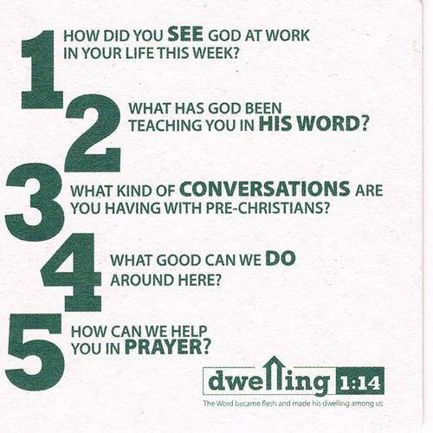

**JR. CONFIRMATION:** Calling all 5th graders and above who are interested in attending Confirmation Class this year. We will have our first meeting Wednesday August 31st at 4:30pm. Parents please plan on attending this first meeting with your child so that we can establish if this is a good day and time to meet and to give an overview of what is expected. Parents of 5th and 6th graders … if you prefer to wait until your child is in the 7th or 8th grade that is fine. We seem to be on a path that calls for having a class every other year. Questions, concerns give me a call/email.



**HELLO EVERYONE, I AM ON THE BOARD FOR KIDS COME FIRST** which is in the process of collecting items for needy children in our community that have no shoes or clothes for school. We have 400 homeless children right here in Monroe County and over 4,000 children on our free lunch program. I have set a goal to try and collect 400 pairs of sneakers in all sizes ranging from kindergarten to senior's in high school. If you feel you can help me in this goal please let me know and I can either pick up shoes or money to buy shoes. Thank you so much in advance.

Cheryl Cates Send checks to:

305-587-6726 Kids Come First

[CATESAUTO@aol.com](mailto:CATESAUTO@aol.com) 3405 Eagle Ave

Key West FL

**STAINED GLASS WINDOWS:** We only have 9 clear glass impact windows in the bathrooms and front entry, and the two side entry doors that need to be replaced.  When those are completed, the entire church will be protected with hurricane proof, impact windows. The cost of the windows is roughly $2000.00 each depending on size. Thank you donors of the stained glass windows and to all those who have contributed to the building fund for this project. Your generous giving is much appreciated

**THE GRACE LUTHERAN CHURCH WEB PAGE AND FACE BOOK PAGE** now contains a vocal recording of last week’s sermon. So if you are not able to attend church on Sunday please go to our website where you will find a copy of the bulletin and a recording of Pastor Faith’s sermon.

**A NUMBER OF CAPITAL IMPROVEMENTS** are needed to keep our facilities in good health for the future. The narthex has been rebuilt. Roof repairs are needed on school buildings. If you can help it would be much appreciated! A big thanks to all who

have contributed to these repairs.

**WOMEN’S BIBLE STUDY:** The Ladies Bible Study finished their studies on “Stories of Deliverance from the Old Testament”, asking 7 questions that answered why it was told and what we are to take from it, mainly asking how does this story show how God loves me. We are looking forward to a new study in the fall please consider joining us for an hour of interesting insights and lively discussions.

**MEN’S BIBLE FELLOWSHIP**: They meet the first and third Wednesday’s of each month at 12:30pm. Their next meeting will be September 7th located at Hogfish on Stock Island. All guys are welcome.