

Grace Lutheran Church

2713 Flagler Ave

Key West, FL. 33040

(305)296-5161

[GraceLutheranKW@att.net](mailto:GraceLutheranKW@att.net)

Gracelutherankw.360unite

Pastor Faith

(504) 858-8872

garyfaith@aol.com

**FOURTEENTH SUNDAY AFTER PENTECOST**

**AUGUST 21ST, 2016 9:00 a.m.**

**WORSHIP SERVICE**

***In the Name of Jesus!***

**Our Mission Statement:**

**Anchored in Christ, each person a missionary.**

**PRELUDE**

**ANNOUNCEMENTS:**

**We welcome you. We are glad you are here to share with us the joy and peace we have in Jesus Christ. It doesn’t matter whether this is your first time in this church or if you are a lifelong member, you are welcome. We come together today in order to celebrate the gift God has given us-His own Son, Jesus, Our Savior.**

**PREPARATION**

*(Please Stand…)*

**HYMN: “We Thank You, God, For Teachers”**

**Sung to the tune of “Sing to the Lord of Harvest” LSB 893**

1) We thank you, God, for teachers

Who help us learn your Way,

Who show by their example

How we can serve and pray,

Who find great joy in worship,

Who listen with concern;

For in their loving witness,

They help us want to learn.

2) We thank you, God, for children

And older people, too,

Who value times of learning

And want to grow in you,

Who seek your precious kingdom

And wisdom from above;

For wise ones of all ages

Still seek to learn your love.

3) We thank you, God, for families

Of every kind and size,

Who keep the vows they spoke when

Their children were baptized,

Who pray and read the Bible,

Who love and serve the poor;

They teach, by what they value,

The way of Christ our Lord.

4) We thank you, God, for churches

That welcome one and all,

That nurture every person

In answer to Christ's call.

So fill us with your Spirit,

And give us life anew,

That we may help each other

Live faithfully in you.

Copyright © 1999 by Carolyn Winfrey Gillette, from her book *Gifts of Love* (Geneva Press, 2000)

Pastor: In the Name of the Father and of the Son and Holy Spirit.

**Congregation: Amen.**

*(Please Remain Standing Or You May Kneel…)*

**GOD’S PEOPLE CONFESS THEIR SINS:**

Pastor: By grace you have been saved, through faith-and this is not from yourselves, it is the gift of God-not of works, so that no man can boast, for we are God’s workmanship, created in Christ Jesus.

**Congregation: I know that nothing good lives in me, that is, in my sinful nature, for I have the desire to do what is good, but I cannot carry it out.**

Pastor: What I do is not the good I want to do; no, the evil I do not want to do-this I keep doing.

**Congregation: In my heart I delight in God’s law, the law that points out what a wretched person I am! Who will rescue me from this body of death?**

Pastor: Thanks be to God through Jesus Christ our Lord! Only He can achieve the perfection we fail to achieve. By the forgiveness He purchased on the cross, our forgiveness is complete!

**SERVICE OF THE WORD**

*You may be seated…*

**THE FIRST READING: Proverbs 22:1-6**

Lector: This is the Word of the Lord.

**People: Thanks be to God.**

**THE EPISTLE LESSON: 2 Peter 3:18**

Lector: This is the Word of the Lord.

**People: Thanks be to God.**

*Please stand…*

**THE HOLY GOSPEL: Mark 10:13-16**

Pastor: The Holy Gospel according to St. Mark the 10th Chapter

**People: Glory to You, O Lord.**

Pastor: This is the Gospel of the Lord.

**People: Praise to You, O Christ!**

*Please be seated…*

**CHILDREN’S MESSAGE**

**NOISE OFERING**

**THE SERMON HYMN: *“Jesus Loves Me”* LSB 588**

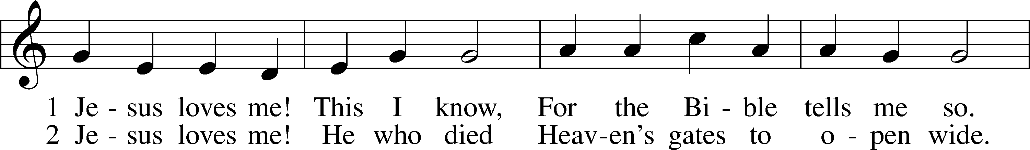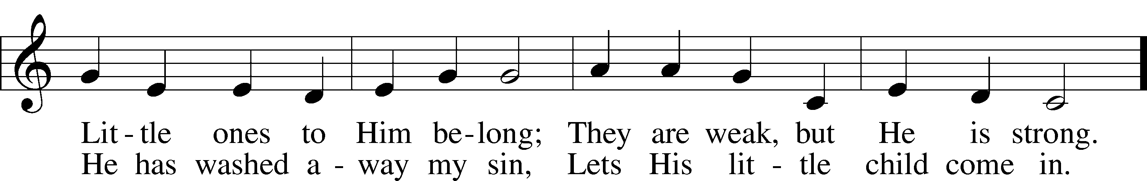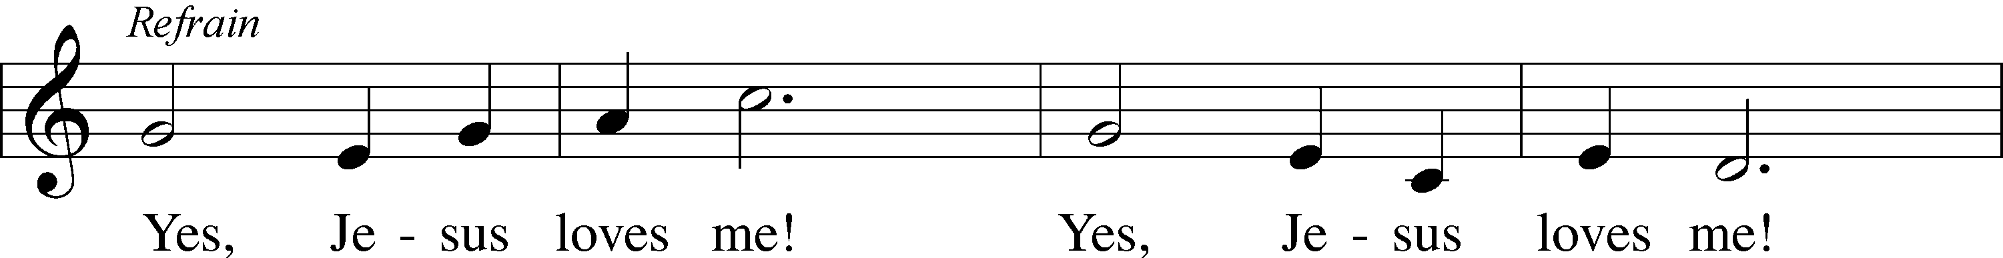

Public domain



.

**THE SERMON: *“Jesus Loves Kids”***

**INTRODUCTION OF GRACE’S SCHOOL BOARD**

**GRACE LUTHERAN SCHOOL TEACHERS/STAFF INSTALLATION:**

Pastor: The people of Grace and God Himself are pleased that you have been hired to be a part of GLS.

We now ask you to consider that teaching children is more than a job it is a precious privilege given to only a gifted few.

I now ask you, will you consider your position at GLS to be a privilege? Will you help the children to grow in their understanding of God’s world and in their understanding of God’s Word?

If so answer I will with the help of God.

**Teachers/Staff: I will with the help of God**

Pastor: Will you show the children the love of Jesus with Your words and with your life? Will you build loving relationships with the children so that they will better learn what healthy relationships are all about?

**Teachers/Staff: We will with the help of God.**

Pastor: We praise God for your committed joyful response. It’s through those healthy relationships that you will better be able to guide the students learning so that they and you will find joy in the learning process.

I now ask you the members of Grace Lutheran Church; will you support the work of these teachers and staff? Will you commit to praying for them and the children they serve?

Will you as opportunity presents itself offer words of encouragement to staff and children? And as you are able will you offer a helping hand when it is needed?

**Congregation: We will with the help of God**

Pastor: Your promises please our Father in Heaven. May we the people of Grace Lutheran Church and School be led by the Holy Spirit to carry out this noble work.

I now have the privilege of installing you as staff of Grace Lutheran School. In the Name of the Father, and of the Son, and of the Holy Spirit.

Go with God’s grace and be empowered by the Holy Spirit to grow and equip our children to grow in their understanding of Go’s world and God’s word.

**A BLESSING FOR ALL THOSE WHO TEACH IN THE KEY WEST COMMUNITY**

*(You may be seated…)*

**OFFERING RECEIVED**

**(***Please stand…)*

**THE PRAYERS OF THE CHURCH: based on Psalm 98**

Pastor: Dear Lord, we thank You for everything You’ve done for us, and most of all for Your own Son, Jesus, our Savior. We will never stop praising You for this wonderful gift.

**Congregation: Sing to the Lord a new song, for He has done marvelous things; His right hand and His holy arm have worked salvation for Him.**

Pastor: We thank You for those missionaries long ago who brought the Good News to our people. When we were in darkness, You sent men and women to bring us the light. Thank you, Lord.

**Congregation: The Lord has made His salvation known and revealed His Righteousness to the nation.**

Pastor: O Lord, You are our Savior, we trust in You for all our needs, give healing to the sick, courage to those who are afraid, and peace to those we name in our hearts either silently or out loud. **(a moment of silence)** We praise You, gracious Lord, for all Your benefits to us. You give us home, friends and family, food, shelter, rest and everything we need. You give us sight and hearing and touch and taste and provide for all of our needs.

**Congregation: Shout for joy to the Lord, praise His Name Amen.**



Jesus let the things that break

your heart also break our hearts.

Amen

**SERVICE OF THE SACRAMENT**

*(Please be seated…)*

**THE WORDS OF INSTITUTION**

**Communion Distribution Will Be Continuous Flow**

**DISTRIBUTION HYMNS: *“Children of the Heavenly Father”* LSB 725**

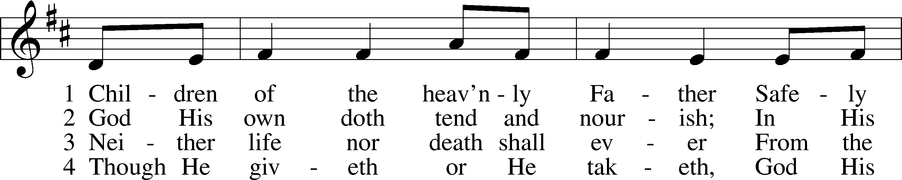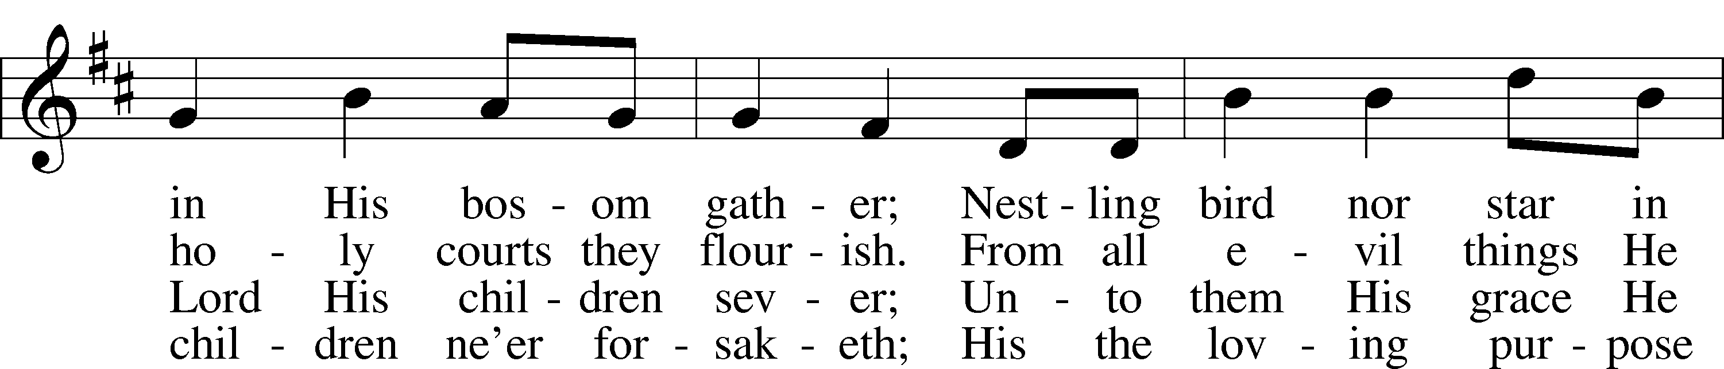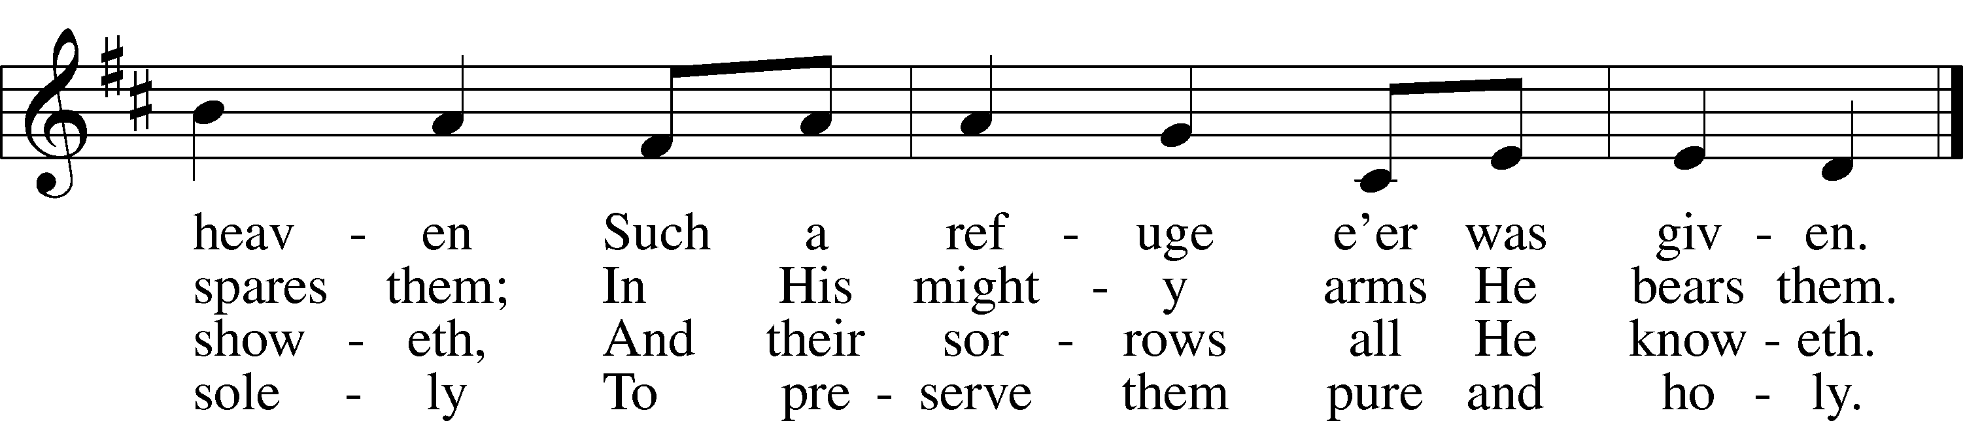

© Augsburg Publishing House. Used by permission: LSB Hymn License .NET, no. 100011641. Public domain



***“Christ Be My Leader”* LSB 861**

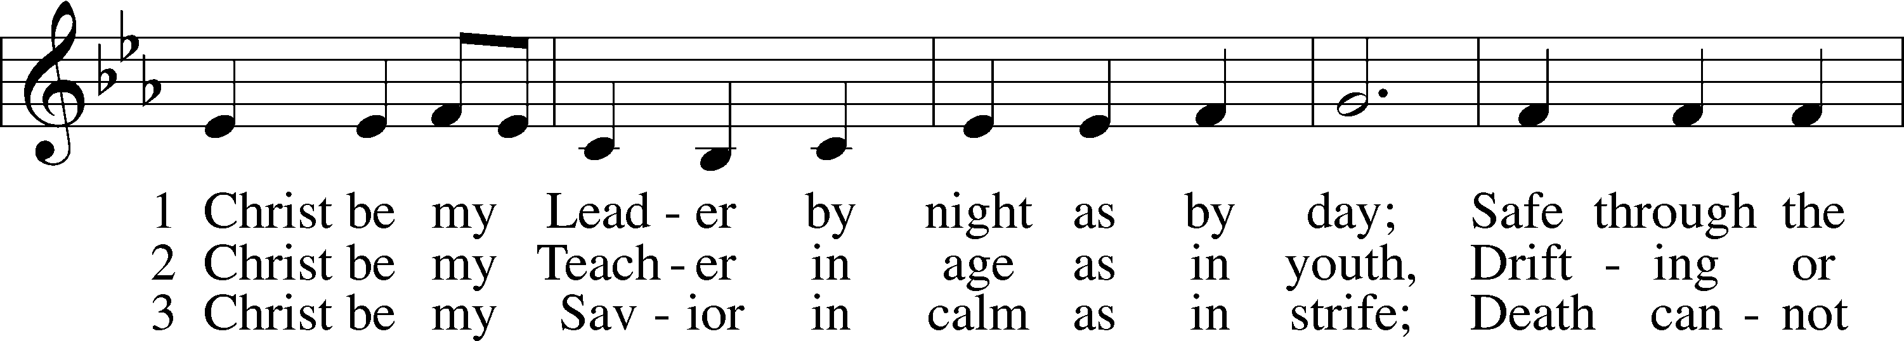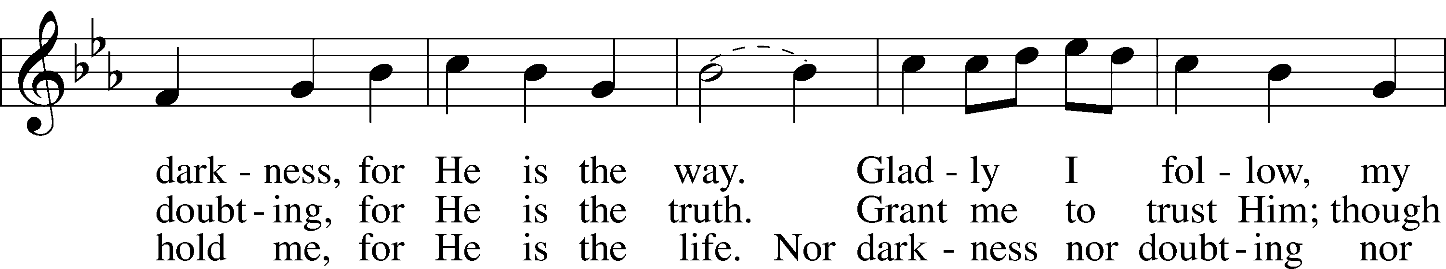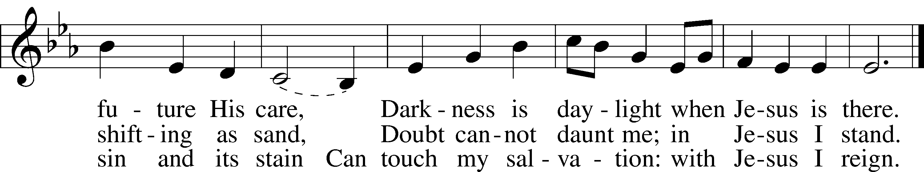

© 1964, renewed 1992 Hope Publishing Co. Used by permission: LSB Hymn License .NET, no. 100011641. Public domain

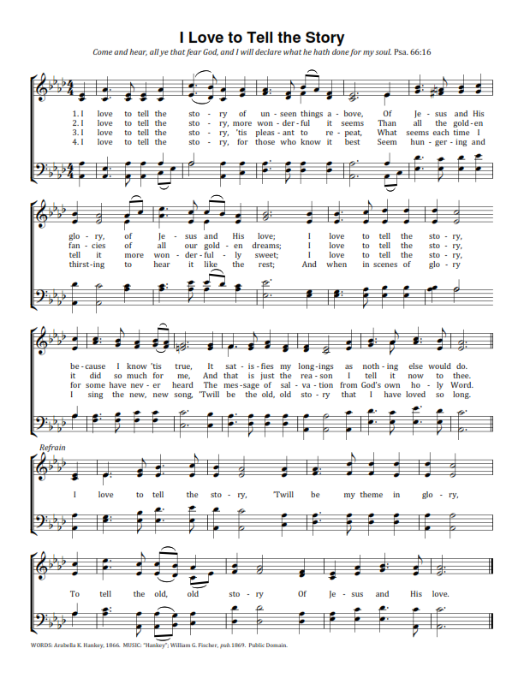

*(Please stand…)*

**THE LORD’S PRAYER:**

**All: Our Father, who art in heaven, hallowed be thy name, thy kingdom come, thy will be done, on earth as it is in heaven. Give us this day our daily bread; and forgive us our trespasses as we forgive those who trespass against us; and lead us not into temptation, but deliver us from evil. For thine is the kingdom, and the power, and the glory, forever and ever. Amen**

**THE BENEDICTION**

**THE CLOSING HYMN: *“Earth and All Stars”* LSB 817**

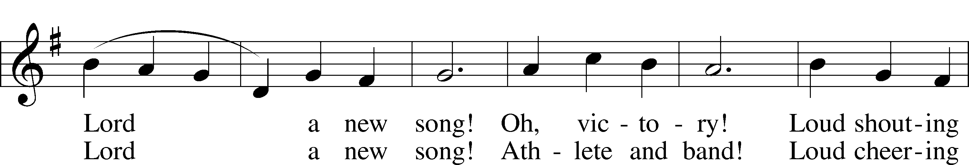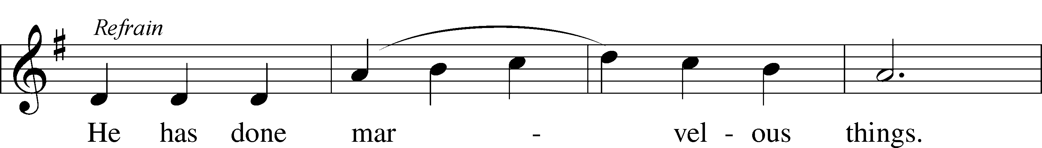

6 Knowledge and truth!  
 Loud sounding wisdom!  
Sing to the Lord a new song!  
 Daughter and son!   
 Loud praying members!  
Sing to the Lord a new song! Refrain  
© 1968 Augsburg Publishing House. Used by permission: LSB Hymn License .NET, no. 100011641.

**ANNOUNCEMENTS**

**WELCOME TO GRACE LUTHERAN CHURCH:** We are glad that you are here to worship God with us today! We pray that you will enjoy the wonderful fellowship as friends in Christ as God gathers us around His means of grace, the Word and Sacraments, to bless us with His treasured gifts of forgiveness, faith, abundant life and eternal salvation. If you are a guest, please also sign our Guest Book. Please talk to Pastor if you would like **to learn more about becoming a member of Grace. Also, please join us for refreshments** and fellowship after the Service. We invite you to come and worship with us often as God gathers us in His Grace.

**WELCOME TO THE LORD’S TABLE:** We invite and encourage all present who are baptized and faithful Christians, and who confess the Father, Son, and Holy Spirit to be the only true God and who believe that Jesus Christ died for the sins of the World and is our only hope and salvation…to join us in receiving the very and true body and blood of Christ in this Sacrament. The clear liquid cups in the center of the tray are non-alcoholic wine.

Children not yet confirmed in the faith are always welcome to join their parents at the Lord’s Table, but should keep their hands folded in front of them. The Pastor will give them a blessing.

**SERVING TODAY:** Acolyte: James Reynolds; Lector: Kris Bly; Communion Assistants: David Rose and Steve Bringle; Usher: Terry Richardson; Altar Care: Kris Howard; Refreshments: Potluck in the Parish Hall.

**SERVING NEXT SUNDAY:** Acolyte: Elizabeth Reynolds; Lector: David Walker; Communion Assistants: David Rose and Steve Bringle; Usher: Terry Richardson; Altar Care: Kris Howard; Refreshments: The Morris Family.

**FLOWERS**: were placed on the altar today to the glory of God and by Henry Hamilton.



**THIS WEEK AT A GLANCE:**

**Today: This Sunday**

9:00 am Worship Service with Communion and Teacher/Staff Installation

10:15 am Fellowship/Pot Luck in the Parish Hall

**Monday: August 22nd**

Pastor’s Day Off

5:30 pm Zumba

**Tuesday: August 23rd**

11:30 pm Gracious Ladies of Grace Luncheon (Lynn Jones Home, 24 Bamboo Terrace

3:00 pm Jan’s Mobile Gym (Parish Hall)

6:00 pm Weight Watcher’s (Parish Hall)

**Wednesday: August 24th**

**Thursday: August 25th**

7:00 pm Missional Communities (Room #3)

**Next Sunday: August 28th**

9:00 am Worship Service with Communion

10:15 am Fellowship/Refreshments

10:30 am Adult Bible Class/Children’s Sunday School

12:00 pm Adult Information Class (Room #3)

**IN YOUR PRAYERS THIS WEEK:** Mary Ellen Jessel, Marcos Diaz, Kaci Doran, Michael Willard, Angela Kolhagen, Kristen Howell, Charlie Sutherland, Will Plagens, Rev. Alfred Schubert II, the family and friends of Harry Htut, Auwina Weed, Kit Billings, Bill Billings Jr., Laura MacQuarie, Gabriel Kirkland, family and friends of Bryan Kay, Kay Sattelmeier, Phil Zielinski, the family and friends of Mary Bacle, the victims of the Lahore Pakistan attack, Esther Faith, Jameson Parker, the family and friends of Hwana, Liz and Ryan Grady, Larry, Dan, Gabriel, Andrew, Julia Pateman, David Lopez, Annie Garner, Nancy Amling, Alicia Llama, Erich & Erika Hoffmann, Katharina Lutz, Robert and Regina Hoffmann, Walter Hulme, Carole Steinle, Joanne Cates, Jane Howard, Jean Grafsgaurd, Denis Julson, Mary Kay, Sandy Harris, and those you are praying for at home. If anyone has a special prayer request please submit it in writing in the collection plate; or you may call Pastor Gary Faith at (504-858-8872), or Kris Howard at (305-296-5161).

**\*The first Sunday of September we will have a new prayer list available. If you would like the name of a person that is on this current prayer list to remain in the bulletin, please let me know by Wednesday August 31st.**

**GIFTS, TITHES, & ATTENDANCE LAST SUNDAY** for Sunday August 14th was $4164.00, the building fund received $400.00, the window fund received $3640.00 and the noise offering will be combined with this Sunday’s noise offering. Our attendance was 61.

**TO HELP US GROW…** The Bible readings for next Sunday’s service readings are Proverbs 25:2-10, Hebrews 13:1-17, and Luke 14:1-14.



**WELCOME TO ALL OF THE STAFF AND STUDENTS:** of our school. We are glad that you are part of the Grace family.

**FOLLOWING SERVICE TODAY** we will have a potluck to welcome and support the teachers. We hope you can all come and join us for some wonderful fellowship.

**NEXT SUNDAY** we will have a door offering to support the recovery work that the Lutheran Church is doing in Louisiana. If you are unable to attend next week and would like to donate either place your donation in the offering basket and label it Flood Recovery or drop your donation by the office.

If you can mail your donation directly to: Southern District LCMS

100 Mission Dr.

Slidell, LA 70460

If you would like to volunteer travel to LA and help with the recovery see the Southern District Website: [www.southernlcms.org](http://www.southernlcms.org).

Thank you for your prayers and support.

**GRACIOUS LADIES OF GRACE:** Well it was worth the journey heading up north to get a good meal and fellowship.  Our lunch at Square Grouper was 5* for cuisine, atmosphere, and service. There was a lot of ooing and ahhing and oh wow's. Ann and Martha finally showed up and joined us and it was like the good ole days.  We thought maybe they had found some other Grace Lutheran Church out in Arkansas that they liked better. No way!  We missed Patti, Deb, Garnet and Bev.  Not to mention Thelma and Louise oh I mean Faye and Yvonne. I think their off in their convertible looking for Robert Redford or some other famous handsome star and forgot about our luncheon date. We shared delicious desserts in honor of Angie's Birthday and remembered Patti's and Bev's birthday as well. We're mixing it up next time with a potluck (bring your favorite salad to share) at Lynn Jones's house 24 Bamboo Terrace at 11:30 Aug. 30th.

**WE HAVE SCHEDULED AN ADULT INFORMATION CLASS:** Part 1 will be held on August 28th from noon until 2pm. Part 2 will be held Sept 11th, noon until 2pm. This is for those who may be interested in joining and/or learning more about what we teach/believe. It is also a good review for our members.

**NEW LOCATION - MISSIONAL COMMUNITIE:** Missional Communities continues again this Thursday. We have changed the location from the parsonage to classroom #3. We plan on meeting every Thursday to talk about how we see God at work and as time allows we will also prepare for Sunday worship by looking at the appointed scriptures for that Sunday. Everyone is welcome and encouraged to attend. We will start the 5 Questions at 7pm and end the session by 8pm. The room will be open at 6:30 for those who like to arrive early and chat.

**JR. CONFIRMATION:** Calling all 5th graders and above who are interested in attending Confirmation Class this year. We will have our first meeting Wednesday August 31st at 4:30pm. Parents please plan on attending this first meeting with your child so that we can establish if this is a good day and time to meet and to give an overview of what is expected. Parents of 5th and 6th graders … if you prefer to wait until your child is in the 7th or 8th grade that is fine. We seem to be on a path that calls for having a class every other year. Questions, concerns give me a call/email.

**HELLO EVERYONE, I AM ON THE BOARD FOR KIDS COME FIRST** which is in the process of collecting items for needy children in our community that have no shoes or clothes for school. We have 400 homeless children right here in Monroe County and over 4,000 children on our free lunch program. I have set a goal to try and collect 400 pairs of sneakers in all sizes ranging from kindergarten to senior's in high school. If you feel you can help me in this goal please let me know and I can either pick up shoes or money to buy shoes. Thank you so much in advance.

Cheryl Cates Send checks to:

305-587-6726 Kids Come First

[CATESAUTO@aol.com](mailto:CATESAUTO@aol.com) 3405 Eagle Ave

Key West FL

**STAINED GLASS WINDOWS:** We only have 9 clear glass impact windows in the bathrooms and front entry, and the two side entry doors that need to be replaced.  When those are completed, the entire church will be protected with hurricane proof, impact windows. The cost of the windows is roughly $2000.00 each depending on size. Thank you donors of the stained glass windows and to all those who have contributed to the building fund for this project. Your generous giving is much appreciated

**THE GRACE LUTHERAN CHURCH WEB PAGE AND FACE BOOK PAGE** now contains a vocal recording of last week’s sermon. So if you are not able to attend church on Sunday please go to our website where you will find a copy of the bulletin and a recording of Pastor Faith’s sermon.

**A NUMBER OF CAPITAL IMPROVEMENTS** are needed to keep our facilities in good health for the future. The narthex has been rebuilt. Roof repairs are needed on school buildings. If you can help it would be much appreciated! A big thanks to all who

have contributed to these repairs.



**WOMEN’S BIBLE STUDY:** The Ladies Bible Study finished their studies on “Stories of Deliverance from the Old Testament”, asking 7 questions that answered why it was told and what we are to take from it, mainly asking how does this story show how God loves me. We are looking forward to a new study in the fall please consider joining us for an hour of interesting insights and lively discussions.

**MEN’S BIBLE FELLOWSHIP**: They meet the first and third Wednesday’s of each month at 12:30pm. Their next meeting will be September 7th located at Hogfish on Stock Island. All guys are welcome.

**FOURTEENTH SUNDAY AFTER PENTECOST**

**Old Testament Reading:**

**Proverbs 22:1-6**

22 A good name is more desirable than great riches; to be esteemed is better than silver or gold. 2Rich and poor have this in common: The LORD is the Maker of them all. 3A prudent man sees danger and takes refuge, but the simple keep going and suffer for it. 4Humility and the fear of the LORD bring wealth and honor and life. 5In the paths of the wicked lie thorns and snares, but he who guards his soul stays far from them. 6Train a child in the way he should go, and when he is old he will not turn from it.

**Epistle: 2 Peter 3:18**

18But grow in the grace and knowledge of our Lord and Savior Jesus Christ. To him be glory both now and forever! Amen.

**Holy Gospel: Mark 10:13-16**

13People were bringing little children to Jesus to have him touch them, but the disciples rebuked them. 14When Jesus saw this, he was indignant. He said to them, “Let the little children come to me, and do not hinder them, for the kingdom of God belongs to such as these. 15I tell you the truth, anyone who will not receive the kingdom of God like a little child will never enter it.” 16And he took the children in his arms, put his hands on them and blessed them.