**July 31st, 2016**

**9:00 am**

**ELEVENTH**

**SUNDAY AFTER PENTECOST**



**Grace Lutheran Church**

**2713 Flagler Ave.**

**Key West, FL 33040**

**305-296-5161**

**GraceLutheranKW@att.net**

**Pastor Faith**

**(504) 858-8872**

**garyfaith@aol.com**

**ELEVENTH SUNDAY AFER PENTECOST**

**JULY 31ST, 2016 9:00 a.m.**

**WORSHIP SERVICE**

***In the Name of Jesus!***

**Our Mission Statement:**

**Anchored in Christ, each person a missionary.**

**PRELUDE**

**ANNOUNCEMENTS:**

**We welcome you. We are glad you are here to share with us the joy and peace we have in Jesus Christ. It doesn’t matter whether this is your first time in this church or if you are a lifelong member, you are welcome. We come together today in order to celebrate the gift God has given us-His own Son, Jesus, Our Savior.**

**PREPARATION**

*(Please Stand…)*

**HYMN: *“God of Grace and God of Glory”* LSB 850**

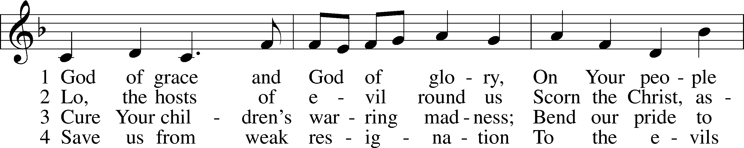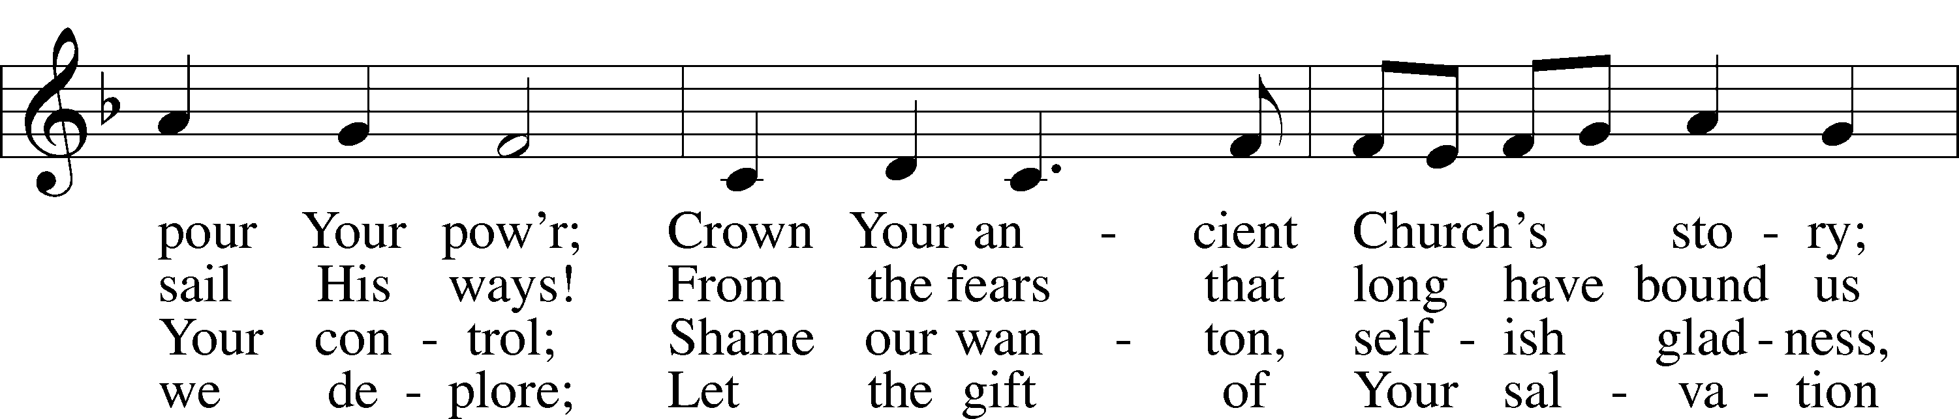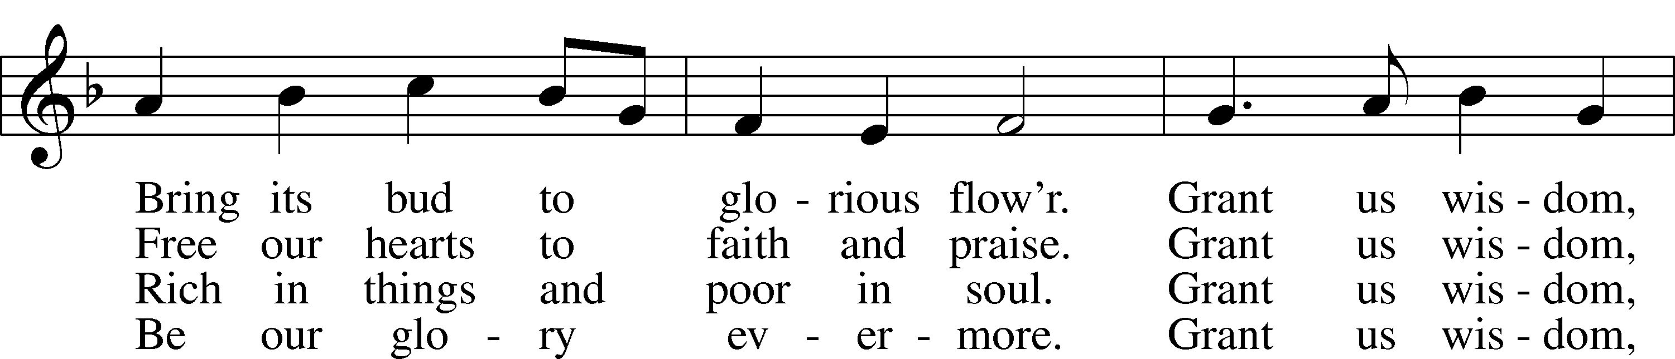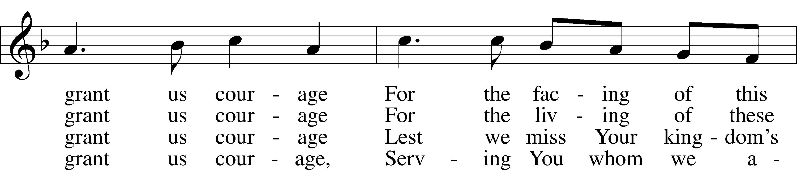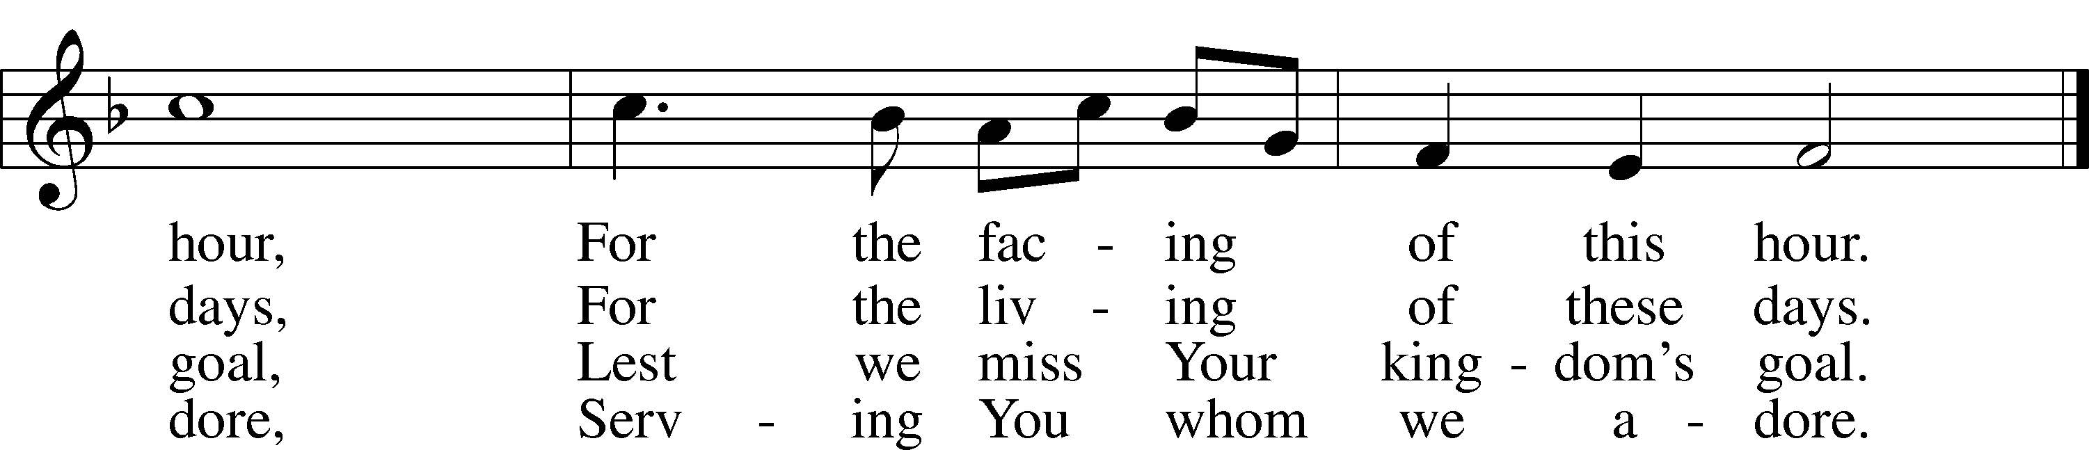

Public domain

Pastor: In the Name of the Father and of the Son and Holy Spirit.

**Congregation: Amen.**

**SERVICE OF HOLY BAPTISM**

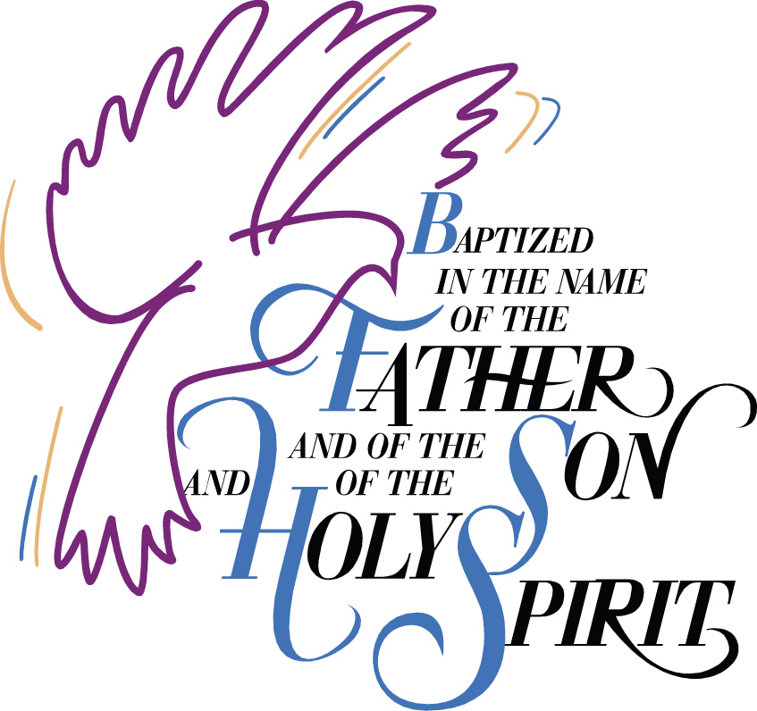

***“Father Welcomes”* LSB 605**

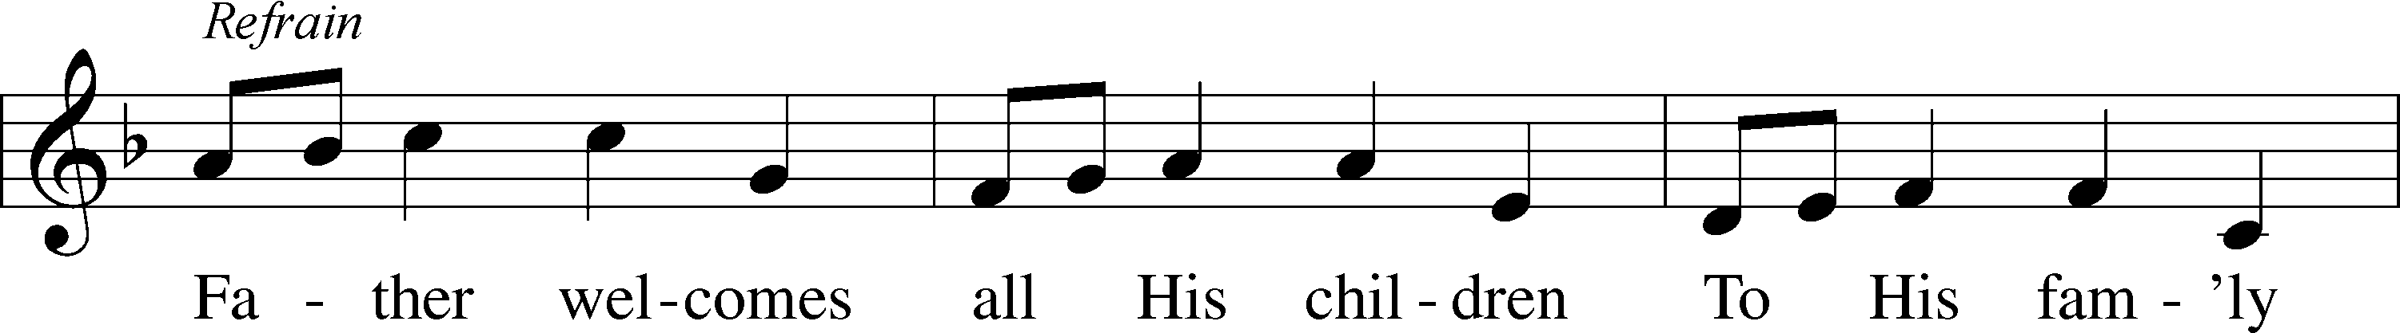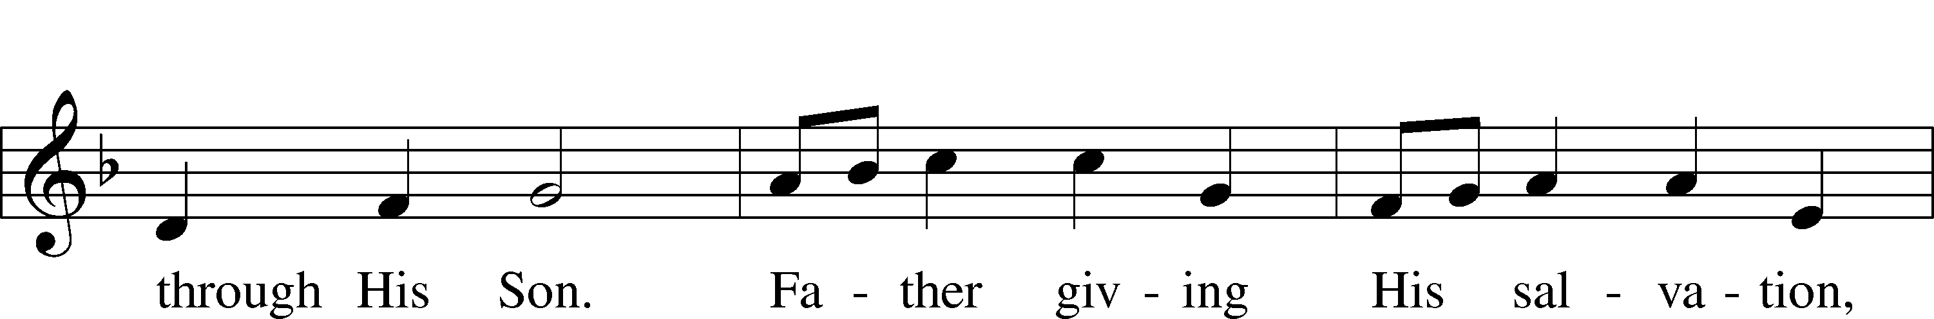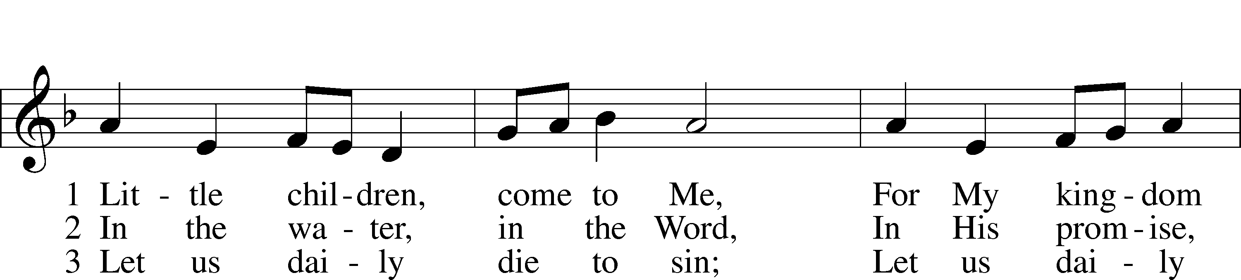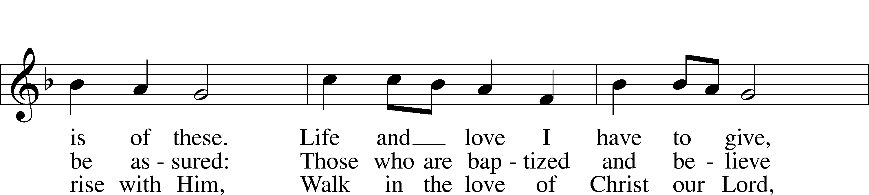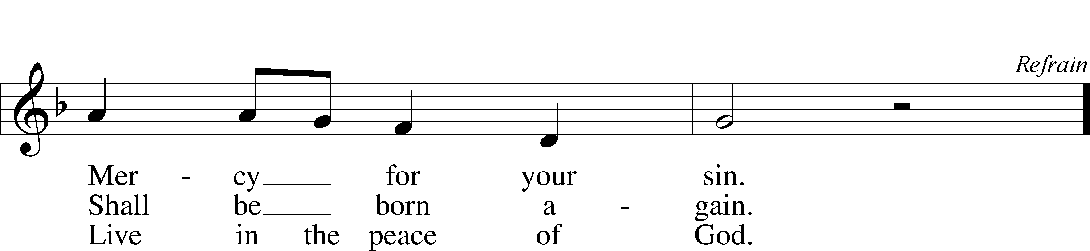

© 1986 Kevin Mayhew Ltd. Used by permission: LSB Hymn License .NET, no. 100011641.

*(Please Remain Standing Or You May Kneel…)*

**GOD’S PEOPLE CONFESS THEIR SINS:**

Pastor: By grace you have been saved, through faith-and this is not from yourselves, it is the gift of God-not of works, so that no man can boast, for we are God’s workmanship, created in Christ Jesus.

**Congregation: I know that nothing good lives in me, that is, in my sinful nature, for I have the desire to do what is good, but I cannot carry it out.**

Pastor: What I do is not the good I want to do; no, the evil I do not want to do-this I keep doing.

**Congregation: In my heart I delight in God’s law, the law that points out what a wretched person I am! Who will rescue me from this body of death?**

Pastor: Thanks be to God through Jesus Christ our Lord! Only He can achieve the perfection we fail to achieve. By the forgiveness He purchased on the cross, our forgiveness is complete!

**SERVICE OF THE WORD**

*You may be seated…*

**THE FIRST READING: Ecclesiastes 1:2, 2-14, 2:18-26**

Lector: This is the Word of the Lord.

**People: Thanks be to God.**

**THE EPISTLE LESSON: Colossians 3:1-11**

Lector: This is the Word of the Lord.

**People: Thanks be to God.**

*Please stand…*

**THE HOLY GOSPEL: Luke 12:13-21**

Pastor: The Holy Gospel according to St. Luke the 12th Chapter

**People: Glory to You, O Lord.**

Pastor: This is the Gospel of the Lord.

**People: Praise to You, O Christ!**

*Please be seated…*

**CHILDREN’S MESSAGE**

**NOISE OFERING**



**THE SERMON HYMN: *“Gracious God, You Send Great Blessings”* LSB 782**

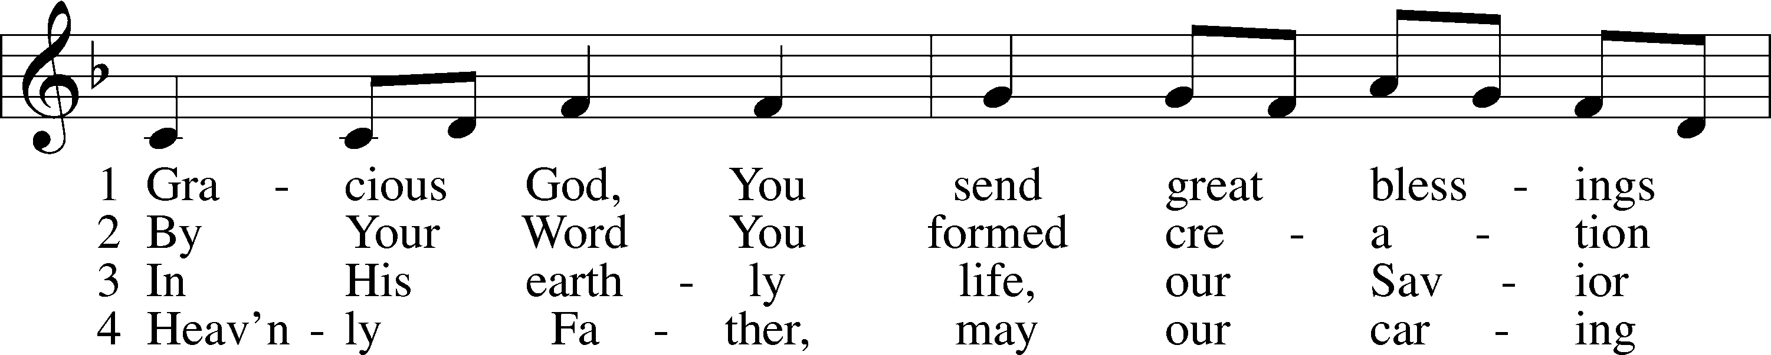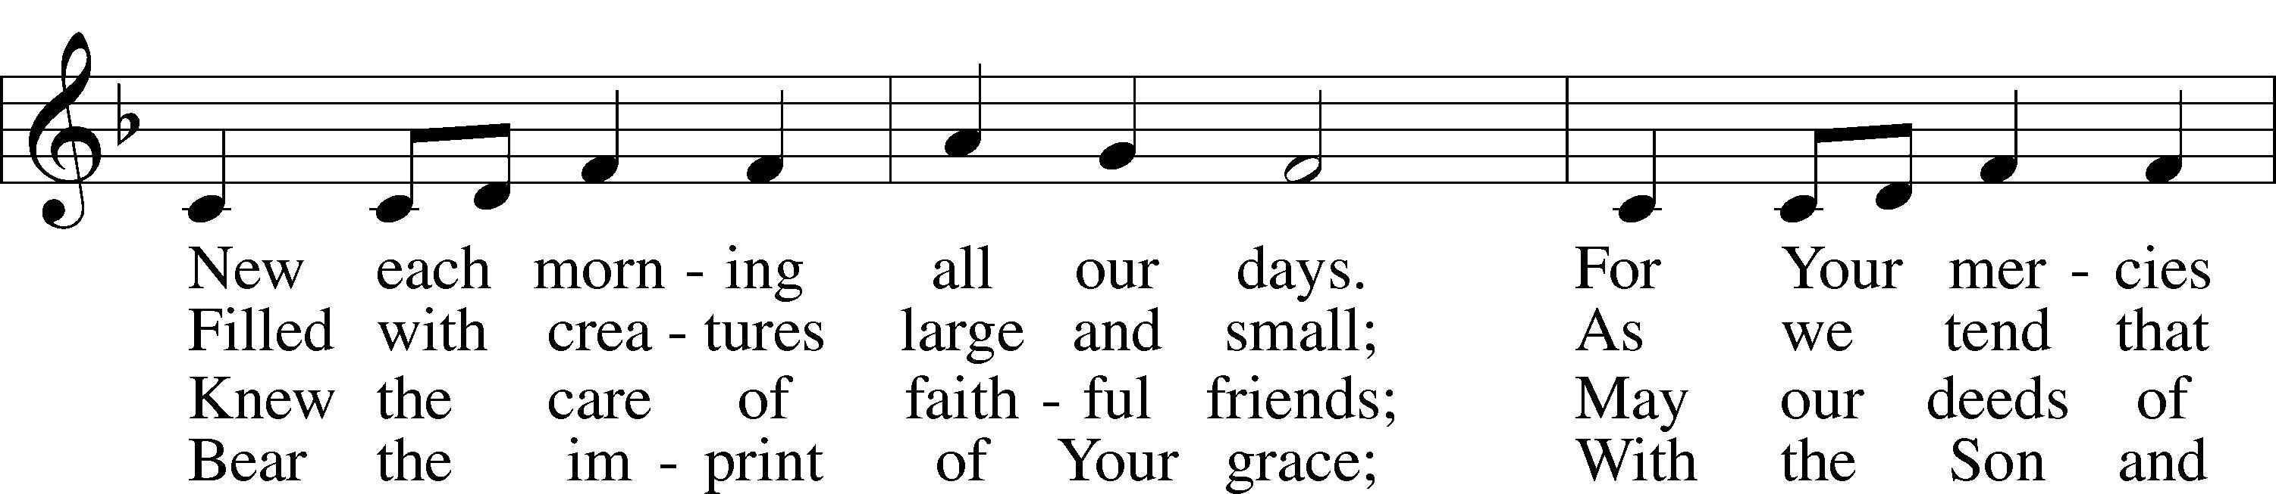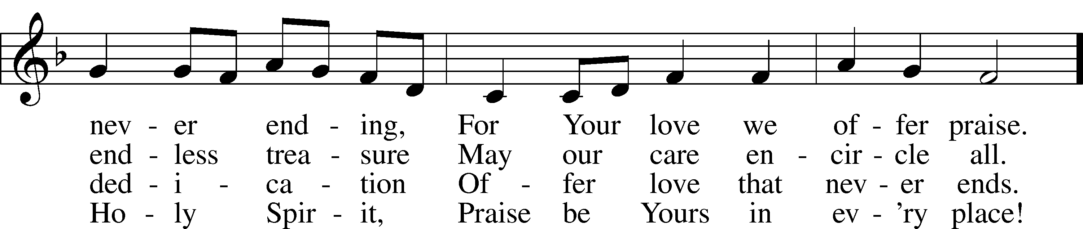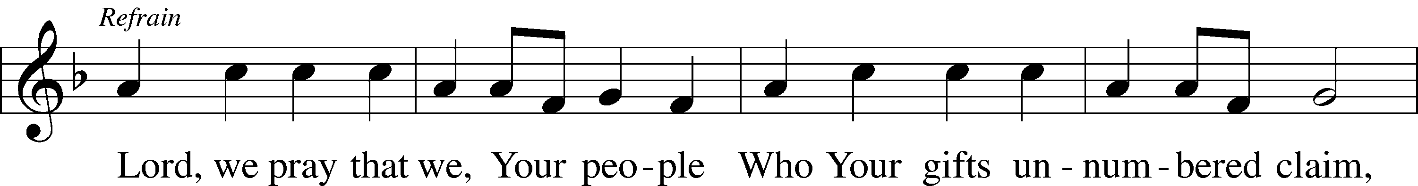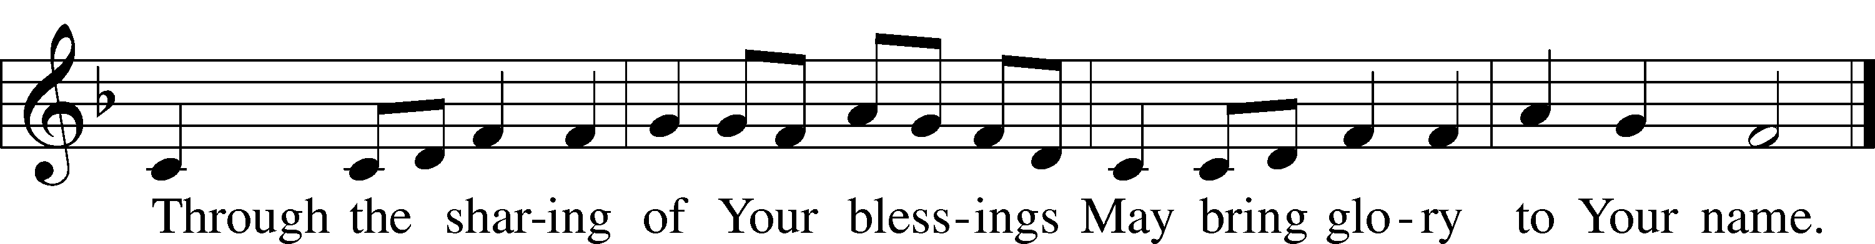

© 2004 Gregory J. Wismar. Used by permission: LSB Hymn License .NET, no. 100011641.  
Public domain

**THE SERMON: *“What’s the Point?”* Ecclesiastes 1:2, 12-14, 2:18-26**

*(You may be seated…)*

**OFFERING RECEIVED**

**(***Please stand…)*

**THE PRAYERS OF THE CHURCH: based on Psalm 98**

Pastor: Dear Lord, we thank You for everything You’ve done for us, and most of all for Your own Son, Jesus, our Savior. We will never stop praising You for this wonderful gift.

**Congregation: Sing to the Lord a new song, for He has done marvelous things; His right hand and His holy arm have worked salvation for Him.**

Pastor: We thank You for those missionaries long ago who brought the Good News to our people. When we were in darkness, You sent men and women to bring us the light. Thank you, Lord.

**Congregation: The Lord has made His salvation known and revealed His Righteousness to the nation.**

Pastor: O Lord, You are our Savior, we trust in You for all our needs, give healing to the sick, courage to those who are afraid, and peace to those we name in our hearts either silently or out loud. **(a moment of silence)** We praise You, gracious Lord, for all Your benefits to us. You give us home, friends and family, food, shelter, rest and everything we need. You give us sight and hearing and touch and taste and provide for all of our needs.

**Congregation: Shout for joy to the Lord, praise His Name Amen.**

**SERVICE OF THE SACRAMENT**

*(Please be seated…)*

**THE WORDS OF INSTITUTION**

**DISTRIBUTION HYMNS: *“Beautiful Savior”* LSB 537**

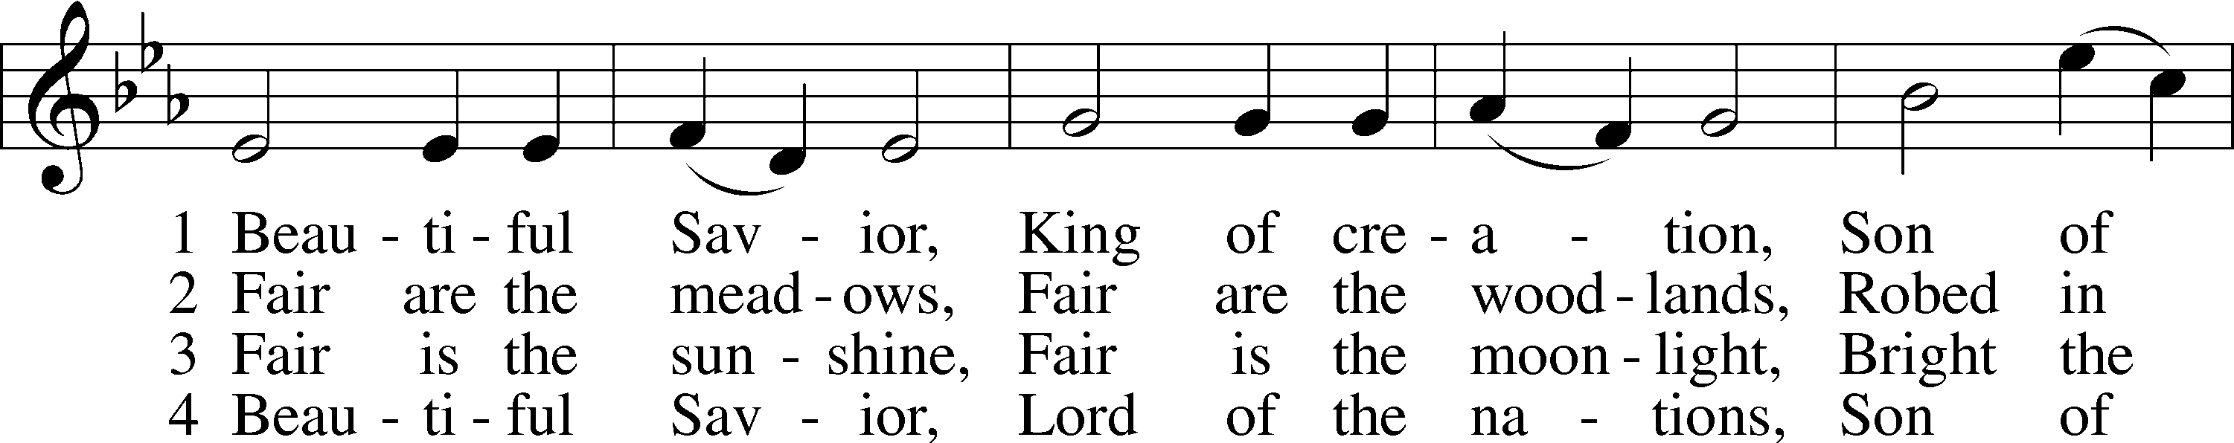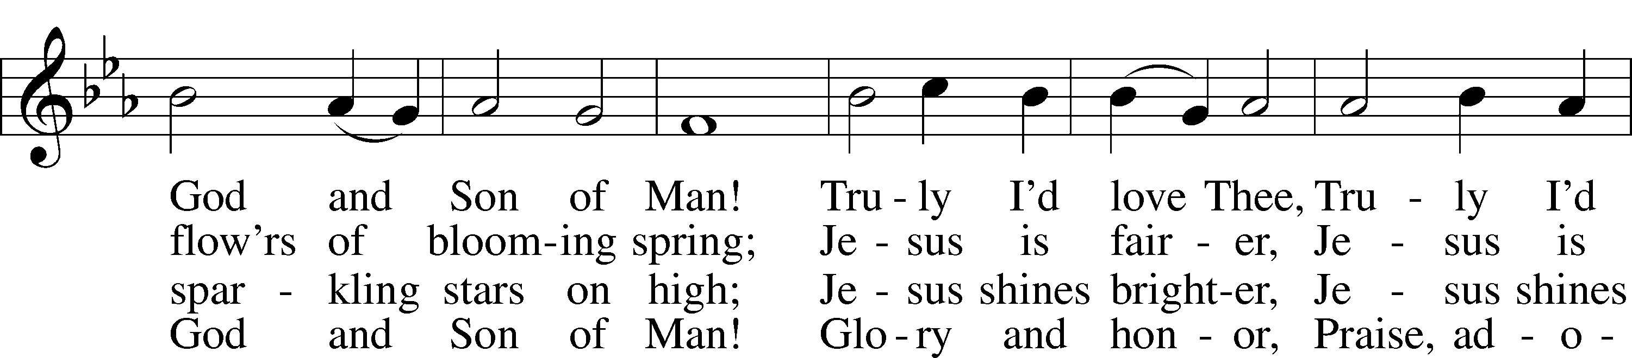

Public domain

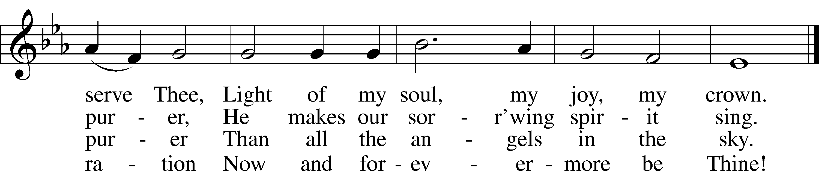

Jesus let the things that break your heart also break our hearts.



Amen

***“Rock of Ages, Cleft for Me”* LSB 761**

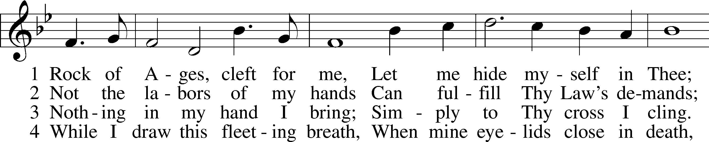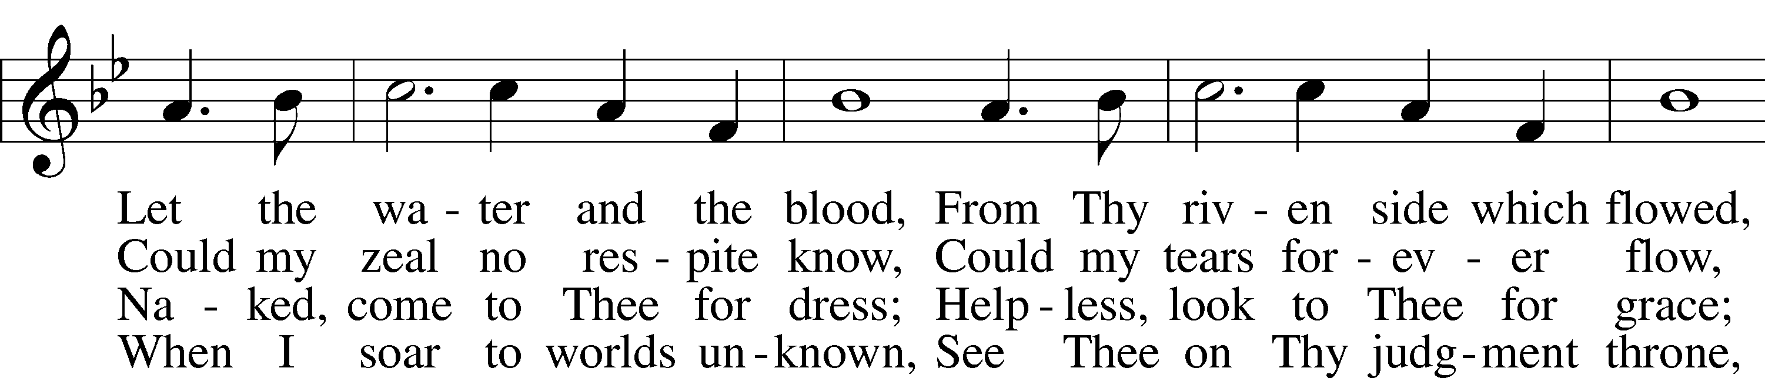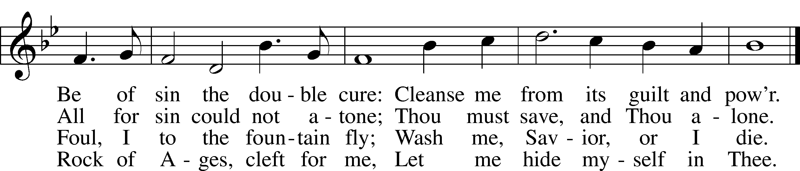

Public domain

***“Oh, That the Lord Would Guide My Ways”* LSB 707**

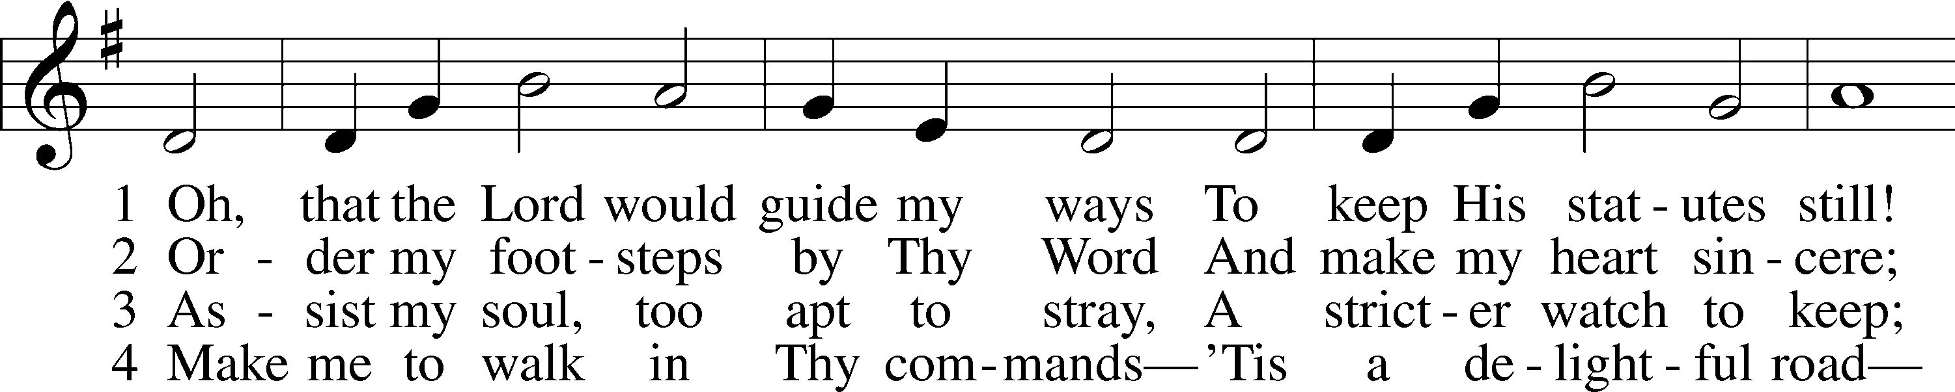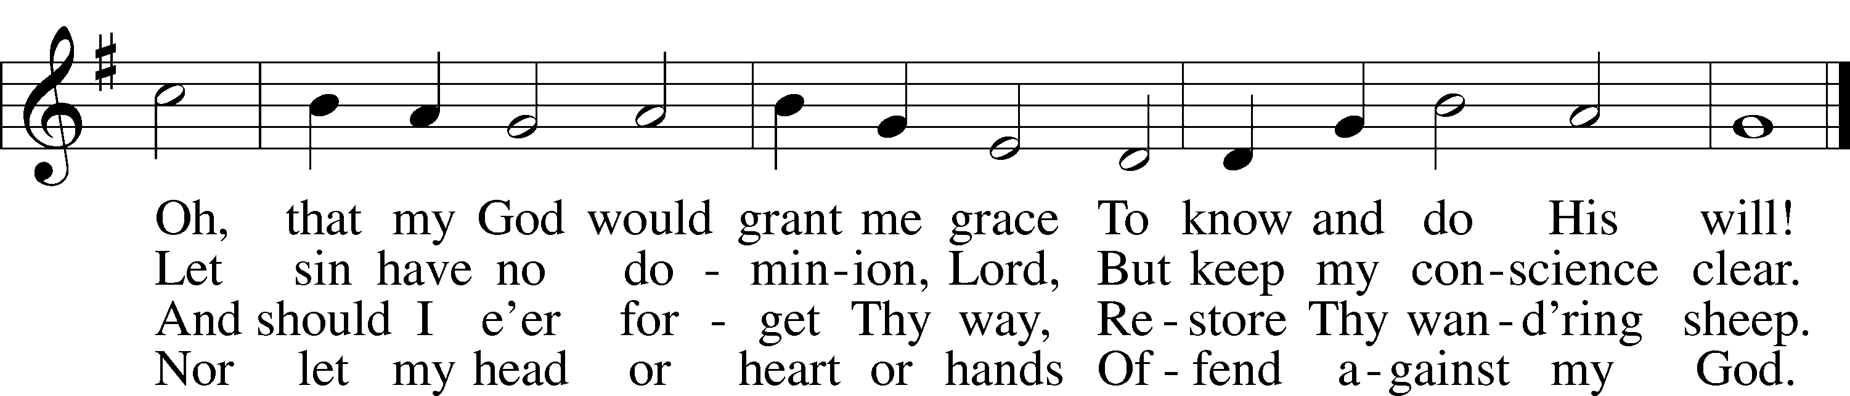

Public domain

*(Please stand…)*

**THE LORD’S PRAYER:**

**All: Our Father, who art in heaven, hallowed be thy name, thy kingdom come, thy will be done, on earth as it is in heaven. Give us this day our daily bread; and forgive us our trespasses as we forgive those who trespass against us; and lead us not into temptation, but deliver us from evil. For thine is the kingdom, and the power, and the glory, forever and ever. Amen**

**THE BENEDICTION**



**THE CLOSING HYMN: *“To God Be The Glory”***

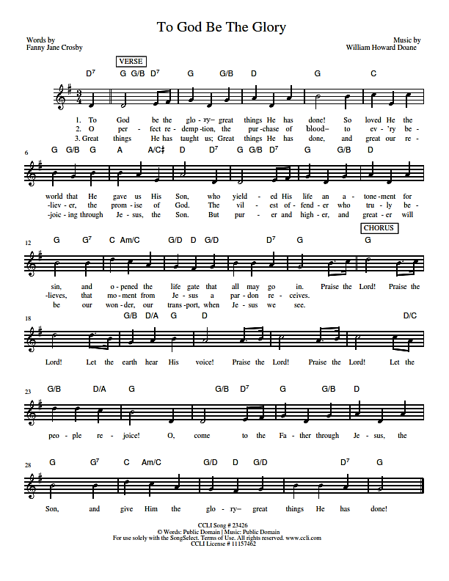

**music by William Howard Doane, Words by Fanny Jan Crosby**



**ANNOUNCEMENTS**

**WELCOME TO GRACE LUTHERAN CHURCH:** We are glad that you are here to worship God with us today! We pray that you will enjoy the wonderful fellowship as friends in Christ as God gathers us around His means of grace, the Word and Sacraments, to bless us with His treasured gifts of forgiveness, faith, abundant life and eternal salvation. If you are a guest, please also sign our Guest Book. Please talk to Pastor if you would like **to learn more about becoming a member of Grace. Also, please join us for refreshments** and fellowship after the Service. We invite you to come and worship with us often as God gathers us in His Grace.

**WELCOME TO THE LORD’S TABLE:** We invite and encourage all present who are baptized and faithful Christians, and who confess the Father, Son, and Holy Spirit to be the only true God and who believe that Jesus Christ died for the sins of the World and is our only hope and salvation…to join us in receiving the very and true body and blood of Christ in this Sacrament. The clear liquid cups in the center of the tray are non-alcoholic wine.

Children not yet confirmed in the faith are always welcome to join their parents at the Lord’s Table, but should keep their hands folded in front of them. The Pastor will give them a blessing.

**SERVING TODAY:** Acolyte: Maddie Schoepf; Lector: Jim Picking; Communion Assistants: Vince Winters and Max Broadbent; Usher: David Rose; Altar Care: Monica Bacle; Refreshments: Monica Bacle.

**SERVING NEXT SUNDAY:** Acolyte: Lillian Howard; Lector: David Rose; Communion Assistants: David Rose and Steve Bringle; Usher: Terry Richardson; Altar Care: Kris Howard; Refreshments: ________________.

**FLOWERS**: were placed on the altar today to the glory of God and to celebrate Norma Bringle’s birthday.



**THIS WEEK AT A GLANCE:**

**Today: This Sunday**

9:00 am Worship Service with Communion

10:15 am Fellowship/Refreshments

10:30 am Adult Bible Class/Children’s Sunday School

**Monday: August 1st**

Pastor’s Day Off

5:30 pm Zumba

**Tuesday: August 2nd**

11:30 am Gracious Ladies of Grace Luncheon (Hyatt, 601 Front St.)

3:00 pm Jan’s Mobile Gym (Parish Hall)

6:00 pm Weight Watcher’s (Parish Hall)

**Wednesday: August 3rd**

12:30 pm Men’s Bible Fellowship (Chico’s Restaurant)

**Next Sunday: August 7th**

9:00 am Worship Service with Communion

10:15 am Fellowship/Refreshments

10:30 am Adult Bible Class/Children’s Sunday School

**IN YOUR PRAYERS THIS WEEK:** Charlie Sutherland, Will Plagens, Re. Alfred Schubert II, the family and friends of Harry Htut, Auwina Weed, Kit Billings, Bill Billings Jr., Laura MacQuarie, Gabriel Kirkland, family and friends of Bryan Kay, Kay Sattelmeier, Suzanne Kolhagan, Phil Zielinski, Cressie Brown, the family and friends of Mary Bacle, the victims of the Lahore Pakistan attack, Esther Faith, Jameson Parker, the family and friends of Hwana, Liz and Ryan Grady, Loretta Cates, Larry, Dan, Gabriel, Andrew, Julia Pateman, David Lopez, Annie Garner, Nancy Amling, Alicia Llama, Erich & Erika Hoffmann, Katharina Lutz, Robert and Regina Hoffmann, Walter Hulme, Carole Steinle, Joanne Cates, Jane Howard, Jean Grafsgaurd, Denis Julson, Mary Kay, Sandy Harris, and those you are praying for at home. If anyone has a special prayer request please submit it in writing in the collection plate; or you may call Pastor Gary Faith at (504-858-8872), or Kris Howard at (305-296-5161).

**GIFTS, TITHES, & ATTENDANCE LAST SUNDAY** for Sunday July 17th were $5258.00, the building fund received $700.00, and the noise offering totaled $50.00 with an attendance of 46. For Sunday July 24th the church received $2444.00, the building fund received $600.00, with an attendance of 44. The noise offering will be announced in next weeks’ announcements.

**TO HELP US GROW…** The Bible readings for next Sunday’s service readings are Genesis 15:1-6, Hebrews 11:1-16, and Luke 12:22-34.



**TODAY WE RECEIVE** into the kingdom of God through the washing of holy baptism Estella Grace and Jackson Brooks Lopez. They are the children of Tony and Tiffany Lopez. We thank God for the gift of holy baptism and the blessings we receive from it.

**ELEVEN GRACIOUS LADIES** dined at the Key West Yacht Club on the 19th.  We had a couple of first timers and we all enjoyed the new faces and conversation and hope they enjoyed the fellowship. We missed Faye, Yvonne and Lynn, our regulars, hope they were having fun.  All in all, it was a great turnout for the summertime.  We gave a 5-star rating for service, ambiance, and delicious cuisine.   Chef Eric always comes out to check on our approval. The next luncheon will be on the 2nd of August at 11:30 at the Hyatt on 601 Front St. They have dining on the ocean with a great view and we hope great food. This is our first time at this restaurant. Come join the ladies for fun, fellowship, and good food.

**ADULT INFORMATION CLASS:** We would like to schedule an Adult Information Class. This is for those who would like to become a member of Grace and/or learn more about what we teach and believe. It is also a good review for members. If interested, please let Pastor or Kris know. Thanks.

**MISSIONAL COMMUNITIES** will not meet again until August 11th.

**STAINED GLASS WINDOWS:** We only have 9 clear glass impact windows in the bathrooms and front entry, and the two side entry doors that need to be replaced.  When those are completed, the entire church will be protected with hurricane proof, impact windows. The cost of the windows is roughly $2000.00 each depending on size. Thank you donors of the stained glass windows and to all those who have contributed to the building fund for this project. Your generous giving is much appreciated

**THE GRACE LUTHERAN CHURCH WEB PAGE AND FACE BOOK PAGE** now contains a vocal recording of last week’s sermon. So if you are not able to attend church on Sunday please go to our website where you will find a copy of the bulletin and a recording of Pastor Faith’s sermon.

**A NUMBER OF CAPITAL IMPROVEMENTS** are needed to keep our facilities in good health for the future. The narthex has been rebuilt. Roof repairs are needed on school buildings. If you can help it would be much appreciated! A big thanks to all who

have contributed to these repairs.



**WOMEN’S BIBLE STUDY:** The Ladies Bible Study finished their studies on “Stories of Deliverance from the Old Testament”, asking 7 questions that answered why it was told and what we are to take from it, mainly asking how does this story show how God loves me. We are looking forward to a new study in the fall please consider joining us for an hour of interesting insights and lively discussions.

**MEN’S BIBLE FELLOWSHIP**: They meet the first and third Wednesday’s of each month at 12:30pm at Chico’s Restaurant. Their next meeting will be August 3rd. All guys are welcome.

