**July 10th, 2016**

**9:00 am**

**EIGHTH SUNDAY AFTER PENTECOST**



**Grace Lutheran Church**

**2713 Flagler Ave.**

**Key West, FL 33040**

**305-296-5161**

[**GraceLutheranKW@att.net**](mailto:GraceLutheranKW@att.net)

gracelutherankw.360unite

**Pastor Faith**

**(504) 858-8872**

**garyfaith@aol.com**

**EIGHTH SUNDAY AFTER PENTECOST**

**JULY 10TH, 2016 9:00 a.m.**

**WORSHIP SERVICE**

***In the Name of Jesus!***

**Our Mission Statement: Anchored in Christ, each person a missionary.**

**PRELUDE**

**ANNOUNCEMENTS:**

**God is with us all during the week, wherever we are and in whatever we are doing. This week, let’s enjoy His presence.**

*(Please Stand…)*

**HYMN:  *“Joyful, Joyful We Adore Thee”* LSB 803**

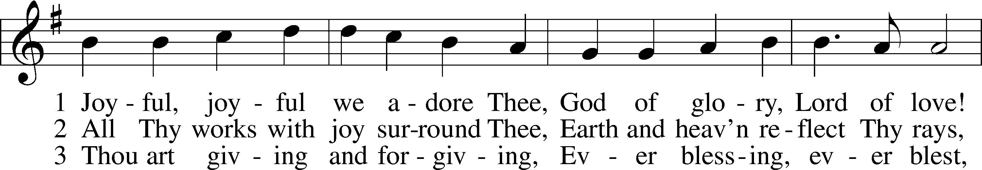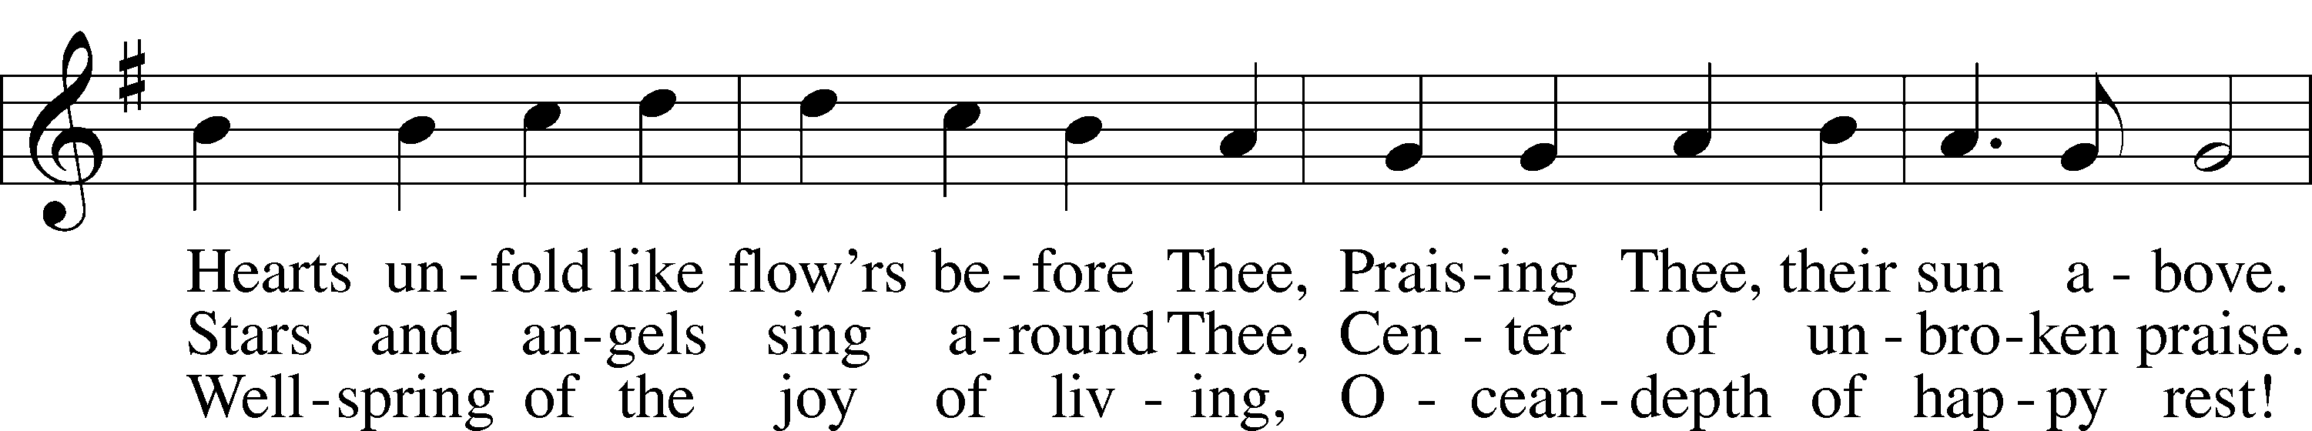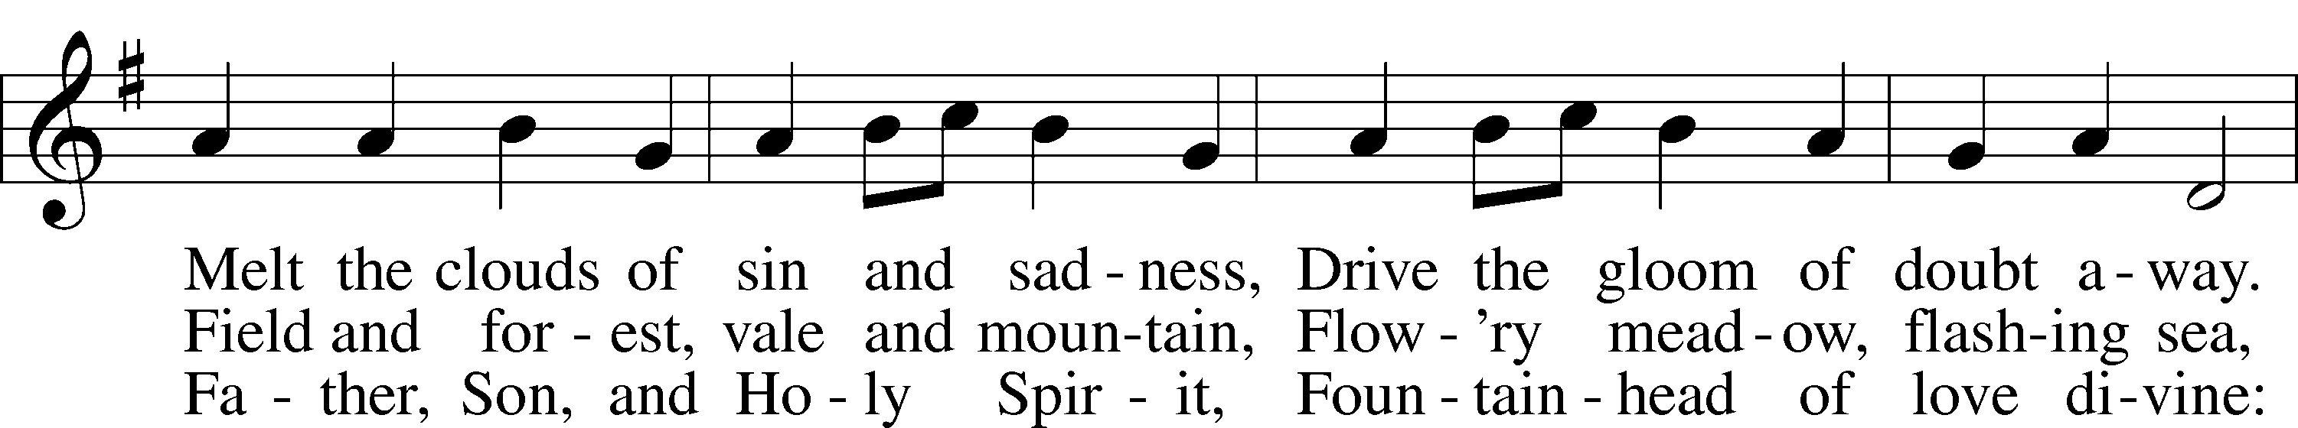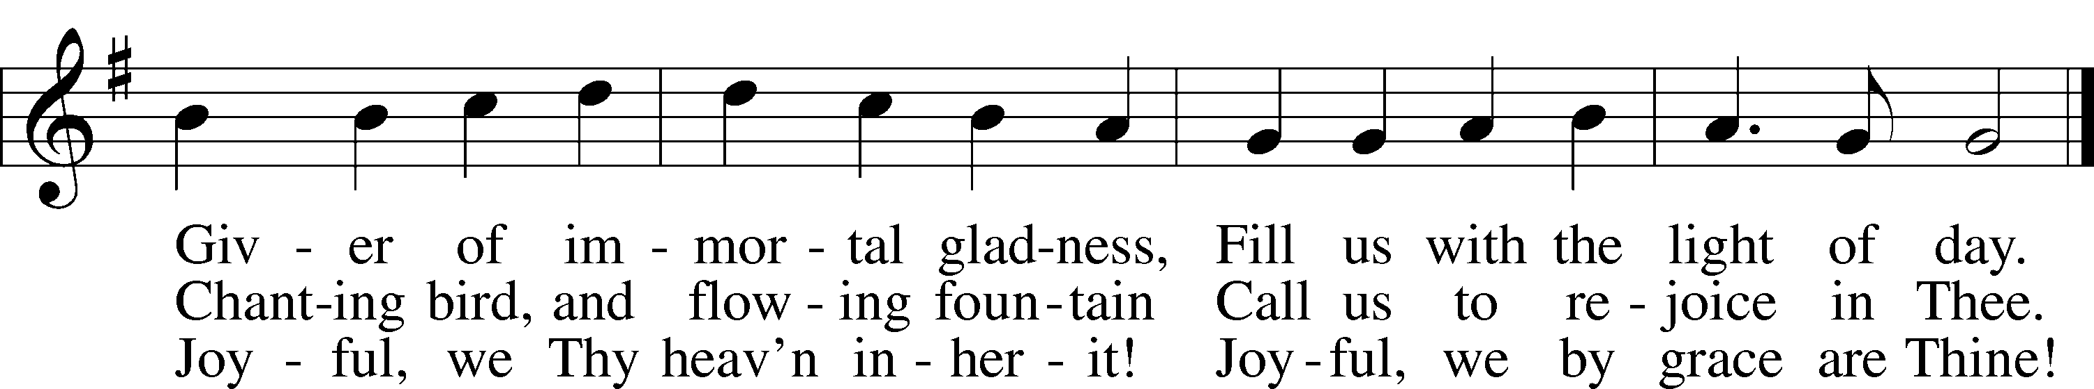

Public domain

Pastor: In the Name of the Father and of the Son and Holy Spirit.

**Congregation: Amen.**

**PREPARATION**

*(Please Remain Standing Or You May Kneel…)*

**CONFESSION OF SIN:**

**All: God, I admit I have broken all of your commandments; I am not holy or sinless even though I often pretend a righteousness I do not have. I offer excuses. I have broken relationships by what I have said, or done. I have not loved either You or my neighbor as I ought. (time for personal confession____)**

**YOU ARE FORGIVEN:**

Pastor: God is merciful and gracious; He has given His Son, Jesus Christ to die and rise again for us, the sinful ones that we might be forgiven and enjoy His Peace. This is also a reminder of God’s gifts and blessing that have become ours in Holy Baptism.

**Congregation: thank you God for Your blessing!**

Pastor: Yes, the Grace of our Lord Jesus Christ, and the Love of God, and the fellowship of His Holy Spirit is with you all.

**Congregation: And also with you.**

Pastor: In peace and as His forgiven people, we can pray to the Lord:

**Congregation: He is gracious to us and hears our prayers.**

Pastor: For the peace of the whole world and our involvement in Christ’s Mission in the world, we pray:

**Congregation: Keep us mindful of our purpose as Christians and our ability to share your blessings of peace and forgiveness with others.**

Pastor: We are the children of the Risen Christ. His victory is Our Victory!

**THE PRAYERS OF THE CHURCH:**

**All: Lord Jesus Christ, in Your deep compassion You rescue us from whatever may hurt us. Teach us to love You above all things and to love our neighbors as ourselves; for You live and reign with the Father and the Holy Spirit, one God, now and forever. Amen.**

**SERVICE OF THE WORD**

**God speaks to us through his word, the Bible:**

*You may be seated…*

**THE OLD TESTAMENT LESSON: Leviticus 19:9-18**

Lector: This is the Word of the Lord.

**People: Thanks be to God.**

**THE EPISTLE LESSON: Colossians 1:1-14**

Lector: This is the Word of the Lord.

**People: Thanks be to God.**

*Please stand…*

**THE HOLY GOSPEL: Luke 10:25-37**

Pastor: The Holy Gospel according to St. Luke the 10th Chapter

**People: Glory to You, O Lord.**

Pastor: This is the Gospel of the Lord.

**People: Praise to You, O Christ!**

*Please be seated…*

**CHILDREN’S MESSAGE**

**NOISE OFERING**



**THE SERMON HYMN: *“Lord of Glory, You Have Bought Us”* LSB 851**

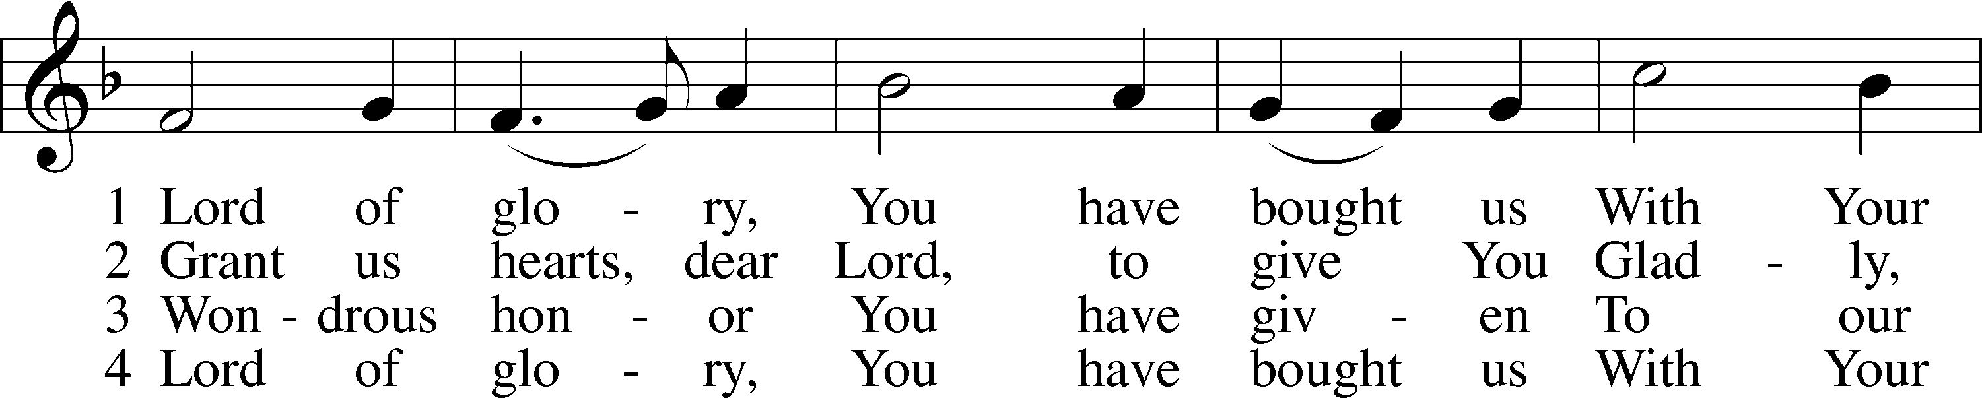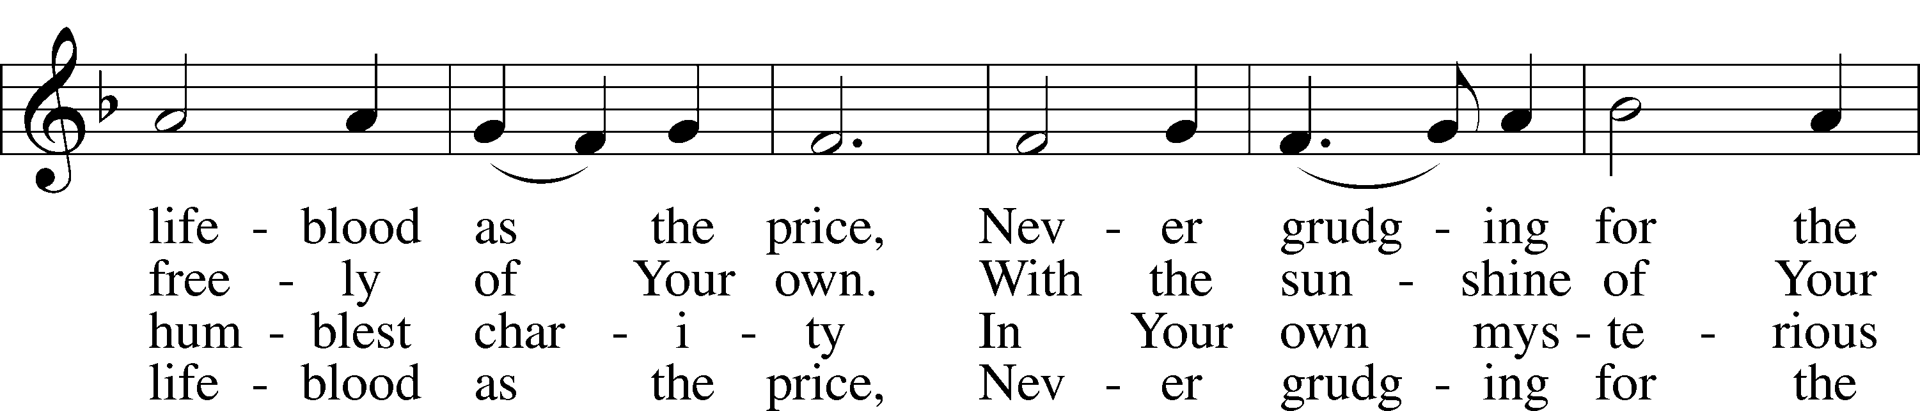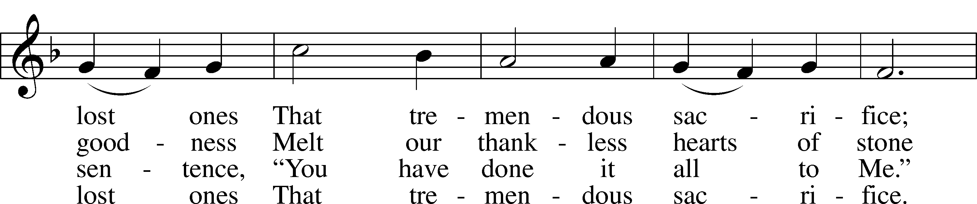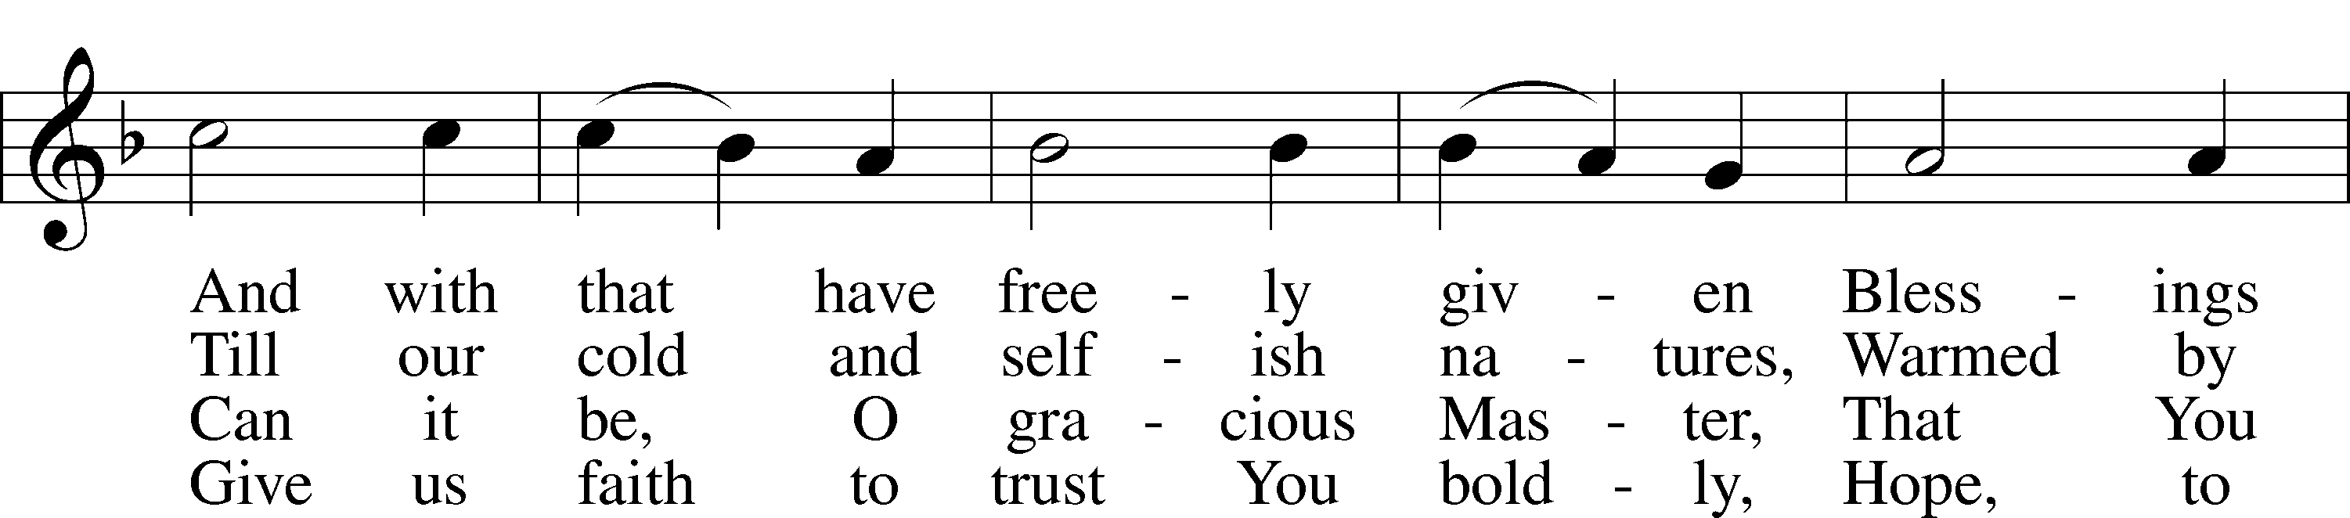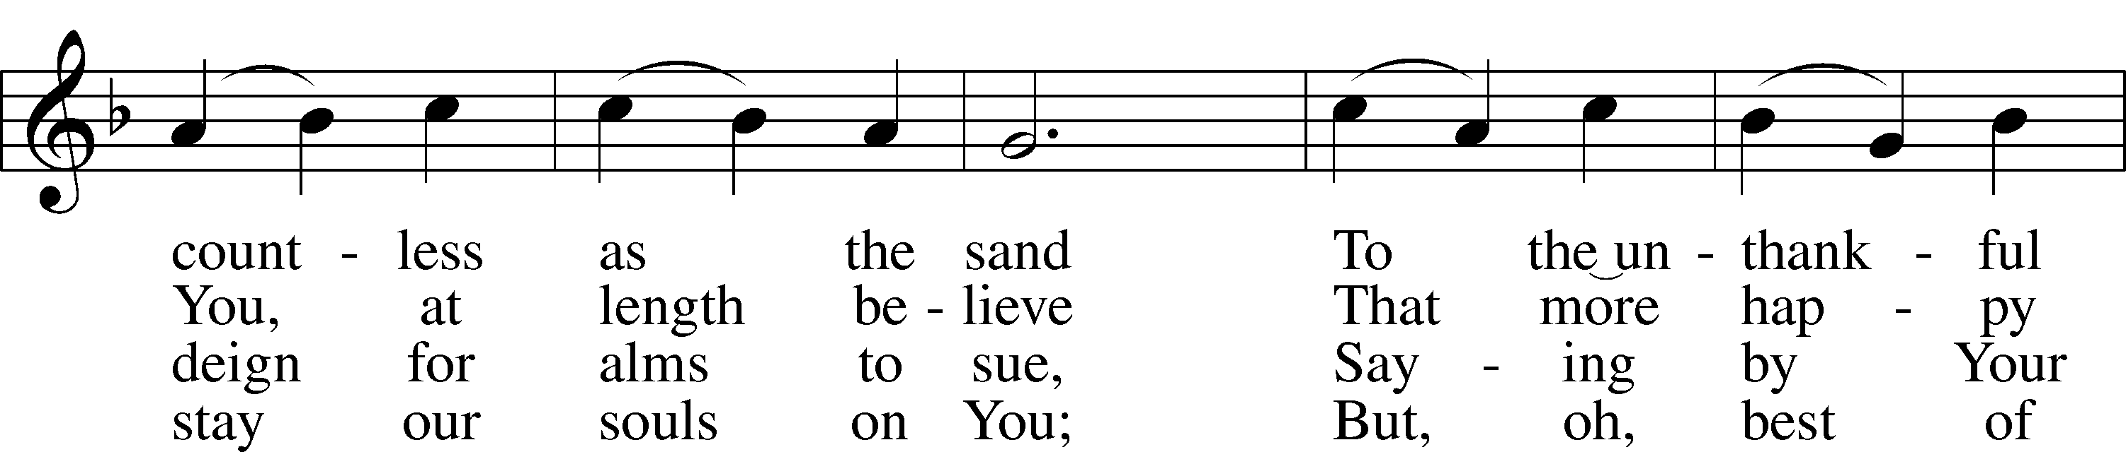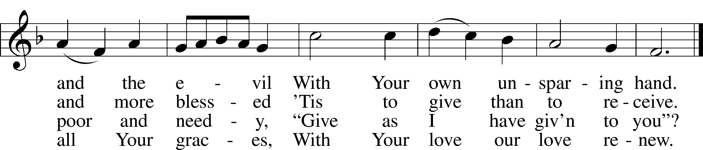

Public domain

**THE SERMON**

*(Please stand…)*

**THE PROFESSION OF FAITH:**

Pastor: God has given us a great message to take to His world. Let us remind ourselves and one another of what that message is:

Pastor: I believe in God the Father, Almighty

**Congregation: Maker of heaven and earth**

Pastor: And in His Son, Jesus Christ our Lord,

**Congregation: Who was conceived by the Holy Spirit**

Pastor: Born of the Virgin Mary

**Congregation: Suffered under Pontius Pilate**

Pastor: Was crucified, died and was buried

**Congregation: He descended into hell.**

Pastor: On the third day He rose again from the dead,

**Congregation: And ascended into heaven**

Pastor: And sits on the right hand of God, the Father almighty

**Congregation: From there He will come to judge the living and the dead**

Pastor: I believe in the Holy Spirit,

**Congregation: The Holy Christian Church as**

**All: the communion of saints; the forgiveness of sins, the resurrection of the body, and the life everlasting. Amen.**

*(You may be seated…)*

**OFFERING RECEIVED**

**SERVICE OF THE SACRAMENT**

*(Please stand…)*

**PREPARE FOR THE LORD’S SUPPER:**

Pastor: We begin with the reminder: “The Lord is with you.”

**Congregation: We are mindful and thankful for His presence.**

Pastor: Let your life reflect the joy of your salvation.

**Congregation: We do give Him thanks and praise. We will share His blessing with others.**

Pastor: It is proper that we should at all times and in all places…(prayer)… we praise your name and join others in singing:

**All: (sing) “Holy, holy, holy Lord God of pow’r and might:**

**Heaven and earth are full of your glory.**

**Hosanna, Hosanna, Hosanna in the highest.**

**Blessed is he who comes in the name of the Lord.**

**Hosanna in the highest.”**

*(Please be seated…)*

**THE WORDS OF INSTITUTION**

**DISTRIBUTION HYMNS: *“O Sing to the Lord”* LSB 808**

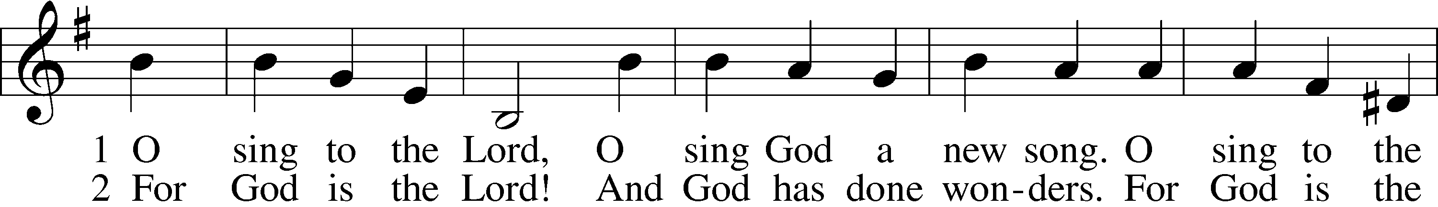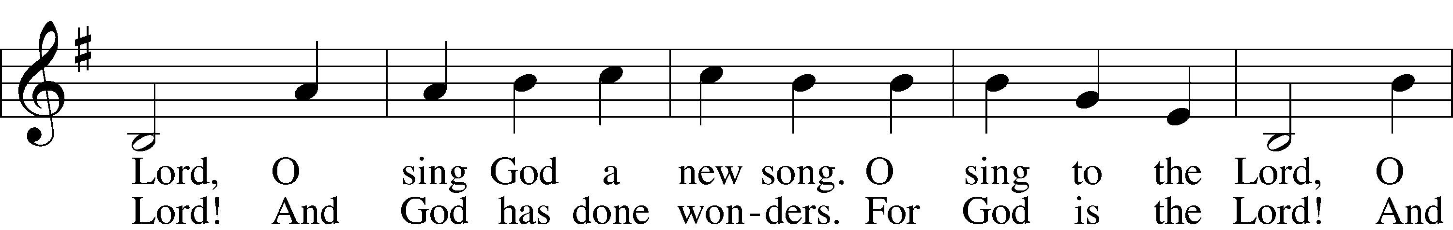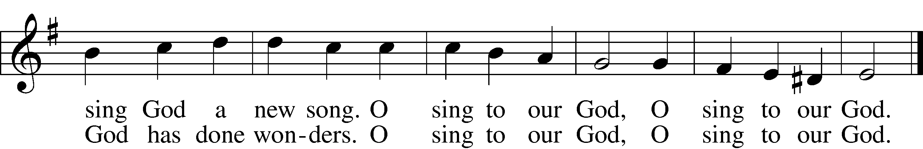

3 So dance for our God 4 O shout to our God,  
 And blow all the trumpets. Who gave us the Spirit.  
So dance for our God O shout to our God,  
 And blow all the trumpets. Who gave us the Spirit.  
So dance for our God O shout to our God,  
 And blow all the trumpets. Who gave us the Spirit.  
And sing to our God, O sing to our God,  
 And sing to our God. O sing to our God.

5 For Jesus is Lord!  
 Amen! Alleluia!  
For Jesus is Lord!  
 Amen! Alleluia!  
For Jesus is Lord!  
 Amen! Alleluia!  
O sing to our God,  
 O sing to our God.

© Gerhard Cartford. Used by permission: LSB Hymn License .NET, no. 100011641. Public domain

***“What Wondrous Love Is This”* LSB 543**

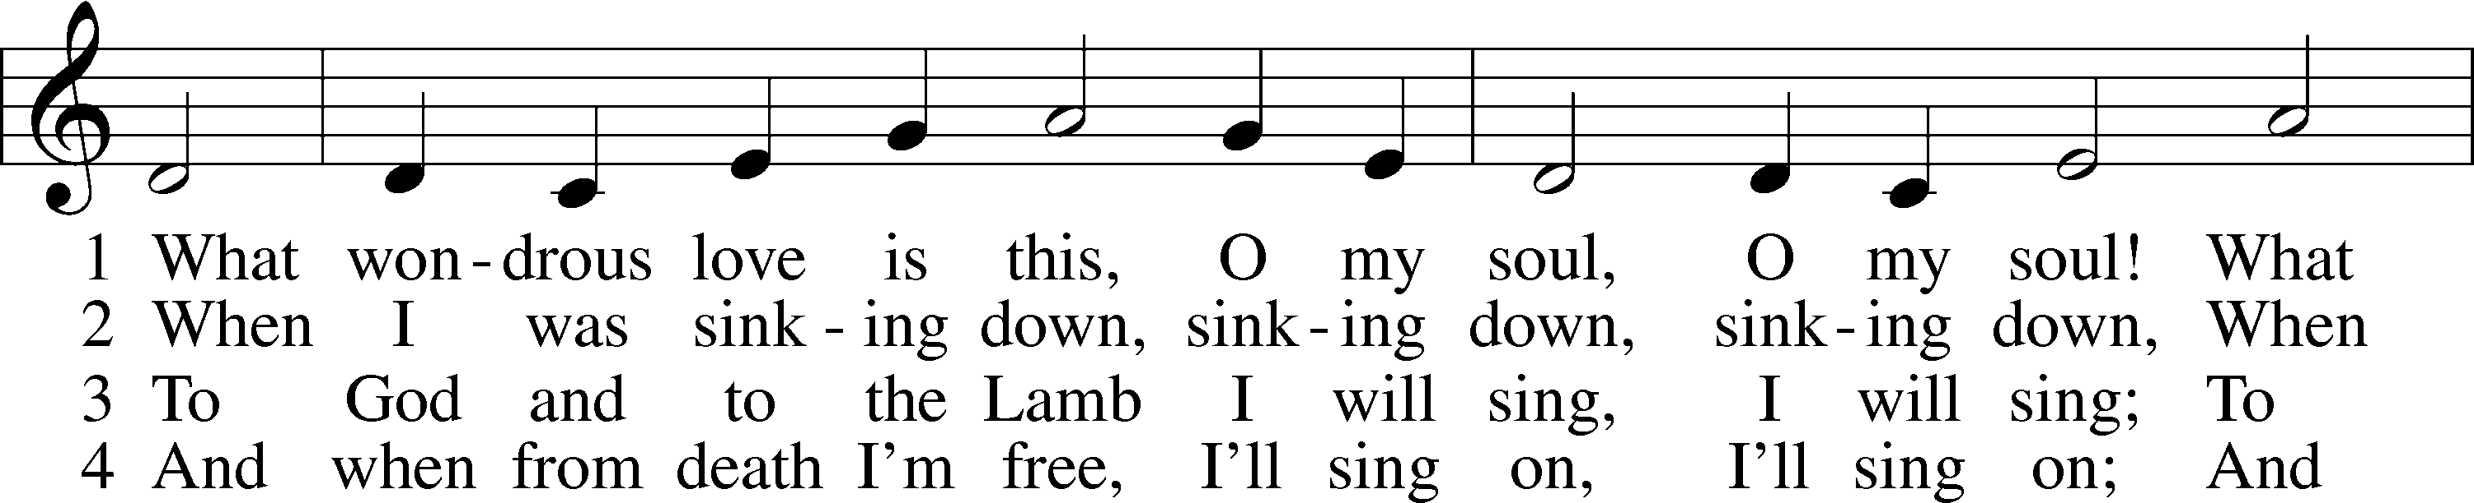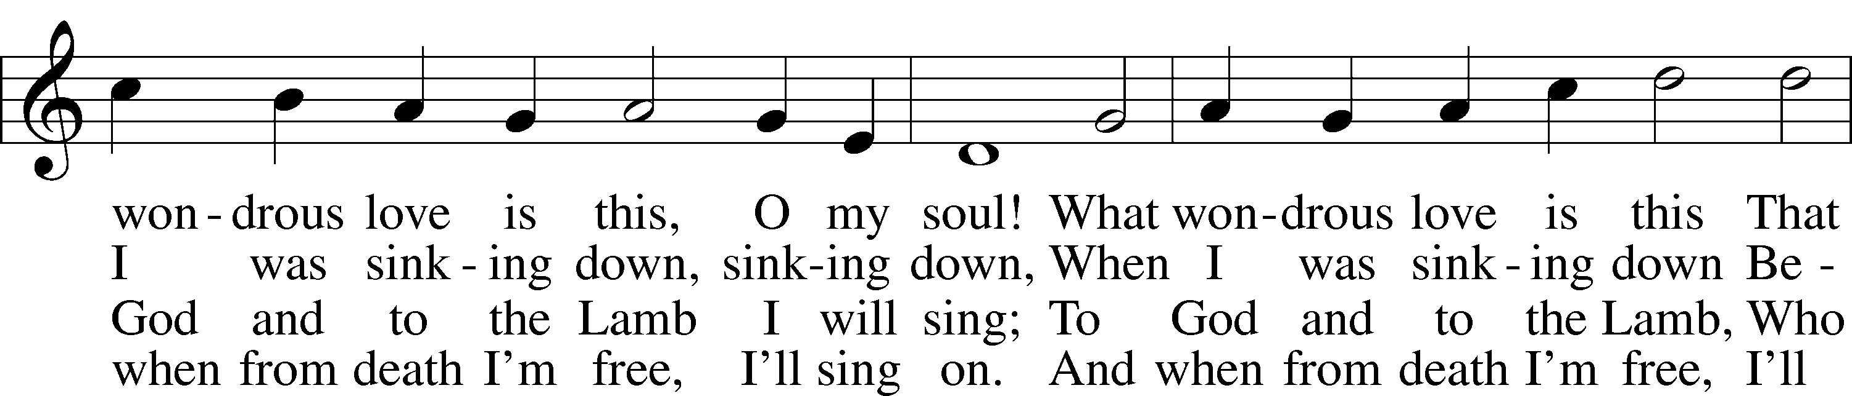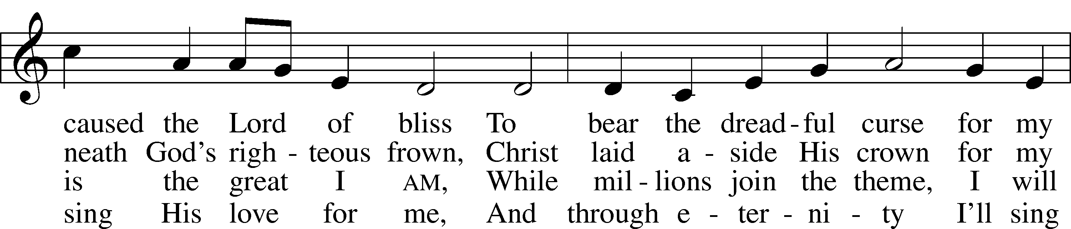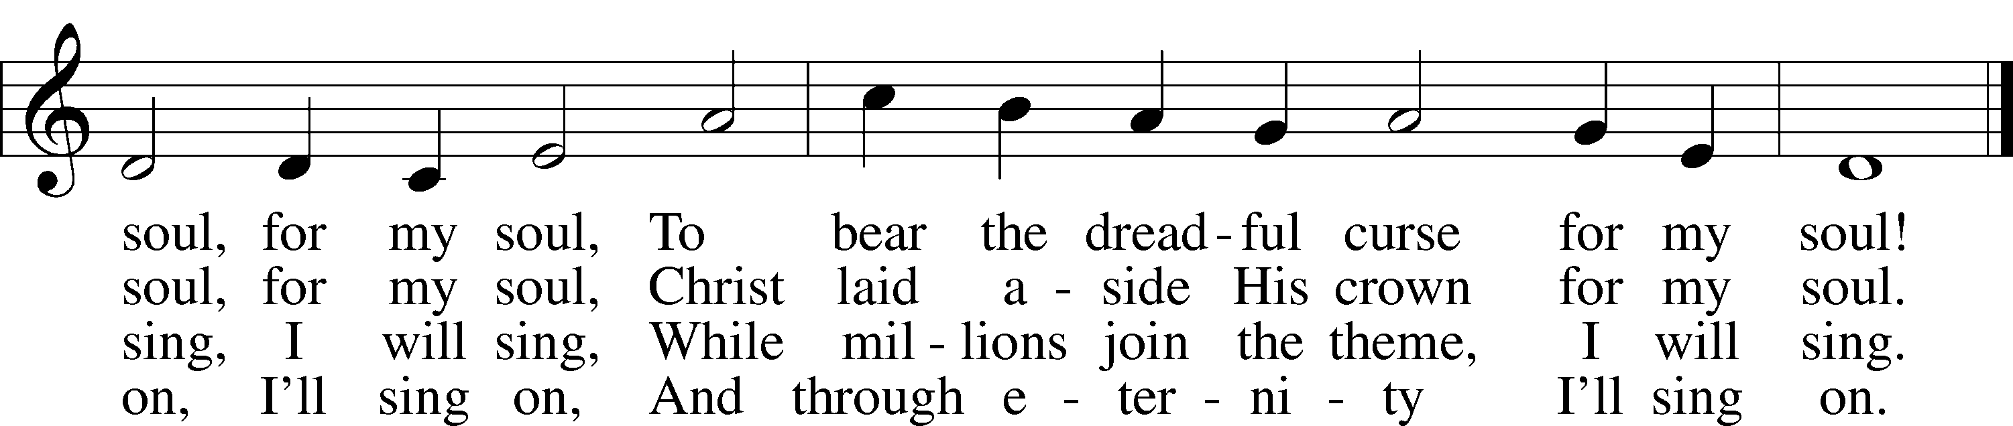

Public domain



***“O Jesus, Blessed Lord, to Thee”* LSB 632**

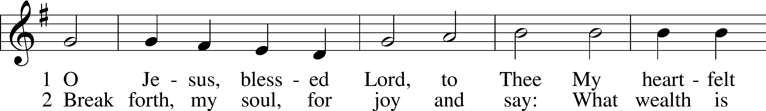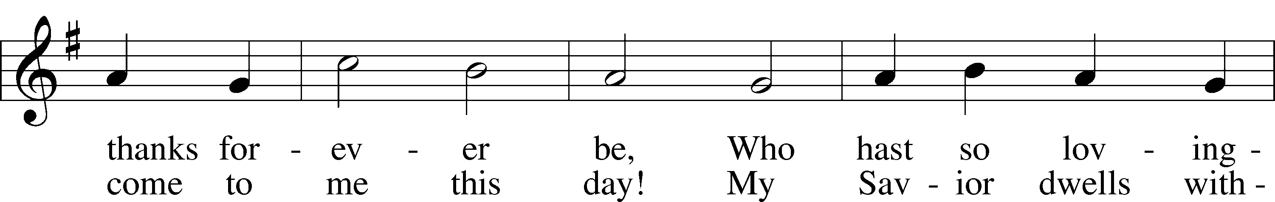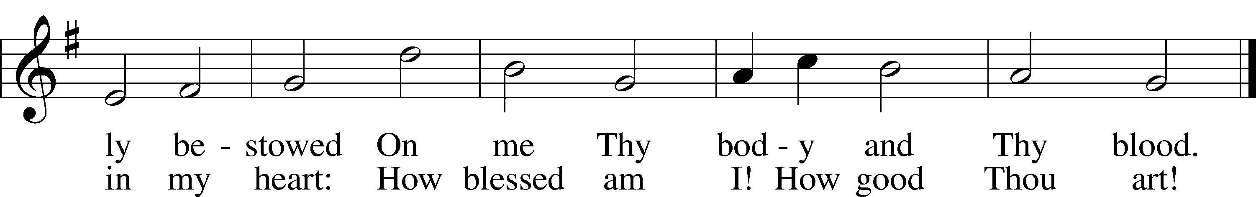

Public domain

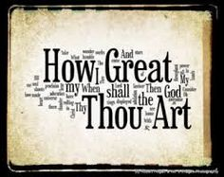

*(Please stand…)*

**THE LORD’S PRAYER:**

**All: Our Father, who art in heaven, hallowed be thy name, thy kingdom come, thy will be done, on earth as it is in heaven. Give us this day our daily bread; and forgive us our trespasses as we forgive those who trespass against us; and lead us not into temptation, but deliver us from evil. For thine is the kingdom, and the power, and the glory, forever and ever. Amen**

**THE BLESSING AND BENEDICTION:**

Pastor: The Lord Blesses you and keeps you, the Lord makes His face to shine upon you and He is Gracious to you. The Lord looks upon you with His favor and gives you His peace.

**Congregation: God blesses us so that we can be a blessing to others.**

Pastor: Go in His peace and serve the Lord by serving others.

**Congregation: Amen**

Jesus let the things that break your heart also break our hearts.

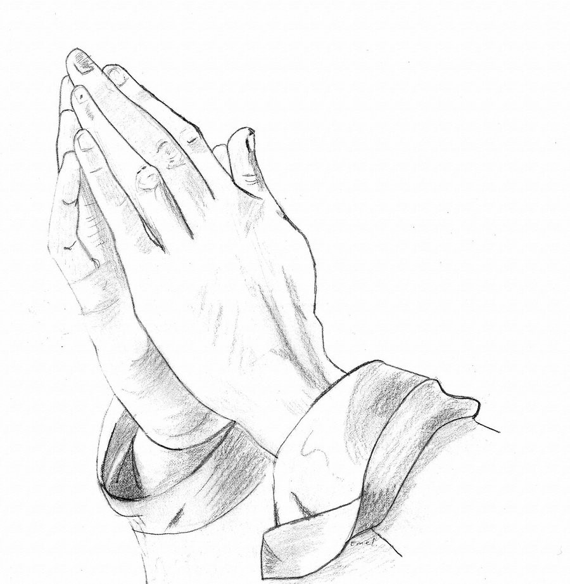

Amen

**THE CLOSING HYMN: *“For the Fruits of His Creation”* LSB 894**

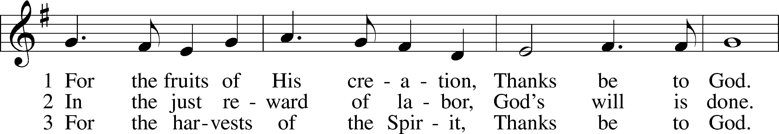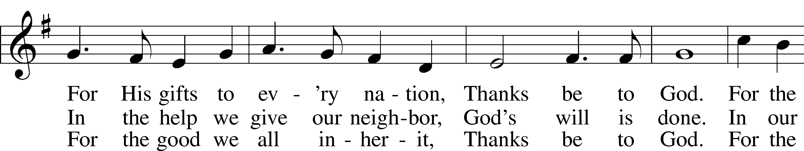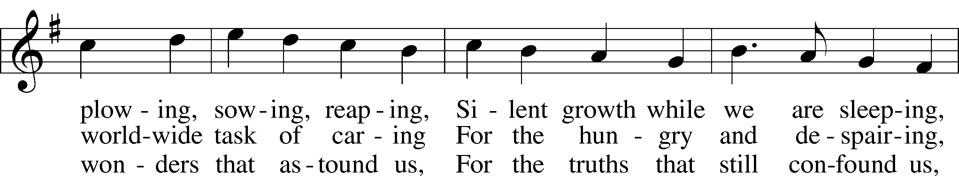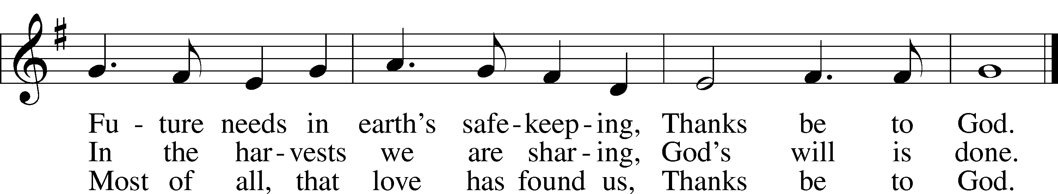

© 1970 Hope Publishing Co. Used by permission: LSB Hymn License .NET, no. 100011641.  
Public domain



**ANNOUNCEMENTS**

**WELCOME TO GRACE LUTHERAN CHURCH:** We are glad that you are here to worship God with us today! We pray that you will enjoy the wonderful fellowship as friends in Christ as God gathers us around His means of grace, the Word and Sacraments, to bless us with His treasured gifts of forgiveness, faith, abundant life and eternal salvation. If you are a guest, please also sign our Guest Book. Please talk to Pastor if you would like **to learn more about becoming a member of Grace. Also, please join us for refreshments** and fellowship after the Service. We invite you to come and worship with us often as God gathers us in His Grace.

**WELCOME TO THE LORD’S TABLE:** We invite and encourage all present who are baptized and faithful Christians, and who confess the Father, Son, and Holy Spirit to be the only true God and who believe that Jesus Christ died for the sins of the World and is our only hope and salvation…to join us in receiving the very and true body and blood of Christ in this Sacrament. The clear liquid cups in the center of the tray are non-alcoholic wine.

Children not yet confirmed in the faith are always welcome to join their parents at the Lord’s Table, but should keep their hands folded in front of them. The Pastor will give them a blessing.

**SERVING TODAY:** Acolyte: Amelia Bly; Lector: JoAnn Broadbent; Communion Assistants: Vince Winters and Max Broadbent; Usher: David Rose; Altar Care: _______; Refreshments: The Schuetzler Family.

**SERVING NEXT SUNDAY:** Acolyte: _______________; Lector: JoAnn Broadbent; Communion Assistants: Vince Winters and Max Broadbent; Usher: David Rose; Altar Care: Jim and Garnet Picking; Refreshments: Jim and Garnet Picking.

**FLOWERS**: were placed on the altar today to the glory of God and to celebrate Jim and Jolynn’s Anniversary.

**THIS WEEK AT A GLANCE:**

**Today: This Sunday**

9:00 am Worship Service with Communion

10:15 am Fellowship/Refreshments

10:30 am Adult Bible Class/Children’s Sunday School

**Monday: July 11th**

5:30 pm Zumba

**Tuesday: July 12th**

3:00 pm Jan’s Mobile Gym (Parish Hall)

6:00 pm Weight Watcher’s (Parish Hall)

**Next Sunday: July 17th**

9:00 am Worship Service with Communion

10:15 am Fellowship/Refreshments

10:30 am Adult Bible Class/Children’s Sunday School

**IN YOUR PRAYERS THIS WEEK:** Re. Alfred Schubert II, the family and friends of Harry Htut, Auwina Weed, Kit Billings, Bill Billings Jr., Laura MacQuarie, family and friends of Gary Winters, Gabriel Kirkland, family and friends of Bryan Kay, Kay Sattelmeier, Suzanne Kolhagan, Phil Zielinski, Cressie Brown, the family and friends of Mary Bacle, the victims of the Lahore Pakistan attack, the family and friends of Carol Shimp, Esther Faith, Jameson Parker, the family and friends of Hwana, Liz and Ryan Grady, Loretta Cates, Larry, Dan, Gabriel, Andrew, Julia Pateman, David Lopez, Annie Garner, Nancy Amling, Alicia Llama, Erich & Erika Hoffmann, Katharina Lutz, Robert and Regina Hoffmann, Walter Hulme, Carole Steinle, Joanne Cates, Jane Howard, Jean Grafsgaurd, Denis Julson, Mary Kay, Sandy Harris, and those you are praying for at home. If anyone has a special prayer request please submit it in writing in the collection plate; or you may call Pastor Gary Faith at (504-858-8872), or Kris Howard at (305-296-5161).



**GIFTS, TITHES, & ATTENDANCE LAST SUNDAY** was $1622.00. The building fund received $10.00. The noise offering for Sunday, July 3rd was $29.89. Our 9am service had an attendance of 66.

**TO HELP US GROW…** The Bible readings for next Sunday’s service readings are Genesis 18:1-10a, Colossians 1:21-29, and Luke 10:38-42.

**PASTOR AND PATTIE** are on vacation. Good Lord willing they will return on July 13th. If you have needs, please contact Kris or one of our Elders.

**GRACIOUS LADIES OF GRACE** will be meeting for a wonderful lunch at the Key West Yacht Club at 11:30 am on July 19th. We hope that you all can come and join us.

**ADULT INFORMATION CLASS:** We would like to schedule an Adult Information Class. This is for those who would like to become a member of Grace and/or learn more about what we teach and believe. It is also a good review for members. If interested, please let Pastor or Kris know. Thanks.

**MISSIONAL COMMUNITIES** will not meet again until August 11th.

**STAINED GLASS WINDOWS:** We only have 9 clear glass impact windows in the bathrooms and front entry, and the two side entry doors that need to be replaced.  When those are completed, the entire church will be protected with hurricane proof, impact windows. The cost of the windows is roughly $2000.00 each depending on size. Thank you donors of the stained glass windows and to all those who have contributed to the building fund for this project. Your generous giving is much appreciated

**THE GRACE LUTHERAN CHURCH WEB PAGE AND FACE BOOK PAGE** now contains a vocal recording of last week’s sermon. So if you are not able to attend church on Sunday please go to our website where you will find a copy of the bulletin and a recording of Pastor Faith’s sermon.

**A NUMBER OF CAPITAL IMPROVEMENTS** are needed to keep our facilities in good health for the future. The narthex has been rebuilt. Roof repairs are needed on school buildings. If you can help it would be much appreciated! A big thanks to all who

have contributed to these repairs.

**WOMEN’S BIBLE STUDY:** The Ladies Bible Study finished their studies on “Stories of Deliverance from the Old Testament”, asking 7 questions that answered why it was told and what we are to take from it, mainly asking how does this story show how God loves me. We are looking forward to a new study in the fall please consider joining us for an hour of interesting insights and lively discussions.

**MEN’S BIBLE FELLOWSHIP**: They meet the first and third Wednesday’s of each month at 12:30pm at Chico’s Restaurant. Their next meeting will be July 20th. All guys are welcome.

