July 3rd, 2016
9:00 am

SEVENTH SUNDAY AFTER
PENTECOST

Grace Lutheran Church
2713 Flagler Ave.
Key West, FL 33040
305-296-5161
GraceLutheranKW@att.net
gracelutherankw.360unite
Pastor Faith
(504) 858-8872
garyfaith@aol.com

SEVENTH SUNDAY AFTER PENTECOST
JULY 3RD, 2016 9:00 a.m.
In the Name of Jesus!
Our Mission Statement: Anchored in Christ, each person a missionary.

PRELUDE

ANNOUNCEMENTS:
We welcome you. We are glad you are here to share with us the joy and peace we have in Jesus Christ. It doesn’t matter whether this is your first time in this church or if you are a lifelong member, you are welcome. We come together today in order to celebrate the gift God has given us-His own Son, Jesus, Our Savior.

PREPARATION
(Please Stand…)
HYMN: “Before You, Lord, We Bow” LSB 966
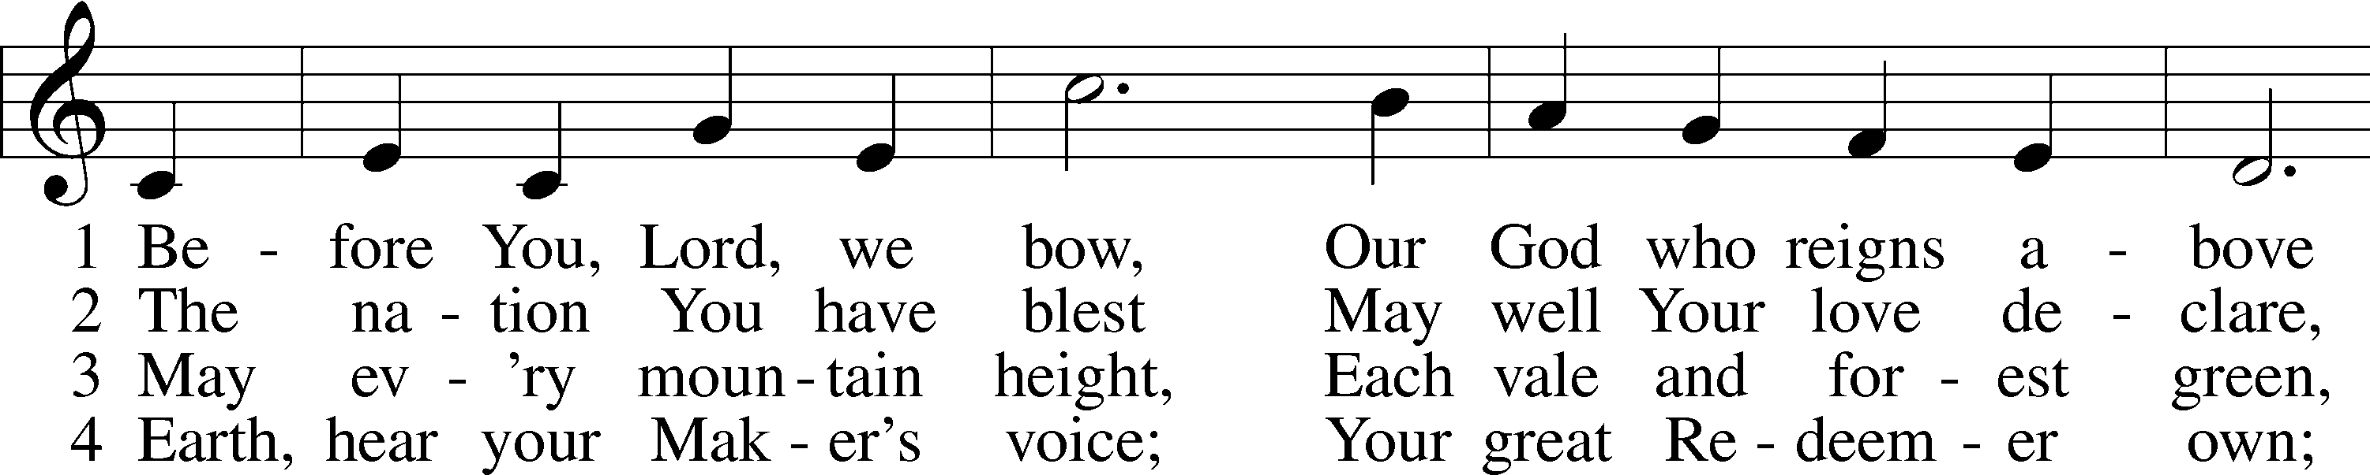
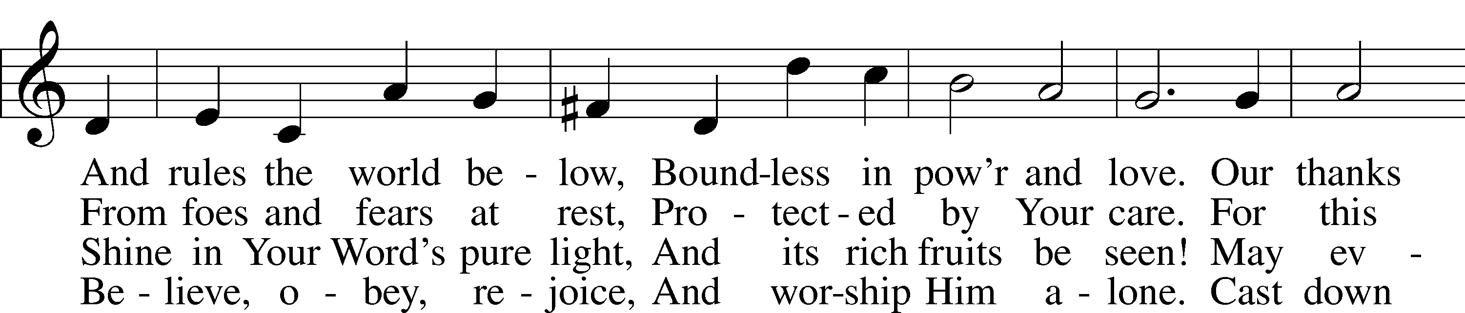
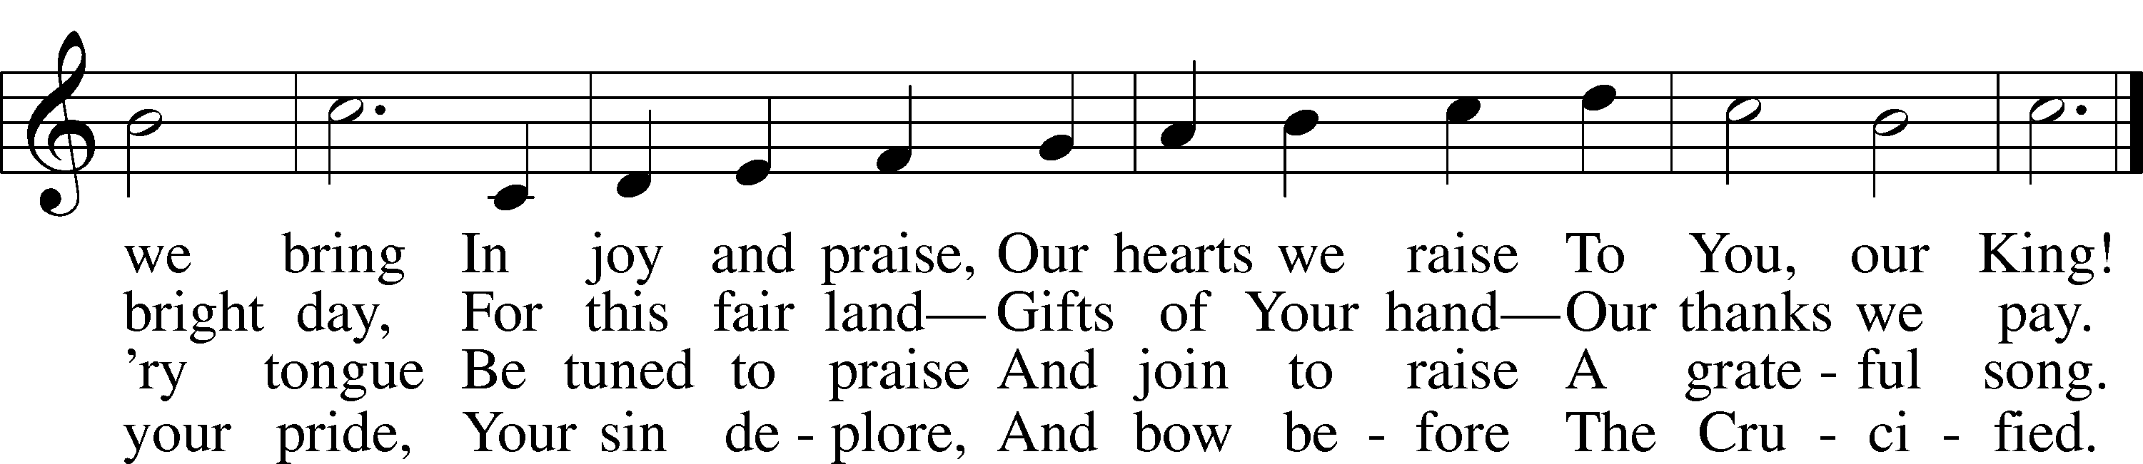

5 And when in pow’r He comes,
Oh, may our native land
From all its rending tombs
Send forth a glorious band,
A countless throng,
With joy to sing
To heav’n’s high King
Salvation’s song! Public domain
Pastor: In the Name of the Father and of the Son and Holy Spirit.
Congregation: Amen.

(Please Remain Standing Or You May Kneel…)
GOD’S PEOPLE CONFESS THEIR SINS:
Pastor: By grace you have been saved, through faith-and this is not from yourselves, it is the gift of God-not of works, so that no man can boast, for we are God’s workmanship, created in Christ Jesus.
Congregation: I know that nothing good lives in me, that is, in my sinful nature, for I have the desire to do what is good, but I cannot carry it out.
Pastor: What I do is not the good I want to do; no, the evil I do not want to do-this I keep doing.
Congregation: In my heart I delight in God’s law, the law that points out what a wretched person I am! Who will rescue me from this body of death?
Pastor: Thanks be to God through Jesus Christ our Lord! Only He can achieve the perfection we fail to achieve. By the forgiveness He purchased on the cross, our forgiveness is complete!

SERVICE OF THE WORD

You may be seated…
THE FIRST READING: Isaiah 66:10-14
Lector: This is the Word of the Lord.
People: Thanks be to God.

THE EPISTLE LESSON: Galatians 6:1-10, 14-18
Lector: This is the Word of the Lord.
People: Thanks be to God.

Please stand…
THE HOLY GOSPEL: Luke 10:1-20
Pastor: The Holy Gospel according to St. Luke the 10th Chapter
People: Glory to You, O Lord.
Pastor: This is the Gospel of the Lord.
People: Praise to You, O Christ!

Please be seated…
CHILDREN’S MESSAGE
NOISE OFERING

THE SERMON HYMN: “Hark, the Voice of Jesus Crying” LSB 826
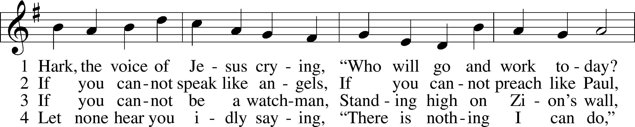
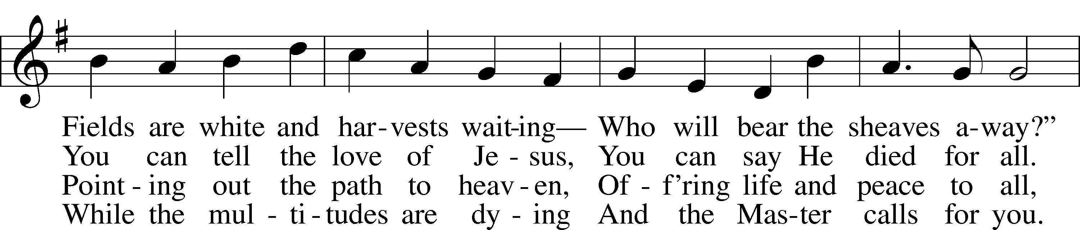
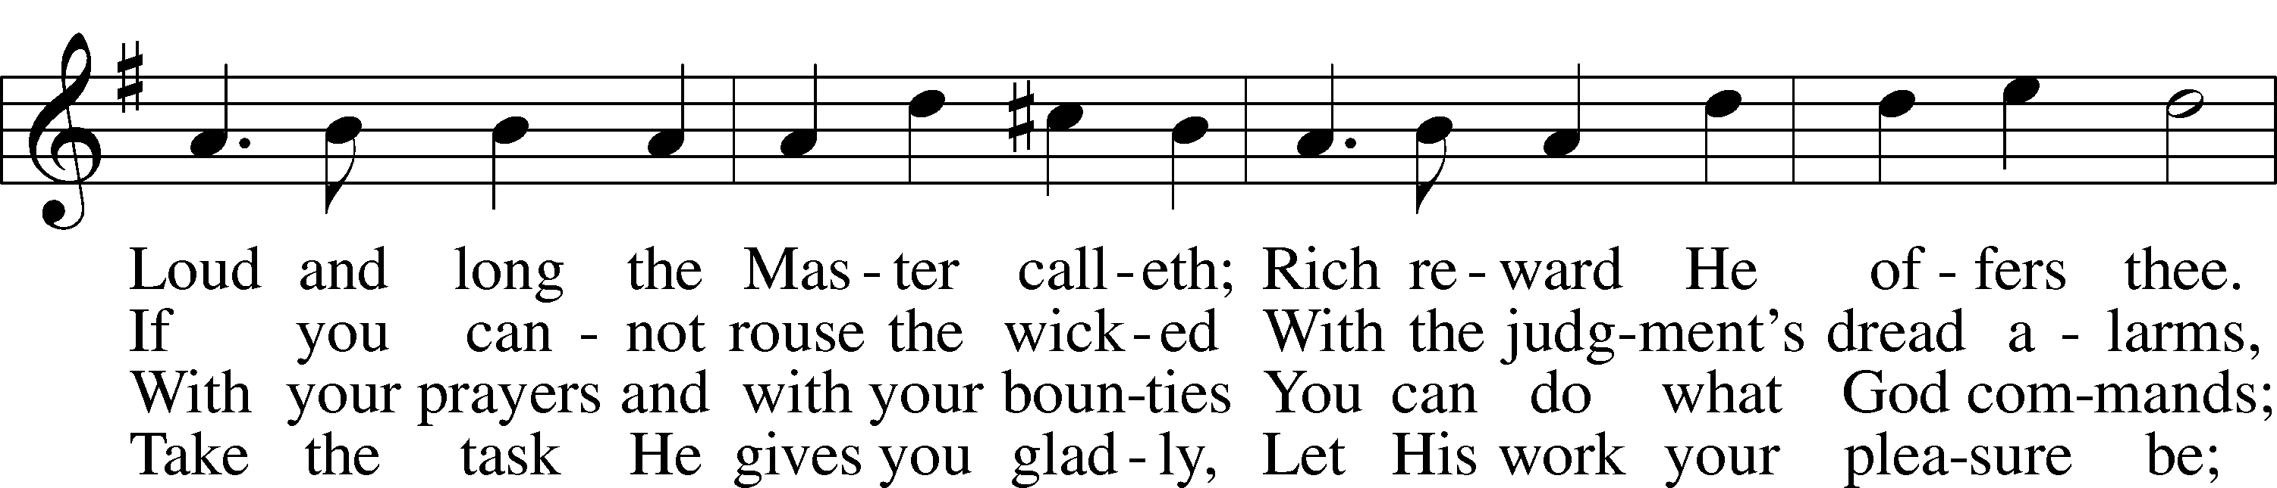
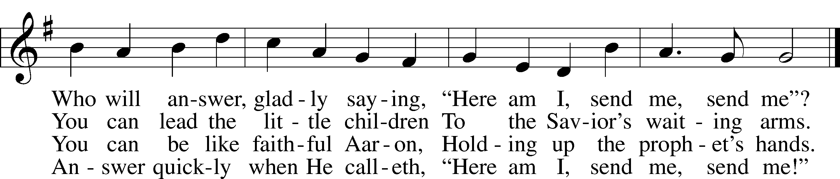
Public domain

THE SERMON

(Please stand…)
THE PROFESSION OF FAITH:
Pastor: God has given us a great message to take to His world. Let us remind ourselves and one another of what that message is:
Pastor: I believe in God the Father, Almighty
Congregation: Maker of heaven and earth
Pastor: And in His Son, Jesus Christ our Lord,
Congregation: Who was conceived by the Holy Spirit
Pastor: Born of the Virgin Mary
Congregation: Suffered under Pontius Pilate
Pastor: Was crucified, died and was buried
Congregation: He descended into hell.
Pastor: On the third day He rose again from the dead,
Congregation: And ascended into heaven
Pastor: And sits on the right hand of God, the Father almighty
Congregation: From there He will come to judge the living and the dead
Pastor: I believe in the Holy Spirit,
Congregation: The Holy Christian Church as
All: the communion of saints; the forgiveness of sins, the resurrection of the body, and the life everlasting. Amen.

(You may be seated…)
OFFERING RECEIVED

(Please stand…)
THE PRAYERS OF THE CHURCH: based on Psalm 98
Pastor: Dear Lord, we thank You for everything You’ve done for us, and most of all for Your own Son, Jesus, our Savior. We will never stop praising You for this wonderful gift.
Congregation: Sing to the Lord a new song, for He has done marvelous things; His right hand and His holy arm have worked salvation for Him.
Pastor: We thank You for those missionaries long ago who brought the Good News to our people. When we were in darkness, You sent men and women to bring us the light. Thank you, Lord.
Congregation: The Lord has made His salvation known and revealed His Righteousness to the nation.
Pastor: O Lord, You are our Savior, we trust in You for all our needs, give healing to the sick, courage to those who are afraid, and peace to those we name in our hearts either silently or out loud. (a moment of silence) We praise You, gracious Lord, for all Your benefits to us. You give us home, friends and family, food, shelter, rest and everything we need. You give us sight and hearing and touch and taste and provide for all of our needs.
Congregation: Shout for joy to the Lord, praise His Name Amen.

SERVICE OF THE SACRAMENT

(Please be seated…)
THE WORDS OF INSTITUTION
DISTRIBUTION HYMNS: “In the Cross of Christ I Glory” LSB 427 (Public domain)
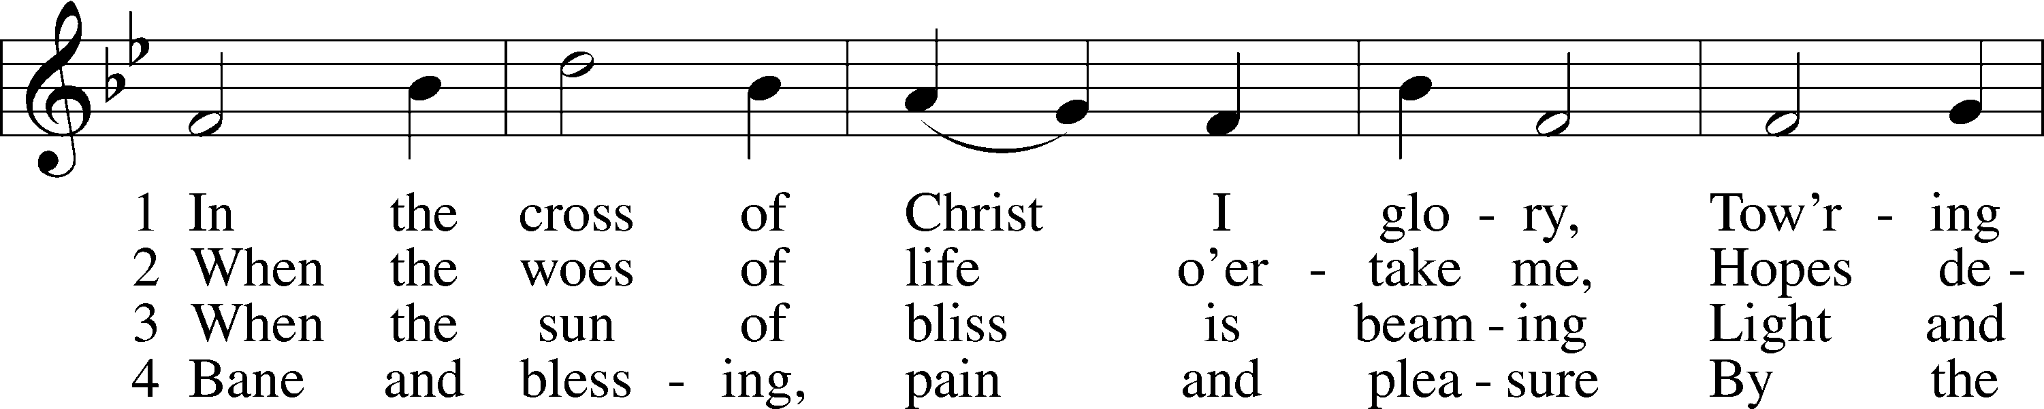
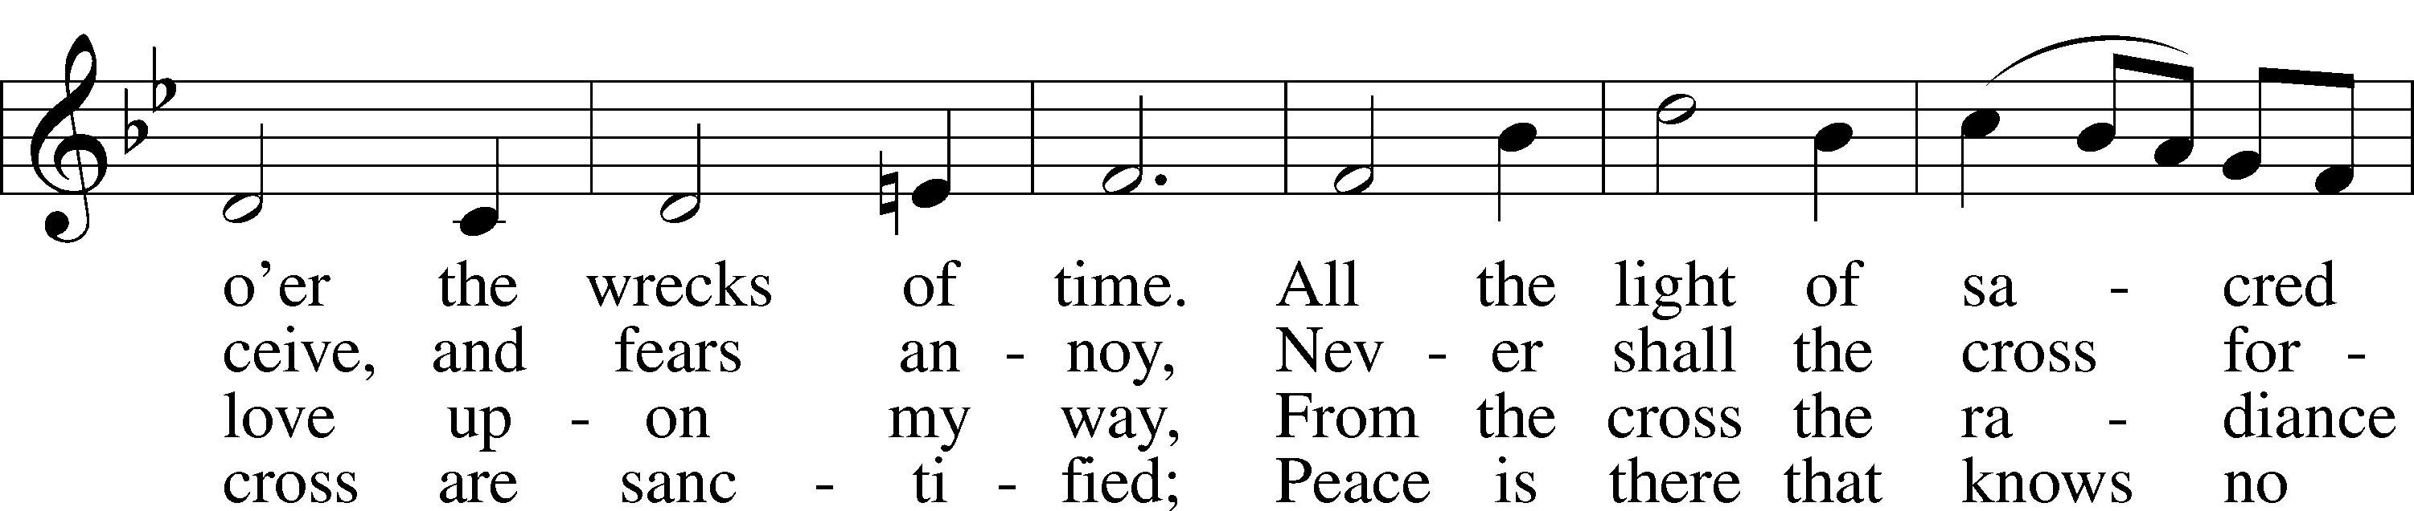
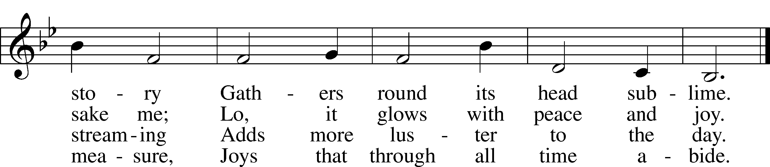

“When Peace, like a River” LSB 763 (Public domain)
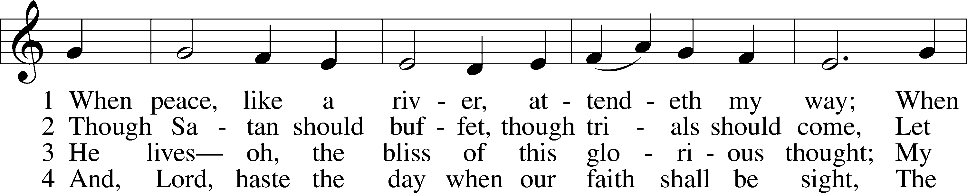
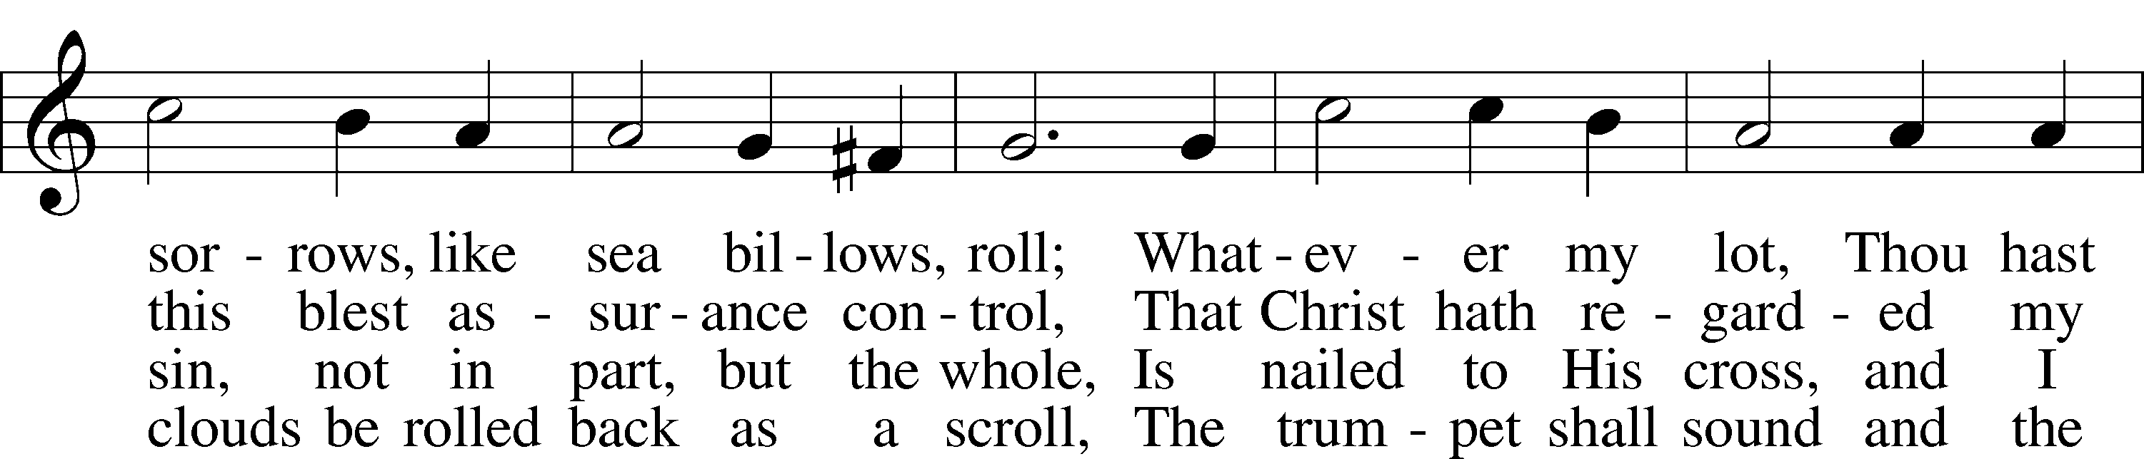
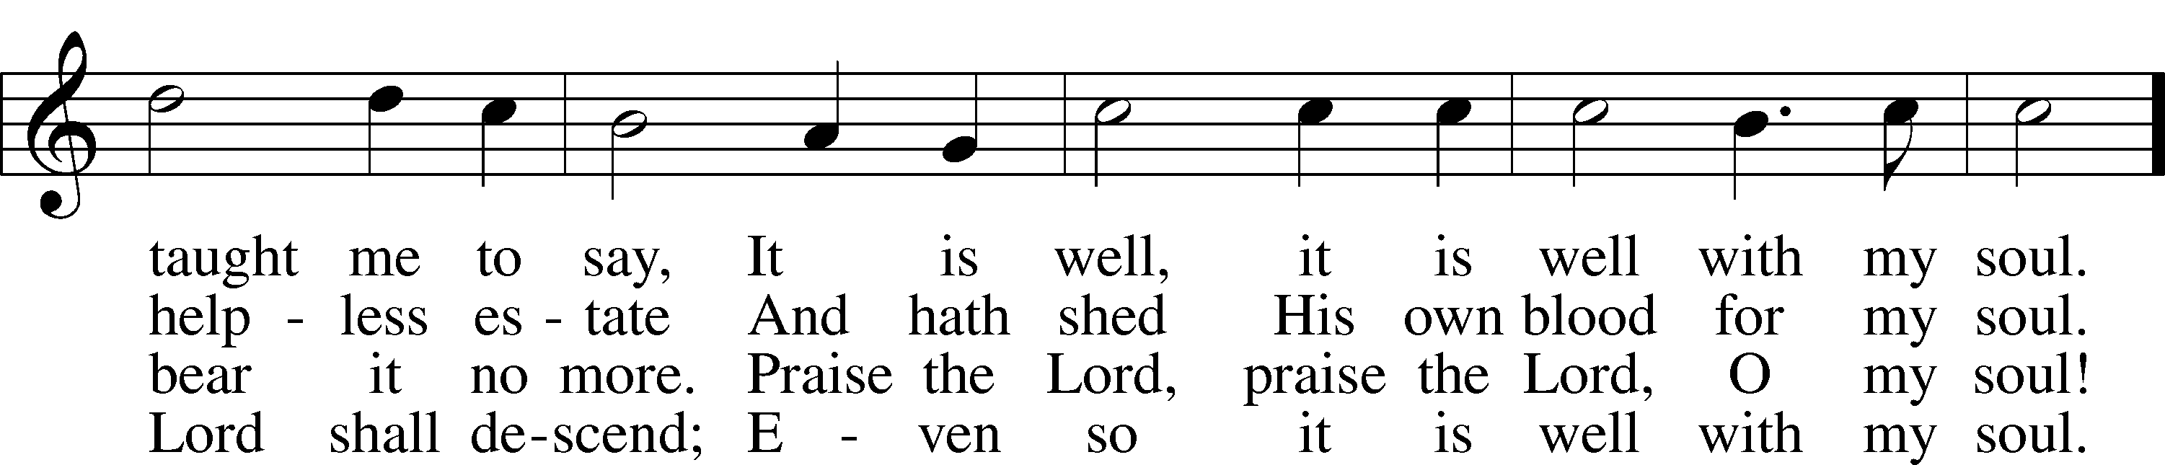
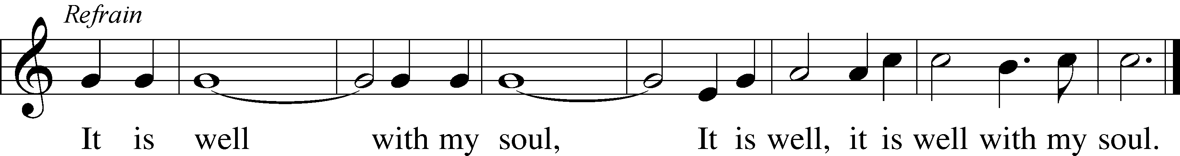

“O Christ, Who Called the Twelve” LSB 856
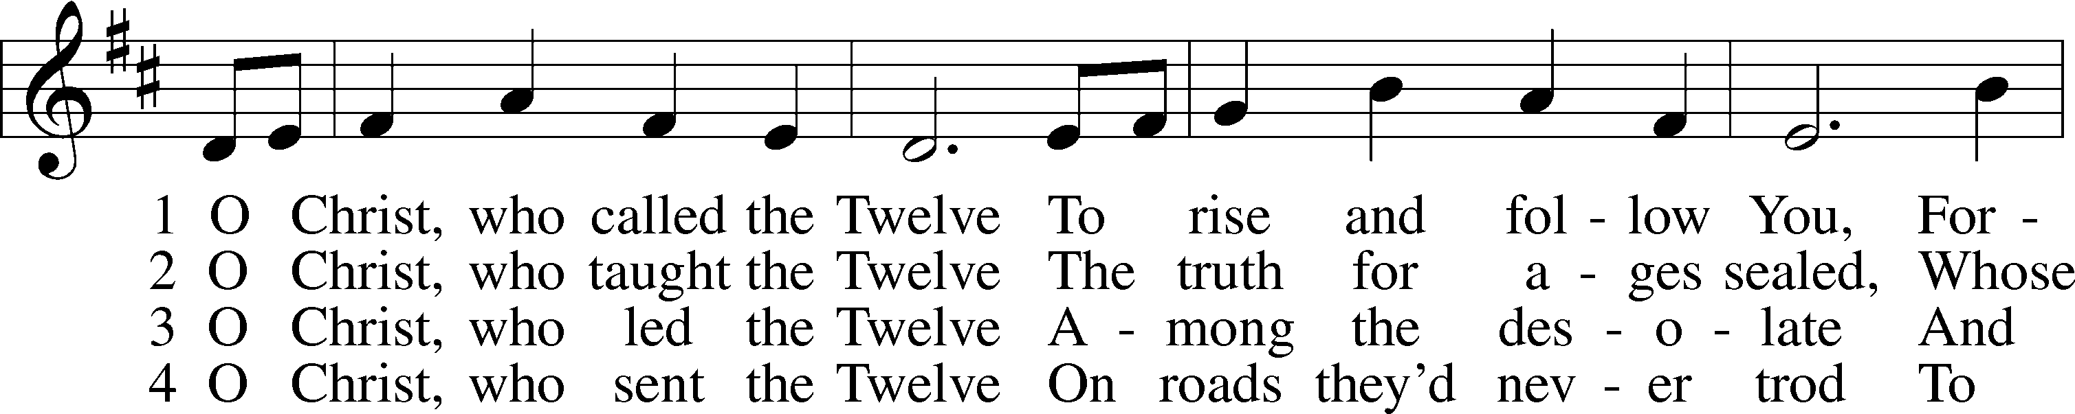
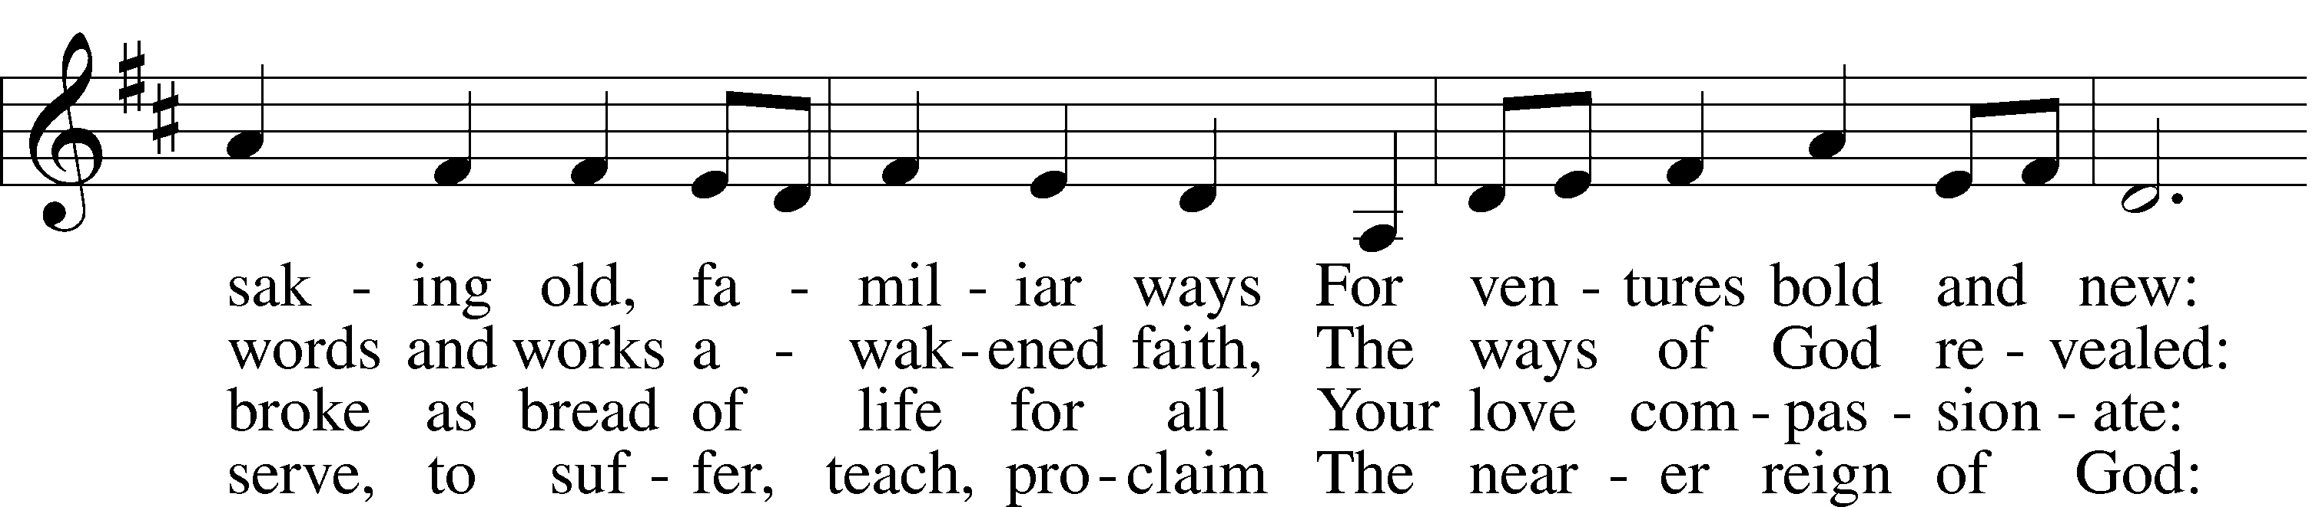
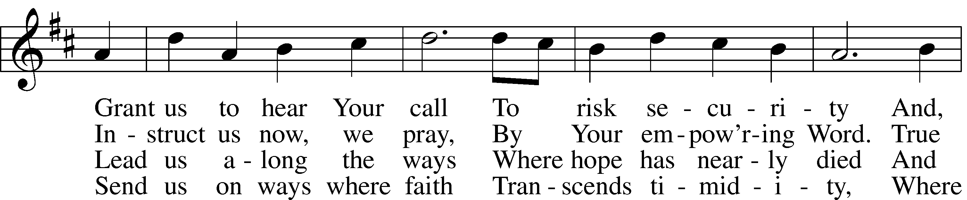
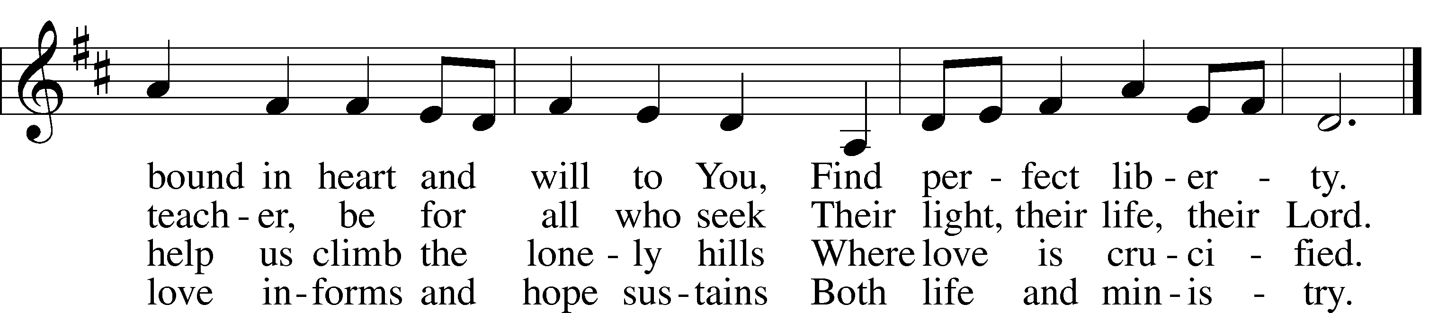

5 O Christ, the_apostles’ Lord,
The martyrs’ strength and song,
The crucified and risen King
To whom the saints belong:
Though generations pass,
Our tribute still we bring,
Our hymns a sacrifice of praise,
Our lives an offering.
© 1993 GIA Publications, Inc. Used by permission: LSB Hymn License .NET, no. 100011641. Public domain

(Please stand…)
THE LORD’S PRAYER:
All: Our Father, who art in heaven, hallowed be thy name, thy kingdom come, thy will be done, on earth as it is in heaven. Give us this day our daily bread; and forgive us our trespasses as we forgive those who trespass against us; and lead us not into temptation, but deliver us from evil. For thine is the kingdom, and the power, and the glory, forever and ever. Amen

THE BENEDICTION

THE CLOSING HYMN: “Battle Hymn of the Republic”
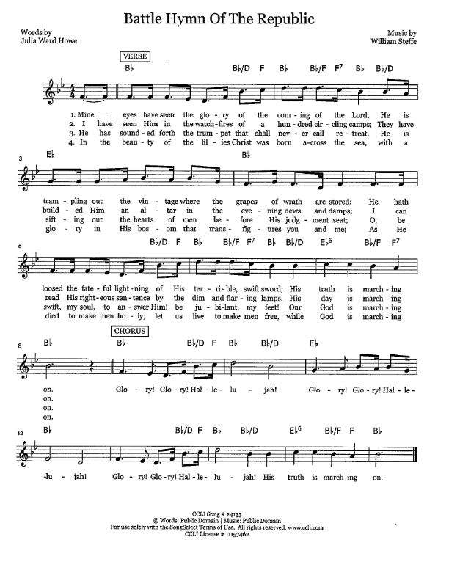
Words by: Julia Ward Howe, Music by: William Steffe, CCLI Song #24133, Words: Public Domain | Music: Public Domain
For use solely with the SongSelect Terms of Use. All rights reserved. www.ccli.com CCLI License #11157462

ANNOUNCEMENTS

WELCOME TO GRACE LUTHERAN CHURCH: We are glad that you are here to worship God with us today! We pray that you will enjoy the wonderful fellowship as friends in Christ as God gathers us around His means of grace, the Word and Sacraments, to bless us with His treasured gifts of forgiveness, faith, abundant life and eternal salvation. If you are a guest, please also sign our Guest Book. Please talk to Pastor if you would like to learn more about becoming a member of Grace. Also, please join us for refreshments and fellowship after the Service. We invite you to come and worship with us often as God gathers us in His Grace.

WELCOME TO THE LORD’S TABLE: We invite and encourage all present who are baptized and faithful Christians, and who confess the Father, Son, and Holy Spirit to be the only true God and who believe that Jesus Christ died for the sins of the World and is our only hope and salvation…to join us in receiving the very and true body and blood of Christ in this Sacrament. The clear liquid cups in the center of the tray are non-alcoholic wine.

Children not yet confirmed in the faith are always welcome to join their parents at the Lord’s Table, but should keep their hands folded in front of them. The Pastor will give them a blessing.

SERVING TODAY: Acolyte: Maddie Schoepf; Lector: Peter Bacle; Communion Assistants: Vince Winters and Max Broadbent; Usher: David Rose; Altar Care: Monica Bacle; Refreshments: Monica Bacle.

SERVING NEXT SUNDAY: Acolyte: Amelia Bly; Lector: JoAnn Broadbent; Communion Assistants: Vince Winters and Max Broadbent; Usher: David Rose; Altar Care: ____________; Refreshments: ________________.

FLOWERS: were placed on the altar today to the glory of God and to celebrate Deglys Chavarria’s Birthday.

THIS WEEK AT A GLANCE:

Today: This Sunday
9:00 am Worship Service with Communion
10:15 am Fellowship/Refreshments
11:00 am Auwina Weed Celebration (Trinity Presbyterian Church)

Tuesday: July 5th
3:00 pm Jan’s Mobile Gym (Parish Hall)
6:00 pm Weight Watcher’s (Parish Hall)

Wednesday: July 6th
12:30 pm Men’s Bible Fellowship (Chico’s Restaurant)
Next Sunday: July 10th
9:00 am Worship Service with Communion
10:15 am Fellowship/Refreshments
10:30 am Adult Bible Class/Children’s Sunday School

IN YOUR PRAYERS THIS WEEK: Re. Alfred Schubert II, the family and friends of Harry Htut, Auwina Weed, Kit Billings, Bill Billings Jr., Laura MacQuarie, family and friends of Gary Winters, Gabriel Kirkland, family and friends of Bryan Kay, Kay Sattelmeier, Suzanne Kolhagan, Phil Zielinski, Cressie Brown, the family and friends of Mary Bacle, the victims of the Lahore Pakistan attack, the family and friends of Carol Shimp, Esther Faith, Jameson Parker, the family and friends of Hwana, Liz and Ryan Grady, Loretta Cates, Larry, Dan, Gabriel, Andrew, Julia Pateman, David Lopez, Annie Garner, Nancy Amling, Alicia Llama, Erich & Erika Hoffmann, Katharina Lutz, Robert and Regina Hoffmann, Walter Hulme, Carole Steinle, Joanne Cates, Jane Howard, Jean Grafsgaurd, Denis Julson, Mary Kay, Sandy Harris, and those you are praying for at home. If anyone has a special prayer request please submit it in writing in the collection plate; or you may call Pastor Gary Faith at (504-858-8872), or Kris Howard at (305-296-5161).

GIFTS, TITHES, & ATTENDANCE LAST SUNDAY was $3252.00. The noise offering for Sunday, June 26th was $50.62. Our 9am service had an attendance of 66.

TO HELP US GROW… The Bible readings for next Sunday’s service readings are Leviticus 19:9-18, Colossians 1:1-14, Luke 10:25-37.

PASTOR AND PATTIE are on vacation. Good Lord willing they will return on July 13th. If you have needs, please contact Kris or one of our Elders.

GRACIOUS LADIES OF GRACE will be meeting for a wonderful lunch at the Key West Yacht Club at 11:30 am on July 19th. We hope that you all can come and join us.

ADULT INFORMATION CLASS: We would like to schedule an Adult Information Class. This is for those who would like to become a member of Grace and/or learn more about what we teach and believe. It is also a good review for members. If interested, please let Pastor or Kris know. Thanks.

MISSIONAL COMMUNITIES will not meet again until August 11th.

STAINED GLASS WINDOWS: We only have 9 clear glass impact windows in the bathrooms and front entry, and the two side entry doors that need to be replaced. When those are completed, the entire church will be protected with hurricane proof, impact windows. The cost of the windows is roughly $2000.00 each depending on size. Thank you donors of the stained glass windows and to all those who have contributed to the building fund for this project. Your generous giving is much appreciated

THE GRACE LUTHERAN CHURCH WEB PAGE AND FACE BOOK PAGE now contains a vocal recording of last week’s sermon. So if you are not able to attend church on Sunday please go to our website where you will find a copy of the bulletin and a recording of Pastor Faith’s sermon.

A NUMBER OF CAPITAL IMPROVEMENTS are needed to keep our facilities in good health for the future. The narthex has been rebuilt. Roof repairs are needed on school buildings. If you can help it would be much appreciated! A big thanks to all who
have contributed to these repairs.

WOMEN’S BIBLE STUDY: The Ladies Bible Study finished their studies on “Stories of Deliverance from the Old Testament”, asking 7 questions that answered why it was told and what we are to take from it, mainly asking how does this story show how God loves me. We are looking forward to a new study in the fall please consider joining us for an hour of interesting insights and lively discussions.

MEN’S BIBLE FELLOWSHIP: They meet the first and third Wednesday’s of each month at 12:30pm at Chico’s Restaurant. Their next meeting will be July 6th. All guys are welcome.

