**June 12th, 2016**

**9:00 am**

**FOURTH SUNDAY AFTER PENTECOST**



**Grace Lutheran Church**

**2713 Flagler Ave.**

**Key West, FL 33040**

**305-296-5161**

**GraceLutheranKW@att.net**

**Pastor Faith**

**(504) 858-8872**

**garyfaith@aol.com**

**FOURTH SUNDAY AFTER PENTECOST**

**JUNE 12TH, 2016 9:00 a.m.**

**WORSHIP SERVICE**

***In the Name of Jesus!***

**Our Mission Statement:Anchored in Christ, each person a missionary.**

**PRELUDE**

**ANNOUNCEMENTS:**

**God is with us all during the week, wherever we are and in whatever we are doing. This week, let’s enjoy His presence.**

*(Please Stand…)*

**HYMN: *“Come, Thou Fount of Every Blessing”* LSB 686**

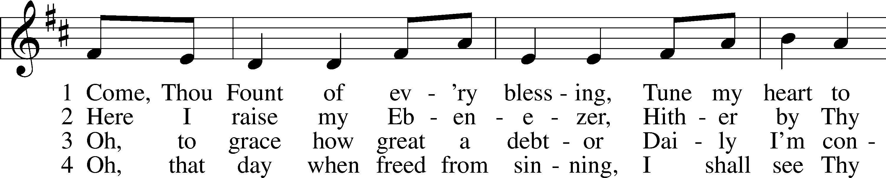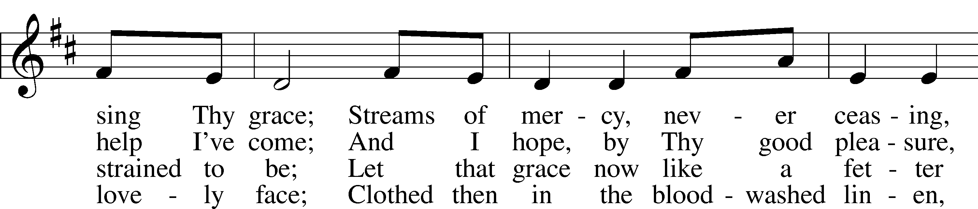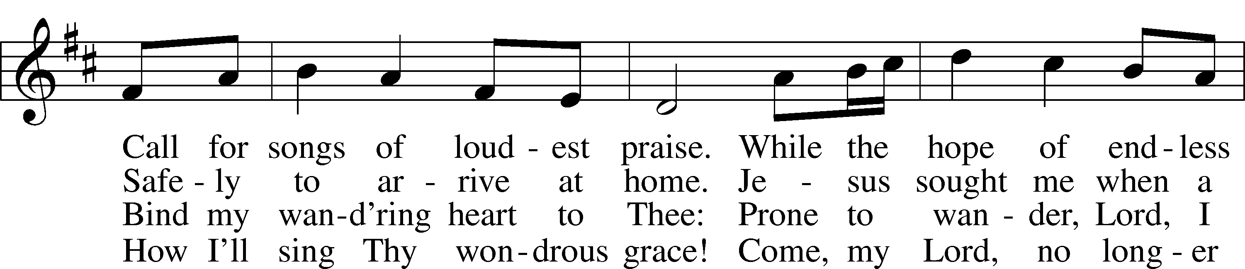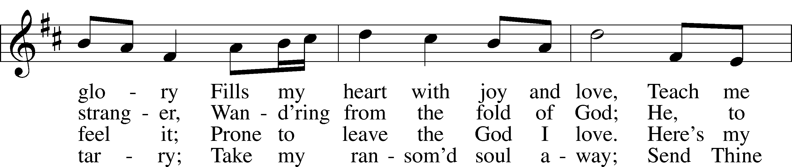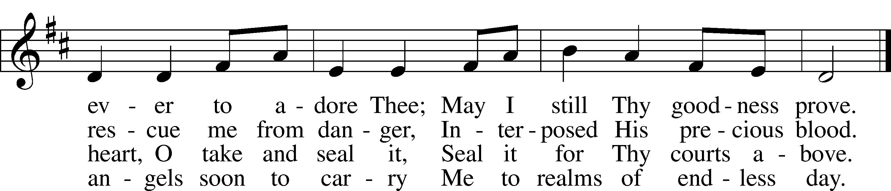

Public domain

Pastor: In the Name of the Father and of the Son and Holy Spirit.

**Congregation: Amen.**

**PREPARATION**

*(Please Remain Standing Or You May Kneel…)*

**CONFESSION OF SIN:**

**All: God, I admit I have broken all of your commandments; I am not holy or sinless even though I often pretend a righteousness I do not have. I offer excuses. I have broken relationships by what I have said, or done. I have not loved either You or my neighbor as I ought. (time for personal confession____)**

**YOU ARE FORGIVEN:**

Pastor: God is merciful and gracious; He has given His Son, Jesus Christ to die and rise again for us, the sinful ones that we might be forgiven and enjoy His Peace. This is also a reminder of God’s gifts and blessing that have become ours in Holy Baptism.

**Congregation: thank you God for Your blessing!**

Pastor: Yes, the Grace of our Lord Jesus Christ, and the Love of God, and the fellowship of His Holy Spirit is with you all.

**Congregation: And also with you.**

Pastor: In peace and as His forgiven people, we can pray to the Lord:

**Congregation: He is gracious to us and hears our prayers.**

Pastor: For the peace of the whole world and our involvement in Christ’s Mission in the world, we pray:

**Congregation: Keep us mindful of our purpose as Christians and our ability to share your blessings of peace and forgiveness with others.**

Pastor: We are the children of the Risen Christ. His victory is Our Victory!

**THE PRAYERS OF THE CHURCH:**

**All: Almighty and everlasting God, increase in us Your gifts of faith, hope, and love that we may receive the forgiveness You have promised and love what You have commanded; through Jesus Christ, Your Son, our Lord, who lives and reigns with You and the Holy Spirit, one God, now and forever. Amen.**

**SERVICE OF THE WORD**

**God speaks to us through his word, the Bible:**

*You may be seated…*

**THE OLD TESTAMENT LESSON: 2 Samuel 11:26-12:10, 13-14**

Lector: This is the Word of the Lord.

**People: Thanks be to God.**

**THE EPISTLE LESSON: Galatians 2:15-21, 3:10-14**

Lector: This is the Word of the Lord.

**People: Thanks be to God.**

*Please stand…*

**THE HOLY GOSPEL: Luke 7:36-8:3**

Pastor: The Holy Gospel according to St. Luke the 7th Chapter

**People: Glory to You, O Lord.**

Pastor: This is the Gospel of the Lord.

**People: Praise to You, O Christ!**

*Please be seated…*

**CHILDREN’S MESSAGE**

**NOISE OFERING**

**THE SERMON HYMN: *“Standing in the Need of Prayer”***



PM STANDING



# Text and Tune: Afro-American spiritual

[www.hymnary.org/text/not_my_brother_nor_my_sister_but_its_me](http://www.hymnary.org/text/not_my_brother_nor_my_sister_but_its_me)

This hymn is in the public domain. You may freely use this score for personal and congregational worship. If you reproduce the score, please credit Hymnary.org as the source.



**THE SERMON: *“Jesus is the Man”* 2 Samuel 11:26-12:10, 13-14**

*(Please stand…)*

**THE PROFESSION OF FAITH:**

Pastor: God has given us a great message to take to His world. Let us remind ourselves and one another of what that message is:

Pastor: I believe in God the Father, Almighty

**Congregation: Maker of heaven and earth**

Pastor: And in His Son, Jesus Christ our Lord,

**Congregation: Who was conceived by the Holy Spirit**

Pastor: Born of the Virgin Mary

**Congregation: Suffered under Pontius Pilate**

Pastor: Was crucified, died and was buried

**Congregation: He descended into hell.**

Pastor: On the third day He rose again from the dead,

**Congregation: And ascended into heaven**

Pastor: And sits on the right hand of God, the Father almighty

**Congregation: From there He will come to judge the living and the dead**

Pastor: I believe in the Holy Spirit,

**Congregation: The Holy Christian Church as**

**All: the communion of saints; the forgiveness of sins, the resurrection of the body, and the life everlasting. Amen.**

*(You may be seated…)*

**OFFERING RECEIVED**



**SERVICE OF THE SACRAMENT**

*(Please be seated…)*

**THE WORDS OF INSTITUTION**

**DISTRIBUTION HYMNS:**

***“Drawn to the Cross, Which Thou Hast Blessed”* LSB 560**

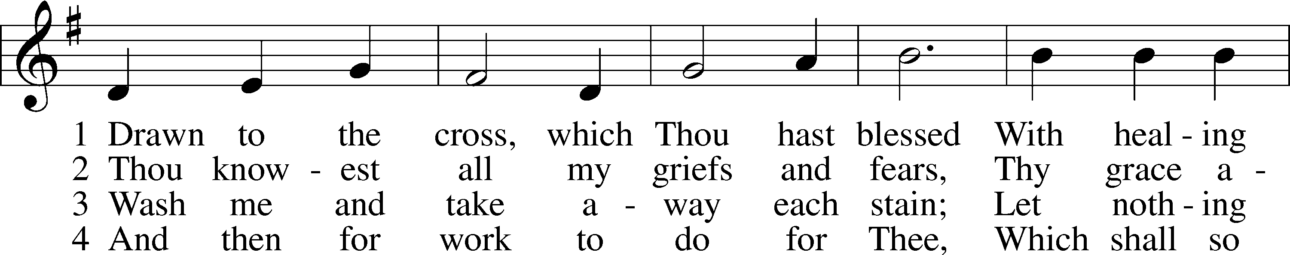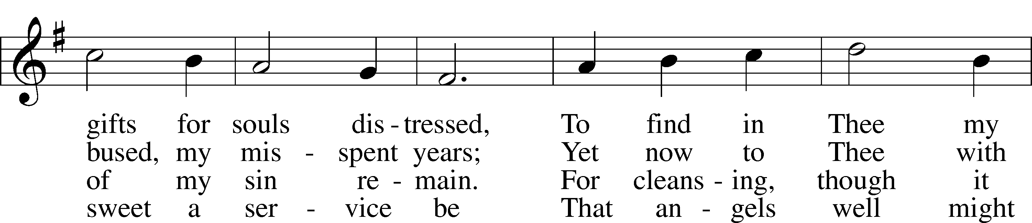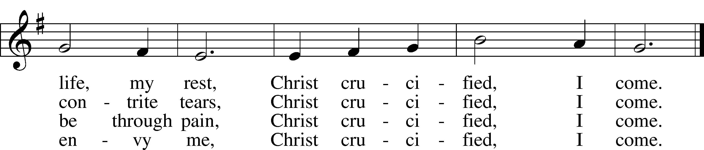

Public domain



***“Precious Lord, Take My Hand”* LSB 739**

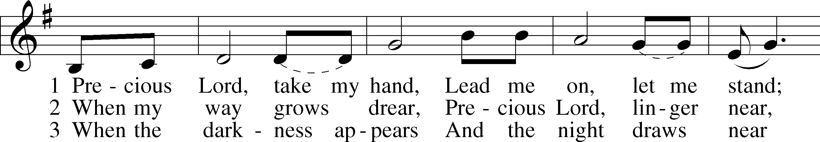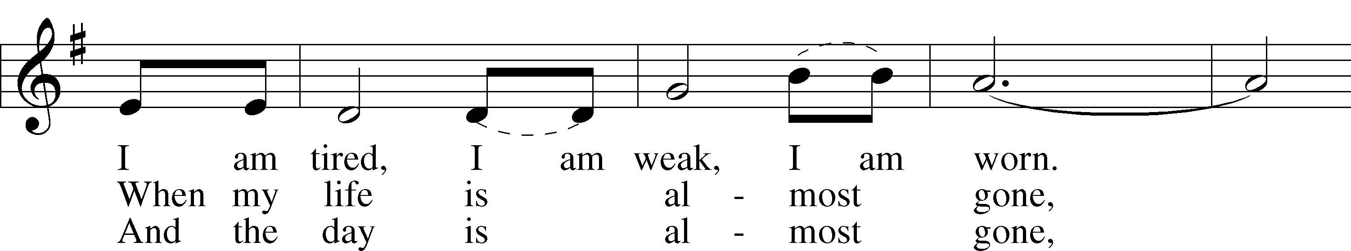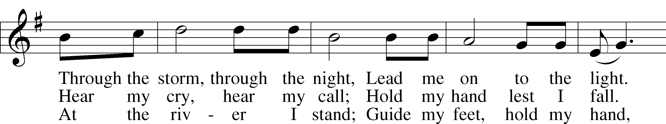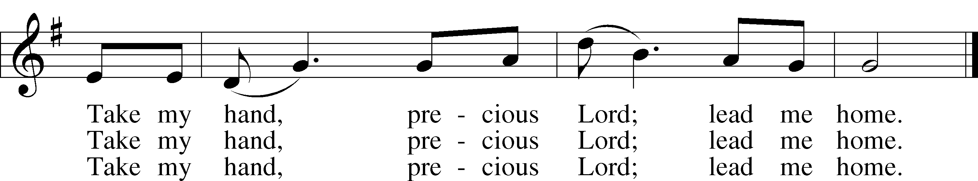

© 1938 Unichappell Music; admin. Alfred Publishing Co., Inc. Used by permission: LSB Hymn License .NET, no. 100011641.



***“I Am Trusting Thee, Lord Jesus”* LSB 729**

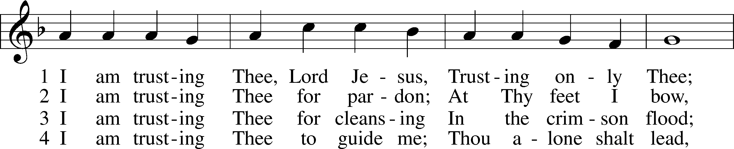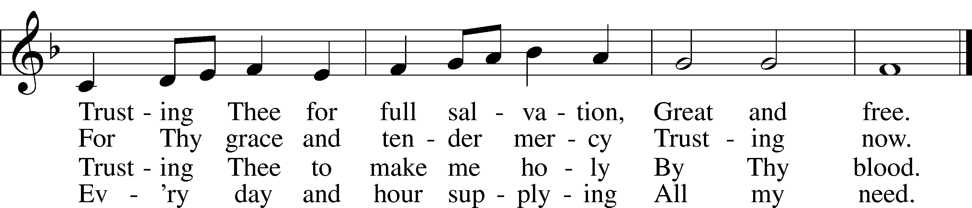

5 I am trusting Thee for power;  
 Thine can never fail.  
Words which Thou Thyself shalt give me  
 Must prevail.

6 I am trusting Thee, Lord Jesus;  
 Never let me fall.  
I am trusting Thee forever  
 And for all.

Public domain

Jesus let the things that break your heart also break our hearts.



Amen

*(Please stand…)*

**THE LORD’S PRAYER:**

**All: Our Father, who art in heaven, hallowed be thy name, thy kingdom come, thy will be done, on earth as it is in heaven. Give us this day our daily bread; and forgive us our trespasses as we forgive those who trespass against us; and lead us not into temptation, but deliver us from evil. For thine is the kingdom, and the power, and the glory, forever and ever. Amen**

**THE BLESSING AND BENEDICTION:**

Pastor: The Lord Blesses you and keeps you, the Lord makes His face to shine upon you and He is Gracious to you. The Lord looks upon you with His favor and gives you His peace.

**Congregation: God blesses us so that we can be a blessing to others.**

Pastor: Go in His peace and serve the Lord by serving others.

**Congregation: Amen**

**THE CLOSING HYMN: *“Lord, Dismiss Us with Your Blessing”* LSB 924**

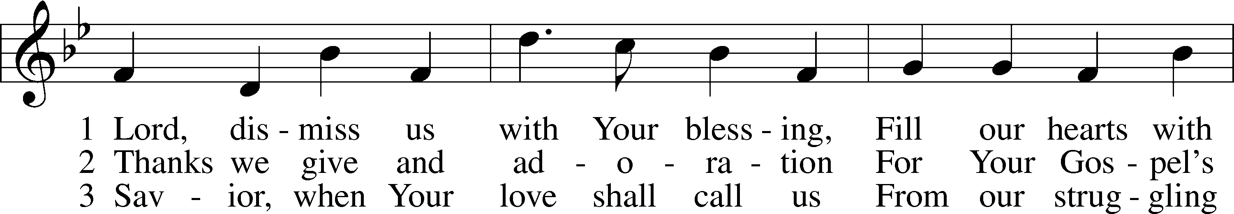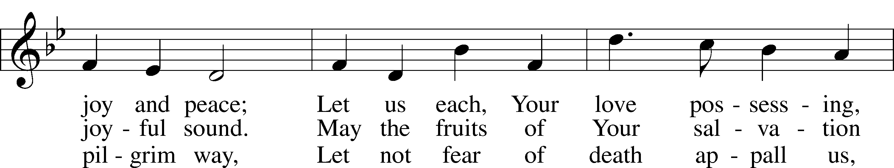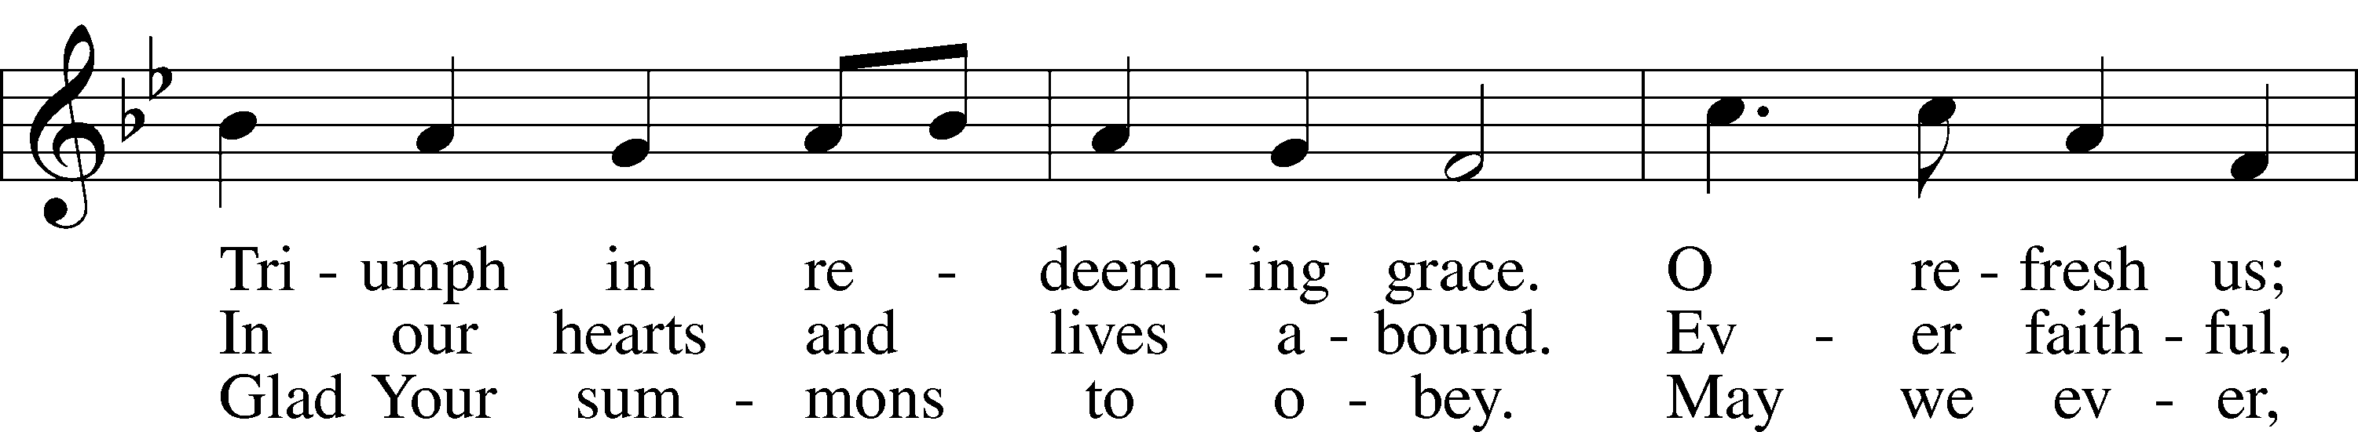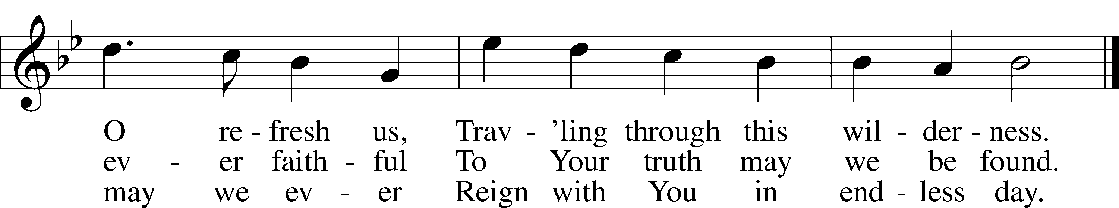

Public domain

**ANNOUNCEMENTS**

**WELCOME TO GRACE LUTHERAN CHURCH:** We are glad that you are here to worship God with us today! We pray that you will enjoy the wonderful fellowship as friends in Christ as God gathers us around His means of grace, the Word and Sacraments, to bless us with His treasured gifts of forgiveness, faith, abundant life and eternal salvation. If you are a guest, please also sign our Guest Book. Please talk to Pastor if you would like **to learn more about becoming a member of Grace. Also, please join us for refreshments** and fellowship after the Service. We invite you to come and worship with us often as God gathers us in His Grace.

**WELCOME TO THE LORD’S TABLE:** We invite and encourage all present who are baptized and faithful Christians, and who confess the Father, Son, and Holy Spirit to be the only true God and who believe that Jesus Christ died for the sins of the World and is our only hope and salvation…to join us in receiving the very and true body and blood of Christ in this Sacrament. The clear liquid cups in the center of the tray are non-alcoholic wine.

Children not yet confirmed in the faith are always welcome to join their parents at the Lord’s Table, but should keep their hands folded in front of them. The Pastor will give them a blessing.

**SERVING TODAY:** Acolyte: Amelia Bly; Lector: David Rose; Communion Assistants: Peter Bacle and Dean Thompson; Usher: Terry Richardson; Altar Care: The Bly Family; Refreshments: The Bly Family.

**SERVING NEXT SUNDAY:** Acolyte: Maddie Schoepf; Lector: Jessy Archer; Communion Assistants: Peter Bacle and Dean Thompson; Usher: Terry Richardson; Altar Care: ____________; Refreshments: ________________.

**FLOWERS**: were placed on the altar today to the glory of God.



**THIS WEEK AT A GLANCE:**

**Today: This Sunday**

9:00 am Worship Service with Communion (Graduate Appreciation)

10:15 am Fellowship/Refreshments

10:30 am Adult Bible Class/Children’s Sunday School

**Monday: June 13th**

Pastor’s Day Off

9:00 am VBS

5:00 pm Zumba

**Tuesday: June 14th**

9:00 am VBS

11:30 am Gracious Ladies of Grace Luncheon (The Café)

3:00 pm Jan’s Mobile Gym (Parish Hall)

6:00 pm Weight Watcher’s (Parish Hall)

**Wednesday: June 15th**

9:00 am VBS

8:30 am Grace Lutheran School Chapel

12:30 pm Men’s Bible Fellowship (Chico’s Restaurant)

**Thursday: June 16th**

9:00 am VBS

**Friday: June 17th**

9:00 am VBS

**Next Sunday: June 12th**

9:00 am Worship Service with Communion

10:15 am Fellowship/Refreshments

10:30 am Adult Bible Class/Children’s Sunday School

**IN YOUR PRAYERS THIS WEEK:** Kit Billings, Bill Billings Jr., Laura MacQuarie, family and friends of Gary Winters, Gabriel Kirkland, family and friends of Bryan Kay, Kay Sattelmeier, Suzanne Kolhagan, Phil Zielinski, Cressie Brown, the family and friends of Mary Bacle, the victims of the Lahore Pakistan attack, the family and friends of Carol Shimp, Esther Faith, Jameson Parker, the family and friends of Hwana, Liz and Ryan Grady, Loretta Cates, Larry, Dan, Gabriel, Andrew, Julia Pateman, David Lopez, Annie Garner, Nancy Amling, Alicia Llama, Erich & Erika Hoffmann, Katharina Lutz, Robert and Regina Hoffmann, Walter Hulme, Carole Steinle, Joanne Cates, Jane Howard, Jean Grafsgaurd, Denis Julson, Mary Kay, Sandy Harris, and those you are praying for at home. If anyone has a special prayer request please submit it in writing in the collection plate; or you may call Pastor Gary Faith at (504-858-8872), or Kris Howard at (305-296-5161).

**GIFTS, TITHES, & ATTENDANCE LAST SUNDAY** was $5208.00, building fund received $234.00. The noise offering for last Sunday, June 5th was will be combined with this Sunday’s noise offering. Our 9am service had an attendance of 85.

**TO HELP US GROW…** The Bible readings for next Sunday’s service readings are Isaiah 65:1-9, Galatians 3:23-4:7, Luke 8:26-39.



**VBS TIME: BARNYARD ROUND:** We will be staying after church today to set up for VBS this week. If you can help please stay and lend a hand. We are also still in need of 2 leaders. If you can volunteer, please contact Deb Schuetzler at [debschuetz@me.com](mailto:debschuetz@me.com) or (904) 625-4335.



**ADULT INFORMATION CLASS:** We would like to schedule an Adult Information Class. This is for those who would like to become a member of Grace and/or learn more about what we teach and believe. It is also a good review for members. If interested, please let Pastor or Kris know. Thanks.

**THE GRACIOUS LADIES OF GRACE:** ­­­­­­­­­­­­The Gracious Ladies of Grace went nautical this time at the Key West Yacht Club. Some of us even dressed for the occasion with our wardrobe adorned with anchors and such. The food was fab, service great, and we got to sit at a round table which was very conducive to hearing everything that was said. It was mainly a whole litany of iguana complaints and woes. It was decided that as a fundraiser we were going to sell iguana stands, pellet rifles, and hibiscus pink camo. Faye and Yvonne will be heading up that project. Proceeds will be going to setting off small explosives around the church property. You know it’s bad when people are confused whether were are a Church and School or Jurassic park. We did give a 5* rating and decided to go on June 14th at 11:30 to the Café at 509 Southard St. Elaine says it’s very healthy and delicious. The city parking lot is very close on Simonton St. Join us for our next adventure.

**MISSIONAL COMMUNITIES – CHANGE IN SCHEDULE:** In an effort to increase participation Missional Communities will meet twice monthly on the 2nd and 4th Thursday’s. The 5 Questions we discuss are designed to help us grow in our relationship with Jesus and in our ability to see the opportunities God places in our path. Questions; ask one of those who participates.

**STAINED GLASS WINDOWS:** Thanks be to God, all four of the remaining stained glass windows on right side of altar have been donated.  The three windows on the left side will be installed in March.  We only have 9 clear glass impact windows in the bathrooms and front entry, and the two side entry doors that need to be replaced.  When those are completed, the entire church will be protected with hurricane proof, impact windows. The cost of the windows is roughly $2000.00 each depending on size.  We are waiting on the estimates of the windows and doors as they have just been measured. Thank you donors of the stained glass windows and to all those who have contributed to the building fund for this project. Your generous giving is much appreciated. Pickel Studios is known throughout America and Europe for the quality of their stained glass work, and the new windows are spectacular works of art that glorify our Savior.

**THE GRACE LUTHERAN CHURCH WEB PAGE AND FACE BOOK PAGE** now contains a vocal recording of last week’s sermon. So if you are not able to attend church on Sunday please go to our website where you will find a copy of the bulletin and a recording of Pastor Faith’s sermon. The new webpage address is gracelutherankw.360unite.

**A NUMBER OF CAPITAL IMPROVEMENTS** are needed to keep our facilities in good health for the future. The narthex has been rebuilt. Roof repairs are needed on school buildings. If you can help it would be much appreciated! A big thanks to all who have contributed to these repairs.

**WOMEN’S BIBLE STUDY:** The Ladies Bible Study finished their studies on “Stories of Deliverance from the Old Testament”, asking 7 questions that answered why it was told and what we are to take from it, mainly asking how does this story show how God loves me. We are looking forward to a new study in the fall please consider joining us for an hour of interesting insights and lively discussions.

**MEN’S BIBLE FELLOWSHIP**: They meet the first and third Wednesday’s of each month at 12:30pm at Chico’s Restaurant. Their next meeting will be June 15th. All guys are welcome.