**June 5th, 2016**

**9:00 am**

**THIRD SUNDAY AFTER PENTECOST**



**Grace Lutheran Church**

**2713 Flagler Ave.**

**Key West, FL 33040**

**305-296-5161**

**GraceLutheranKW@att.net**

**Pastor Faith**

**(504) 858-8872**

**garyfaith@aol.com**

**THIRD SUNDAY AFTER PENTECOST**

**JUNE 5, 2016 9:00 a.m.**

**WORSHIP SERVICE**

***In the Name of Jesus!***

**Our Mission Statement:**

**Anchored in Christ, each person a missionary.**

**ORGAN PRELUDE: (A time for Meditation and Preparation)**

**WELCOME**

**ANNOUNCEMENTS**

**PREPARATION**

*(Please Stand…)*

**HYMN: *“Earth and All Stars”* LSB 817**

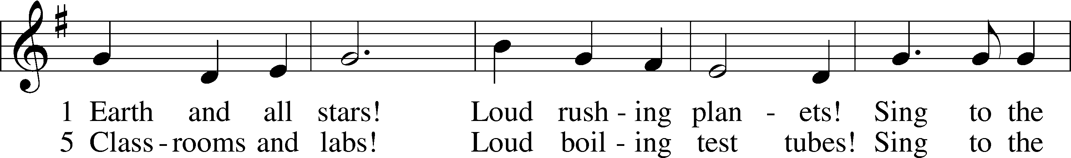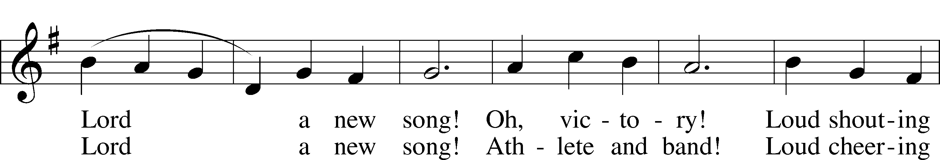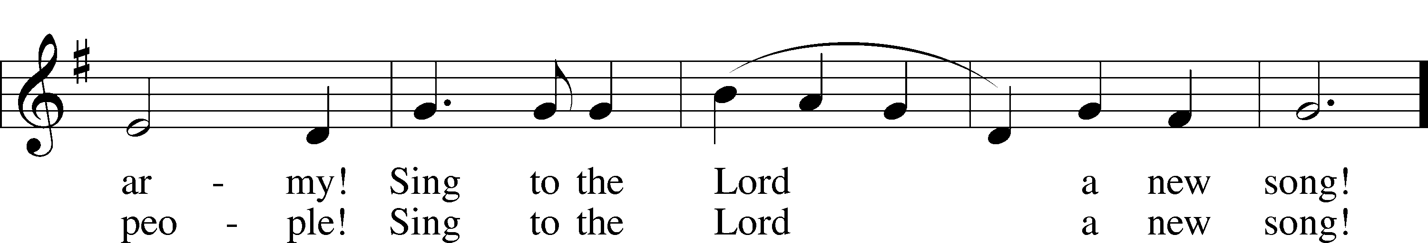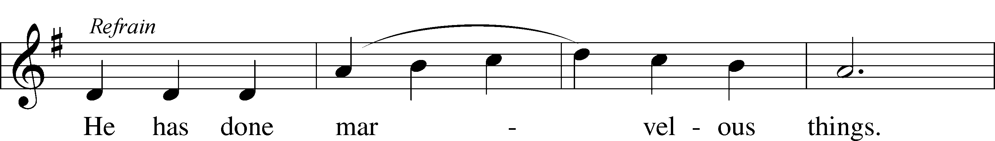

6 Knowledge and truth!  
 Loud sounding wisdom!  
Sing to the Lord a new song!  
 Daughter and son!   
 Loud praying members!  
Sing to the Lord a new song! Refrain

7 Children of God,  
 Dying and rising,  
Sing to the Lord a new song!  
 Heaven and earth,  
 Hosts everlasting,  
Sing to the Lord a new song! Refrain

© 1968 Augsburg Publishing House. Used by permission: LSB Hymn License .NET, no. 100011641.

Pastor: In the Name of the Father and of the Son and Holy Spirit.

**Congregation: Amen.**

*(Please Remain Standing or You May Kneel)*

**CONFESSION AND ABSOLUTION:**

Pastor: Holy God, in your mercy you look with grace and favor upon us, Your people. Hear now, our solemn confession, and as Your Spirit moves us to true repentance, remind us again that You have forgiven us for the sake of Jesus Christ.

**Congregation: Father, how often my sinful nature controls my life! I am easily tempted and fall into sin; I am blind to Your will; I am self-serving, self-seeking, self-righteous and deluded; I am dead in sin. The works of my flesh are demonstrated in my actions and thoughts and words. I have not acted as your baptized child. My heart breaks in my shame and guilt. Gratefully I remember Your blood shed for me to wash me clean. I am forgiven. Holy Spirit, control my life.**

Pastor: God has heard our cry. He is faithful even when we are not. As your called servant of His Word, I announce that we have what we seek; the entire forgiveness of all our sins, as God’s free gift. New life, new sights and a new heart are ours. Live in the freedom of the Spirit.

**Congregation: Amen!**

**THE PRAYERS OF THE DAY:**

**All: O Lord, Father of all mercy and God of all comfort, You always go before and follow after us. Grant that we may rejoice in Your gracious presence and continually be given to all good works; through Jesus Christ, Your Son, our Lord, who lives and reigns with You and the Holy Spirit, one God, now and forever. Amen.**

**SERVICE OF THE WORD**

*You may be seated…*

**THE FIRST READING: 1 Kings 17:17-24**

Lector: This is the Word of the Lord.

**People: Thanks be to God.**

**THE EPISTLE LESSON: Galatians 1:11-24**

Lector: This is the Word of the Lord.

**People: Thanks be to God.**

*Please stand…*

**THE HOLY GOSPEL: Luke 7:11-17**

Pastor: The Holy Gospel according to St. Luke the 7th Chapter

**People: Glory to You, O Lord.**

Pastor: This is the Gospel of the Lord.

**People: Praise to You, O Christ!**

*Please be seated…*

**CHILDREN’S MESSAGE**

**NOISE OFERING**



**THE SERMON HYMN: *“I Know That My Redeemer Lives”* LSB 461**

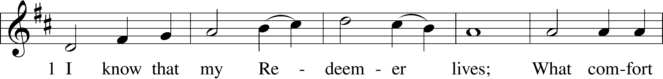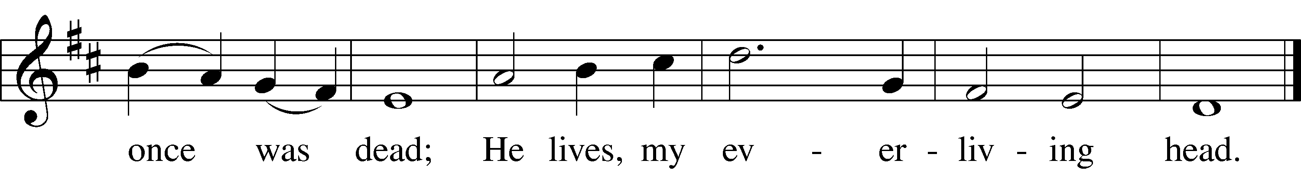

5 He lives to silence all my fears;  
He lives to wipe away my tears;  
He lives to calm my troubled heart;  
He lives all blessings to impart.

6 He lives, my kind, wise, heav’nly friend;  
He lives and loves me to the end;  
He lives, and while He lives, I’ll sing;  
He lives, my Prophet, Priest, and King.

7 He lives and grants me daily breath;  
He lives, and I shall conquer death;  
He lives my mansion to prepare;  
He lives to bring me safely there.

Public domain

**THE SERMON: *“The Big Picture”* 1 Kings 17:17-24 Luke 7:11-17**



*(Please stand…)*

**THE PROFESSION OF FAITH:**

Pastor: God has given us a great message to take to His world. Let us remind ourselves and one another of what that message is:

Pastor: I believe in God the Father, Almighty

**Congregation: Maker of heaven and earth**

Pastor: And in His Son, Jesus Christ our Lord,

**Congregation: Who was conceived by the Holy Spirit**

Pastor: Born of the Virgin Mary

**Congregation: Suffered under Pontius Pilate**

Pastor: Was crucified, died and was buried

**Congregation: He descended into hell.**

Pastor: On the third day He rose again from the dead,

**Congregation: And ascended into heaven**

Pastor: And sits on the right hand of God, the Father almighty

**Congregation: From there He will come to judge the living and the dead**

Pastor: I believe in the Holy Spirit,

**Congregation: The Holy Christian Church as**

**All: the communion of saints; the forgiveness of sins, the resurrection of the body, and the life everlasting. Amen.**

**BLESSING OF THE GRADUATES**

*(You may be seated…)*

**OFFERING RECEIVED**

*(Please stand…)*

**THE PRAYER:**

Pastor: Lord God, Heavenly Father, You are the Light of our life and the Hope of

our salvation.

**Response: With you we have nothing to fear.**

Pastor: You protect us, and are the source of all our joy and happiness.

**Response: Accept our grateful songs of praise.**

Pastor: We pray for those whom we now name silently in our hearts or out loud… According to Your will, heal the sick, strengthen the faith of all who doubt and lift up the depressed. Into Your hand we commend all for whom we pray, trusting in Your mercy, through Your Son, Jesus Christ our Lord.

**All: Amen!**

**SERVICE OF THE SACRAMENT**

*(Please be seated…)*

**THE WORDS OF INSTITUTION**

**DISTRIBUTION HYMNS: *“What Is This Bread”*  LSB 629**

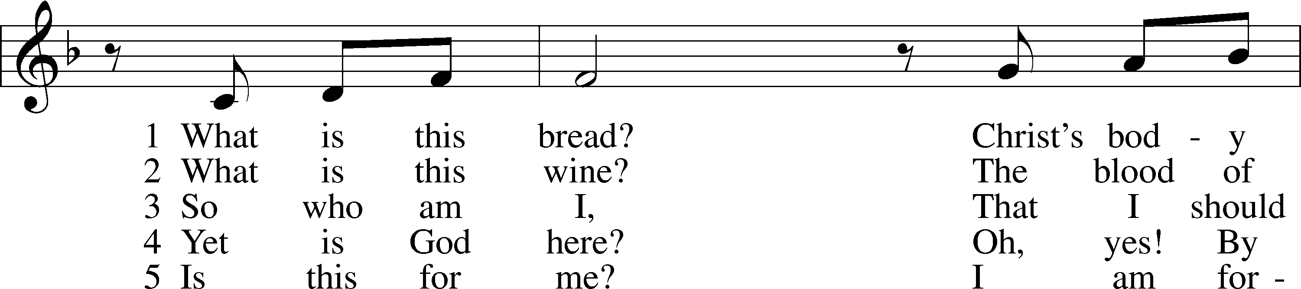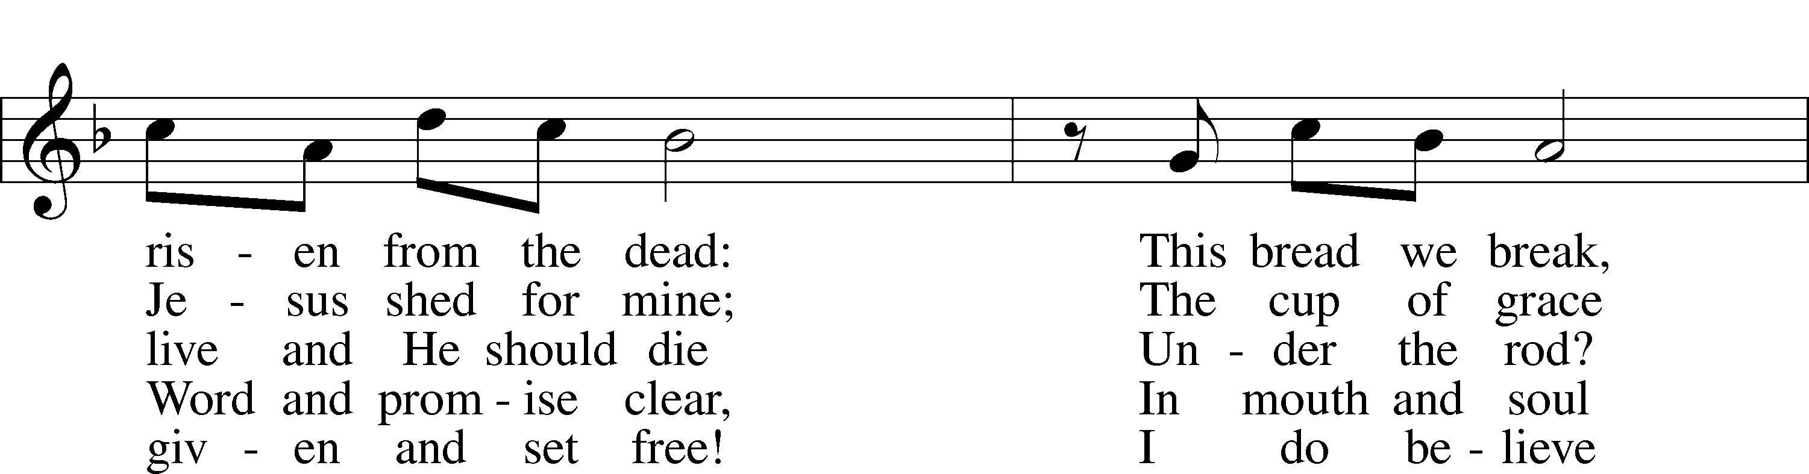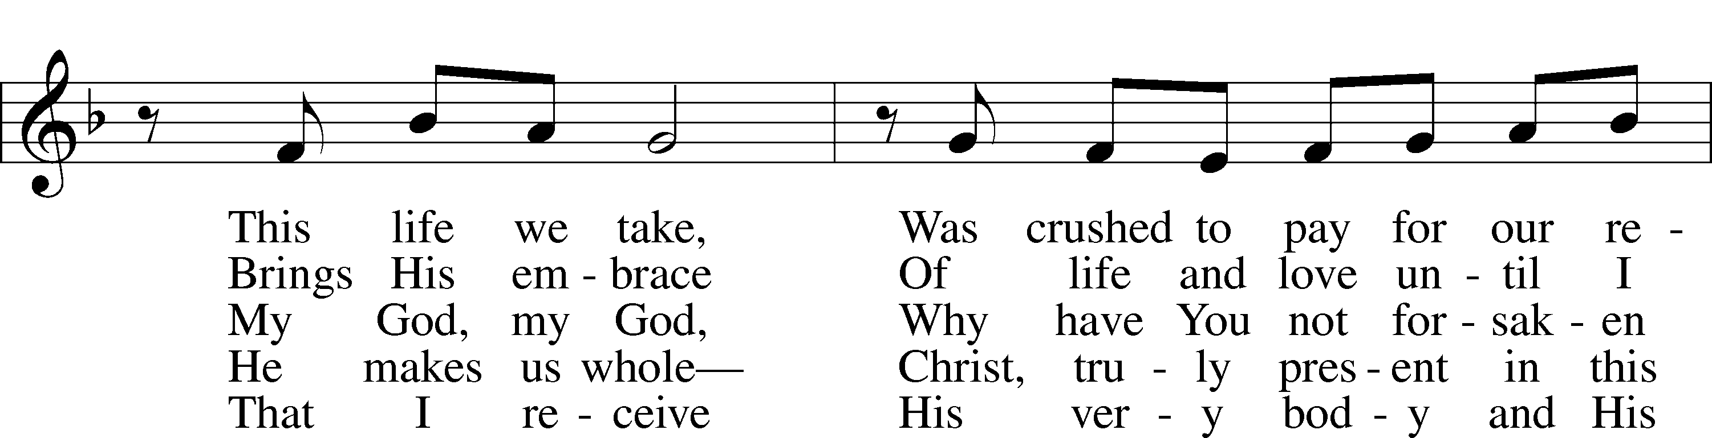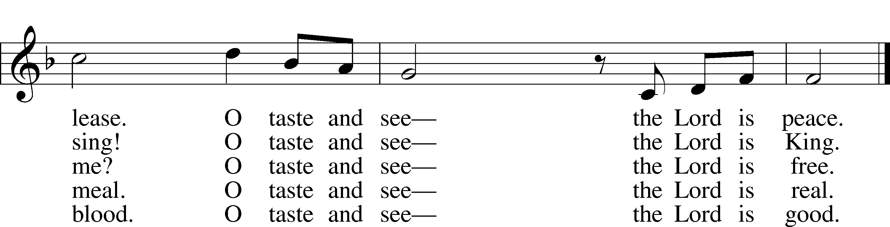

© 1991 Fred and Jean Baue. Used by permission: LSB Hymn License .NET, no. 100011641.

***“Seek Ye First”* LSB 712**

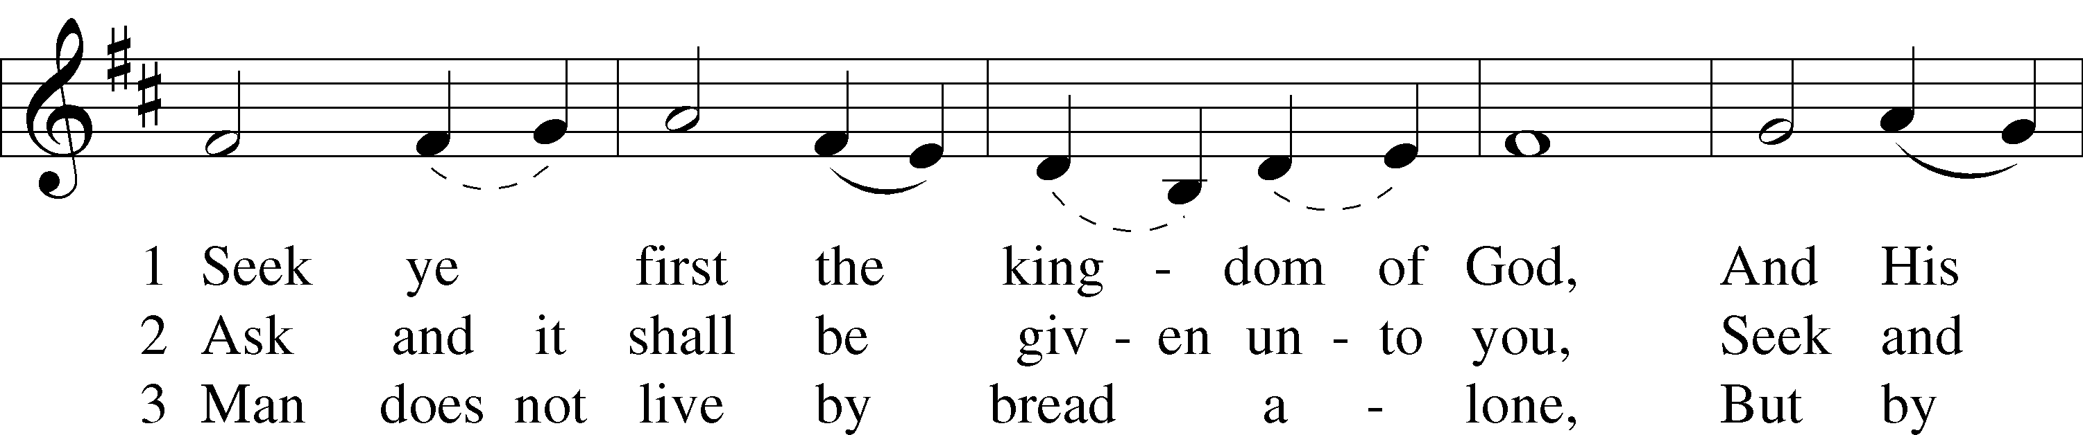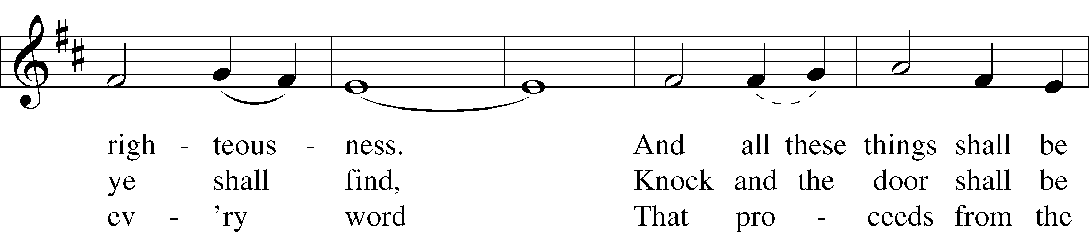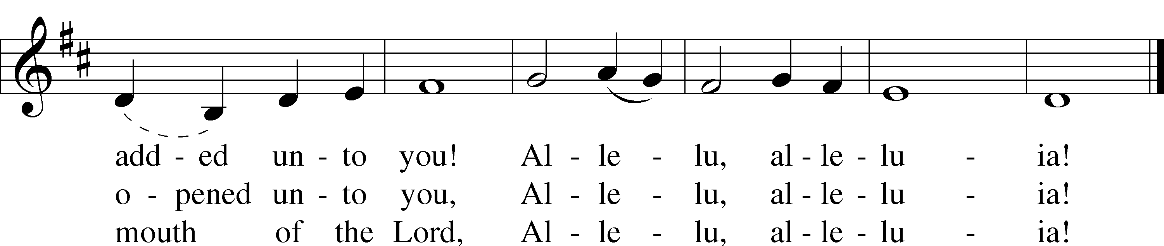

© 1972 Maranatha! Music; admin. Music Services (ASCAP). Used by permission: New License, no. 11157462.

Jesus let the things that break your heart also break our hearts.



Amen

***“Jesus Loves Me”*  LSB 588**

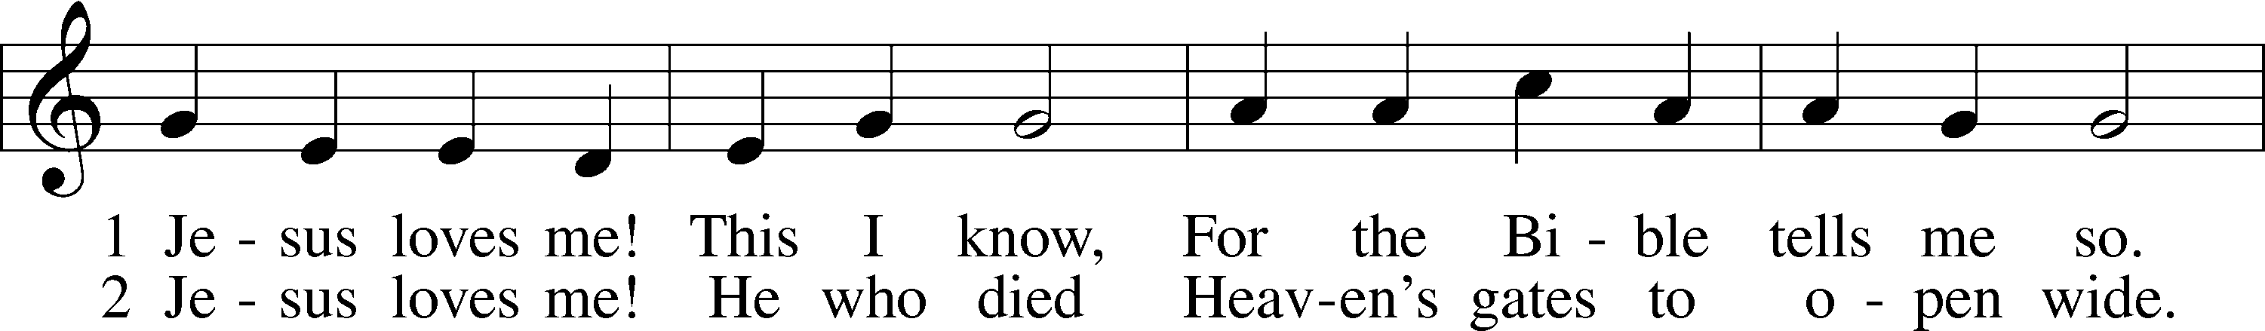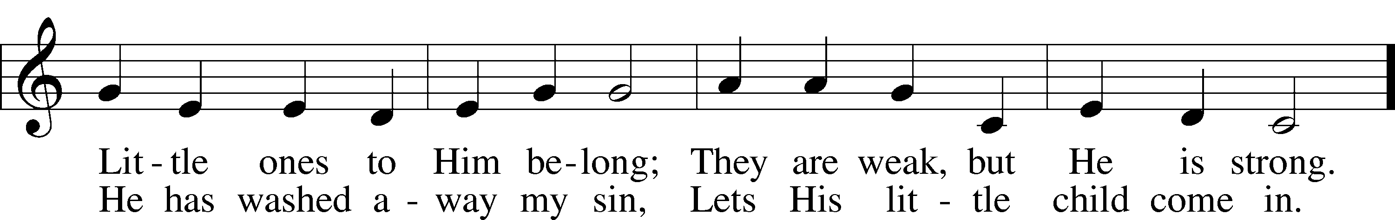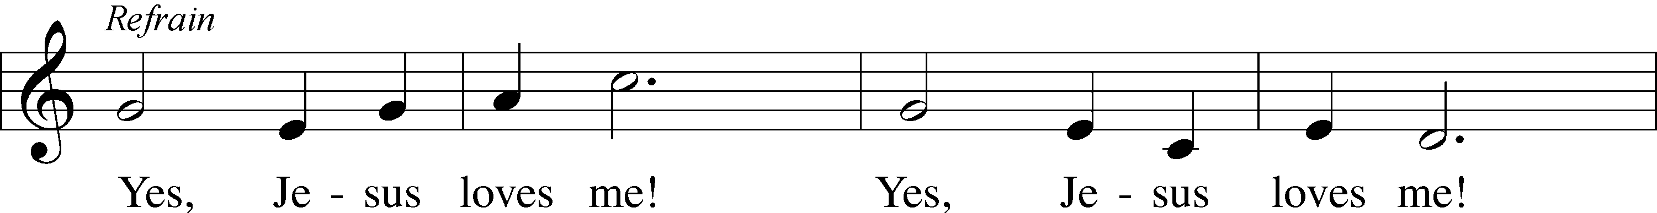

Public domain

*(Please stand…)*

**THE LORD’S PRAYER:**

**All: Our Father, who art in heaven, hallowed be thy name, thy kingdom come, thy will be done, on earth as it is in heaven. Give us this day our daily bread; and forgive us our trespasses as we forgive those who trespass against us; and lead us not into temptation, but deliver us from evil. For thine is the kingdom, and the power, and the glory, forever and ever. Amen**

**THE BENEDICTION**



**THE CLOSING HYMN: *“Go, My Children, with My Blessing”* LSB 922**

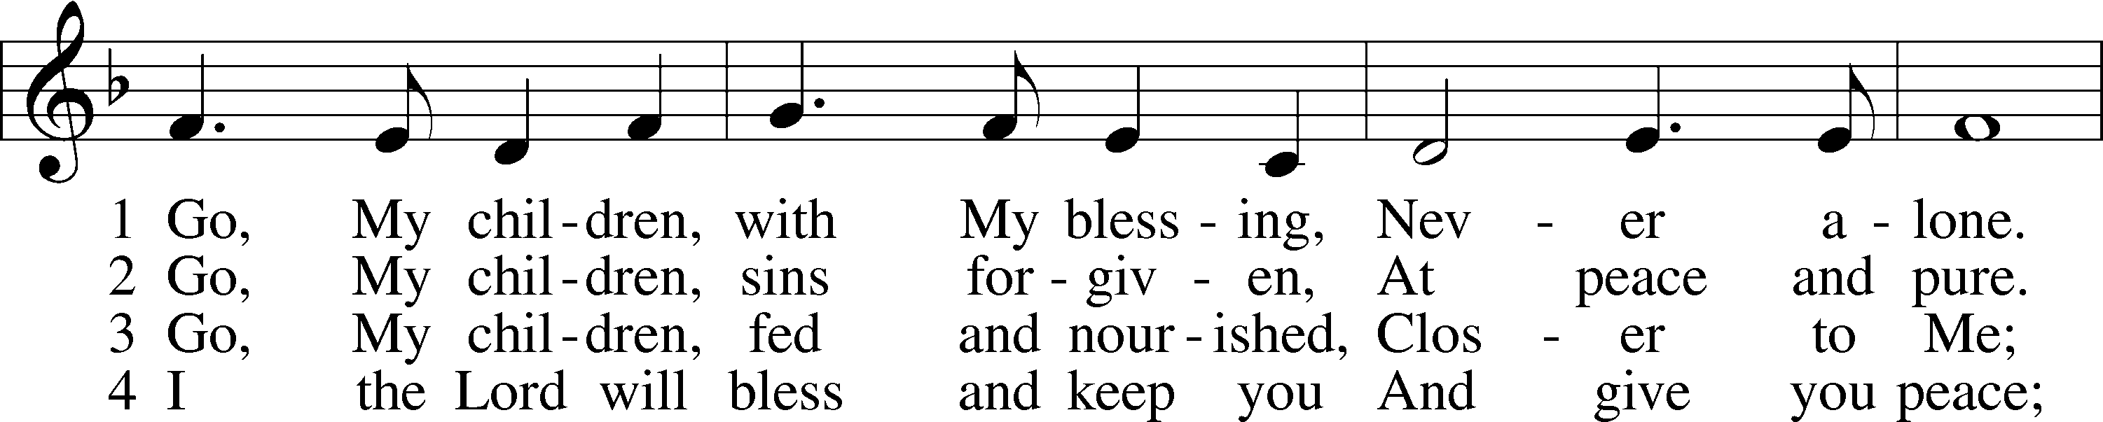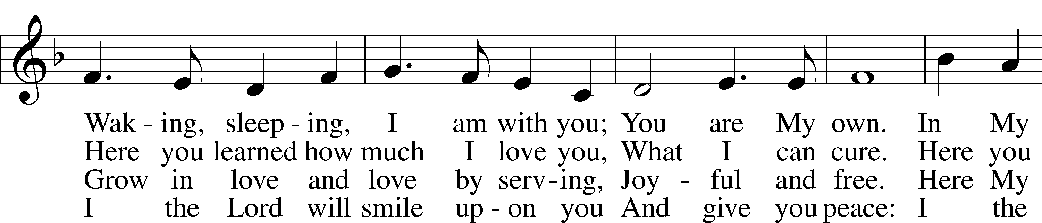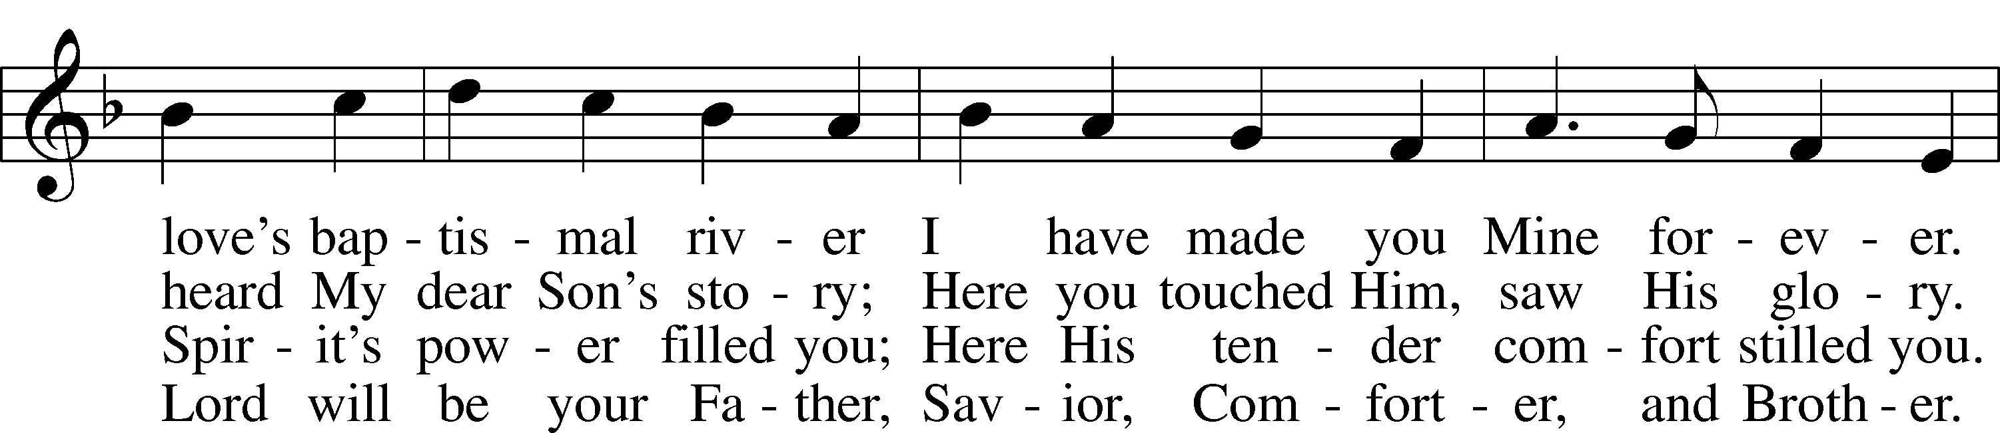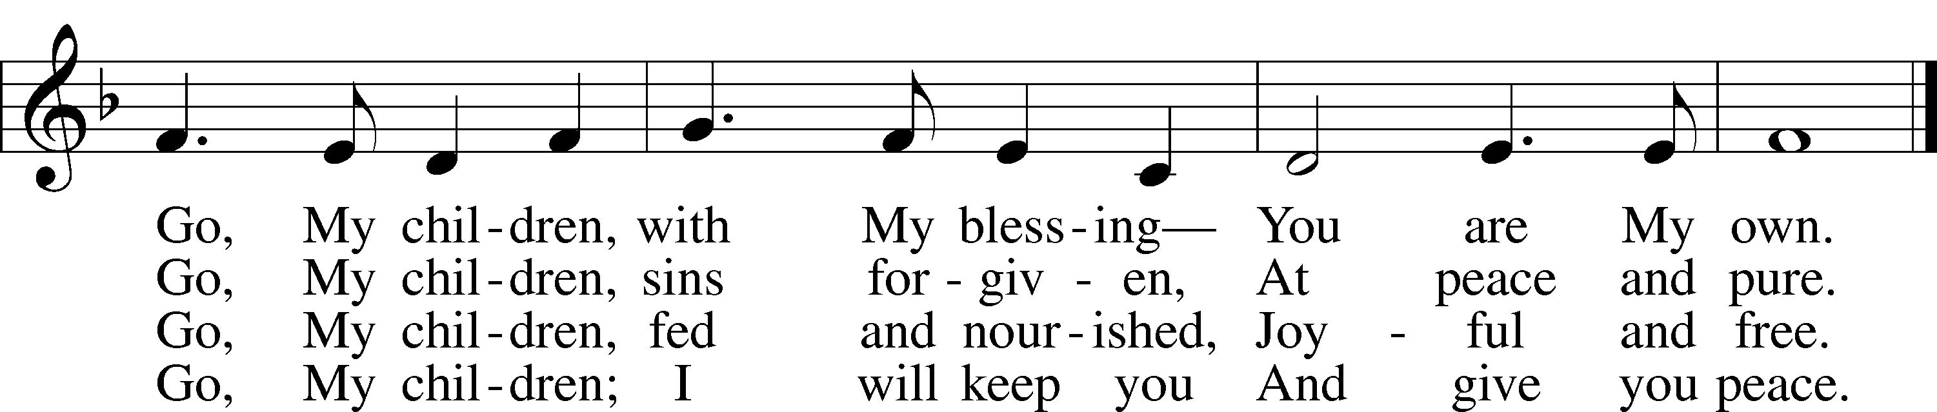

© 1983 Concordia Publishing House. Used by permission: LSB Hymn License .NET, no. 100011641.  
Public domain

**ANNOUNCEMENTS**

**WELCOME TO GRACE LUTHERAN CHURCH:** We are glad that you are here to worship God with us today! We pray that you will enjoy the wonderful fellowship as friends in Christ as God gathers us around His means of grace, the Word and Sacraments, to bless us with His treasured gifts of forgiveness, faith, abundant life and eternal salvation. If you are a guest, please also sign our Guest Book. Please talk to Pastor if you would like **to learn more about becoming a member of Grace. Also, please join us for refreshments** and fellowship after the Service. We invite you to come and worship with us often as God gathers us in His Grace.

**WELCOME TO THE LORD’S TABLE:** We invite and encourage all present who are baptized and faithful Christians, and who confess the Father, Son, and Holy Spirit to be the only true God and who believe that Jesus Christ died for the sins of the World and is our only hope and salvation…to join us in receiving the very and true body and blood of Christ in this Sacrament. The clear liquid cups in the center of the tray are non-alcoholic wine.

Children not yet confirmed in the faith are always welcome to join their parents at the Lord’s Table, but should keep their hands folded in front of them. The Pastor will give them a blessing.

**SERVING TODAY:** Acolyte: Jacob Baugh; Lector: Mike Sattelmeier; Communion Assistants: Peter Bacle and Dean Thompson; Usher: Terry Richardson; Altar Care: ____________; Refreshments: The Morris Family.

**SERVING NEXT SUNDAY:** Acolyte: Amelia Bly; Lector: ___________; Communion Assistants: Peter Bacle and Dean Thompson; Usher: Terry Richardson; Altar Care: The Bly Family; Refreshments: The Bly Family.

**FLOWERS**: were placed on the altar today to the glory of God.



**THIS WEEK AT A GLANCE:**

**Today: This Sunday**

9:00 am Worship Service with Communion (Graduate Appreciation)

10:15 am Fellowship/Refreshments

10:30 am Annual Voter’s Meeting

**Monday: June 6th**

Pastor’s Day Off

5:00 pm Zumba

**Tuesday: June 7th**

3:00 pm Jan’s Mobile Gym (Parish Hall)

6:00 pm Weight Watcher’s (Parish Hall)

**Wednesday: June 8th**

12:30 am Men’s Bible Fellowship (Chico’s Restaurant)

8:30 am Grace Lutheran School Chapel

4:30 pm Women’s Bible Study

**Thursday: June 9th**

12:30 pm Men’s Bible Fellowship (Chico’s Restaurant)

**Next Sunday: June 12th**

9:00 am Worship Service with Communion

10:15 am Fellowship/Refreshments

10:30 am Adult Bible Class/Children’s Sunday School

**IN YOUR PRAYERS THIS WEEK:** Laura MacQuarie, family and friends of Gary Winters, Gabriel Kirkland, family and friends of Bryan Kay, Kay Sattelmeier, Suzanne Kolhagan, Phil Zielinski, Cressie Brown, the family and friends of Mary Bacle, the victims of the Lahore Pakistan attack, the family and friends of Carol Shimp, Esther Faith, Jameson Parker, the family and friends of Hwana, Liz and Ryan Grady, Loretta Cates, Larry, Dan, Gabriel, Andrew, Julia Pateman, David Lopez, Annie Garner, Nancy Amling, Alicia Llama, Erich & Erika Hoffmann, Katharina Lutz, Robert and Regina Hoffmann, Walter Hulme, Carole Steinle, Joanne Cates, Jane Howard, Jean Grafsgaurd, Denis Julson, Mary Kay, Sandy Harris, and those you are praying for at home. If anyone has a special prayer request please submit it in writing in the collection plate; or you may call Pastor Gary Faith at (504-858-8872), or Kris Howard at (305-296-5161).

**GIFTS, TITHES, & ATTENDANCE LAST SUNDAY** was $3461.00, building fund received $0. The noise offering for last Sunday, May 29th was $56.65. Our 9am service had an attendance of 64.

**TO HELP US GROW…** The Bible readings for next Sunday’s service readings are 2 Samuel 11:26-12:10, 13-14, Galatians 2:15-21, 3:10-14, and Luke 7:36-8:3.



**GRADUATES:** The following members are graduating from High School, College, 8th grade, or Kindergarten. We are proud of all of them and wish them God’s blessing on the next step of their journey with Jesus.

From Kindergarten going into 1st Grade:

Angelina Bringle

RJ Williams

From 8th Grade going into High School 9th Grade:

Emmie Thompson

Conary McGee

Jacob Baugh

Amelia Bly

Graduating High School

Sydney Hamilton (University of Texas)

Spencer Morgan Hamilton (University of Florida)

Graduating University of Florida

Justin Hamilton (University of Florida Masters Program)



**THE ANNUAL VOTER’S MEETING** will take place after today’s service starting at 10:30am. All members are asked to attend.

**VBS TIME: BARNYARD ROUND:** Come join us for some fun as we learn about Jesus our Good Shepherd the week of June 13th – 17th from 9am – 12 noon. Ages 4 years old thru the 6th Grade are invited to attend. If you can volunteer, please contact Deb Schuetzler at [debschuetz@me.com](mailto:debschuetz@me.com) or (904) 625-4335.

**ADULT INFORMATION CLASS:** We would like to schedule an Adult Information Class. This is for those who would like to become a member of Grace and/or learn more about what we teach and believe. It is also a good review for members. If interested, please let Pastor or Kris know. Thanks.

**THE GRACIOUS LADIES OF GRACE:** ­­­­­­­­­­­­The Gracious Ladies of Grace went nautical this time at the Key West Yacht Club. Some of us even dressed for the occasion with our wardrobe adorned with anchors and such. The food was fab, service great, and we got to sit at a round table which was very conducive to hearing everything that was said. It was mainly a whole litany of iguana complaints and woes. It was decided that as a fundraiser we were going to sell iguana stands, pellet rifles, and hibiscus pink camo. Faye and Yvonne will be heading up that project. Proceeds will be going to setting off small explosives around the church property. You know it’s bad when people are confused whether were are a Church and School or Jurassic park. We did give a 5* rating and decided to go on June 14th at 11:30 to the Café at 509 Southard St. Elaine says it’s very healthy and delicious. The city parking lot is very close on Simonton St. Join us for our next adventure.

**MISSIONAL COMMUNITIES – CHANGE IN SCHEDULE:** In an effort to increase participation Missional Communities will meet twice monthly on the 2nd and 4th Thursday’s. The 5 Questions we discuss are designed to help us grow in our relationship with Jesus and in our ability to see the opportunities God places in our path. Questions; ask one of those who participates.

**STAINED GLASS WINDOWS:** Thanks be to God, all four of the remaining stained glass windows on right side of altar have been donated.  The three windows on the left side will be installed in March.  We only have 9 clear glass impact windows in the bathrooms and front entry, and the two side entry doors that need to be replaced.  When those are completed, the entire church will be protected with hurricane proof, impact windows. The cost of the windows is roughly $2000.00 each depending on size.  We are waiting on the estimates of the windows and doors as they have just been measured. Thank you donors of the stained glass windows and to all those who have contributed to the building fund for this project. Your generous giving is much appreciated. Pickel Studios is known throughout America and Europe for the quality of their stained glass work, and the new windows are spectacular works of art that glorify our Savior.

**THE GRACE LUTHERAN CHURCH WEB PAGE AND FACE BOOK PAGE** now contains a vocal recording of last week’s sermon. So if you are not able to attend church on Sunday please go to our website where you will find a copy of the bulletin and a recording of Pastor Faith’s sermon. The new webpage address is gracelutherankw.360unite.

**A NUMBER OF CAPITAL IMPROVEMENTS** are needed to keep our facilities in good health for the future. The narthex has been rebuilt. Roof repairs are needed on school buildings. If you can help it would be much appreciated! A big thanks to all who have contributed to these repairs.

**WOMEN’S BIBLE STUDY:** Bible stories: what are their value and meaning for us today?  God loves to tell a good story, you might call Him "the Great Storyteller". By examining these stories, we will be asking: how does He show us how much He loves us, how powerful He is, how He will save us, how an ordinary person can do powerful things, how obedience and trust are the key to a blessed life, how God is giving gifts to His children, and how He longs to give us peace and hope, the best gifts of all.

   We will be studying 4 stories of God's deliverance of His children from perilous circumstances.  God is almighty and it is not impossible or unthinkable for Him to rescue you from whatever seems to be insurmountable in your life.  The power of deliverance from troubles no matter how looming or momentary they are, is available to you. You just have to ask.

God is our refuge and strength,

an ever-present help in trouble.

Therefore we will not fear, though the earth give way,

and the mountains fall into the heart of the sea,

though its waters roar and foam

and the mountains quake with their surging.   Psalm 46:1-3

Please join us through the month of May on Wednesday's at 4:30 in room 3.

**MEN’S BIBLE FELLOWSHIP**: They meet the first and third Wednesday’s of each month at 12:30pm at Chico’s Restaurant. Their next meeting will be June 15th. All guys are welcome.