SEVENTH SUNDAY OF EASTER
MAY 8, 2016 9:00 a.m.
WORSHIP SERVICE
In the Name of Jesus!
Our Mission Statement: Anchored in Christ, each person a missionary.

PRELUDE

ANNOUNCEMENTS:
God is with us all during the week, wherever we are and in whatever we are doing. This week, let’s enjoy His presence.

OPENING HYMN: “See This Wonder in the Making” LSB 593
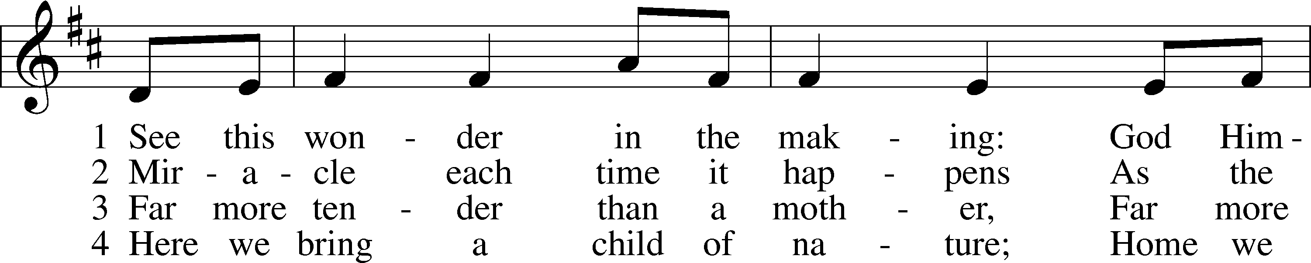
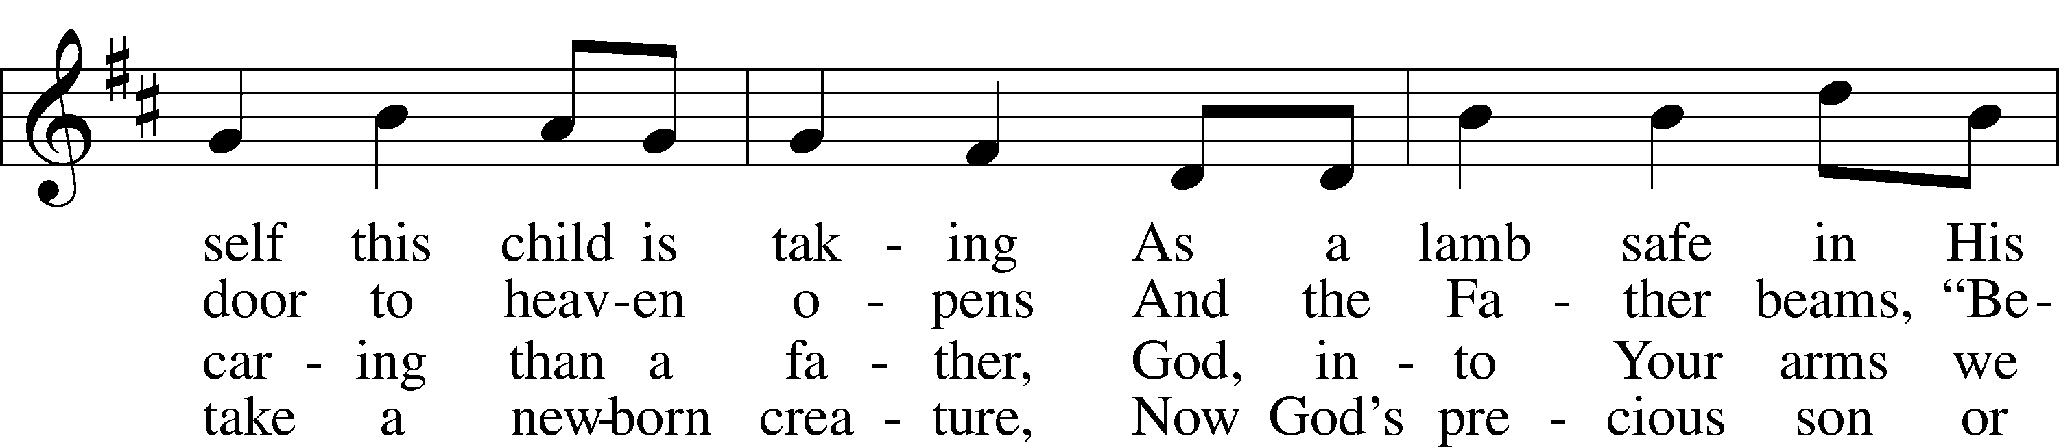
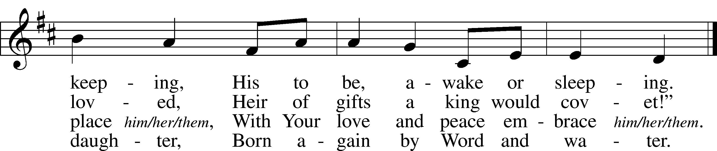
© 1984 Concordia Publishing House. Used by permission: LSB Hymn License .NET, no. 100011641.
Public domain

Pastor: In the Name of the Father and of the Son and of the Holy Spirit.
Congregation: Amen

SERVICE OF HOLY BAPTISM

RECEPTION OF NEW MEMBERS
“Father Welcomes” LSB 605
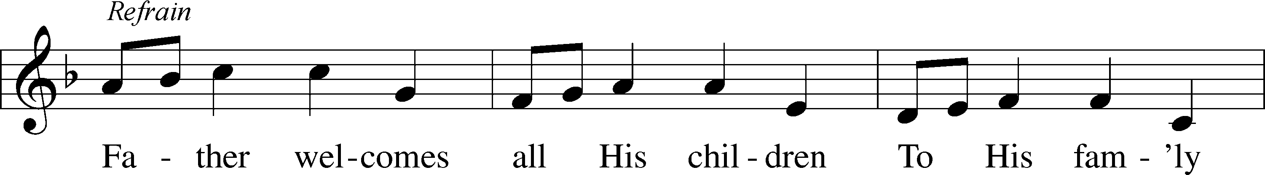
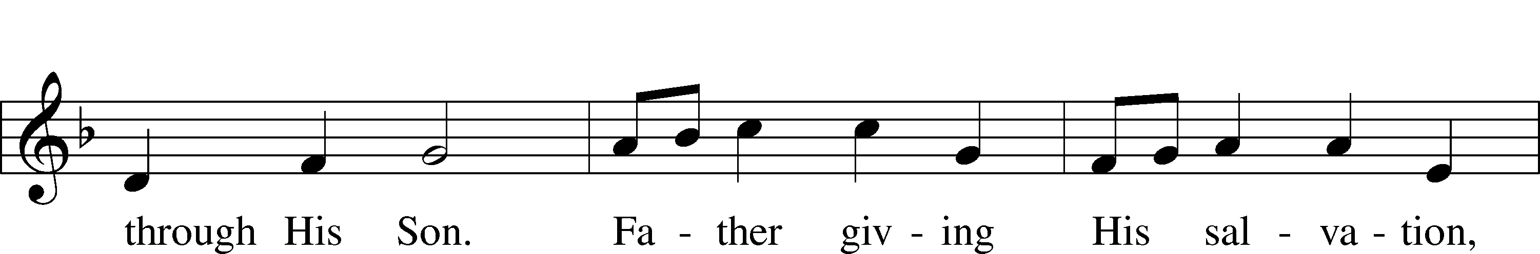
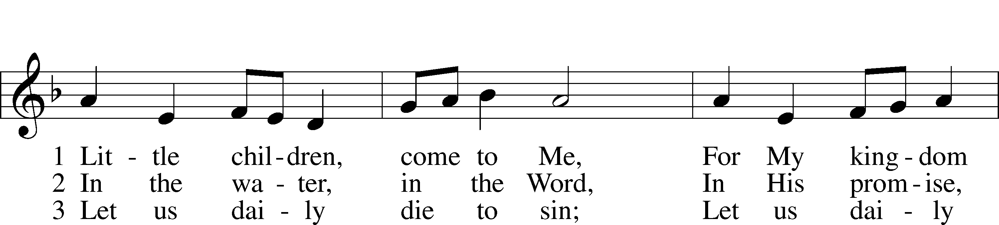
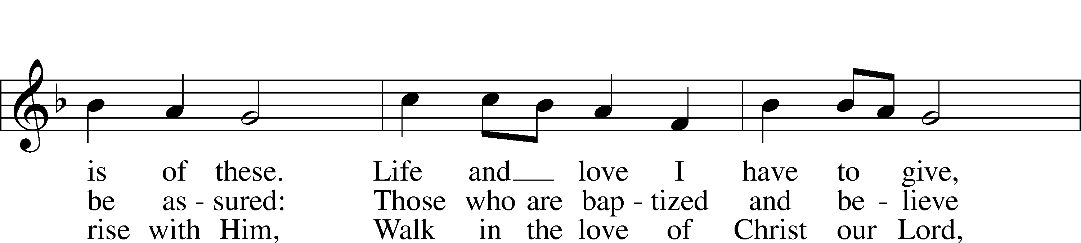
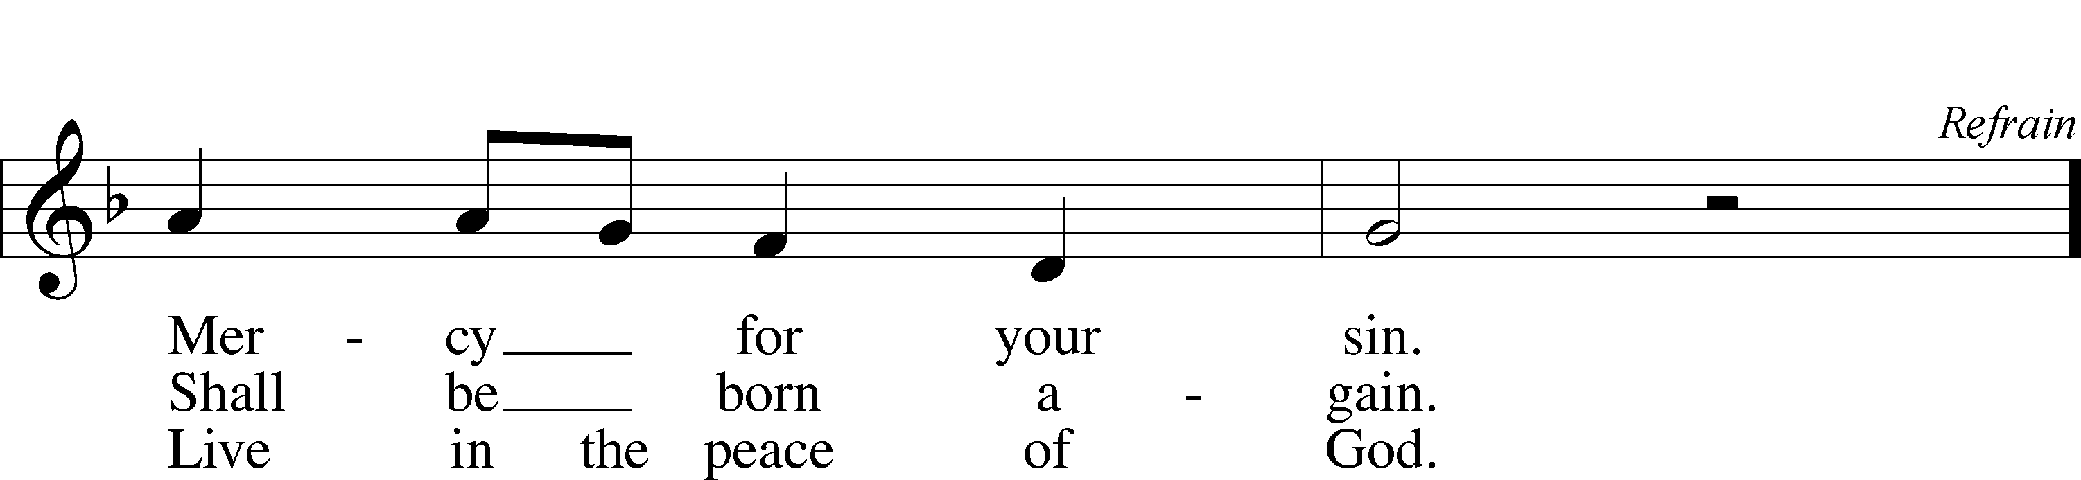
© 1986 Kevin Mayhew Ltd. Used by permission: LSB Hymn License .NET, no. 100011641.

PREPARATION

(Please Remain Standing Or You May Kneel…)
CONFESSION OF SIN:
All: God, I admit I have broken all of your commandments; I am not holy or sinless even though I often pretend a righteousness I do not have. I offer excuses. I have broken relationships by what I have said, or done. I have not loved either You or my neighbor as I ought. (time for personal confession____)

YOU ARE FORGIVEN:
Pastor: God is merciful and gracious; He has given His Son, Jesus Christ to die and rise again for us, the sinful ones that we might be forgiven and enjoy His Peace. This is also a reminder of God’s gifts and blessing that have become ours in Holy Baptism.
Congregation: thank you God for Your blessing!
Pastor: Yes, the Grace of our Lord Jesus Christ, and the Love of God, and the fellowship of His Holy Spirit is with you all.
Congregation: And also with you.
Pastor: In peace and as His forgiven people, we can pray to the Lord:
Congregation: He is gracious to us and hears our prayers.
Pastor: For the peace of the whole world and our involvement in Christ’s Mission in the world, we pray:
Congregation: Keep us mindful of our purpose as Christians and our ability to share your blessings of peace and forgiveness with others.
Pastor: We are the children of the Risen Christ. His victory is Our Victory!

THE PRAYERS OF THE CHURCH:
All: o King of glory, Lord of hosts, uplifted in triumph far above all heavens, leave us not without consolation but send us the spirit of truth whom You promised from the Father; for You live and reign with Him and the Holy Spirit, one God now and forever. Amen.

SERVICE OF THE WORD

God speaks to us through his word, the Bible:

(You may be seated…)
THE OLD TESTAMENT LESSON: Acts 1:12-26
Lector: This is the Word of the Lord.
People: Thanks be to God.

THE EPISTLE LESSON: Revelation 22:1-6, 12-20
Lector: This is the Word of the Lord.
People: Thanks be to God.

(Please stand…)
THE HOLY GOSPEL: John 17:20-26
Pastor: The Holy Gospel according to St. John Chapter 17.
People: Glory to You, O Lord.
Pastor: This is the Gospel of the Lord.
People: Praise to You, O Christ!

(Please be seated…)
NOISE OFFERING

THE SERMON HYMN: “Sweet Hour of Pray”

THE SERMON: “Yal Come” Revelation 22:17

(Please be seated…)
OFFERING: “For the Beauty of the Earth” Vocal Choir and
Youth Handbell Ensemble

LITURGY OF UNITY ACKNOWLEDING THE WIDE CONTINUUM OF MOTHERING:
Pastor: For those who gave birth this year
Congregation: We celebrate and thank God with you
Pastor: For those who lost a child
Congregation: We mourn with you and ask God to grant you His peace
Pastor: For those who are in the trenches with little ones every day and
wear the badge of food stain
Congregation: We appreciate you and pray for patience and joy
Pastor: For those who experienced loss through miscarriage, failed adoptions, or running way
Congregation: We mourn with you and pray for healing
Pastor: For those who walk the hard path of infertility, fraught with pokes, prods, tears, and disappointment
Congregation: We walk with you
Pastor: Forgive us when we say foolish things
Congregation: and we pray that you will find strength in Jesus
Pastor: For those who are foster moms, mentors, spiritual moms
Congregation: We need you and thank God for you
Pastor: For those who have warm and close relationships with your children
Congregation: We praise God for this gift
Pastor: For moms who have disappointment, heartache and distance with their children
Congregation: We pray for peace and healing
Pastor: For those who have lost their mother
Congregation: We grieve with you and look forward to a happy reunion in heaven for all who die with faith in Jesus
Pastor: For those who experienced abuse at the hands of their mother
Congregation: We acknowledge your hurt and pray for healing
Pastor: For those who are single and long to be married and mother your own children
Congregation: We mourn that life has not turned out as you longed for it to be and pray for comfort, peace, and love
Pastor: For those who step-parent
Congregation: We acknowledge the complex path you are on and pray for wisdom and grace
Pastor: For those who envisioned lavishing love on grandchildren and yet the dream is not to be
Congregation: We pray for peace and finding joy in filling that role of grandparent with children who have lost their grandparents or who’s grandparents are far away
Pasto: For any empty nesters
Congregation: We thank God for your past sacrifice of time and celebrate your ongoing gift of prayer and love to your grown children
Pastor: For those who placed children up for adoption
Congregation: We commend you for your selflessness
Pastor: And remember how you hold that child in your heart.
Congregation: Lord bless those children and birth mothers with peace and grace
Pastor: For those who are pregnant with new life, both expected and surprising
Congregation: We thank God for this great gift
Pastor: And commit him and her to the Lord’s keeping
Congregation: Until He claims them as His own through the washing of holy baptism
Pastor: This Mother’s day we walk with you
Congregation: Mothering is not for the faint of heart
Pastor: And we have real warriors in our midst
Congregation: We remember you and thank God for you
Pastor: In Jesus name
Congregation: Amen

SERVICE OF THE SACRAMENT

(Please stand…)
PREPARE FOR THE LORD’S SUPPER:
Pastor: We begin with the reminder: “The Lord is with you.”
Congregation: We are mindful and thankful for His presence.
Pastor: Let your life reflect the joy of your salvation.
Congregation: We do give Him thanks and praise. We will share His blessing with others.
Pastor: It is proper that we should at all times and in all places…(prayer)… we praise your name and join others in singing:

All: (sing) “Holy, holy, holy Lord God of pow’r and might:
Heaven and earth are full of your glory.
Hosanna, Hosanna, Hosanna in the highest.
Blessed is he who comes in the name of the Lord.
Hosanna in the highest.”

(Please be seated…)
THE CONSECRATION AND DISTRIBUTION:

Hymns: “When Peace, like a River” LSB 763
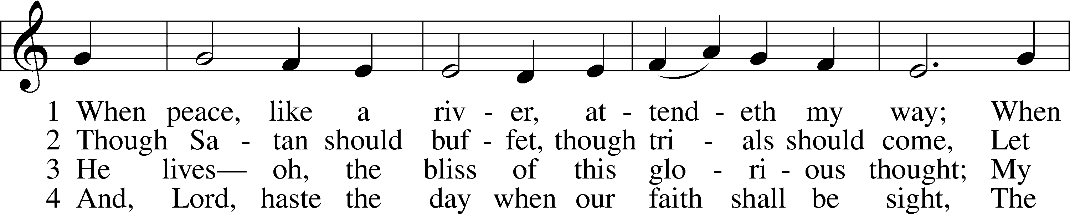
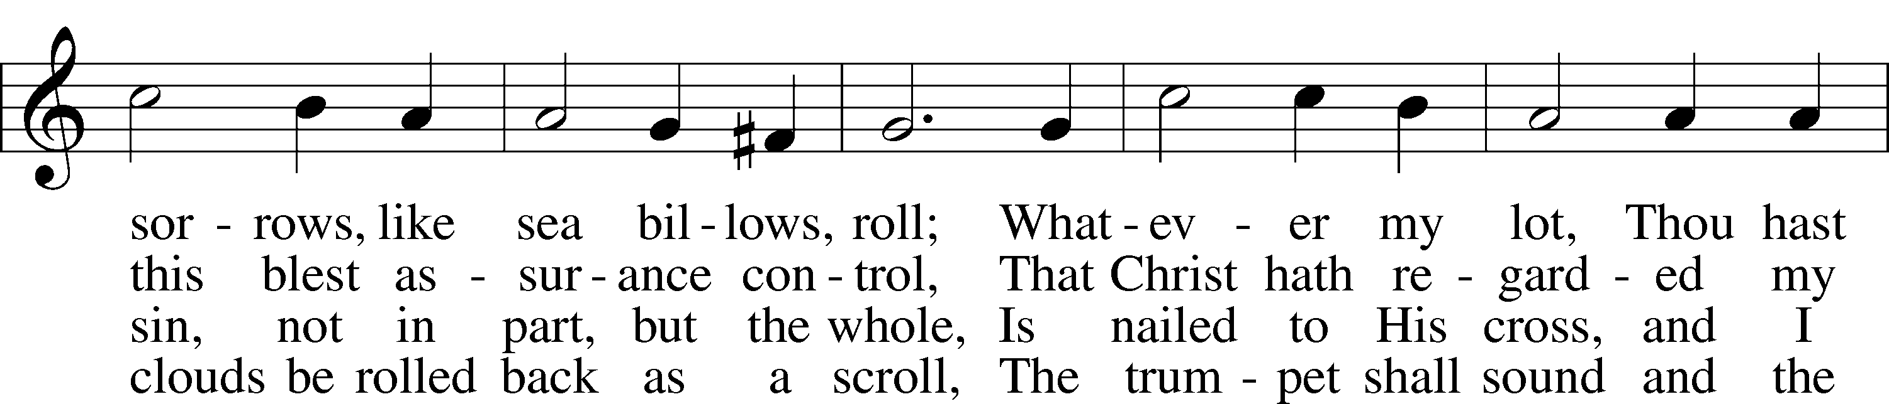
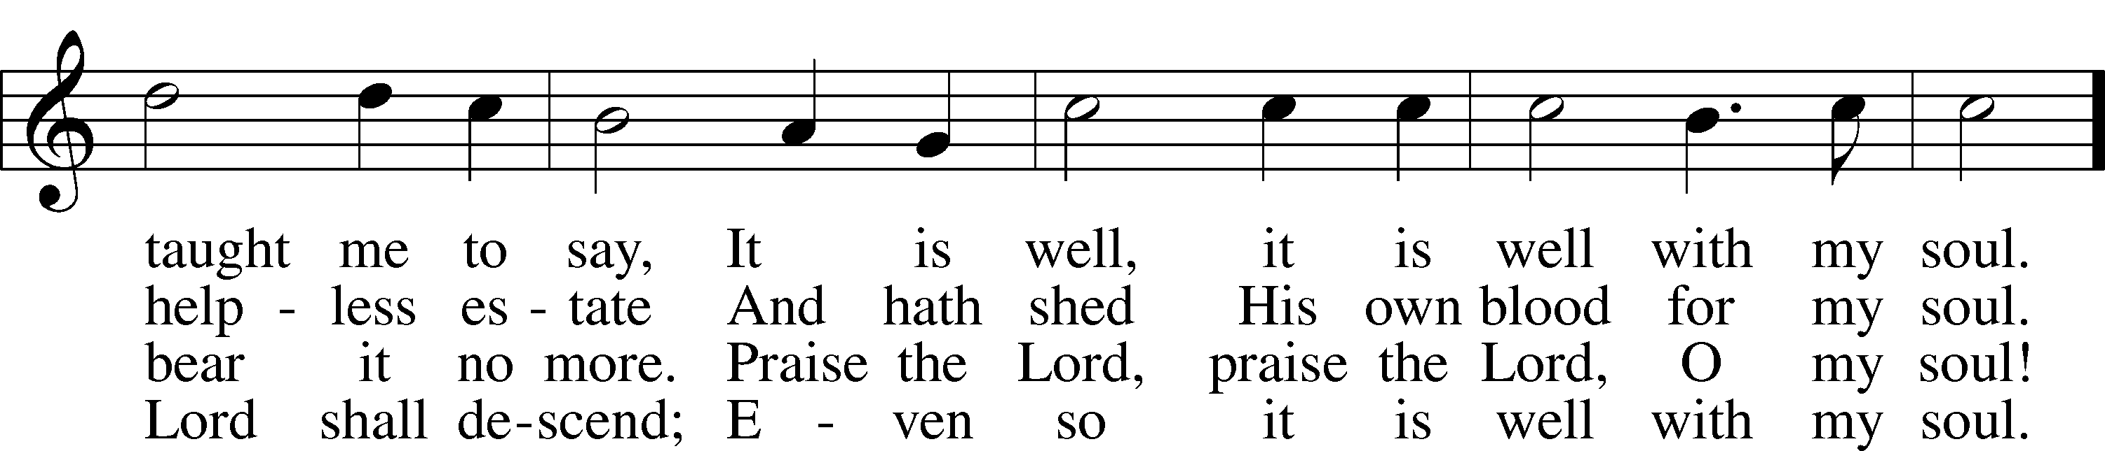
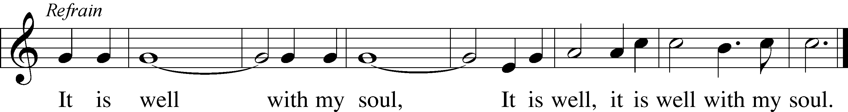
Public domain

“Eat This Bread” LSB 638
*Congregation will only sing the Refrain after the Choir sings the Chorus
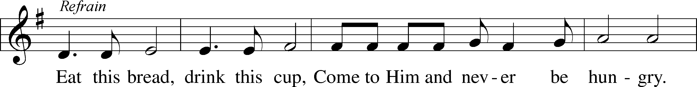
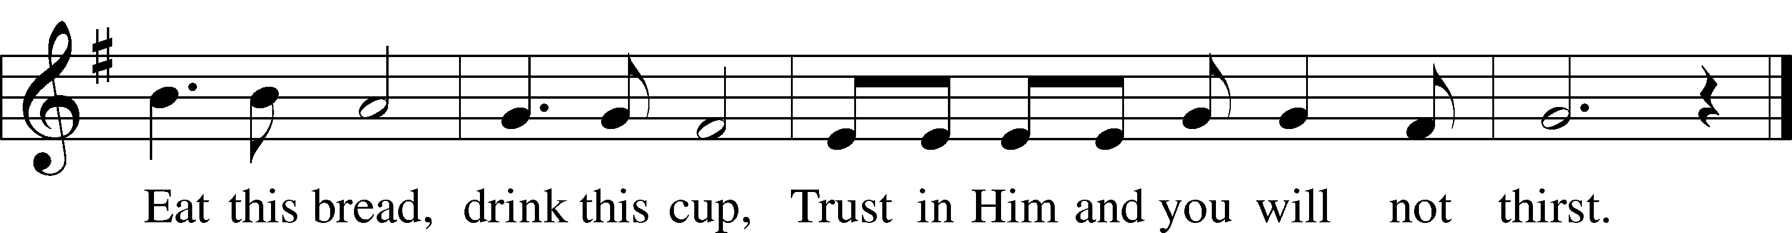
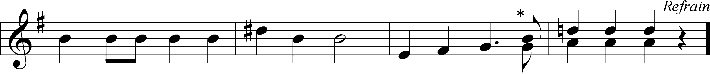
© 1998 Concordia Publishing House. Used by permission: LSB Hymn License .NET, no. 100011641.
© 1984 Ateliers et Presses de Taizé, Taizé Community, France
admin. GIA Publications, Inc. Used by permission: LSB Hymn License .NET, no. 100011641.

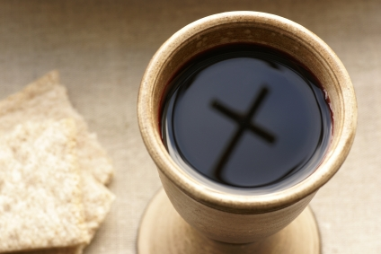

“Christ, the Word of God Incarnate” LSB 540
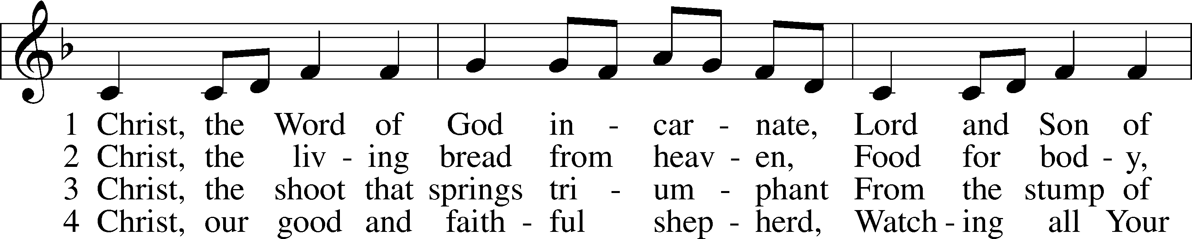
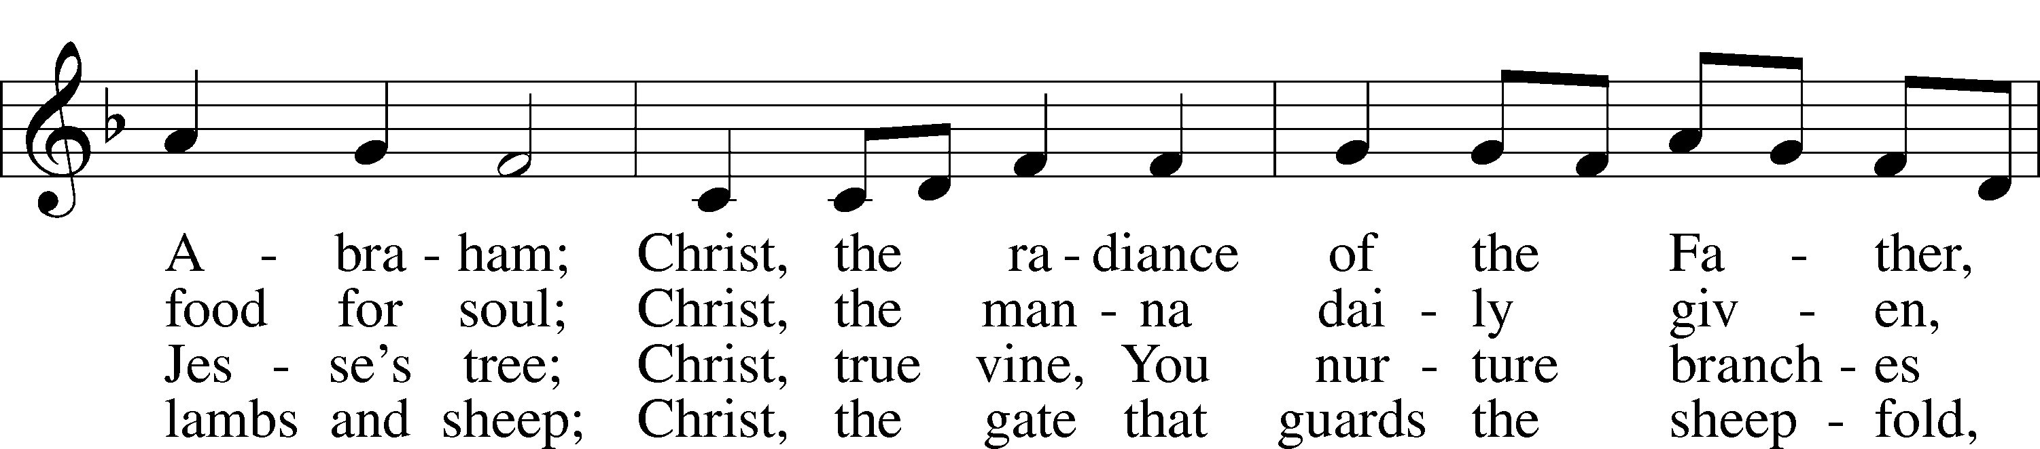
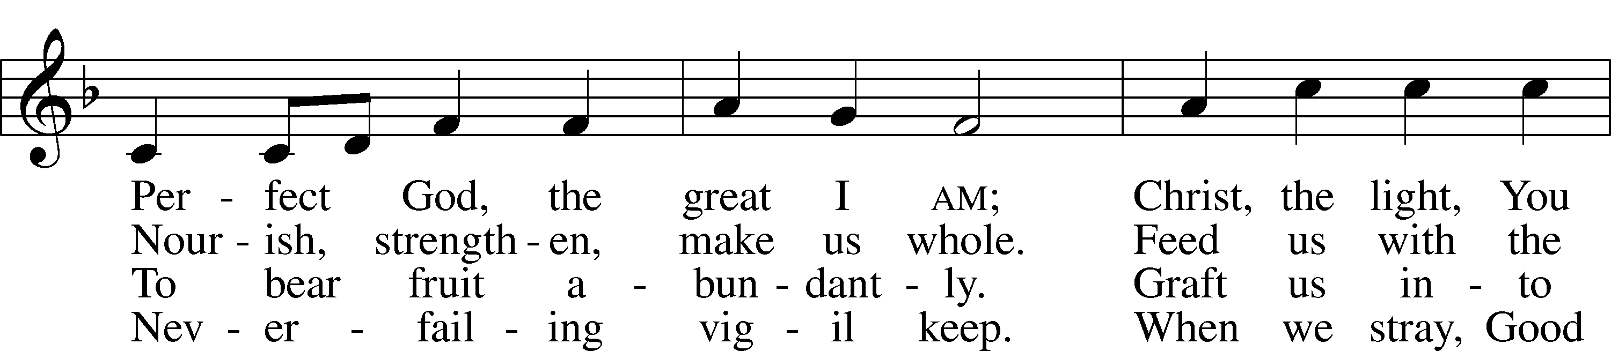
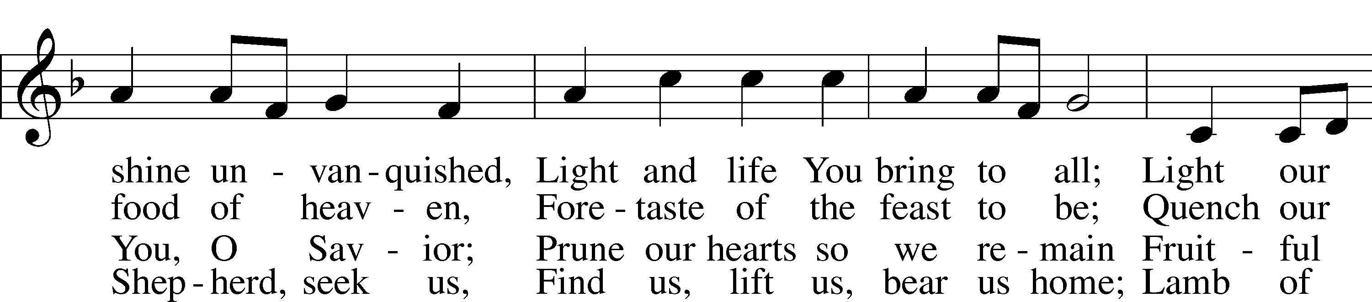
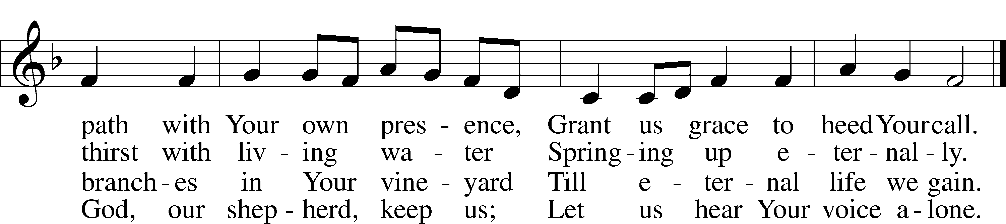

5 Christ, the way that leads unfailing
To the Father’s home on high,
Christ, the truth that frees the captive,
Christ, the life that cannot die.
Mediator to the Father,
Sacrifice and great High Priest:
Lead us to Your heav’nly mansions,
There to share Your wedding feast.
6 Christ, the Alpha and Omega,
Christ, the firstborn from the dead,
Christ, the life and resurrection,
Christ, the Church’s glorious head:
Praise and thanks and adoration
And unending worship be
To the Father and the Spirit
And to You eternally.
© 2001 Steven P. Mueller. Used by permission: LSB Hymn License .NET, no. 100011641.
Public domain

(Please stand…)
THE LORD’S PRAYER:
All: Our Father, who art in heaven, Hallowed be thy name, thy kingdom come, thy will be done, on earth as it is in heaven. Give us this day our daily bread; and forgive us our trespasses, as we forgive those who trespass against us; and lead us not into temptation, but deliver us from evil. For thine is the kingdom, and the power, and the glory, forever and ever. Amen.

THE BLESSING AND BENEDICTION:
Pastor: The Lord Blesses you and keeps you, the Lord makes His face to shine upon you and He is Gracious to you. The Lord looks upon you with His favor and gives you His peace.
Congregation: God blesses us so that we can be a blessing to others.
Pastor: Go in His peace and serve the Lord by serving others.
Congregation: Amen

CLOSING HYMN: “Praise God, from Whom All Blessings Flow” LSB 805
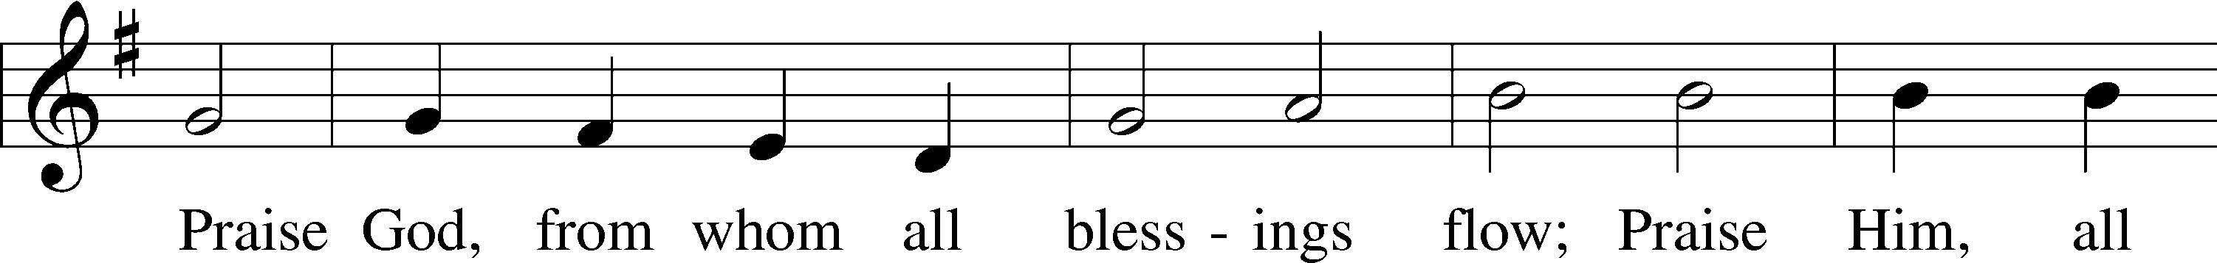
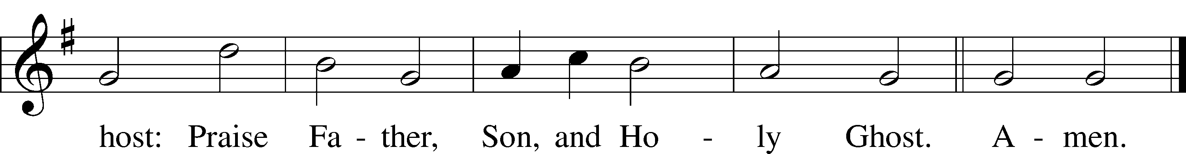
Public domain

ANNOUNCEMENTS

WELCOME TO GRACE LUTHERAN CHURCH: We are glad that you are here to worship God with us today! We pray that you will enjoy the wonderful fellowship as friends in Christ as God gathers us around His means of grace, the Word and Sacraments, to bless us with His treasured gifts of forgiveness, faith, abundant life and eternal salvation. If you are a guest, please also sign our Guest Book. Please talk to Pastor if you would like to learn more about becoming a member of Grace. Also, please join us for refreshments and fellowship after the Service. We invite you to come and worship with us often as God gathers us in His Grace.

WELCOME TO THE LORD’S TABLE: We invite and encourage all present who are baptized and faithful Christians, and who confess the Father, Son, and Holy Spirit to be the only true God and who believe that Jesus Christ died for the sins of the World and is our only hope and salvation…to join us in receiving the very and true body and blood of Christ in this Sacrament. The clear liquid cups in the center of the tray are non-alcoholic wine.

Children not yet confirmed in the faith are always welcome to join their parents at the Lord’s Table, but should keep their hands folded in front of them. The Pastor will give them a blessing.

SERVING TODAY: Acolyte: Ali Harrison; Lector: JoAnn Broadbent; Communion Assistants: David Rose and Steve Bringle; Usher: Ed Morris; Altar Care: Lillian Howard; Refreshments: The Donaldson Family.

SERVING NEXT SUNDAY: Acolyte: Lillian Howard; Lector: Garnet Picking; Communion Assistants: David Rose and Steve Bringle; Usher: Ed Morris; Altar Care: Lillian Howard; Refreshments: The Morris Family.

FLOWERS: were placed on the altar today to the glory of God from the Howard family in celebration of Lillian’s 9th birthday.

THIS WEEK AT A GLANCE:

Today: This Sunday
9:00 am Worship Service with Communion
10:15 am Fellowship/Refreshments
10:30 am Adult Bible Class/Children’s Sunday School

Monday: May 9th
Pastor’s Day Off
5:00 pm Zumba

Tuesday: May 10th
3:00 pm Jan’s Mobile Gym (Parish Hall)
6:00 pm Weight Watcher’s (Parish Hall)

Wednesday: May11th
8:30 am Grace Lutheran School Chapel
4:30 pm Women’s Bible Study
5:45 pm Bell Choir Rehearsal

Saturday: May 14th
11:00 am Vocal Choir Rehearsal

Next Sunday: May 15th
9:00 am Worship Service with Communion
10:15 am Fellowship/Refreshments
10:30 am Adult Bible Class/Children’s Sunday School

IN YOUR PRAYERS THIS WEEK: Phil Zielinski, Cressie Brown, the family and friends of Mary Bacle, the victims of the Lahore Pakistan attack, the family and friends of Carol Shimp, Esther Faith, Jameson Parker, the family and friends of Hwana, Liz and Ryan Grady, Loretta Cates, Larry, Dan, Gabriel, Andrew, Julia Pateman, David Lopez, Annie Garner, Nancy Amling, Alicia Llama, Erich & Erika Hoffmann, Katharina Lutz Brian Kay, Robert and Regina Hoffmann, jean 7 Walter Hulme, Carole Steinle, Joanne Cates, Jane Howard, Jean Grafsgaurd, Denis Julson, Mary Kay, Sandy Harris, Gary Winters, and those you are praying for at home. If anyone has a special prayer request please submit it in writing in the collection plate; or you may call Pastor Gary Faith at (504-858-8872), or Kris Howard at (305-296-5161).

GIFTS, TITHES, & ATTENDANCE LAST SUNDAY was $3715.00, building fund received $370. The noise offering for April 24th was $85.49 and for last Sunday, May 1st $52.67. Our 9am service had an attendance of 90.

TO HELP US GROW… The Bible readings for next Sunday’s service readings are Genesis 11:1-9, Acts 2:1-21, John 14:23-31.

THANKS TO ALL FOR the birthday gifts, cards, and goodies that were given to me last Sunday. I am blessed to be a part of the Grace family.

PATTIE AND PASTOR WILL BE ON VACATION from May 9th through May 16th. If you have needs please contact one of our Elders; Dave Walker, Steve Bringle, Max Broadbent, or Mike Sattelmeier.

ONE OF OUR SCHOOL FAMILIES has 3 children who have been blessed with success in Taekwondo. The success calls for trips out of state. The family is looking for sponsors to help defray the cost. If you are interested, see Pastor.

MISSIONAL COMMUNITIES – CHANGE IN SCHEDULE: In an effort to increase participation Missional Communities will meet twice monthly on the 2nd and 4th Thursday’s. The 5 Questions we discuss are designed to help us grow in our relationship with Jesus and in our ability to see the opportunities God places in our path. Questions; ask one of those who participates.

THE GRACIOUS LADIES OF GRACE: Ten of the Ladies dined on the ocean at Spencer’s at the Reach for a 5* feast. Really ladies you should have been there for the yummy desserts pro bono by the good looking chef, Zingg who Elaine just happens to know. The perfect turquoise waters and balmy breezes topped everything off with a Key West flair. We are gathering again on May 17th at the Key West Harbor Restaurant located on Stock Island, at the end of Maloney Ave. take a left. We will meet at 11:30 am. See you there.

STAINED GLASS WINDOWS: Thanks be to God, all four of the remaining stained glass windows on right side of altar have been donated. The three windows on the left side will be installed in March. We only have 9 clear glass impact windows in the bathrooms and front entry, and the two side entry doors that need to be replaced. When those are completed, the entire church will be protected with hurricane proof, impact windows. The cost of the windows is roughly $2000.00 each depending on size. We are waiting on the estimates of the windows and doors as they have just been measured. Thank you donors of the stained glass windows and to all those who have contributed to the building fund for this project. Your generous giving is much appreciated. Pickel Studios is known throughout America and Europe for the quality of their stained glass work, and the new windows are spectacular works of art that glorify our Savior.

THE GRACE LUTHERAN CHURCH WEB PAGE AND FACE BOOK PAGE now contains a vocal recording of last week’s sermon. So if you are not able to attend church on Sunday please go to our website where you will find a copy of the bulletin and a recording of Pastor Faith’s sermon. The new webpage address is gracelutherankw.360unite.

A NUMBER OF CAPITAL IMPROVEMENTS are needed to keep our facilities in good health for the future. The narthex has been rebuilt. Roof repairs are needed on school buildings. If you can help it would be much appreciated! A big thanks to all who have contributed to these repairs.

MUSIC MINISTRY:
Thank you to all of you who have participated in our music ministry this past year. We thank God for the gift of music and for the time and talents of our singers, ringers, and instrumentalists. Weekly choir rehearsals will resume in the Fall.

Bell Choir: Our last rehearsal will be this Wednesday from 5:45 - 6:30 pm.

Vocal Choir: Our last rehearsal will be this Saturday from 11:00 - 11:45 am.

WOMEN’S BIBLE STUDY: Bible stories: what are their value and meaning for us today? God loves to tell a good story, you might call Him "the Great Storyteller". By examining these stories, we will be asking: how does He show us how much He loves us, how powerful He is, how He will save us, how an ordinary person can do powerful things, how obedience and trust are the key to a blessed life, how God is giving gifts to His children, and how He longs to give us peace and hope, the best gifts of all.
We will be studying 4 stories of God's deliverance of His children from perilous circumstances. God is almighty and it is not impossible or unthinkable for Him to rescue you from whatever seems to be insurmountable in your life. The power of deliverance from troubles no matter how looming or momentary they are, is available to you. You just have to ask.

God is our refuge and strength,
an ever-present help in trouble.
Therefore we will not fear, though the earth give way,
and the mountains fall into the heart of the sea,
though its waters roar and foam
and the mountains quake with their surging. Psalm 46:1-3

Please join us through the month of May on Wednesday's at 4:30 in room 3.

MEN’S BIBLE FELLOWSHIP: They meet the first and third Wednesday’s of each month at 12:30pm at Chico’s Restaurant. Their next meeting will be May 18th. All guys are welcome.

Jesus let the things that break your heart also break our hearts.

Amen

