THIRD SUNDAY OF EASTER
APRIL 10TH, 2016 9:00 a.m.
WORSHIP SERVICE
In the Name of Jesus!
Our Mission Statement:
Anchored in Christ, each person a missionary.

PRELUDE

ANNOUNCEMENTS:
God is with us all during the week, wherever we are and in whatever we are doing. This week, let’s enjoy His presence.

OPENING HYMN: “Holy, Holy, Holy” LSB 507
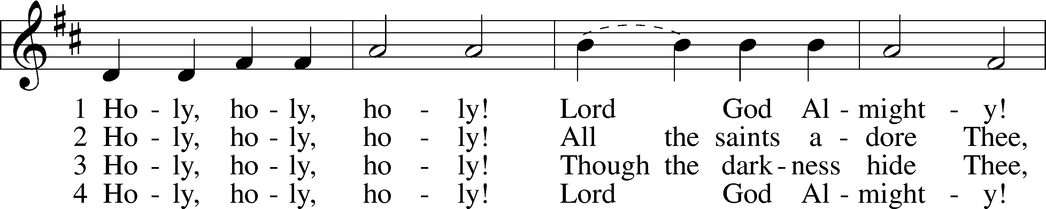
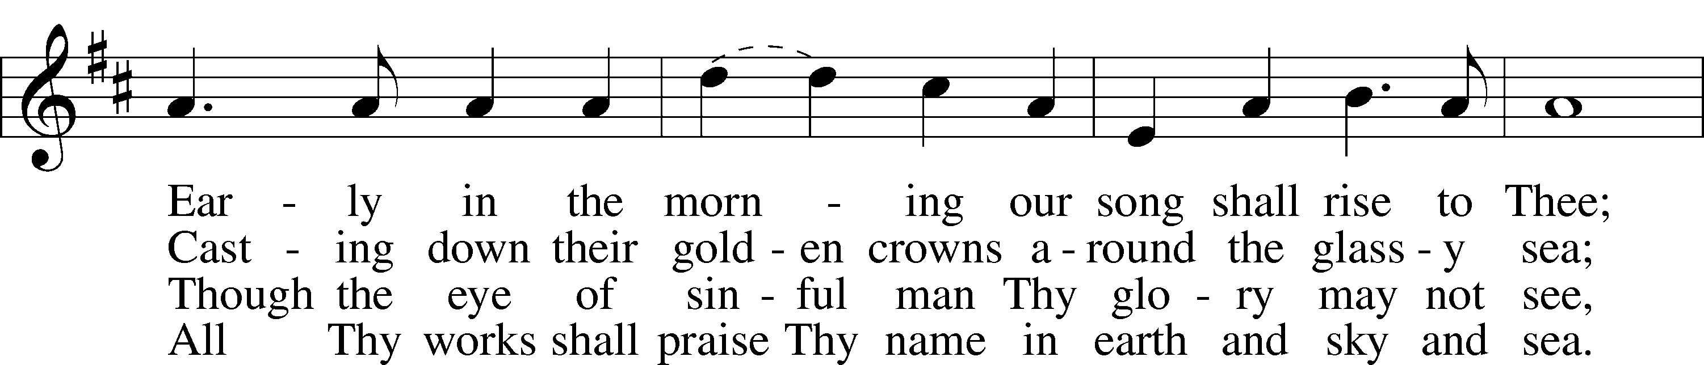
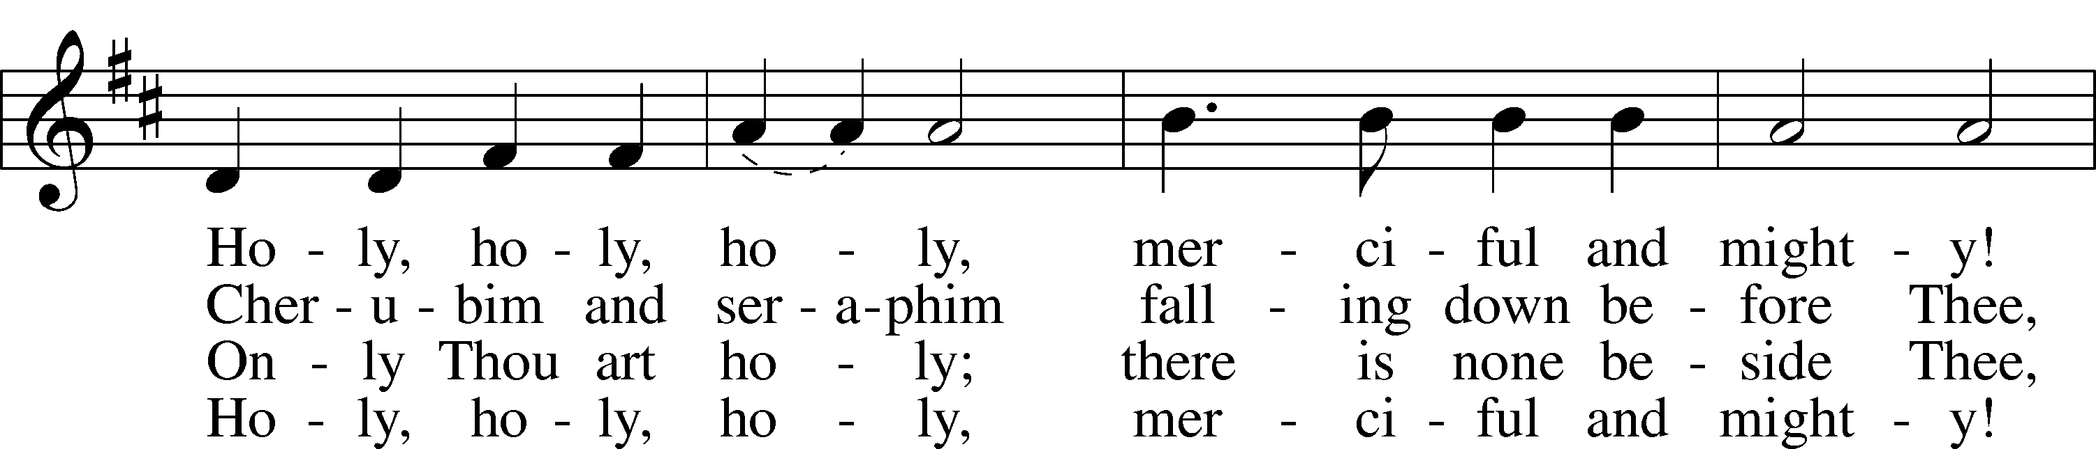
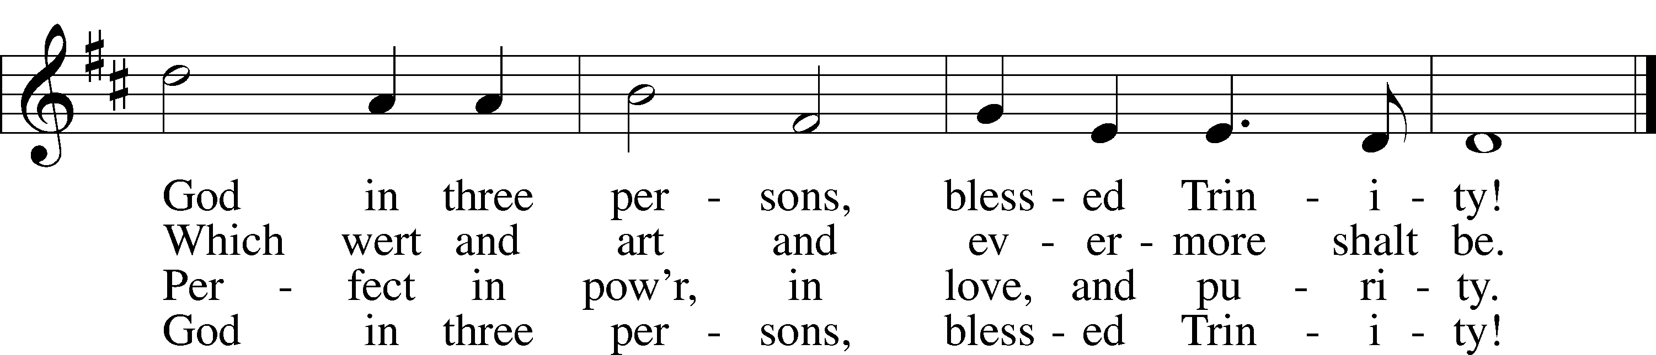

Public domain

Pastor: In the Name of the Father and of the Son and of the Holy Spirit.
Congregation: Amen

PREPARATION

(Please Remain Standing Or You May Kneel…)
CONFESSION OF SIN:
All: God, I admit I have broken all of your commandments; I am not holy or sinless even though I often pretend a righteousness I do not have. I offer excuses. I have broken relationships by what I have said, or done. I have not loved either You or my neighbor as I ought. (time for personal confession____)

YOU ARE FORGIVEN:
Pastor: God is merciful and gracious; He has given His Son, Jesus Christ to die and rise again for us, the sinful ones that we might be forgiven and enjoy His Peace. This is also a reminder of God’s gifts and blessing that have become ours in Holy Baptism.
Congregation: thank you God for Your blessing!
Pastor: Yes, the Grace of our Lord Jesus Christ, and the Love of God, and the fellowship of His Holy Spirit is with you all.
Congregation: And also with you.
Pastor: In peace and as His forgiven people, we can pray to the Lord:
Congregation: He is gracious to us and hears our prayers.
Pastor: For the peace of the whole world and our involvement in Christ’s Mission in the world, we pray:
Congregation: Keep us mindful of our purpose as Christians and our ability to share your blessings of peace and forgiveness with others.
Pastor: We are the children of the Risen Christ. His victory is Our Victory!

THE PRAYERS OF THE CHURCH:
All: O God, through the humiliation of Your Son You raised up the fallen world. Grant to Your faithful people, rescued from the peril of everlasting death, perpetual gladness and eternal joys; through Jesus Christ, our Lord, who lives and reigns with You and the Holy Spirit, one God, now and forever. Amen.

SERVICE OF THE WORD

God speaks to us through his word, the Bible:

(You may be seated…)
THE OLD TESTAMENT LESSON: Acts 9:1-22
Lector: This is the Word of the Lord.
People: Thanks be to God.

THE EPISTLE LESSON: Revelation 5:8-14
Lector: This is the Word of the Lord.
People: Thanks be to God.

(Please stand…)
THE HOLY GOSPEL: John 21:1-14
Pastor: The Holy Gospel according to St. John Chapter 21st.
People: Glory to You, O Lord.
Pastor: This is the Gospel of the Lord.
People: Praise to You, O Christ!

(Please be seated…)
CHILDREN’S MESSAGE

NOISE OFFERING

THE SERMON HYMN: “I Love to Tell the Story”

THE SERMON: “Are You Sure Lord?” Acts 9:1-22

(Please stand…)
THE PROFESSION OF FAITH:
Pastor: God has given us a great message to take to His world. Let us remind ourselves and one another of what that message is:
Pastor: I believe in God the Father, Almighty
Congregation: Maker of heaven and earth
Pastor: And in His Son, Jesus Christ our Lord,
Congregation: Who was conceived by the Holy Spirit
Pastor: Born of the Virgin Mary
Congregation: Suffered under Pontius Pilate
Pastor: Was crucified, died and was buried
Congregation: He descended into hell.
Pastor: On the third day He rose again from the dead,
Congregation: And ascended into heaven
Pastor: And sits on the right hand of God, the Father almighty
Congregation: From there He will come to judge the living and the dead
Pastor: I believe in the Holy Spirit,
Congregation: The Holy Christian Church as
All: the communion of saints; the forgiveness of sins, the resurrection of the body, and the life everlasting. Amen.

(Please be seated…)
OFFERING

SERVICE OF THE SACRAMENT

(Please stand…)
PREPARE FOR THE LORD’S SUPPER:
Pastor: We begin with the reminder: “The Lord is with you.”
Congregation: We are mindful and thankful for His presence.
Pastor: Let your life reflect the joy of your salvation.
Congregation: We do give Him thanks and praise. We will share His blessing with others.
Pastor: It is proper that we should at all times and in all places…(prayer)… we praise your name and join others in singing:

All: (sing) “Holy, holy, holy Lord God of pow’r and might:
Heaven and earth are full of your glory.
Hosanna, Hosanna, Hosanna in the highest.
Blessed is he who comes in the name of the Lord.
Hosanna in the highest.”

(Please be seated…)
THE CONSECRATION AND DISTRIBUTION:

Hymns: “You Satisfy the Hungry Heart” LSB 641
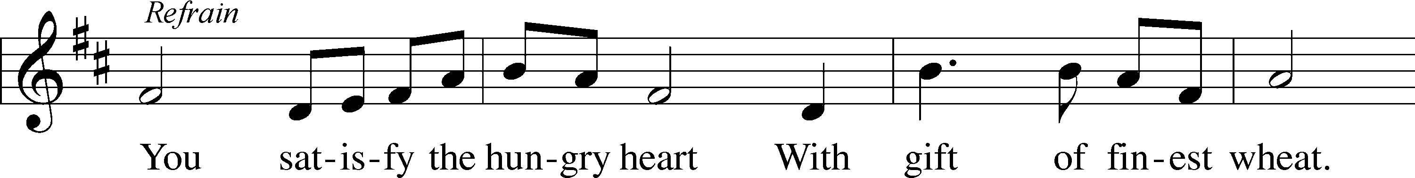
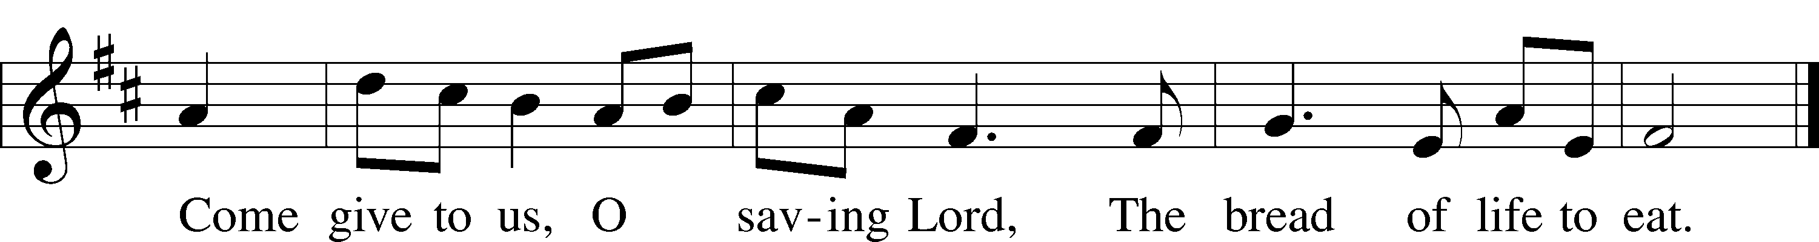
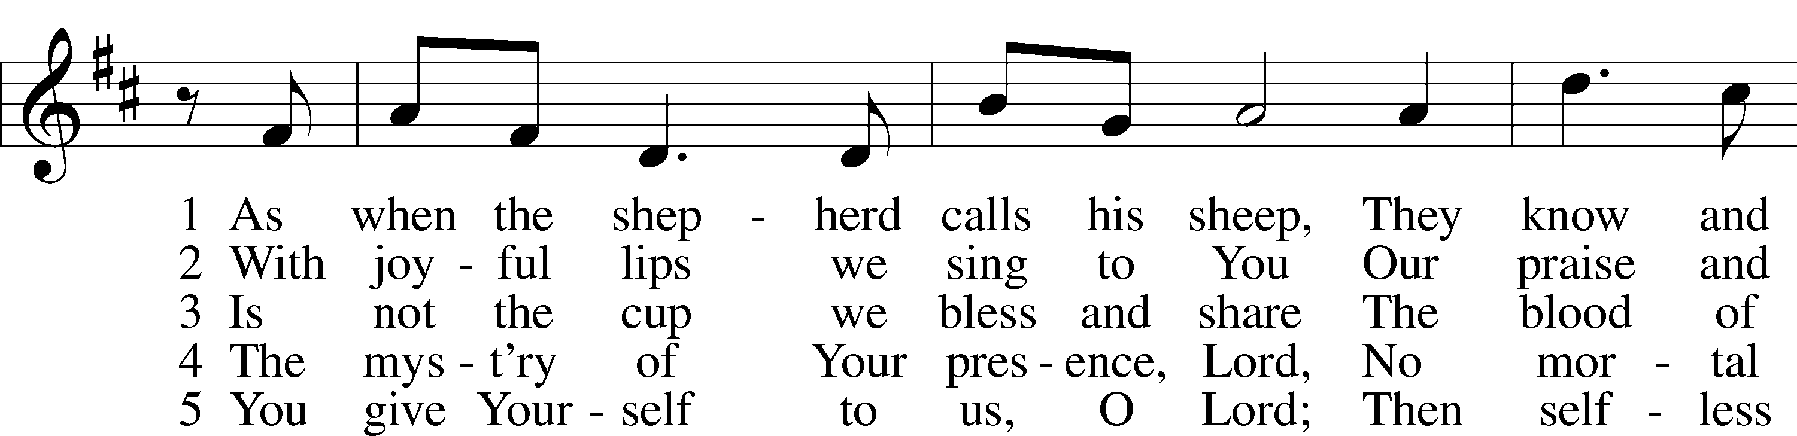
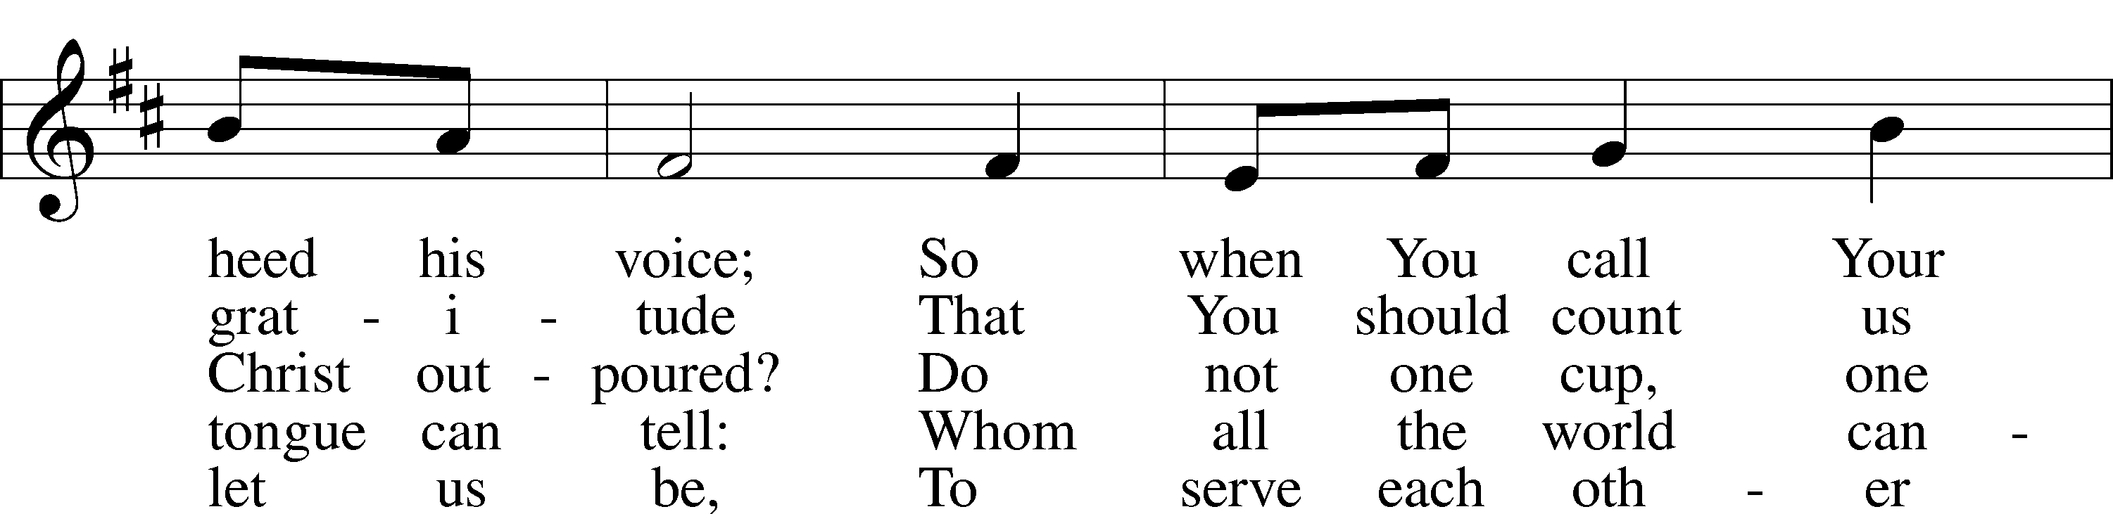
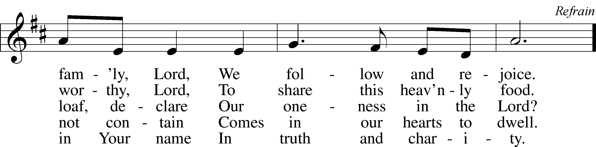
© 1977 Archdiocese of Philadelphia. Used by permission: LSB Hymn License .NET, no. 100011641.

“ Precious Lord, Take My Hand” LSB 739
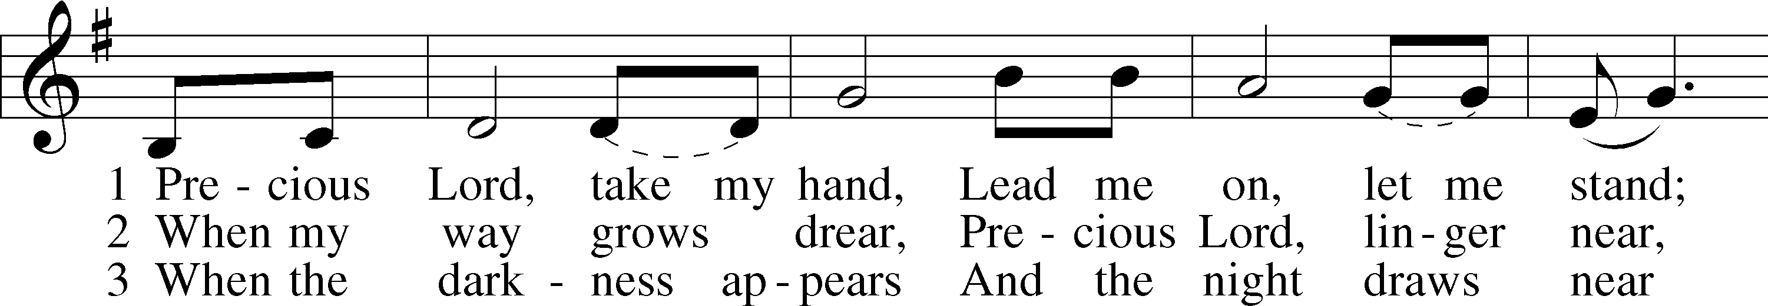
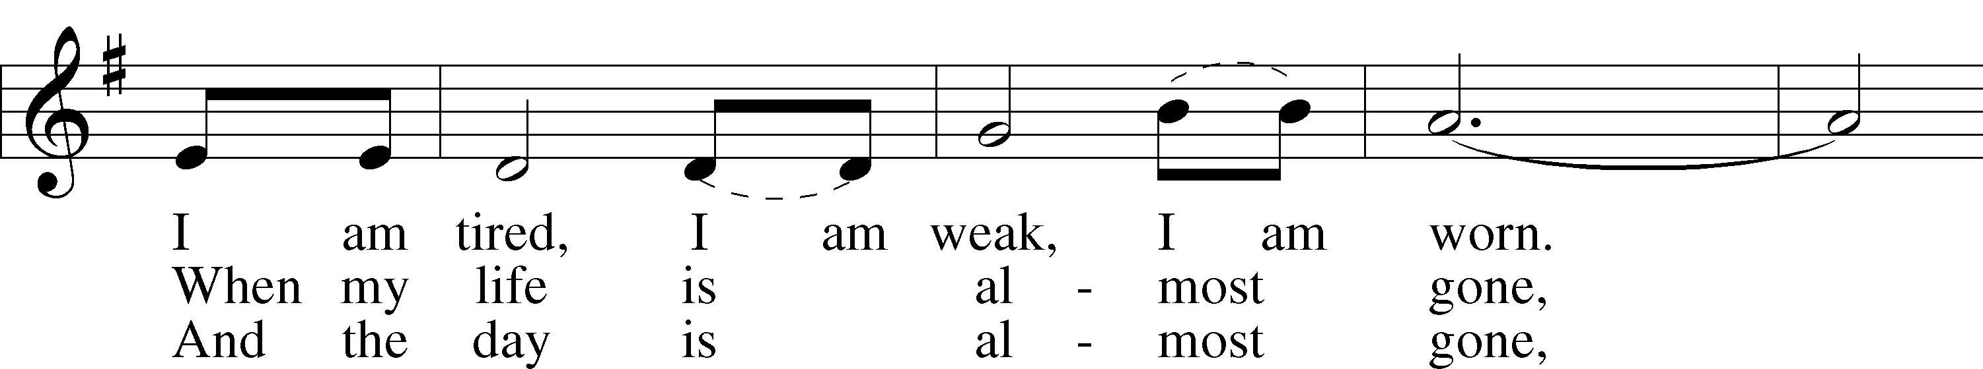
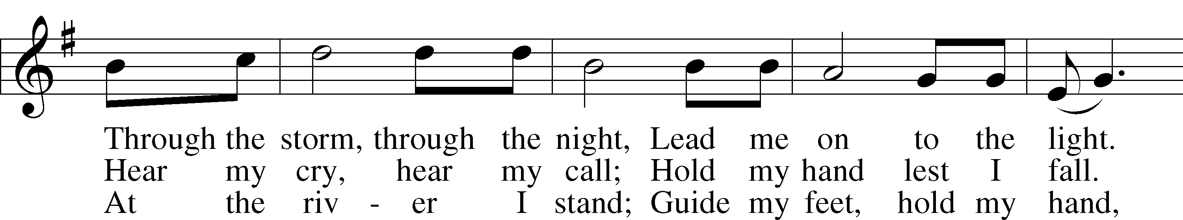
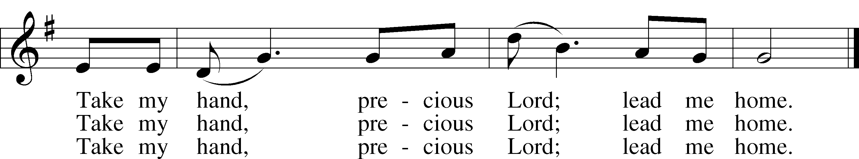
© 1938 Unichappell Music; admin. Alfred Publishing Co., Inc. Used by permission: LSB Hymn License .NET, no. 100011641.

“Crown Him with Many Crowns” LSB 525
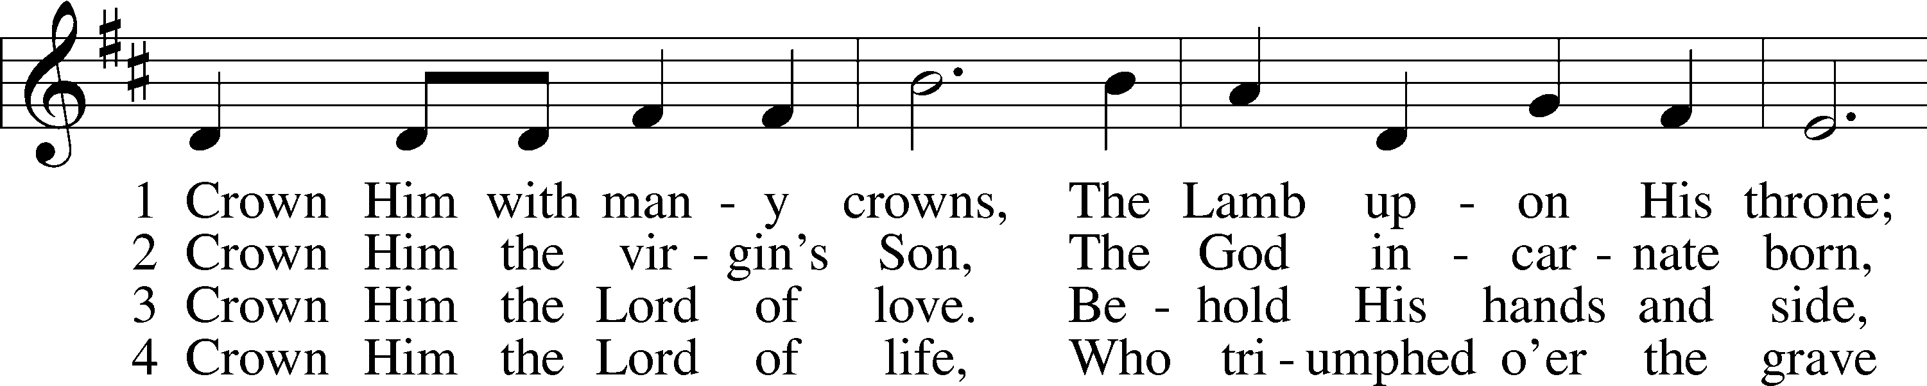
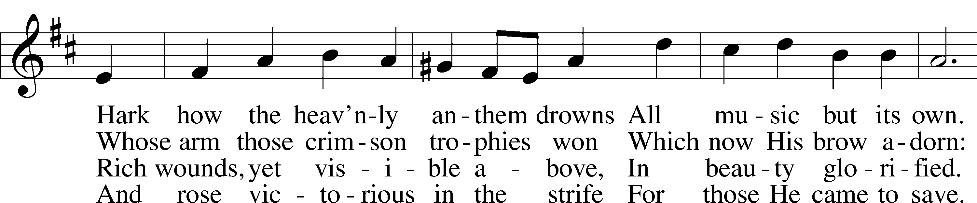
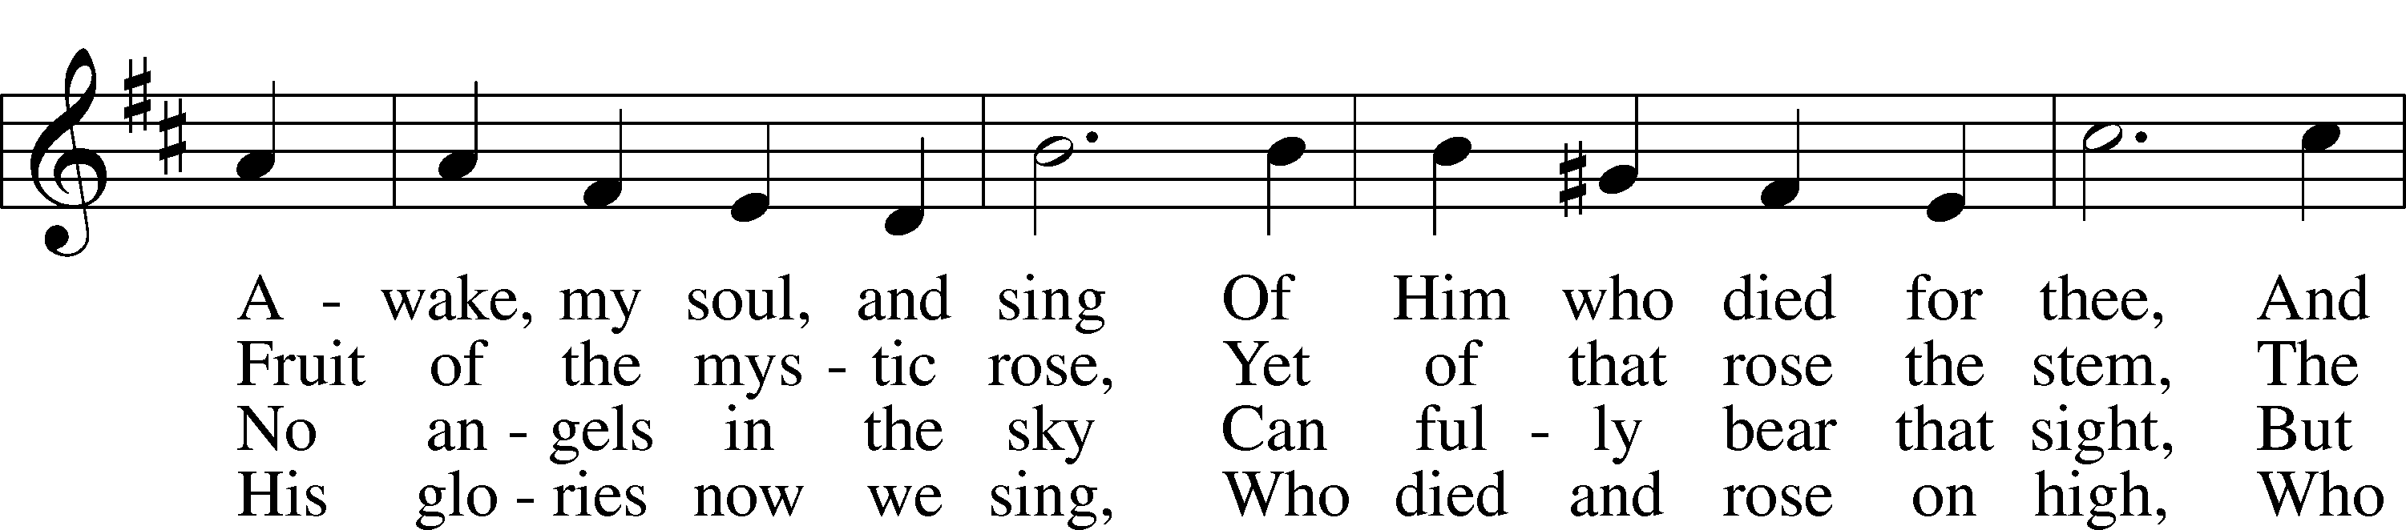
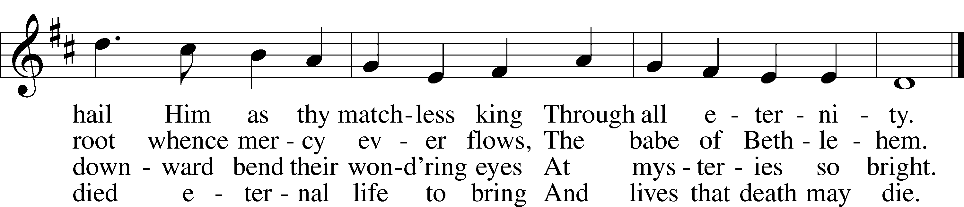

5 Crown Him the Lord of heav’n,
Enthroned in worlds above,
Crown Him the king to whom is giv’n
The wondrous name of Love.
Crown Him with many crowns
As thrones before Him fall;
Crown Him, ye kings, with many crowns,
For He is king of all.
Public domain

(Please stand…)
THE LORD’S PRAYER:
All: Our Father, who art in heaven, Hallowed be thy name, thy kingdom come, thy will be done, on earth as it is in heaven. Give us this day our daily bread; and forgive us our trespasses, as we forgive those who trespass against us; and lead us not into temptation, but deliver us from evil. For thine is the kingdom, and the power, and the glory, forever and ever. Amen.

THE BLESSING AND BENEDICTION:
Pastor: The Lord Blesses you and keeps you, the Lord makes His face to shine upon you and He is Gracious to you. The Lord looks upon you with His favor and gives you His peace.
Congregation: God blesses us so that we can be a blessing to others.
Pastor: Go in His peace and serve the Lord by serving others.
Congregation: Amen

THE CLOSING HYMN: “Onward, Christian Soldiers” LSB 662
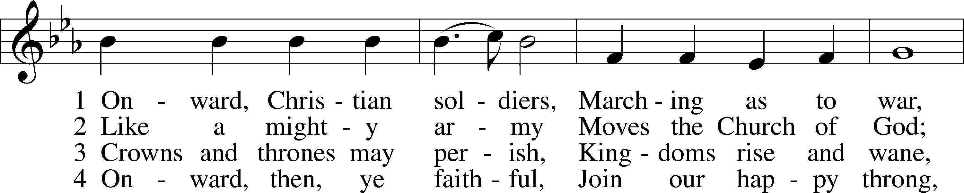
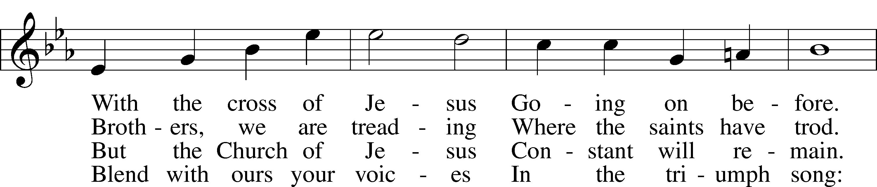
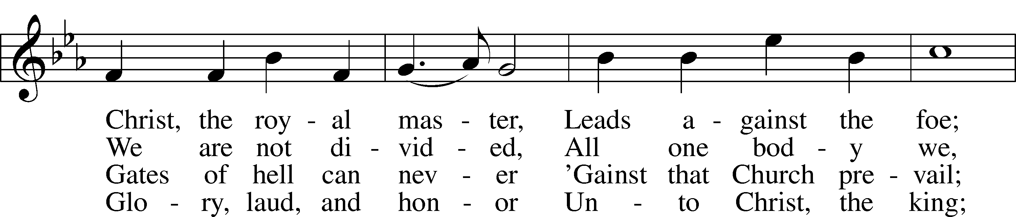
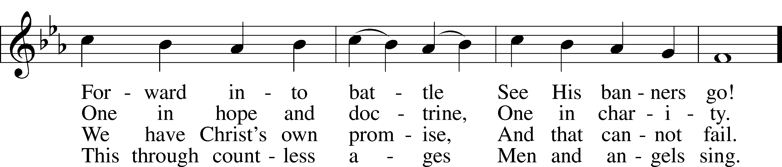
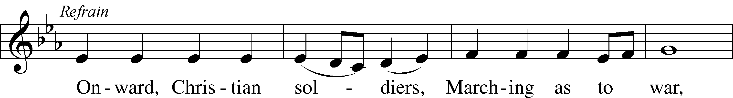
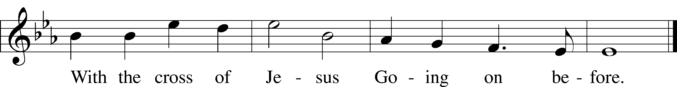
Public domain
ANNOUNCEMENTS

WELCOME TO GRACE LUTHERAN CHURCH: We are glad that you are here to worship God with us today! We pray that you will enjoy the wonderful fellowship as friends in Christ as God gathers us around His means of grace, the Word and Sacraments, to bless us with His treasured gifts of forgiveness, faith, abundant life and eternal salvation. If you are a guest, please also sign our Guest Book. Please talk to Pastor if you would like to learn more about becoming a member of Grace. Also, please join us for refreshments and fellowship after the Service. We invite you to come and worship with us often as God gathers us in His Grace.

WELCOME TO THE LORD’S TABLE: We invite and encourage all present who are baptized and faithful Christians, and who confess the Father, Son, and Holy Spirit to be the only true God and who believe that Jesus Christ died for the sins of the World and is our only hope and salvation…to join us in receiving the very and true body and blood of Christ in this Sacrament. The clear liquid cups in the center of the tray are non-alcoholic wine.

Children not yet confirmed in the faith are always welcome to join their parents at the Lord’s Table, but should keep their hands folded in front of them. The Pastor will give them a blessing.

SERVING TODAY: Acolyte: Elizabeth Reynolds; Lector: Kris Bly; Communion Assistants: David Walker and Mike Sattelmeier; Usher: David Rose; Altar Care: Kathy Greenwood; Refreshments: Elaine Roberts, Don Bly, and Kathy Greenwood.

SERVING NEXT SUNDAY: Acolyte: James Reynolds; Lector: Jessy Archer; Communion Assistants: David Walker and Mike Sattelmeier; Usher: David Rose; Altar Care: Garnet Picking; Refreshments: Jim and Garnet Picking.

FLOWERS: were placed on the altar today to the glory of God and by the Bly Family to celebrate Don’s Birthday.

THIS WEEK AT A GLANCE:

Today: This Sunday
9:00 am Worship Service with Communion
10:15 am Fellowship/Refreshments
10:30 am Adult Bible Class/Children’s Sunday School

Monday: April 11th
Pastor’s Day Off
5:00 pm Zumba

Tuesday: April 12th
11:30 am Gracious Ladies of Grace Luncheon (The Waterfront Brewery)
3:00 pm Jan’s Mobile Gym (Parish Hall)
6:00 pm Weight Watcher’s (Parish Hall)

Wednesday: April 13th
8:30 am Grace Lutheran School Chapel

Thursday: April 14th
7:00 pm Missional Communities (Pastor’s Home)

Next Sunday: April 17th
9:00 am Worship Service with Communion
10:10 am Children’s Chime/Vocal Choir Rehearsal
10:15 am Fellowship/Refreshments
10:30 am Adult Bible Class/Children’s Sunday School

IN YOUR PRAYERS THIS WEEK: the family and friends of Mary Bacle, the victims of the
Lahore Pakistan attack, the family and friends of Carol Shimp, Esther Faith, Jameson Parker, the
family and friends of Hwana, Liz and Ryan Grady,Loretta Cates, Larry, Dan, Gabriel, Andrew,
Julia Pateman, David Lopez, Annie Garner, Nancy Amling, Alicia Llama, Erich & Erika
Hoffmann, Katharina Lutz, Brian Kay, Robert & ReginaHoffmann, Jean & Walter Hulme, Carole
Steinle, Liz, Ryan Grady, Joanne Cates, Katharina Lutz, Jane Howard, Jean Grafsgaurd, Denis
Julson, Mary Kay, Sandy Harris, Gary Winters, and those you are praying for at home. If anyone
has a special prayer request please submit it in writing in the collection plate; or you may call
Pastor Gary Faith at (504-858-8872), or Kris Howard at (305-296-5161).

GIFTS, TITHES, & ATTENDANCE LAST SUNDAY was $3647.00, building fund received $70.00. The noise offering for the last Sunday totaled $_________. Our 9am service had an attendance of 68.

TO HELP US GROW… The Bible readings for next Sunday’s service readings are Acts 20:17-35, Revelation 7:9-17, John 10:22-30.

WE WILL BE OFFERING AN ADULT INFORMATION CLASS that will meet on Sunday April 17th and April 24th from noon until 2 at the latest. This is designed for those who might be interested in becoming members and it is also a good review of what we teach for our members. If you are interested or have questions, contact Pastor at 504-858-8872.

MISSIONAL COMMUNITIES – CHANGE IN SCHEDULE: In an effort to increase participation Missional Communities will meet twice monthly on the 2nd and 4th Thursday’s. The 5 Questions we discuss are designed to help us grow in our relationship with Jesus and in our ability to see the opportunities God places in our path. Questions; ask one of those who participates.

THE GRACIOUS LADIES OF GRACE lunched at Camille's on March 29. We gave it a 4 and 1/3* rating. The food was alright but the service less than stellar. Don't you just love an argumentative waiter? The ambience is "bleh" or is that "meh"? Yes, we are spoiled after that wonderful luncheon at Casa Marina and should probably always dine by our sparkling sea. Please join us Tuesday, April 12 at 11:30 when we once again gather together by the water at The Waterfront Brewery on William St. by the Key West Bight.

STAINED GLASS WINDOWS: Thanks be to God, all four of the remaining stained glass windows on right side of altar have been donated. The three windows on the left side will be installed in March. We only have 9 clear glass impact windows in the bathrooms and front entry, and the two side entry doors that need to be replaced. When those are completed, the entire church will be protected with hurricane proof, impact windows. The cost of the windows is roughly $2000.00 each depending on size. We are waiting on the estimates of the windows and doors as they have just been measured. Thank you donors of the stained glass windows and to all those who have contributed to the building fund for this project. Your generous giving is much appreciated. Pickel Studios is known throughout America and Europe for the quality of their stained glass work, and the new windows are spectacular works of art that glorify our Savior.

GRACE LUTHERAN SCHOOL IS IN NEED: They are in need of Part Time Teacher Assistants/Substitutes. If you are interested or just have questions, please call the school at 305-296-8262.

They are also looking for volunteers to work 3+ hours per week. Duties include reading to children, helping the classroom teacher with arts and crafts, and developing relationships with students.
Shift 1 Shift 2
Monday, Tuesday, Wednesday, Thursday, and/or Friday 8:00-11 10-2

We are flexible if you need to adjust your hours to something other than what is listed. Please contact Kris Howard or Nicole, the school secretary, at 305-296-8262 with your availability if interested.

THE GRACE LUTHERAN CHURCH WEB PAGE AND FACE BOOK PAGE now contains a vocal recording of last week’s sermon. So if you are not able to attend church on Sunday please go to our website where you will find a copy of the bulletin and a recording of Pastor Faith’s sermon. The new webpage address is gracelutherankw.360unite.

A NUMBER OF CAPITAL IMPROVEMENTS are needed to keep our facilities in good health for the future. The narthex has been rebuilt. Roof repairs are needed on school buildings.
If you can help it would be much appreciated! A big thanks to all who have contributed to these repairs.

MUSIC MINISTRY:
"Make a joyful noise to the Lord, all the earth!" Psalm 100:1. Whether you are here year-round or only part-time, we invite you to participate in our music ministry. Please speak with Beverly Walker or contact her at beverlywalker@gmail.com if you have any questions.

Bell Choir: The next rehearsal will be Wednesday, May 4 from 5:45 - 6:30 pm.

Children's Choir: No practice today. We will meet next Sunday from 10:10 - 10:25.

Vocal Choir: Rehearses this Saturday from 11:00 - 12 noon.

WOMEN’S BIBLE STUDY: We finished our 8 week study by Sarah Young on Wednesday which enlightened and gave insight into Jesus's ever present "Presence" protecting, guiding and loving us. We will be taking a break until April 20th with the study TBA. Have a Happy and blessed Easter.

The MEN’S BIBLE FELLOWSHIP: They meet the first and third Wednesday’s of each month at 12:30pm at Chico’s Restaurant. Their next meeting will be April 20th. All guys are welcome

Jesus let the things that break your heart also break our hearts.

Amen

