SECOND SUNDAY OF EASTER
APRIL 3RD, 2016, 9:00 a.m.
WORSHIP SERVICE
In the Name of Jesus!
Our Mission Statement:
Anchored in Christ, each person a missionary.

ORGAN PRELUDE: (A time for Meditation and Preparation)

WELCOME

ANNOUNCEMENTS
PREPARATION
(Please stand…)
OPENING HYMN: “Alleluia! Jesus Is Risen” LSB 474
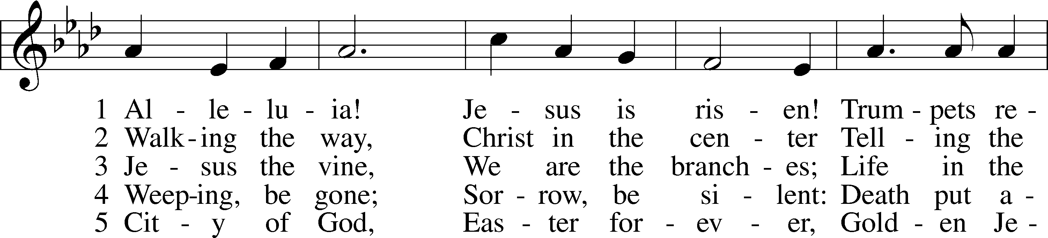
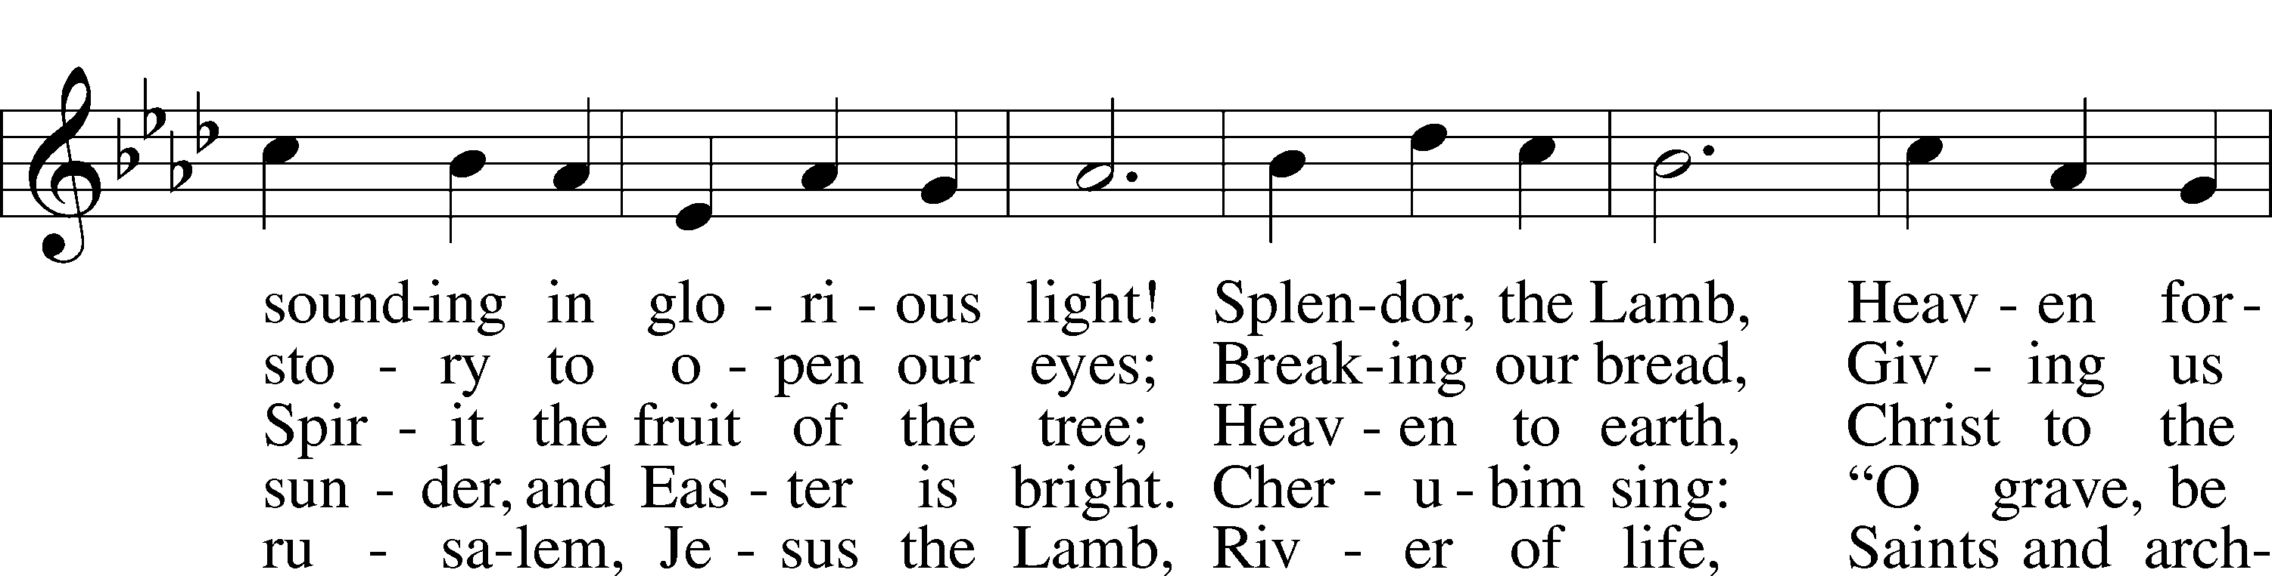
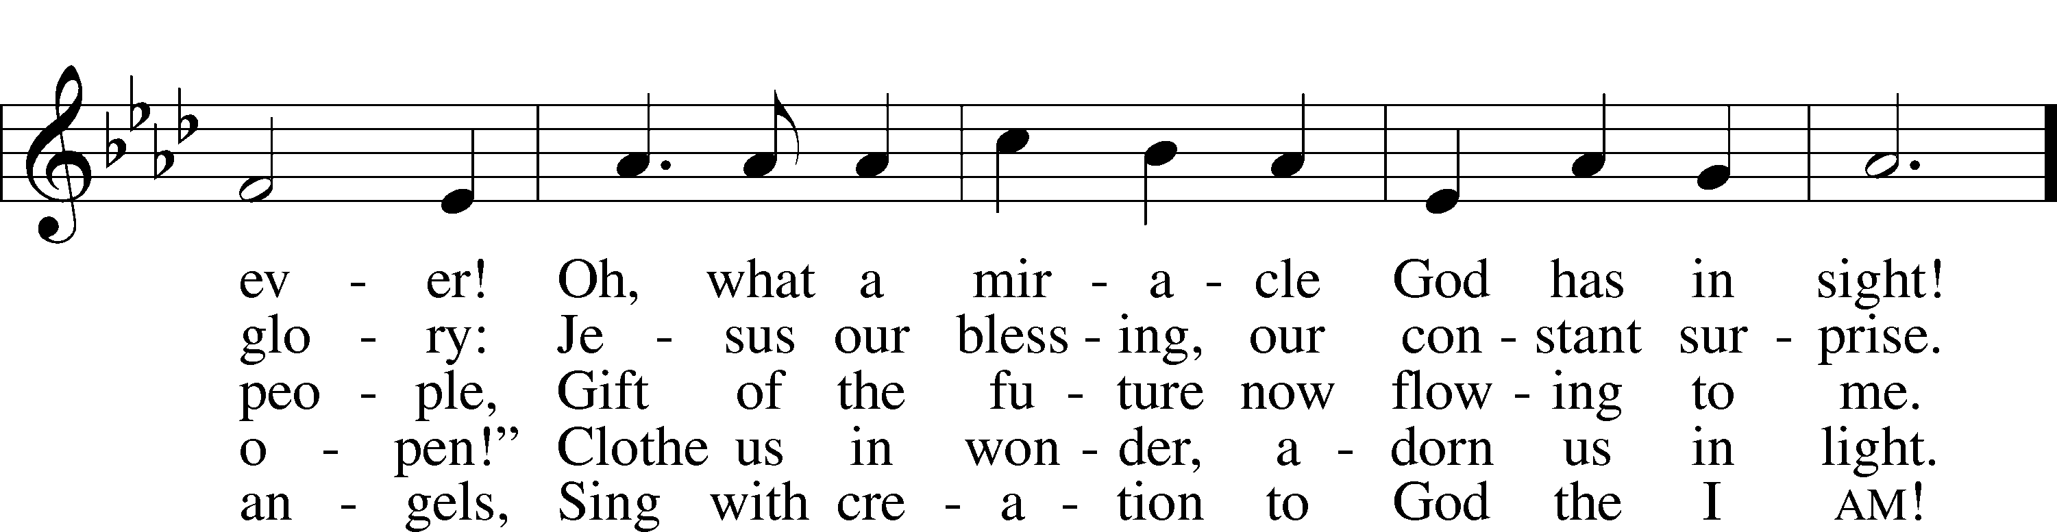
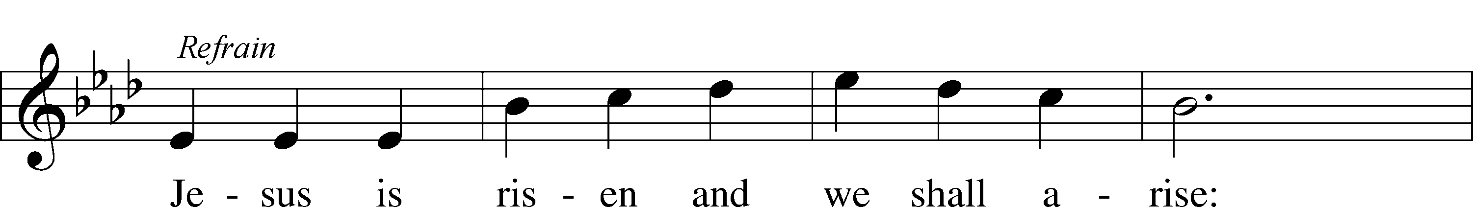
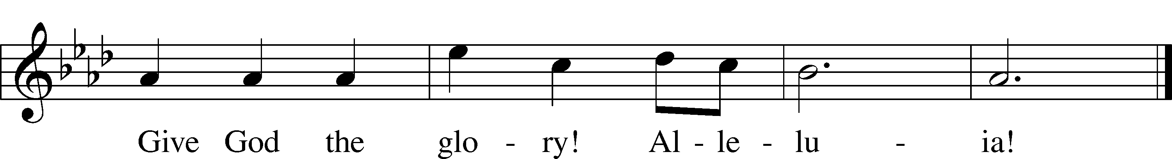
© 1995 Augsburg Fortress. Used by permission: LSB Hymn License .NET, no. 100011641.

Pastor: In the Name of the Father and of the Son and Holy Spirit.
Congregation: Amen.

(Please Remain Standing or You May Kneel)
CONFESSION AND ABSOLUTION:
Pastor: Holy God, in your mercy you look with grace and favor upon us, Your people. Hear now, our solemn confession, and as Your Spirit moves us to true repentance, remind us again that You have forgiven us for the sake of Jesus Christ.
Congregation: Father, how often my sinful nature controls my life! I am easily tempted and fall into sin; I am blind to Your will; I am self-serving, self-seeking, self-righteous and deluded; I am dead in sin. The works of my flesh are demonstrated in my actions and thoughts and words. I have not acted as your baptized child. My heart breaks in my shame and guilt. Gratefully I remember Your blood shed for me to wash me clean. I am forgiven. Holy Spirit, control my life.
Pastor: God has heard our cry. He is faithful even when we are not. As your called servant of His Word, I announce that we have what we seek; the entire forgiveness of all our sins, as God’s free gift. New life, new sights and a new heart are ours. Live in the freedom of the Spirit.
Congregation: Amen!

THE PRAYES OF THE DAY:
All: Almighty God, grant that we who have celebrated the Lord’s resurrection may by Your grace confess in our life and conversation that Jesus is Lord and God; through the same Jesus Christ, Your Son, who lives and reigns with You and the Holy Spirit, one God, now and forever. Amen.

SERVICE OF THE WORD

(You may be seated…)
THE FIRST READING: Acts 5:12-20
Lector: This is the Word of the Lord.
People: Thanks be to God.

THE SECOND READING: Revelation 1:4-18
Lector: This is the Word of the Lord.
People: Thanks be to God.

(Please stand…)
THE HOLY GOSPEL: John 20:19-31
Pastor: The Holy Gospel according to St. John the 20th chapter.
People: Glory to You, O Lord.
Pastor: This is the Gospel of the Lord.
People: Praise to You, O Christ!

(You may be seated…)
CHILDREN’S MESSAGE

NOISE OFFERING

THE SERMON HYMN: “When Peace, like a River” LSB 763
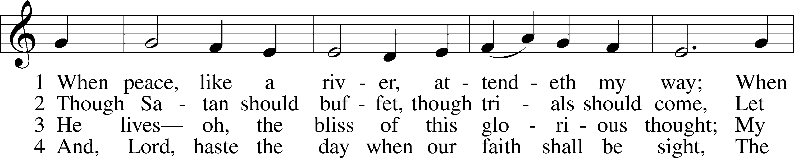
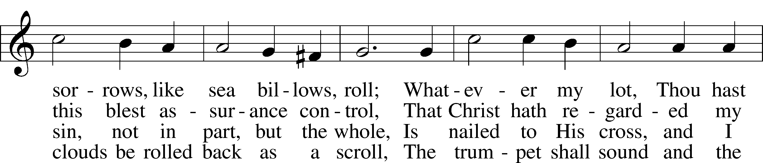
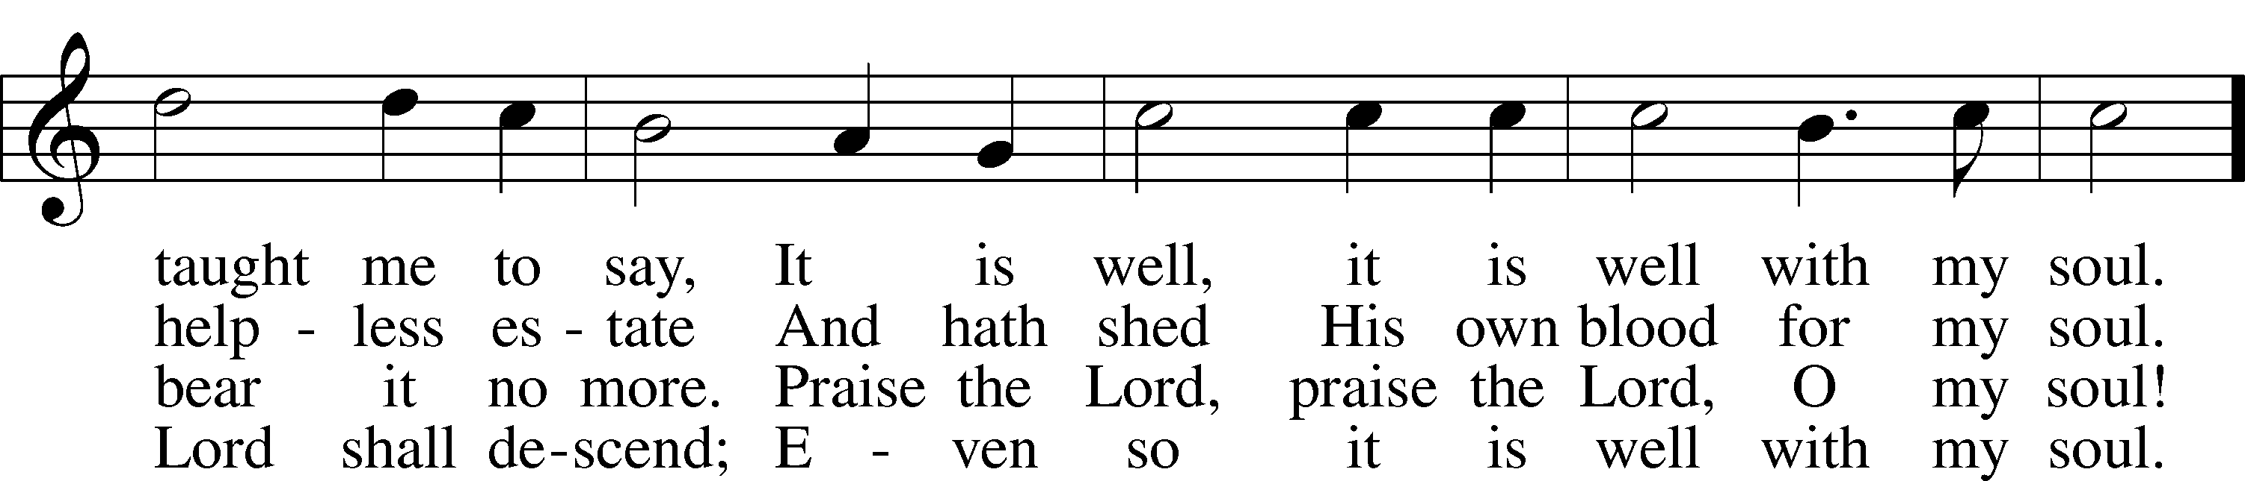
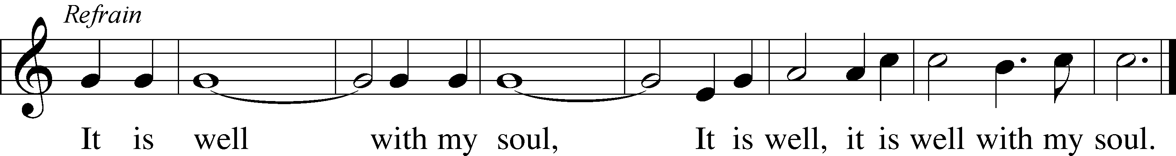
Public domain

THE SERMON: “A Living Voice of Water”

(Please stand…)
THE PROFESSION OF FAITH:
Pastor: God has given us a great message to take to His world. Let us remind ourselves and one another of what that message is:
Pastor: I believe in God the Father, Almighty
Congregation: Maker of heaven and earth
Pastor: And in His Son, Jesus Christ our Lord,
Congregation: Who was conceived by the Holy Spirit
Pastor: Born of the Virgin Mary
Congregation: Suffered under Pontius Pilate
Pastor: Was crucified, died and was buried
Congregation: He descended into hell.
Pastor: On the third day He rose again from the dead,
Congregation: And ascended into heaven
Pastor: And sits on the right hand of God, the Father almighty
Congregation: From there He will come to judge the living and the dead
Pastor: I believe in the Holy Spirit,
Congregation: The Holy Christian Church as
All: the communion of saints; the forgiveness of sins, the resurrection of the body, and the life everlasting. Amen.

THE OFFERING: “Lord of the Dance” Vocal Choir

(Please stand…)
THE PRAYER:
Pastor: Lord God, Heavenly Father, You are the Light of our life and the Hope of our salvation.
Response: With you we have nothing to fear.
Pastor: You protect us, and are the source of all our joy and happiness.
Response: Accept our grateful songs of praise.
Pastor: We pray for those whom we now name silently in our hearts or out
loud…According to Your will, heal the sick, strengthen the faith of all who doubt and lift up the depressed. Into Your hand we commend all for whom we pray, trusting in Your mercy, through Your Son, Jesus Christ our Lord.
All: Amen!

SERVICE OF THE SACRAMENT

(You may be seated…)
THE WORDS OF INSTITUTION

DISTRIBUTION HYMNS: “O Sons and Daughters of the King” LSB 471
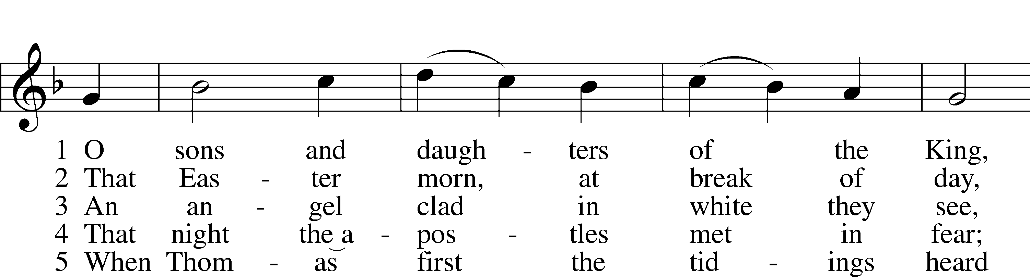
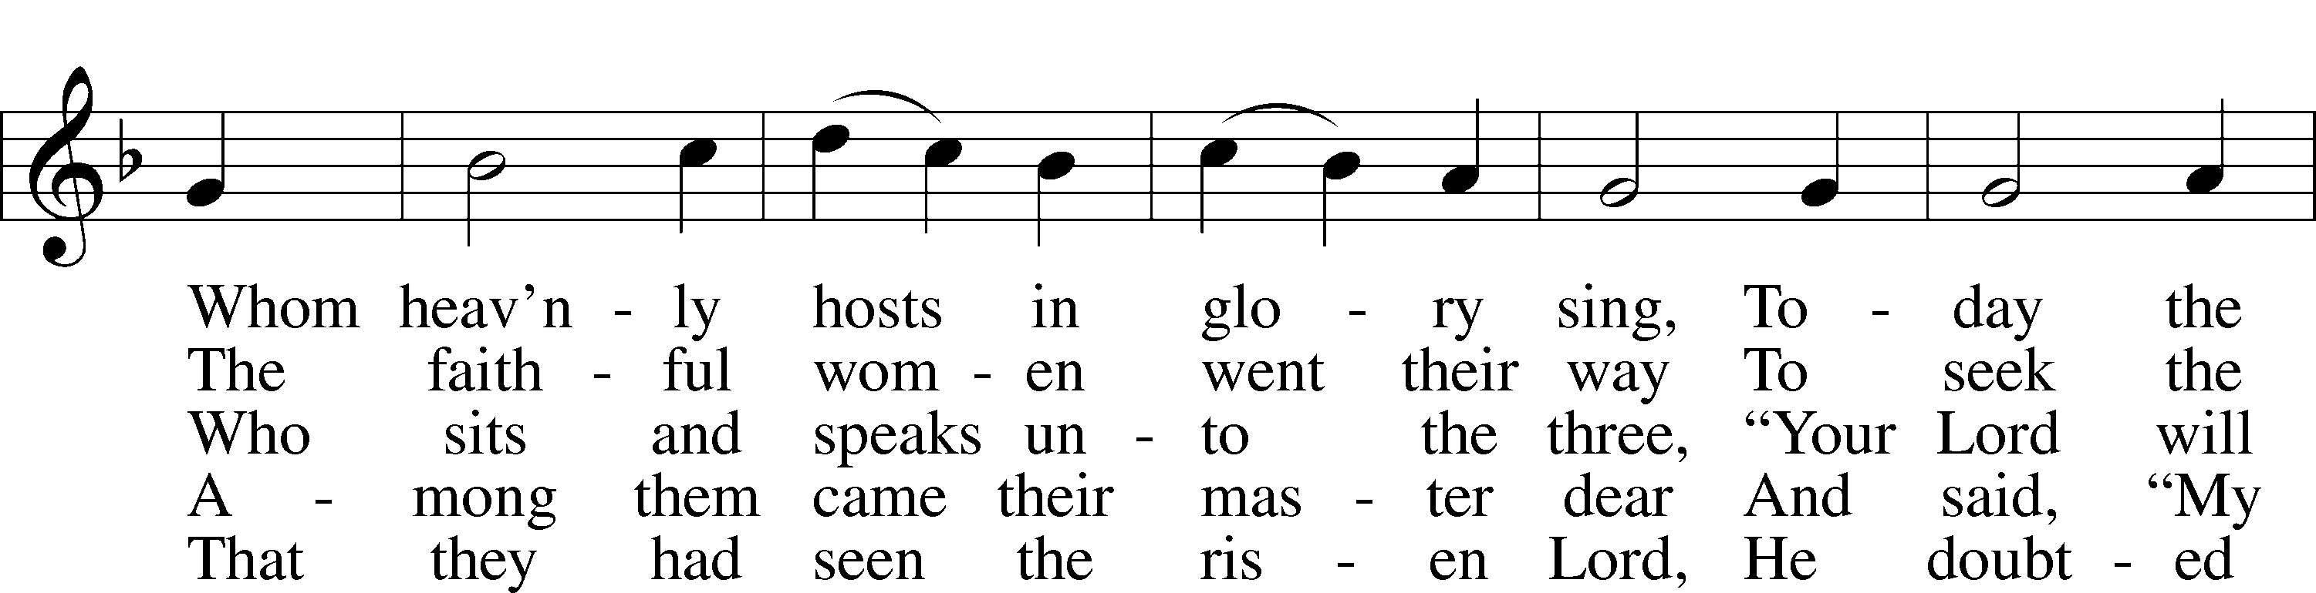
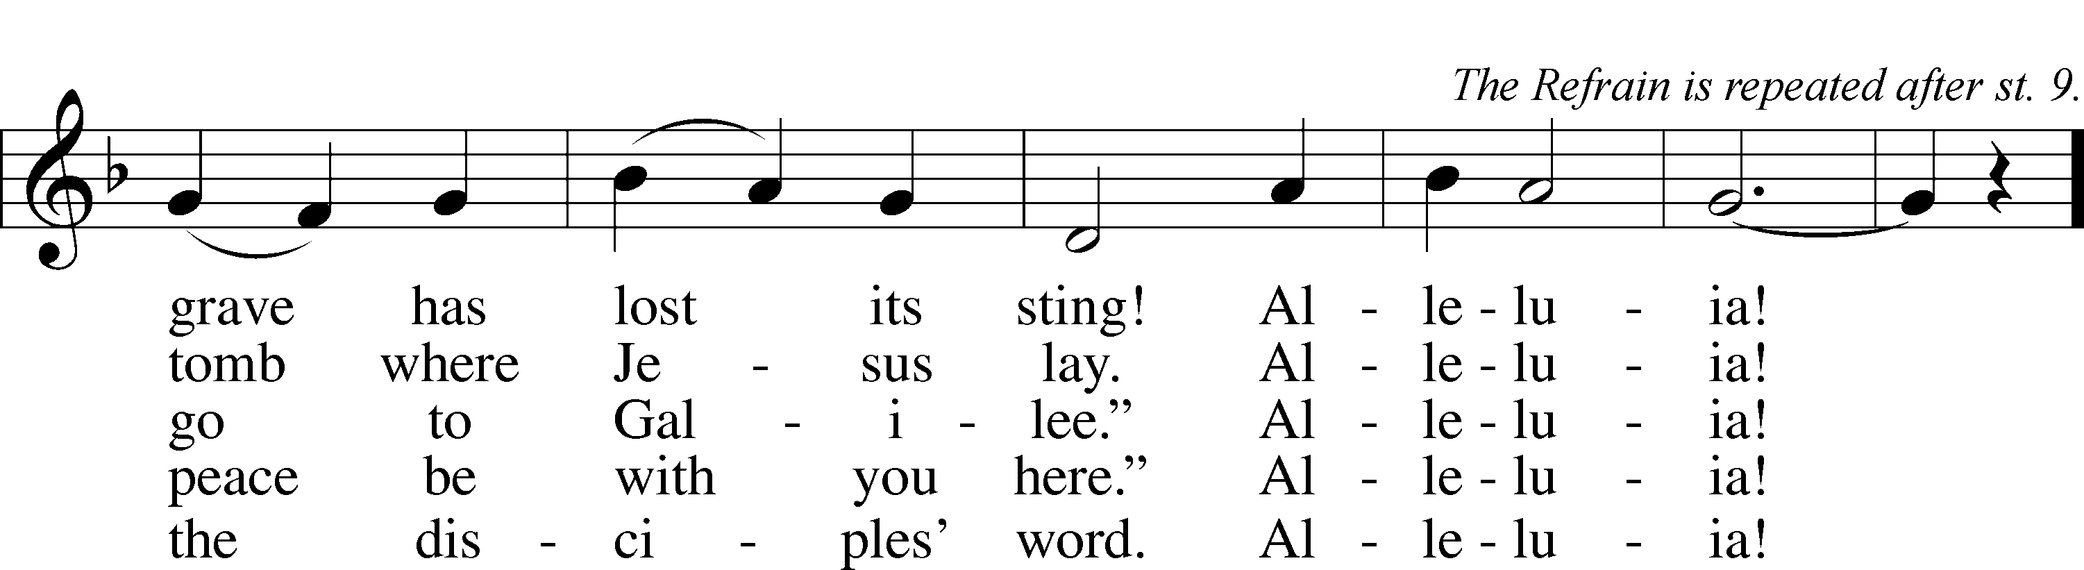

6 “My piercèd side, O Thomas, see,
And look upon My hands, My feet;
Not faithless but believing be.”
Alleluia!

7 No longer Thomas then denied;
He saw the feet, the hands, the side;
“You are my Lord and God!” he cried.
Alleluia!

8 How blest are they who have not seen
And yet whose faith has constant been,
For they eternal life shall win.
Alleluia!

9 On this most holy day of days
Be laud and jubilee and praise:
To God your hearts and voices raise.
Alleluia!
Public domain

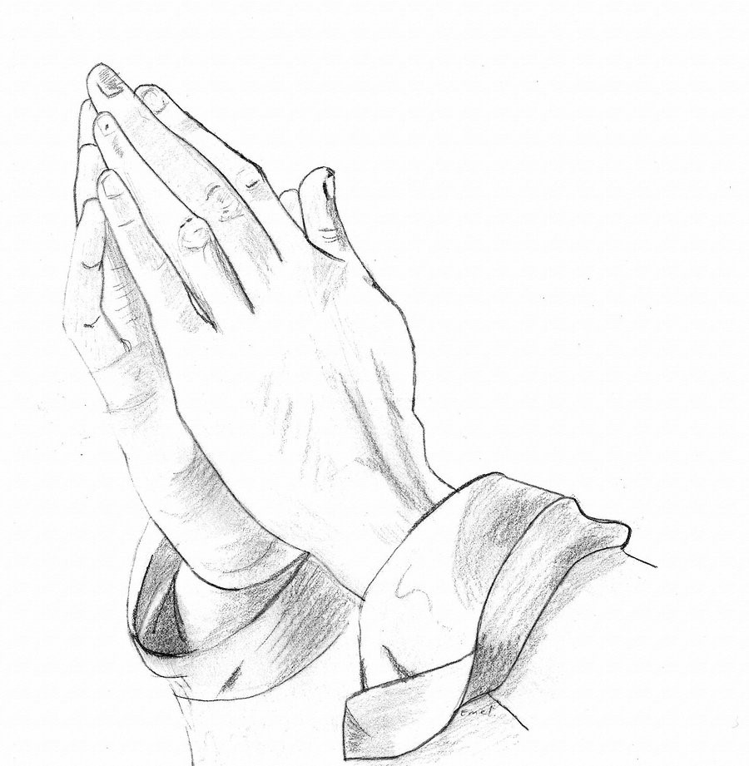

Jesus let the things that break your heart also break our hearts.

Amen

“Thine the Amen, Thine the Praise” LSB 680
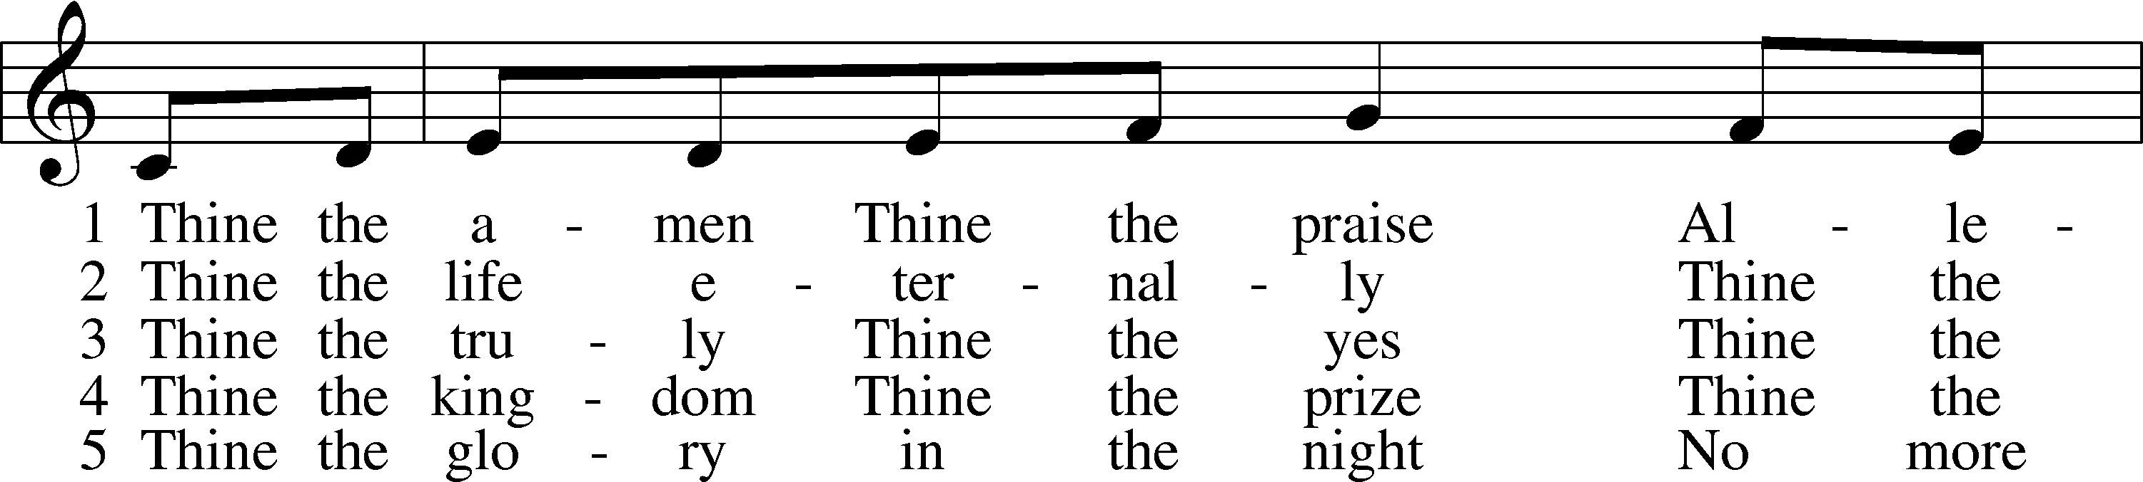
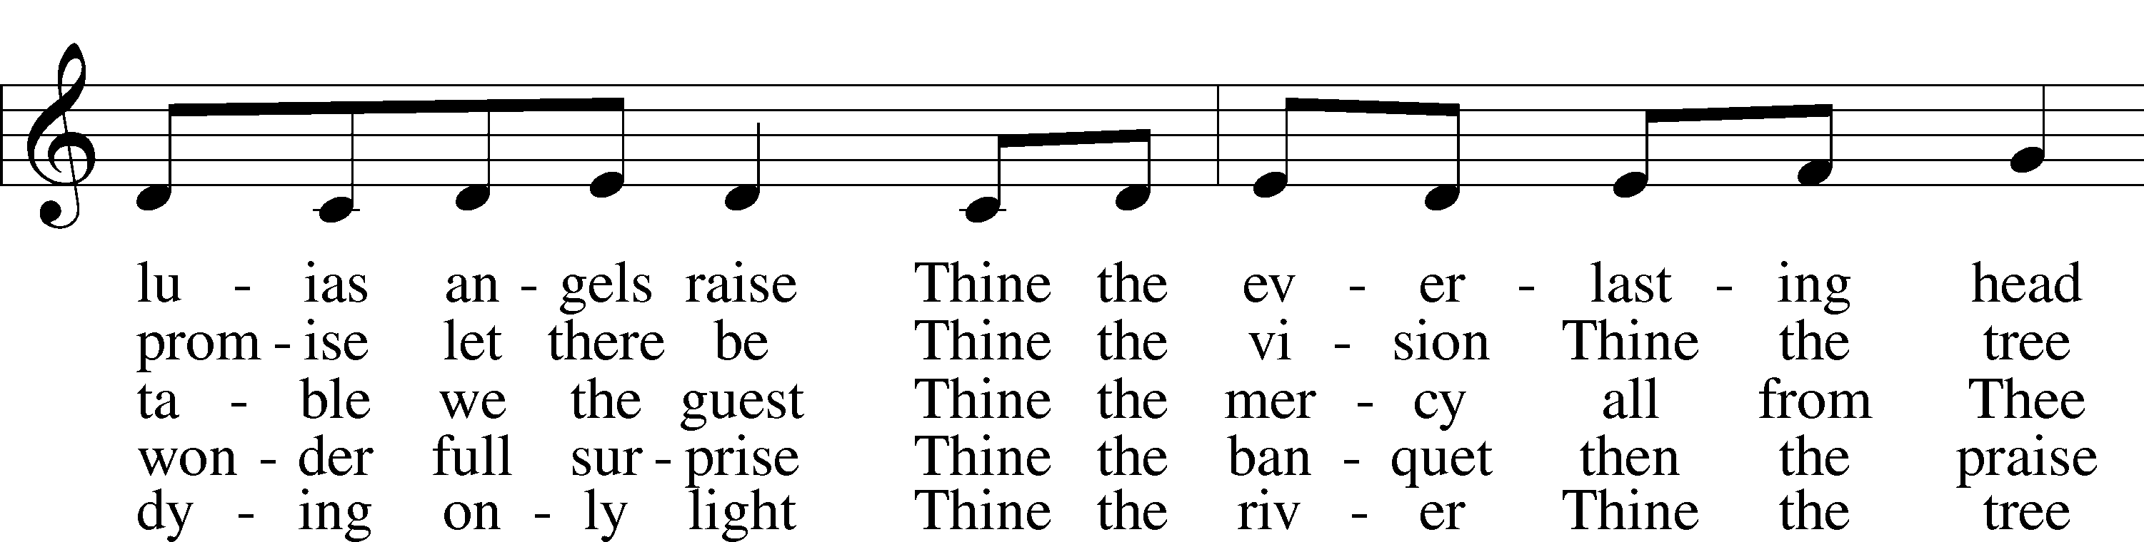
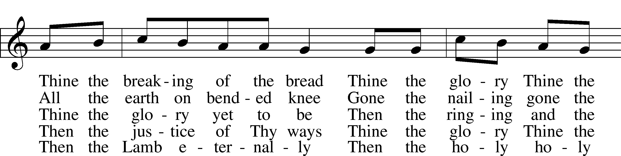
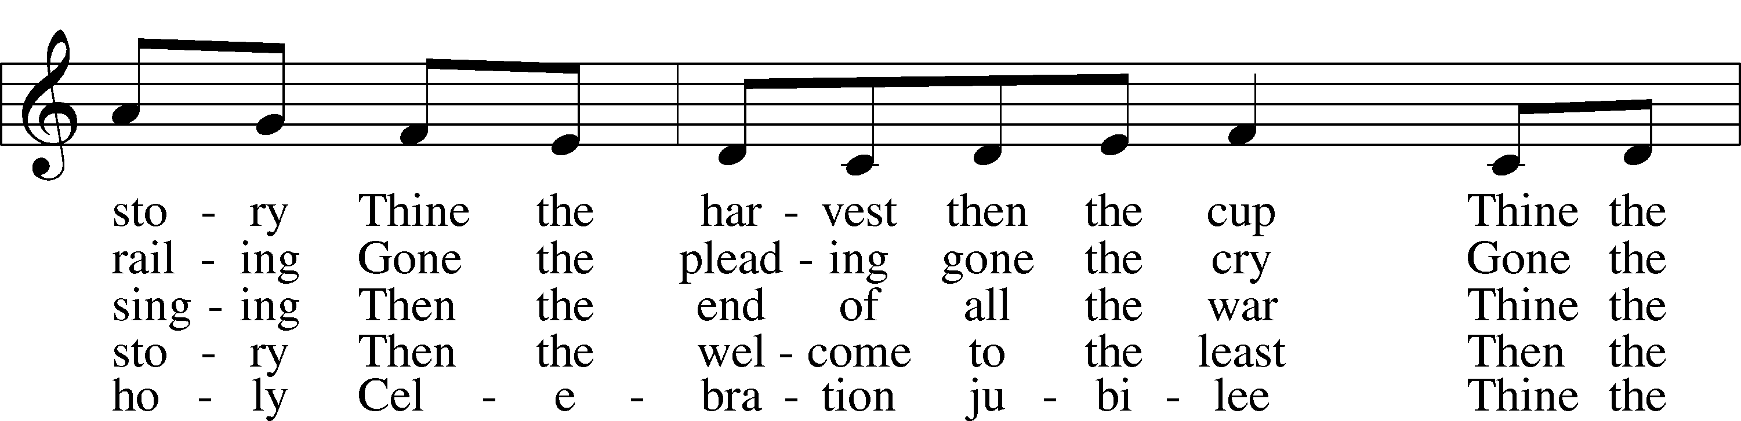
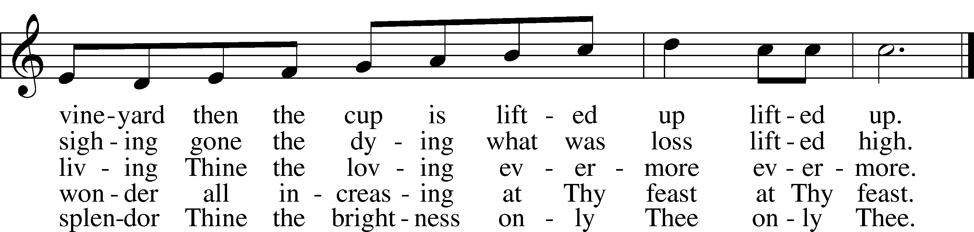
© 1983 Augsburg Publishing House. Used by permission: LSB Hymn License .NET, no. 100011641.

“Oh, That I Had a Thousand Voices” LSB 811
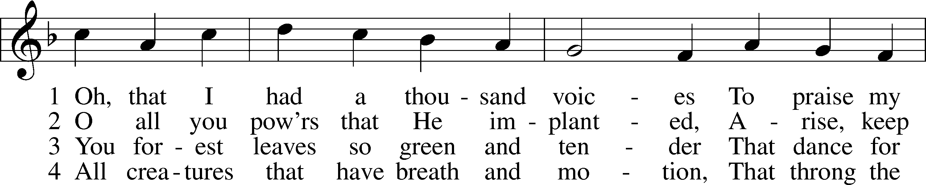
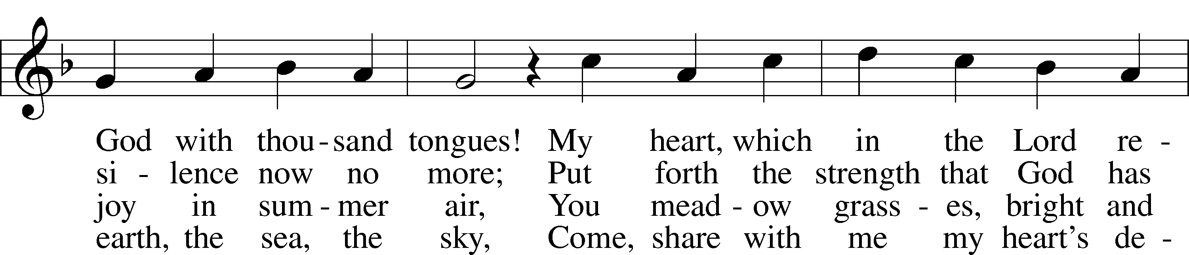
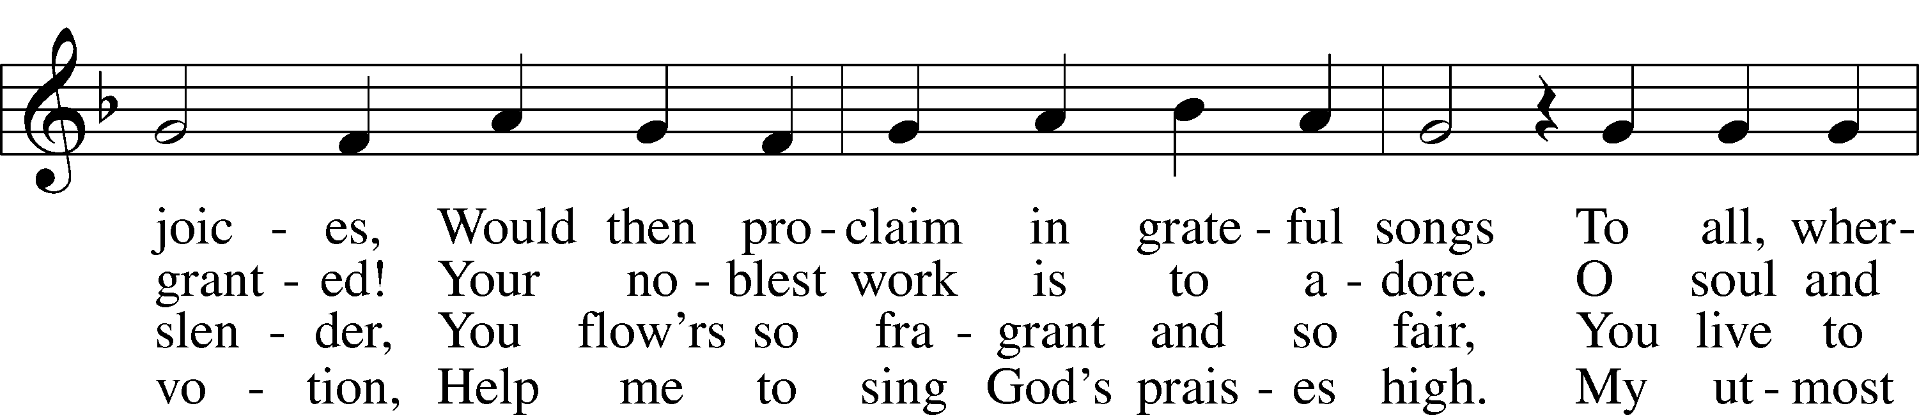
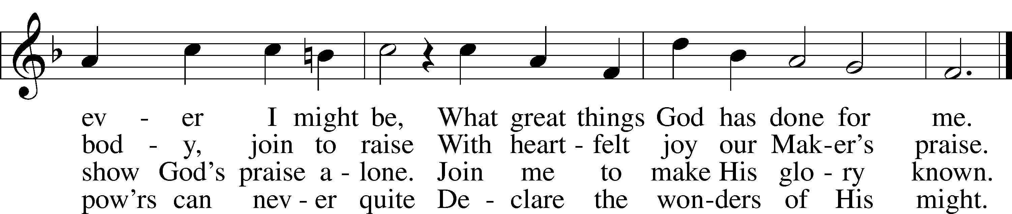

5 Creator, humbly I implore You
To listen to my earthly song
Until that day when I adore You,
Together with the angel throng
And learn with choirs of heav’n to sing
Eternal anthems to my King.
© 1941 Concordia Publishing House. Used by permission: LSB Hymn License .NET, no. 100011641.
Public domain

(Please stand…)
THE LORDS PRAYER:
All: Our Father, who art in heaven, Hallowed be thy name, thy kingdom come, thy will be done, on earth as it is in heaven. Give us this day our daily bread; and forgive us our trespasses, as we forgive those who trespass against us; and lead us not into temptation, but deliver us from evil. For thine is the kingdom, and the power, and the glory, forever and ever. Amen.

BENEDICTION:

THE CLOSING HYMN: “Mine Eyes Have Seen the Glory”

ANNOUNCEMENTS

WELCOME TO GRACE LUTHERAN CHURCH: We are glad that you are here to worship God with us today! We pray that you will enjoy the wonderful fellowship as friends in Christ as God gathers us around His means of grace, the Word and Sacraments, to bless us with His treasured gifts of forgiveness, faith, abundant life and eternal salvation. If you are a guest, please also sign our Guest Book. Please talk to Pastor if you would like to learn more about becoming a member of Grace. Also, please join us for refreshments and fellowship after the Service. We invite you to come and worship with us often as God gathers us in His Grace.

WELCOME TO THE LORD’S TABLE: We invite and encourage all present who are baptized and faithful Christians, and who confess the Father, Son, and Holy Spirit to be the only true God and who believe that Jesus Christ died for the sins of the World and is our only hope and salvation…to join us in receiving the very and true body and blood of Christ in this Sacrament. The clear liquid cups in the center of the tray are non-alcoholic wine.

Children not yet confirmed in the faith are always welcome to join their parents at the Lord’s Table, but should keep their hands folded in front of them. The Pastor will give them a blessing.

Today’s communion distribution will be continuous flow.

SERVING TODAY: Acolyte: _____________; Lector: Mike Sattelmeier; Communion Assistants: David Walker and Mike Sattelmeier; Usher: David Rose; Altar Care: ____________; Refreshments: Sarah Bringle.

SERVING NEXT SUNDAY: Acolyte: Elizabeth Reynolds; Lector: Kris Bly; Communion Assistants: David Walker and Mike Sattelmeier; Usher: David Rose; Altar Care: ___________; Refreshments: ____________.

FLOWERS: were placed on the altar today to the glory of God and by the Morris Family.

THIS WEEK AT A GLANCE:

Today: This Sunday
9:00 am Worship Service with Communion
10:10 am Children’s Hand Chime and Vocal Choir Rehearsal
10:15 am Fellowship/Refreshments
10:30 am Adult Bible Class/Children’s Sunday School

Monday: April 4th
Pastor’s Day Off
5:00 pm Zumba

Tuesday: April 5th
3:00 pm Jan’s Mobile Gym (Parish Hall)
6:00 pm Weight Watcher’s (Parish Hall)

Wednesday: April 6th
8:30 am Grace Lutheran School Chapel
12:30 am Men’s Bible Fellowship (Chico’s)

Next Sunday: April 10th
9:00 am Worship Service with Communion
10:15 am Fellowship/Refreshments
10:30 am Adult Bible Class/Children’s Sunday School

IN YOUR PRAYERS THIS WEEK: the victims of the Lahore Pakistan attack, the family and
friends of Carol Shimp, Esther Faith, Mary Bacle, Jameson Parker, the family and friends of
Hwana, Liz and Ryan Grady,Loretta Cates, Larry, Dan, Gabriel, Andrew, Ramon, Julia Pateman,
David Lopez, Annie Garner, Nancy Amling, Alicia Llama, Erich & Erika Hoffmann, Katharina
Lutz, Brian Kay, Robert & ReginaHoffmann, Jean & Walter Hulme, Carole Steinle, Liz, Ryan
Grady, Joanne Cates, Katharina Lutz, Jane Howard, Jean Grafsgaurd, Denis Julson, Mary Kay,
Sandy Harris, Gary Winters, and those you are praying for at home. If anyone has a special prayer
request please submit it in writing in the collection plate; or you may call Pastor Gary Faith at
(504-858-8872), or Kris Howard at(305-296-5161).

GIFTS, TITHES, & ATTENDANCE LAST SUNDAY was $5114.00, building fund received $245.00. The noise offering for the last Sunday totaled $109.81. Sonrise service had an attendance of 45 and our 9am service had an attendance of 165.

TO HELP US GROW… The Bible readings for next Sunday’s service readings are Acts 9:1-22, Revelation 5:8-14, John 21:1-14.

MISSIONAL COMMUNITIES – CHANGE IN SCHEDULE: In an effort to increase participation Missional Communities will meet twice monthly on the 2nd and 4th Thursday’s. The 5 Questions we discuss are designed to help us grow in our relationship with Jesus and in our ability to see the opportunities life places in our path. Questions; ask one of those who participates.

THANKS TO ALL WHO HELPED make this year’s Easter celebration a blessing. Your service is greatly appreciated. Thanks also for the Easter cards and goodies. We are blessed.

“THE FIRST ROSA” a film (documentary about Rosa Young is available in the church office. Rosa Young was Gods instrument for starting several Lutheran Schools and churches in the South. It’s a part of LCMS history that isn’t well known but is a great story of God reaching into the African American community and raising up many pastors and teachers.

STAINED GLASS WINDOWS: Thanks be to God, all four of the remaining stained glass windows on right side of altar have been donated. The three windows on the left side will be installed in March. We only have 9 clear glass impact windows in the bathrooms and front entry, and the two side entry doors that need to be replaced. When those are completed, the entire church will be protected with hurricane proof, impact windows. The cost of the windows is roughly $2000.00 each depending on size. We are waiting on the estimates of the windows and doors as they have just been measured. Thank you donors of the stained glass windows and to all those who have contributed to the building fund for this project. Your generous giving is much appreciated. Pickel Studios is known throughout America and Europe for the quality of their stained glass work, and the new windows are spectacular works of art that glorify our Savior.

GRACE LUTHERAN SCHOOL IS IN NEED: They are in need of Part Time Teacher Assistants/Substitutes. If you are interested or just have questions, please call the school at 305-296-8262.

They are also looking for volunteers to work 3+ hours per week. Duties include reading to children, helping the classroom teacher with arts and crafts, and developing relationships with students.
Shift 1 Shift 2
Monday, Tuesday, Wednesday, Thursday, and/or Friday 8:00-11 10-2

We are flexible if you need to adjust your hours to something other than what is listed. Please contact Kris Howard or Nicole, the school secretary, at 305-296-8262 with your availability if interested.

THE GRACE LUTHERAN CHURCH WEB PAGE AND FACE BOOK PAGE now contains a vocal recording of last week’s sermon. So if you are not able to attend church on Sunday please go to our website where you will find a copy of the bulletin and a recording of Pastor Faith’s sermon. The new webpage address is gracelutherankw.360unite.

A NUMBER OF CAPITAL IMPROVEMENTS are needed to keep our facilities in good health for the future. The narthex has been rebuilt. Roof repairs are needed on school buildings.
If you can help it would be much appreciated! A big thanks to all who have contributed to these repairs.

MUSIC MINISTRY:
"Make a joyful noise to the Lord, all the earth!" Psalm 100:1. Whether you are here year-round or only part-time, we invite you to participate in our music ministry. Please speak with Beverly Walker or contact her at beverlywalker@gmail.com if you have any questions.

Bell Choir: The next rehearsal will be Wednesday, May 4 from 5:45 - 6:30 pm.

Children's Choir: Rehearses today from 10:10 - 10:25. There is no rehearsal next Sunday.

Vocal Choir: There is no rehearsal this week. The next rehearsal is Saturday, April 16 from 11:00 - 12 noon.

WOMEN’S BIBLE STUDY: We finished our 8 week study by Sarah Young on Wednesday which enlightened and gave insight into Jesus's ever present "Presence" protecting, guiding and loving us. We will be taking a break until April 20th with the study TBA. Have a Happy and blessed Easter.

The MEN’S BIBLE FELLOWSHIP: They meet the first and third Wednesday’s of each month at 12:30pm at Chico’s Restaurant. Their next meeting will be April 6th. All guys are welcome

