EASTER SUNDAY
MARCH 27TH, 2015 9:00 a.m.
WORSHIP SERVICE
In the Name of Jesus!
Our Mission Statement:
Anchored in Christ, each person a missionary.

PRESERVICE MUSIC:
“Rejoice, The Lord is King” Bell Choir

WELCOME
PREPARATION
(Please stand…)
OPENING HYMN:

AN EASTER DIALOG:
Pastor: Grace and peace to you from Him who is, who was, and who is to come, from our Lord,
Jesus Christ, who is the faithful witness, the first-born of the dead, and the ruler of the
kings of the earth.
People: To Him who loves us and has freed us from our sins by His blood, and has made us a kingdom of priests, to serve God the Father…to Him be glory and power forever and ever!. Amen.
Pastor: Christ is risen! Alleluia!
People: He is risen indeed! Alleluia!
Pastor: Nations and peoples stand before the Lamb upon His throne and cry out with a loud
voice:
People: Salvation belongs to our God, Who sits on the throne, and to the Lamb!
Pastor: And all the angels around the throne worship Him saying:
People: Blessing and honor, glory and thanksgiving, power and might be to our God
forever and ever! Amen.
Pastor: Christ is Risen!
People: He is risen indeed!
Pastor: So then lift up your hearts.
People: We lift them up unto the Lord
Pastor: Sing unto the Lord, for He has done excellent things.
People: Sing O heavens, and be joyful, O earth; for the Lord has comforted His people.
Pastor: We pray:
All: Almighty God, our Father, we praise You for turning the despair of the disciple
into a time of spiritual joy; through the resurrection of Christ, give us the faith to
believe, that every good which seems to be overcome by evil, and every love which
seems to be buried in darkness and death; shall rise again to life immortal, through
Christ, our risen Lord. Amen.

“This Is the Feast”
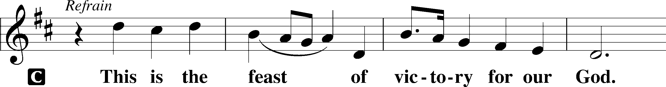
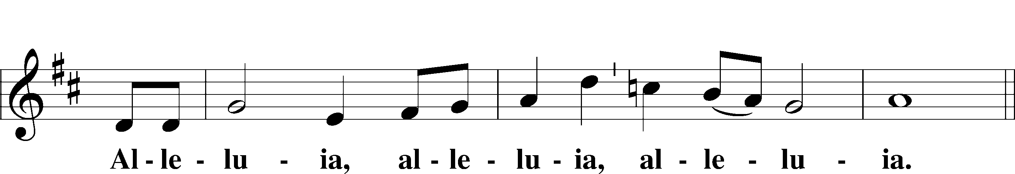
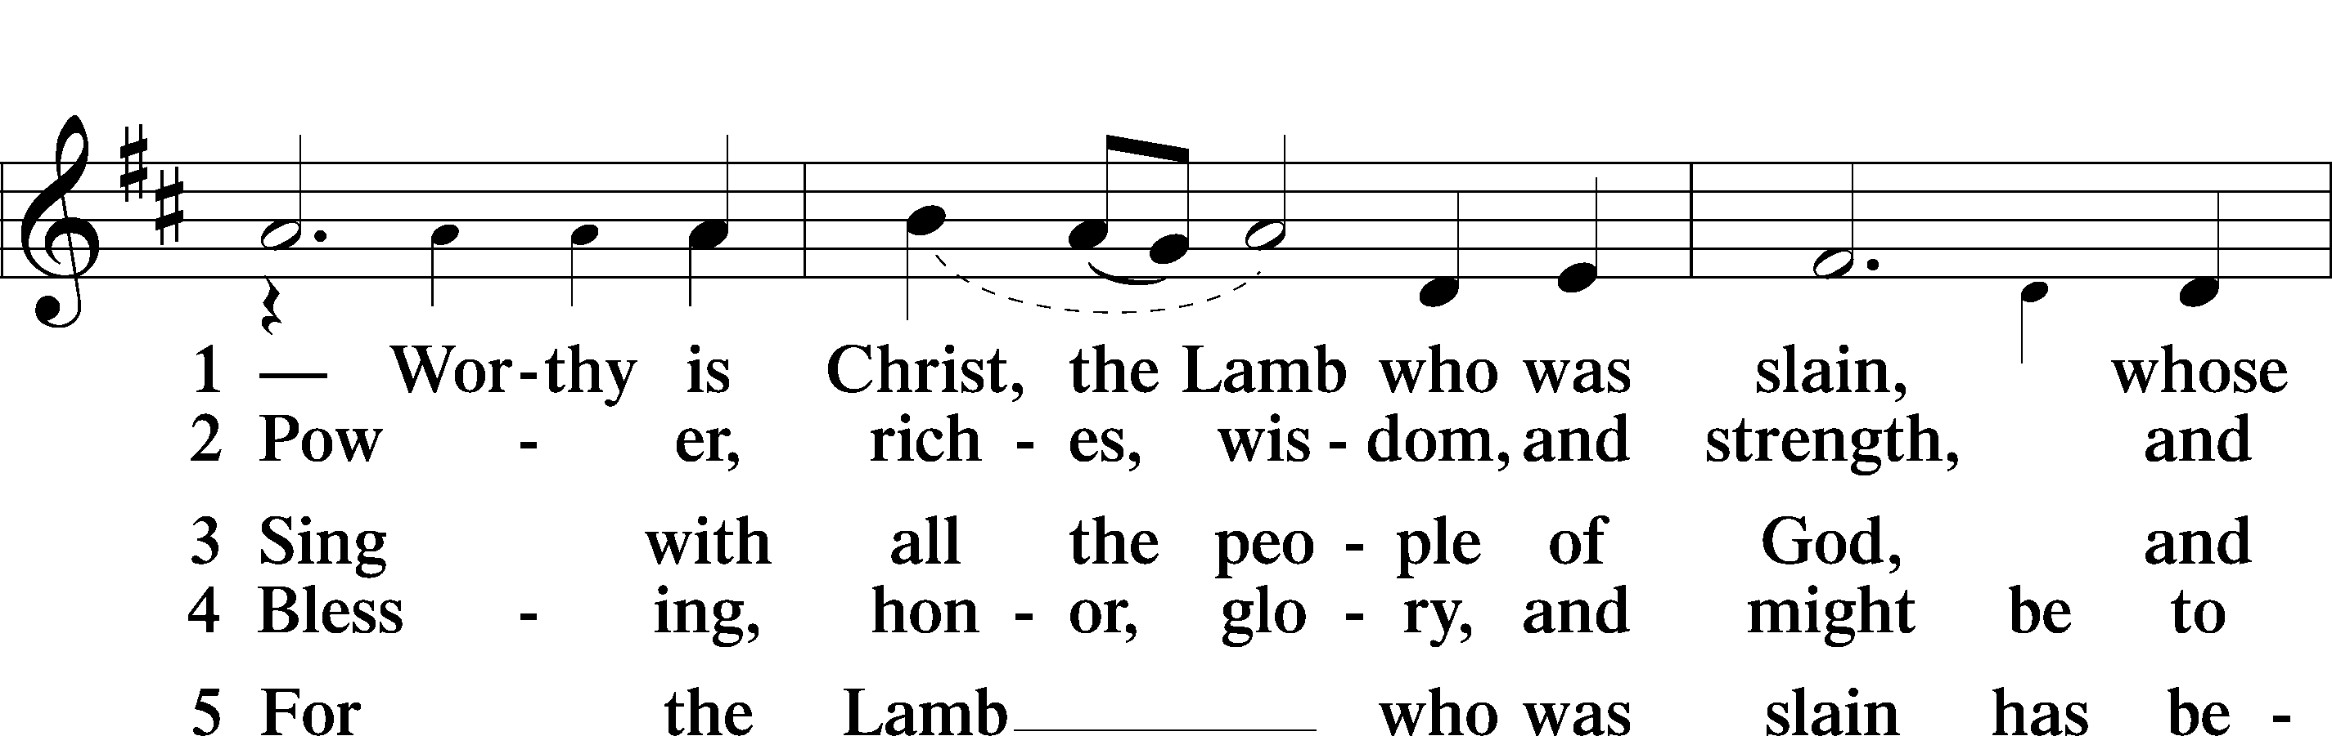
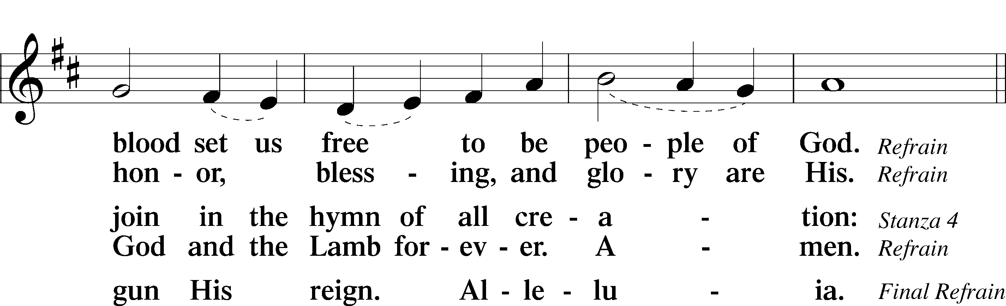
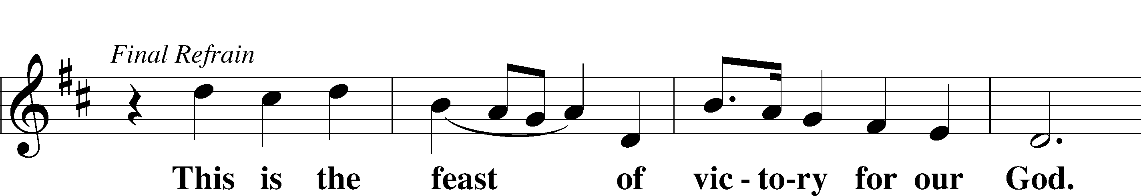
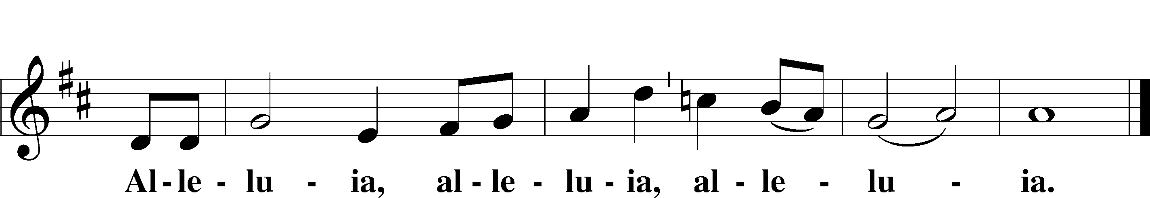

SERVICE OF THE WORD

(You may be seated…)
THE FIRST READING: Isaiah 65:17-25
Lector: This is the Word of the Lord.
People: Thanks be to God.

THE SECOND READING: 1 Corinthians 15:19-26
Lector: This is the Word of the Lord.
People: Thanks be to God.

SPECIAL MUSIC: “Halle, Halle” Children’s Choir

(Please stand…)
THE HOLY GOSPEL: Luke 24:1-12
Pastor: The Holy Gospel according to St. Luke the 24th Chapter.
People: Glory to You, O Lord.
Pastor: This is the Gospel of the Lord.
People: Praise to You, O Christ!

CHILDREN’S MESSAGE

(You may be seated…)
THE SERMON HYMN:

THE SERMON:

OFFERING: “Bell Carol” Vocal Choir

PRAYER OF THE CHURCH:
Pastor: Let us pray for the whole people of God, in Christ Jesus and for all people according to their needs: (silently or our loud).
O Gracious Father, help us to believe that as Jesus lives, we too, are made alive by faith and shall live with Him forever.
People: Risen Lord, live in us that we may live in You.
Pastor: Risen Lord, lift our eyes from sin and death and guide us in the way of forgiveness and life that we may delight in Your Will and bring glory to Your Name.
People: Risen Lord, we celebrate the resurrection.
Pastor: Merciful God, be with the sick, the suffering and the dying. Give them healing and strength in accordance with Your Will and bring us all, at last, to the day when we shall dwell eternally in Your presence.
People: Risen Lord, continue to be with us.
Pastor: Into Your hand, O Lord, we commend all for whom we pray, trusting in Your mercy through Your Son, Jesus Christ, who taught us all to pray:

THE LORD’S PRAYER:
All: Our Father, who art in heaven, hallowed be thy name, thy kingdom come, thy will be done, on earth as it is in heaven. Give us this day our daily bread; and forgive us our trespasses, as we forgive those who trespass against us; and lead us not into temptation, but deliver us from evil. For thine is the kingdom, and the power, and the glory, forever and ever. Amen.

WORDS OF CONSECRATION:

DISTRIBUTION HYMNS:

OUR LITANY OF HOPE:
Pastor: As the clouds of gloom that seemed to over shadow the followers of Christ passed away to reveal the brightness of the dawn of a new day of hope.
People: May this Easter day bring new hope to us, as we allow the light of His spiritual presence, to shine in our hearts.
Pastor: As the fear that filled the minds of the disciples, and caused their faith to weaken, was transformed to hope through His resurrection.
People: May the power of His spirit, sustain us from within, and bring us renewed faith and courage, so that we may be able to face the future unafraid.
Pastor: As the sorrow that came to His followers through the death of their leader gave way to new hope as He triumphed over the grave,
People: May we never forget that His presence is with us now, and always, and that he will guide us as we pass from life, through death, to eternal life.

BENEDICTION

SPECIAL MUSIC: “Hallelujah Chorus” Bell Choir

Jesus let the things that break your heart also break our hearts.

Amen

THE CLOSING HYMN:

