THIRD SUNDAY IN LENT
FEBRUARY 28TH, 2016, 9:00 a.m.
WORSHIP SERVICE
In the Name of Jesus!
Our Mission Statement:
Anchored in Christ, each person a missionary.

ORGAN PRELUDE: (A time for Meditation and Preparation)

WELCOME

ANNOUNCEMENTS
PREPARATION
(Please stand…)
OPENING HYMN: “Great Is Thy Faithfulness” LSB 809
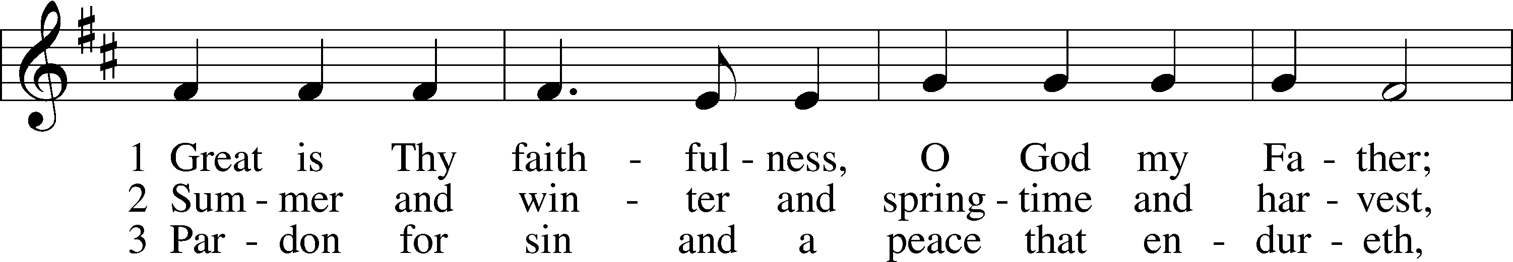
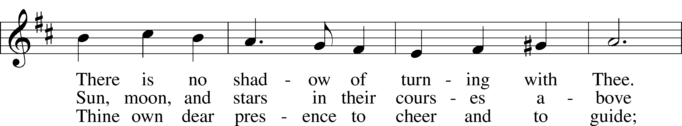
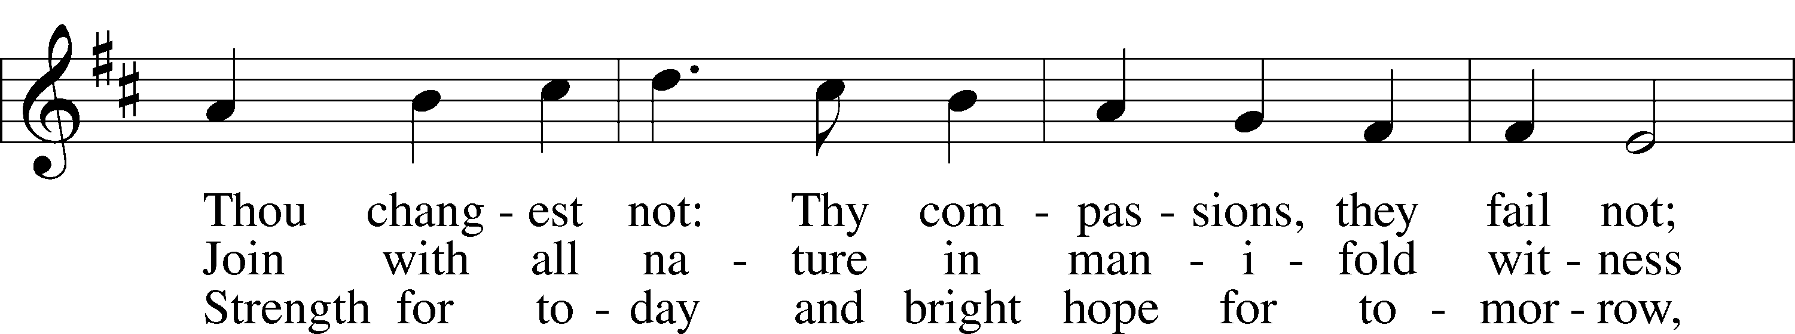
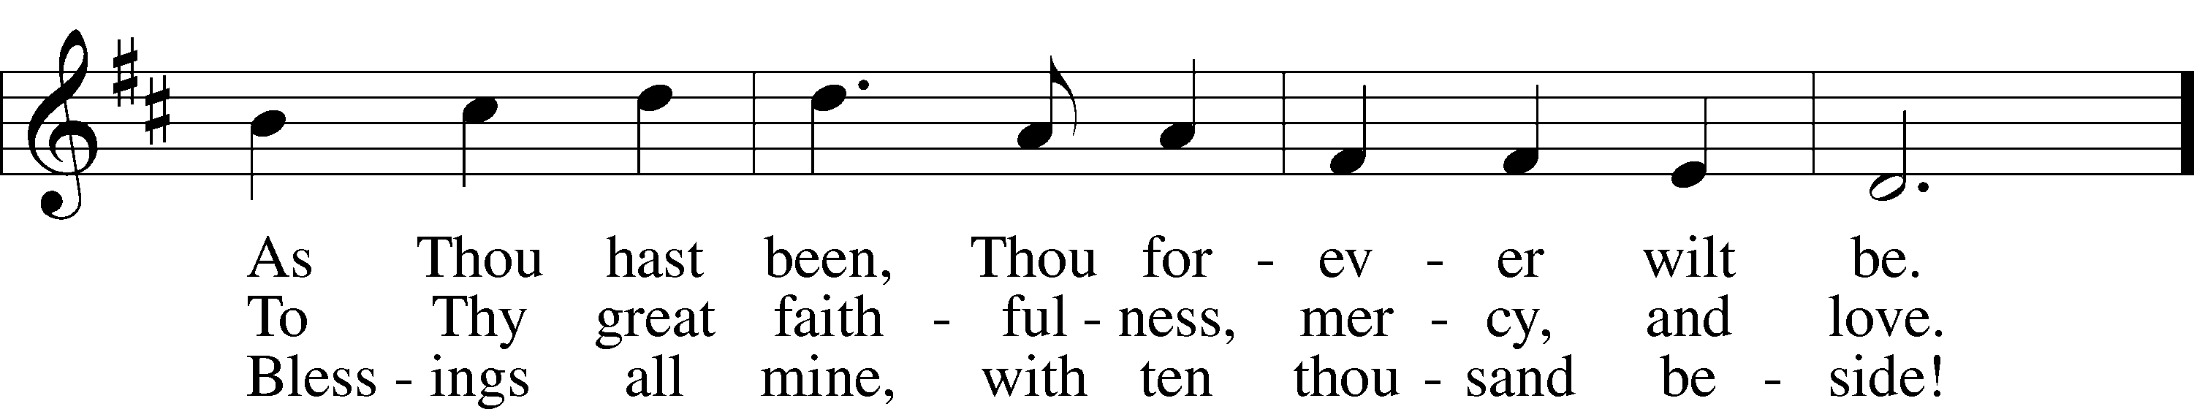
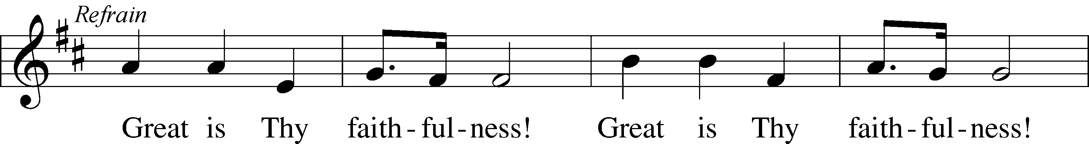
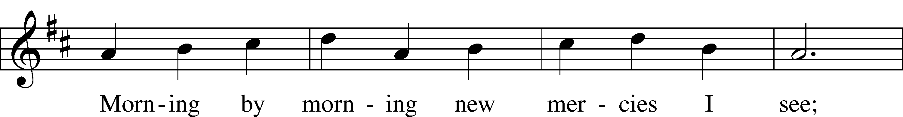
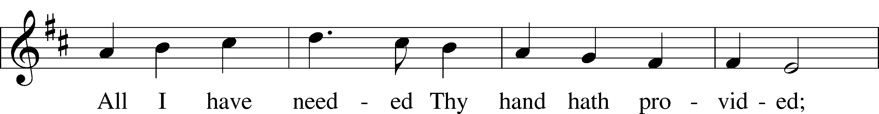
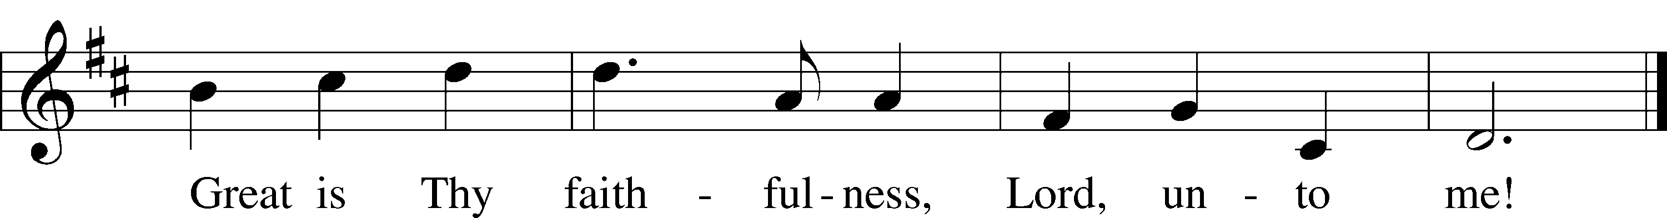
© 1923, renewed 1951 Hope Publishing Co. Used by permission: LSB Hymn License .NET, no. 100011641.

Pastor: In the Name of the Father and of the Son and Holy Spirit.
Congregation: Amen.

(Please Remain Standing or You May Kneel)
CONFESSION AND ABSOLUTION:
Pastor: Holy God, in your mercy you look with grace and favor upon us, Your people. Hear now, our solemn confession, and as Your Spirit moves us to true repentance, remind us again that You have forgiven us for the sake of Jesus Christ.
Congregation: Father, how often my sinful nature controls my life! I am easily tempted and fall into sin; I am blind to Your will; I am self-serving, self-seeking, self-righteous and deluded; I am dead in sin. The works of my flesh are demonstrated in my actions and thoughts and words. I have not acted as your baptized child. My heart breaks in my shame and guilt. Gratefully I remember Your blood shed for me to wash me clean. I am forgiven. Holy Spirit, control my life.
Pastor: God has heard our cry. He is faithful even when we are not. As your called servant of His Word, I announce that we have what we seek; the entire forgiveness of all our sins, as God’s free gift. New life, new sights and a new heart are ours. Live in the freedom of the Spirit.
Congregation: Amen!

THE PRAYES OF THE DAY:
All: O God, whose glory it is always to have mercy, be gracious to all who have gone astray from Your ways and bring them again with penitent hearts and steadfast faith to embrace and hold fast the unchangeable truth of Your Word; through Jesus Christ, Your Son, our Lord, who lives and reigns with You and the Holy Spirit, one God, now and forever. Amen.
SERVICE OF THE WORD

(You may be seated…)
THE FIRST READING: Ezekiel 33:7-20
Lector: This is the Word of the Lord.
People: Thanks be to God.

THE SECOND READING: 1 Corinthians 10:1-13
Lector: This is the Word of the Lord.
People: Thanks be to God.

(Please stand…)
THE HOLY GOSPEL: Luke 13:1-9
Pastor: The Holy Gospel according to St. Luke the 13th chapter.
People: Glory to You, O Lord.
Pastor: This is the Gospel of the Lord.
People: Praise to You, O Christ!

(You may be seated…)
CHILDREN’S MESSAGE

NOISE OFFERING

THE SERMON HYMN: “Come to Calvary's Holy Mountain” LSB 435
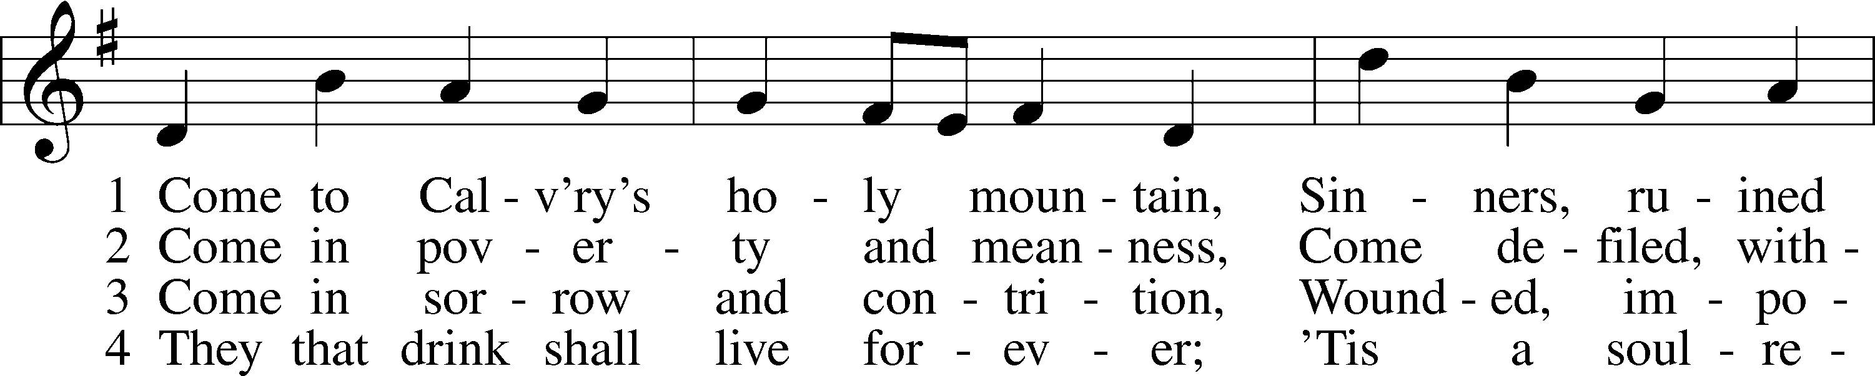
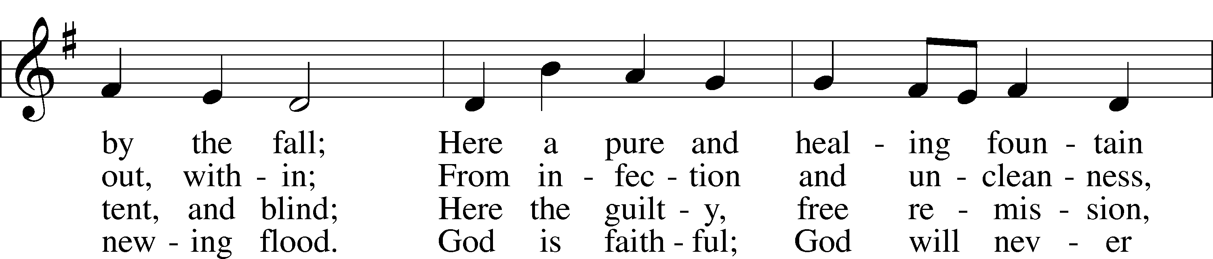
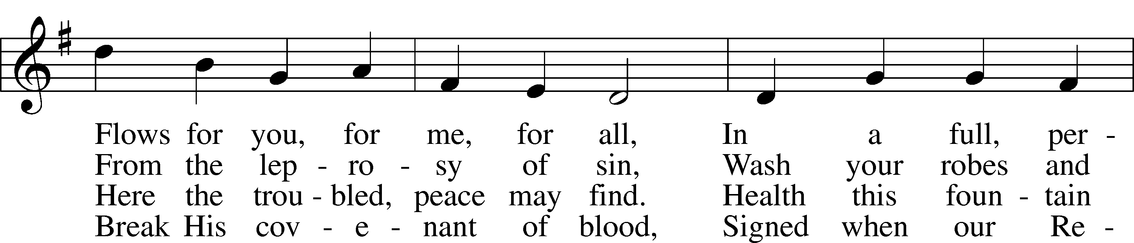
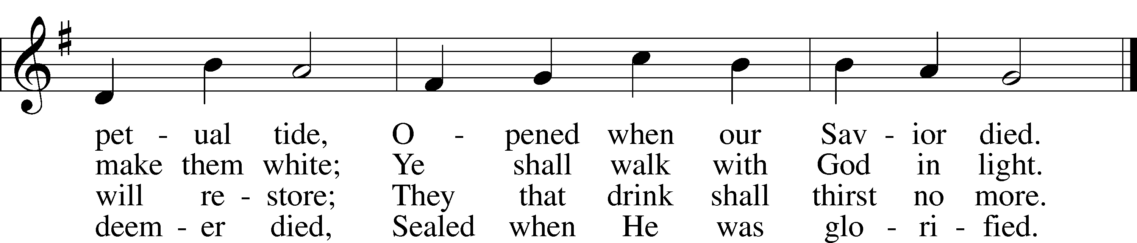
Public domain

THE SERMON: “The Way of the Cross Leads Home”

(Please stand…)
THE PROFESSION OF FAITH:
Pastor: God has given us a great message to take to His world. Let us remind ourselves and one another of what that message is:
Pastor: I believe in God the Father, Almighty
Congregation: Maker of heaven and earth
Pastor: And in His Son, Jesus Christ our Lord,
Congregation: Who was conceived by the Holy Spirit
Pastor: Born of the Virgin Mary
Congregation: Suffered under Pontius Pilate
Pastor: Was crucified, died and was buried
Congregation: He descended into hell.
Pastor: On the third day He rose again from the dead,
Congregation: And ascended into heaven
Pastor: And sits on the right hand of God, the Father almighty
Congregation: From there He will come to judge the living and the dead
Pastor: I believe in the Holy Spirit,
Congregation: The Holy Christian Church as
All: the communion of saints; the forgiveness of sins, the resurrection of the body, and the life everlasting. Amen.

THE OFFERING: “There is a Redeemer” Vocal Choir

(Please stand…)
THE PRAYER:
Pastor: Lord God, Heavenly Father, You are the Light of our life and the Hope of our salvation.
Response: With you we have nothing to fear.
Pastor: You protect us, and are the source of all our joy and happiness.
Response: Accept our grateful songs of praise.
Pastor: We pray for those whom we now name silently in our hearts or out
loud…According to Your will, heal the sick, strengthen the faith of all who doubt and lift up the depressed. Into Your hand we commend all for whom we pray, trusting in Your mercy, through Your Son, Jesus Christ our Lord.
All: Amen!

SERVICE OF THE SACRAMENT

(You may be seated…)
THE WORDS OF INSTITUTION

DISTRIBUTION HYMNS: “O Lord, throughout These Forty Days” LSB 418
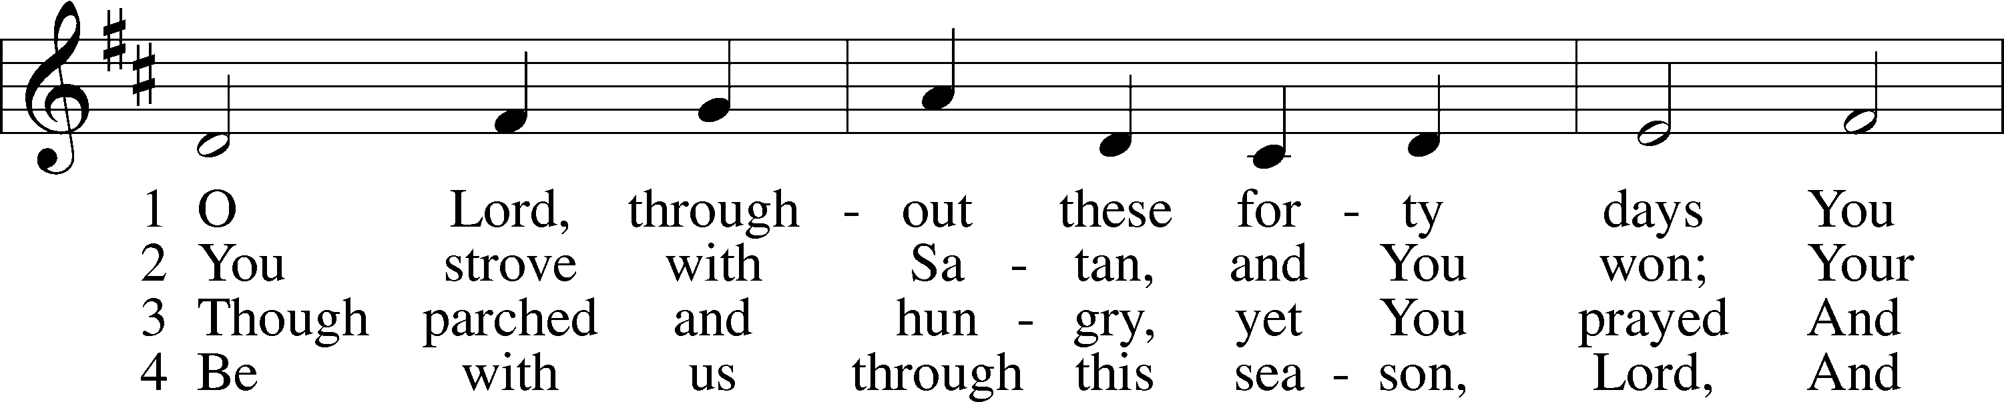
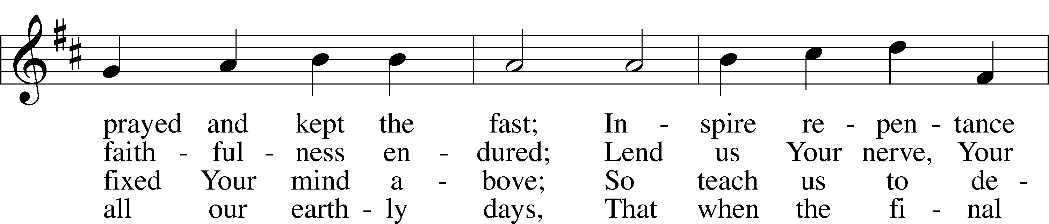
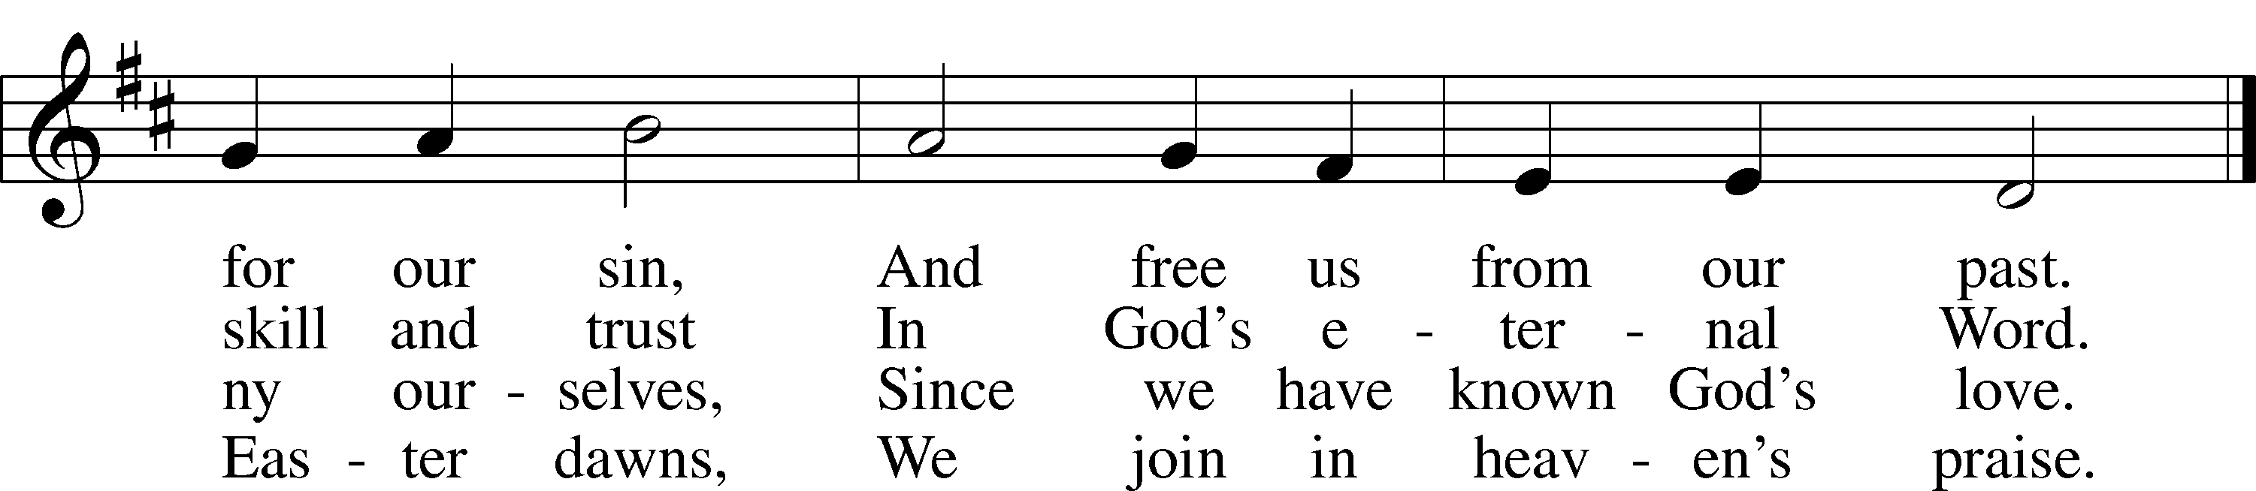
© 1978 Lutheran Book of Worship. Used by permission: LSB Hymn License .NET, no. 100011641.
Public domain
“Precious Lord, Take My Hand” LSB 739
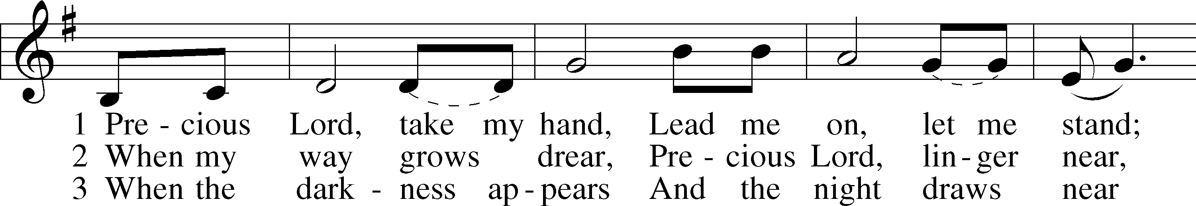
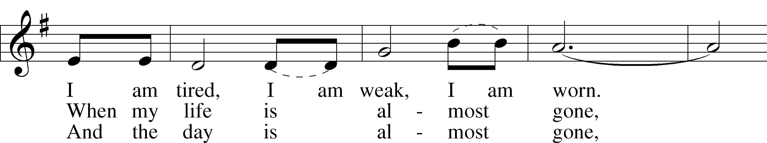
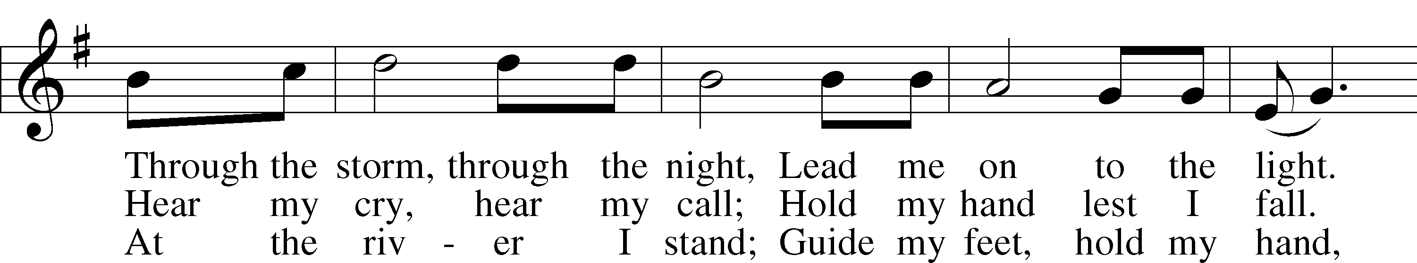
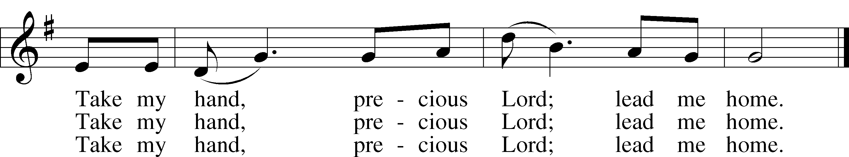
© 1938 Unichappell Music; admin. Alfred Publishing Co., Inc. Used by permission: LSB Hymn License .NET, no. 100011641.
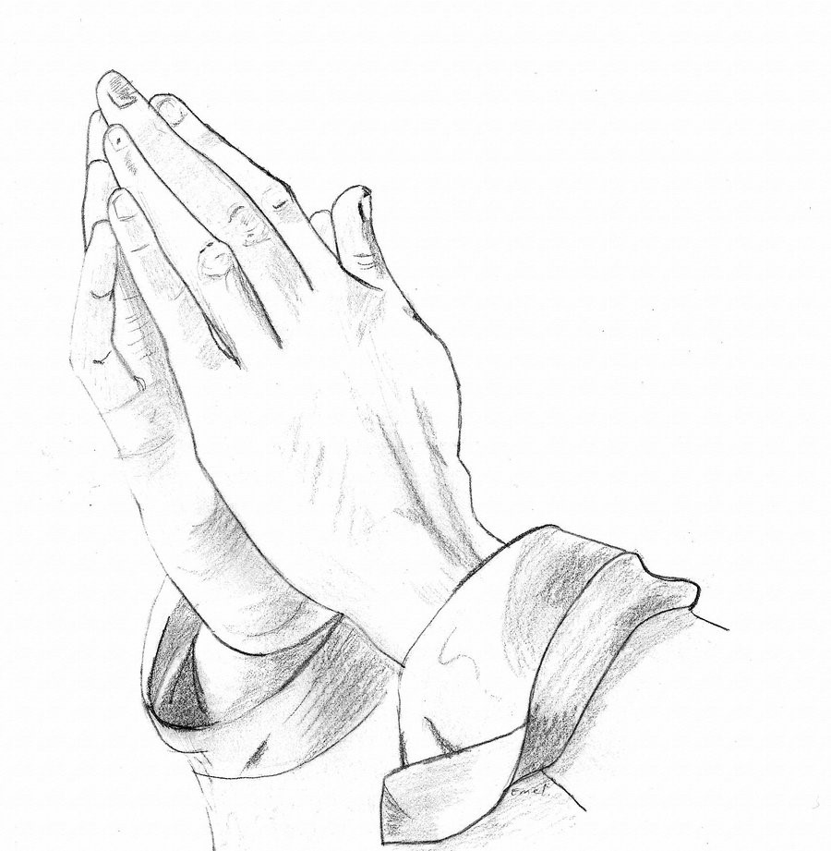
“We Praise You, O God” LSB 785
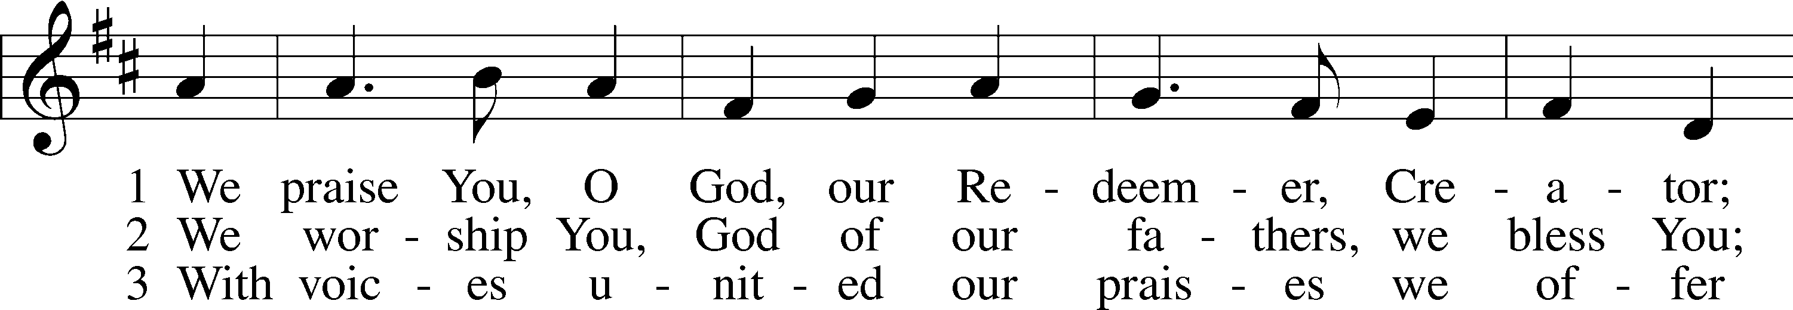
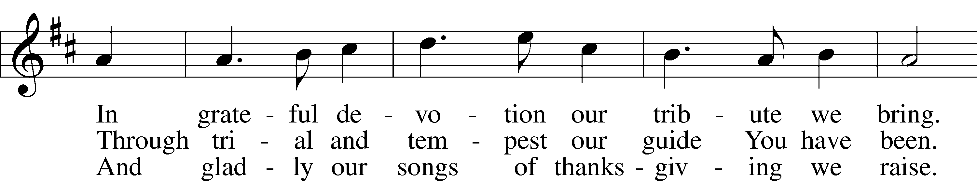
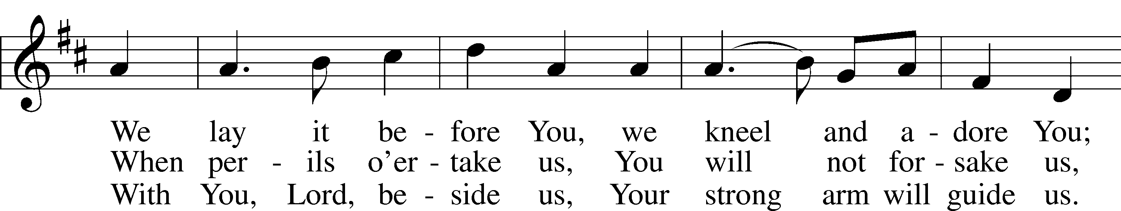
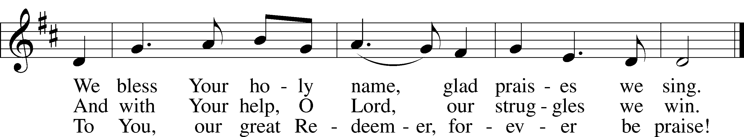
Public domain
“Rock of Ages, Cleft for Me” LSB 761
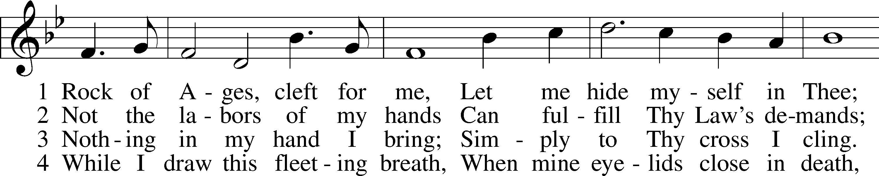
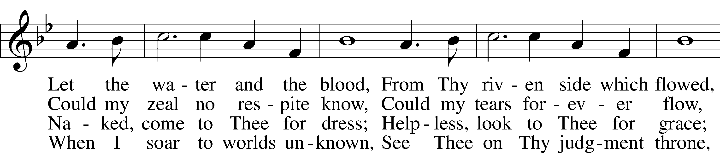
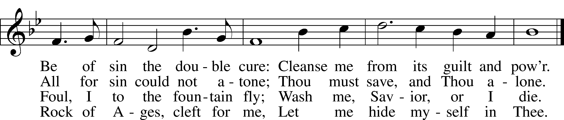
Public domain

(Please stand…)
THE LORDS PRAYER:
All: Our Father, who art in heaven, Hallowed be thy name, thy kingdom come, thy will be done, on earth as it is in heaven. Give us this day our daily bread; and forgive us our trespasses, as we forgive those who trespass against us; and lead us not into temptation, but deliver us from evil. For thine is the kingdom, and the power, and the glory, forever and ever. Amen.

BENEDICTION

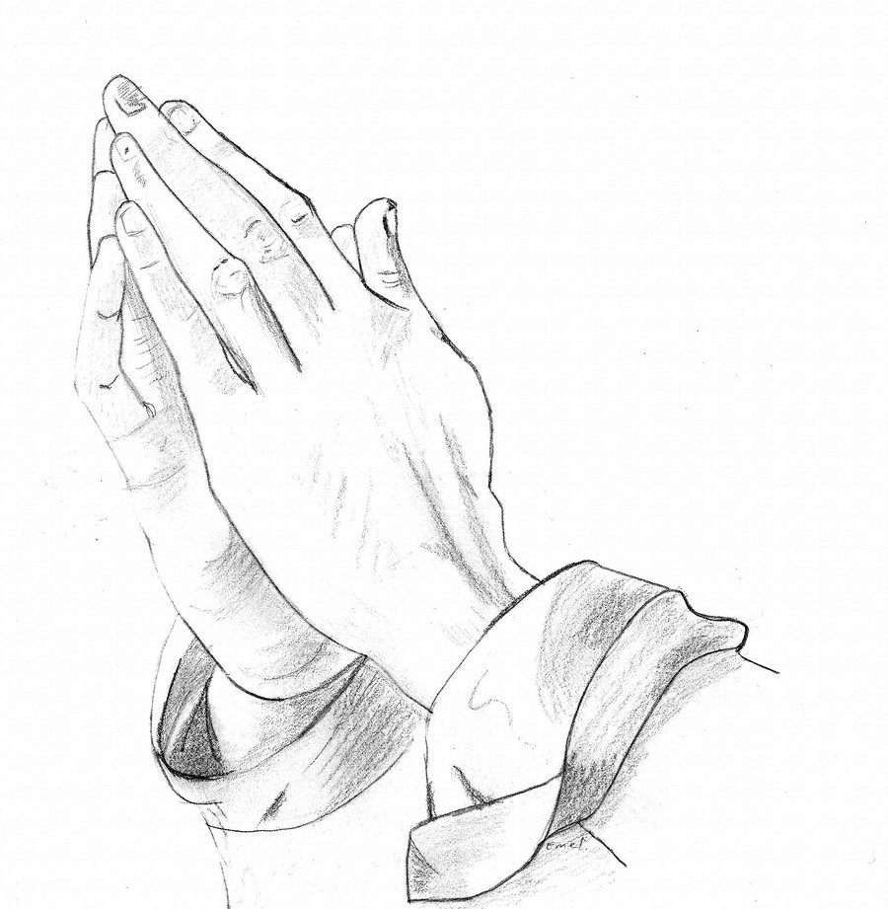
Jesus let the things that break your heart also break our hearts.

Amen
THE CLOSING HYMN: “There is a Green Hill Far Away”

ANNOUNCEMENTS

WELCOME TO GRACE LUTHERAN CHURCH: We are glad that you are here to worship God with us today! We pray that you will enjoy the wonderful fellowship as friends in Christ as God gathers us around His means of grace, the Word and Sacraments, to bless us with His treasured gifts of forgiveness, faith, abundant life and eternal salvation. If you are a guest, please also sign our Guest Book. Please talk to Pastor if you would like to learn more about becoming a member of Grace. Also, please join us for refreshments and fellowship after the Service. We invite you to come and worship with us often as God gathers us in His Grace.

WELCOME TO THE LORD’S TABLE: We invite and encourage all present who are baptized and faithful Christians, and who confess the Father, Son, and Holy Spirit to be the only true God and who believe that Jesus Christ died for the sins of the World and is our only hope and salvation…to join us in receiving the very and true body and blood of Christ in this Sacrament. The clear liquid cups in the center of the tray are non-alcoholic wine.

Children not yet confirmed in the faith are always welcome to join their parents at the Lord’s Table, but should keep their hands folded in front of them. The Pastor will give them a blessing.

SERVING TODAY: Acolyte: Amelia Bly; Lector: Jim Picking; Communion Assistants: Don Bly and Edward Morris; Usher: Terry Richardson; Altar Care: __________; Refreshments: The Faith Family.

SERVING WEDNESDAY, THE 2nd AT 7PM: Acolyte: Ali Harrison; Usher: Terry Richardson.

SERVING NEXT SUNDAY: Acolyte: Elizabeth Reynolds; Lector: Mike Sattelmeier; Communion Assistants: Vince Winters and Max Broadbent; Usher: Edward Morris; Altar Care: ______________; Refreshments: _______________.

FLOWERS: were placed on the altar today to the glory of God and by the Broadbent family to celebrate their 63rd wedding anniversary.

THIS WEEK AT A GLANCE:

Today: This Sunday
9:00 am Worship Service with Communion
10:10 am Children’s Chime and Vocal Choir Rehearsal
10:15 am Fellowship
10:30 am Adult Bible Class/Children’s Sunday School

Monday: February 29th
Pastor’s Day Off
5:00 pm Zumba
Tuesday: March 1st
11:30 am Gracious Ladies of Grace Luncheon (Azure)
3:00 pm Jan’s Mobile Gym (Parish Hall)
6:00 pm Weight Watcher’s (Parish Hall)

Wednesday: March 2nd
8:30 am School Chapel Service
12:30 pm Men’s Bible Fellowship (Chico’s Restaurant)
4:30 pm Women’s Bible Study
5:45 pm Bell Choir Rehearsal
6:00 pm Lenten Potluck Supper
7:00 pm Lent Service

Thursday: March 3rd
7:00 pm Missional Communities (Parsonage)

Saturday: March 5th
11:00 am Vocal Choir Rehearsal

Next Sunday: March 6th
9:00 am Worship Service with Communion
10:00 am Children’s Chime and Vocal Choir Rehearsal
10:15 am Fellowship
10:30 am Planning Meeting (Parish Hall) (Lunch will be provided)/Children’s
Sunday School

IN YOUR PRAYERS THIS WEEK: Annie Garner, Nancy Amling, Alicia Llama, Erich & Erika Hoffmann, Katharina Lutz, Brian Kay, Al & Kathleen Schubert, Robert & Regina Hoffmann, Jean & Walter Hulme, Carole Steinle, Liz, Ryan Grady, Joanne Cates, Katharina Lutz, Jane Howard, Jean Grafsgaurd, Denis Julson, Mary Kay, Carol McMann, the Marston family, Sandy Harris, Carol Shimp, Gary Winters, and those you are praying for at home. If anyone has a special prayer request please submit it in writing in the collection plate; or you may call Pastor Gary Faith at (504-858-8872), or Kris Howard at (305-296-5161).

GIFTS, TITHES, & ATTENDANCE LAST SUNDAY was $4444.00, building fund received $350.00. The noise offering for the last two Sundays totaled $147.36. The Bible Sticks Mission received $350.00. With 108 in attendance.

TO HELP US GROW… The Bible readings for next Sunday’s service readings are Ezekiel 33:7-20, 1 Corinthians 10:1-13, and Luke 13:1-9. The reading for our Lent Wednesday Service on February 24th at 7pm will be Matthew 22:1-14 from the NIV Bible.

MILITARY BIBLESTICKS: Thank you to all who were able to make a donation to “Faith Comes By Hearing.” We were able to collect $1120.00 which will be matched for a donation of $2240.00.

PEACE COVENANT PRESBYTERIAN CHURCH WILL HOST THEIR ANNUAL LENTEN RECITALS WITH AUWINA WEED AND JOSEPH LOWE playing piano duets and light organ music on Thursdays during Lent at 1 pm. The recitals are free. Donations will be accepted. The church is located at 2610 Flagler Avenue.

ADULT INFORMATION CLASS: We will have another Adult Information Class for those who want to learn more about wheat we believe and teach. If you are interested, please let Pastor know so the dates for these classes can be agreeable for all.

STAINED GLASS WINDOWS: Thanks be to God, all four of the remaining stained glass windows on right side of altar have been donated. The three windows on the left side will be installed in March. We only have 9 clear glass impact windows in the bathrooms and front entry, and the two side entry doors that need to be replaced. When those are completed, the entire church will be protected with hurricane proof, impact windows. The cost of the windows is roughly $2000.00 each depending on size. We are waiting on the estimates of the windows and doors as they have just been measured. Thank you donors of the stained glass windows and to all those who have contributed to the building fund for this project. Your generous giving is much appreciated. Pickel Studios is known throughout America and Europe for the quality of their stained glass work, and the new windows are spectacular works of art that glorify our Savior.

GRACE LUTHERAN SCHOOL IS IN NEED: They are in need of Part Time Teacher Assistants/Substitutes. If you are interested or just have questions, please call the school at 305-296-8262.

They are also looking for volunteers to work 3+ hours per week. Duties include reading to children, helping the classroom teacher with arts and crafts, and developing relationships with students.
Shift 1 Shift 2
Monday, Tuesday, Wednesday, Thursday, and/or Friday 8:00-11 10-2

We are flexible if you need to adjust your hours to something other than what is listed. Please contact Kris Howard or Nicole, the school secretary, at 305-296-8262 with your availability if interested.

GRACIOUS LADIES OF GRACE: Gorgeous, gorgeous day at the Pier House as we celebrated Elaine’s 35th birthday. Don’t know what else was so important but not too many Gracious Ladies attended our lovely 5* luncheon. We we’ll give you another opportunity to “do lunch” on March 1st at Azure at 11:30. Bon something or other.
LENT SERVICE ON WEDNESDAY MARCH 2ND: We will have a dinner at 6pm and worship service at 7pm. This Lenten season we will be looking at some of Jesus parables. Our Wednesday service will focus on Matthew 25:1-13. “Wise and Foolish Virgins.”

NEXT SUNDAY we will be having a congregational meeting to dream and plan about what the future of GLCS might look like. Start talking with others about what our strengths, weaknesses, and opportunities might be. We will meet after the fellowship hour and lunch will be served. The leadership of Grace wants to know what you are thinking.

MANY IN THE WORLD are being persecuted for their faith in Jesus. Hugh Smith from Voice of the Martyrs will be speaking on this topic during the Bible Class on March 13th.

OFFERING ENVELOPES ARE KRIS’S OFFICE for all of our members. If have not received yours yet, please let Kris know and she will get them to you.

PICTORIAL DIRECTORY: The pictures are up. If you do not like the picture of you that is posted, you can send one to me that you like better or we can do a retake. If you do not have a picture in the directory and you would like to be included, please let me know. As stated before only the names will be published. To find the directory just go to our website; http://gracelutherankw.360unite.com/home, click on ABOUT US. You will then see a drop down menu, click on DIRECTORY. That’s all. If you have not been to our website before please take your time and look around. You will find an updated calendar of our events, information on all of our bible classes, a link to this week’s bulletin, even an audio file of this week’s sermon, and so much more.

THE GRACE LUTHERAN CHURCH WEB PAGE AND FACE BOOK PAGE now contains a vocal recording of last week’s sermon. So if you are not able to attend church on Sunday please go to our website where you will find a copy of the bulletin and a recording of Pastor Faith’s sermon. The new webpage address is gracelutherankw.360unite.

A NUMBER OF CAPITAL IMPROVEMENTS are needed to keep our facilities in good health for the future. The narthex has been rebuilt. Roof repairs are needed on school buildings.
If you can help it would be much appreciated! A big thanks to all who have contributed to these repairs.

MUSIC MINISTRY:
"Make a joyful noise to the Lord, all the earth!" Psalm 100:1. Whether you are here year-round or only part-time, we invite you to participate in our music ministry. Please speak with Beverly Walker or contact her at beverlywalker@gmail.com if you have any questions.

Children's Chime/Vocal Choir (Kindergarten - 4th grade). Rehearses today from 10:10 to 10:25.

Bell Choir: Rehearses on Wednesday from 5:45 - 6:15 pm.

Vocal Choir: Rehearses from 11:00am – noon.

WOMEN’S BIBLE STUDY: Experiencing God's Presence is the subject of the next study by Sarah Young from her devotional book Jesus Calling. This study is designed to help meditate on the words of Scripture and hear them not just as words said to people long ago but as words said to us today in the here and now. The goal is to help the heart hear and respond to what the mind reads--to encounter the living God as He speaks through the Scriptures.

Please join us on Wednesday's at 4:30 in room 3 for an hour and enjoy fellowship, grow in your faith, and maybe have some new and enlightening thoughts.

The MEN’S BIBLE FELLOWSHIP: They meet the first and third Wednesday’s of each month at 12:30pm at Chico’s Restaurant. Their next meeting will be March 2nd. All guys are welcome.

