FOURTH SUNDAY AFTER ADVENT
JANUARY 31ST, 2016, 2015 9:00 a.m.
WORSHIP SERVICE
In the Name of Jesus!
Our Mission Statement:
Anchored in Christ, each person a missionary.

ORGAN PRELUDE: (A time for Meditation and Preparation)

WELCOME

ANNOUNCEMENTS
PREPARATION
(Please stand…)
OPENING HYMN: “Christ the Eternal Lord” LSB 829
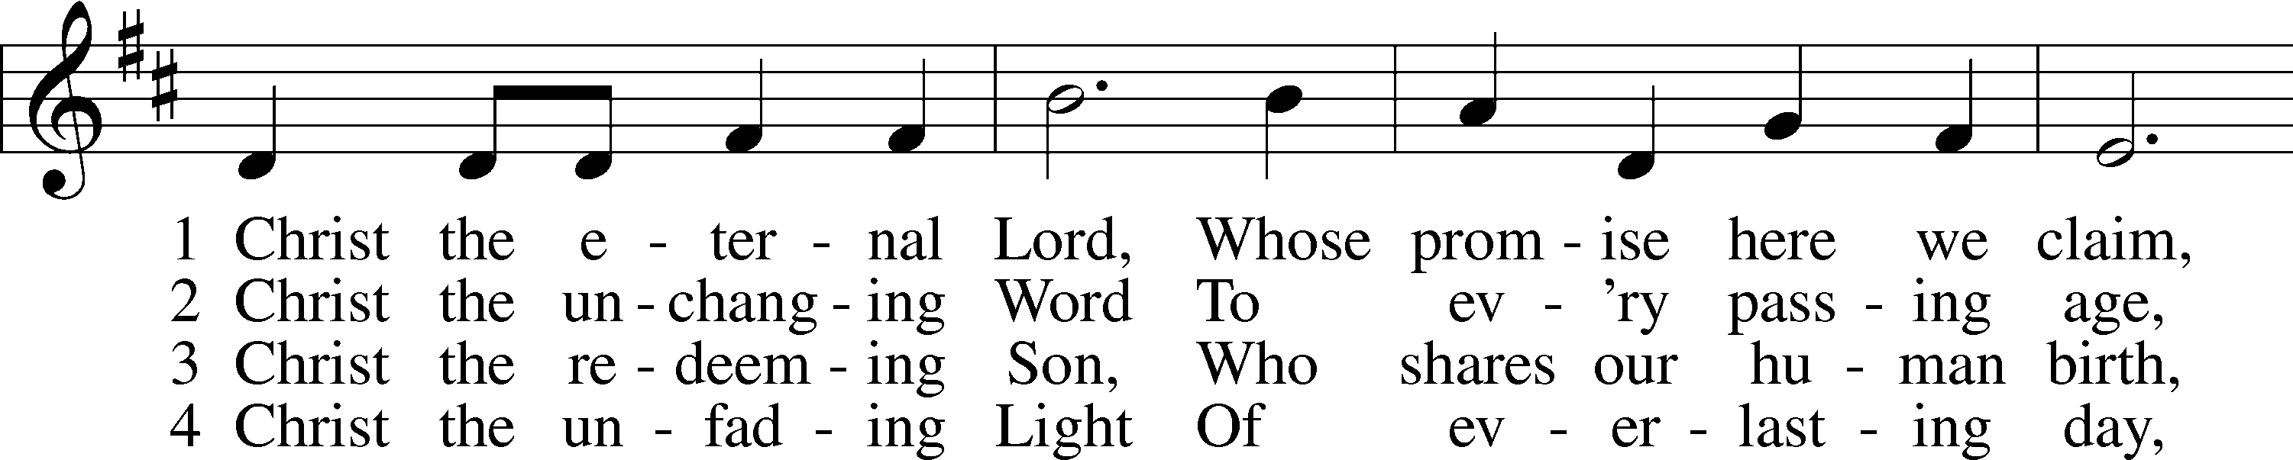
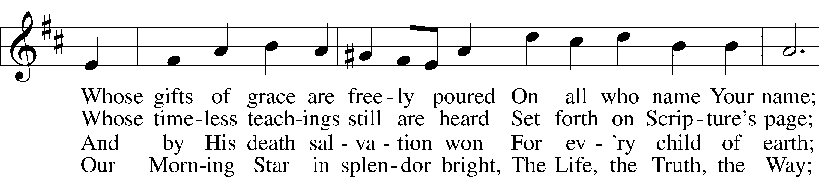
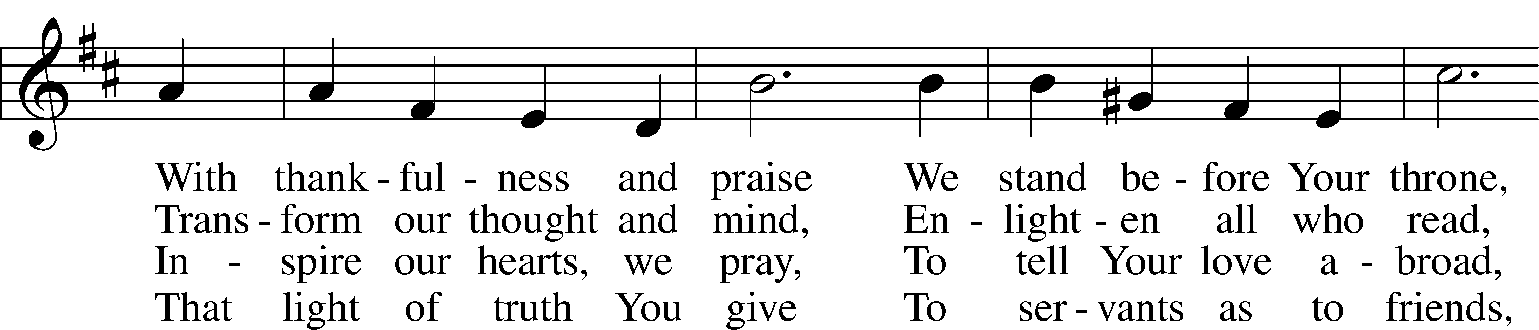
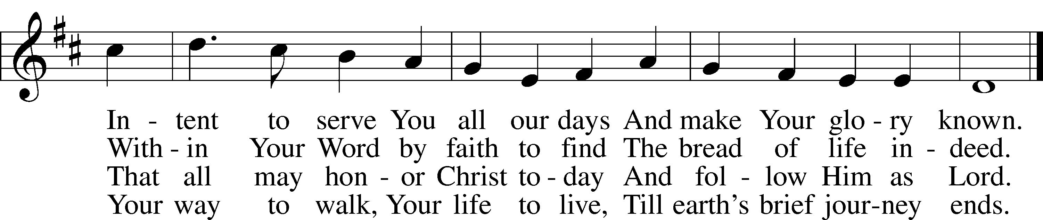
© 1999 Hope Publishing Co. Used by permission: LSB Hymn License .NET, no. 100011641.
Public domain

Pastor: In the Name of the Father and of the Son and Holy Spirit.
Congregation: Amen.

(Please Remain Standing or You May Kneel)
CONFESSION AND ABSOLUTION:
Pastor: Holy God, in your mercy you look with grace and favor upon us, Your people. Hear now, our solemn confession, and as Your Spirit moves us to true repentance, remind us again that You have forgiven us for the sake of Jesus Christ.
Congregation: Father, how often my sinful nature controls my life! I am easily tempted and fall into sin; I am blind to Your will; I am self-serving, self-seeking, self-righteous and deluded; I am dead in sin. The works of my flesh are demonstrated in my actions and thoughts and words. I have not acted as your baptized child. My heart breaks in my shame and guilt. Gratefully I remember Your blood shed for me to wash me clean. I am forgiven. Holy Spirit, control my life.
Pastor: God has heard our cry. He is faithful even when we are not. As your called servant of His Word, I announce that we have what we seek; the entire forgiveness of all our sins, as God’s free gift. New life, new sights and a new heart are ours. Live in the freedom of the Spirit.
Congregation: Amen!

THE PRAYES OF THE DAY:
All: Almighty God, You know we live in the midst of so many dangers that in our frailty we cannot stand upright. Grant strength and protection to support us in all dangers through Jesus Christ, Your Son, our Lord, who lives and reigns with You and the Holy Spirit, one God, now and forever. Amen

SERVICE OF THE WORD

(You may be seated…)
THE FIRST READING: Jeremiah 1:4-10
Lector: This is the Word of the Lord.
People: Thanks be to God.

THE SECOND READING: 1 Corinthians 12:31b-13:13
Lector: This is the Word of the Lord.
People: Thanks be to God.

(Please stand…)
THE HOLY GOSPEL: Luke 4:31-44
Pastor: The Holy Gospel according to St. Luke the 4th chapter.
People: Glory to You, O Lord.
Pastor: This is the Gospel of the Lord.
People: Praise to You, O Christ!

(You may be seated…)
CHILDREN’S MESSAGE

NOISE OFFERING

THE SERMON HYMN: “Be Thou My Vision” Words by Eleanor Hull, Translation by Mary Byrne, Music Tradional Irish Tune, CCLI Song # 30369, CCLI License #11157462

THE SERMON: “I Want To”

(Please stand…)
THE PROFESSION OF FAITH:
Pastor: God has given us a great message to take to His world. Let us remind ourselves and one another of what that message is:
Pastor: I believe in God the Father, Almighty
Congregation: Maker of heaven and earth
Pastor: And in His Son, Jesus Christ our Lord,
Congregation: Who was conceived by the Holy Spirit
Pastor: Born of the Virgin Mary
Congregation: Suffered under Pontius Pilate
Pastor: Was crucified, died and was buried
Congregation: He descended into hell.
Pastor: On the third day He rose again from the dead,
Congregation: And ascended into heaven
Pastor: And sits on the right hand of God, the Father almighty
Congregation: From there He will come to judge the living and the dead
Pastor: I believe in the Holy Spirit,
Congregation: The Holy Christian Church as
All: the communion of saints; the forgiveness of sins, the resurrection of the body, and the life everlasting. Amen.

THE OFFERING: “Healer of Our Every Ill” Vocal Choir

(Please stand…)
THE PRAYER:
Pastor: Lord God, Heavenly Father, You are the Light of our life and the Hope of our salvation.
Response: With you we have nothing to fear.
Pastor: You protect us, and are the source of all our joy and happiness.
Response: Accept our grateful songs of praise.
Pastor: We pray for those whom we now name silently in our hearts or out
loud…According to Your will, heal the sick, strengthen the faith of all who doubt and lift up the depressed. Into Your hand we commend all for whom we pray, trusting in Your mercy, through Your Son, Jesus Christ our Lord.
All: Amen!
SERVICE OF THE SACRAMENT

(You may be seated…)
THE WORDS OF INSTITUTION

DISTRIBUTION HYMNS: “You Satisfy the Hungry Heart” LSB 641
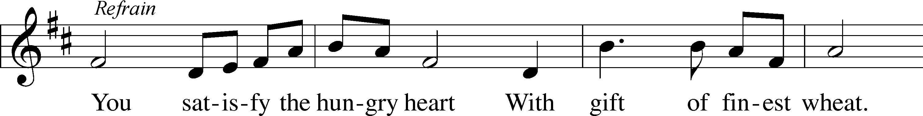
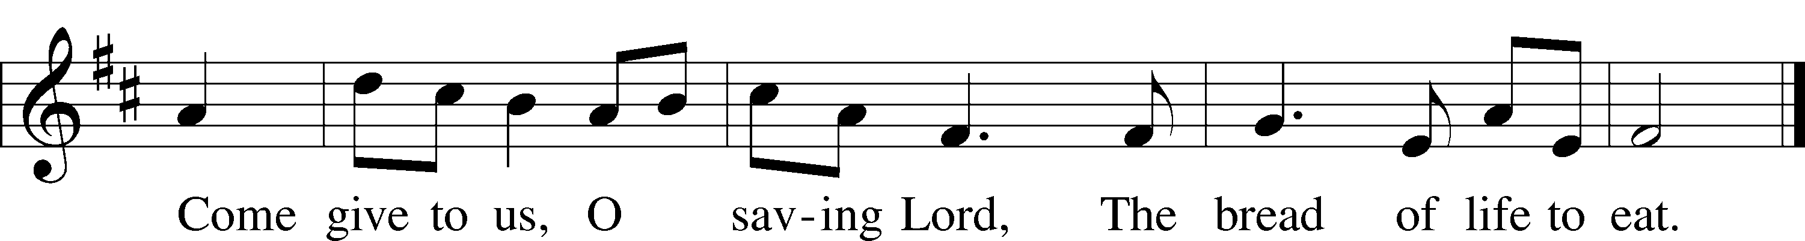
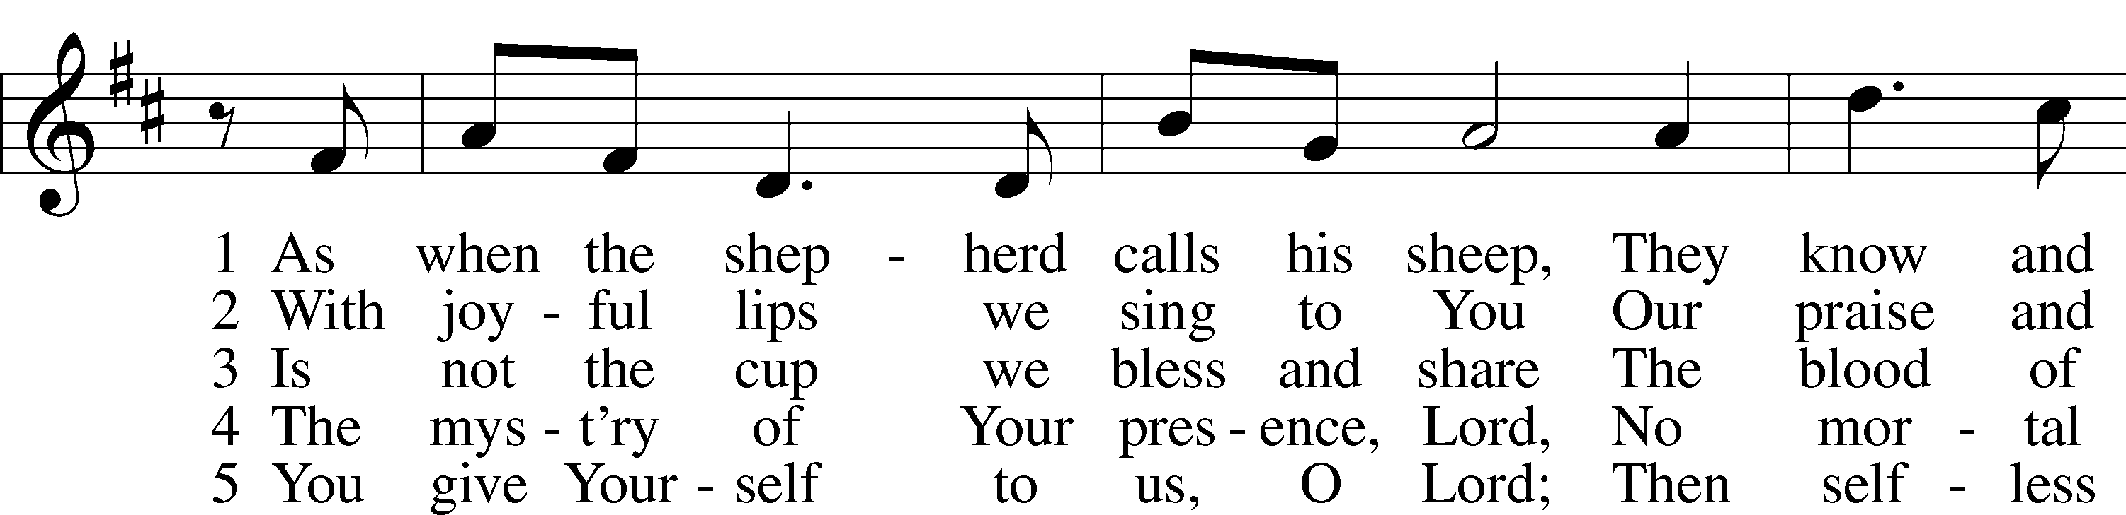
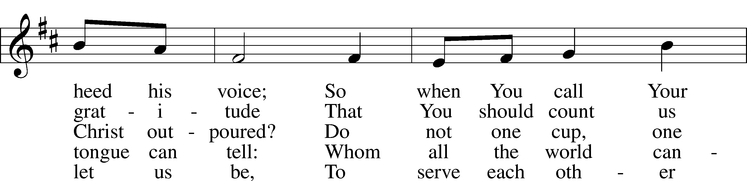
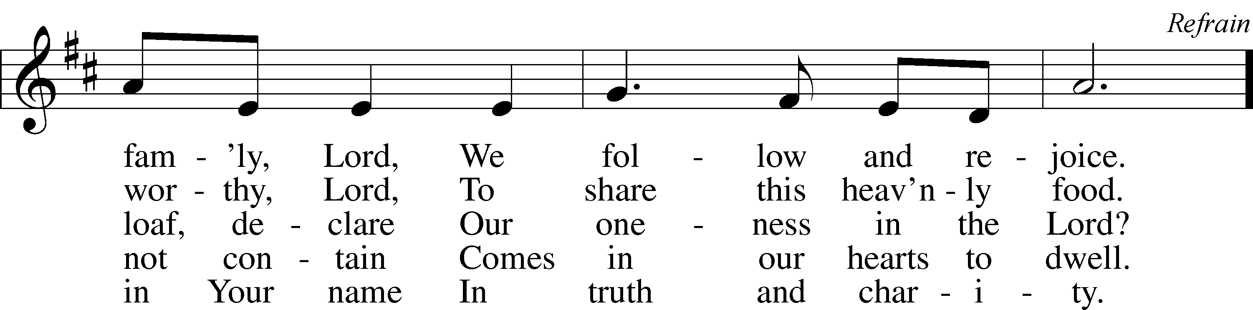
© 1977 Archdiocese of Philadelphia. Used by permission: LSB Hymn License .NET, no. 100011641.

“Jesus Comes Today with Healing” LSB 620
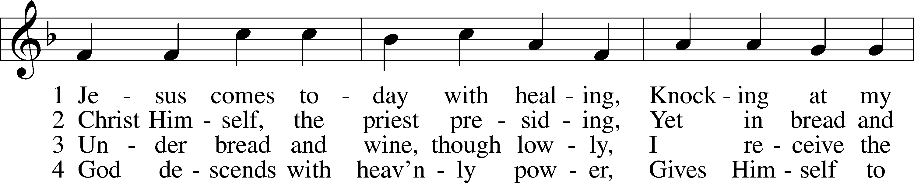
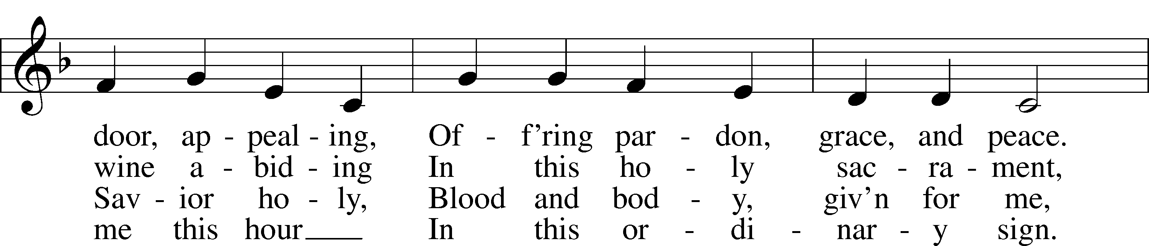
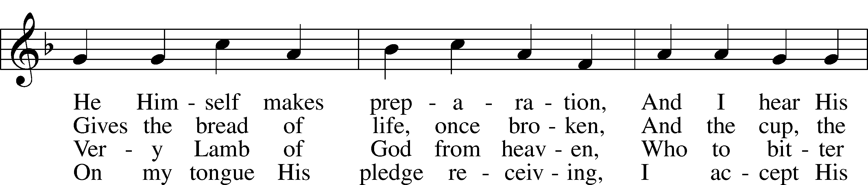
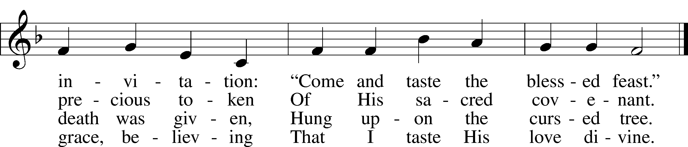

5 Let me praise God’s boundless favor,
Whose own feast of love I savor,
Bidden by His gracious call.
Wedding garments He provides me,
With a robe of white He hides me,
Fits me for the royal hall.

6 Now have I found consolation,
Comfort in my tribulation,
Balm to heal the troubled soul.
God, my shield from ev’ry terror,
Cleanses me from sin and error,
Makes my wounded spirit whole.
© David W. Rogner. Used by permission: LSB Hymn License .NET, no. 100011641.
Public domain
“Take My Life and Let It Be” LSB 784
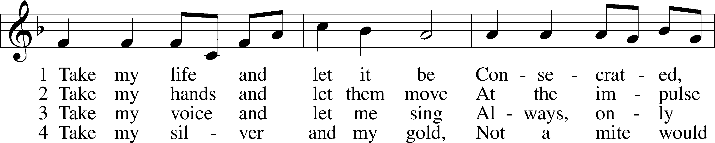
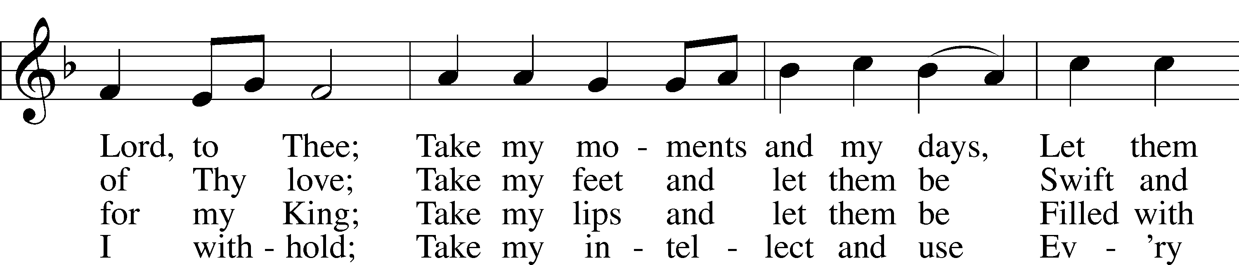
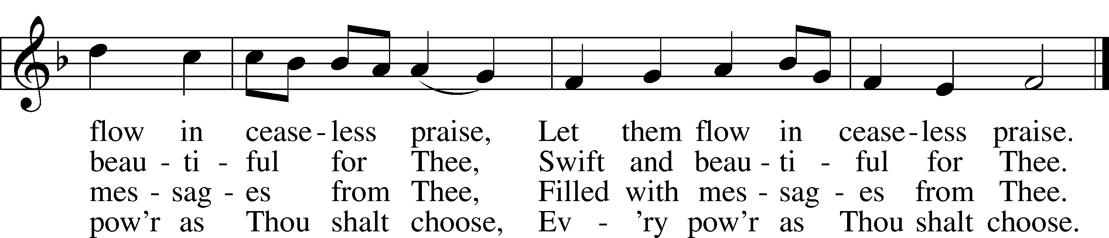

5 Take my will and make it Thine,
It shall be no longer mine;
Take my heart, it is Thine own,
It shall be Thy royal throne.

6 Take my love, my Lord, I pour
At Thy feet its treasure store;
Take myself, and I will be
Ever, only, all for Thee.
Public domain
(Please stand…)
THE LORD’S PRAYER:
All: Our Father, who art in heaven, Hallowed be thy name, thy kingdom come, thy will be done, on earth as it is in heaven. Give us this day our daily bread; and forgive us our trespasses, as we forgive those who trespass against us; and lead us not into temptation, but deliver us from evil. For thine is the kingdom, and the power, and the glory, forever and ever. Amen.

BENEDICTION

THE CLOSING HYMN: “To God Be the Glory”

ANNOUNCEMENTS

WELCOME TO GRACE LUTHERAN CHURCH: We are glad that you are here to worship God with us today! We pray that you will enjoy the wonderful fellowship as friends in Christ as God gathers us around His means of grace, the Word and Sacraments, to bless us with His treasured gifts of forgiveness, faith, abundant life and eternal salvation. If you are a guest, please also sign our Guest Book. Please talk to Pastor if you would like to learn more about becoming a member of Grace. Also, please join us for refreshments and fellowship after the Service. We invite you to come and worship with us often as God gathers us in His Grace.

WELCOME TO THE LORD’S TABLE: We invite and encourage all present who are baptized and faithful Christians, and who confess the Father, Son, and Holy Spirit to be the only true God and who believe that Jesus Christ died for the sins of the World and is our only hope and salvation…to join us in receiving the very and true body and blood of Christ in this Sacrament. The clear liquid cups in the center of the tray are non-alcoholic wine.

Children not yet confirmed in the faith are always welcome to join their parents at the Lord’s Table, but should keep their hands folded in front of them. The Pastor will give them a blessing.

SERVING TODAY: Acolyte: James Reynolds; Lector: Mike Sattelmeier; Communion Assistants: Peter Bacle and ____________; Usher: David Rose; Altar Care: Kathy Greenwood; Refreshments: Morris Family.

SERVING NEXT SUNDAY: Acolyte: Jacob Baugh; Lector: David Walker; Communion Assistants: Don Bly and Edward Morris; Usher: Terry Richardson; Altar Care: ______________; Refreshments: ____________.

FLOWERS: were placed on the altar today by the Faye Pike.

THIS WEEK AT A GLANCE:

Today: This Sunday
9:00 am Worship Service with Communion
10:10 am Children’s Chime and Vocal Choir Rehearsal
10:15 am Fellowship
10:30 am Adult Bible Class/Children’s Sunday School

Monday: February 1st
Pastor’s Day Off
5:00 pm Zumba

Tuesday: February 2nd
3:00 pm Jan’s Mobile Gym (Parish Hall)
6:00 pm Weight Watcher’s (Parish Hall)

Wednesday: February 3rd
8:30 am School Chapel Service
12:30 pm Men’s Bible Fellowship (Chico’s Restaurant)
4:30 pm Women’s Bible Study
5:45 pm Bell Choir Rehearsal

Thursday: February 4th
7:00 pm Missional Community (Parsonage)

Saturday: February 6th
11:00 am Vocal Choir Rehearsal
12:30 am Gracious Ladies of Grace Luncheon (Roostica on Stock Island)

Next Sunday: February 7th
9:00 am Worship Service with Communion
10:00 am Children’s Chime and Vocal Choir Rehearsal
10:15 am Fellowship
10:30 am Adult Bible Class/Children’s Sunday School

IN YOUR PRAYERS THIS WEEK: Erich & Erika Hoffmann, Katharina Lutz, Brian Kay, Al & Kathleen Schubert, Robert & Regina Hoffmann, Jean & Walter Hulme, Carole Steinle, Liz, Ryan Grady, Joanne Cates, Katharina Lutz, Jane Howard, Jean Grafsgaurd, Denis Julson, Mary Kay, Carol McMann, the Marston family, Sandy Harris, the family Carol Sebree, Carol Shimp, Gary Winters, and those you are praying for at home. If anyone has a special prayer request please submit it in writing in the collection plate; or you may call Pastor Gary Faith at (504-858-8872), or Kris Howard at (305-296-5161).

WE HAVE STARTED THE PRAYER LIST OVER: If you would like to keep someone’s name on the list, please let Kris or Pastor know either by placing information in the offering basket or contacting them. Thanks.

GIFTS, TITHES, & ATTENDANCE LAST SUNDAY was $2965.00, building fund received $100.00. The noise offering for the Sunday the 24th of January was totaled $63.63. With 92 in attendance.

TO HELP US GROW… The Bible readings for next Sunday’s service readings are Deuteronomy 34:1-12, Hebrews 3:1-6, Luke 9:28-36.

LENT BEGINS ON ASH WEDNESDAY FEB. 10TH: We will have a potluck at 6pm and worship with the imposition of ashes and Holy Communion at 7pm. This Lenten season we will be looking at some of Jesus parables. “All Jesus did that day was tell stories” Matthew 13:34. Did you ever wonder why Jesus told so many stories?

THANKS TO ALL WHO SUPPORTED our high school youth this past Saturday. It was a wonderful evening filled with fellowship with not only some of our church members but with a good number of people from our community. They will be holding another Cuban Dinner on Saturday February 13th, from 5-7pm. Please come and join in the fun.

ADULT INFORMATION CLASS: We will have another Adult Information Class for those who want to learn more about wheat we believe and teach. If you are interested, please let Pastor know so the dates for these classes can be agreeable for all.

GRACE LUTHERAN SCHOOL IS IN NEED: They are in need of Part Time Teacher Assistants/Substitutes. If you are interested or just have questions, please call the school at 305-296-8262.

THE GRACIOUS LADIES OF GRACE: The Ladies had a nice luncheon at Bobalu's with 11 attending. It got a 4* rating primarily because of slow service but the food and ambience were fine. It must be good because it was crowded. We will be meeting on Sat. Feb. 6th at Roostica on Maloney Ave. Stock Island at 12:30. It was decided that we would try having our lunch one time a month on Sat. for the ladies who can't make it on a week day. Hope to see you there.

THE KEY WESTMINSTER DOG SHOW is scheduled for Saturday Feb 13th from 11am – 1pm at the Little White House. It’s a fun day and a great way to support our school. To register your dog or for more information visit our school website.

MILITARY BIBLESTICKS: During the month of February we will be collecting donations for “Faith Comes By Hearing”. They provide the military overseas with bible sticks. These bible sticks contain an audio version of the New Testament, they withstand weather, and are pocket sized. We will be collecting donation until Sunday February 21st. This will ensure that our donation reaches “Faith Comes By Hearing” before the end of February and all of our contributions will be matched by a donor.

PLEASE JOIN US ON FEBRUARY 14, 2016 as we host an LCEF Sunday. Daniel J. Reichard, Lutheran Church Extension Fund (LCEF) District Vice President will share the “LCEF Story” and how Investments, Loans, and Ministry Support can help move your ministry efforts forward.

LCEF is a financial organization that empowers ministry. The concept of "church extension" began back in 1902 when members of several congregations raised $400 to start a new congregation in a neighboring community. From that inauspicious start, LCEF now empowers ministry through a total asset portfolio of $1.8 billion funded by over 50,000 individuals, congregations, schools, organizations and businesses.
The LCEF business model is rather simple:
Your Investments = Congregation Loans + Ministry Support
Dan Reichard will explain these components and how you can use your financial resources to help move ministry forward.

LCEF is your Ministry Partner

MARK YOU CALENDARS FOR MARCH 6TH we will be having a congregational meeting to dream and plan about what the future of GLCS might look like. Start talking with others about what our strengths, weaknesses, and opportunities might be. We will meet after the fellowship hour and lunch will be served. The leadership of Grace wants to know what you are thinking.

MANY IN THE WORLD are being persecuted for their faith in Jesus. Hugh Smith from Voice of the Martyrs will be speaking on this topic during the Bible Class on March 13th.

YOU MAY SEND CARDS TO SANDY HARRIS at the following address: 12610 Equestrian Circle #1606, Ft. Myers, FL. 33907.

OFFERING ENVELOPES ARE IN THE NARTHEX for all of our members. If you do not see a box with your name on them, please let Kris know and she will prepare a set for you.

PICTORIAL DIRECTORY: The pictures are up. If you do not like the picture of you that is posted you can send one to me that you like better or we can do a retake. If you do not have a picture in the directory and you would like to be included please let me know. As stated before only the names will be published. To find the directory just go to our website; http://gracelutherankw.360unite.com/home, click on ABOUT US. You will then see a drop down menu, click on DIRECTORY. That’s all. If you have not been to our website before please take your time and look around. You will find an updated calendar of our events, information on all of our bible classes, a link to this week’s bulletin, even an audio file of this week’s sermon, and so much more.

THE GRACE LUTHERAN CHURCH WEB PAGE AND FACE BOOK PAGE now contains a vocal recording of last week’s sermon. So if you are not able to attend church on Sunday please go to our website where you will find a copy of the bulletin and a recording of Pastor Faith’s sermon. The new webpage address is gracelutherankw.360unite.

A NUMBER OF CAPITAL IMPROVEMENTS are needed to keep our facilities in good health for the future. The narthex has been rebuilt. Roof repairs are needed on school buildings.
If you can help it would be much appreciated! A big thanks to all who have contributed to these repairs.

MUSIC MINISTRY:

"Make a joyful noise to the Lord, all the earth!" Psalm 100:1. Whether you are here year-round or only part-time, we invite you to participate in our music ministry. Please speak with Beverly Walker or contact her at beverlywalker@gmail.com if you have any questions.

Children's Chime/Vocal Choir (Kindergarten - 4th grade). Rehearses today from 10:10 to 10:25.

Bell Choir: Rehearses on Wednesday from 5:45 - 6:30 pm.

Vocal Choir: Rehearses on Saturday from 11:00 - 12 noon.

WOMEN’S BIBLE STUDY: Experiencing God's Presence is the subject of the next study by Sarah Young from her devotional book Jesus Calling. This study is designed to help meditate on the words of Scripture and hear them not just as words said to people long ago but as words said to us today in the here and now. The goal is to help the heart hear and respond to what the mind reads--to encounter the living God as He speaks through the Scriptures.

Please join us on Wednesday's at 4:30 in room 3 for an hour and enjoy fellowship, grow in your faith, and maybe have some new and enlightening thoughts.

The MEN’S BIBLE FELLOWSHIP will be starting their new study “The Intersection of Church & State”, Wednesday February 3rd. They meet the first and third Wednesday’s of each month at 12:30pm at Chico’s Restaurant. All guys are welcome.

These 3 windows have been donated by individual members of Grace Lutheran. The three windows (Creation,Birth,Crucifixion)are to be installed in March hopefully before Easter. 2 more windows have been donated, the first two to the right of the altar. One being "the Resurrection" and the other "Christ's Second Coming". We have plans for 2 more on the right side. There is only one fully visible window (Heaven) left and the window in the corner (Holy Trinity). As of yet we do not have any donors. The approximate cost is $13,000 each, this includes the stained glass window and the outside impact glass window. If you would like to donate to a window but cannot afford the total price, several families could contribute together. A name plate (if you wish) will be installed directly in the window at the bottom. Given to the glory of God by the family of Mary Smith is an example.
These 7 windows will depict the life of Christ starting with Creation and ending with Heaven. The last window will honor the Holy Trinity. All the windows will include Holy Scripture. Conrad Pickel Studios, owned by Paul Pickel, is a renowned producer of stained glass windows passed down from father to son. They are fortunate to employ the skilled artistry of April Moyer
and it is evidenced in our Christ altar window.
Contact Jim Reynolds or Monica Bacle for a contribution of one of these beautiful windows.
God Bless and thank you for your consideration.

