THIRD SUNDAY AFTER THE EPIPHANY
JANUARY 24TH, 2016 9:00 a.m.
WORSHIP SERVICE
In the Name of Jesus!
Our Mission Statement:
Anchored in Christ, each person a missionary.

PRELUDE

ANNOUNCEMENTS:
We welcome you. We are glad you are here to share with us the joy and peace we have in Jesus Christ. It doesn’t matter whether this is your first time in this church or if you are a lifelong member, you are welcome. We come together today in order to celebrate the gift God has given us-His own Son, Jesus, Our Savior.

PREPARATION

(Please Stand…)
HYMN: “How Great Thou Art” LSB 801
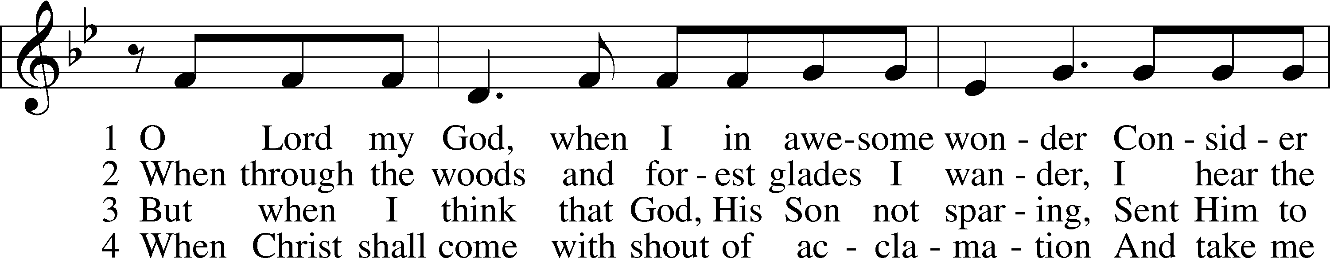
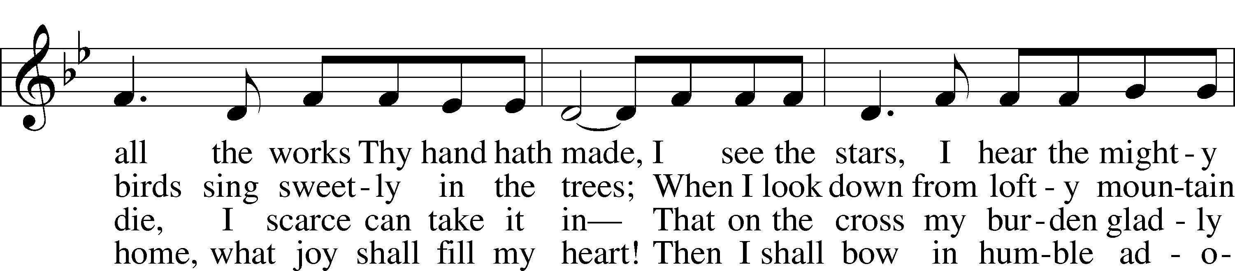
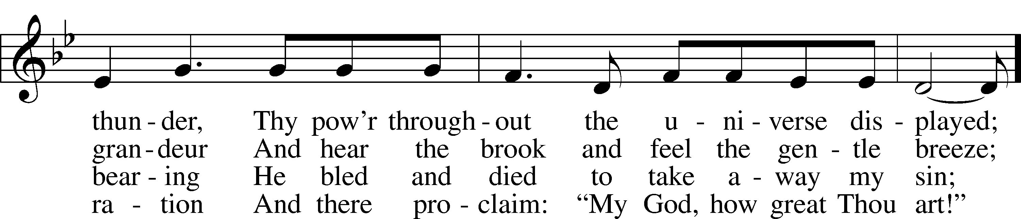
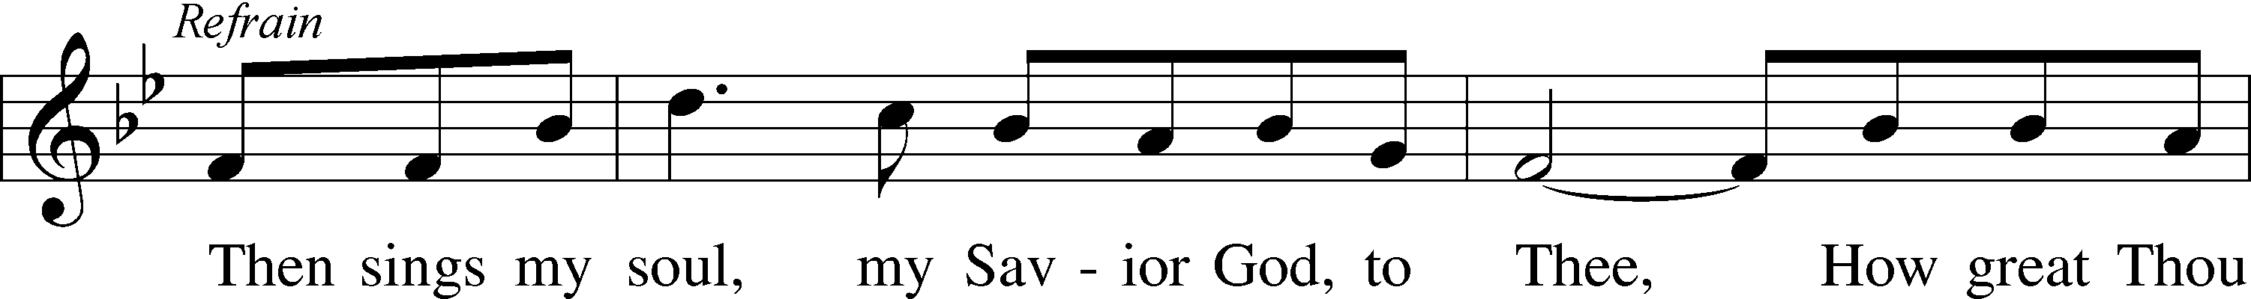
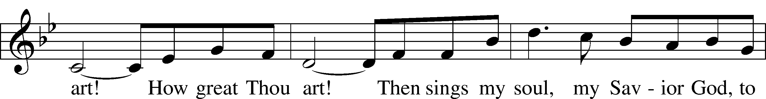
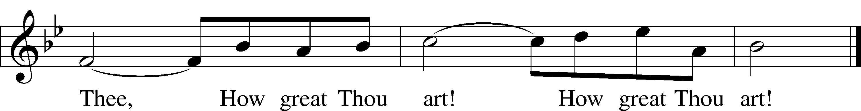
© 1953, renewed 1981 Manna Music. Used by permission: LSB Hymn License .NET, no. 100011641.

Pastor: In the Name of the Father and of the Son and Holy Spirit.
Congregation: Amen.

(Please Remain Standing Or You May Kneel…)
GOD’S PEOPLE CONFESS THEIR SINS:
Pastor: By grace you have been saved, through faith-and this is not from yourselves, it is the gift of God-not of works, so that no man can boast, for we are God’s workmanship, created in Christ Jesus.
Congregation: I know that nothing good lives in me, that is, in my sinful nature, for I have the desire to do what is good, but I cannot carry it out.
Pastor: What I do is not the good I want to do; no, the evil I do not want to do-this I keep doing.
Congregation: In my heart I delight in God’s law, the law that points out what a wretched person I am! Who will rescue me from this body of death?
Pastor: Thanks be to God through Jesus Christ our Lord! Only He can achieve the perfection we fail to achieve. By the forgiveness He purchased on the cross, our forgiveness is complete!

SERVICE OF THE WORD

You may be seated…
OLD TESTAMENT READING: Nehemiah 8:1-3, 5-6, 8-10
Lector: This is the Word of the Lord.
People: Thanks be to God.

THE EPISTLE LESSON: 1 Corinthians 12:12-31a
Lector: This is the Word of the Lord.
People: Thanks be to God.

Please stand…
THE HOLY GOSPEL: Luke 4:16-30
Pastor: The Holy Gospel according to St. Luke the 4th Chapter
People: Glory to You, O Lord.
Pastor: This is the Gospel of the Lord.
People: Praise to You, O Christ!
Please be seated…
CHILDREN’S MESSAGE

NOISE OFFERING

THE SERMON HYMN: “Thy Strong Word” LSB 578
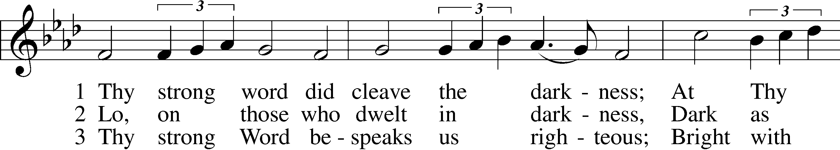
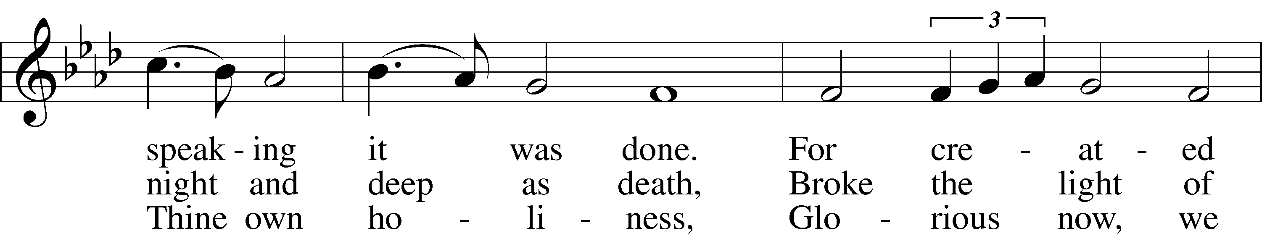
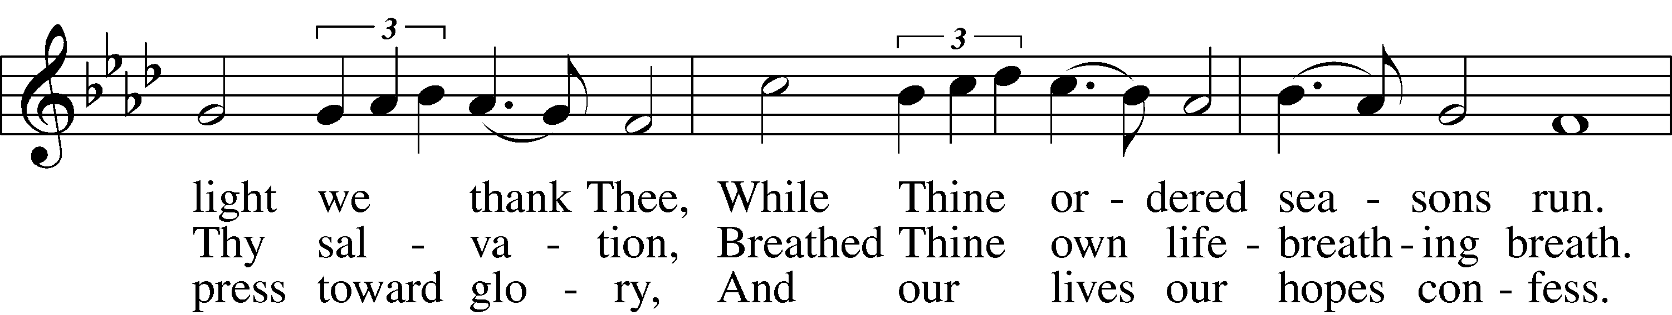
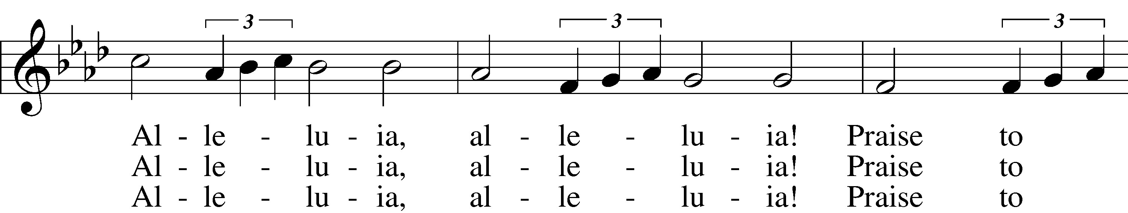
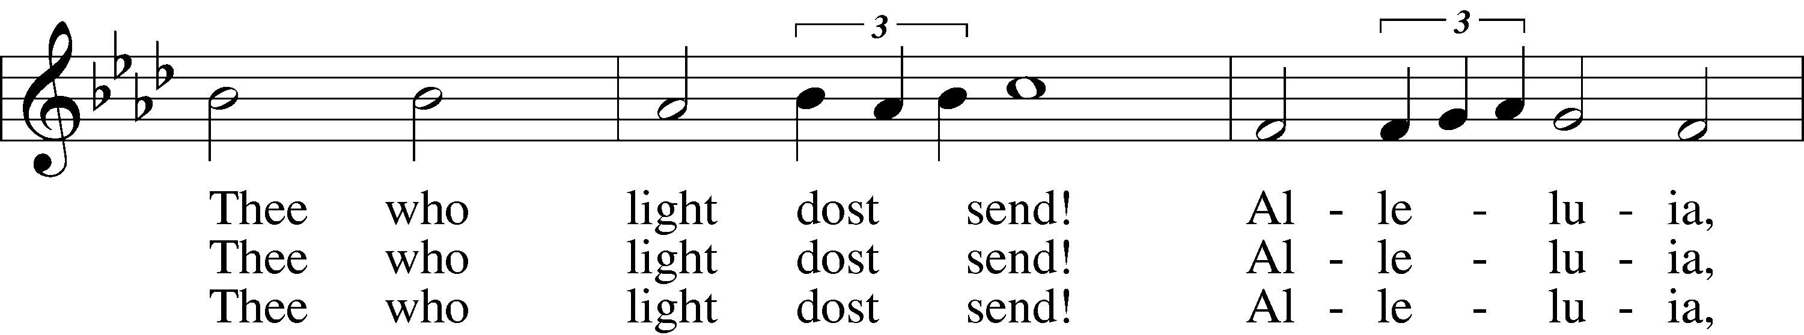
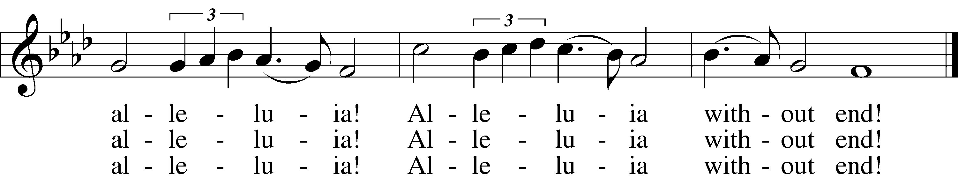

5 Give us lips to sing Thy glory,
Tongues Thy mercy to proclaim,
Throats that shout the hope that fills us,
Mouths to speak Thy holy name.
Alleluia, alleluia!
May the light which Thou dost send
Fill our songs with alleluias,
Alleluias without end!
© 1969 Concordia Publishing House. Used by permission: LSB Hymn License .NET, no. 100011641.
Public domain

THE SERMON

(Please stand…)
THE PROFESSION OF FAITH:
Pastor: God has given us a great message to take to His world. Let us remind ourselves and one another of what that message is:
Pastor: I believe in God the Father, Almighty
Congregation: Maker of heaven and earth
Pastor: And in His Son, Jesus Christ our Lord,
Congregation: Who was conceived by the Holy Spirit
Pastor: Born of the Virgin Mary
Congregation: Suffered under Pontius Pilate
Pastor: Was crucified, died and was buried
Congregation: He descended into hell.
Pastor: On the third day He rose again from the dead,
Congregation: And ascended into heaven
Pastor: And sits on the right hand of God, the Father almighty
Congregation: From there He will come to judge the living and the dead
Pastor: I believe in the Holy Spirit,
Congregation: The Holy Christian Church as
All: the communion of saints; the forgiveness of sins, the resurrection of the body, and the life everlasting. Amen.

OFFERING RECEIVED: “Come, Thou Fount of Every Blessing” Vocal Choir

(Please stand…)
THE PRAYERS OF THE CHURCH: based on Psalm 98
Pastor: Dear Lord, we thank You for everything You’ve done for us, and most of all for Your own Son, Jesus, our Savior. We will never stop praising You for this wonderful gift.
Congregation: Sing to the Lord a new song, for He has done marvelous things; His right hand and His holy arm have worked salvation for Him.
Pastor: We thank You for those missionaries long ago who brought the Good News to our people. When we were in darkness, You sent men and women to bring us the light. Thank you, Lord.
Congregation: The Lord has made His salvation known and revealed His Righteousness to the nations.
Pastor: O Lord, You are our Savior, we trust in You for all our needs, give healing to the sick, courage to those who are afraid, and peace to those we name in our hearts or out loud. (a moment to speak a name out loud or to pray silently) We praise You, gracious Lord, for all Your benefits to us. You give us home, friends and family, food, shelter, rest and everything we need. You give us sight and hearing and touch and taste and provide for all of our needs.
Congregation: Shout for joy to the Lord, praise His Name Amen.

SERVICE OF THE SACRAMENT

(Please be seated…)
THE WORDS OF INSTITUTION

DISTRIBUTION HYMNS: “Praise the One Who Breaks the Darkness” LSB 849
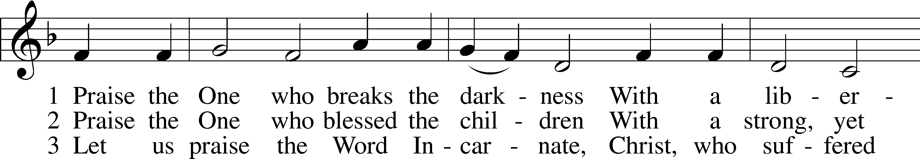
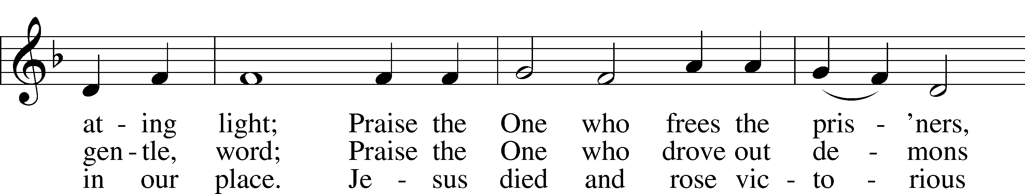
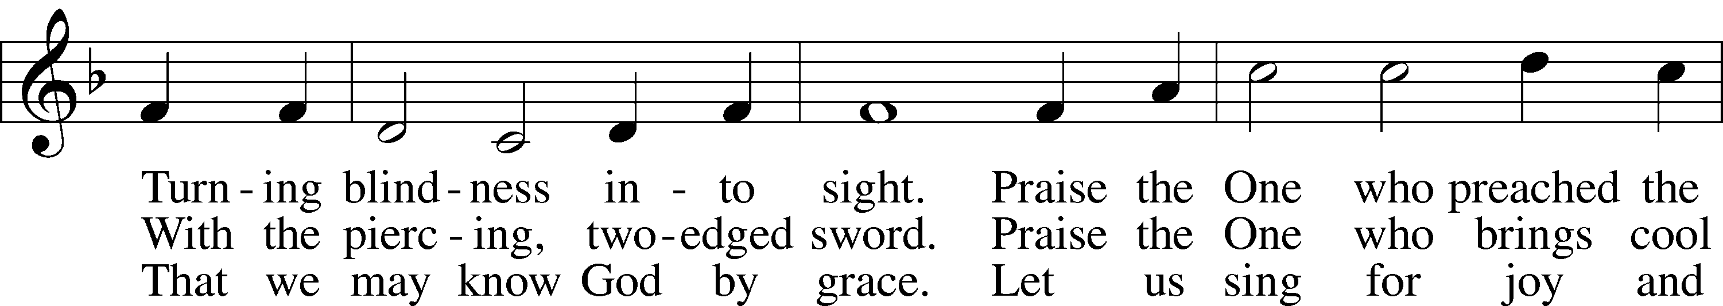
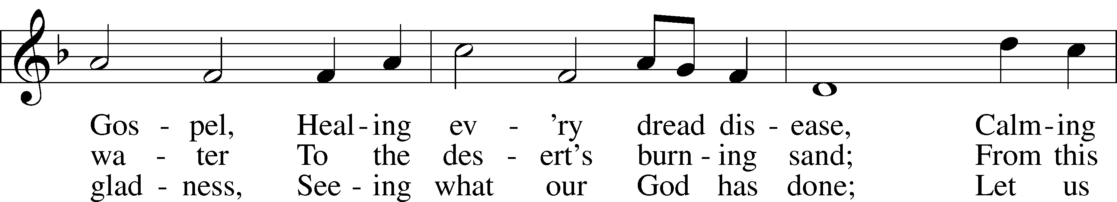
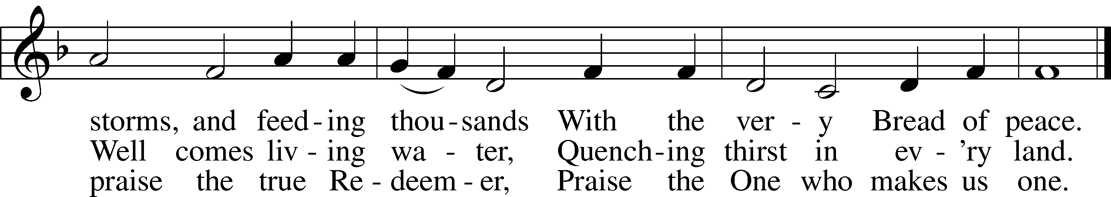
© 1987 Hope Publishing Co. Used by permission: LSB Hymn License .NET, no. 100011641.

“In Christ There Is No East or West” LSB 653
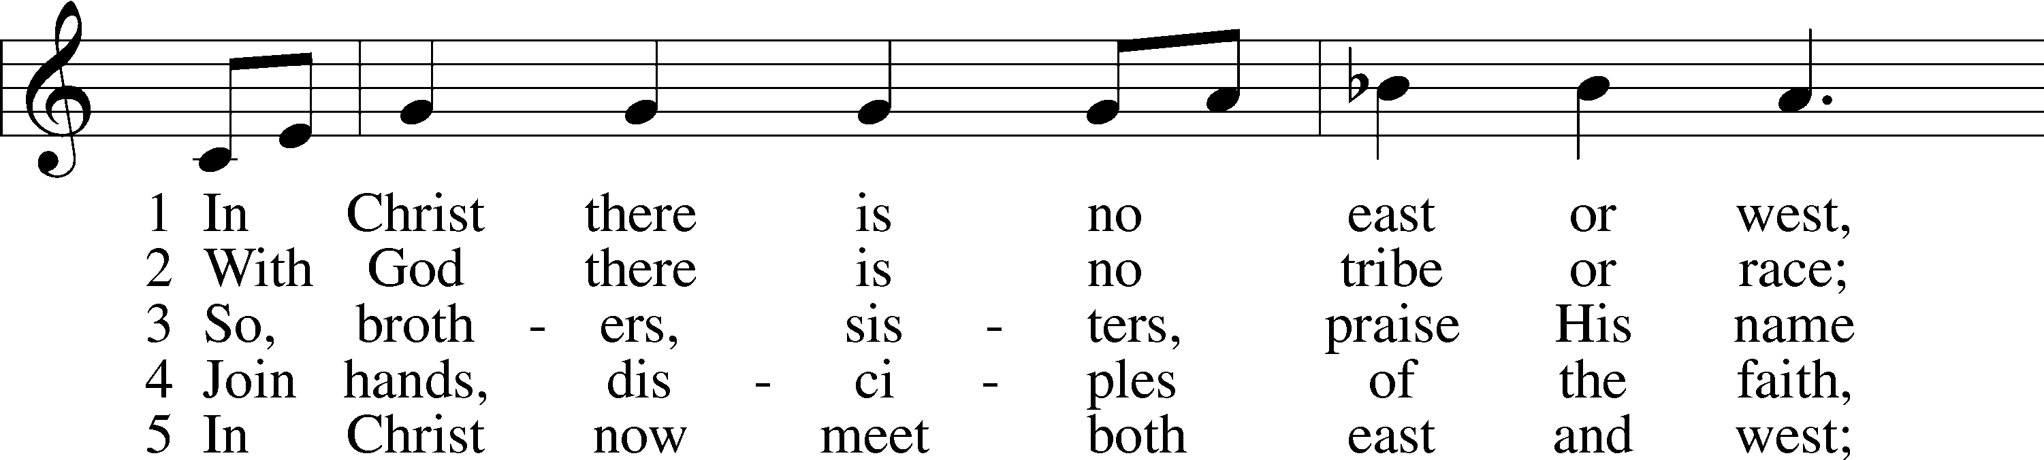
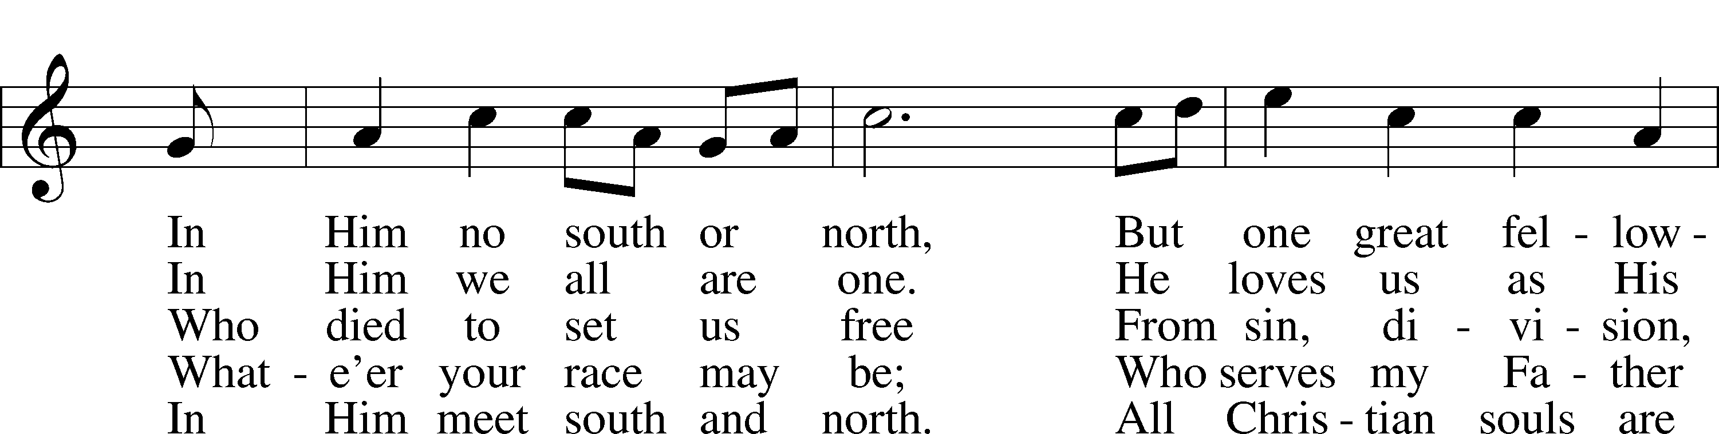
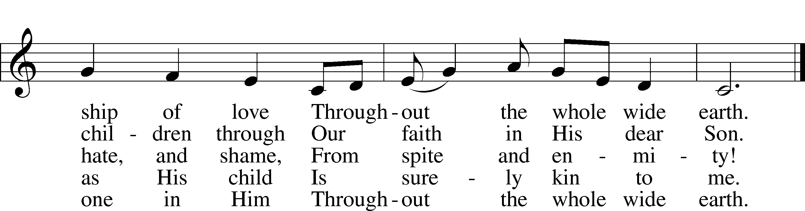
admin. Hope Publishing Co. Used by permission: LSB Hymn License .NET, no. 100011641.; © 1993 Mark A. Jeske; © 1982 Jubilate Hymns Ltd.
Public domain

“I Know That My Redeemer Lives” LSB 461
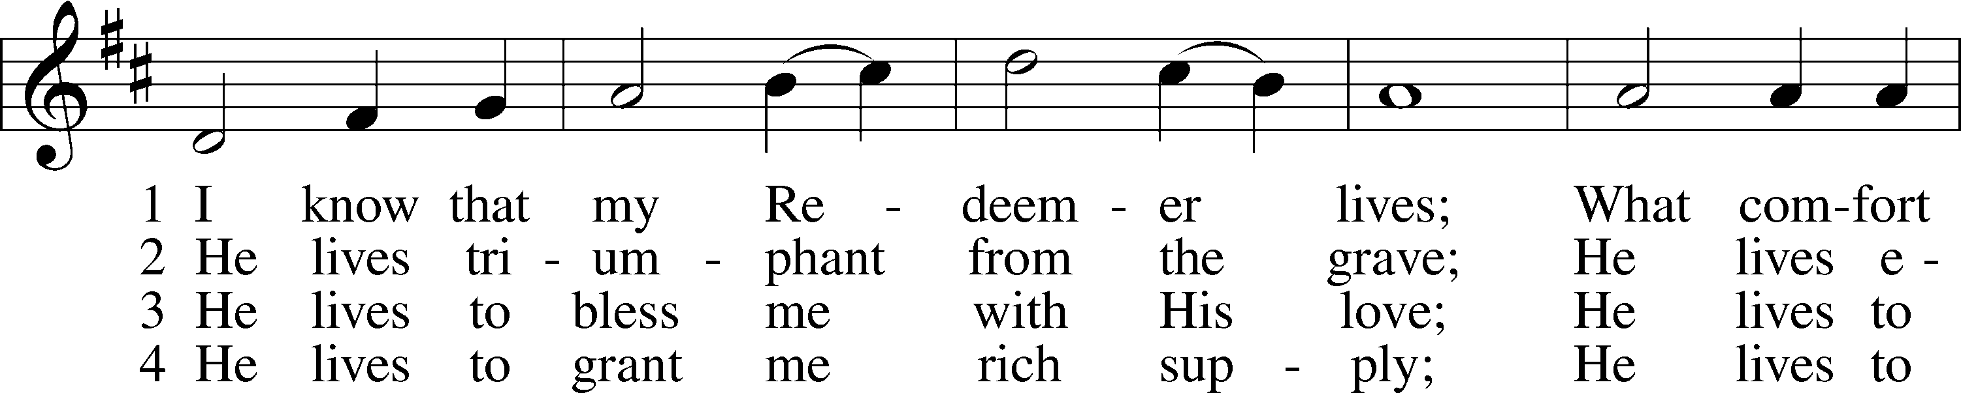
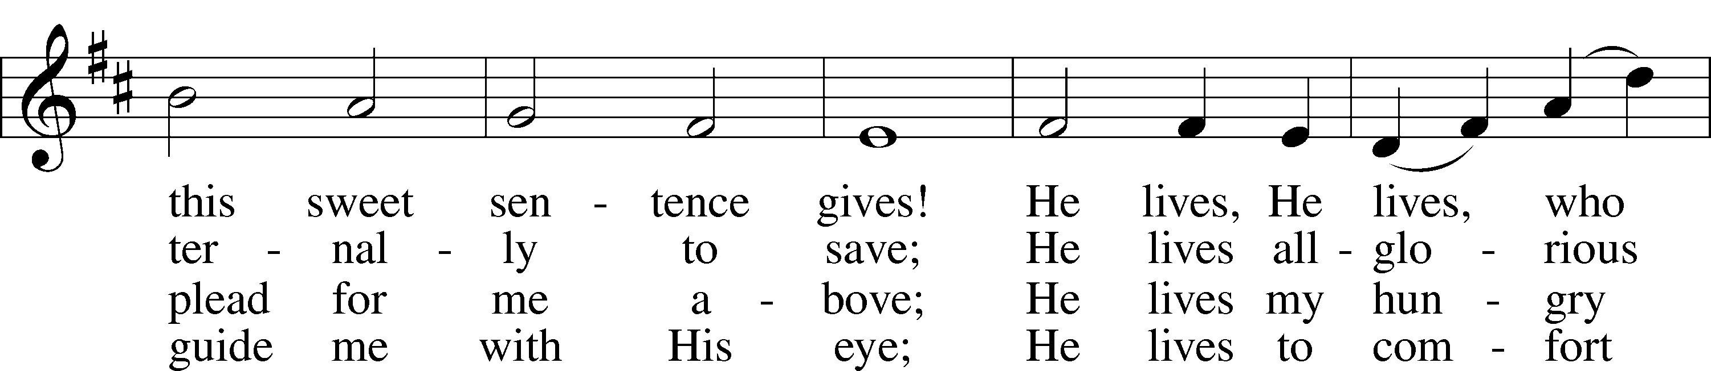
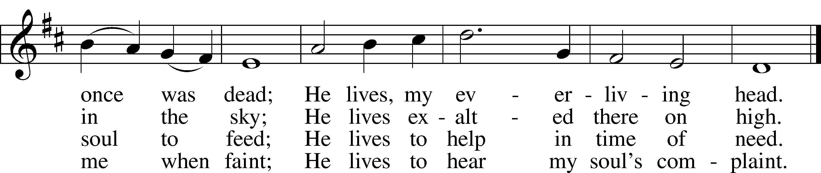

5 He lives to silence all my fears;
He lives to wipe away my tears;
He lives to calm my troubled heart;
He lives all blessings to impart.

6 He lives, my kind, wise, heav’nly friend;
He lives and loves me to the end;
He lives, and while He lives, I’ll sing;
He lives, my Prophet, Priest, and King.

7 He lives and grants me daily breath;
He lives, and I shall conquer death;
He lives my mansion to prepare;
He lives to bring me safely there.

8 He lives, all glory to His name!
He lives, my Jesus, still the same;
Oh, the sweet joy this sentence gives:
I know that my Redeemer lives!
Public domain

(Please stand…)
THE LORD’S PRAYER:
All: Our Father, who art in heaven, hallowed be thy name, thy kingdom come, thy will be done, on earth as it is in heaven. Give us this day our daily bread; and forgive us our trespasses as we forgive those who trespass against us; and lead us not into temptation, but deliver us from evil. For thine is the kingdom, and the power, and the glory, forever and ever. Amen

THE BENEDICTION

CLOSING HYMN: “ I Love to Tell the Story”

ANNOUNCEMENTS

WELCOME TO GRACE LUTHERAN CHURCH: We are glad that you are here to worship God with us today! We pray that you will enjoy the wonderful fellowship as friends in Christ as God gathers us around His means of grace, the Word and Sacraments, to bless us with His treasured gifts of forgiveness, faith, abundant life and eternal salvation. If you are a guest, please also sign our Guest Book. Please talk to Pastor if you would like to learn more about becoming a member of Grace. Also, please join us for refreshments and fellowship after the Service. We invite you to come and worship with us often as God gathers us in His Grace.

WELCOME TO THE LORD’S TABLE: We invite and encourage all present who are baptized and faithful Christians, and who confess the Father, Son, and Holy Spirit to be the only true God and who believe that Jesus Christ died for the sins of the World and is our only hope and salvation…to join us in receiving the very and true body and blood of Christ in this Sacrament. The clear liquid cups in the center of the tray are non-alcoholic wine.

Children not yet confirmed in the faith are always welcome to join their parents at the Lord’s Table, but should keep their hands folded in front of them. The Pastor will give them a blessing.

SERVING TODAY: Acolyte: Elizabeth Reynolds; Lector: David Rose, Communion Assistants: Peter Bacle and Dean Thompson; Usher: David Rose; Altar Care: Emily Howard; Refreshments: Chavarria Family.

SERVING NEXT SUNDAY: Acolyte: James Reynolds; Lector: Mike Sattelmeier; Communion Assistants: Peter Bacle and ____________; Usher: David Rose; Altar Care: _______________; Refreshments: Morris Family.

FLOWERS: were placed on the altar today by the

THIS WEEK AT A GLANCE:

Today: This Sunday
9:00 am Worship Service with Communion
10:10 am Children’s Chime and Vocal Choir Rehearsal
10:15 am Fellowship
10:30 am Adult Bible Class/Children’s Sunday School

Monday: January 25th
Pastor’s Day Off
5:00 pm Zumba

Tuesday: January 26th
3:00 pm Jan’s Mobile Gym (Parish Hall)
6:00 pm Weight Watcher’s (Parish Hall)

Wednesday: January 27th
8:30 am School Chapel Service
4:30 pm Women’s Bible Study
5:45 pm Bell Choir Rehearsal

Thursday: January 28th
7:00 pm Missional Community (Parsonage)

Saturday: January 30th
11:00 am Vocal Choir Rehearsal

Next Sunday: January 31st
9:00 am Worship Service with Communion
10:10 am Children’s Chime and Vocal Choir Rehearsal
10:15 am Fellowship
10:30 am Adult Bible Class/Children’s Sunday School

IN YOUR PRAYERS THIS WEEK: Brian Kay, Al & Kathleen Schubert, Robert & Regina Hoffmann, Jean & Walter Hulme, Carole Steinle, Liz, Ryan Grady, Joanne Cates, Katharina Lutz, Jane Howard, Jean Grafsgaurd, Denis Julson, Mary Kay, Carol McMann, the Marston family, Sandy Harris, the family Carol Sebree, Carol Shimp, Gary Winters, and those you are praying for at home. If anyone has a special prayer request please submit it in writing in the collection plate; or you may call Pastor Gary Faith at (504-858-8872), or Kris Howard at (305-296-5161).

WE HAVE STARTED THE PRAYER LIST OVER: If you would like to keep someone’s name on the list, please let Kris or Pastor know either by placing information in the offering basket or contacting them. Thanks.

GIFTS, TITHES, & ATTENDANCE LAST SUNDAY was $3686.10, building fund received $50.00. The noise offering for the Sunday the 10th of January was totaled $ The door offering for the Pastor of Lord of the Sea Lutheran Church was $253.23. With 94 in attendance.

TO HELP US GROW… The Bible readings for next Sunday’s service readings are Jeremiah 1:4-10, 1 Corinthians 12:31b-13:3, and Luke 4:31-44.

THANKS TO CHAPLAN JASON DART for sharing God’s word with us today. We are glad you and your family are a part of the Grace family.

PATTIE AND PASTOR are on vacation and are scheduled to return Tuesday evening.
ADULT INFORMATION CLASS: We will have another Adult Information Class for those who want to learn more about wheat we believe and teach. If you are interested, please let Pastor know so the dates for these classes can be agreeable for all.

THANKS TO ALL WHO ATTENDED the “Getting to Know You Better Picnic”. A good time was had by one and all.

GRACE LUTHERAN SCHOOL IS IN NEED: They are in need of Part Time Teacher Assistants/Substitutes. If you are interested or just have questions, please call the school at 305-296-8262.

THE GRACIOUS LADIES OF GRACE: The Ladies had a nice luncheon at Bobalu's with 11 attending. It got a 4* rating primarily because of slow service but the food and ambience were fine. It must be good because it was crowded. We will be meeting on Sat. Feb. 6th at Roostica on Maloney Ave. Stock Island at 12:30. It was decided that we would try having our lunch one time a month on Sat. for the ladies who can't make it
on a week day. Hope to see you there.

YOU MAY SEND CARDS TO SANDY HARRIS at the following address: 12610 Equestrian Circle #1606, Ft. Myers, FL. 33907.

OFFERING ENVELOPES ARE IN THE NARTHEX for all of our members. If you do not see a box with your name on them, please let Kris know and she will prepare a set for you.

PICTORIAL DIRECTORY: The pictures are up. If you do not like the picture of you that is posted you can send one to me that you like better or we can do a retake. If you do not have a picture in the directory and you would like to be included please let me know. As stated before only the names will be published. To find the directory just go to our website; http://gracelutherankw.360unite.com/home, click on ABOUT US. You will then see a drop down menu, click on DIRECTORY. That’s all. If you have not been to our website before please take your time and look around. You will find an updated calendar of our events, information on all of our bible classes, a link to this week’s bulletin, even an audio file of this week’s sermon, and so much more.

THE GRACE LUTHERAN CHURCH WEB PAGE AND FACE BOOK PAGE now contains a vocal recording of last week’s sermon. So if you are not able to attend church on Sunday please go to our website where you will find a copy of the bulletin and a recording of Pastor Faith’s sermon. The new webpage address is gracelutherankw.360unite.

A NUMBER OF CAPITAL IMPROVEMENTS are needed to keep our facilities in good health for the future. The narthex has been rebuilt. Roof repairs are needed on school buildings.

If you can help it would be much appreciated! A big thanks to all who have contributed to these repairs.

MUSIC MINISTRY:

"Make a joyful noise to the Lord, all the earth!" Psalm 100:1. Whether you are here year-round or only part-time, we invite you to participate in our music ministry. Please speak with Beverly Walker or contact her at beverlywalker@gmail.com if you have any questions.

Children's Chime/Vocal Choir (Kindergarten - 4th grade). Rehearses today from 10:10 to 10:25.

Bell Choir: Rehearses on Wednesday from 5:45 - 6:30 pm.

Vocal Choir: Rehearses on Saturday from 11:00 - 12 noon.

WOMEN’S BIBLE STUDY: Experiencing God's Presence is the subject of the next study by Sarah Young from her devotional book Jesus Calling. This study is designed to help meditate on the words of Scripture and hear them not just as words said to people long ago but as words said to us today in the here and now. The goal is to help the heart hear and respond to what the mind reads--to encounter the living God as He speaks through the Scriptures.

Please join us on Wednesday's at 4:30 in room 3 for an hour and enjoy fellowship, grow in your faith, and maybe have some new and enlightening thoughts.

The MEN’S BIBLE FELLOWSHIP will be starting their new study “The Intersection of Church & State”, Wednesday February 3rd. They meet the first and third Wednesday’s of each month at 12:30pm at Chico’s Restaurant. All guys are welcome.

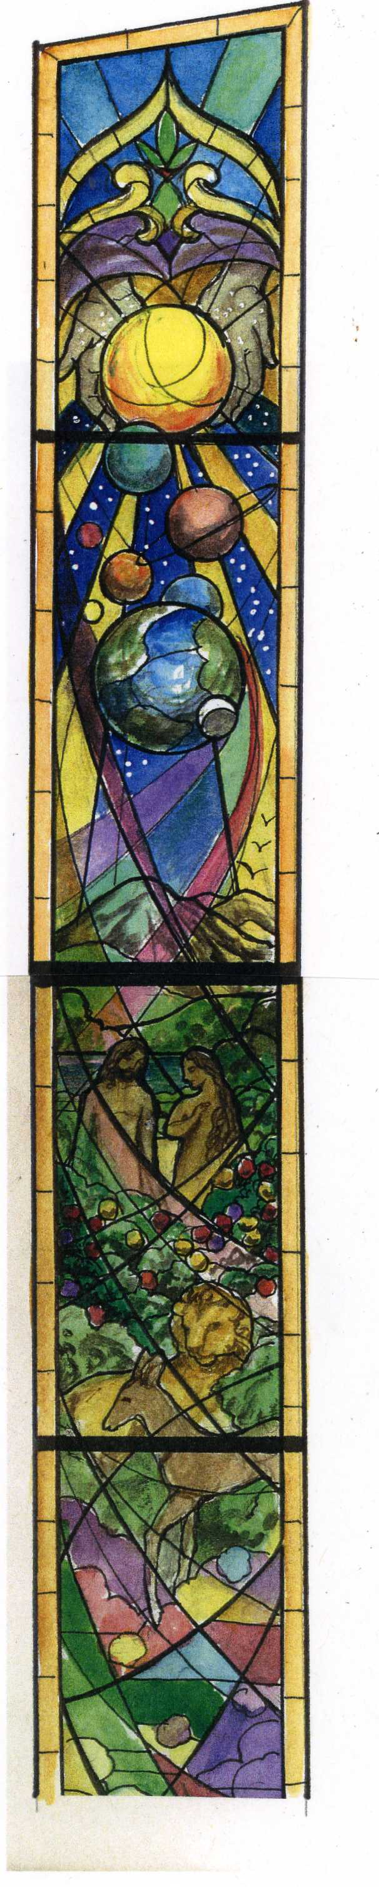
These 3 windows have been donated by individual members of Grace Lutheran. They will be installed on the left side of the church facing the altar in January. We have plans for 4 more on the right side. As of yet we do not have any donors. The approximate cost is $13,000 each, this includes the stained glass window and the outside impact glass window. If you would like to donate to a window but cannot afford the total price, several families could contribute together. A name plate (if you wish) will be installed directly in the window at the bottom. Given to the glory of God by the family of Mary Smith is an example.
These 7 windows will depict the life of Christ starting with Creation and ending with Heaven. The last window will honor the Holy Trinity. All the windows will include Holy Scripture. Conrad Pickel Studios ,owned by Paul Pickel, is a renown producer of stained glass windows passed down from father to son. They are fortunate to employ the skilled artistry of April Moyer
and it is evidenced in our Christ altar window.
Contact Jim Reynolds or Monica Bacle for a contribution of one of these beautiful windows.
God Bless and thank you for your consideration.

