ADVENT SERVICE
DECEMBER 2, 2014 7:00 p.m.
In the Name of Jesus!
Our Mission Statement:
Anchored in Christ, each person a missionary.

WELCOME

(Please stand…)
OPENING HYMN: “O Come, O Come, Emmanuel” LSB 357
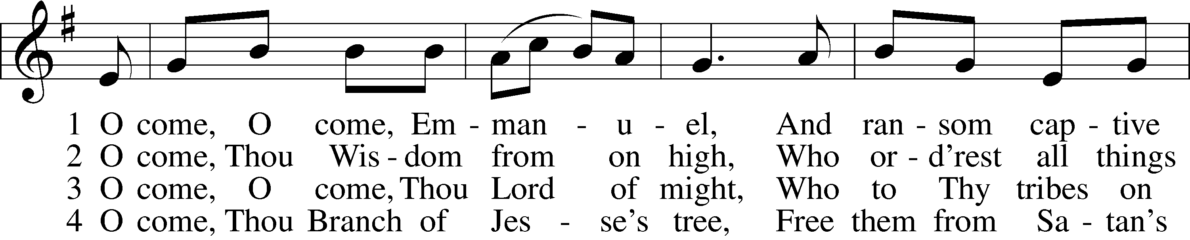
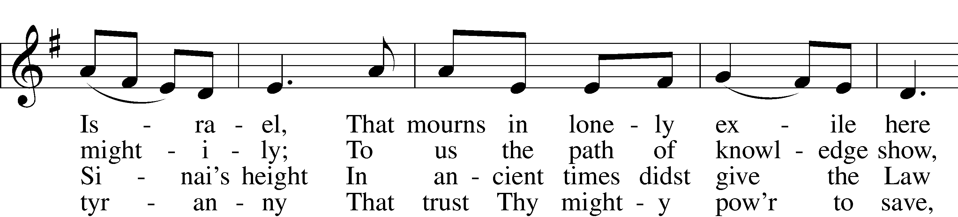
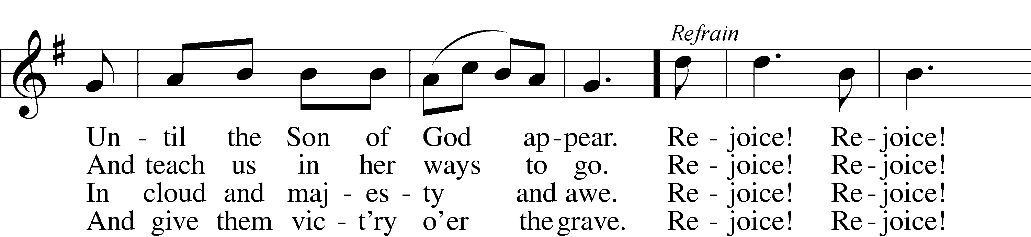
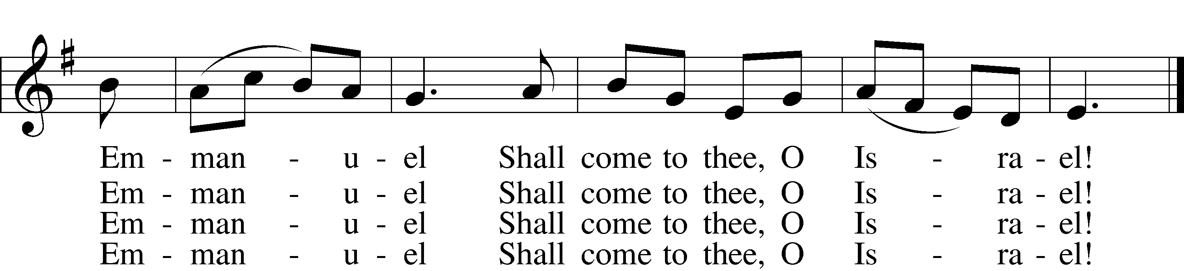

Refrain: Rejoice! Rejoice! Emmanuel
Shall come to thee, O Israel!
Public domain

Pastor: In the Name of the Father and of Son and of the Holy Spirit.
Congregation: Amen

PSALM 1:
Pastor: ¹Blessèd is the man who walks not in the counsel of the wicked, nor stands in
the way of sinners, nor sits in the seat of scoffers;
Congregation: ²but his delight is in the law of the Lord, and on his law he meditates day and
night.
Pastor: ³He is like a tree planted by streams of water that yields its fruit in its season,
and its leaf does not wither. In all that he does, he prospers.
Congregation: ⁴The wicked are not so, but are like chaff that the wind drives away.
Pastor: ⁵Therefore the wicked will not stand in the judgment, nor sinners in the
congregation of the righteous;
Congregation: ⁶for the Lord knows the way of the righteous, but the way of the wicked will
perish.

(Please be seated…)
SERMON HYMN: “Let the Earth Now Praise the Lord” LSB 352
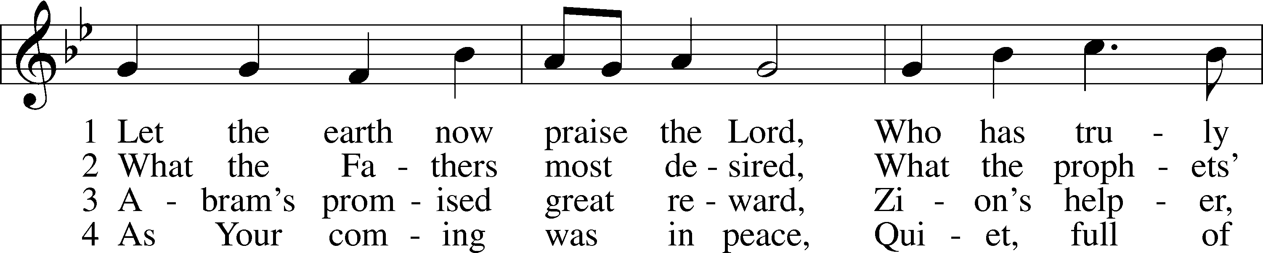
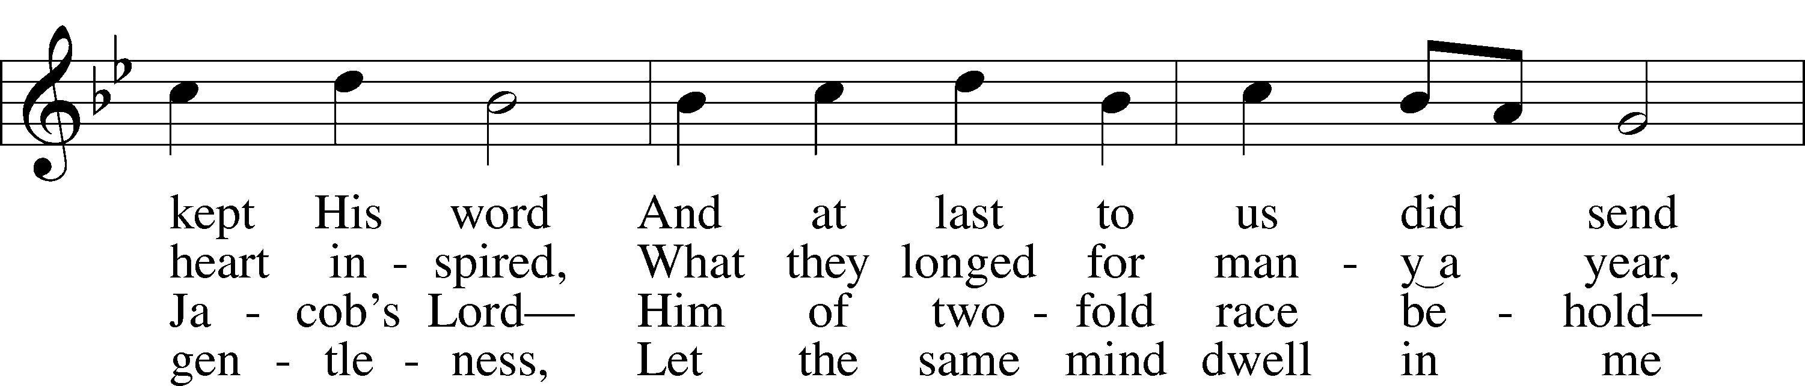
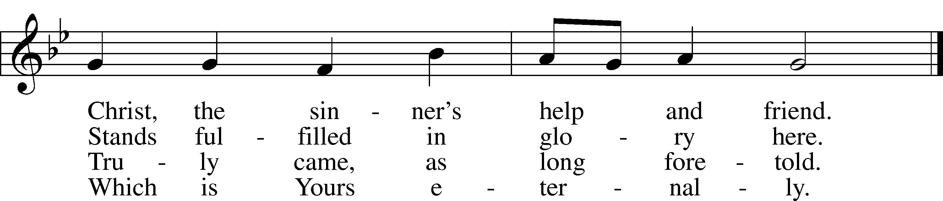

5 Bruise for me the serpent’s head
That, set free from doubt and dread,
I may cling to You in faith,
Safely kept through life and death.
Public domain

SERMON: “Christmas in Genesis” Genesis 3:1-15

¹Now the serpent was more crafty than any of the wild animals the Lord God had made. He said to the woman, “Did God really say, ‘You must not eat from any tree in the garden’?”

² The woman said to the serpent, “We may eat fruit from the trees in the garden, ³ but God did say, ‘You must not eat fruit from the tree that is in the middle of the garden, and you must not touch it, or you will die.’”

⁴ “You will not certainly die,” the serpent said to the woman. ⁵ “For God knows that when you eat from it your eyes will be opened, and you will be like God, knowing good and evil.”

⁶ When the woman saw that the fruit of the tree was good for food and pleasing to the eye, and also desirable for gaining wisdom, she took some and ate it. She also gave some to her husband, who was with her, and he ate it. ⁷ Then the eyes of both of them were opened, and they realized they were naked; so they sewed fig leaves together and made coverings for themselves.

⁸ Then the man and his wife heard the sound of the Lord God as he was walking in the garden in the cool of the day, and they hid from the Lord God among the trees of the garden. ⁹ But the Lord God called to the man, “Where are you?”

¹⁰ He answered, “I heard you in the garden, and I was afraid because I was naked; so I hid.”
¹¹ And he said, “Who told you that you were naked? Have you eaten from the tree that I commanded you not to eat from?”

¹² The man said, “The woman you put here with me—she gave me some fruit from the tree, and I ate it.”

¹³ Then the Lord God said to the woman, “What is this you have done?”
The woman said, “The serpent deceived me, and I ate.”

¹⁴ So the Lord God said to the serpent, “Because you have done this,
“Cursed are you above all livestock
and all wild animals!
You will crawl on your belly
and you will eat dust
all the days of your life.
¹⁵ And I will put enmity
between you and the woman,
and between your offspring and hers;
he will crush your head,
and you will strike his heel.”

Genesis 12:1-4

¹The Lord had said to Abram, “Go from your country, your people and your father’s household to the land I will show you.
² “I will make you into a great nation,
and I will bless you;
I will make your name great,
and you will be a blessing.
³ I will bless those who bless you,
and whoever curses you I will curse;
and all peoples on earth
will be blessed through you.”
⁴ So Abram went, as the Lord had told him; and Lot went with him. Abram was seventy-five years old when he set out from Harran. ⁵ He took his wife Sarai, his nephew Lot, all the possessions they had accumulated and the people they had acquired in Harran, and they set out for the land of Canaan, and they arrived there.

Genesis 49:8-10

⁸ “Judah, your brothers will praise you;
your hand will be on the neck of your enemies;
your father’s sons will bow down to you.
⁹ You are a lion’s cub, Judah;
you return from the prey, my son.
Like a lion he crouches and lies down,
like a lioness—who dares to rouse him?
¹⁰ The scepter will not depart from Judah,
nor the ruler’s staff from between his feet,
until he to whom it belongs shall come
and the obedience of the nations shall be his.

OFFERING

PRAYERS

(Please stand…)
THE LORD’S PRAYER:
Congregation: Our Father, who art in heaven, Hallowed be thy name, thy kingdom come, thy will be done, on earth as it is in heaven. Give us this day our daily bread; and forgive us our trespasses, as we forgive those who trespass against us; and lead us not into temptation, but deliver us from evil. For thine is the kingdom, and the power, and the glory, forever and ever. Amen.

BENEDICTION

THE CLOSING HYMN: “Lord, Bid Your Servant Go in Peace” LSB 937
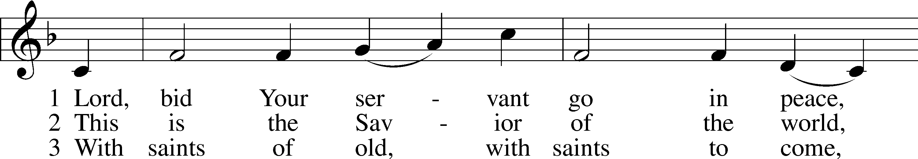
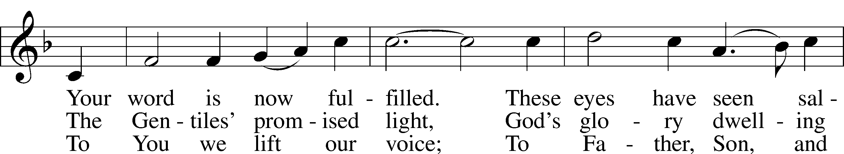
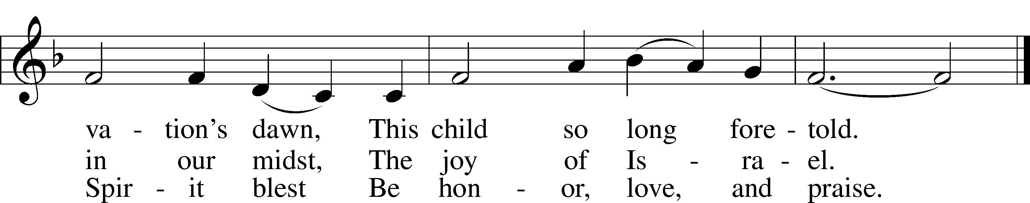
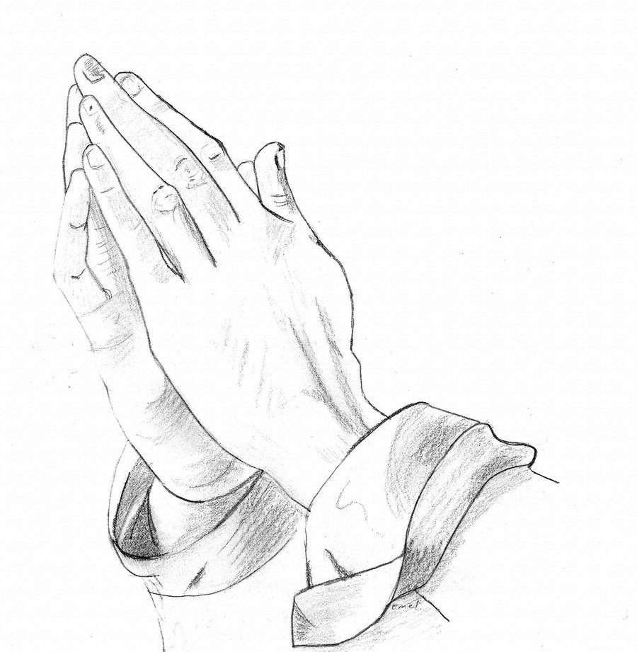
© 1969, 1989 James Quinn; admin. Selah Publishing Co., Inc. Used by permission: LSB Hymn License .NET, no. 100011641.
Public domain

Jesus let the things that break your heart also break our hearts.

Amen

