TWENTY-FOURTH SUNDAY AFTER PENTECOST
NOVEMBER 8TH, 2015 9:00 a.m.
WORSHIP SERVICE
In the Name of Jesus!
Our Mission Statement:
Anchored in Christ, each person a missionary.

PRELUDE

ANNOUNCEMENTS:
God is with us all during the week, wherever we are and in whatever we are doing. This week, let’s enjoy His presence.

OPENING HYMN: “Lord of All Hopefulness” LSB 738
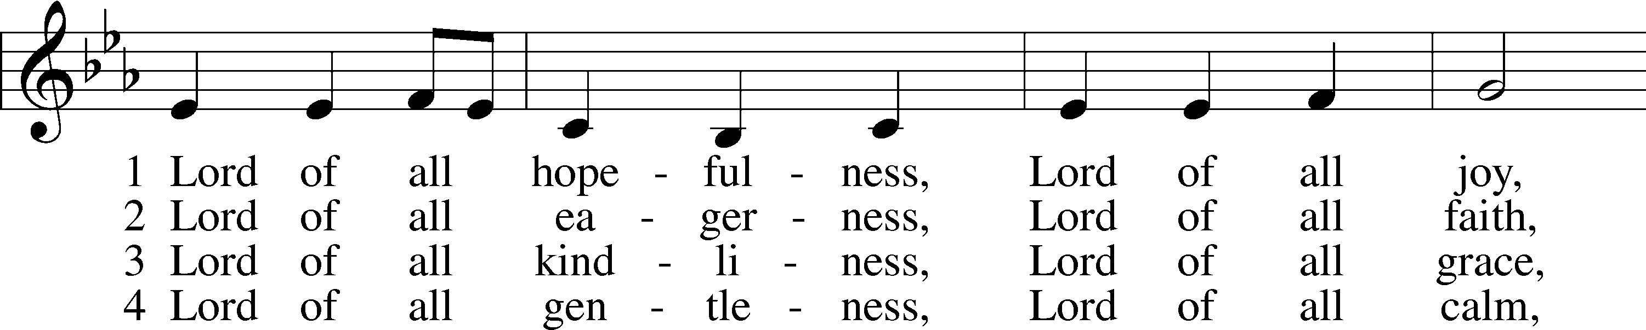
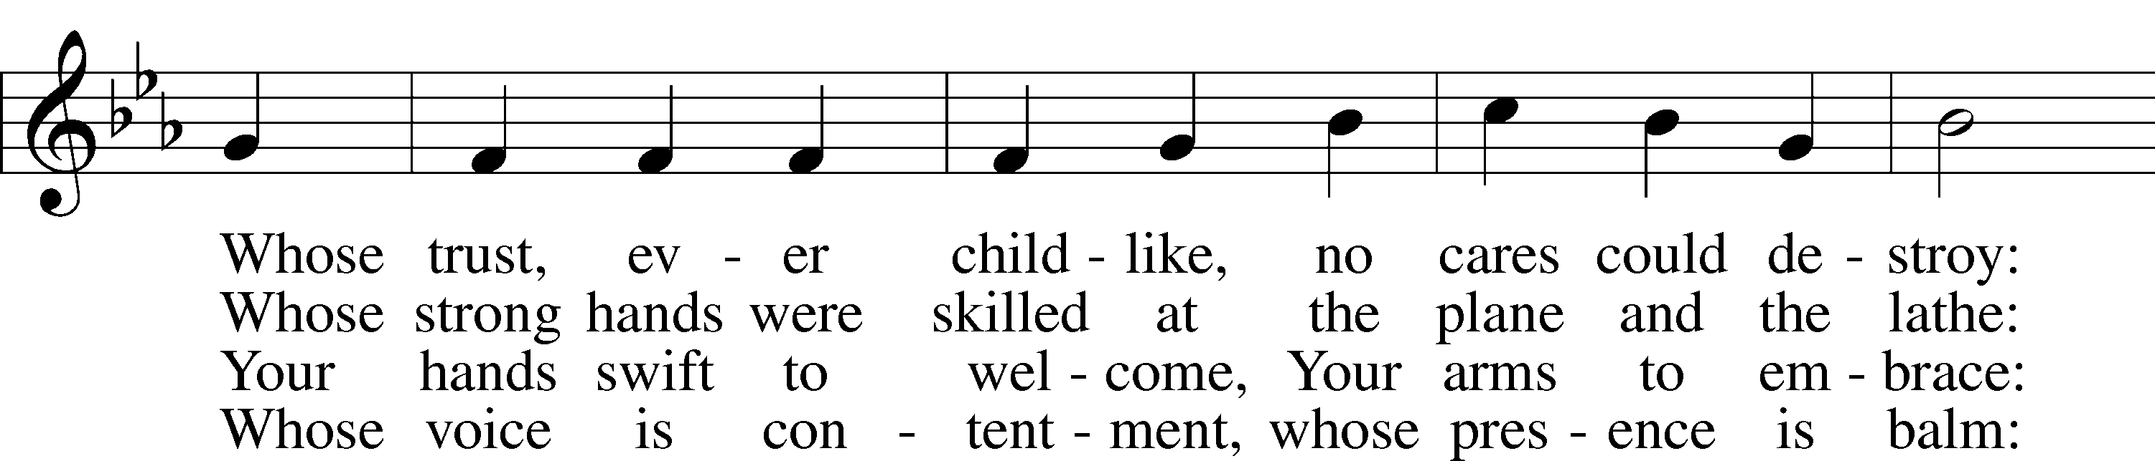
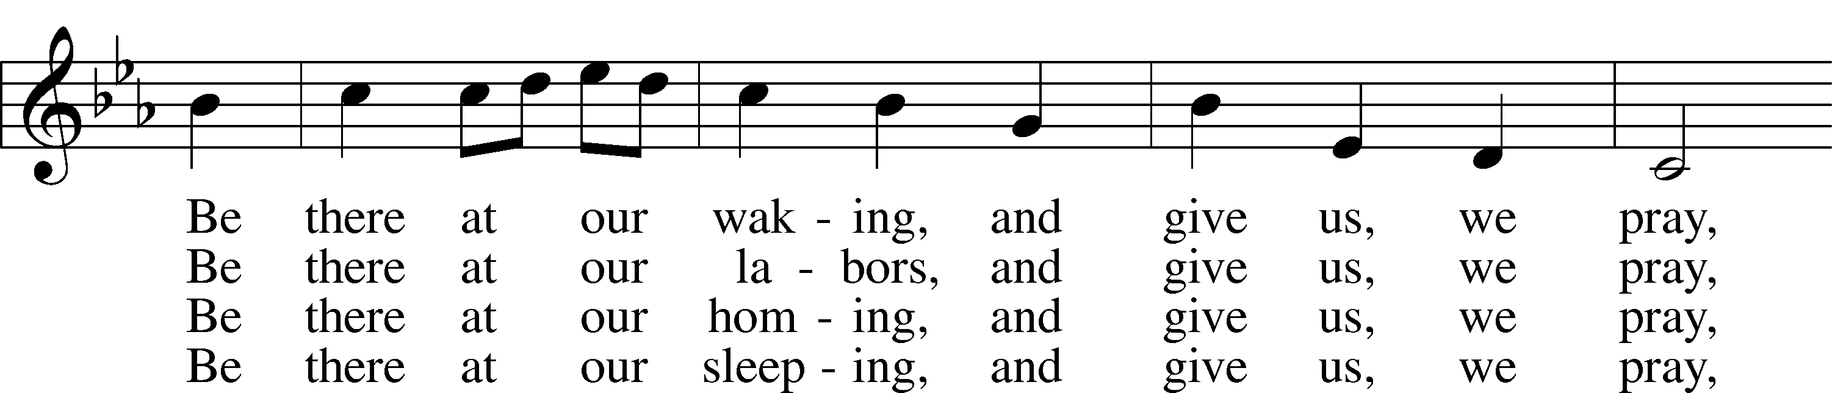
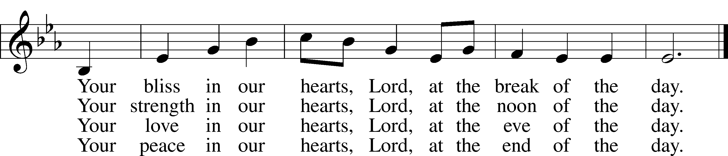
© Oxford University Press. Used by permission: LSB Hymn License .NET, no. 100011641.
Public domain

Pastor: In the Name of the Father and of the Son and of the Holy Spirit.
Congregation: Amen

PREPARATION

(Please Remain Standing Or You May Kneel…)
CONFESSION OF SIN:
All: God, I admit I have broken all of your commandments; I am not holy or sinless even though I often pretend a righteousness I do not have. I offer excuses. I have broken relationships by what I have said, or done. I have not loved either You or my neighbor as I ought. (time for personal confession____)

YOU ARE FORGIVEN:
Pastor: God is merciful and gracious; He has given His Son, Jesus Christ to die and rise again for us, the sinful ones that we might be forgiven and enjoy His Peace. This is also a reminder of God’s gifts and blessing that have become ours in Holy Baptism.
Congregation: thank you God for Your blessing!
Pastor: Yes, the Grace of our Lord Jesus Christ, and the Love of God, and the fellowship of His Holy Spirit is with you all.
Congregation: And also with you.
Pastor: In peace and as His forgiven people, we can pray to the Lord:
Congregation: He is gracious to us and hears our prayers.
Pastor: For the peace of the whole world and our involvement in Christ’s Mission in the world, we pray:
Congregation: Keep us mindful of our purpose as Christians and our ability to share your blessings of peace and forgiveness with others.
Pastor: We are the children of the Risen Christ. His victory is Our Victory!
THE PRAYERS OF THE CHURCH:
All: Lord Jesus Christ, whose grace always precedes and follows us, help us to forsake all trust in earthly gain and to find in You our heavenly treasure; for You live and reign with the Father and the Holy Spirit, one God, now and forever. Amen

SERVICE OF THE WORD

God speaks to us through his word, the Bible:

(You may be seated…)
THE OLD TESTAMENT LESSON: 1 Kings 17:8-16
Lector: This is the Word of the Lord.
People: Thanks be to God.
THE EPISTLE LESSON: Hebrews 9:24-28
Lector: This is the Word of the Lord.
People: Thanks be to God.

(Please stand…)
THE HOLY GOSPEL: Mark 12:38-44
Pastor: The Holy Gospel according to St. Mark Chapter 38.
People: Glory to You, O Lord.
Pastor: This is the Gospel of the Lord.
People: Praise to You, O Christ!

(Please be seated…)
NOISE OFFERING

THE SERMON HYMN:

THE SERMON: “Moving Toward All In” 1 Kings 17:8-16, Mark 12:38-44

OFFERING
SERVICE OF THE SACRAMENT

(Please stand…)
PREPARE FOR THE LORD’S SUPPER:
Pastor: We begin with the reminder: “The Lord is with you.”
Congregation: We are mindful and thankful for His presence.
Pastor: Let your life reflect the joy of your salvation.
Congregation: We do give Him thanks and praise. We will share His blessing with others.
Pastor: It is proper that we should at all times and in all places…(prayer)… we praise your name and join others in singing:
All: (sing) “Holy, holy, holy Lord God of pow’r and might:
Heaven and earth are full of your glory.
Hosanna, Hosanna, Hosanna in the highest.
Blessed is he who comes in the name of the Lord.
Hosanna in the highest.”

(Please be seated…)
THE CONSECRATION AND DISTRIBUTION:

Hymns: “You Satisfy the Hungry Heart” LSB 641
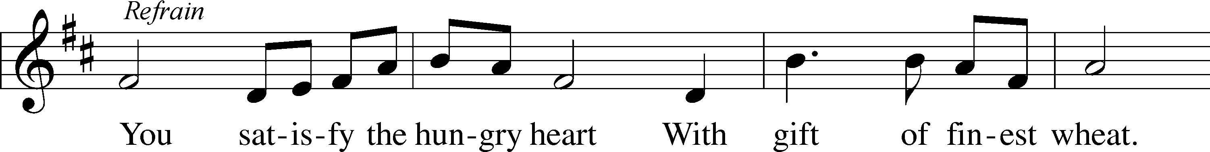
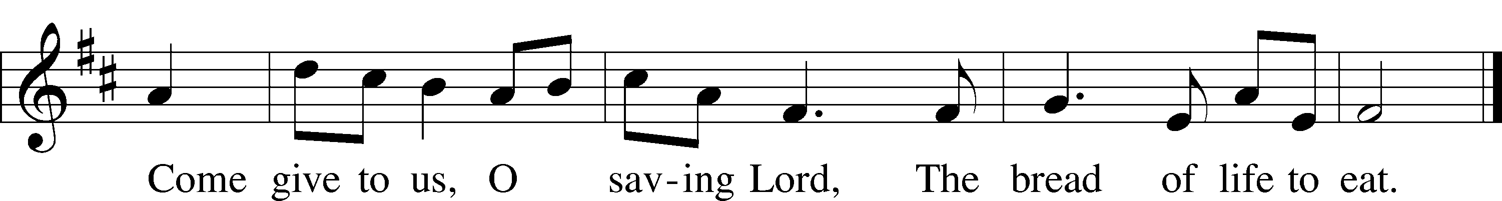
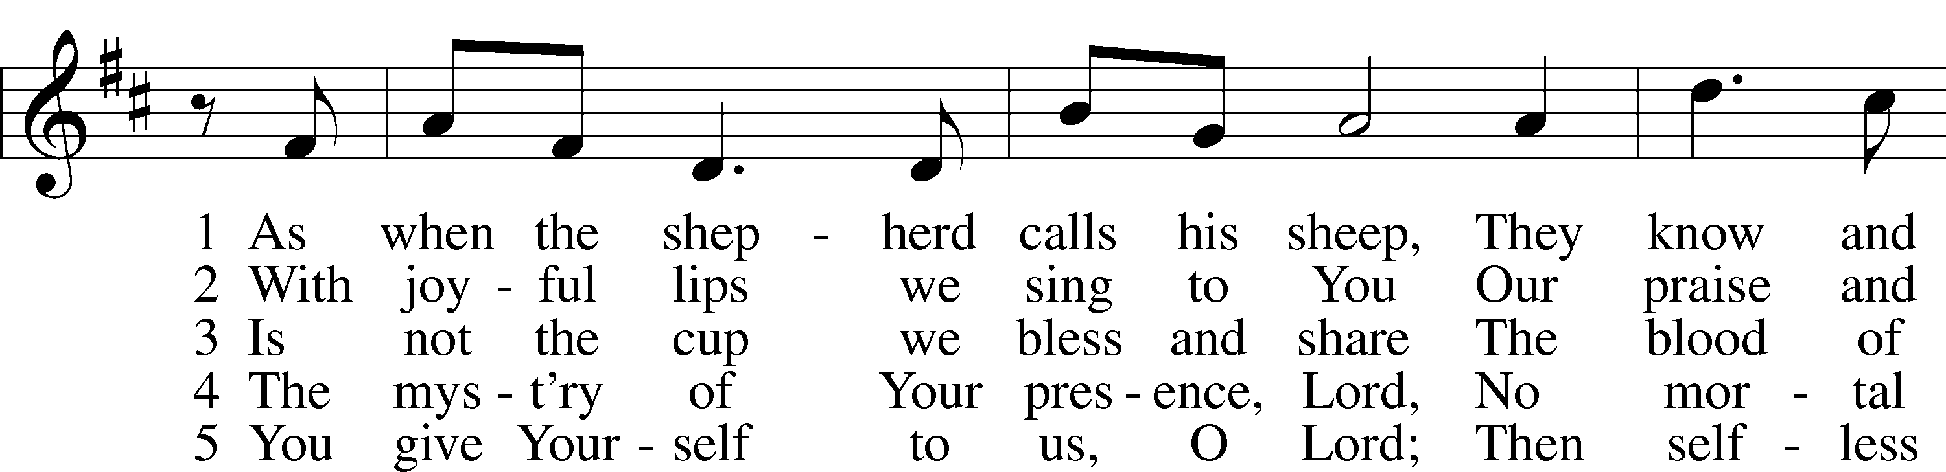
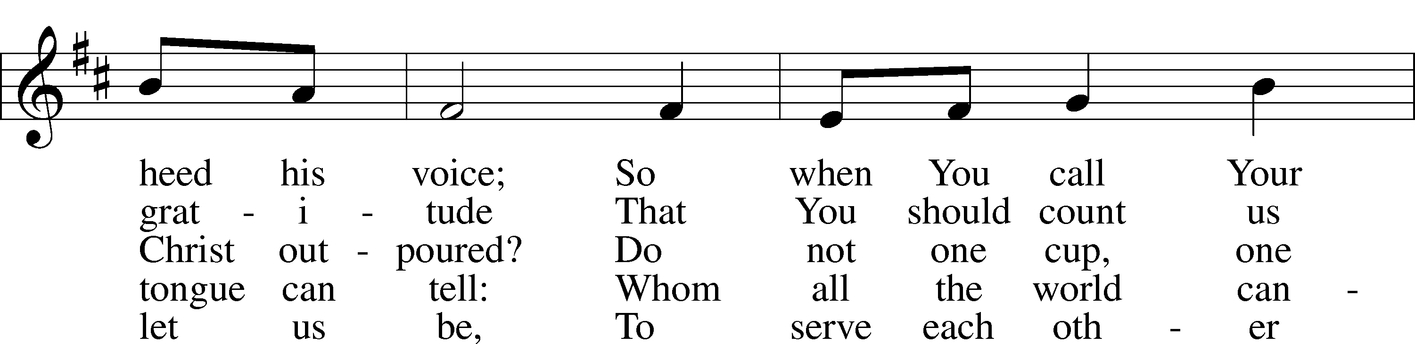
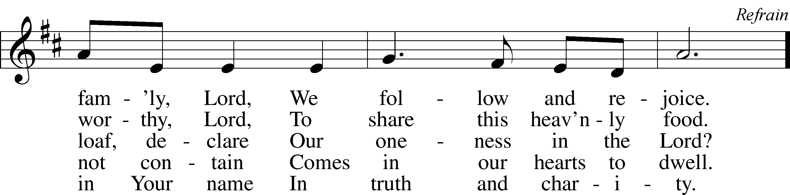
© 1977 Archdiocese of Philadelphia. Used by permission: LSB Hymn License .NET, no. 100011641.

“The Temple Rang with Golden Coins” LSB 787
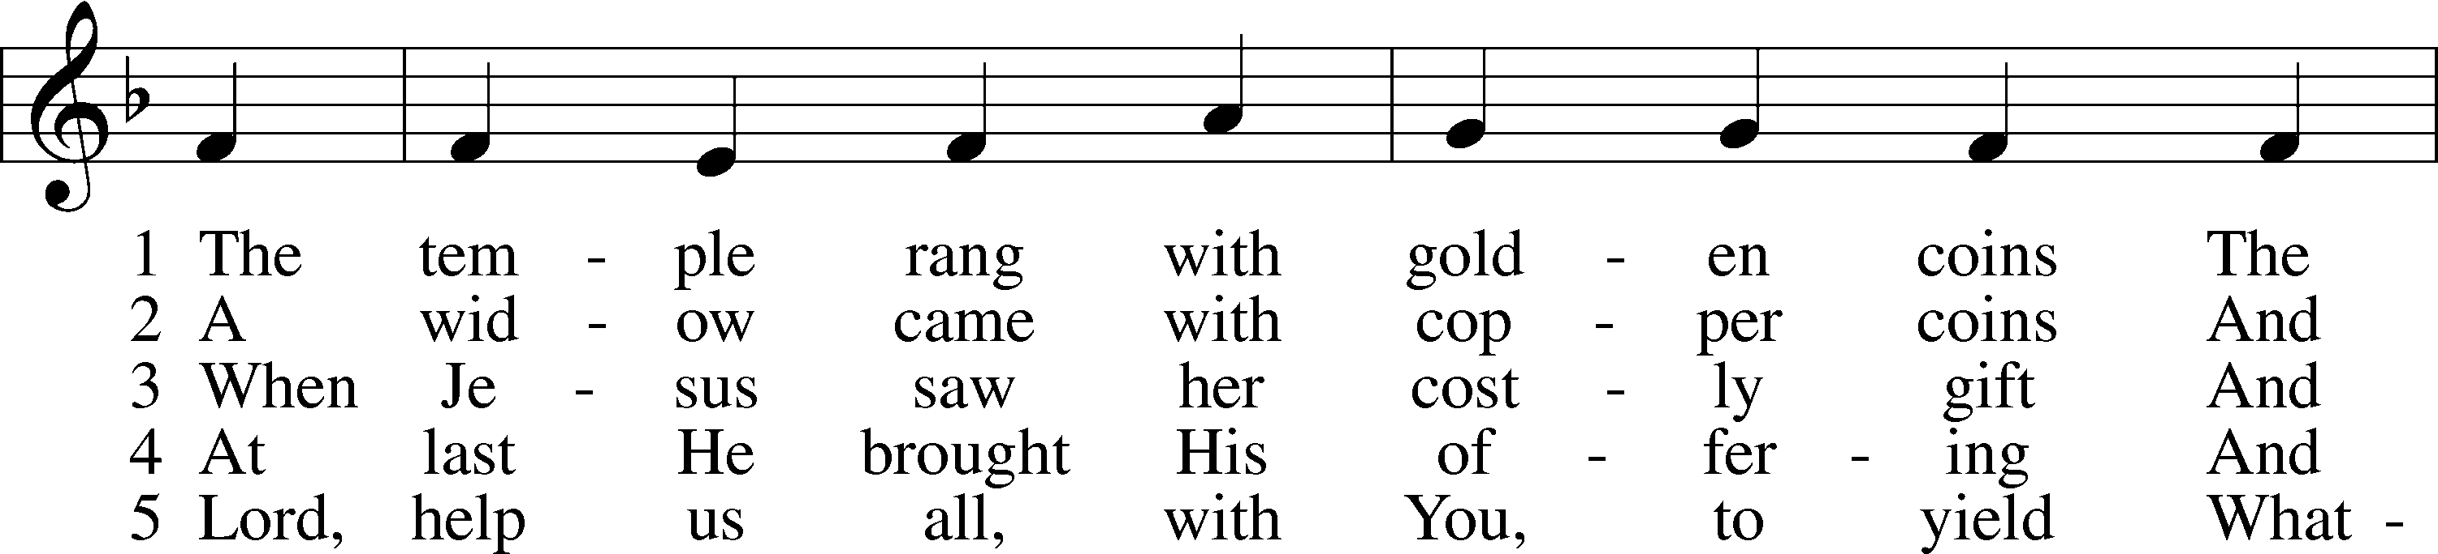
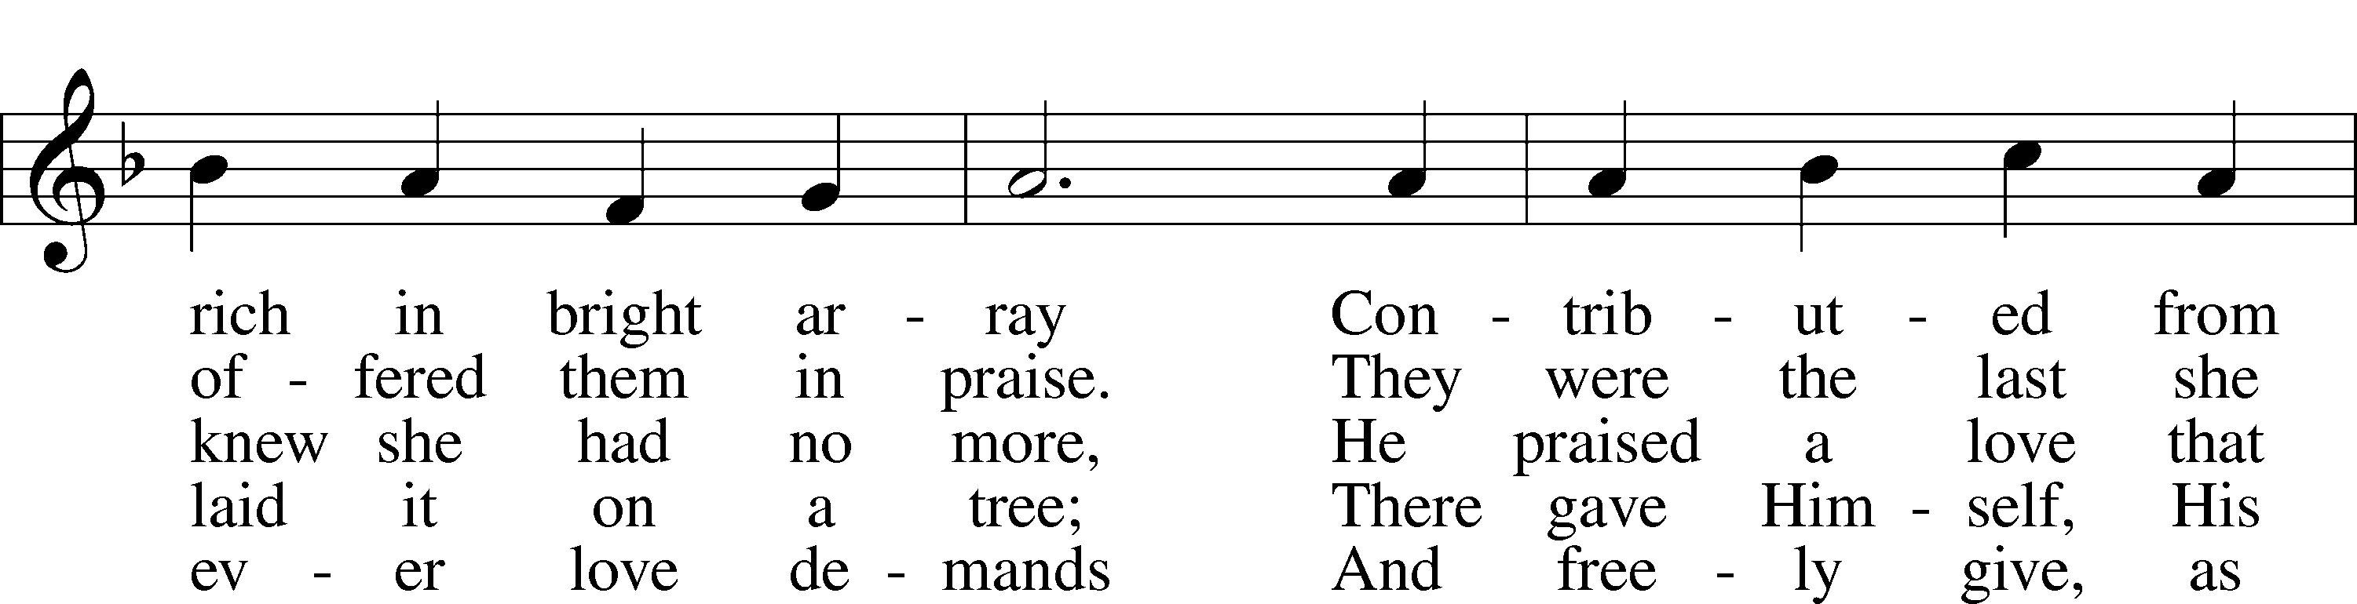
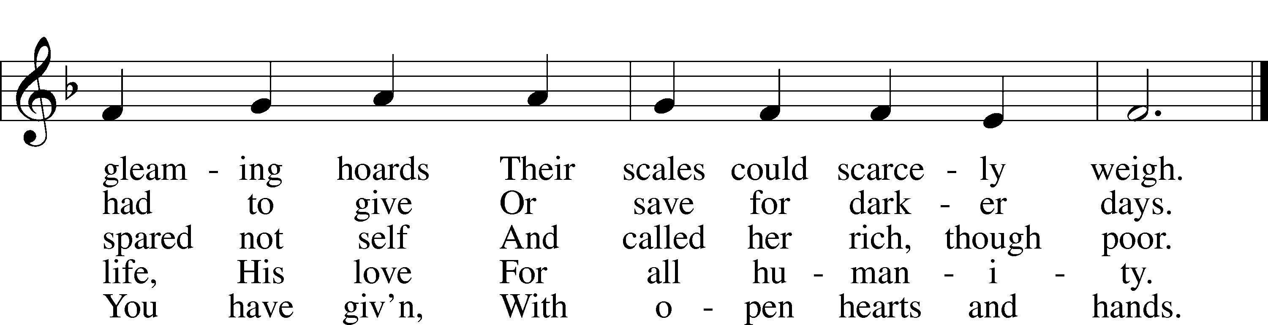
© 1993 GIA Publications, Inc. Used by permission: LSB Hymn License .NET, no. 100011641.
Public domain

“Gracious God, You Send Great Blessings” LSB 782
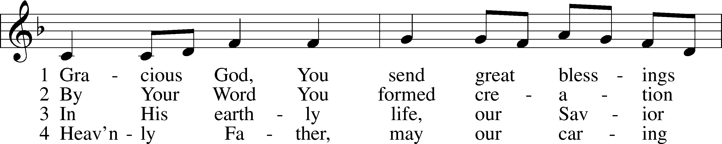
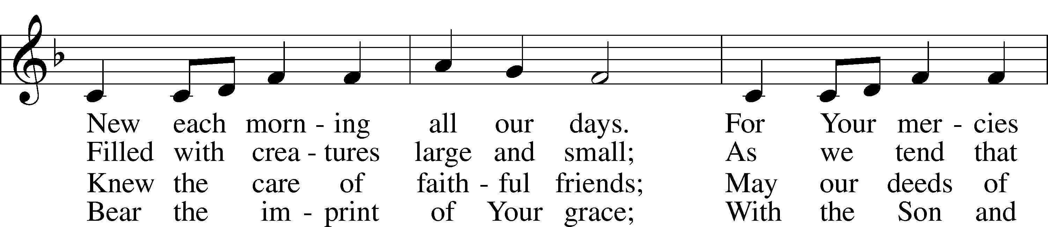
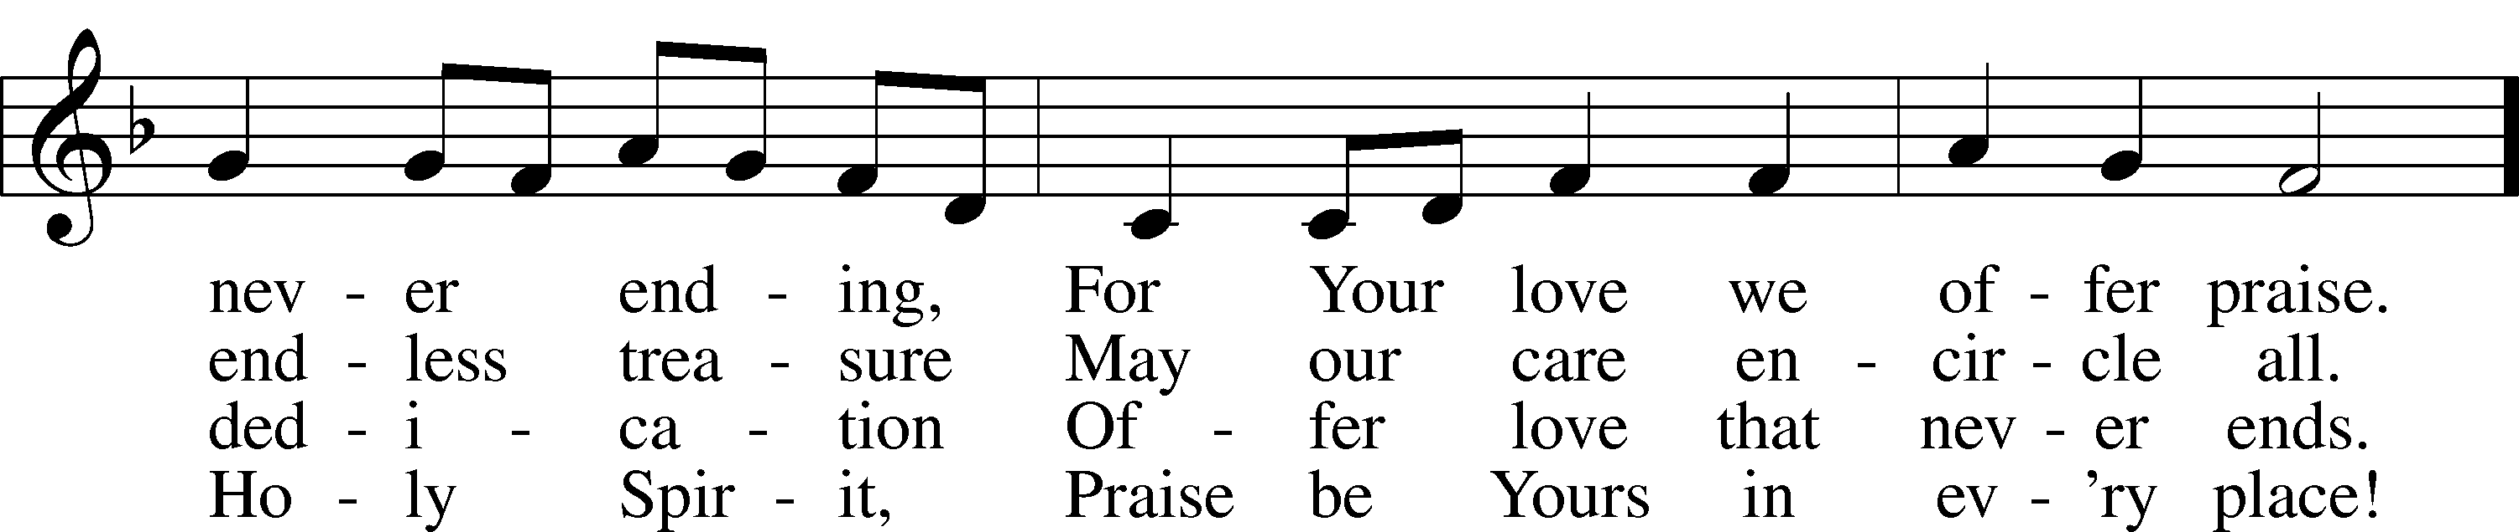
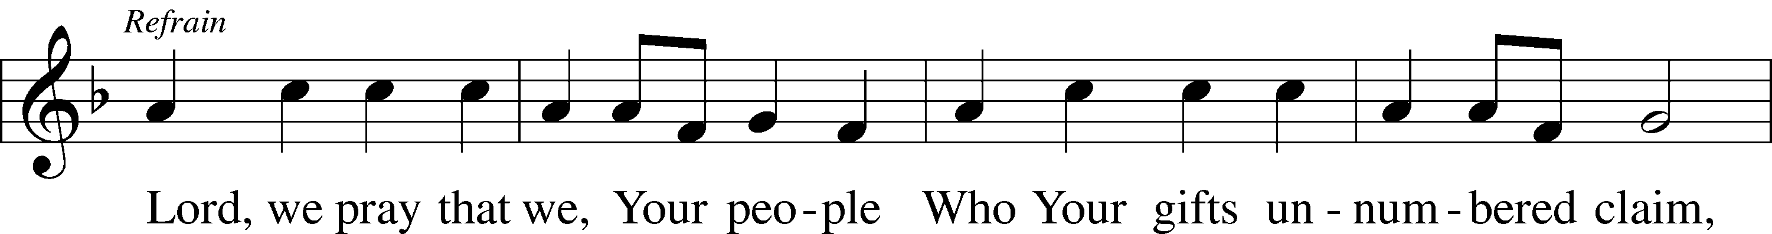
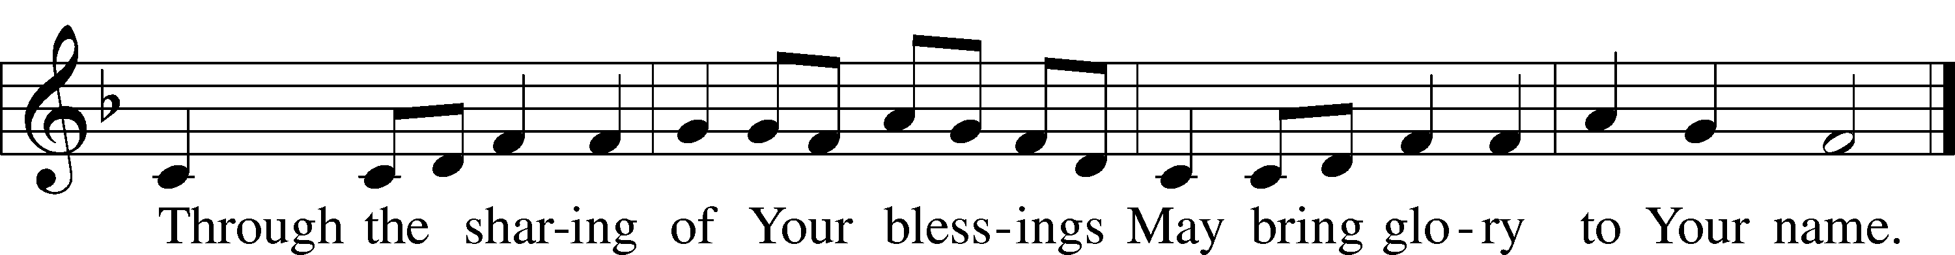
© 2004 Gregory J. Wismar. Used by permission: LSB Hymn License .NET, no. 100011641.
Public domain

(Please stand…)
THE LORD’S PRAYER:
All: Our Father, who art in heaven, Hallowed be thy name, thy kingdom come, thy will be done, on earth as it is in heaven. Give us this day our daily bread; and forgive us our trespasses, as we forgive those who trespass against us; and lead us not into temptation, but deliver us from evil. For thine is the kingdom, and the power, and the glory, forever and ever. Amen.

THE BLESSING AND BENEDICTION:
Pastor: The Lord Blesses you and keeps you, the Lord makes His face to shine upon you and He is Gracious to you. The Lord looks upon you with His favor and gives you His peace.
Congregation: God blesses us so that we can be a blessing to others.
Pastor: Go in His peace and serve the Lord by serving others.
Congregation: Amen

THE CLOSING HYMN: “God Bless Our Native Land” LSB 965
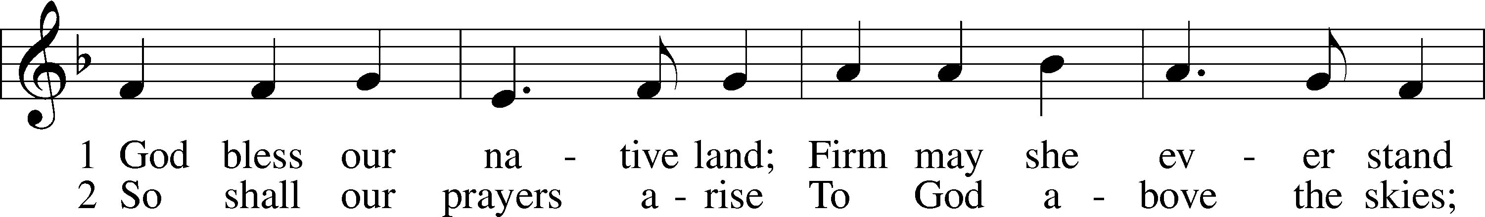
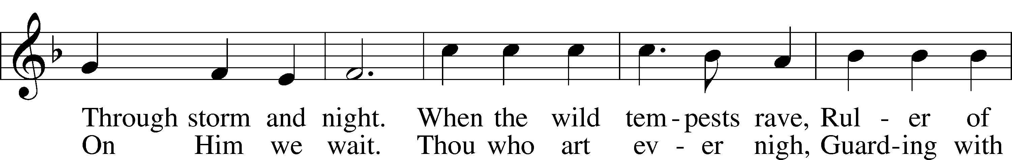
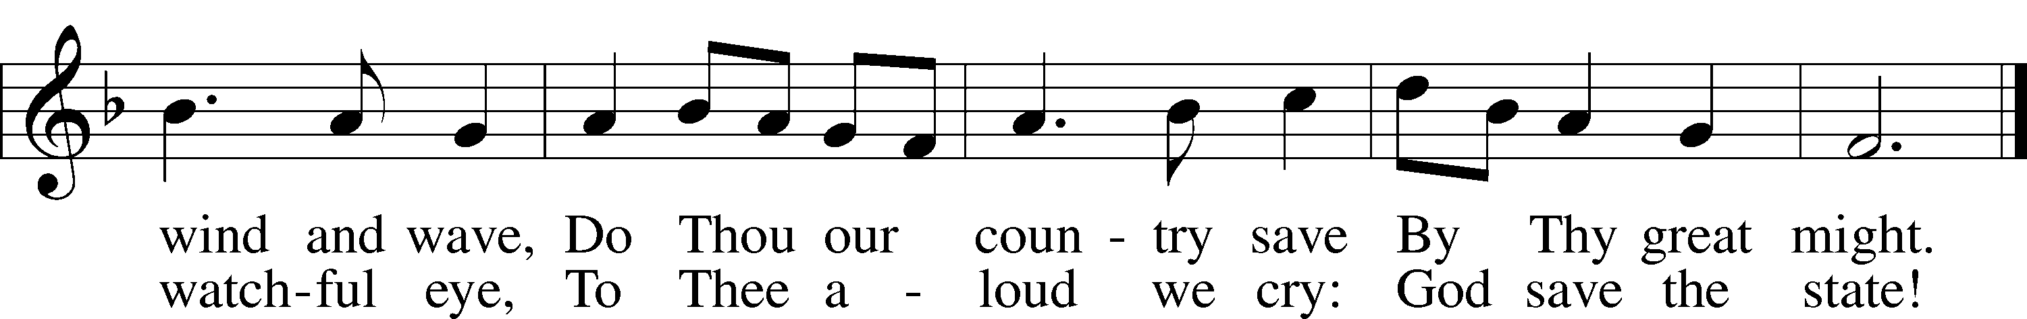
Public domain

ANNOUNCEMENTS

WELCOME TO GRACE LUTHERAN CHURCH: We are glad that you are here to worship God with us today! We pray that you will enjoy the wonderful fellowship as friends in Christ as God gathers us around His means of grace, the Word and Sacraments, to bless us with His treasured gifts of forgiveness, faith, abundant life and eternal salvation. If you are a guest, please also sign our Guest Book. Please talk to Pastor if you would like to learn more about becoming a member of Grace. Also, please join us for refreshments and fellowship after the Service. We invite you to come and worship with us often as God gathers us in His Grace.

WELCOME TO THE LORD”S TABLE: We invite and encourage all present who are baptized and faithful Christians, and who confess the Father, Son, and Holy Spirit to be the only true God and who believe that Jesus Christ died for the sins of the World and is our only hope and salvation…to join us in receiving the very and true body and blood of Christ in this Sacrament. The clear liquid cups in the center of the tray are non-alcoholic wine.

Children not yet confirmed in the faith are always welcome to join their parents at the Lord’s Table, but should keep their hands folded in front of them. The Pastor will give them a blessing.

SERVING TODAY: Acolyte: ____________; Lector: Peter Bacle, Communion Assistants: Matt Meritt and Mitch Cook; Usher: David Rose; Altar Care: Kim McGee; Refreshments: Laurie Cook.

SERVING NEXT SUNDAY: Acolyte: Elizabeth Reynolds; Lector: Kara McGee; Communion Assistants: Matt Meritt and Mitch Cook; Usher: David Rose; Altar Care: Kim McGee; Refreshments: the Chavarria family.

FLOWERS: were placed on the altar today to the glory of God and by the Morris Family.

THIS WEEK AT A GLANCE:

Today: This Sunday
Middle School Youth Gathering
9:00 am Worship Service with Communion
10:10 am Children’s Hand chime and Vocal Choir Rehearsal
10:15 am Fellowship
10:30 am Adult Bible Class/Children’s Sunday School, Bell Choir Rehearsal

Monday: November 9th
Pastor’s Day Off
5:00 pm Zumba

Tuesday: November 10th
3:00 pm Jan’s Mobile Gym (Parish Hall)
6:00 pm Weight Watcher’s (Parish Hall)

Wednesday: November 11th
No School
10:00 am Water Aerobics (Community Pool)

Thursday: November 12th
5:00 pm Zumba
6:30 pm Missional Community (Pastor’s Home)

Saturday: November 14th
11:00 am Vocal Choir Rehearsal
12:00 pm OCC Packing party at Fifth Street Baptist

Next Sunday: November 15th
9:00 am Worship Service with Communion
10:10 am Children’s Hand chime and Vocal Choir Rehearsal
10:15 am Fellowship
10:30 am Adult Bible Class/Children’s Sunday School

IN YOUR PRAYERS THIS WEEK: The Gonzales family, Grace White, Glen Heubner, family and friends of Ramon Rodriquez, Gretchen Liebi, Carol Sebree, Holly Purdy, friends and family of Wendy Asplundh, Floss Flenard, Katie Higgs Wyrwicki, Peggy Mira, Micheal son of Will and Noelle Plagens, Walter Lepperd, Mary Hoffman, Robert Hoffmann, Will Plagens, Peter Pike, Frank, Harry, Mary McNeal, Donald Rollman, Jonathan Satel, VanderKooi family, Bobby Bringle, Meggan Meggs, Cheryl Kucera, Tim Rodriguez, Elsie Hamilton, Mary Bacle, Michael Gillis, Joe Lamberson, Vernon Julson, Dennis Julson, Mary Ellen Jessel, and those you are praying for at home. If anyone has a special prayer request please submit it in writing in the collection plate; or you may call Pastor Gary Faith at (504-858-8872), or Kris Howard at (305-296-5161).

GIFTS, TITHES, & ATTENDANCE LAST SUNDAY were $8054.00, the building fund received $320.00 and the noise offering for the last Sunday’s totaled $______. The attendance for last Sunday was 71.

TO HELP US GROW… The Bible readings for next Sunday’s service readings are Daniel 12:1-3, Hebrews 10:11-25, and Mark 13:1-13.

THE GRACIOUS LADIES OF GRACE Ten of the Gracious Ladies enjoyed a seafront lunch at Conch Republic and rated it 4*. On Nov. 17th we will be dining at the Waterfront Brewery on Caroline St. at 11:30 am. Please join us for a lot of conversation and good times. Ladies please come and join us.

THE ARTS AND CRAFT FESTIVAL is just around the corner and will take place Saturday November 14th from 9-2:30pm. We are looking for venders to sell their wares, donations for our silent auction, and volunteers to help in the kitchen (signup sheet is in the narthex). If you have any questions please contact Kris in the church office at 305-296-5161, she will either be able to answer your question or get you in contact with the appropriate person.

WOMEN’S BIBLE STUDY will have their final meeting for this year on Wednesday Nov. 18th at 4:30. We will be celebrating the completion of this wonderful series with dinner on Thursday Nov. 19th at Bistro Sole’. All of the Grace Lutheran woman are invited to this dinner. Please join us for some great food and conversation.

WATER AEROBICS: Christine Gorham is now teaching a low impact water aerobics class for women and men at the Martin Luther King community pool on Wednesdays from 10:00am – 10:45 am. There is a low cost of $5.00 per class. Please come and join in the fun.

IF THERE ARE ANY TOPICS or Scripture you would like Pastor to consider for our Midweek Advent Services please let Pastor know by placing an info card in the offering, emailing him or even calling him.

PICTORIAL DIRECTORY: The pictures are up. If you do not like the picture of you that is posted you can send one to me that you like better or we can do a retake. If you do not have a picture in the directory and you would like to be included please let me know. As stated before only the names will be published. To find the directory just go to our website; http://gracelutherankw.360unite.com/home, click on ABOUT US. You will then see a drop down menu, click on DIRECTORY. That’s all. If you have not been to our website before please take your time and look around. You will find an updated calendar of our events, information on all of our bible classes, a link to this week’s bulletin, even an audio file of this week’s sermon, and so much more.

NOISE OFFERING: The offering will go to the Samaritan’s Purse to pay for the postage on the Christmas boxes for the children that our school and church will be working on. Be on the lookout for more information on how you can be involved in helping kids get some Christmas presents.

THE GRACE LUTHERAN CHURCH WEB PAGE AND FACE BOOK PAGE now contains a vocal recording of last week’s sermon. So if you are not able to attend church on Sunday please go to our website where you will find a copy of the bulletin and a recording of Pastor Faith’s sermon. The new webpage address is gracelutherankw.360unite.

A NUMBER OF CAPITAL IMPROVEMENTS are needed to keep our facilities in good health for the future. The narthex has been rebuilt. Roof repairs are needed on school buildings.
If you can help it would be much appreciated! A big thanks to all who have contributed to these repair.

MUSIC MINISTRY

"Make a joyful noise to the Lord, all the earth!" Psalm 100:1. Whether you are here year-round or only part-time, we invite you to participate in our music ministry. Please speak with Beverly Walker or contact her at beverlywalker@gmail.com if you have any questions.

Bell choir rehearses today at 10:30. There is no rehearsal this Wednesday.

Children's Chime/Vocal Choir rehearses today from 10:10 to 10:25.

Vocal Choir rehearses on Saturdays from 11:00 to 12 noon.

WOMEN’S BIBLE STUDY: We are called to be daughters and wives, sisters, and friends, mothers and grandmas. We are called to be volunteers, employees, citizens, and leaders. And as we fill these various roles, we are to be intuitive, creative, persistent, supportive, and productive.

This nine-session Bible study titled Golden Fruit by Julie Hale Maschhoff helps the Christian woman put all of these roles, characteristics, and emotions into perspective. Each session focuses on one fruit of the spirit and considers how the lives and stories of nine biblical women convey that characteristic. Like these women you'll see how God is at work in your life too.

Won't you please join our group for one hour on Wednesday Nov. 18th at 4:30 in room 3 and grow in your faith and in unity and fellowship with your sisters at Grace. This will be the final meeting until after the Christmas Holiday’s.

The MEN’S BIBLE FELLOWSHIP will be working on their study “The Journey from Unbelief to Faith”, Wednesday November 18th. They meet the first and third Wednesday’s of each month at 12:30pm at Chico’s Restaurant. All guys are welcome.

This is a preliminary sketch of one of 7 windows that are planned to replace the existing ones. They include the 3 windows looking to the left of the center window of Christ and the 4 to the right. They will represent the life of Christ starting with Creation, Christmas, Crucifixion, Easter, Ascension,
Heaven, and ending with the Trinity.
Paul Pickel at Pickel Studios and his artist Apryl Moyer are designing the windows and are responsible for the new windows already installed. These windows have all been funded by special contributions from members of Grace.
The Board of Directors is asking for donors who would be interested at an estimated cost of $15,000.00 per new window.
This is a work in progress and not all details have been worked out but changes will be minor.
Contact Jim Reynolds 305 394-5987 with questions or to donate a window.

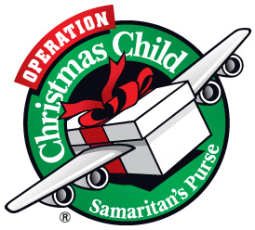

Operation Christmas Child

Operation Christmas Child (OCC) is a project of the international Relief organization, Samaritan’s Purse. They are committed to reaching out to millions of underprivileged children with “Shoe Box Gifts”. Fifth Street Baptist Church has asked Grace Lutheran Church and School as well as other area churches to join them in packing shoe boxes with small gifts for OCC. The boxes will be hand delivered to the children all over the world suffering from war, poverty, famine, disease and natural disasters. To find out more about OCC please visit the website www.samaritaspurse.org.

Here’s How You Can Help!

Prayer! Pray that hearts are reached and lives are changed on all sides of the shoeboxes-those giving and those receiving!

Donate bulk goods like school supplies, hygiene items, toys or hard candy to be used for packing the boxes. (No liquids, chocolate, or war related items please). We will also need empty shoe boxes or other boxes about that size to be used to pack the gifts. Our school children will pack the boxes here at grace and we will deliver them to Fifth Street Baptist Church. Any extra items will be brought to the packing party on the 14th.

If you would like to make this a family project your family can bring a packed box of items your family has chosen and drop it off at Grace. You may include a letter, card, and family photo. Please wrap the lid of the box separately.

The boxes are packed for a boy or girl and the ages range from 2-4 years old, 5-9 years old, and 10-14 years old.

You can also join the packing party at Fifth Street Baptist on Saturday November 14th, 2015 (time to be announced). There will be food, games, and packing of boxes. Each box costs $7 to ship.

The Noisy Offering this month will fund the shipping so please give generously hen the bucket comes your way!!

Jesus let the things that break your heart also break our hearts.

Amen

